.  Contact  Websites, Portfolios, Profiles  - htps://premjishnuganapathy.dev  Achievements  - Awarded the Good Citizenship Award in American Legion Michigan Boys State, a highly selective program only a few people get to go to.  - Completed CPR Certification through the American Red Cross in June 2025.  Skills  - Teamwork and collaboration  - Strong written and verbal communication  - Fast learner  - Mentoring and tutoring  - Team management  - Time management  - Community engagement  - Problem-solving and Critical thinking  - Volunteer service  - Academic excellence  Certifications  - SolidWorks Additive Manufacturing Certification.  - SolidWorks Electrical Certification.  Languages  Spanish  Limited Working:  English  Professional Working:  Tamil  Native or Bilingual:  Volunteer work  - Assisted in organizing community outreach events to promote local resources.  - Supported team members by preparing materials for workshops and training sessions.  - Assisted with special events and programs.  - Used strong interpersonal communication skills to convey information to others.  - Strengthened volunteer team effectiveness by providing training sessions.  References  Teacher Recommendations  Awards  Good Citizenship Citation |  | Aspiring technology and engineering student with hands-on AI/ML internship experience and a strong foundation in programming and analytical problem-solving. Passionate about leveraging artificial intelligence, robotics, and cybersecurity to tackle complex, real-world challenges through rigorous higher education.  Education  High School Diploma - Expected in June 2027  Grand Ledge High School, Grand Ledge, MI  Clubs/Activities  - Mathlets Club  - Collaborated with peers to tackle complex analytical problems during weekly study sessions.  - Calculus Club  - Worked through advanced calculus theory and application problems with peers to strengthen mathematical rigor.  - Participated in group problem-solving workshops focused on complex differential and integral equations.  - Future Mathematician Initiative  - Provided peer-to-peer tutoring in foundational and advanced mathematics to improve student academic performance.  - Robotics Club  - Assisted in designing, prototyping, and programming robotic systems to execute specific competitive tasks.  - Utilized engineering design principles, coding, and hardware troubleshooting under strict competitive constraints.  - National Technical Honor Society  - Maintained high academic standing in technical coursework while committing to community service projects.  - Developed professional skills in leadership, technical communication, and practical problem-solving.  - Asian American Student Union  - Participated in organizing school-wide cultural events and educational initiatives to foster an inclusive community  - Engaged in group discussions regarding diversity, equity, and  representation in secondary education.  - Student Council  - Coordinated school-wide initiatives, fundraisers, and community outreach events in collaboration with faculty and peers.  - Served as a voice for the student body to communicate ideas and feedback directly to school administration.  Experience  1. AI/ML Intern | BetterMind Labs  August 10, 2026 – September 7, 2026  - Completed a four-week AI/ML internship focused on building foundational knowledge and practical understanding of artificial intelligence and machine learning concepts.  - Developed analytical and problem-solving skills through hands-on learning, exercises, and exposure to AI/ML applications.  - Demonstrated adaptability and a willingness to learn new concepts through consistent practice and active engagement.  - Applied feedback to improve understanding and refine approaches to technical challenges.  - Strengthened collaboration, communication, and idea-sharing skills through participation in group learning activities and discussions.  - Demonstrated professionalism, attention to detail, and dedication throughout the internship.  Projects  Real Time Artificial Intelligence Projects  2. Intern Todd Martin Youth Leadership, Lansing, MI  August 10, 2026 – September 7, 2026  - Assisted in organizing leadership workshops and community events to enhance youth engagement.  - Collaborated with 15 team members to develop educational materials and resources for program participants.  - Supported daily operations by managing 25 participant registrations and ensuring smooth event execution.  - Conducted research on best practices in youth leadership programs to inform program development.  sports  - Tennis: 8 years of experience and current member of the School Varsity Tennis Team; earned multiple medals in local and school tournaments. Developed discipline, perseverance, and teamwork through competitive play.  - Golf: Recently began learning golf as a new challenge and opportunity to develop skills in a different sport.  - Recreational: Regularly play pickleball and table tennis with friends for fitness and enjoyment.  Interests  - Volunteering  - Cooking  - Gardening  - Tech enthusiast, passionate about exploring the latest advancements and innovations.  - Strategy Games  - Video Gaming  - Playing Sports  - Team Sports  - Fundraising Events  Extracurricular Activities  Volunteering: Helped young kids learn tennis during the summer. Mentored 1st graders in an after-school program.  Organized and distributed food for families in need.  Sports: Played tennis for 6 years and have won multiple medals in local and school tournaments.  Recently started golfing to challenge myself with a new sport. Playing  pickleball and ping pong for fun with friends.  Volunteering: Helped young kids learn tennis during the summer. Mentored 1st graders in an after-school program.  Organized and distributed food for families in need. Sports:
  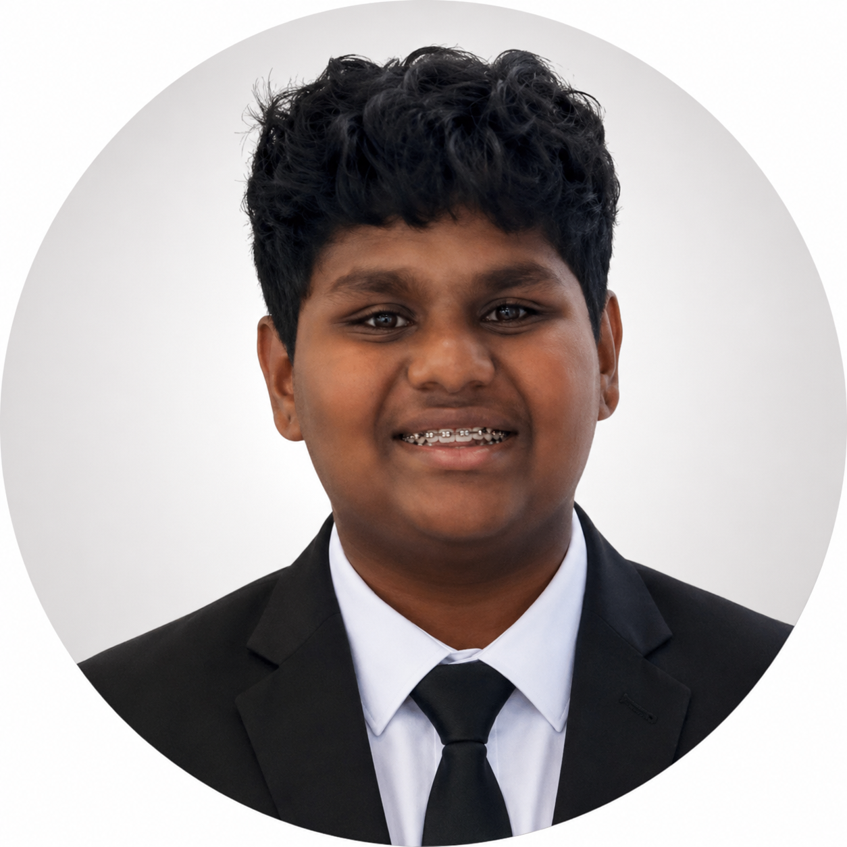 Prem Jishnu Ganapathy
   |  | Lansing, MI 48917
   |  | 5177749991
   |  | premjishnu.g@gmail.com
.

