Research Summarizer Agent: Test Scenarios
This document lists every test of the Research Summarizer Agent, with the request sent, the expected result, and the actual result.
- Part 1, Unit tests: automated JUnit tests. They need no running application and no API keys.
- Part 2, API test scenarios: 17 requests sent to the running application with Postman. Most important first, edge cases last.
The Postman collection with all 17 requests, including automatic checks, is in postman/research-summarizer.postman_collection.json.

Part 1: Unit tests
Command: ./mvnw test (Windows: mvnw.cmd test)
Test class | What it tests | Tests
SearchAgentTest | Agent 1: the routing rule (isOpenAiRelated), search-word cleaning (searchQuery), and the relevance check for MCP results (isRelevant) | 6
InsightExtractorAgentTest | Agent 2: the hallucination check (keepGrounded). A real quote is kept; formatting differences do not matter; an invented quote, a quote cited to the wrong source, an unknown source and a missing quote are all dropped | 3

Expected result: Tests run: 9, Failures: 0, Errors: 0, BUILD SUCCESS
Result: ✅ Pass
Maven
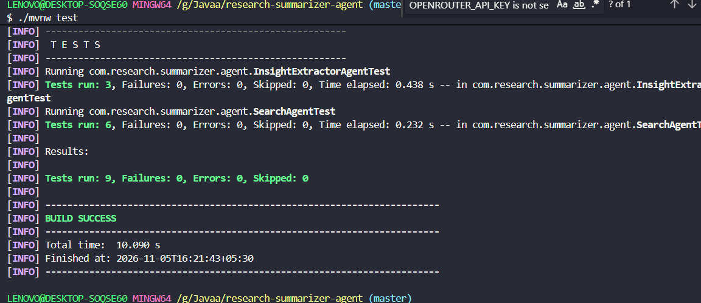
Run Test 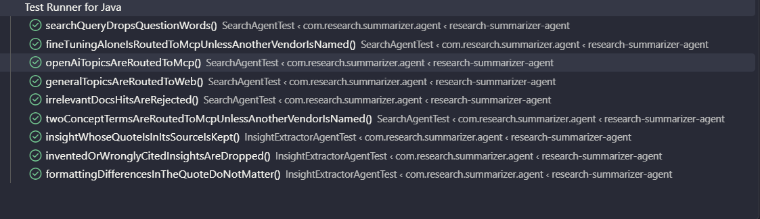

Part 2: API test scenarios

Setup
- Add your own API keys to .env (refer .env.example).
- Start the application: docker compose up --build (or ./mvnw spring-boot:run).
- In Postman, import postman/research-summarizer.postman_collection.json.
All requests in scenarios 1 to 14:
- Method: POST (except scenario 14)
- URL: http://localhost:8080/api/research/summarize
- Header: Content-Type: application/json
Scenarios that call the LLM take about 30 to 120 seconds, because the app uses a free model.

Overview
# | Scenario | Expected | Result
1 | OpenAI topic → MCP | 200, MCP | ✅ Pass
2 | General topic → web search | 200, WEB | ✅ Pass
3 | OpenAI topic not in the docs → fallback to web | 200, WEB | ✅ Pass
4 | Fine-tuning topic → MCP (routing rule 3) | 200, MCP | ✅ Pass
5 | Other AI vendor → web (routing rule 2) | 200, WEB | ✅ Pass
6 | Blank topic | 400 | ✅ Pass
7 | maxSources = 0 | 400 | ✅ Pass
8 | Malformed JSON | 400 | ✅ Pass
9 | Caller's own trace id is returned | 200, same X-Trace-Id | ✅ Pass
10 | maxSources omitted → default 5 | 200, at most 5 sources | ✅ Pass
11 | Missing topic | 400 | ✅ Pass
12 | maxSources = 11 | 400 | ✅ Pass
13 | maxSources has the wrong type | 400 | ✅ Pass
14 | GET instead of POST | 405 | ✅ Pass
15 | OpenAI Docs MCP server unavailable | 200, falls back to WEB | ✅ Pass
16 | Tavily API key missing | 500, clear message | ✅ Pass
17 | OpenRouter API key missing | Application does not start | ✅ Pass

Section A: Main scenarios (routing)

Scenario 1: OpenAI developer topic → OpenAI Docs MCP server
Purpose: shows the main path. An OpenAI developer topic is answered from the official OpenAI documentation through the MCP server.
Request:
{ "topic": "How does streaming work in the OpenAI Responses API?", "maxSources": 3 }
Expected result:
- 200 OK, "searchSource": "MCP"
- The report has executiveSummary, keyFindings, details and sources.
- Every source is a page on developers.openai.com.
Result: ✅ Pass
Screenshot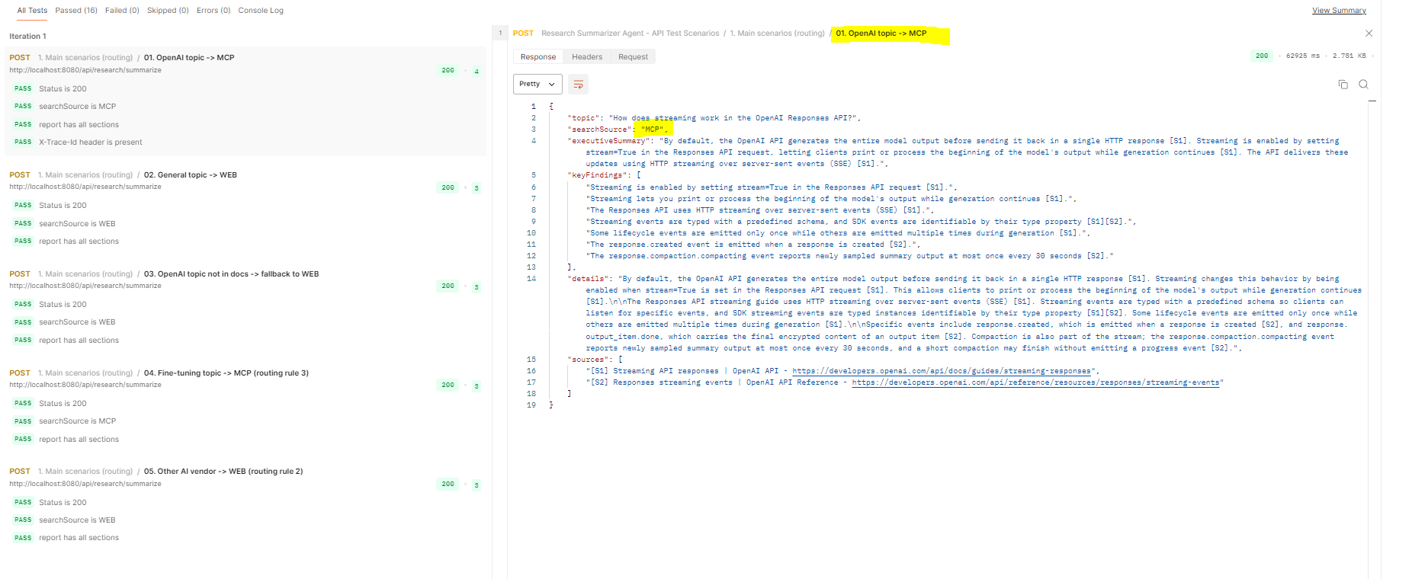Postman response

Scenario 2: General topic → web search
Purpose: shows that a topic unrelated to OpenAI goes straight to Tavily web search.
Request:
{ "topic": "Health benefits of intermittent fasting", "maxSources": 3 }
Expected result:
- 200 OK, "searchSource": "WEB"
- Sources are public web pages.
Result: ✅ Pass
Screenshot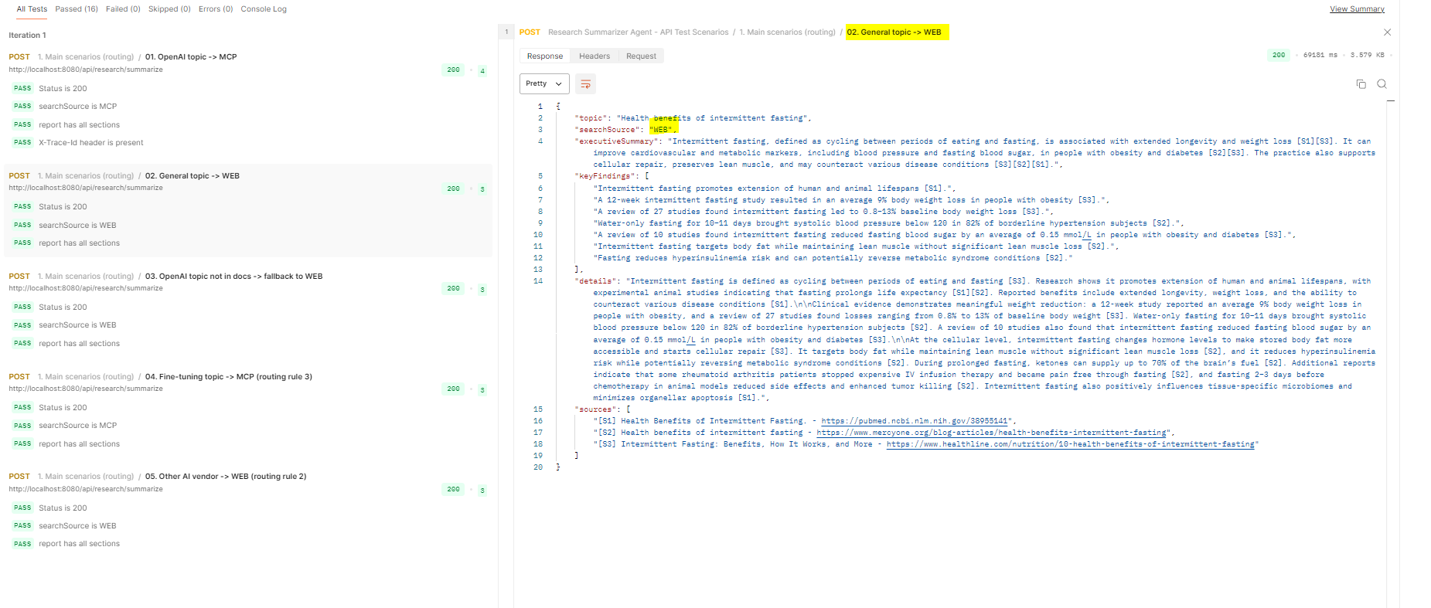 Postman response

Scenario 3: OpenAI topic not covered by the docs → fallback to web search
Purpose: shows the fallback. The topic names OpenAI, so the MCP server is tried first. The developer docs have no relevant page, so the app switches to web search.
Request:
{ "topic": "Who founded OpenAI?", "maxSources": 3 }
Expected result:
- 200 OK, "searchSource": "WEB"
- The application log shows SearchAgent: MCP returned only 0 relevant docs, falling back to web.
Result: ✅ Pass
Screenshot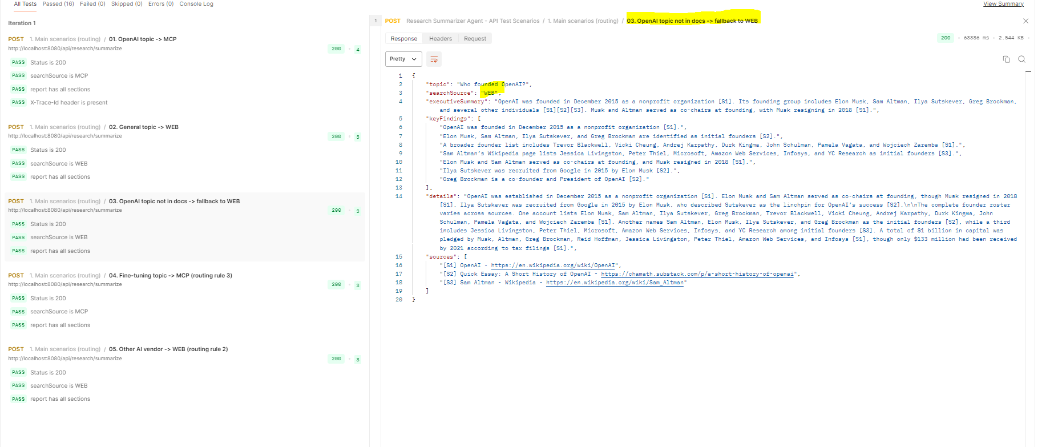
Postman response
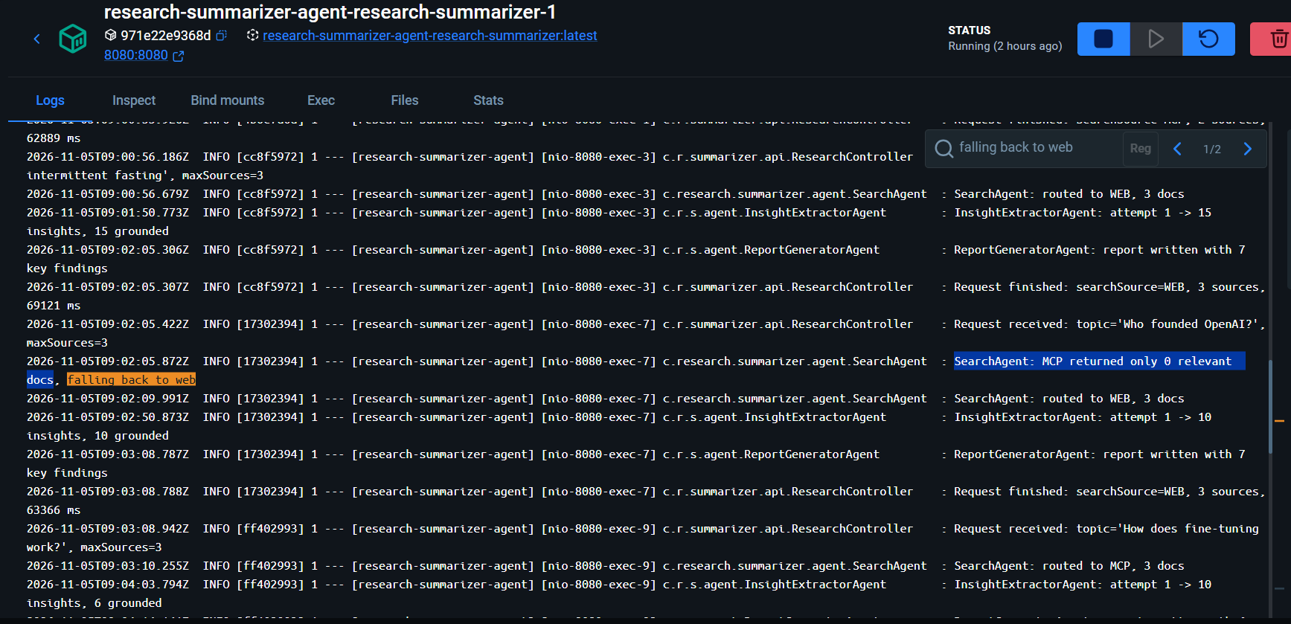
application log with the fall-back line

Scenario 4: Fine-tuning topic → MCP (routing rule 3)
Purpose: shows that fine-tuning, an OpenAI query type named in the assignment, is routed to the MCP server even when no OpenAI product is named.
Request:
{ "topic": "How does fine-tuning work?", "maxSources": 3 }
Expected result: 200 OK, "searchSource": "MCP"
Result: ✅ Pass
Screenshot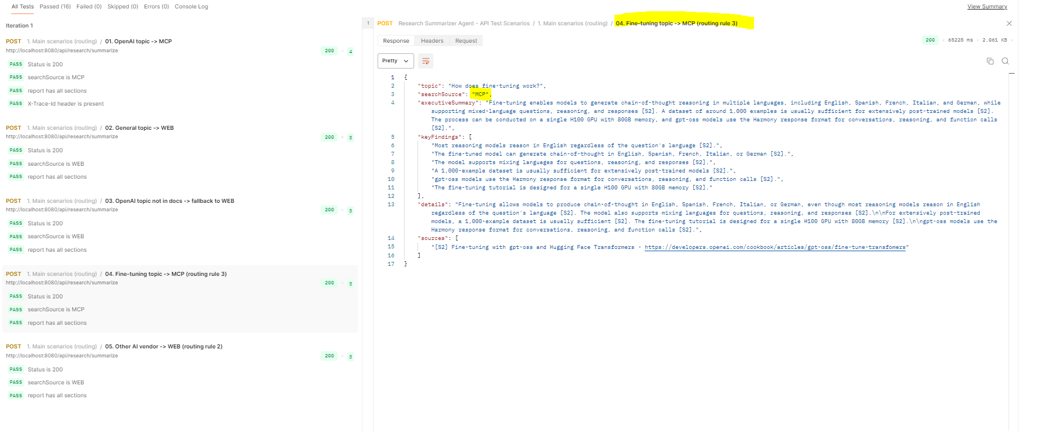 Postman response

Scenario 5: Topic about another AI vendor → web search (routing rule 2)
Purpose: shows that a topic naming another AI vendor goes to the web, even when the topic contains an OpenAI-related concept. "Llama" is a Meta model, so the OpenAI docs are the wrong place to search.
Request:
{ "topic": "Fine-tuning Llama with LoRA", "maxSources": 3 }
Expected result: 200 OK, "searchSource": "WEB"
Result: ✅ Pass
Screenshot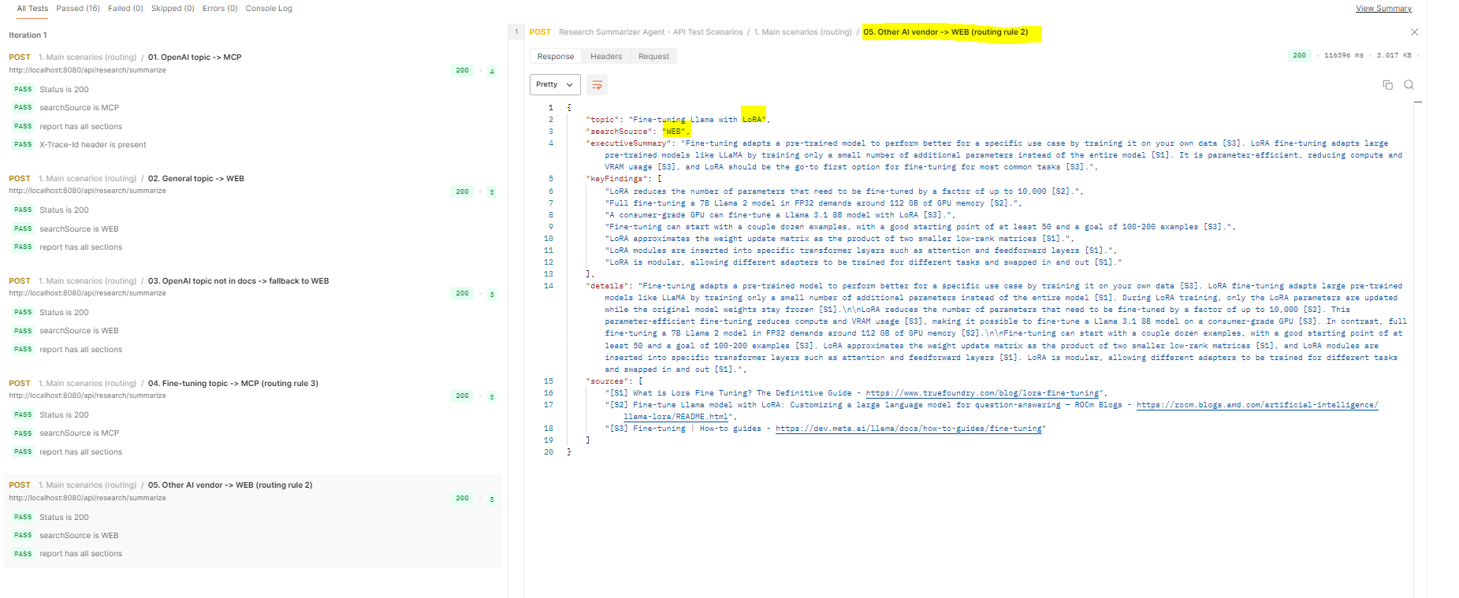 Postman response

Section B: Input validation and API behaviour
Scenarios 6, 7, 8, 11, 12 and 13 are rejected before any agent runs, so they answer immediately and make no LLM call.

Scenario 6: Blank topic
Purpose: a topic that contains only spaces is rejected.
Request:
{ "topic": " " }
Expected result:
{ "status": 400, "error": "Bad Request", "message": "topic must not be blank" }
Result: ✅ Pass
Screenshot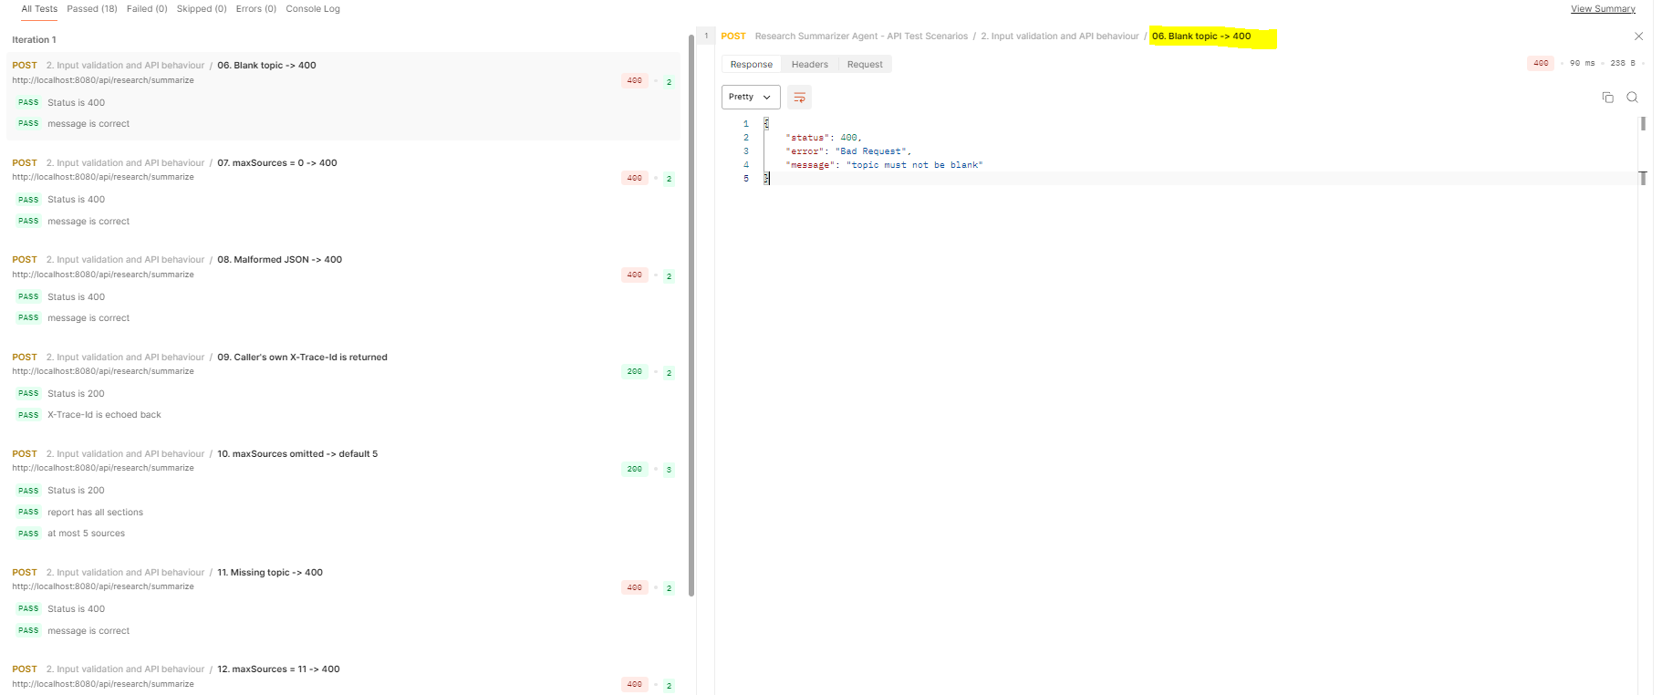 Postman response

Scenario 7: maxSources below the minimum
Purpose: maxSources must be between 1 and 10.
Request:
{ "topic": "How does fine-tuning work?", "maxSources": 0 }
Expected result:
{ "status": 400, "error": "Bad Request", "message": "maxSources must be between 1 and 10" }
Result: ✅ Pass
Screenshot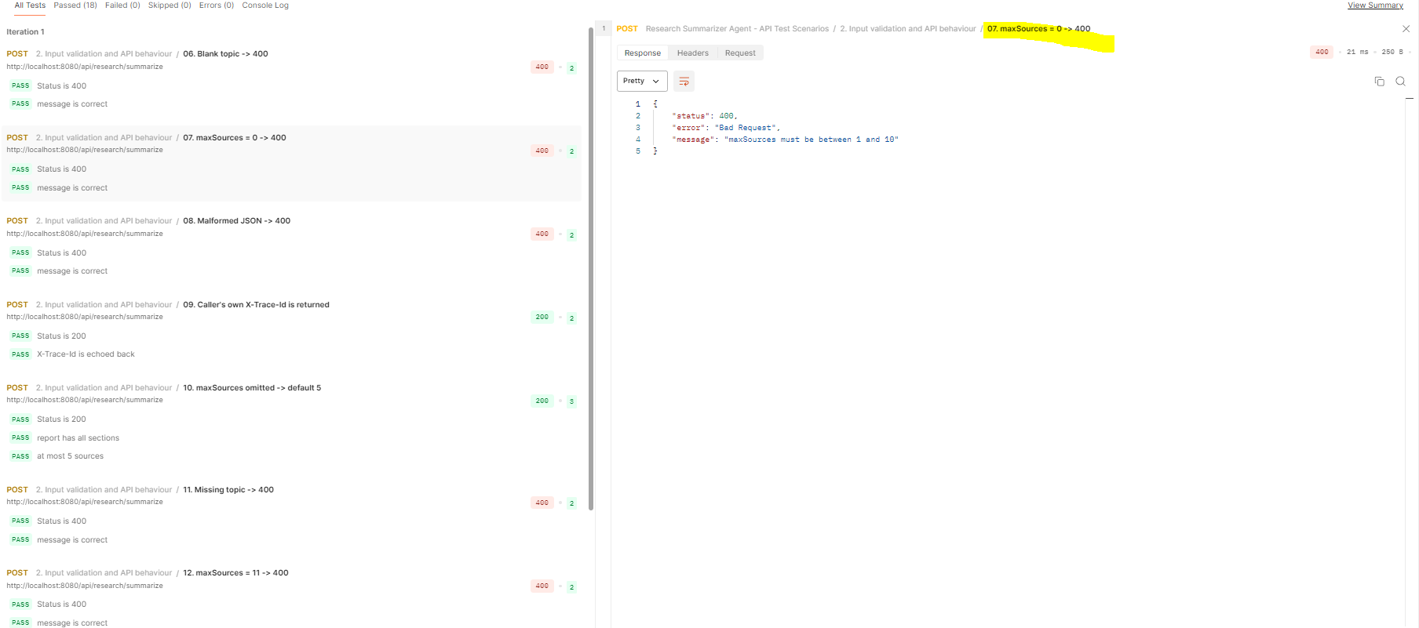 Postman response

Scenario 8: Malformed JSON
Purpose: a request body that is not valid JSON gets a clear error. The closing } is missing on purpose.
Request:
{ "topic": "How does fine-tuning work?"
Expected result:
{ "status": 400, "error": "Bad Request", "message": "Malformed JSON request body" }
Result: ✅ Pass
Screenshot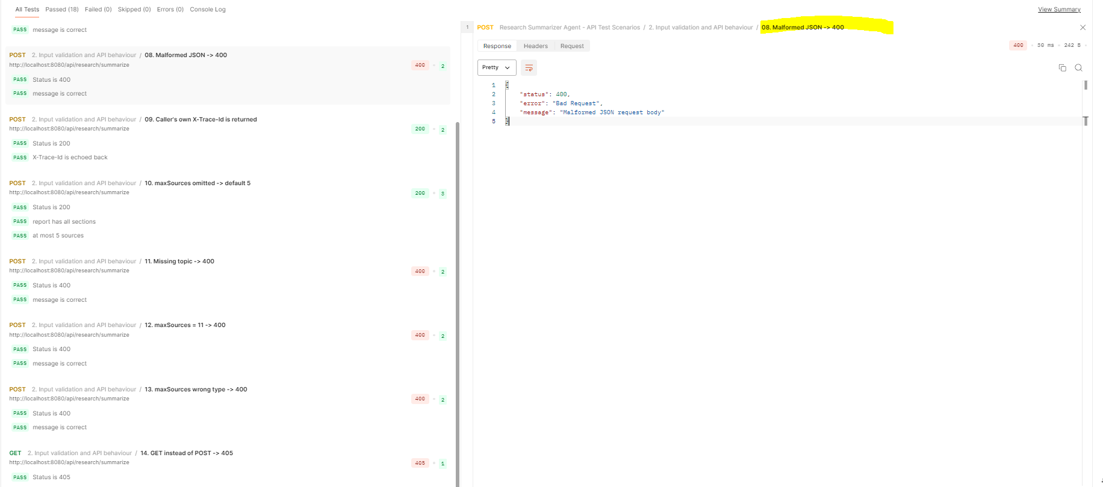 Postman response

Scenario 9: Caller's own trace id is returned and logged
Purpose: shows request tracing. A caller can send its own trace id. The application returns the same id in the response header and prints the id on every log line of the request, across all three agents. If no id is sent, the application creates one.
Request:
- Extra header: X-Trace-Id: postman-test-1
{ "topic": "How does fine-tuning work?", "maxSources": 3 }
Expected result:
- 200 OK
- Response header X-Trace-Id: postman-test-1
- Every log line of this request contains [postman-test-1]:
INFO [postman-test-1] ResearchController : Request received: topic='How does fine-tuning work?', maxSources=3
INFO [postman-test-1] SearchAgent : SearchAgent: routed to MCP, 3 docs
INFO [postman-test-1] InsightExtractorAgent : InsightExtractorAgent: attempt 1 -> ... insights, ... grounded
INFO [postman-test-1] ReportGeneratorAgent : ReportGeneratorAgent: report written with ... key findings
INFO [postman-test-1] ResearchController : Request finished: searchSource=MCP, ... sources, ... ms
Result: ✅ Pass
Headers Tab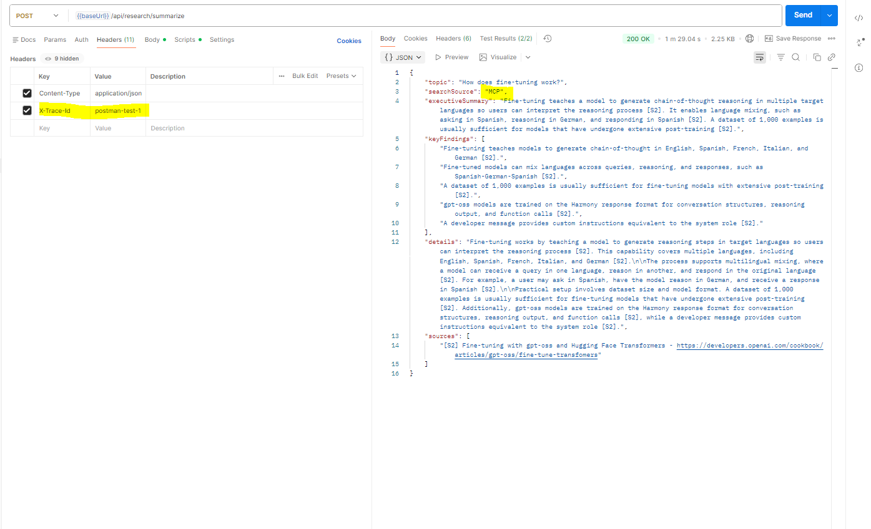
application log filtered by postman-test-1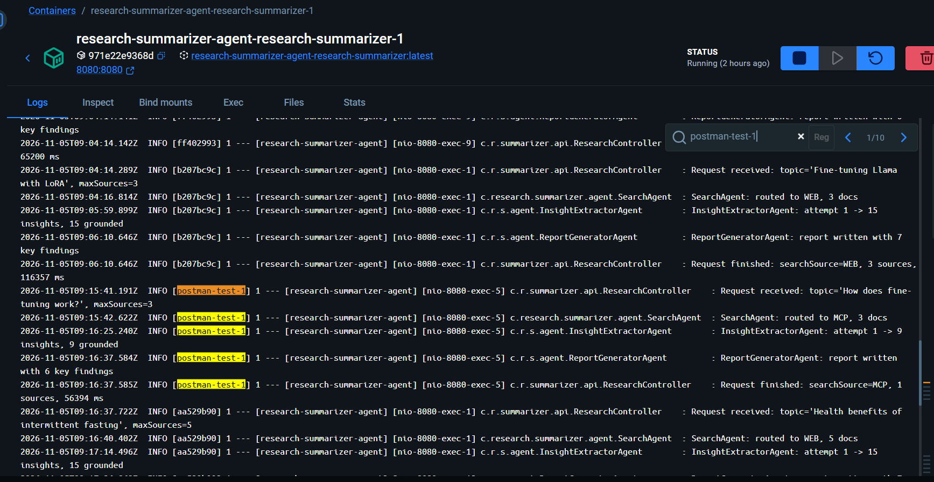

Scenario 10: maxSources omitted → default value 5
Purpose: maxSources is optional. Without it, the application uses 5.
Request:
{ "topic": "Health benefits of intermittent fasting" }
Expected result: 200 OK, at most 5 entries in sources
Result: ✅ Pass
Screenshot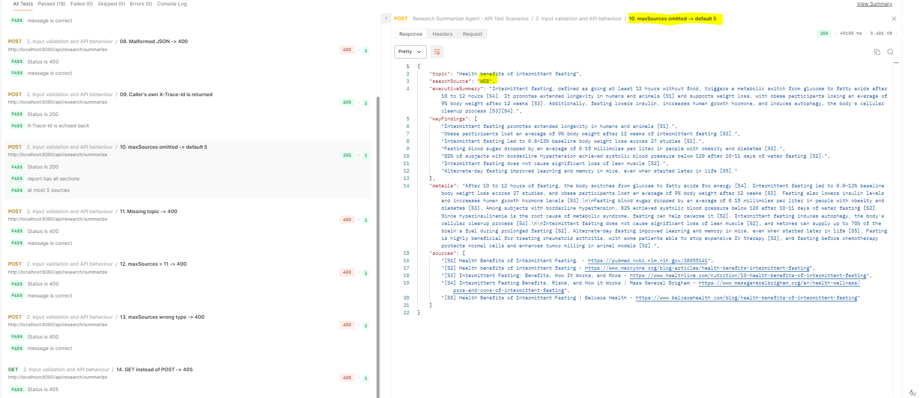Postman response

Scenario 11: Missing topic
Purpose: the topic field is required.
Request:
{ "maxSources": 3 }
Expected result:
{ "status": 400, "error": "Bad Request", "message": "topic must not be blank" }
Result: ✅ Pass
Screenshot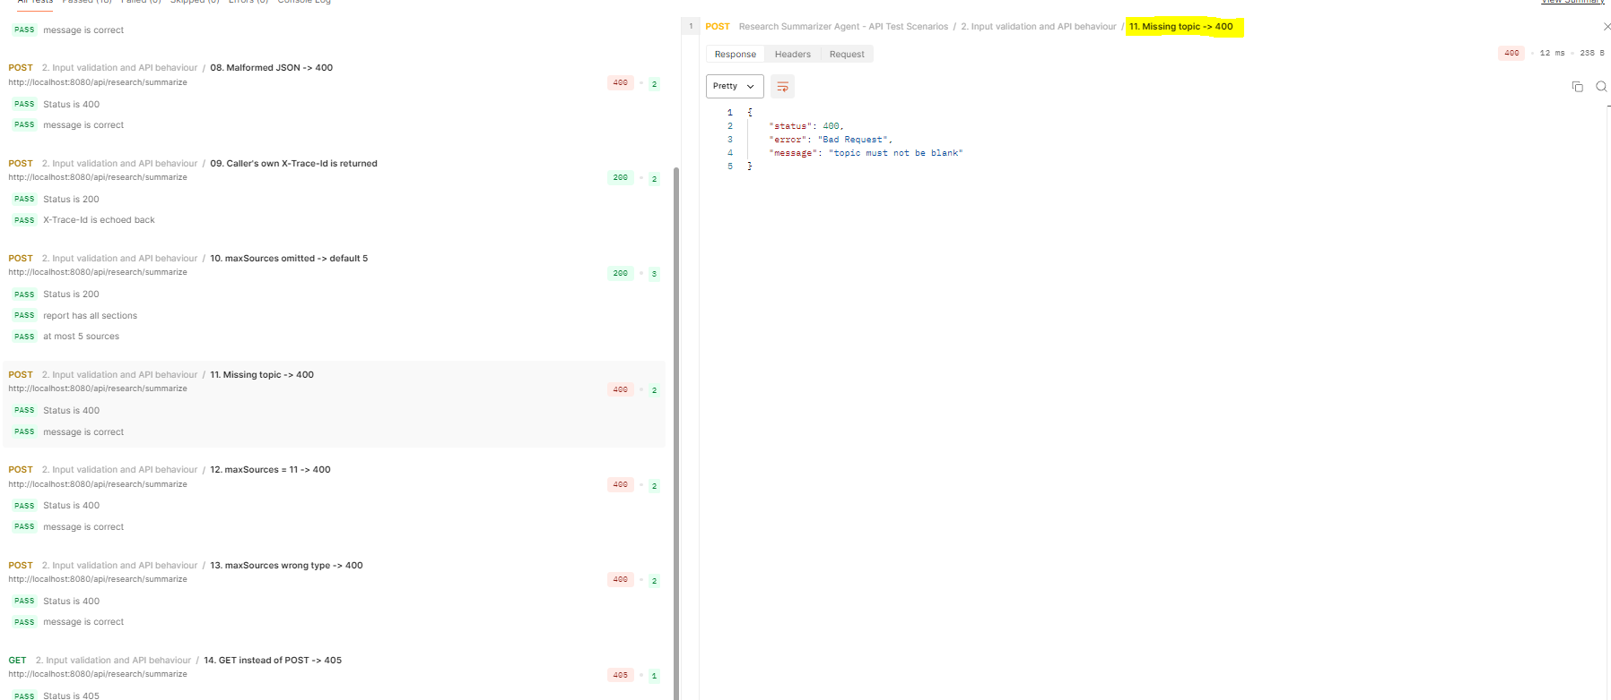 Postman response

Scenario 12: maxSources above the maximum
Purpose: upper limit of maxSources.
Request:
{ "topic": "How does fine-tuning work?", "maxSources": 11 }
Expected result:
{ "status": 400, "error": "Bad Request", "message": "maxSources must be between 1 and 10" }
Result: ✅ Pass
Screenshot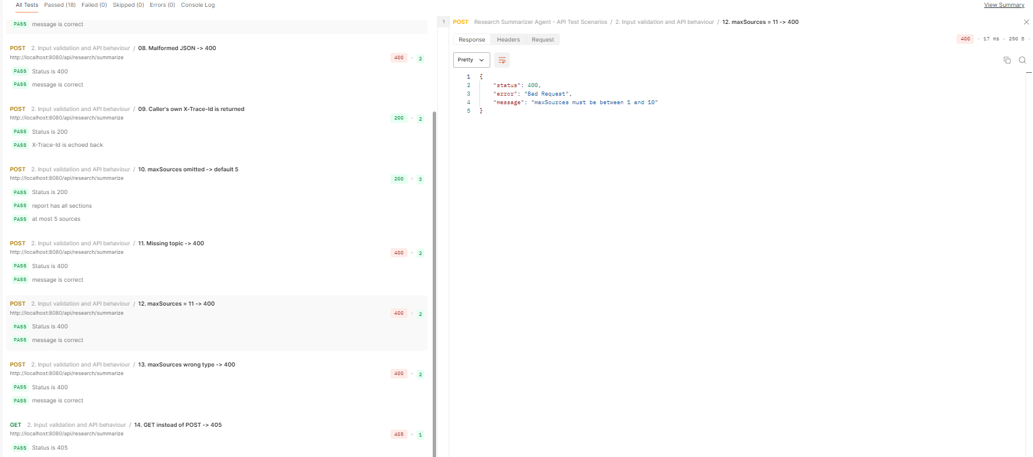 Postman response

Scenario 13: maxSources has the wrong type
Purpose: text where a number is expected is rejected.
Request:
{ "topic": "How does fine-tuning work?", "maxSources": "five" }
Expected result:
{ "status": 400, "error": "Bad Request", "message": "Malformed JSON request body" }
Result: ✅ Pass
Screenshot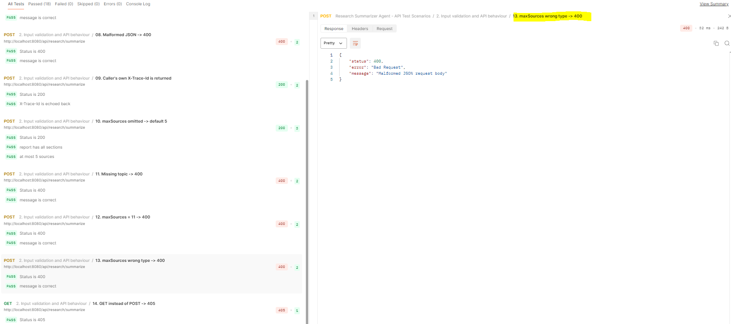 Postman response

Scenario 14: Wrong HTTP method
Purpose: the endpoint accepts only POST.
Request: GET http://localhost:8080/api/research/summarize (no body)
Expected result:
- 405 Method Not Allowed, response header Allow: POST
- Spring answers before the controller runs, so the body has Spring's default error format:
{ "timestamp": "...", "status": 405, "error": "Method Not Allowed", "path": "/api/research/summarize" }
Result: ✅ Pass
Screenshot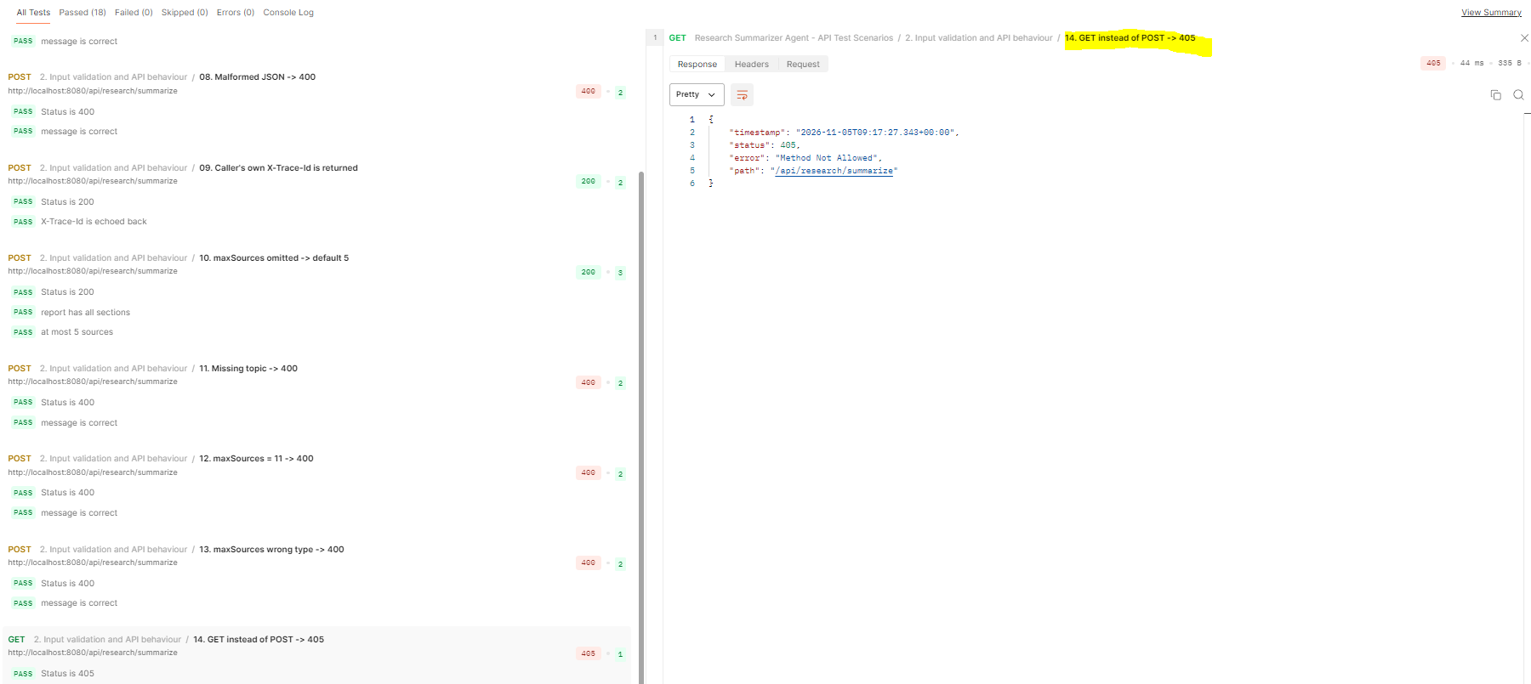 Postman response

Section C: Edge cases (failures and recovery)

Why these scenarios need a separate setup
Scenarios 15 to 17 test how the application behaves when something it depends on is unavailable or misconfigured: the OpenAI Docs MCP server, the Tavily API key, or the OpenRouter API key. These failures cannot be caused by a request alone. For example, the real OpenAI Docs server cannot be switched off, and the API keys are read only once, at startup.
So each of these scenarios starts a separate test container: a second copy of the same application, built from the same Docker image, with one setting deliberately broken. Each test container runs on its own port, so the normal application on port 8080 stays unchanged.
Scenario | Test container | Port | Setting changed on purpose
OpenAI docs server down | test-mcp-down | 8081 | MCP_URL points to an address where no server is listening
Missing Tavily key | test-no-tavily | 8082 | TAVILY_API_KEY is empty
Missing OpenRouter key | test-no-openrouter | 8083 | OPENROUTER_API_KEY is empty

The changed setting is passed with -e when the container starts. Docker passes the setting to the app as an environment variable, which replaces the same value from the .env file. No code or configuration file is changed for these tests.
Prerequisites
- Docker Desktop is running.
- The image is built (docker compose up --build).
- Commands are run from the project folder, because they read the API keys from .env.

Scenario 15: OpenAI Docs MCP server unavailable → fallback to web search
Purpose: shows that the application still answers an OpenAI topic when the OpenAI Docs MCP server cannot be reached, by falling back to Tavily web search.
Setup:
docker run --rm -d --name test-mcp-down -p 8081:8080 --env-file .env -e MCP_URL=http://127.0.0.1:9/mcp research-summarizer-agent-research-summarizer
Request: POST http://localhost:8081/api/research/summarize
{ "topic": "How does streaming work in the OpenAI Responses API?", "maxSources": 3 }
Expected result:
- The application starts normally, even though the MCP server is unreachable. The MCP client is created only on first use (@Lazy).
- Response 200 OK with "searchSource": "WEB".
- The container log shows SearchAgent: MCP failed (...), falling back to web.
Result: ✅ Pass
Postman response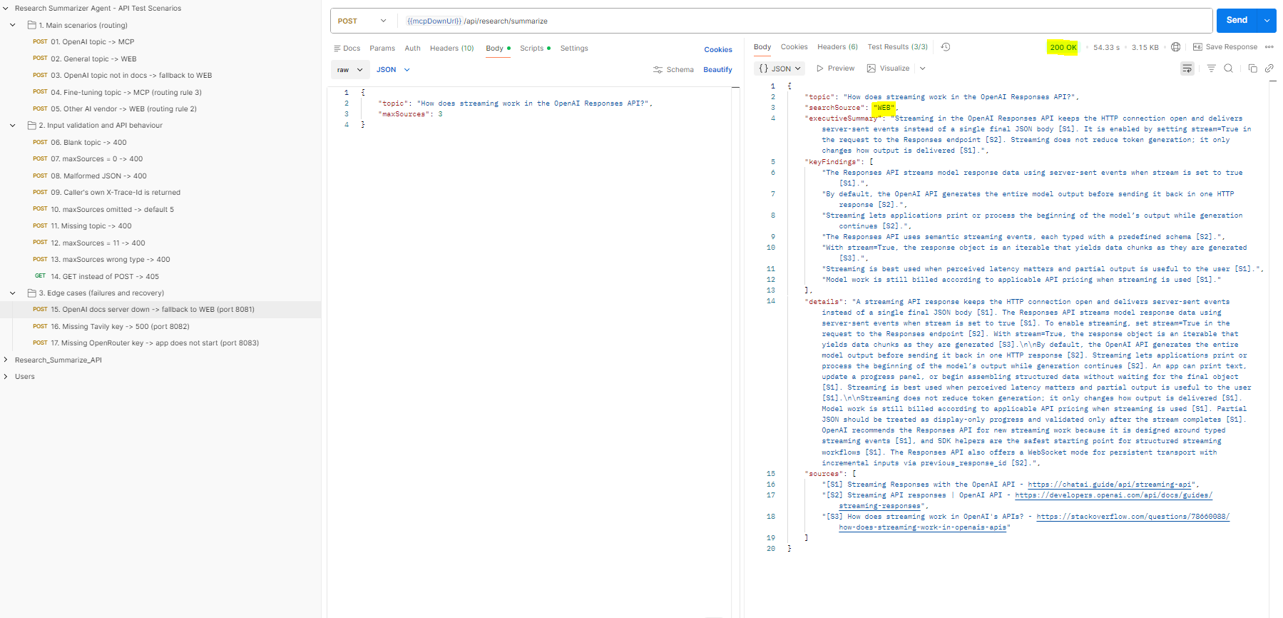
container log with the fallback line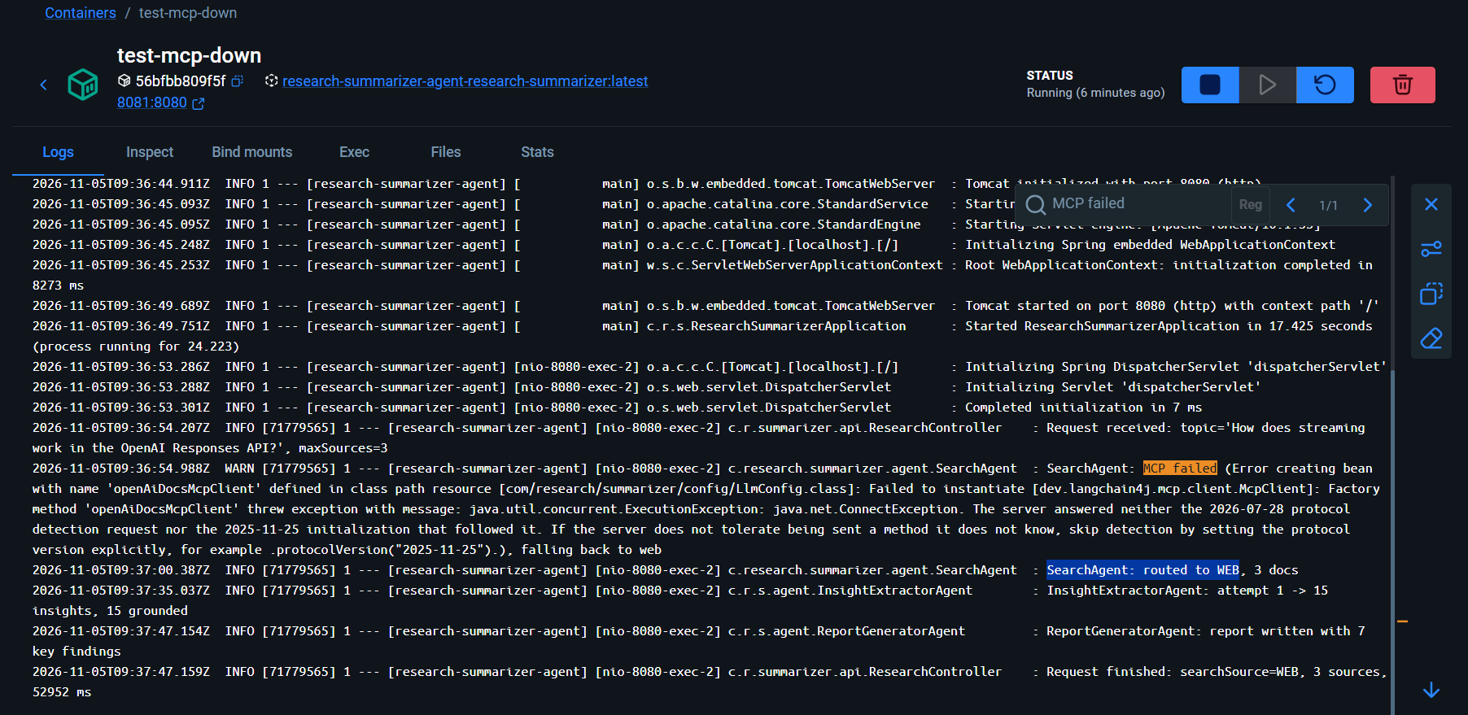
Clean-up (after the log screenshot, because --rm deletes the log): docker stop test-mcp-down

Scenario 16: Tavily API key missing → clear error message
Purpose: shows that a missing or invalid Tavily key returns a clear, readable error instead of the raw error text from Tavily.
Setup:
docker run --rm -d --name test-no-tavily -p 8082:8080 --env-file .env -e TAVILY_API_KEY= research-summarizer-agent-research-summarizer
Request: POST http://localhost:8082/api/research/summarize
{ "topic": "Health benefits of intermittent fasting", "maxSources": 3 }
Expected result:
- Response 500 Internal Server Error:
{ "status": 500, "error": "Internal Server Error", "message": "Web search failed: TAVILY_API_KEY is missing or invalid (see .env.example)" }
- The container log shows Web search failed: Tavily returned HTTP 401.
Result: ✅ Pass
Postman response
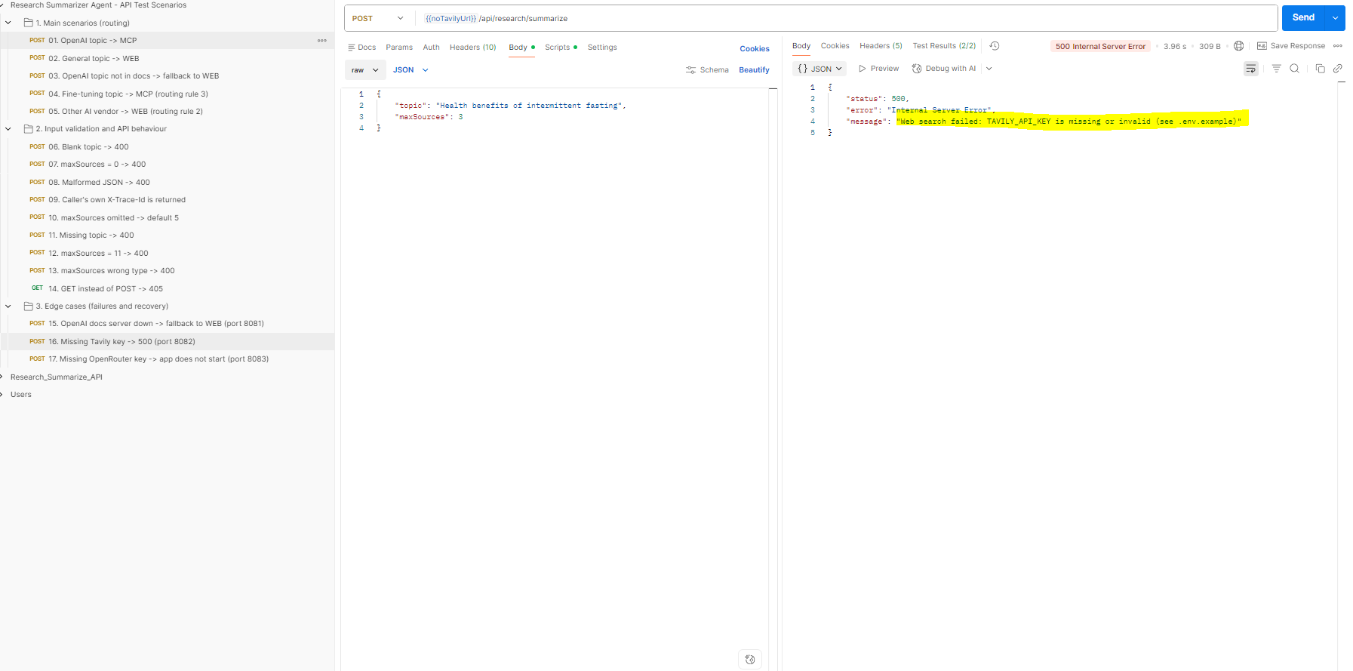
container log 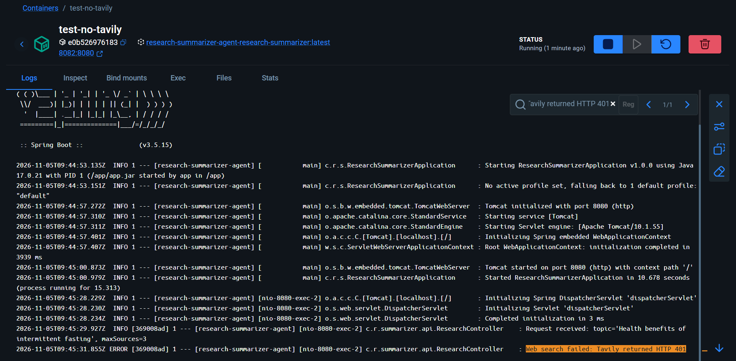
Clean-up: docker stop test-no-tavily

Scenario 17: OpenRouter API key missing → application refuses to start (fail fast)
Purpose: shows that a missing LLM key is detected immediately at startup with a clear message, instead of failing later on a user's first request.
Setup: run without --rm, so the stopped container and its log remain available for inspection:
docker run --name test-no-openrouter -p 8083:8080 --env-file .env -e OPENROUTER_API_KEY= research-summarizer-agent-research-summarizer
Request: POST http://localhost:8083/api/research/summarize
{ "topic": "How does fine-tuning work?", "maxSources": 3 }
Expected result:
- The container stops at startup with status Exited (1). The log shows OPENROUTER_API_KEY is not set (see .env.example).
- Postman cannot connect: Error: connect ECONNREFUSED 127.0.0.1:8083. This is expected, because no application is running on port 8083.
Result: ✅ Pass
container log ( Turn off toggle – Only show running containers)
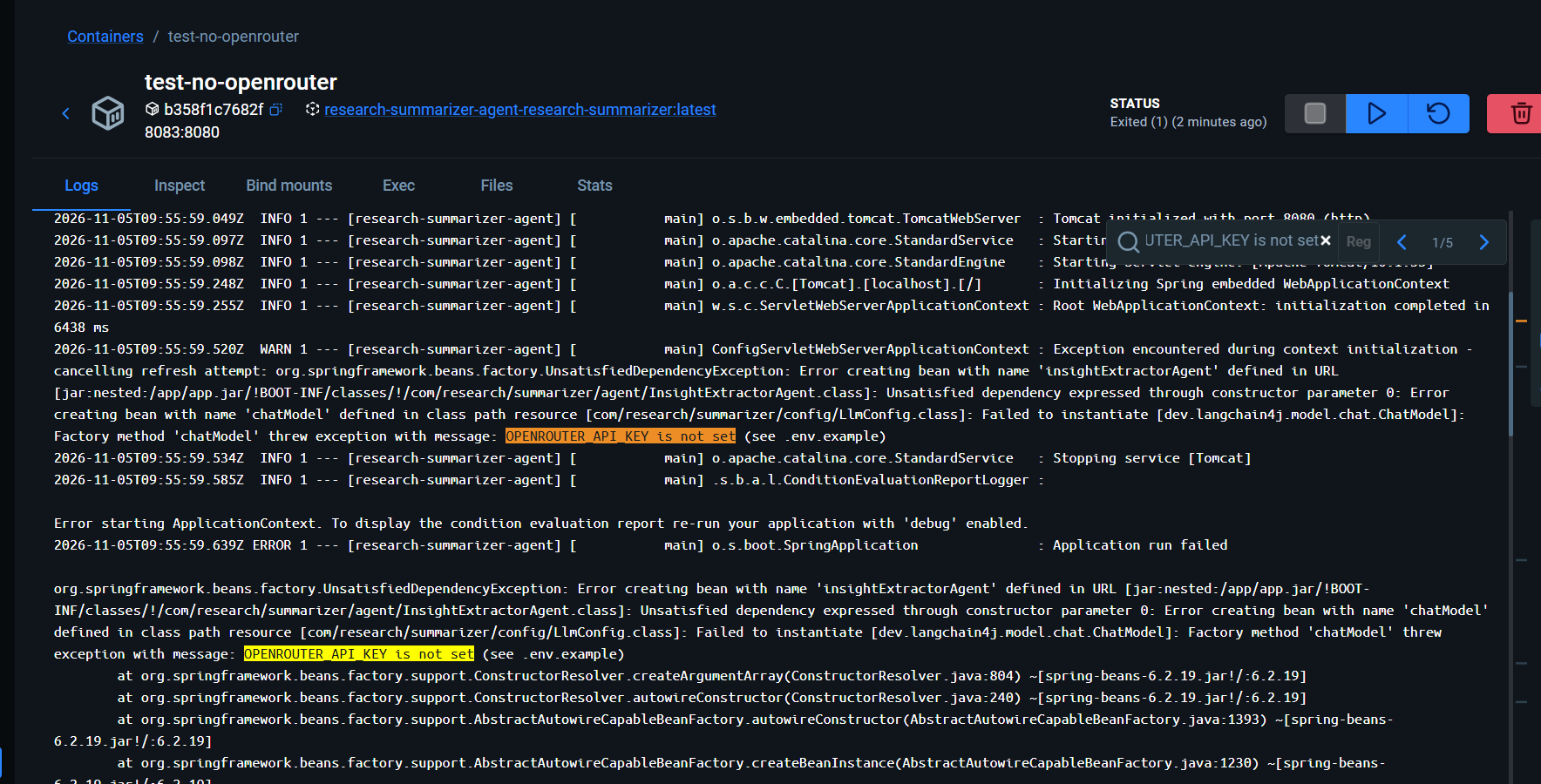
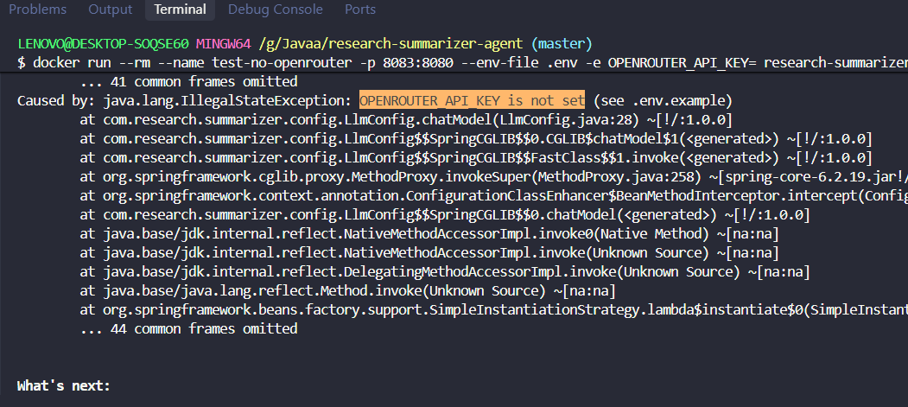

Postman error
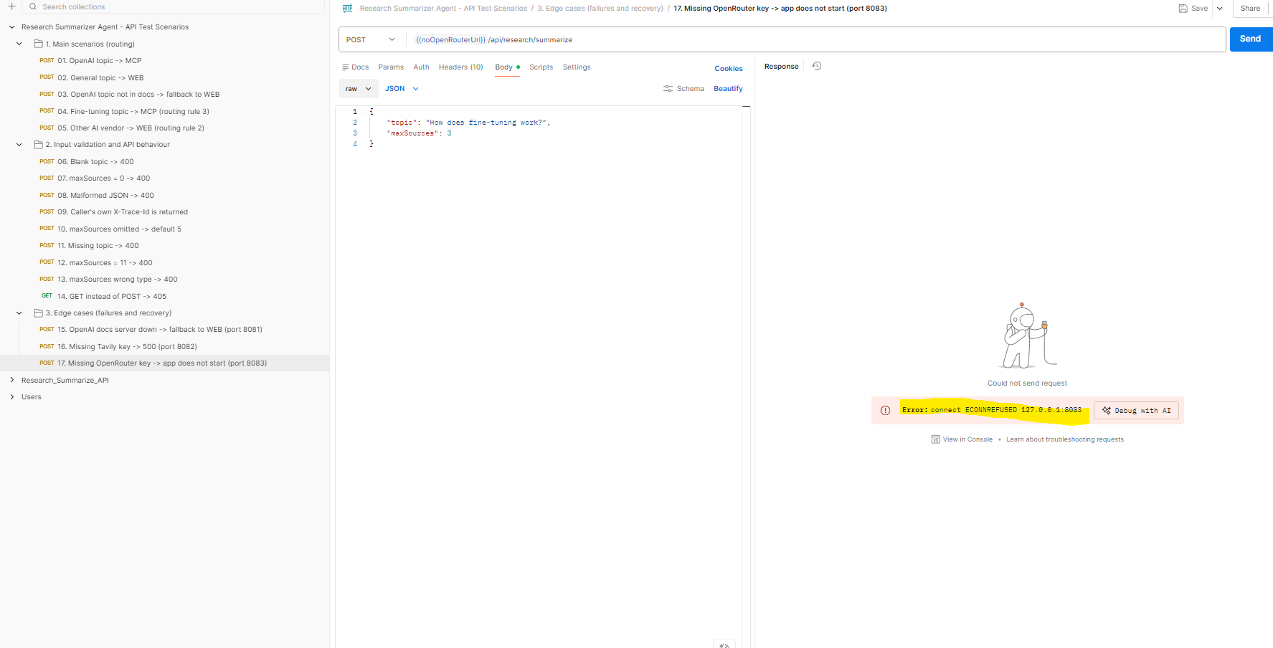
Clean-up: docker rm test-no-openrouter

Summary of the edge cases
Dependency | What happens when it fails | Why
OpenAI Docs MCP server | The request still succeeds, using web search | The MCP client is created lazily, and every MCP failure falls back to Tavily
Tavily API key | Web-search requests fail with a clear 500 message | A dedicated error handler turns Tavily's HTTP error into a readable message
OpenRouter API key | The application does not start | The key is checked at startup (fail fast), so a misconfiguration is found immediately

Final summary
Part | Tests | Passed
Unit tests (JUnit) | 9 | 9
API scenarios: main routing (Section A) | 5 | 5
API scenarios: validation and API behaviour (Section B) | 9 | 9
API scenarios: edge cases (Section C) | 3 | 3
Total | 26 | 26

