Machine Learning Project Report
P03 – Music Genre from Audio DNA (MFCC)
Multi-class genre classification of 30-second music clips using a Support Vector Machine on the GTZAN audio-feature dataset
Name | Prem Patel
Roll No. | B-35
Enrollment No. | 24004501210261
Division | D
Project ID | P03
Project Title | Music Genre from Audio DNA (MFCC)

1. Problem Statement
Music streaming services and recommendation systems need to know the genre of a track without a person listening to every song. The goal of this project is to predict the genre of a 30-second music clip from numeric audio features extracted from the sound. This is a multi-class classification problem with ten possible genres: blues, classical, country, disco, hiphop, jazz, metal, pop, reggae and rock.
I use a Support Vector Machine (SVM) classifier on the GTZAN feature table, which summarises each clip with MFCCs (Mel-Frequency Cepstral Coefficients, the “audio DNA” of timbre) and other spectral features. Models are compared using accuracy, macro precision, recall, F1, specificity and macro one-vs-rest ROC-AUC.

2. Dataset Description and Data Dictionary
The dataset is the GTZAN music genre feature file (features_30_sec.csv). It has 1,000 rows and 60 columns: one row per 30-second clip, with exactly 100 clips per genre. There are no missing values and no duplicate rows. Of the 60 columns, 57 are numeric audio features, 2 are identifiers that are not used for learning (filename, length) and 1 is the target (label).
Column(s) | No. | Meaning | Use
filename | 1 | Audio file name, e.g. blues.00000.wav | Dropped
length | 1 | Clip length in samples (about 661,794 = 30 s) | Dropped
chroma_stft_mean / _var | 2 | Strength of the 12 pitch classes (harmony / key content) | Feature
rms_mean / _var | 2 | Root-mean-square energy, i.e. loudness | Feature
spectral_centroid_mean / _var | 2 | Centre of mass of the spectrum, perceived “brightness” | Feature
spectral_bandwidth_mean / _var | 2 | Spread of frequencies around the centroid | Feature
rolloff_mean / _var | 2 | Frequency below which most spectral energy lies | Feature
zero_crossing_rate_mean / _var | 2 | How often the waveform crosses zero (noisiness) | Feature
harmony_mean / _var | 2 | Energy of the harmonic (tonal) component | Feature
perceptr_mean / _var | 2 | Energy of the percussive component | Feature
tempo | 1 | Estimated beats per minute | Feature
mfcc1 … mfcc20 (_mean, _var) | 40 | Timbre coefficients: mean and variance of 20 MFCCs | Feature
label | 1 | Music genre (10 classes) | Target
Table 1. Data dictionary (grouped; mean and variance of each feature are separate columns).

3. Data Cleaning and Exploratory Data Analysis

3.1 Cleaning steps
- Quality checks: 0 missing values, 0 duplicate rows, all 1,000 rows have a genre label, so no rows were removed.
- Dropped columns: filename (identifier) and length (clip length, nearly constant and unrelated to genre).
- Safety steps: infinite values would be turned into NaN and median-imputed (none were found). Imputation, feature selection and scaling were all fitted on the training set only to avoid data leakage.
- Feature engineering: one new feature, audio_feature_mean (the row-wise mean of all numeric audio features), was added, giving 58 candidate features.
- Encoding: genre names were label-encoded to 0–9.

3.2 Charts and insights
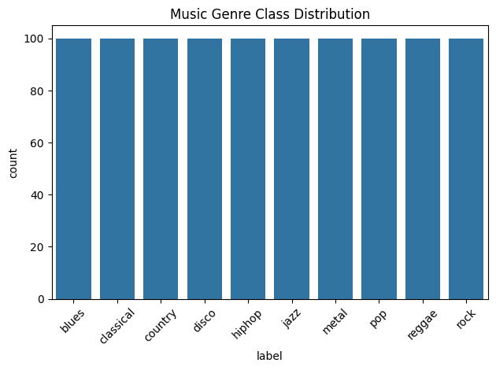  Figure 1. Class distribution: perfectly balanced. | 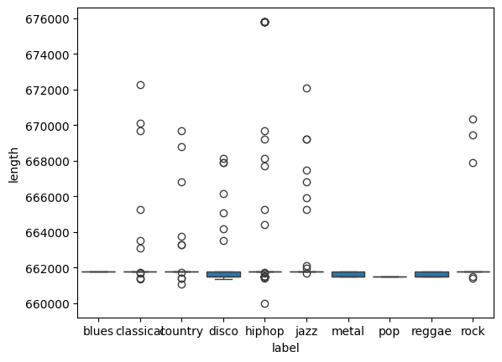  Figure 2. Clip length by genre: a few outliers only.
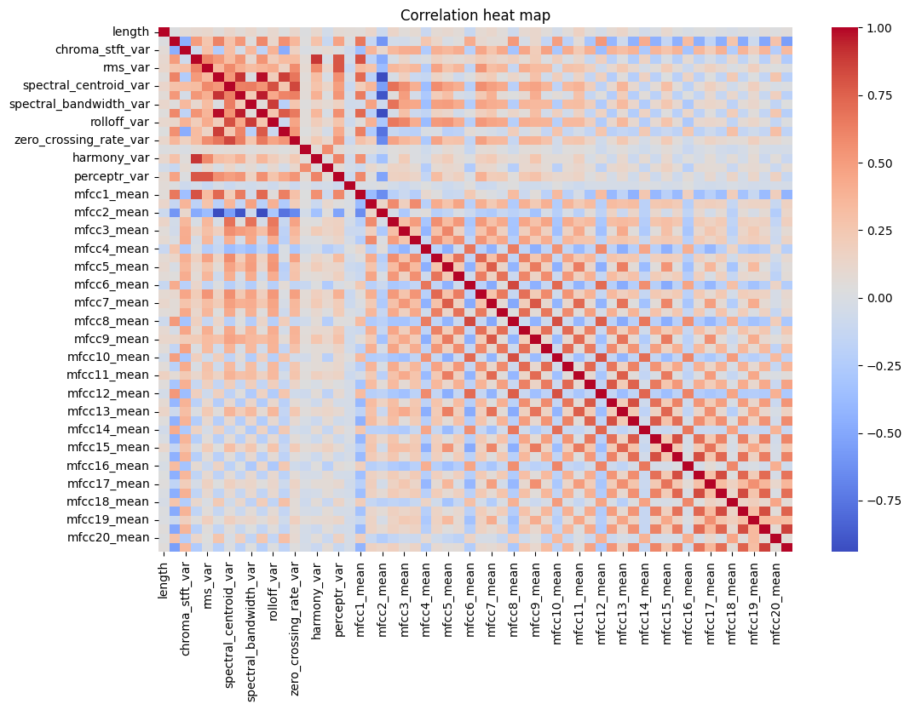
Figure 3. Correlation heat map of the numeric columns.
- Balanced classes (Fig. 1): every genre has 100 clips (10 % each), so accuracy is a fair metric and no resampling or class weighting is needed.
- Clip length (Fig. 2): almost every clip is about 661,800 samples long; the few outliers (660,000–676,000) are tiny differences, which supports dropping length.
- Distributions (histograms): the “_var” features and rms, zero-crossing rate and perceptual energy are strongly right-skewed, while most MFCC means look roughly bell-shaped. Features sit on very different scales (e.g. spectral centroid in the thousands, chroma below 1), so scaling is essential for an SVM.
- Correlation (Fig. 3): spectral centroid, bandwidth and rolloff form a strongly correlated block, and the MFCC means are moderately correlated with each other. Several features carry overlapping information, which is a reason to select a smaller feature set.

4. Model and Settings Tried
Model: Support Vector Machine (sklearn SVC) with probability estimates enabled and random_state = 42. SVM was chosen because it works well on small, dense, numeric tables and its RBF kernel can learn curved decision boundaries between genres.

4.1 Preprocessing pipeline (same for every setting)
- Split: 80 % train (800 clips) / 20 % test (200 clips), stratified by genre, random_state = 42, so the test set holds 20 clips per genre.
- Imputation: median imputer fitted on training data (safety step, nothing was missing).
- Feature selection: SelectKBest with ANOVA F-test, keeping the top 15 of 58 features: chroma_stft_mean/var, rms_mean/var, spectral_centroid_mean/var, spectral_bandwidth_mean, rolloff_mean, zero_crossing_rate_mean, perceptr_var, mfcc1, 2, 4, 6 and 8 means.
- Scaling: StandardScaler fitted on training data only.

4.2 Settings compared
I first trained a baseline (RBF kernel, C = 1), then compared a linear vs RBF kernel and three values of the regularisation parameter C = 0.1, 1 and 10 for the RBF kernel. A small C gives a smoother, more tolerant boundary; a large C fits the training data more tightly. The best setting was picked by accuracy, with macro F1 as the tie-breaker.

5. Results

5.1 Comparison of settings (test set, 200 clips)
Setting | Accuracy | Precision | Recall | F1 | Specificity | AUC
Linear kernel, C = 1 | 0.650 | 0.657 | 0.650 | 0.648 | 0.961 | 0.932
RBF, C = 0.1 | 0.525 | 0.505 | 0.525 | 0.506 | 0.947 | 0.917
RBF, C = 1 (baseline, selected) | 0.685 | 0.690 | 0.685 | 0.682 | 0.965 | 0.942
RBF, C = 10 | 0.655 | 0.663 | 0.655 | 0.653 | 0.962 | 0.949
Table 2. Precision, recall, F1 and specificity are macro-averaged; AUC is macro one-vs-rest.
Final model: RBF kernel, C = 1 with accuracy 68.5 %, macro F1 0.682 and macro AUC 0.942. C = 0.1 under-fits (52.5 %), while C = 10 gives the highest AUC (0.949) but lower accuracy and F1, a sign of mild over-fitting. The linear kernel is 3.5 points behind RBF, so the genre boundaries are not purely linear.

5.2 Confusion matrix and ROC curves of the final model
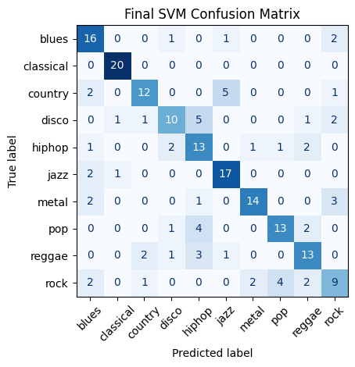  Figure 4. Confusion matrix (20 test clips per genre). | 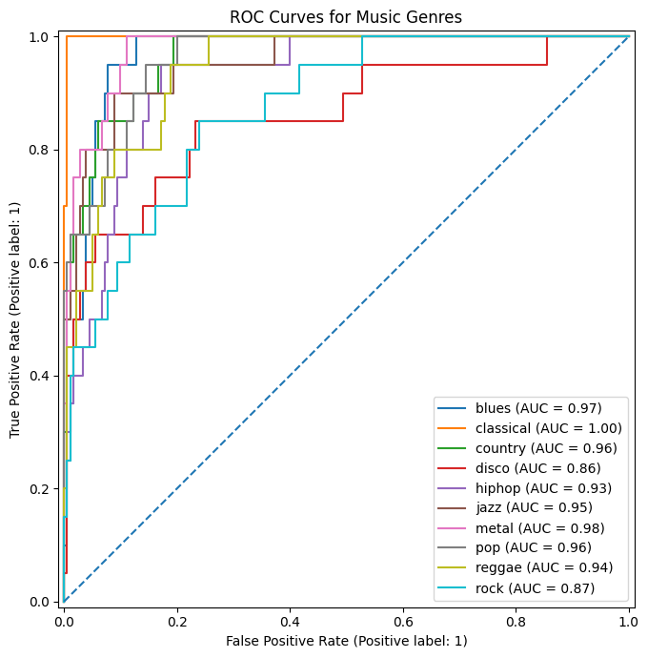  Figure 5. One-vs-rest ROC curves (macro AUC = 0.942).
- Easiest genre: classical, with all 20 clips correct (F1 0.95, AUC 1.00). Jazz (F1 0.77) and metal (F1 0.76, AUC 0.98) follow.
- Hardest genres: rock (F1 0.49, only 9 of 20 correct), disco (0.57) and hiphop (0.57). Rock is spread across blues, pop, metal and others.
- Typical confusions: disco → hiphop (5), country → jazz (5), pop → hiphop (4) and rock → pop (4). These genres share rhythm or instrumentation, so similar audio statistics are expected.
- ROC: every curve is well above the diagonal; AUC is lowest for disco (0.86) and rock (0.87), matching the confusion matrix.

6. Conclusion and What I Learned
An RBF-kernel SVM with C = 1, trained on 15 selected and standardised audio features, classifies the ten GTZAN genres with 68.5 % accuracy, macro F1 of 0.68 and macro AUC of 0.94 on unseen data. That is far better than random guessing (10 %). The model separates classical and jazz clearly but still mixes rock, disco and hiphop. The high AUC with moderate accuracy shows the model ranks the correct genre highly even when it is not the top prediction.

What I learned
- Scaling and leakage: SVMs need standardised features, and every preprocessing step (imputer, selector, scaler) must be fitted on the training set only.
- Hyper-parameters matter: changing C alone moved accuracy from 52.5 % to 68.5 %; a kernel choice added another 3.5 points.
- Look beyond accuracy: the confusion matrix and per-class F1 show which genres fail, which one accuracy number hides.
- Engineered feature did not help: the audio_feature_mean I created was not among the 15 features chosen by the F-test, so a new feature needs to be tested, not assumed useful.

Limitations and next steps
- Results come from one 80/20 split with only 20 test clips per genre, so each clip is worth 0.5 % accuracy. Cross-validation would give a more stable estimate, and the best C was chosen on the same test set, so 68.5 % may be slightly optimistic.
- Next steps: grid search with cross-validation over C and gamma, try Random Forest or gradient boosting for comparison, and use the 3-second feature file to get more training samples.

