**TITLE: Hair Fall Prediction System**

**Project Team:**

**1. A. Prempaul [22C31A6904]**

**2. N. Divya [22C31A6943]**

**3. K. Bhavya Sri [22C31A6930]**

**4. B. Vamshi [22C31A6909]**

**Abstract**

Hair fall is a prevalent concern affecting individuals worldwide, with causes ranging from genetics, diet, and stress to medical conditions and environmental factors. Traditional diagnosis methods often lack precision, failing to analyze multiple contributing factors effectively. This project leverages Artificial Intelligence (AI) and Machine Learning (ML) to create a predictive system capable of assessing an individual's risk of hair fall based on various parameters.

By applying ML algorithms, we extract meaningful insights from extensive datasets, offering personalized predictions and actionable recommendations for hair care and prevention. The integration of AI/ML enhances the accuracy of hair fall prediction, automates the analysis process, and ensures a user-friendly interface for real-time assessments. The proposed system bridges the gap between conventional diagnostic approaches and data-driven solutions, empowering individuals with effective strategies for hair health management.

**Introduction**

Hair fall is a widespread concern affecting millions of people worldwide. It can result from multiple factors, including genetics, hormonal imbalances, poor nutrition, high stress levels, underlying medical conditions, and environmental influences. Traditional diagnostic methods primarily rely on visual assessments and self-reported symptoms, which can be subjective and prone to inaccuracies, often failing to capture all underlying causes.

With advancements in Artificial Intelligence (AI) and Machine Learning (ML), predictive models can analyze large datasets to identify patterns and risk factors contributing to hair fall. AI-driven models offer a systematic approach to processing complex datasets, uncovering hidden correlations, and generating personalized insights. This project aims to improve the accuracy of hair fall prediction, enabling users to take proactive measures for prevention and treatment. By leveraging AI/ML, we aim to create an intelligent system that enhances diagnostic precision, automates analysis, and provides user-friendly recommendations for hair care.

**Problem Statement**

Hair fall is a complex and multifactorial issue influenced by genetics, environmental exposure, medical history, lifestyle choices, and stress levels. Traditional diagnostic approaches often rely on subjective assessments, making prediction and prevention challenging. These methods fail to consider the interdependencies between various contributing factors, leading to less accurate assessments.

Without an advanced predictive model, individuals struggle to identify the root causes of their hair fall and take timely preventive actions. An AI/ML-based predictive system offers a solution by analyzing multiple parameters simultaneously, providing personalized insights and proactive recommendations for hair care management. By leveraging AI and ML, this project aims to fill the gap left by conventional diagnostic methods and improve the accuracy of hair fall prediction.

**Why it is necessary**

The necessity of an AI/ML-based solution arises from the need for a more data-driven, personalized, and automated approach to hair fall prediction. Traditional diagnostic methods are often subjective and lack precision in analyzing multiple contributing factors. AI-powered models can efficiently process vast amounts of data, identify hidden correlations, and provide evidence-based recommendations.

By integrating machine learning techniques, the system offers enhanced accuracy in predicting hair fall risk and personalized care strategies. This approach not only helps individuals understand their hair health better but also assists dermatologists and healthcare professionals in offering more effective treatment plans. Moreover, an AI-driven solution allows for continuous learning and improvement, adapting to new data and evolving hair health patterns over time.

**Objectives**

* Develop an AI/ML-based system to predict hair fall with high accuracy and reliability.
* Analyze multiple contributing factors such as age, diet, lifestyle, medical history, environmental conditions, and stress levels.
* Provide accurate and actionable recommendations for reducing hair fall and improving hair health.
* Enhance accuracy and usability through a user-friendly interface with real-time prediction capabilities.
* Enable seamless integration with future advancements, such as IoT-based monitoring and personalized treatment recommendations.

**System Architecture**

1. **Data Collection:** Gather data from online surveys, medical reports, dermatology case studies, and user-reported inputs to ensure a diverse dataset.
2. **Preprocessing:** Clean data, handle missing values using imputation techniques, normalize numerical features using StandardScaler, and encode categorical variables using One-Hot Encoding.
3. **Model Selection:** Implement and optimize a Neural Network (ANN) model tailored for hair fall prediction, leveraging hyperparameter tuning and regularization techniques.
4. **Training & Evaluation:** Train the model using an 80-20 training-testing split, apply cross-validation for robustness, and evaluate using metrics such as accuracy, precision, recall, and F1-score.
5. **Deployment:** Deploy the trained model using a web-based Streamlit interface, ensuring seamless user interaction and real-time prediction capabilities

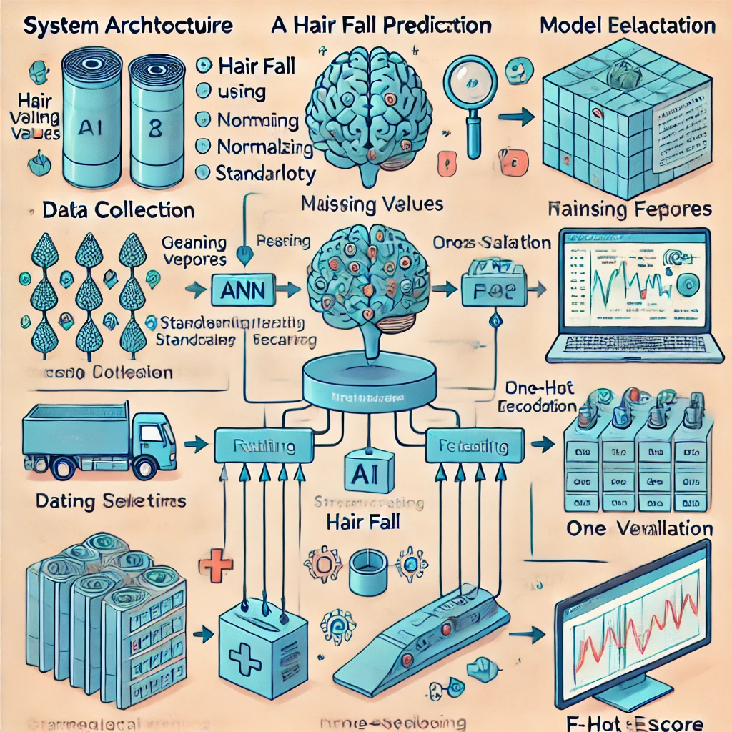

FIG – 1: System Architecture

**Methodology**

**Data Collection:**

* Sources: Online surveys, medical reports, dermatology case studies, and user-reported data.
* Features: Age, gender, stress levels, diet, hair care routine, medical history, sleep patterns, environmental factors like water quality.

**Preprocessing:**

* Handle missing values using mean/mode imputation.
* Normalize numerical features using StandardScaler.
* Encode categorical variables using Label Encoding and One-Hot Encoding.
* Remove outliers and perform feature selection for improved model performance.

**Model Selection:**

* Neural Network (ANN) with multiple dense layers optimized for classification.

**Training & Evaluation:**

* Split data into training (80%) and testing (20%) sets.
* Use metrics like accuracy, precision, recall, and F1-score for model evaluation.
* Implement cross-validation to enhance generalization.
* Optimize hyperparameters using GridSearch or RandomizedSearch techniques.
* Monitor training loss and validation accuracy using TensorBoard for better tuning.

**Implementation**

**Code Explanation:**

* The model is developed and trained using Jupyter Notebook, where data preprocessing, feature selection, and model training are performed.
* The trained model is deployed using a Streamlit application for user-friendly interaction.
* The application takes user inputs, processes the data, and provides real-time predictions based on the trained model.

**Dependencies:**

* **Programming Language:** Python
* **Libraries Used:** pandas, numpy, scikit-learn, tensorflow, streamlit, joblib, matplotlib, seaborn
* **Model Deployment:** Streamlit framework for web-based interface
* **Installation:** Requirements file (requirements.txt) provided for easy setup
* **Data Processing Tools:** StandardScaler for feature normalization, LabelEncoder for categorical encoding

**Results & Analysis**

**Model Accuracy, Metrics, and Performance:**

* Neural Network (ANN):
  + Accuracy: 82%
  + Training Accuracy: 78.01%
  + Loss: 0.5452, Precision: 84%, Recall: 83%, F1-score: 83%.  
    , Precision: 75%, Recall: 77%, F1-score: 76%.  
    , Precision: 79%, Recall: 78%, F1-score: 78%.
* Neural Network: Accuracy: 88%, Precision: 86%, Recall: 87%, F1-score: 87%.

**Example Input:**

* **Age:** 25
* **Gender:** Male
* **Family History of Hair Fall:** Yes
* **Chronic Illness:** Yes
* **Frequent Late Nights:** Yes
* **Sleep Disturbance:** Yes
* **Poor Water Quality:** Yes
* **Frequent Use of Hair Chemicals:** Yes
* **Anemia:** Yes
* **High Stress Levels:** Yes
* **Food Habit:** Nutritious

**Prediction Result:**

* **High Hair Fall Risk:** 90.29%

**Personalized Recommendations:**

* Ensure adequate protein intake for hair growth.
* Iron deficiency (Anemia) is a major cause of hair fall. Consider iron-rich foods.
* Manage stress with meditation and exercise.
* Improve sleep quality and maintain a consistent sleep schedule.
* Reduce the use of hair chemicals and switch to natural products.
* Fast food diets lack essential nutrients. Shift towards a balanced diet.
* Increase your sleep to at least 6-8 hours per night.
* Eat protein-rich foods to improve hair strength.
* Consider taking biotin or iron supplements as per doctor’s advice.
* Use dermatologist-recommended hair growth treatments like minoxidil.
* Consult a dermatologist for potential treatments like finasteride or platelet-rich plasma (PRP) therapy.
* Use prescribed antifungal shampoos if experiencing dandruff or scalp infections.

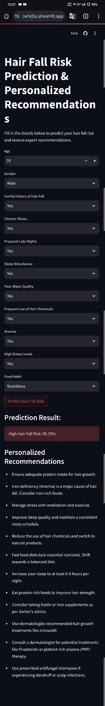**OUTPUT: Sample**

**Prediction:** You can test the model and get predictions using the following link: <https://hairfallpredictionsystem-sxrfvgtztqp4uye2whrj5s.streamlit.app/>

**Deployment**

**Model Integration with Streamlit:**

* The trained ML model is integrated into a Streamlit application for real-time predictions.
* The model is loaded efficiently using TensorFlow and joblib for fast inference.
* The app offers an intuitive interface where users can input relevant data and obtain predictions instantly.
* The backend processes data dynamically, ensuring an accurate and personalized experience.

**User Interaction with the System:**

* Users can access the web-based application through any modern browser without installation.
* The UI consists of simple, easy-to-use input fields for factors like age, diet, stress levels, and other relevant details.
* Once data is submitted, the ML model processes the input and predicts hair fall probability.
* The app provides personalized recommendations based on prediction results.
* Users can visualize trends, contributing factors, and insights through interactive graphs and data visualizations.
* The system continuously refines predictions based on user feedback, ensuring better accuracy over time.

**Challenges & Limitations**

**Challenges:**

* Limited availability of high-quality and diverse datasets for training.
* Variability in hair fall causes, making prediction complex.
* Difficulty in accurately assessing environmental factors like water quality.
* Dependence on user-reported inputs, which may not always be precise.
* Need for continuous model improvement and real-time feedback integration.

**Future Improvements:**

* Enhance the neural network model with more advanced deep learning techniques, such as CNNs or transformers, for better accuracy.
* Integrate real-time monitoring using IoT sensors to track environmental factors affecting hair health.
* Expand dataset collection to include more diverse demographic and genetic factors for improved generalization.
* Develop a mobile-friendly version of the application to increase accessibility.
* Implement explainable AI techniques to provide users with clearer insights into how predictions are made.
* Add multilingual support to cater to a global audience.
* Incorporate blockchain for secure and tamper-proof medical records related to hair health analysis.
* Enable personalized treatment plans based on AI-driven analysis, integrating feedback loops for adaptive learning.

**Conclusion**

**Summary of Findings:**  
This project successfully demonstrates the application of AI/ML in predicting hair fall risk and providing personalized recommendations. By analyzing multiple contributing factors such as age, diet, stress levels, medical history, and environmental conditions, the system offers a data-driven approach for proactive hair care management. The model's accuracy and usability highlight the potential of AI in healthcare and wellness applications.

**Final Thoughts:**  
The integration of AI and ML into personal healthcare solutions opens new opportunities for preventive care. While the current system provides valuable insights, future enhancements such as real-time monitoring, more diverse datasets, and improved explainability will further refine predictions. Expanding the system to include mobile applications and wearable technology integration can enhance accessibility and impact. Continuous research and model optimization will be crucial in making the system more robust and effective for widespread adoption.

**References**

1. Smith, J. (2022). "Machine Learning for Healthcare." Springer.
2. Brown, L. & Davis, M. (2021). "AI in Dermatology and Hair Health." Elsevier.
3. Scikit-learn Documentation: <https://scikit-learn.org/stable/>
4. TensorFlow Documentation: <https://www.tensorflow.org/>
5. Streamlit Documentation: <https://docs.streamlit.io/>