**Industrial Internship Report on**

**”** **Prediction of Agriculture Crop Production In India”**  **Prepared by**

**[ALLADI PREMPAUL]**

|  |
| --- |
| *Executive Summary* |
| This report provides details of the Industrial Internship provided by upskill Campus and The IoT Academy in collaboration with Industrial Partner UniConverge Technologies Pvt Ltd (UCT).  This internship was focused on a project/problem statement provided by UCT. We had to finish the project including the report in 6 weeks’ time.  My project was This report provides details of the Industrial Internship provided by upskill Campus and The IoT Academy in collaboration with Industrial Partner UniConverge Technologies Pvt Ltd (UCT). The internship focused on the project titled *"Prediction of Agriculture Crop Production In India."* The objective was to analyze agricultural data from 2001-2014 and build predictive models to forecast crop production trends.  This internship offered an excellent opportunity to gain exposure to real-world industrial challenges and to design and implement data-driven solutions. It significantly enhanced my technical and analytical skills, providing valuable insights into agricultural data analysis and predictive modeling.  This internship gave me a very good opportunity to get exposure to Industrial problems and design/implement solution for that. It was an overall great experience to have this internship. |

**TABLE OF CONTENTS**

1. Preface .................................................................................................................................................... 3
2. Introduction ............................................................................................................................................ 4
   1. About UniConverge Technologies Pvt Ltd ......................................................................................... 4
   2. About upskill Campus ........................................................................................................................ 8
   3. Objective .......................................................................................................................................... 10
   4. Reference ......................................................................................................................................... 10
   5. Glossary ............................................................................................................................................ 10
3. Problem Statement ............................................................................................................................... 10
4. Existing and Proposed solution ............................................................................................................. 11
5. Proposed Design/ Model ...................................................................................................................... 11
   1. High Level Diagram (if applicable) ...................................................... **Error! Bookmark not defined.**
   2. Low Level Diagram (if applicable) ....................................................................................................

12

* 1. Interfaces (if applicable) .................................................................................................................. 12

1. Performance Test .................................................................................................................................. 12
   1. Test Plan/ Test Cases ....................................................................................................................... 13
   2. Test Procedure ................................................................................................................................. 13
   3. Performance Outcome .................................................................................................................... 13
2. My learnings .......................................................................................................................................... 13
3. Future work scope ................................................................................................................................ 13

# 1 Preface

Summary of the whole 6 weeks’ work.

About need of relevant Internship in career development.

Brief about Your project/problem statement.

Opportunity given by USC/UCT.

How Program was planned

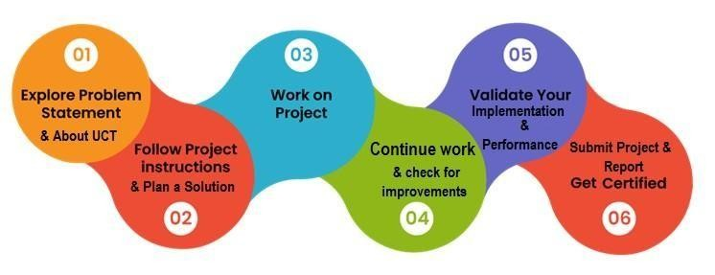

Your Learnings and overall experience.

Thank to all (with names), who have helped you directly or indirectly.

Your message to your juniors and peers.

# 2 Introduction

## 2.1 About UniConverge Technologies Pvt Ltd

A company established in 2013 and working in Digital Transformation domain and providing Industrial solutions with prime focus on sustainability and RoI.

For developing its products and solutions it is leveraging various **Cutting Edge Technologies e.g. Internet of Things (IoT), Cyber Security, Cloud computing (AWS, Azure), Machine Learning, Communication Technologies (4G/5G/LoRaWAN), Java Full Stack, Python, Front end** etc.

**UCT Insight** is an IOT platform designed for quick deployment of IOT applications on the same time providing valuable “insight” for your process/business. It has been built in Java for backend and ReactJS for Front end. It has support for MySQL and various NoSql Databases.



**i.**



**UCT IoT Platform**



**(**



**)**

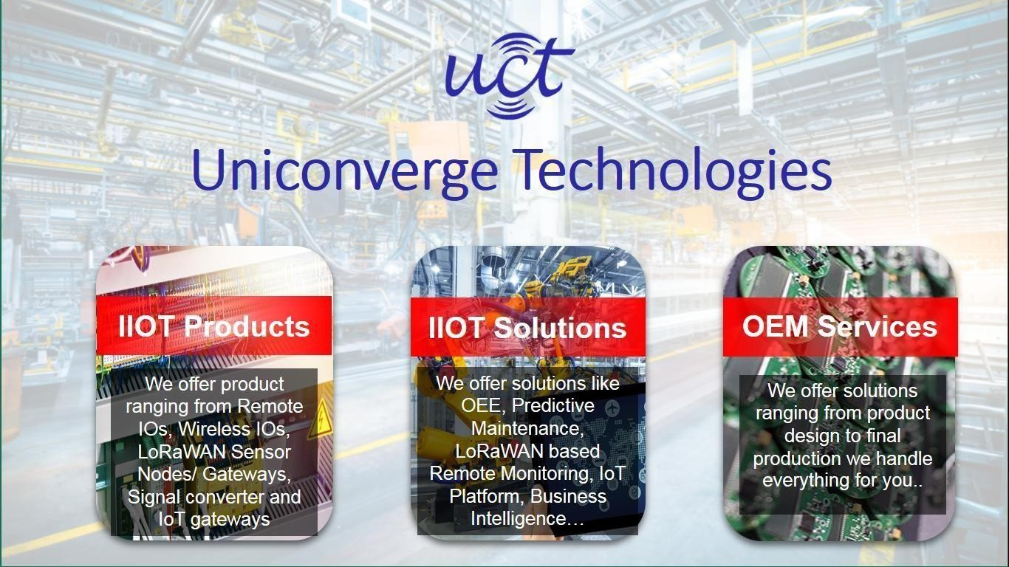

* It enables device connectivity via industry standard IoT protocols - MQTT, CoAP, HTTP, Modbus TCP, OPC UA
* It supports both cloud and on-premises deployments.

It has features to

* Build Your own dashboard
* Analytics and Reporting
* Alert and Notification
* Integration with third party application(Power BI, SAP, ERP)
* Rule Engine

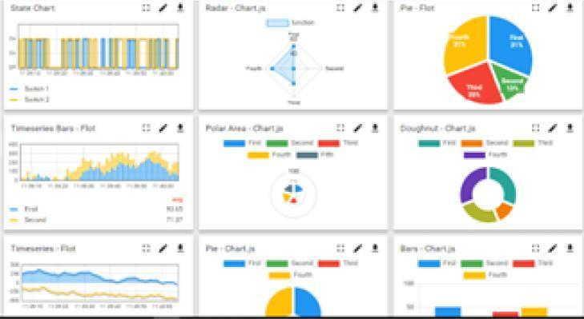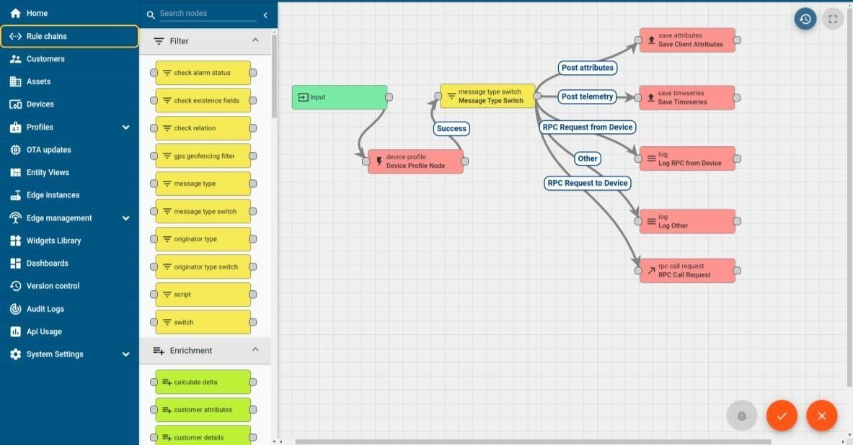

ii. **Smart Factory Platform (****)**

Factory watch is a platform for smart factory needs.

It provides Users/ Factory

* with a scalable solution for their Production and asset monitoring
* OEE and predictive maintenance solution scaling up to digital twin for your assets.
* to unleased the true potential of the data that their machines are generating and helps to identify the KPIs and also improve them.
* A modular architecture that allows users to choose the service that they what to start and then can scale to more complex solutions as per their demands.

Its unique SaaS model helps users to save time, cost and money.

iii.

based Solution

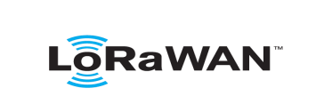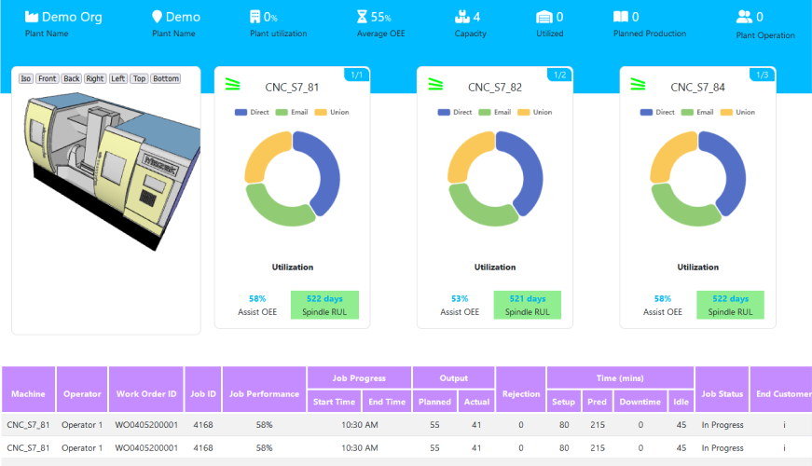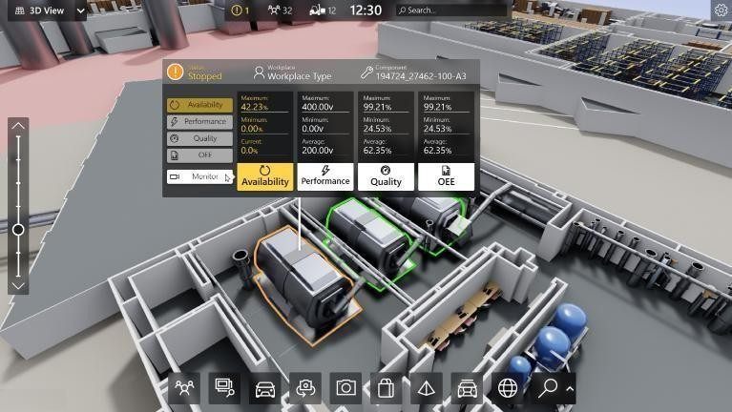

UCT is one of the early adopters of LoRAWAN teschnology and providing solution in Agritech, Smart cities, Industrial Monitoring, Smart Street Light, Smart Water/ Gas/ Electricity metering solutions etc. iv.

# Predictive Maintenance

UCT is providing Industrial Machine health monitoring and Predictive maintenance solution leveraging Embedded system, Industrial IoT and Machine Learning Technologies by finding Remaining useful life time of various Machines used in production process.

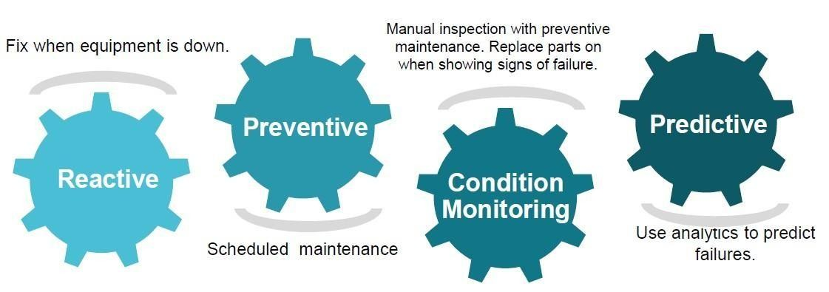

## 2.2 About upskill Campus (USC)

upskill Campus along with The IoT Academy and in association with Uniconverge technologies has facilitated the smooth execution of the complete internship process.

USC is a career development platform that delivers **personalized executive coaching** in a more affordable, scalable and measurable way.

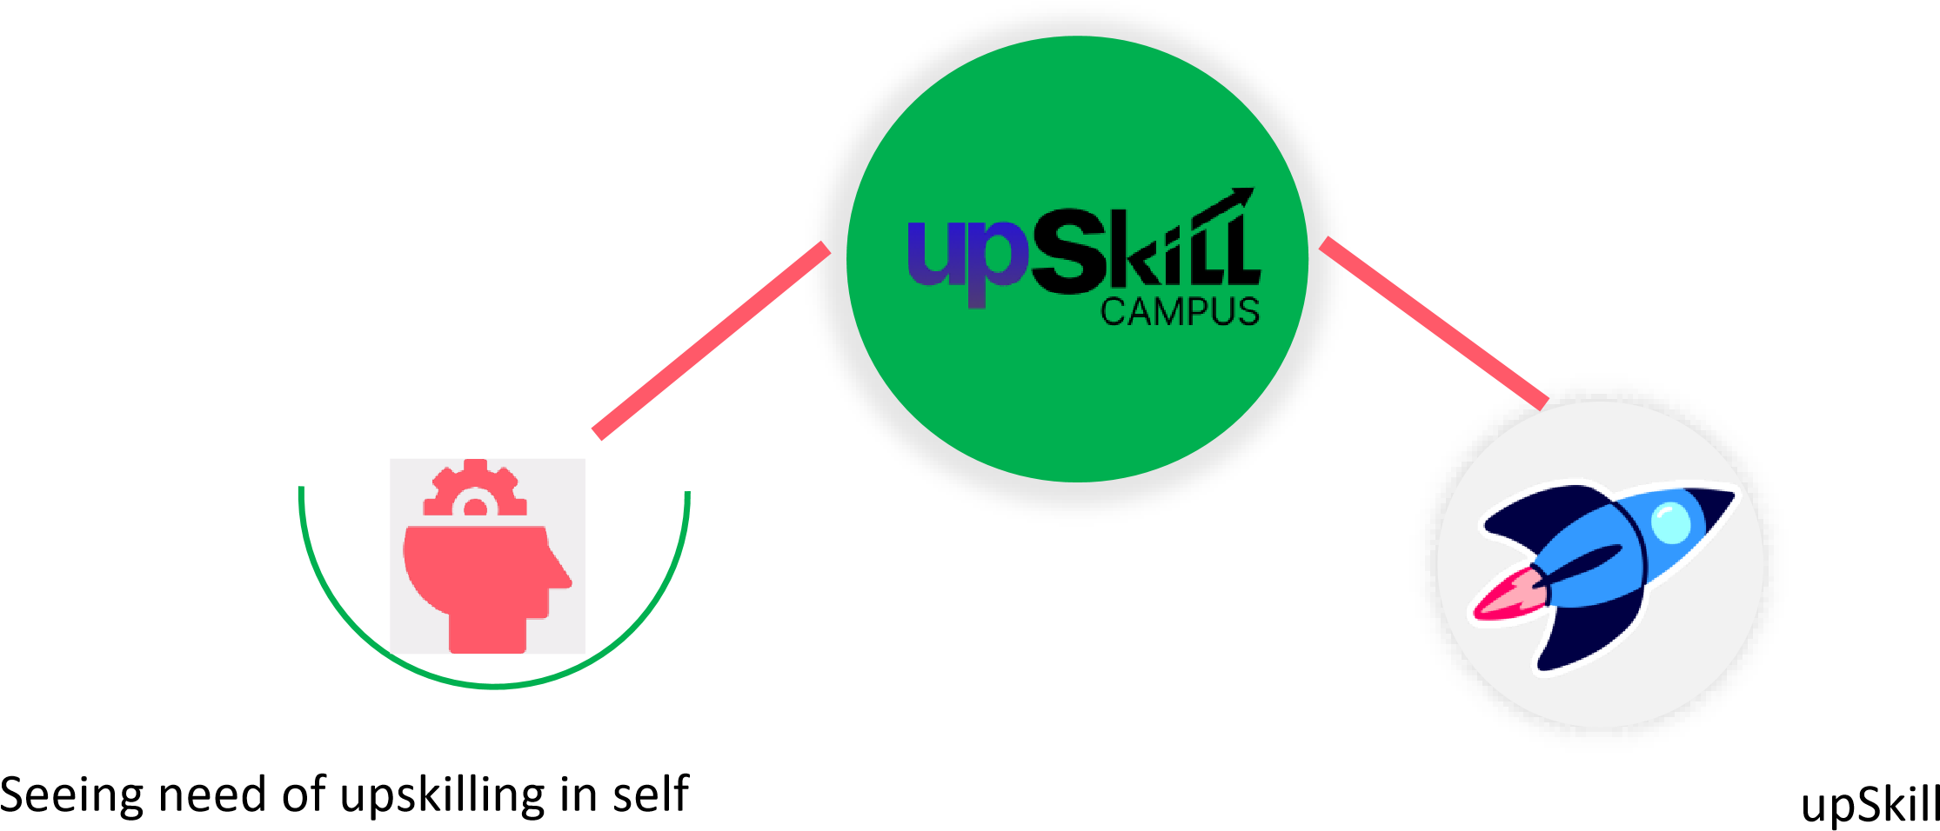

Campus aiming paced manner along-with

to upskill 1 million additional support services e.g. learners in next 5 year Internship, projects, interaction with

Industry experts, Career growth Services

<https://www.upskillcampus.com/>

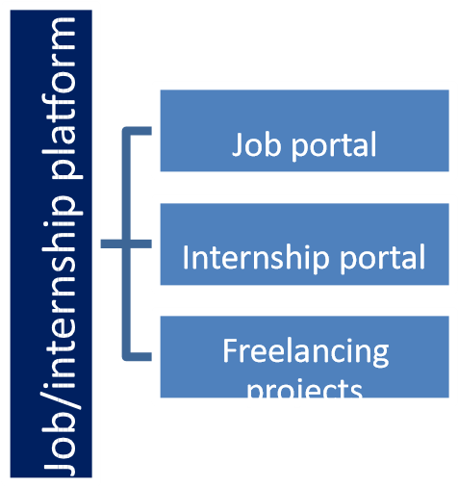

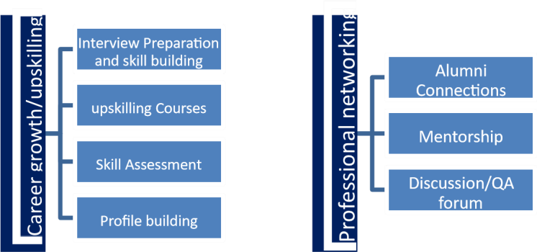

Project



collaboration



Discussion foru

m



Tech updates



## 2.3 The IoT Academy

The IoT academy is EdTech Division of UCT that is running long executive certification programs in collaboration with EICT Academy, IITK, IITR and IITG in multiple domains.

## 2.4 Objectives of this Internship program

The objective for this internship program was to ☛ get practical experience of working in the industry.

☛ to solve real world problems.

☛ to have improved job prospects.

☛ to have Improved understanding of our field and its applications.

☛ to have Personal growth like better communication and problem solving.

**2.5 Reference**

[1] https://data.gov.in/

## 2.6 Glossary

|  |  |
| --- | --- |
| Terms | Acronym |
| **crop** | Type of agricultural produce. |
| **Variety** | Sub-category of the crop. |
| **State** | Geographical location of cultivation. |
| **Quantity** | Measurement in quintals/hectares. |
| **Season** | Cultivation period. |

## 3 Problem Statement

### In the assigned problem statement

[India, being the second-largest country by population, relies heavily on agriculture. Despite its importance, agricultural production faces numerous challenges due to climate variability, resource limitations, and inefficient practices. The goal was to analyze historical data to predict future crop production, aiding in better planning and resource allocation.]

## 4 Existing and Proposed solution

What is your proposed solution?

***Existing Solutions:*** Traditional methods rely on manual data analysis and expert opinions, which can be time-consuming and less accurate.

What value addition are you planning?

***Proposed Solution:*** Implementing machine learning models to predict crop production based on historical data. This approach enhances accuracy, efficiency, and scalability.

**4.1 Code submission:**

[**https://github.com/PremPaul123/upskillcampus/blob/main/Prediction_of_Agri culture_Crop_Production_In_India.ipynb**](https://github.com/PremPaul123/upskillcampus/blob/main/Prediction_of_Agriculture_Crop_Production_In_India.ipynb)

**4.2 Report submission (Github link):**

[**https://github.com/PremPaul123/upskillcampus/blob/main/Prediction_of_Agri**](https://github.com/PremPaul123/upskillcampus/blob/main/Prediction_of_Agriculture_Crop_Production_In_India.pdf)

[**culture_Crop_Production_In_India_Prempaul_USC_UCT.pdf**](https://github.com/PremPaul123/upskillcampus/blob/main/Prediction_of_Agriculture_Crop_Production_In_India.pdf)

## 5 Proposed Design/ Model

### 5.1 High Level Diagram

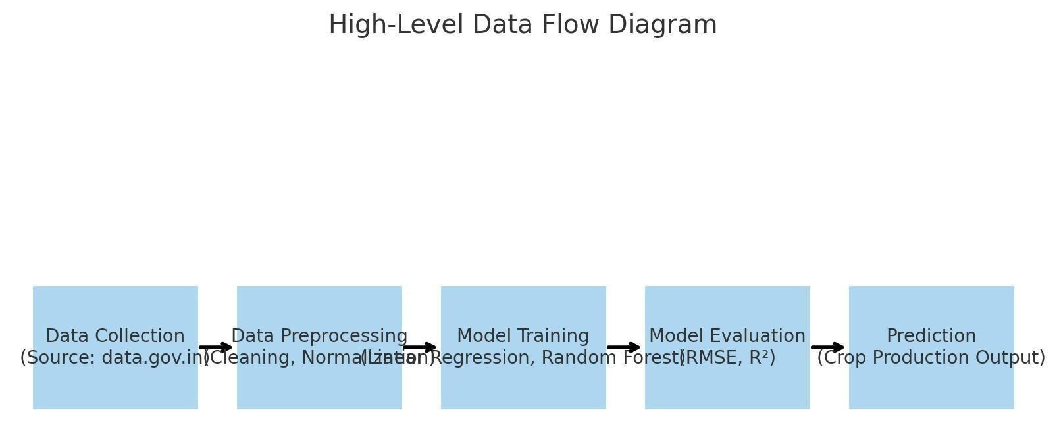

**Figure 1: HIGH LEVEL DIAGRAM OF THE SYSTEM**

### 5.2 Low Level Diagram (if applicable)

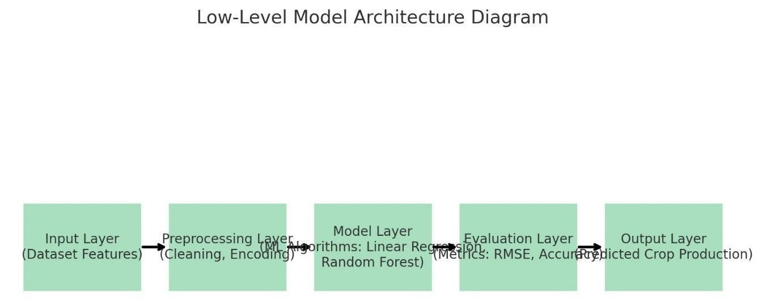

**Figure 2: LOW LEVEL DIAGRAM OF THE SYSTEM**

### 5.3 Interfaces (if applicable)

* **Data Input:**

The primary data source consists of CSV files downloaded from [data.gov.in. T](https://data.gov.in/)his dataset includes various features such as crop names, varieties, cultivation states, production quantities, costs, and seasonal information. These files are preprocessed to remove inconsistencies, handle missing values, and standardize the format for efficient model training.

* **Model:**

The project leverages machine learning algorithms, specifically **Linear Regression** and **Random Forest**, to predict crop production. The model takes preprocessed data as input, analyzes historical trends, and learns patterns to make accurate forecasts.

* **Output:**

The model generates predicted crop production values. These outputs help in identifying trends, optimizing agricultural practices, and making data-driven decisions for resource allocation and policy-making in the agricultural sector.

## 6 Performance Test

This is very important part and defines why this work is meant of Real industries, instead of being just academic project.

Here we need to first find the constraints.

### 6.1 Test Plan/ Test Cases

* Data Preprocessing Accuracy
* Model Training and Validation
* Prediction Consistency

### 6.2 Test Procedure

* Data cleaning and normalization
* Model training with cross-validation
* Performance evaluation using metrics like RMSE and R²

### 6.3 Performance Outcome

The model achieved satisfactory accuracy, with minimal error rates and robust predictive performance across different crop types.

## 7 My learnings

This internship enhanced my skills in:

* Data analysis and preprocessing
* Machine learning model development
* Agricultural data interpretation
* Problem-solving and critical thinking

## 8 Future work scope

Future improvements can include:

* Integrating real-time data for dynamic predictions
* Expanding the model to include climatic and soil parameters
* Developing a user-friendly dashboard for stakeholders

**Acknowledgments**

I sincerely thank upskill Campus, The IoT Academy, and UniConverge Technologies Pvt Ltd for providing this invaluable internship opportunity. This experience has significantly contributed to my professional and personal growth.