 **Metal Aid Engineers**

**G-2, “Jains Brindavan”, 38, Brindavan Street, West Mambalam, Chennai-600033**

**Tel: 044-23711946, 24718292, 23701225 (Fax), Cell: 9444351612**

**Email:** [**metalaidengg@rediffmail.com**](mailto:metalaidengg@rediffmail.com)

**MAGIC-WRAP-PIPE & JOINT REPAIR KIT**

**MAGIC-WRAP** is resin impregnated water activated fiberglass cloth tape, easy to use, quick action answer, will repair broken parts, arrest pipeline / Tank leakages etc. sets rock hard even under water.

**Where to apply?**

PVC, metals, rubber, fiberglass, plastics etc. Under-water, under - ground, and in corrosion protection area.

**In Mediums**

Water, acids, soda solutions, fuel oil with water, white spirit, toluene, xylene, diesel, gasoline, gas, air, steam, hydraulic fluids etc.

**TYPICAL APPLICATION: PIPE LEAK SEALING**

Clean & Roughen the area to Soak the MAGIC-WRAP in Wrap MAGIC-WRAP the Squeeze and mold MAGIC-WRAP

be repaired. Remove any oily Water for 20 seconds entire roll, approximately 2” in the direction of wrap, removing

or foreign particles (Using gloves) above and below the repair excess water and spreading resin

area. Wrap as tightly as possible. Until tacky to touch. (app.3 Mins)

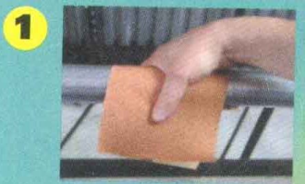 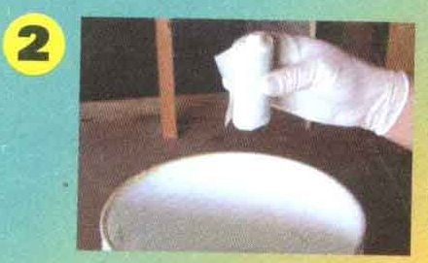 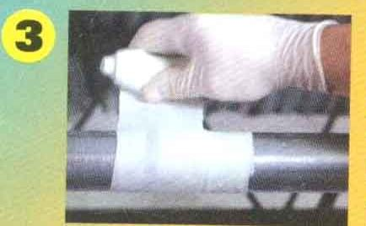 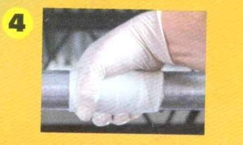

A minimum of 8 layers of ‘MAGIC-WRAP’ is required and shall be applied from right to left or from left to right in a spiraly maner around the pipe using 50% overlap. At the end of first pass, reverse the direction of the wrap and continue to apply until you have achieved specified number of layers. To achieve 8 layer application, apply 4 passes using a 50% overlap. Occasionaly twisting the MAGIC-WRAP as it is applied helps it conform tightly to the pipesurfac atelbows or at odd geometries. Allow 30 minutes for complete curing.

|  |
| --- |
| **MULTIPLE ROLLS CAN BE USED FOR LARGER DIAMETER PIPES OR YOU CAN SPECIAL ORDER SIZES OF 4" X 20', 30', or 50'. AS A GENERAL RULEOF THUMB, USE 4-5 FT OF MAGIC-WRAP FOR EVERY INCH OF PIPE DIAMETER.** |

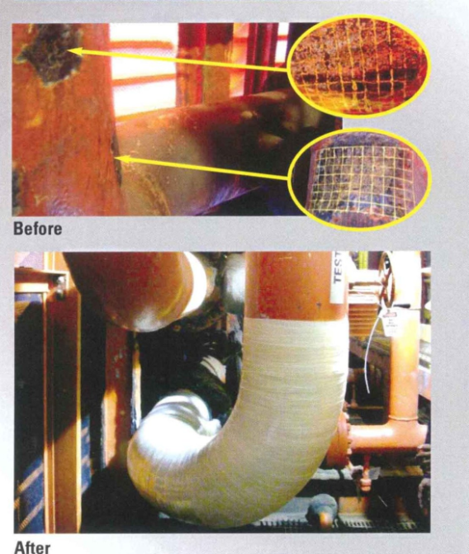

In applications wherever wrapping is not possible, like plugging a hole, MAGIC-WRAP should be unraveled and mold into a ball and plugged into the hole cand hand pressure can be given for about 5 minutes

**Product Data**

**Tensile strength Method: ASTM D3039**

Hoop PSI 56,700

Axial PSI 21,600

**Hardness Shore D**

30 minutes 47

2 hours 76

24 hours 83

**Flexural Method: ASTM D790 – 3 point flex**

Strength PSI 16,100

**Shear Method: ASTM D648**

Strength PSI 7520

**Coeff Of linear exp Method: ASTM D648**

CTLE 1,06E-05

Dielectric strength 16000 volts

Heat resistance 1100°F

**TYPICAL APPLICATIONS**

* impact protection
* emergency repair
* cracked or corroded pipes
* irregular pipe fittings
* force mains and gravity pipe lines
* under water repair and splash zone
* joint and tee repair

**PROPERTIES**

* VOC**s;** None
* Pressure once cured: 20.6 BARS
* Working Time: 5 Minutes at 24ْCelsius
* Set time: 28 minutes at 21 ْCelsius

**MAGIC WRAP-SELECTION AND PRICES**

|  |  |  |  |  |  |  |  |  |  |  |  |  |
| --- | --- | --- | --- | --- | --- | --- | --- | --- | --- | --- | --- | --- |
| |  |  |  | | --- | --- | --- | | **Pipe Diameter** | **ll Roll size recommended size** | **recom Unit Price per unit** | | **½” – 1”** | **50 M.M X 1500 M.M** | **Box= 3 Tapes** | | **1 ¼” – 2”** | **75 M.M X 2700 M.M.** | **Box=2 Tapes** | | **> 2”** | **100 M.M X 4500 M.M** | **Box= 1 Tape** | |

**Chemical Resistance**

|  |  |  |  |  |  |  |  |  |
| --- | --- | --- | --- | --- | --- | --- | --- | --- |
| **Immersion Chemical** | | **Immersion Time** | | **Effect** | **Immersion Chemical** | **Immersion Time** | **Effect** | |
| **Distilled Water** |  |  | **60 Days** | **None** | **White Spirit** | **60 Days** | **None** |  |
| **Sulphuric Acid, 10%** | |  | **60 Days** | **None** | **Toulene** | **60 Days** | **None** |  |
| **Sulphuric Acid, 50%** | |  | **60 Days** | **None** | **Xylene** | **60 Days** | **None** |  |
| **Hydrochloric Acid, 10%** | |  | **60 Days** | **None** | **Diesel Fuel** | **60 Days** | **None** |  |
| **Soda Solution,Saturated** | |  | **60 Days** | **None** | **Gasoline** | **60 Days** | **None** |  |
| **Sodium Hydroxide, 20%** | |  | **60 Days** | **None** | **Steam/Gas** | **60 Days** | **None** |  |
| **Fuel Oil + % Water** | |  | **60 Days** | **None** | **Hydraulic Fluids** | **60 Days** | **None** |  |

**TERMS OF SUPPLY**

1. **Taxes: CST/Vat Extra as applicable**
2. **Packing & Forwarding: Extra @ 3 %**
3. **Freight 2% Extra.**
4. **Insurance Extra to Your account**
5. **Payment 100% Documents Through Bank/ Against Proforma Invoice**
6. **Your Bank Charges to your Account and Our Bank Charges To Our Account**
7. **Delivery: Immediate on receipt of clear purchase Order From Chennai By RPP**

**No L.D Clause Is Applicable.**