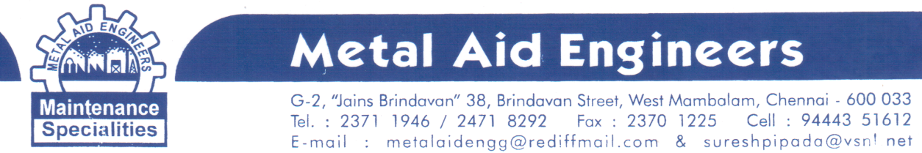
PSI Specialty epoxy putty stick– performance data
- Resistant to hydrocarbon, ketones, alcohols, esters, halocarbons, aqueous salty solutions, dilute acids and base
- When applying to a damp wet or slowly leaking area, work the material forcefully and apply pressure until adhesion begins.
- Once cured it can be machined and painted.

Description | Density  Gm/  cm³ | Work life | Curing | Upper  temp | Lap Shear  Tensile  strength | Compressive strength | Shore  ‘D’  Hard-  ness | Elect.  Resist.  Meg.  Ohms | Di-  Electric  Strengt  Volts/ Mil
QuikTitanium ®  To repair iron pipes,  Tanks, tools and equipments, stripped threads, blow holes, molds, patterns, castings and duct work. | 1.9 | 1.5 – 2 Hrs | 8 Hrs | 232ºC  (260ºC Peak) | 17 Kg/ cm²when cured at 24ºC, 51 Kg/ cm² when cured at 65ºC | 548 Kg/ cm² | 80 | 30,000 | 300
QuikPlastic ®  To repair all major plastic (except polyethylene, polypropylene), metals, wood, glasses and masonry | 1.6 | 20 Min | 60 Mins | 121ºC(150º Peak) | 24 Kg/cm²on PVC | 685 Kg/cm² | 65 | 30,000 | 300
QuikAluminium ®  To repair aluminum metals, wood, glass, masonary and many plastics | 1.6 | 5 Min | 60 Mins | 121º C (150ºC Peak) | 34 Kg/cm²on Aluminium, 41 on steel | 822 Kg/cm² | 80 | 30,000 | 300
QuikCopper ®  To repair copper, brass, bronze, wood, glass, many plastics and non-ferrous metals. | 1.9 | 3 Min | 60 Mins | 121º C (150ºC Peak) | 45 Kg/cm² on steel, 48 on copper | 822 Kg/cm² | 80 | 30,000 | 300
FastSteel ®  Repair steel, metals, wood, glass, masonary and many plastics. | 2.2 | 3 min | 60 Mins | 121º C (150ºC Peak) | 62 Kg/cm² on steel | 822 Kg/cm² | 80 | 30,000 | 300
InstaCrete ®  To repair concrete and masonary, metals, wood, glass, and many plastics | 2 | 4 Min | 60 Mins | 121º C (150ºC Peak) | 41 Kg/cm² on steel, concrete failure on concrete. | 822 Kg/cm² | 80 | 30,000 | 300
RepairitQuik ®  To repair metals, wood, glass, concrete, ceramics and many plastics. | 1.9 | 3 Min | 60 Mins | 121º C (150ºC Peak) | 62 Kg/cm² on steel. | 822 Kg/cm² | 75 | 30,000 | 300
AquaMend ®  (Under water putty)  To repair fiber glass, concrete, glass, metals, wood, many plastics. | 1.9 | 20 Min | 60 Mins | 121º C (150ºC Peak) | 62 Kg/cm² on steel. | 822 Kg/cm² | 70 | 30,000 | 300
QuikWood ®  To repair wood, metal, glass, masonry, and many plastics | 0.9 | 15 Min | 60 Mins | 121°C | 900 Kg/cm² on steel, 500 Kg/cm² on oak | 822 Kg/cm² | 75 | 30,000 | 300
Unit: 1 Box = 9 Sticks, 1 Stick = 114 Grams

Place: For Metal Aid Engineers
AT Date: 01.03.2015
Manager

