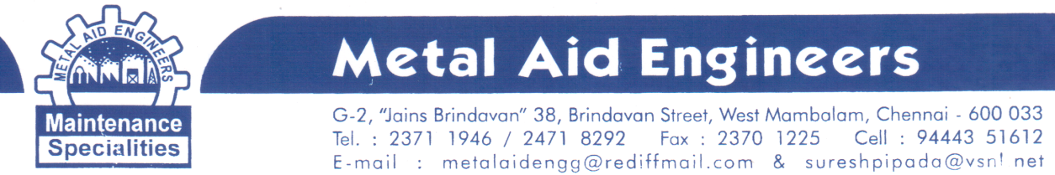COMPANY PROFILE
We are mechanical maintenance consultants who import & market high quality, internationally reputed, mechanical maintenance specialty Products for cost effective, instant repair maintenance systems suitable for HIGH PRESSURE & HIGH TEMPERATURE LEAK SEALING IN VARIOUS AREAS LIKE PIPELINES, GLANDS, JOINTS, FLANGES, PUMPS/VALVES, AGITATORS, AUTOCLAVES (stuffing box) AND OTHER INDUSTRIAL EQUIPMENTS, with excellent chemical resistance applications for use in various companies like refineries, petrochemical industries, sugar plants, pulp & paper mills, chemicals & fertilizer plants, cement plants, steel plants, drugs & pharmaceutical units and hydroelectric, thermal & nuclear power plants , various ports, Government of India organization's like Ministry of Defence, Department of Atomic Energy and Department of Space, ISRO etc. We have been marketing our "STATE OF THE ART" products all over India for the last 20 years. Our Products are,

- G-PAC: UNIVERSAL, FIBROUS- PUTTY TYPE, NON-ASBESTOS, SELF LUBRICATED PTFE & CARBON GRAPHITE GLAND PACKING COMPOUNDS / STUFFING BOX SEALANTS FOR SEALING GLAND LEAKAGES IN PUMPS, VALVES, AGITATORS, AUTOCLAVES EFFECTIVELY,SUITABLE FOR FOOD GRADE APPLICATIONS ALSO.

- MULTI-LON(MAE): BRAIDED, SELF LUBRICATED NON-ASBESTOS, PURE PTFE/CARBON-GRAPHITE IMPREGNATED GLAND PACKING ROPES, FOR SEALING GLAND LEAKAGES IN PUMPS, VALVES, AGITATORS, AUTOCLAVES .

- MULTI-LON(H.T): BRAIDED, SELF LUBRICATED NON-ASBESTOS, PURE CARBON-GRAPHITE GLAND PACKING ROPES APT FOR SUPER-HEATED STEAM APPLICATIONS FOR SEALING GLAND LEAKAGES IN PUMPS, VALVES, AGITATORS, AUTOCLAVES.

- MAGIC-WRAP: RESIN IMPREGNATED WATER ACTIVATED FIBER GLASS CLOTH TAPE, FAST CURING, SETTING ROCK-HARD IN MINUTES EVEN UNDER WATER, FOR USE IN WIDE RANGE OF INDUSTRIAL APPLICATIONS MAINLY IN THE AREAS OF SEALING PIPE AND TANK LEAKAGES PERMANENTLY,TO BE USED DIRECTLY WITH NO MIXING MEASURING OR MESSING AND SPECIALLY IN MOIST AND UNDERWATER APPLICATONS OFFERING GOOD THERMAL RESISTANCE AND ELECTRICAL INSULATION.

- SPECIALTY EPOXY PUTTY STICKS (PSI): SPECIALLY FORMULATED TWO COMPONENTS EPOXY STICK TO BOND AND REPAIR MATERIALS FOR MAXIMUM STRENGTH, DURABILITY, CHEMICAL RESISTANCE & EASE OF APPLICATIONS,SETS IN MINUTES USED FOR SEALING LEAKAGES, FILLING HOLES, CRACKS, REPAIRING WORN-OUT SHAFTS, JOINING BROKEN PARTS AND MANY OTHER INDUSTRIAL REPAIR WORKS. AFTER CURING IT CAN BE DRILLED,MACHINED, SANDED, PAINTED ETC.

- PR2101 FOR SHAFT REPAIRING AND REBUILDING

- RESBOND AND DURABOND – HIGH TEMPERATURE SS PUTTIES

