A Statistical Approach to Adult Census Income
Level Prediction

Harshitha y
Computer sience and engineer
PES university
Bangalore, India
harshitha12.y@gmail.com
Kalisrani M
Computer sience and engineer
PES university
Bangalore, India
kalisranim2711@gmail.com
Monicashree M
Computer sience and engineer
PES university
Bangalore, India
monumonicashree27@gmail.com
Prema Ramappa Hanchinal
Computer sience and engineer
PES university
Bangalore, India
premahanchinal17@gmail.com

Abstract— In the fastest growing world, there are many issues on the poverty, we have taken one of the topics among them i.e. is income, in the world there are inequality of the wealth. In wealth inequality main reason, we can observe is that by income in many nations to overcome the problem likelihood of diminishing poverty is one valid reason to reduce the world’s struggling level of economic inequality. Many nations are trying to overcome the wealth inequality in their nations. In this fastest growing nation, we can make use of the machine learning and data analytics algorithm to overcome poverty in their nation. so, in our project we thought make use of logistic regression. by using adult income data set we can assume if the adult income is more than the average or between the assumed income (50,000) then we can say that nation can overcome the poverty.

Keywords— machine learning, data mining, income equal-
ity, Classification, Logistic Regression.

Introduction
In the recent decades we are getting the large number of data and information in field we are required to solve the problems. We can solve the problems in the many fields by making use of the data or information since we are working on the project called overcome the poverty in the nation by making use of the data set adult income census. adult income plays an important role in the poverty in the nation if all the employee who are working should get the minimum salary (summation 50,000). we thought that one of the solutions to overcome the poverty in the nation is by adult income. The field of data analytics and machine learning have not only exploited them for the knowledge and discovery but also to explore certain hidden patterns and concepts which leads to prediction future events, not easy to obtain. the problem of income inequality has been concerning in the recent years.in the nation people not ready acceptable to inequality of the wealth in the society and demand for the fare equality. So, in our model we aim conduct a complete analysis to highlight the key factors that are necessary in improving an individual’s income. Such an analysis helps to set focus on the important area which can significantly improve the income level of individuals.

Review of most relevient predecessor work
In the past, researchers have made some efforts using machine learning models to predict income levels. With the help of our work, we predict the income of the population and by analyzing the factors that strongly affect income in this section we intend to give an idea of the different works carried out in the field of analytics to understand their meaning in the relationship. with income.

Methods used

• Gradient increase classifier
• Grid search algorithm

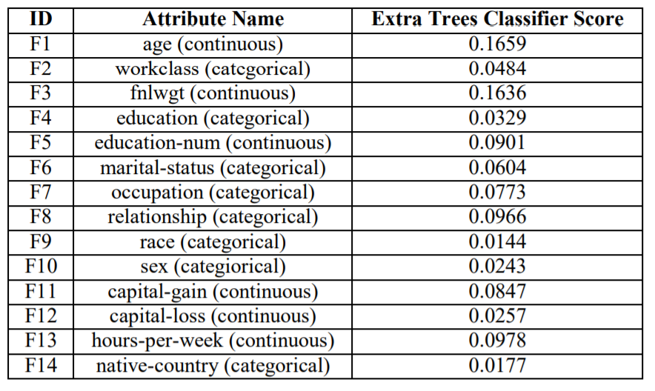

III. ASSUMPTIONS
Finally, the validation accuracy, thus obtained, equal to 88.16% which, according to our knowledge, was the highest numerical precision ever achieved.
• Assumptions of normality: Most parametric tests require that the assumption of normality be satisfied. Normality means that the test distribution is normally (or bell-shaped) distributed with mean 0, with 1 standard deviation and a symmetrical bell curve. To verify the normality assumption, the following measurements and tests can be applied:
• Asymmetry and kurtosis: to test the hypothesis of normal distribution, the asymmetry must be in the range ± 2. The values of kurtosis must be in the range ± 7
• Assumptions about the data content
One specific thing to note is the lack of data or placeholder values. We tend to assume, or at least expect, that every field in the data contains a usable value. in the CSV data there may be "NA", "NaN" or a blank space where there should be a number. It is always a good idea to check if those missing data values occur often enough to cause problems.
• Assumptions about data distribution
We can apply these solution strategies to the problem we have selected so far with any revenue forecasting model.

Limitations

• Not 100% accurate, accuracy is 88.16%.
• The logistic regression model works well if the number of dimensions is small.
• But it is quite cumbersome if we have a large number of dimensions
• In this case, a better approach is to calculate the number of dimensions that can explain a significantly large portion of the variance.

experimental results

Logistic Regression model Logistic Regression accuracy score with all the features we got has 0.8217Authors and Affiliations
Train Logistic Regressor [1]
Here we found a accuracy score and confusion matrix and classification report.
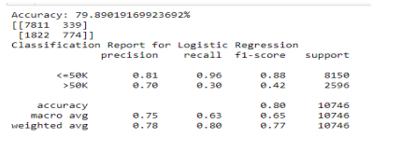
Implementation of PCA algorithm[2]
from sklearn.decomposition import PCA
pca = PCA()
X_train=pca.fit_transform(X_train)
pca.explained_variance_ratio_
and we got output as
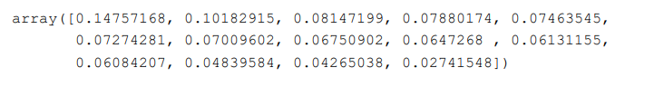
We can see that approximately 97.25% of variance is explained by the first 13 variables.
Only 2.75% of variance is explained by the last variable. So, we are assuming that it carries little information.
So we are dropping it , then training the model again and calculate the accuracy.
• By dropping ['income','native.country']
Logistic Regression accuracy score with the first 13 features: 0.8213
(We can see that accuracy has been decreased from 0.8218 to 0.8213 after dropping the last feature.

Now, if we take the last two features combined, then we can see that approximately 7% of variance is explained by themWe will drop them, train the model again and calculate the accuracy.)
• By dropping ['income','native.country', 'hours.per.week']
Logistic Regression accuracy score with the first 12 features: 0.8227
Now, it can be seen that the accuracy has been increased to 0.8227, if the model is trained with 12 features. Lastly, we will take the last three features combined. Approximately 11.83% of variance is explained by them. We will repeat the process, drop these features, train the model again and calculate the accuracy.
• By dropping ['income','native.country', 'hours.per.week', 'capital.loss']
Logistic Regression accuracy score with the first 11 features: 0.8186[6]
We can see that accuracy has significantly decreased to 0.8187 if we drop the last three features.
• By dropping ['income']
The number of dimensions required to preserve 90% of variance is 12
Our aim is to maximize the accuracy. We get maximum accuracy with the first 12 features and the accuracy is 0.8227.
Selecting right number of dimensions
• The above process works well if the number of dimensions are small.
• But, it is quite cumbersome if we have large number of dimensions.
• In that case, a better approach is to compute the number of dimensions that can explain significantly large portion of the variance.
• The following code computes PCA without reducing dimensionality, then computes the minimum number of dimensions required to preserve 90% of the training set variance.
Here is the plot which shows that almost 90% of variance is explained by the first 12 components.
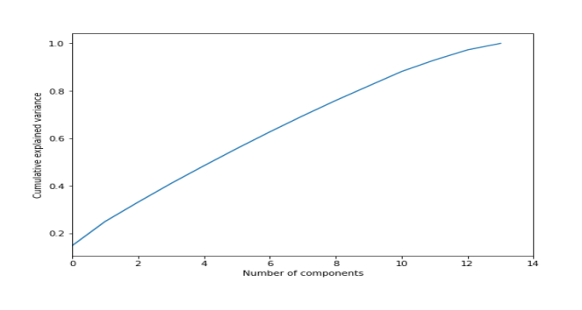

VARIOUS COMPONENTS OF THE SOLUTION

- Import Python libraries
- Import dataset
- Exploratory data analysis
- Split data into training and test set
- Feature engineering
- Feature scaling
- Logistic regression model with all features
- Logistic Regression with PCA
- Select right number of dimensions
- Plot explained variance ratio with number of dimension
Import DataSet

Exploratory Data Analysis

Check shape of dataset
We can see that there are 32561 instances and 15 attributes in the dataset.
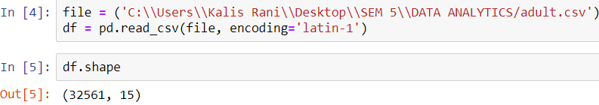

Preview dataset
preview shows that the dataset contains values coded as `?`. So, encode `?` as NaN values.
Encode ? as NaNs

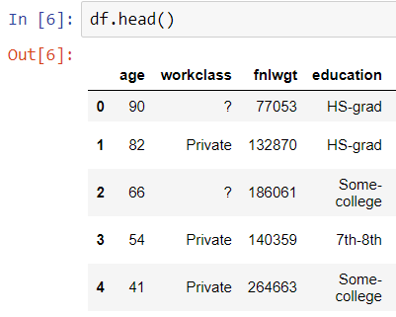

Now Again check the summary :
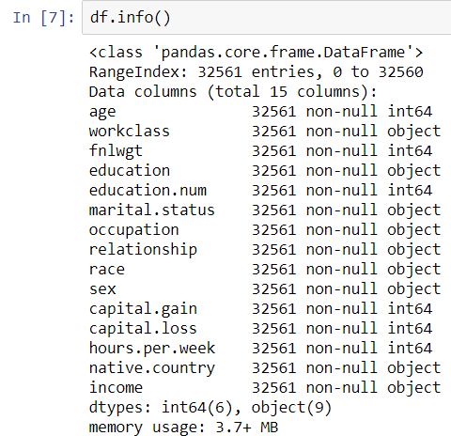
Now the summary shows that the variables - work class, occupation and native country contain missing values. All of these variables are categorical data types. Therefore, I will impute the missing values ​​with the most frequent value: the mode.
Impute missing values with mode

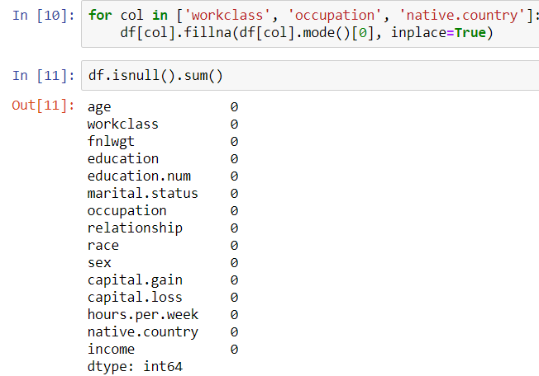
Now we can see that there are no missing values in the dataset.

Setting feature vector and target variable
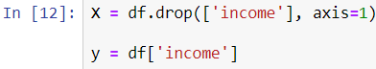

Split data into separate training and test set

Feature Engineering

Encode categorical variables¶
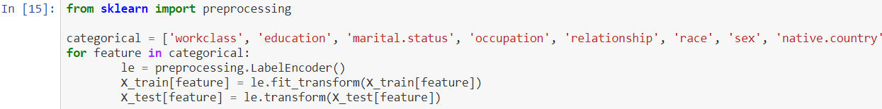

Confusion Matrix :[2]
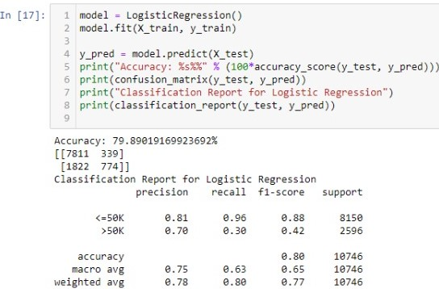

Feature Scaling
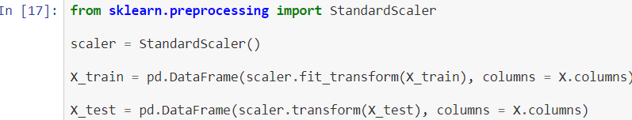

Logistic Regression model with all features[5]
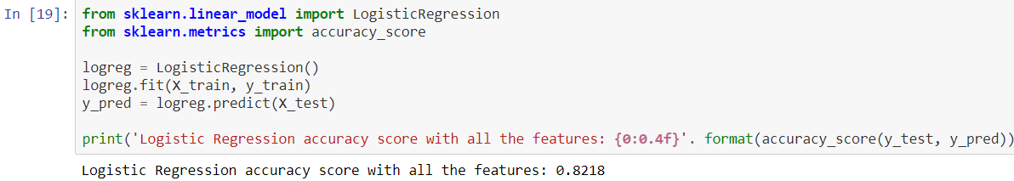
Here the logistic Accuracy with all the features is 0.8218

Explained Variance Ratio
A very useful piece of information is the explained variance ratio of each principal component.It is available via the explained_variance_ratio_ variable. It indicates the proportion of the dataset’s variance that lies along the axis of each principal component.
Now, its PCA implementation.
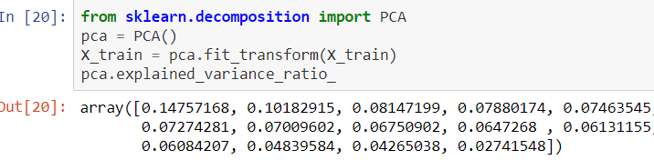
- We can see that approximately 97.25% of variance is explained by the first 13 variables.Only 2.75% of variance is explained by the last variable. So, we can assume that it carries little information.
- So, I will drop it, train the model again and calculate the accuracy.

Logistic Regression with first 13 features
Logistic Regression accuracy score with
- We can see that accuracy has been decreased from 0.8218 to 0.8213 after dropping the last feature.
- Now, if I take the last two features combined, then we can see that approximately 7% of variance is explained by them.I will drop them, train the model again and calculate the accuracy.

Logistic Regression with first 12 features
Now, it can be seen that the accuracy has been increased to 0.8227, if the model is trained with 12 features.
- Lastly, I will take the last three features combined.
- About 11.83% of the variance is explained by them. I'll repeat the process, remove these features, train the model again, and calculate accuracy.
Our aim is to maximize the accuracy. We get maximum accuracy with the first 12 features and the accuracy is 0.8227.

Select right number of dimensions
- The above process works well if the number of dimensions are small.
- But, it is quite cumbersome if we have large number of dimensions.
- In that case, a better approach is to compute the number of dimensions that can explain significantly large portion of the variance.
- The following code computes PCA without reducing dimensionality, then computes the minimum number of dimensions required to preserve 90% of the training set variance.
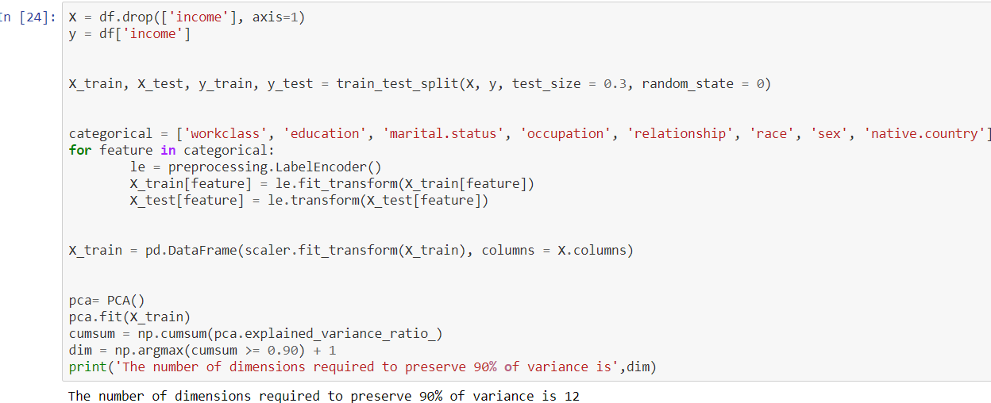
- With the required number of dimensions found, we can then set number of dimensions to dim and run PCA again.
- With the number of dimensions set to dim, we can then calculate the required accuracy.
Plot explained variance ratio with number of dimensions : The plot shows that almost 90% of variance is explained by the first 12 components
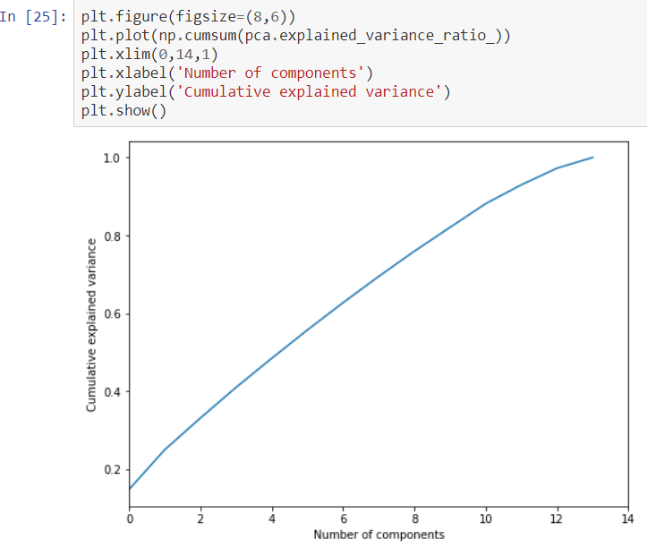

Part :1 : Prema :
- Exploratory Data Analysis

Import data

Impute missing values with Mode

Split data into separate training and test set

Part 2 : Harshitha Y:

Feature Engineering

Encode categorical variables

Feature Scaling

Confusion Matrix

Part 3 : KalisRani M :

Logistic Regression model with all features

Then , Logistic Regression with first 13 features then with first 12 and with first 11 featuresegression accuracy

Logistic Regression with PCA

Explained Variance Ratio

Select right number of dimensions to preserve 90% variance

Part 4 : Monica :

Caluculation of ratio

Plot explained variance ratio with number of dimensions

CONCLUSION
This paper proposed the application of the set learning algorithm, logistic regression with data extended from the adult census. Finally, the validation accuracy thus obtained, equal to 90% which, to our knowledge, was the highest numerical accuracy ever achieved so far by any model of forecasting income. The future purpose of this work is to achieve an overall better set of results by using hybrid models with the inclusion of Machine Learning and Deep Learning together, or by applying many other advanced preprocessing techniques without further reducing accuracy.

References
[1]https://www.coursera.org/projects/logistic-regression-numpy-python
[2]https://www.youtube.com/watch?v=HYcXgN9HaTM
[3]https://www.researchgate.net/publication/299435151_Model_building_strategy_for_logistic_regression_Purposeful_selection
[4]https://arxiv.org/ftp/arxiv/papers/1810/1810.10076.pdf (A Statistical Approach to Adult Census Income Level Prediction)
[5]https://towardsdatascience.com/logistic-regression-detailed-overview-46c4da4303bc
[6]http://scikitlearn.org/stable/modules/generated/sklearn.linear_model.LogisticRegression.html

.

