**Name:** Prema Dongare

**Roll no:** 281067

**Batch:** A3

**Assignment 2: Data Visualization**

**Problem Statement:**

Visualize the dataset provided for Assignment No. 1 and 2 using either R/Python or Tableau. Select a suitable dataset for visualization.

a) Using R/Python:

- Utilize Scatter plot, bar plot, Box plot, and Histogram to visualize the dataset effectively.

**Libraries Used:**

1. NumPy (np)

2.Pandas (pd)

3.Matplotlib (plt)

4.Seaborn (sns)

**Theory:**

**1) Methodology:**

Data visualization using Google Colab involves the use of various Python libraries such as Matplotlib, Seaborn, Pandas, and NumPy. These libraries provide a comprehensive set of tools to create a wide range of visualizations including scatter plots, bar plots, box plots, histograms, and more.

The methodology typically involves the following steps:

* **Data Importing:** Importing the dataset into the Colab environment using Pandas or accessing data from other sources such as Google Drive.
* **Data Preprocessing:** Preprocessing the data if necessary, including handling missing values, data cleaning, and feature engineering.
* **Visualization:** Using Matplotlib and Seaborn to create visualizations based on the requirements of the assignment. This may include choosing appropriate plot types, customizing plot aesthetics, and adding necessary annotations.
* **Interactivity:** Enhancing visualizations with interactive features using libraries like Plotly, if required.
* **Presentation:** Presenting the visualizations in the notebook along with appropriate titles, labels, and legends to convey the insights effectively.

**Screenshots of the Output:**

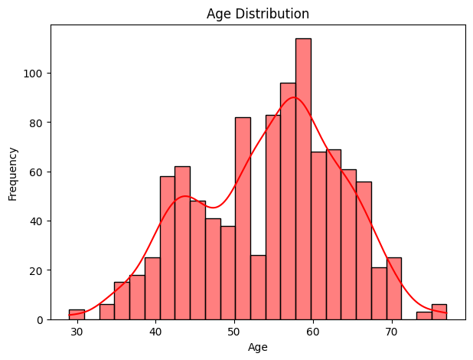 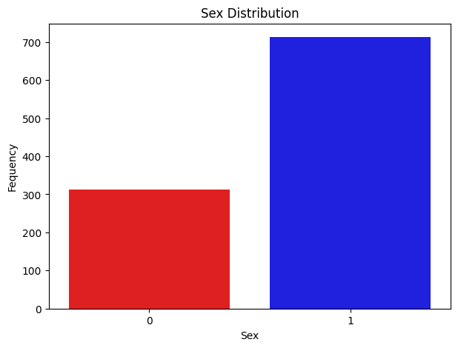

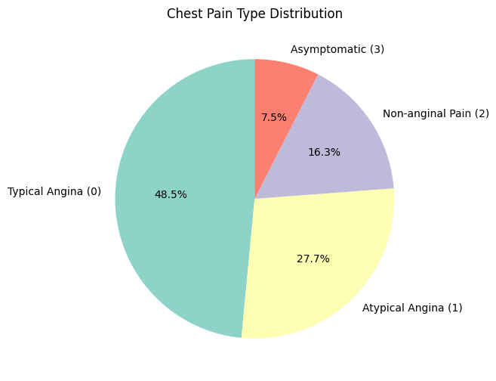 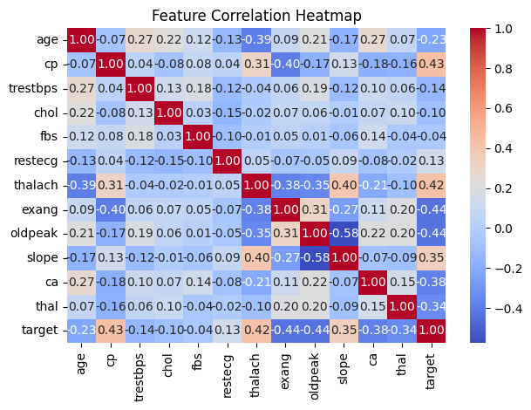 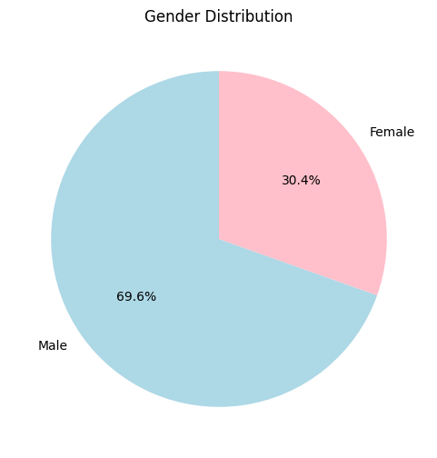 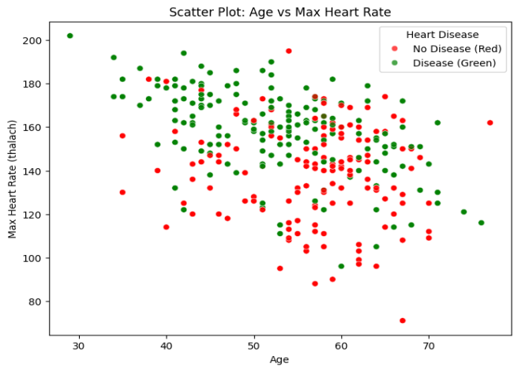

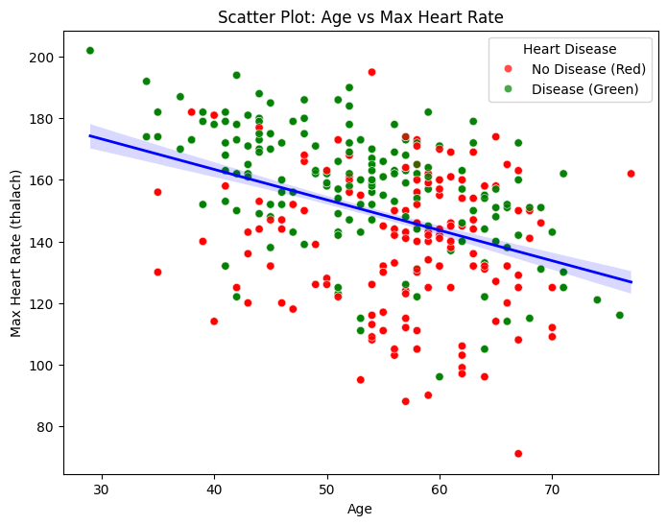 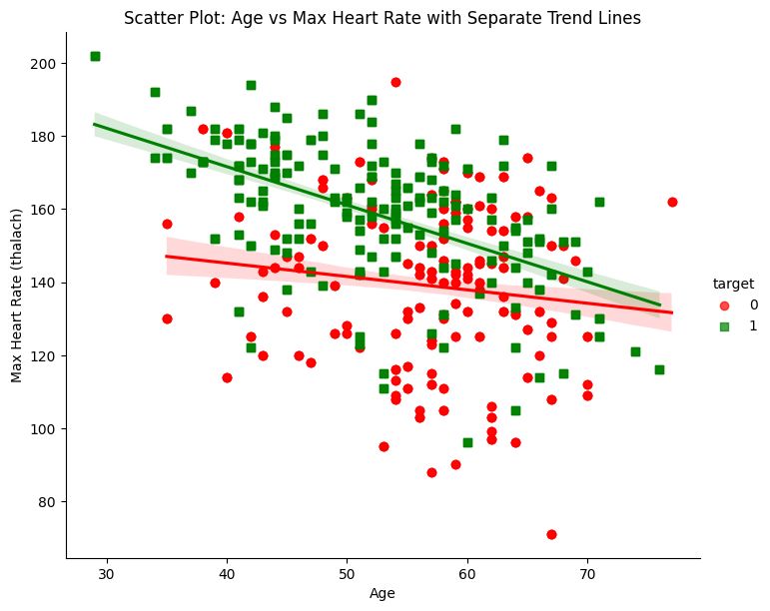

**-**

**Conclusion:**

In conclusion, the methodology outlined for data visualization using Google Colab, alongside Python libraries such as Matplotlib, Seaborn, Pandas, and NumPy, provides a robust framework for exploring and interpreting the university dataset. By following the steps of data importing, preprocessing, visualization, interactivity, and presentation, we have effectively leveraged these tools to gain insights into various aspects of university data.The visualizations generated, including scatter plots, bar plots, box plots, and histograms, have enabled us to uncover patterns, trends, and relationships within the dataset. Through interactive features, stakeholders can dynamically explore the data, gaining deeper insights and making more informed decisions.