**Question1**

package task5;

import java.util.Scanner;

public class Question1 {

public static void main(String[] args) {

// Create a Scanner object to read input from the user

Scanner scanner = new Scanner(System.in);

// Prompt the user to enter a string

System.out.print("Enter a string: ");

String input = scanner.nextLine();

// Convert the input to lowercase to ensure the check is case-insensitive

input = input.toLowerCase();

// Call the function to check if the string is a palindrome

if (isPalindrome(input)) {

System.out.println("\"" + input + "\" is a palindrome.");

} else {

System.out.println("\"" + input + "\" is not a palindrome.");

}

// Close the scanner

scanner.close();

}

// Function to check if a string is a palindrome

public static boolean isPalindrome(String str) {

int length = str.length();

// Loop through the string from both ends towards the center

for (int i = 0; i < length / 2; i++) {

// Compare characters from the beginning and end

if (str.charAt(i) != str.charAt(length - 1 - i)) {

return false; // Not a palindrome

}

}

return true; // Is a palindrome

}

}

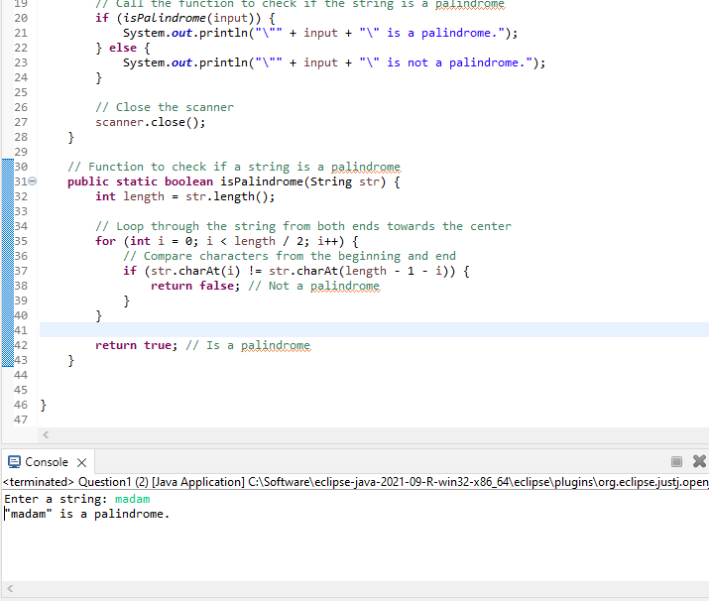

**Question2**

package task5;

import java.util.Scanner;

public class Question2 {

public static void main(String[] args) {

// Create a Scanner object to read input from the user

Scanner scanner = new Scanner(System.in);

// Prompt the user to enter a string

System.out.print("Enter a string: ");

String input = scanner.nextLine();

// Call the function to reverse the string

String reversedString = reverseString(input);

// Output the reversed string

System.out.println("Reversed string: " + reversedString);

// Close the scanner

scanner.close();

}

// Function to reverse a string

public static String reverseString(String str) {

String reversed = ""; // Initialize an empty string to store the reversed result

// Loop through the string from the end to the beginning

for (int i = str.length() - 1; i >= 0; i--) {

reversed += str.charAt(i); // Append each character to the reversed string

}

return reversed; // Return the reversed string

}

}

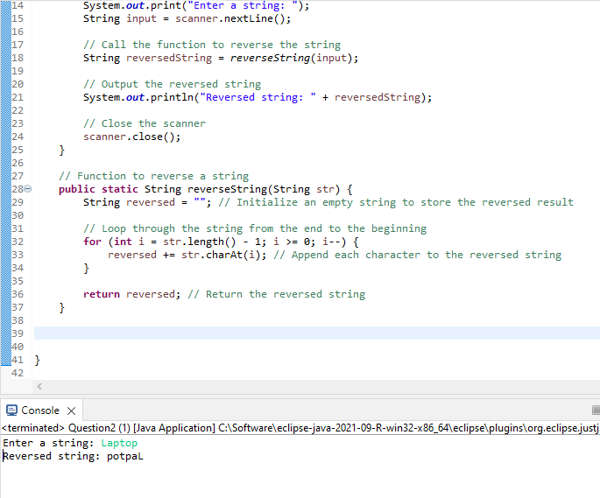

**Question 3**

package task5;

import java.util.Scanner;

public class Question3{

public static void main(String[] args) {

System.out.println("Enter the number");

// Create a Scanner object for input

Scanner scanner = new Scanner(System.in);

// Read the input number

int n = scanner.nextInt();

// Variable to keep track of the current number

int currentNumber = 1;

System.out.println("Output");

// Loop through each row

for (int i = 1; i <= n; i++) {

// Loop through each column in the current row

for (int j = 1; j <= i; j++){

// Print the current number followed by a space

System.out.print(currentNumber + " ");

// Increment the current number

currentNumber++;

}

System.out.println();

}

scanner.close();

}

}

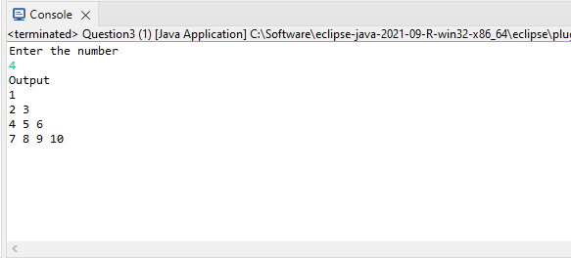

**Question 4**

package task5;

import java.util.Scanner;

public class Question4 {

public static void main(String[] args)

System.out.println("Enter the number");

Scanner scanner = new Scanner(System.in);

// Read the input number

int n = scanner.nextInt();

System.out.println("Output");

for (int i = 0; i < n; i++) {

for (int j = 0; j < n; j++) {

// Print '*' if it's on the diagonal or anti-diagonal, else print a space

if (i == j || i + j == n - 1) {

System.out.print("*");

} else {

System.out.print(" ");

}

}

System.out.println();

}

scanner.close();

}

}

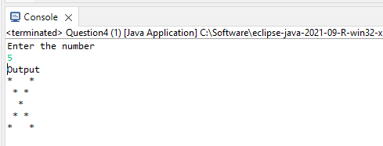

**Question5**

package task5;

import java.util.Scanner;

public class Question5 {

public static void main(String[] args) {

// Create a Scanner object for input

Scanner scanner = new Scanner(System.in);

// Prompt the user to enter the mark

System.out.print("Enter the mark: ");

int mark = scanner.nextInt();

// Determine the grade based on the mark

char grade;

if (mark >= 90 && mark <= 100) {

grade = 'A'; // Marks between 90 and 100

}

else if (mark >= 80 && mark < 90) {

grade = 'B'; // Marks between 80 and 89

}

else if (mark >= 70 && mark < 80) {

grade = 'C'; // Marks between 70 and 79

}

else if (mark >= 60 && mark < 70) {

grade = 'D'; // Marks between 60 and 69

}

else if (mark >= 50 && mark < 60) {

grade = 'E'; // Marks between 50 and 59

}

else if (mark < 50) {

grade = 'F'; // Marks less than 50

}

else {

System.out.println("Invalid mark entered.");

scanner.close();

return; // Exit the program if the mark is not within valid range

}

// Print the corresponding grade

System.out.println("The grade is: " + grade);

// Close the scanner

scanner.close();

}

}

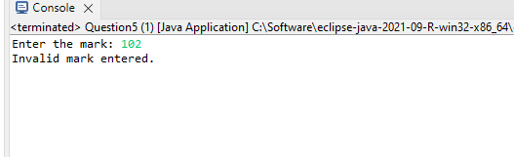

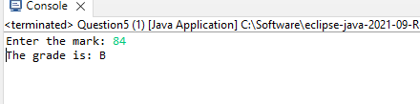

**Question6**

package task5;

import java.util.Scanner;

public class Question6 {

public static void main(String[] args) {

// Create a Scanner object for input

Scanner scanner = new Scanner(System.in);

// Input month

System.out.print("Enter the month (1 for January, 2 for February, ..., 12 for December): ");

int month = scanner.nextInt();

// Input room rent per day

System.out.print("Enter the room rent per day: ");

float roomRentPerDay = scanner.nextFloat();

// Input number of days stayed

System.out.print("Enter the number of days stayed: ");

int numberOfDays = scanner.nextInt();

// Calculate the base total cost

float totalCost = roomRentPerDay * numberOfDays;

// Determine if it's peak season and apply the surcharge

switch (month) {

case 4: // April

case 5: // May

case 6: // June

case 11: // November

case 12: // December

totalCost *= 1.20; // 20% surcharge

break;

default:

// No surcharge for other months

break;

}

// Print the total tariff

System.out.printf("The total tariff is: %.2f%n", totalCost);

// Close the scanner

scanner.close();

}

}

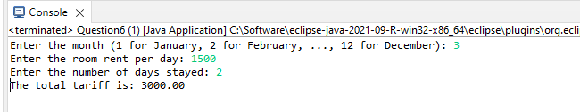

**Question7**

**package** task5;

**import** java.util.Scanner;

**public** **class** Question7 {

**public** **static** **void** main(String[] args) {

// Create a Scanner object for input

Scanner scanner = **new** Scanner(System.***in***);

// Input three numbers

System.***out***.print("Enter the first number: ");

**int** num1 = scanner.nextInt();

System.***out***.print("Enter the second number: ");

**int** num2 = scanner.nextInt();

System.***out***.print("Enter the third number: ");

**int** num3 = scanner.nextInt();

// Initialize the greatest number with the first number

**int** greatest = num1;

// Compare the second number with the current greatest number

**if** (num2 > greatest) {

greatest = num2;

}

// Compare the third number with the current greatest number

**if** (num3 > greatest) {

greatest = num3;

}

// Print the greatest number

System.***out***.println("The greatest number is: " + greatest);

// Close the scanner

scanner.close();

}

}

