1.Encapsulation + Getter/Setter

WAP in Java
Create a class named Employee with private instance variables empId, empName, and salary.

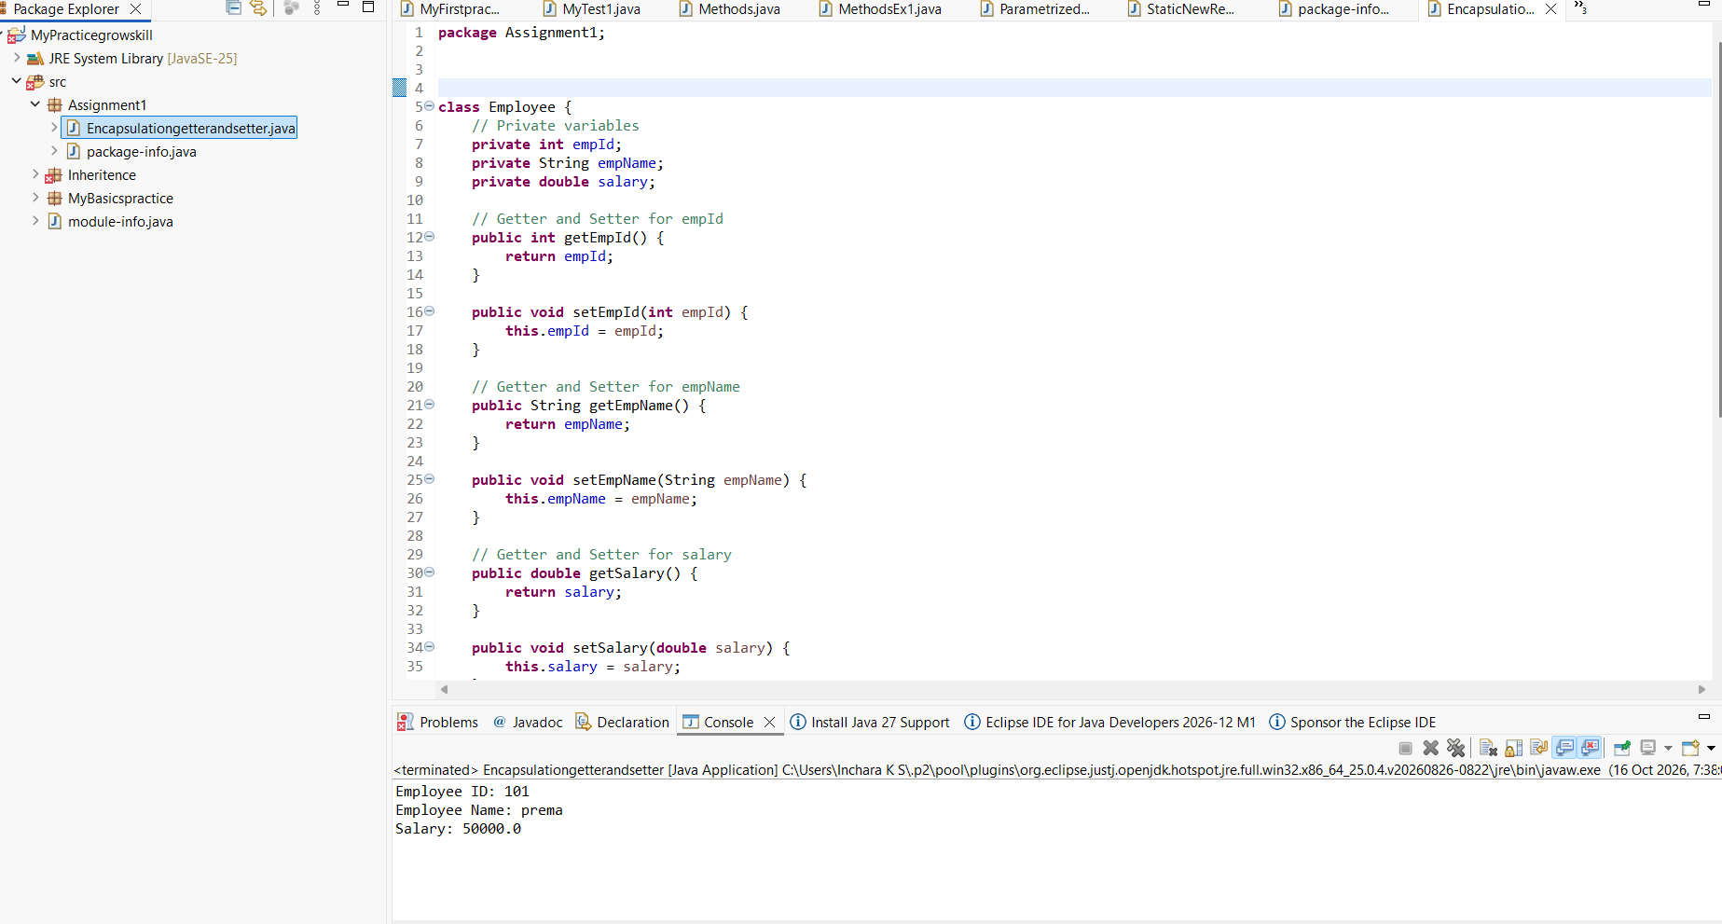

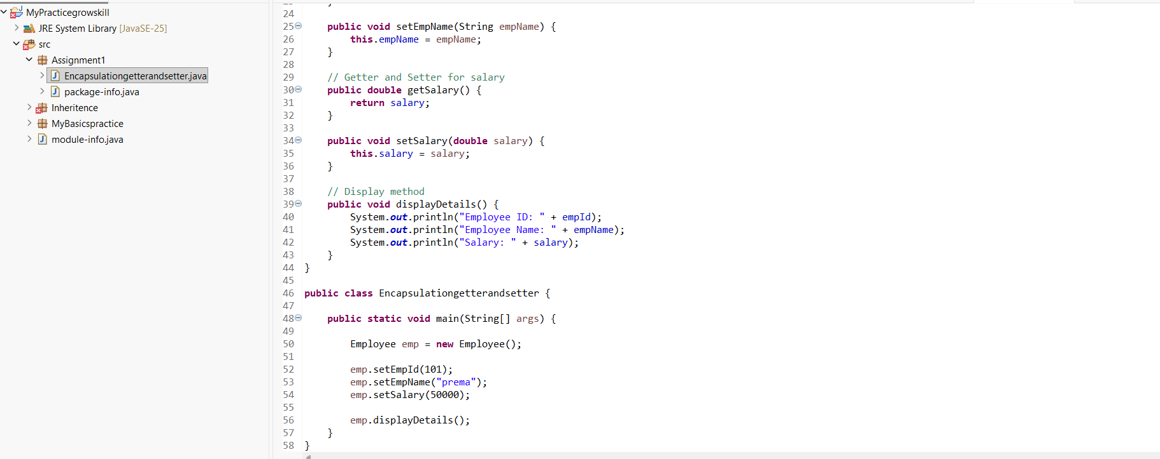

Output: 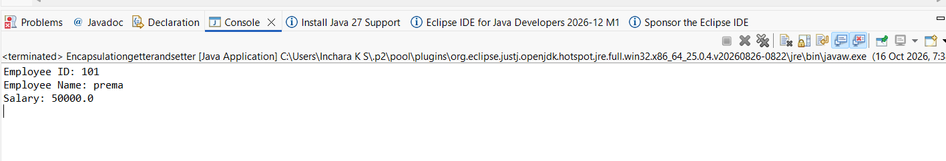

2. Inheritance + Method Overriding

Create a base class Vehicle with a method fuelType() which prints "Runs on fuel".
Create a child class ElectricCar and override the fuelType() method to print "Runs on electricity".
Create objects of both classes and call their respective methods.

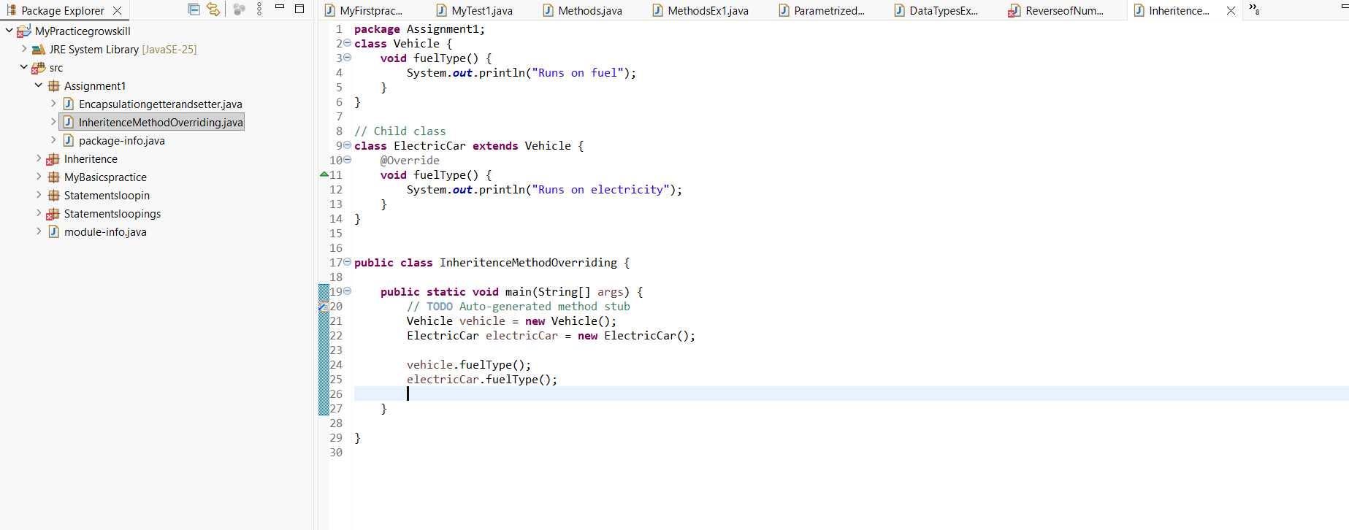

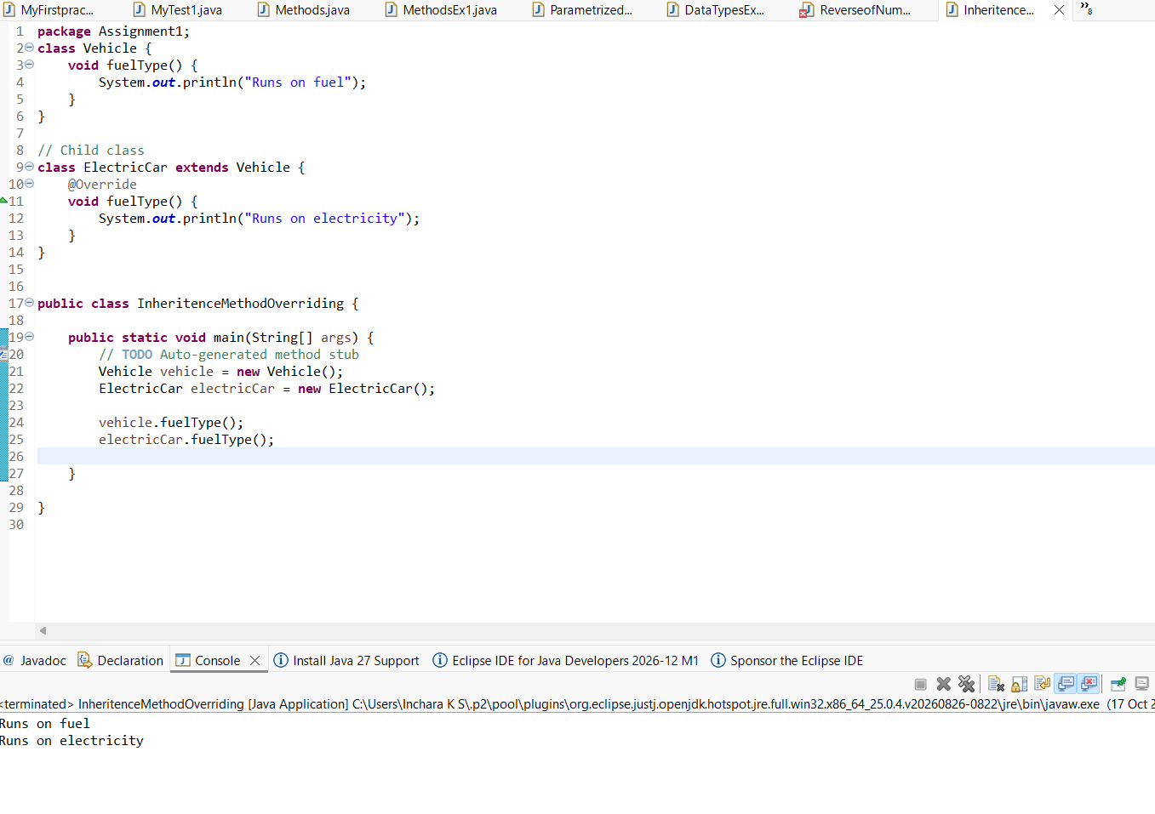

3. Constructor Overloading

Create a class Product having instance variables productId, productName, and price.
Implement:

A default constructor that prints "Product Created".

A parameterized constructor that initializes the product details.
Write a method displayProduct() to print product details.
Create both types of objects in the main method.

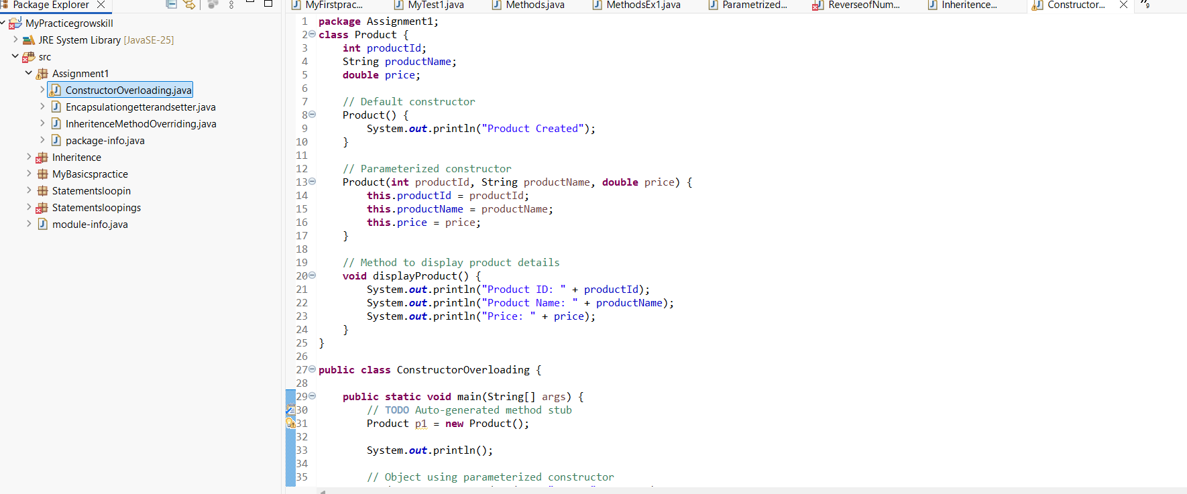
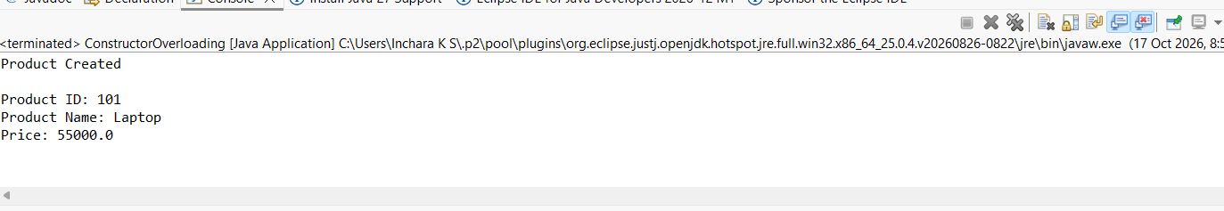

4. Method Overloading

Create a class Calculator with overloaded methods add():

add(int a, int b)

add(double a, double b)
Call both methods inside the main method and print results.

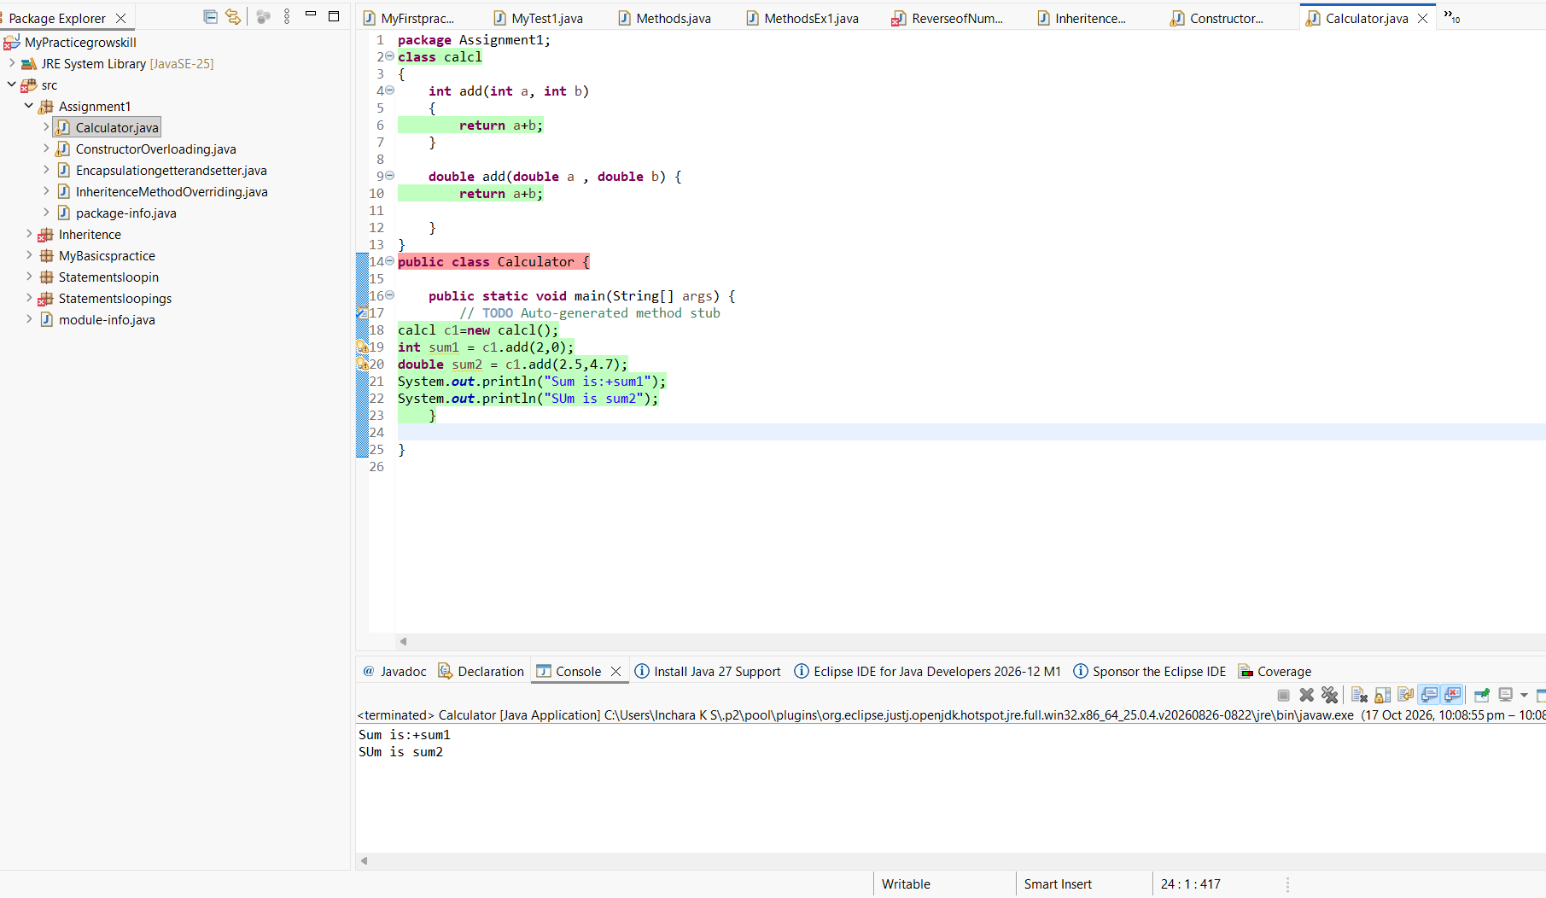

5Abstraction using Abstract Class

Create an abstract class Animal with an abstract method sound().
Create two subclasses Dog and Cat and provide implementation for sound() method.
Create objects and call sound() for each.

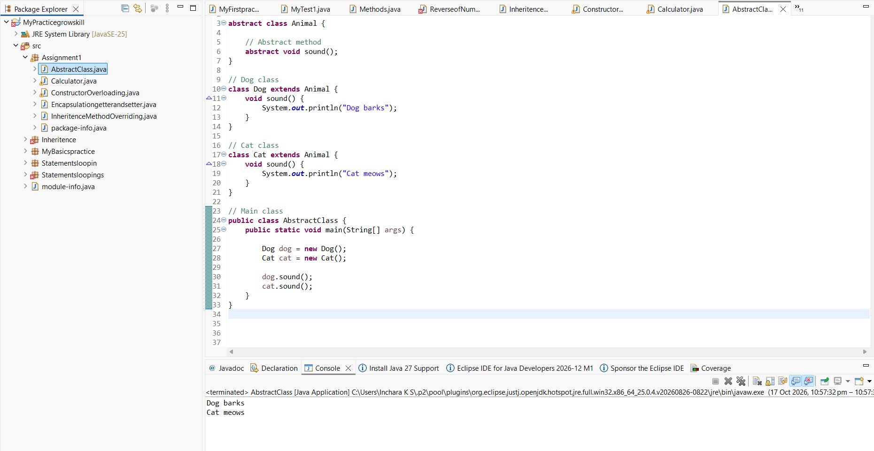
6. Interface Implementation

Create an interface Payment with a method makePayment().
Create two classes UPI and CreditCard implementing this interface and define their own payment messages.
Call the method through interface reference.

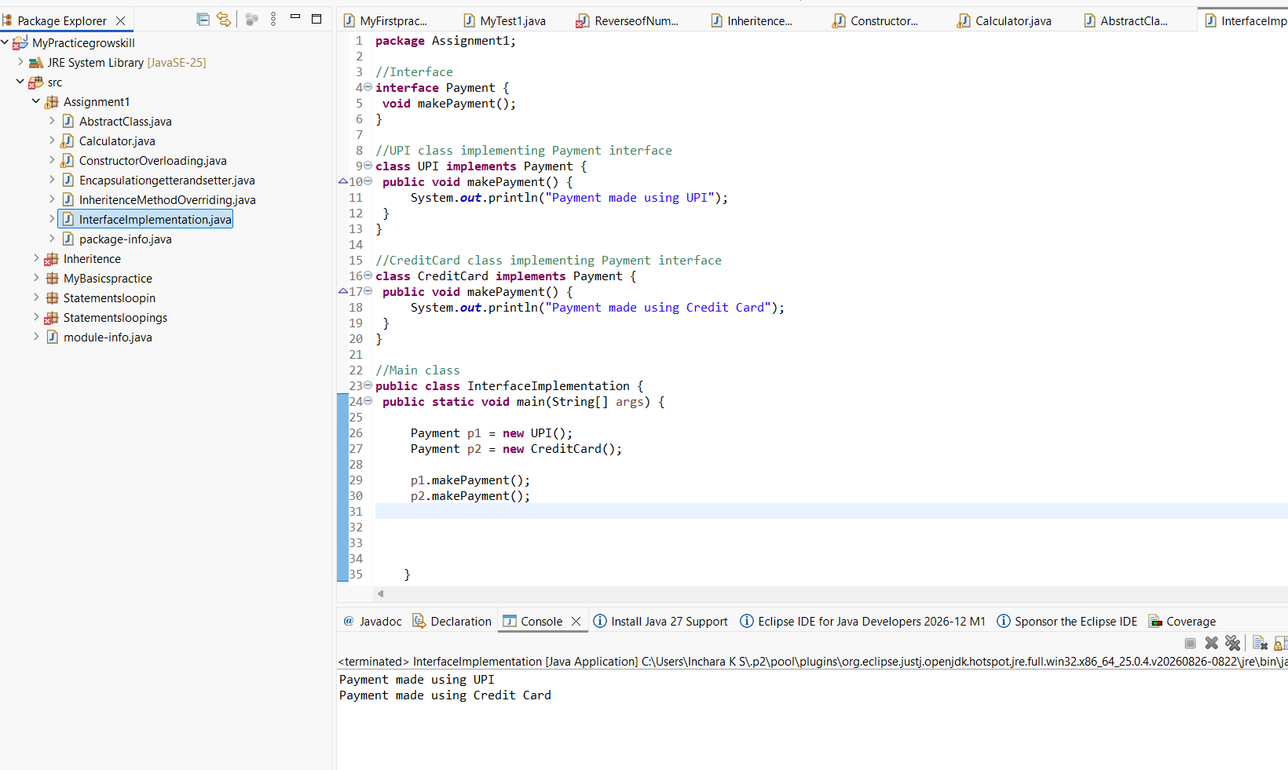

7. Use of super keyword

Create a class Person with a constructor that prints "Person Created".
Create a subclass Student that calls the parent constructor using super() and prints "Student Created".
Create an object and observe the order of execution.

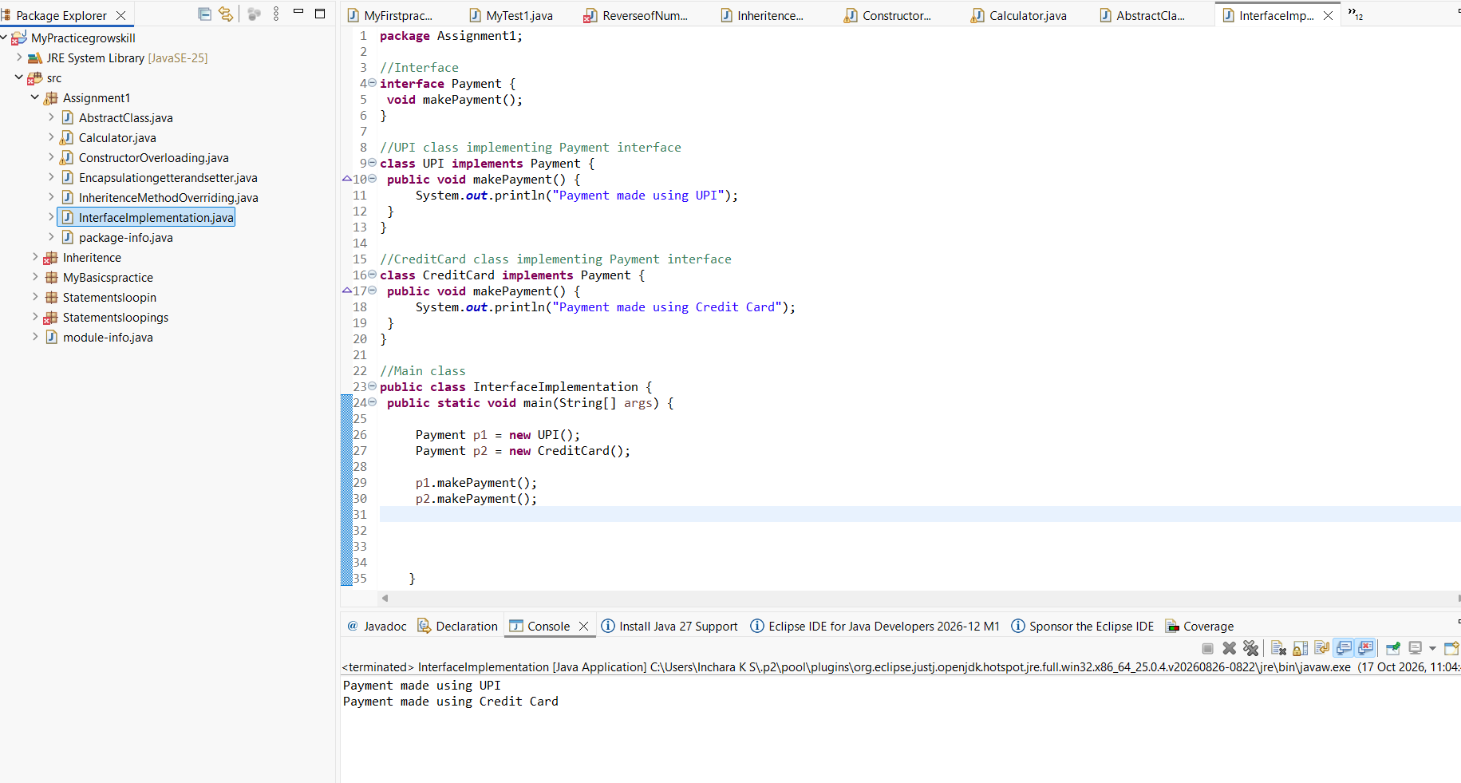

8. Polymorphism (Dynamic Binding)

Create a parent class Shape with a method area().
Create subclasses Rectangle and Circle and override the area() method.
Create a reference of Shape and assign objects of both subclasses one by one, calling area() each time.

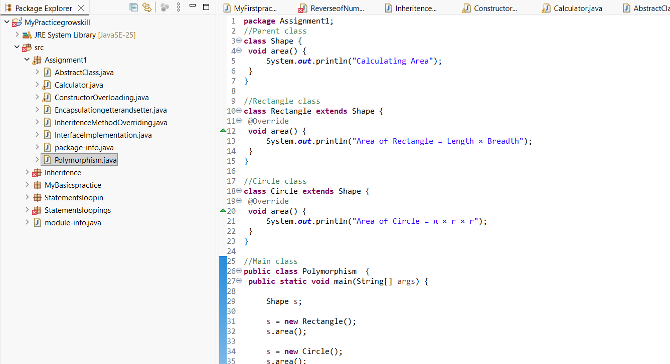
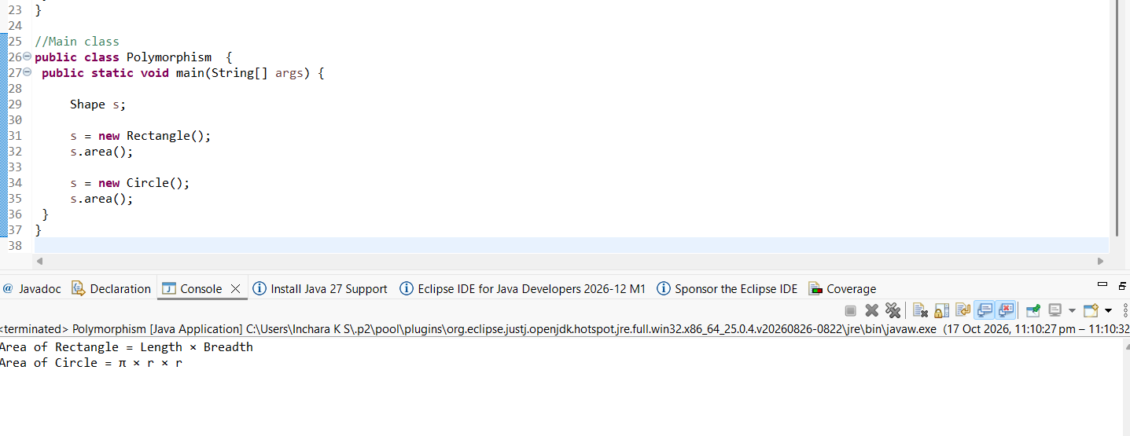

9.Final Keyword

Create a class Bank with a final variable IFSC and final method showIFSC().
Try creating a subclass HDFCBank and attempt overriding the final method (should show compile-time restriction).
Create a main method to demonstrate usage.
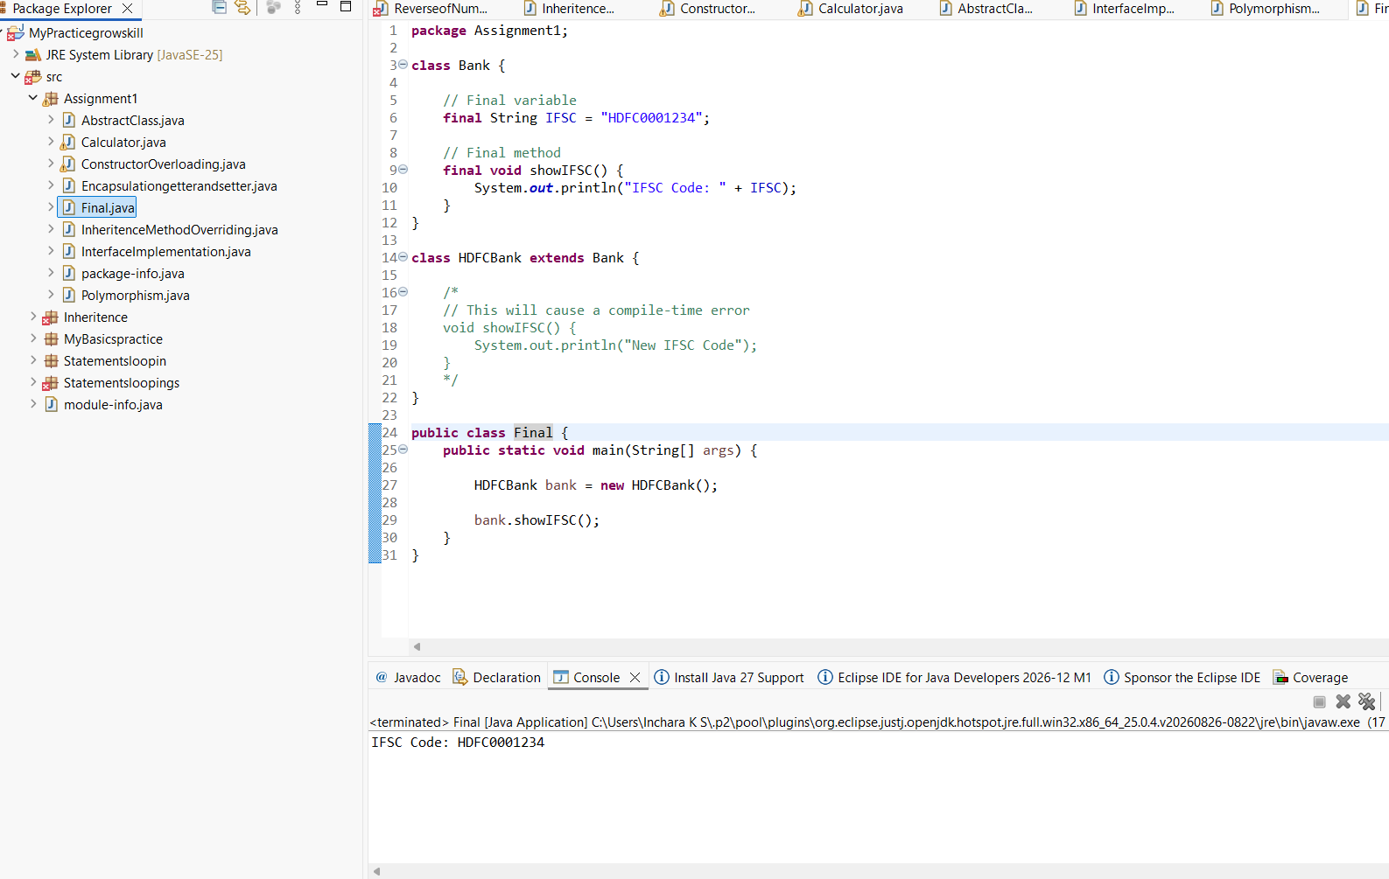
10. Static Keyword

Create a class Student having static variable collegeName and instance variables name and rollNo.
Write a method to print both static and instance data.
Create multiple objects to show static value remains constant.

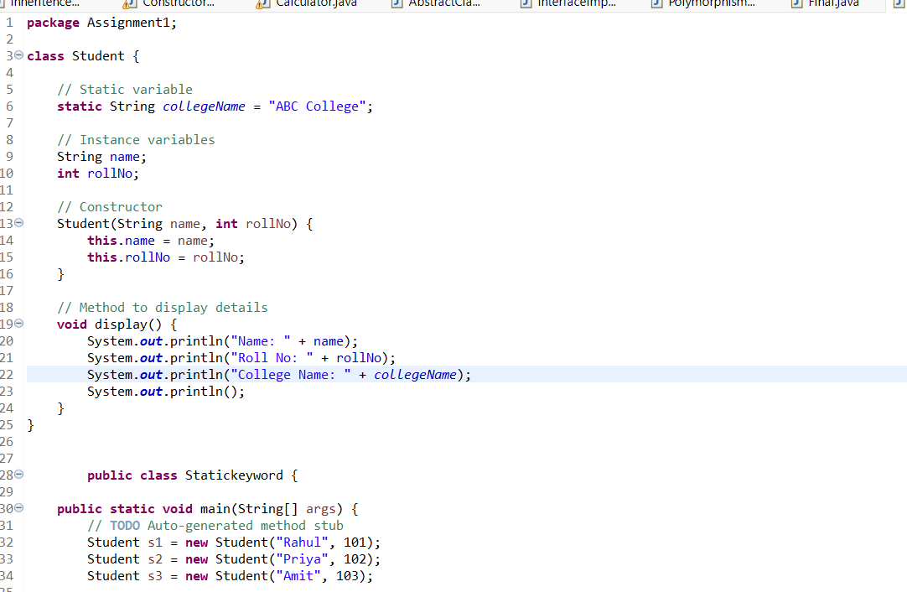
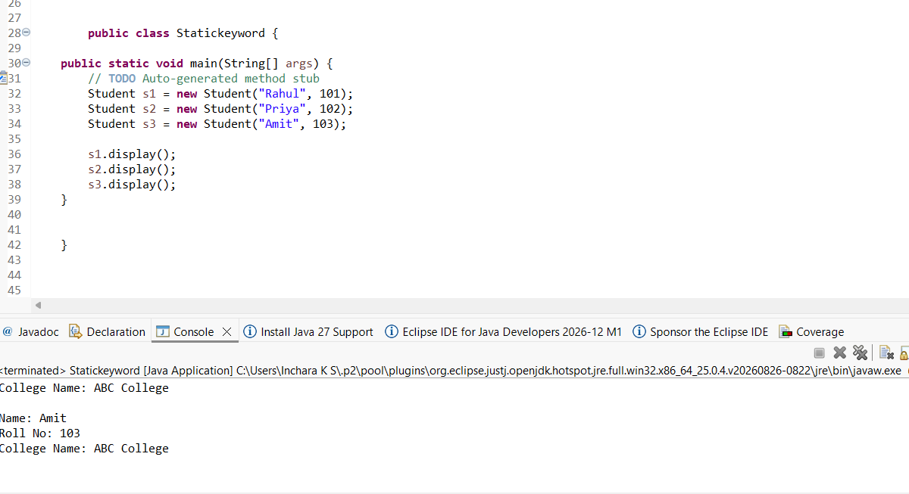

11. Class + Object + Method

Create a class Library with an instance variable libraryName.
Create a default constructor to print "Welcome to the Library!".
Create a method showLocation() which prints "This library is located in Mumbai".
Create an object in main() and call both.

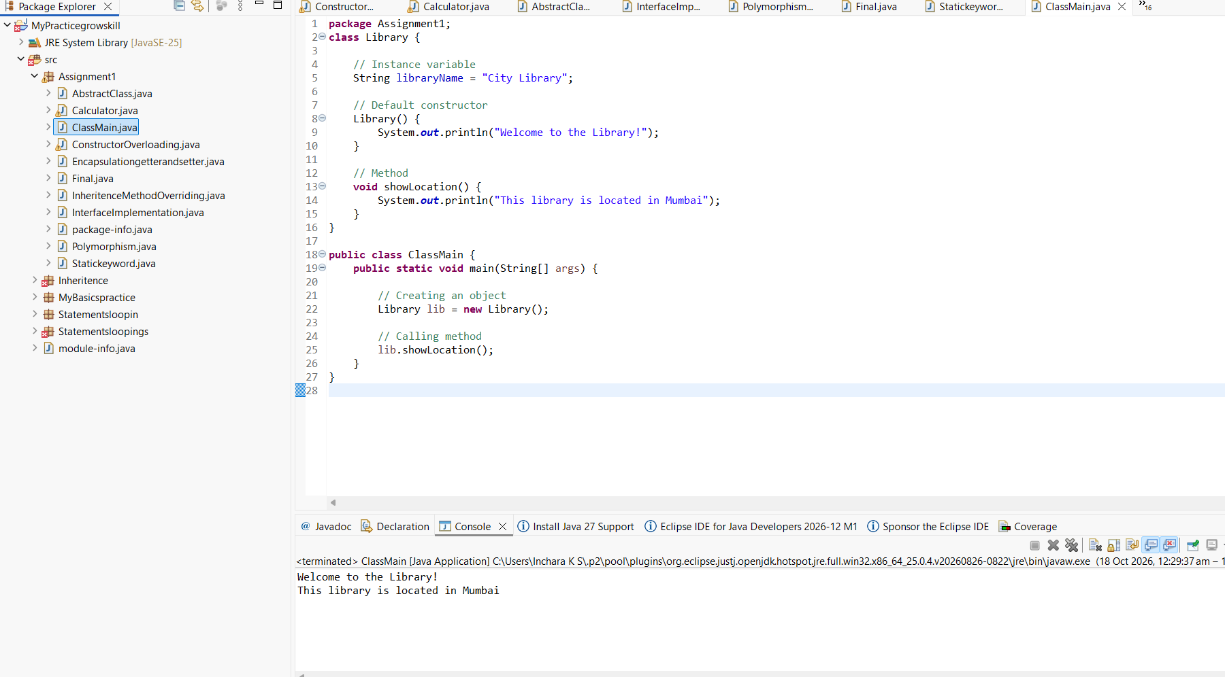

12. Encapsulation + Validation Logic

Create a class Account with private variables accountHolderName and balance.
Provide setters and getters, where:

setBalance() should not accept negative values (print a warning).
Create an object and update values through setters only.

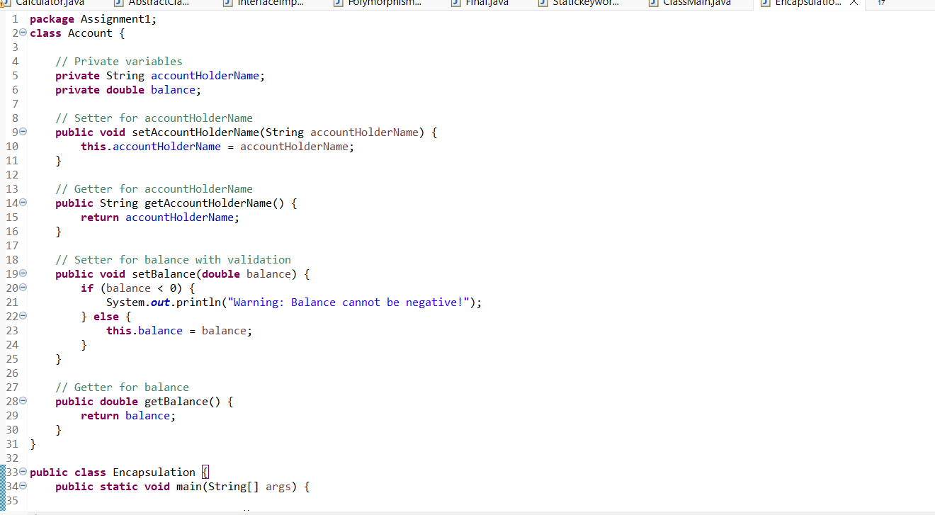
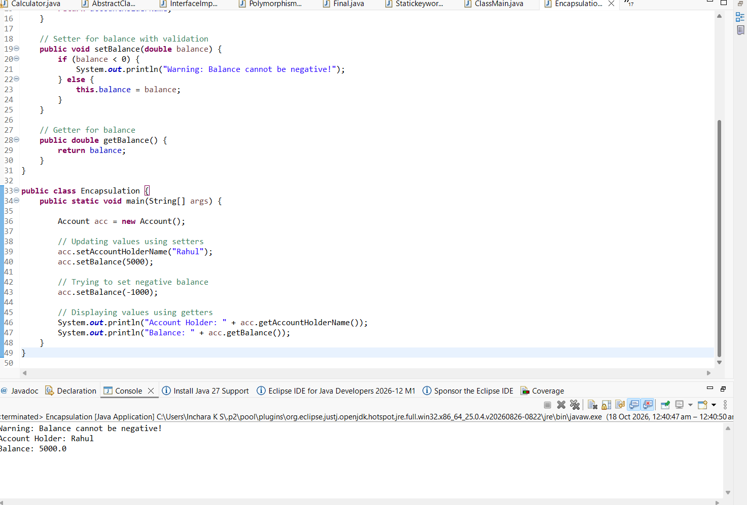

13. Inheritance (Multilevel)

Create three classes:

Device â†’ method start()

Mobile extends Device â†’ method calling()

SmartPhone extends Mobile â†’ method internet()
Create object of SmartPhone and call all methods.

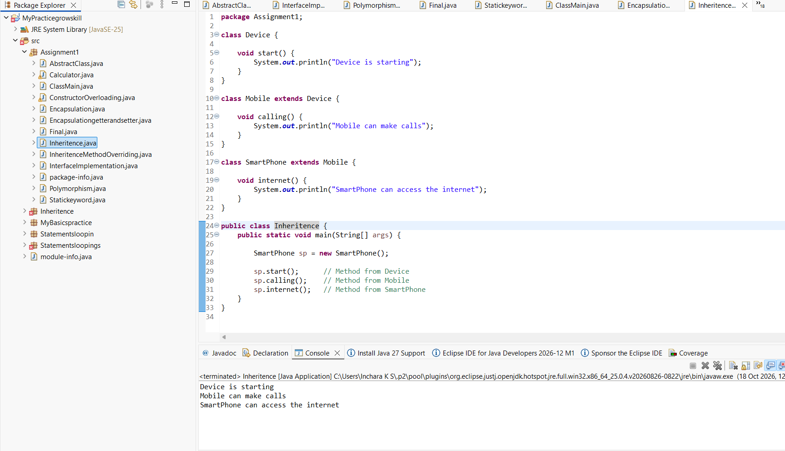

14. Hierarchical Inheritance

Create a class Course with a method courseInfo().
Create subclasses Science, Commerce, and Arts each with their own method.
Create objects of each and call methods to show hierarchy.

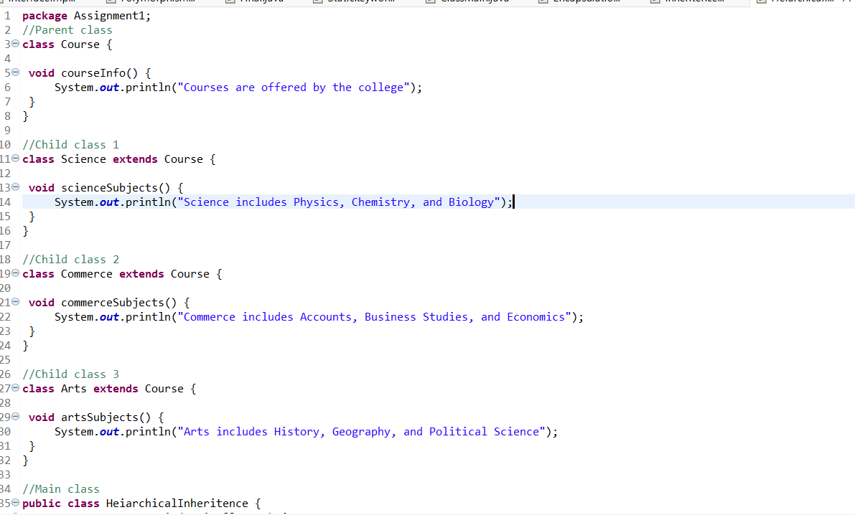
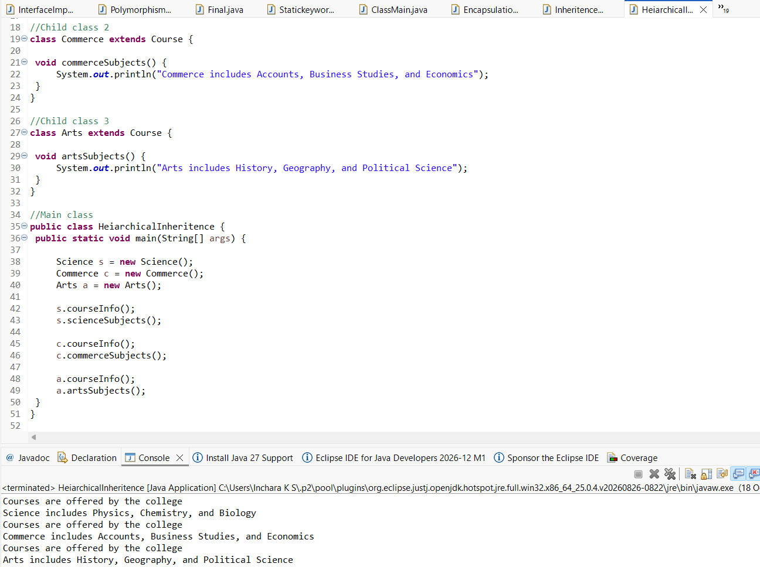

15. Method Overloading (Bank Scenario)

Create a class LoanCalculator with two overloaded methods:

calculateLoan(int amount)

calculateLoan(int amount, double interestRate)
Print loan details accordingly. Call both methods from main.

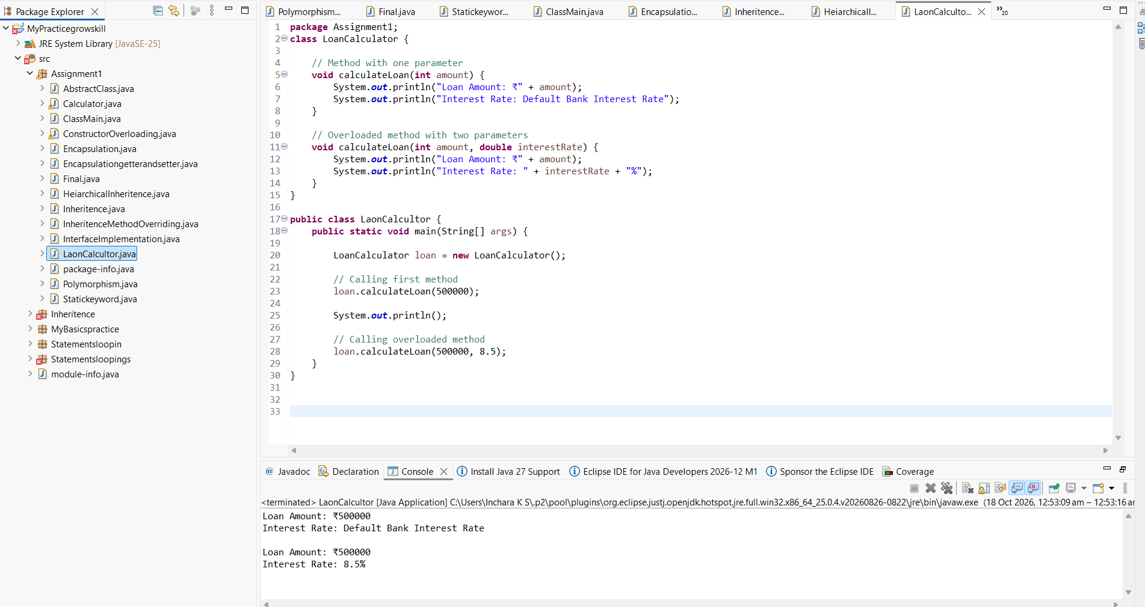

16. Method Overriding with super

Create a base class Hospital with a method emergencyService().
Create a subclass CityHospital that overrides the method and calls parent method using super.emergencyService().
Demonstrate overriding in main.

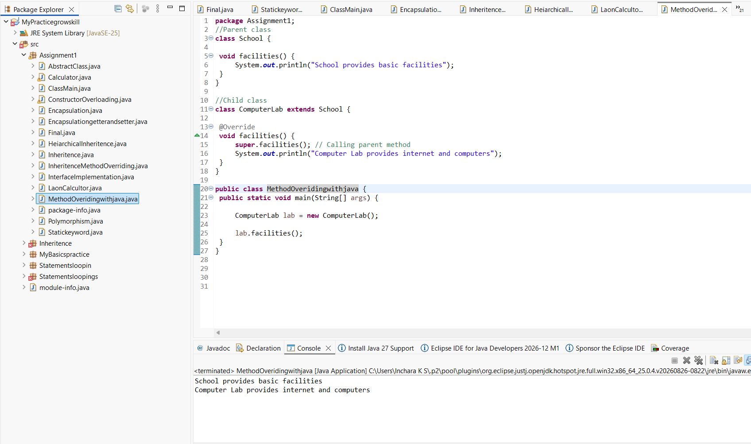
17. Abstract Class + Real Usage

Create an abstract class Employee with:

abstract method: calculateSalary()

concrete method: employeeDetails()
Subclass FullTimeEmployee and PartTimeEmployee implementing salary calculation logic differently.

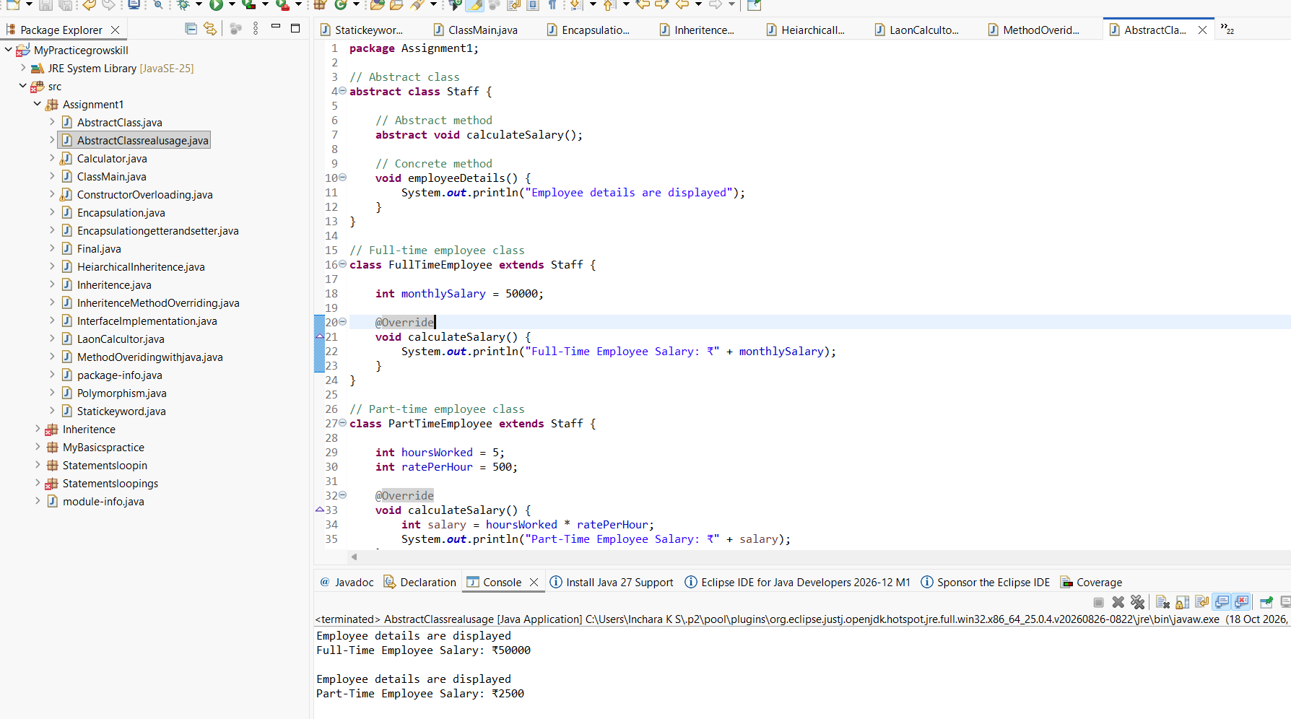


18. Interface with Multiple Implementations

Create an interface Transport with method booking().
Implement it in Bus and Flight classes.
Call using interface reference.

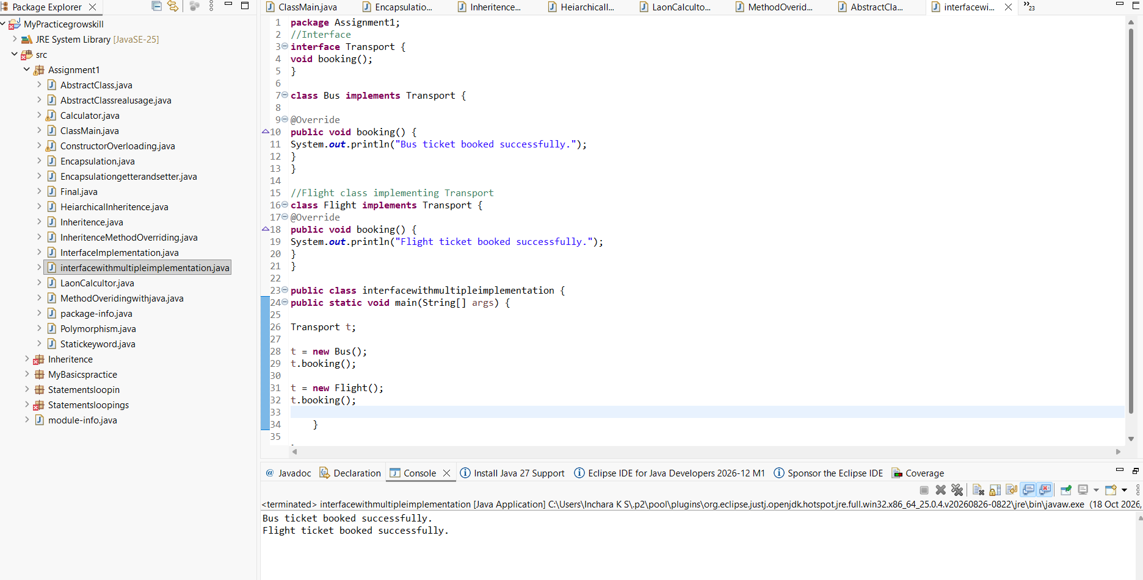

20. Aggregation (Has-A Relationship)

Create a class Engine with a method engineInfo().
Create a class Car that has-a Engine object and uses it to show engine details.
Show aggregation in main method.

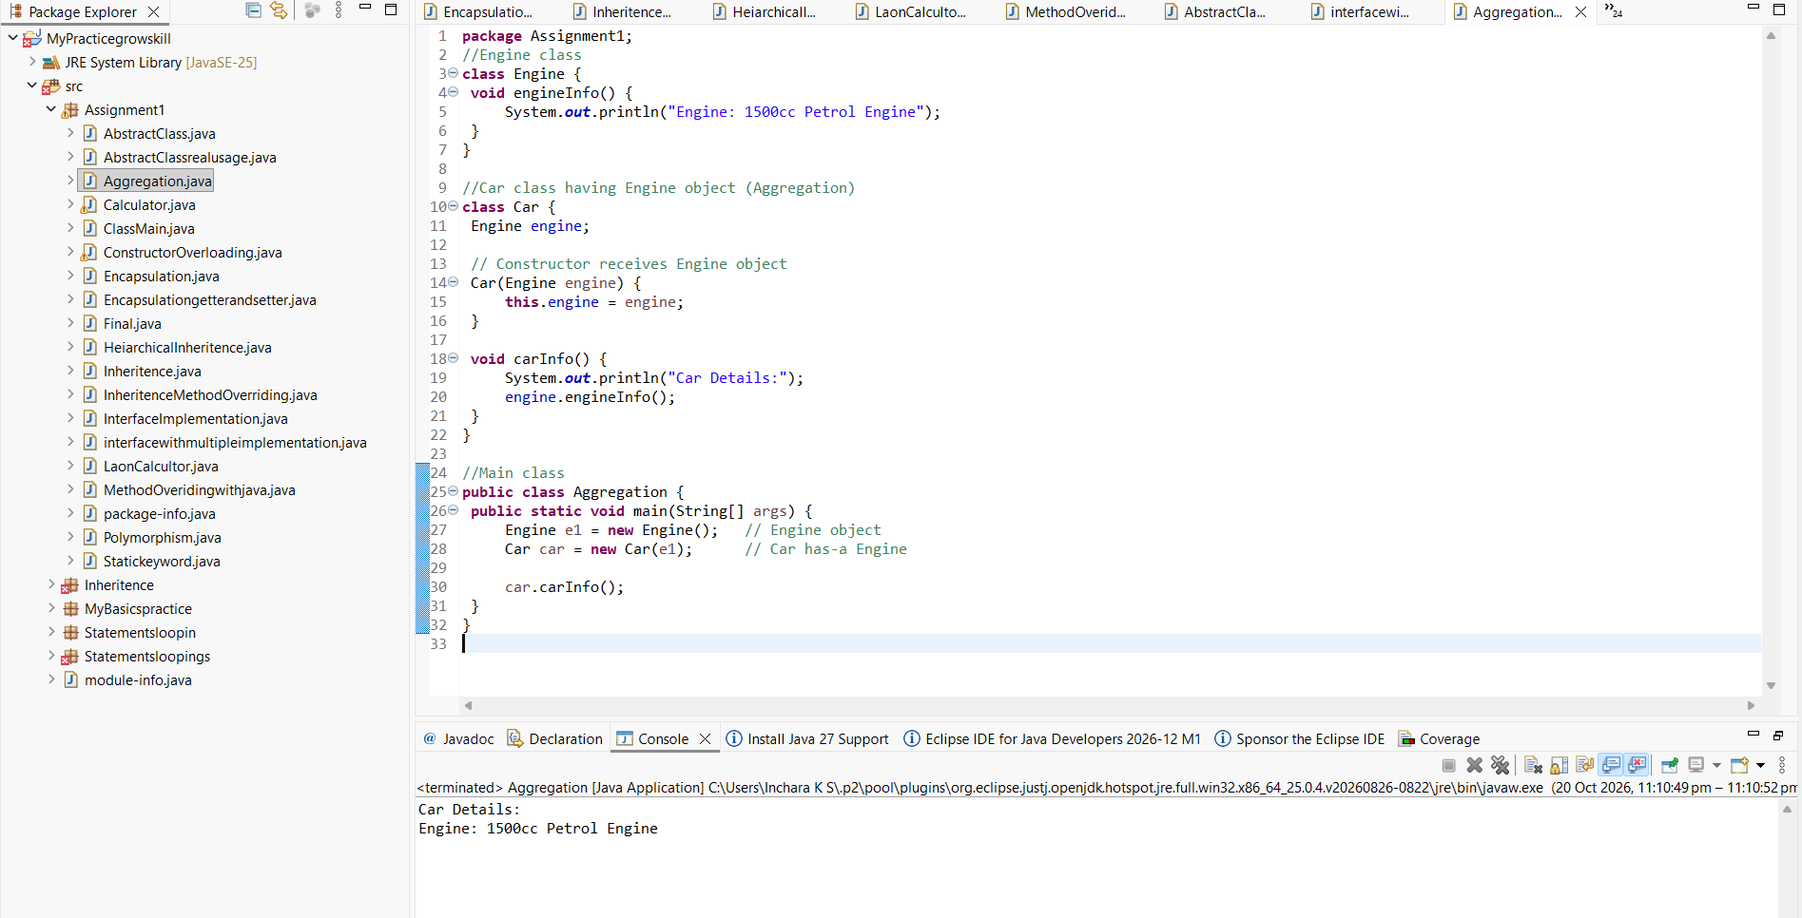

21. 21. Static Concepts

Create a class University with:

static variable country = "India"

instance variable universityName
Print values using different objects to show static effect.

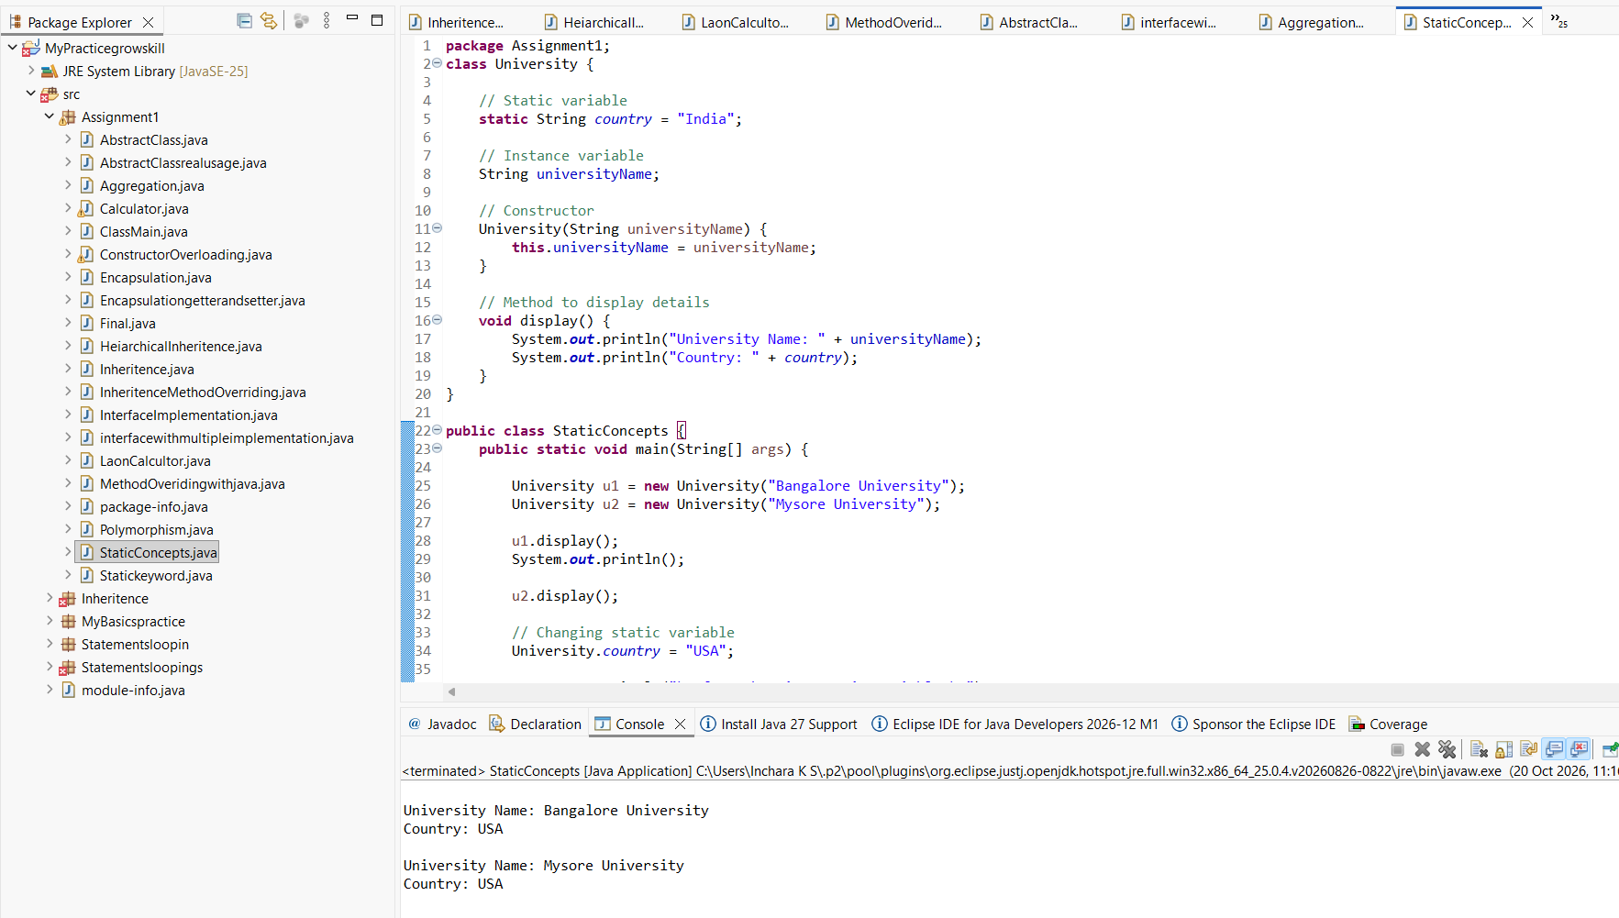

22. Final Keyword + Constant

Create a class GovernmentRules with a final variable MAX_WORKING_HOURS = 8
Try modifying it inside main and observe compile-time restriction.

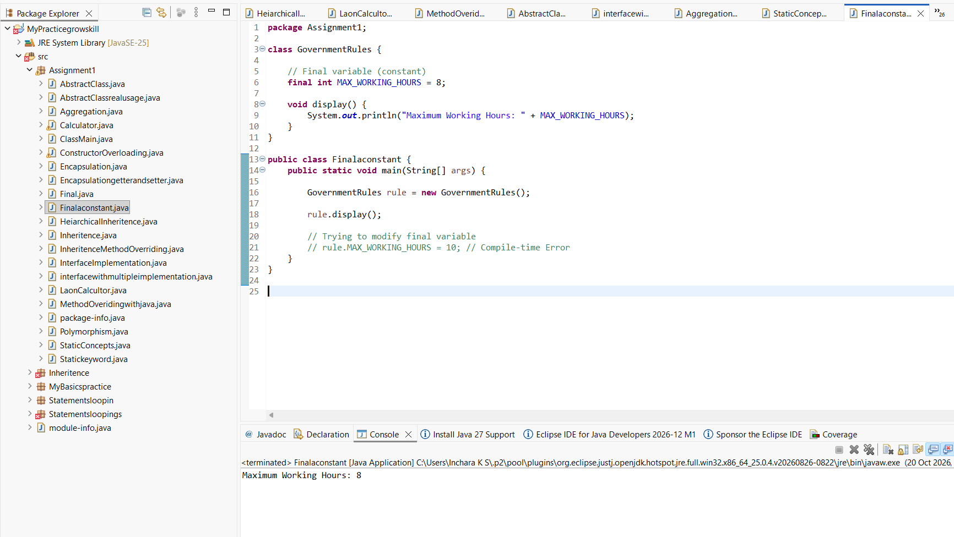

23. Constructor Chaining

Create a class Mall with:

Default constructor printing "Welcome to the Mall"

Parameterized constructor calling default constructor using this()
Demonstrate constructor chaining in main.

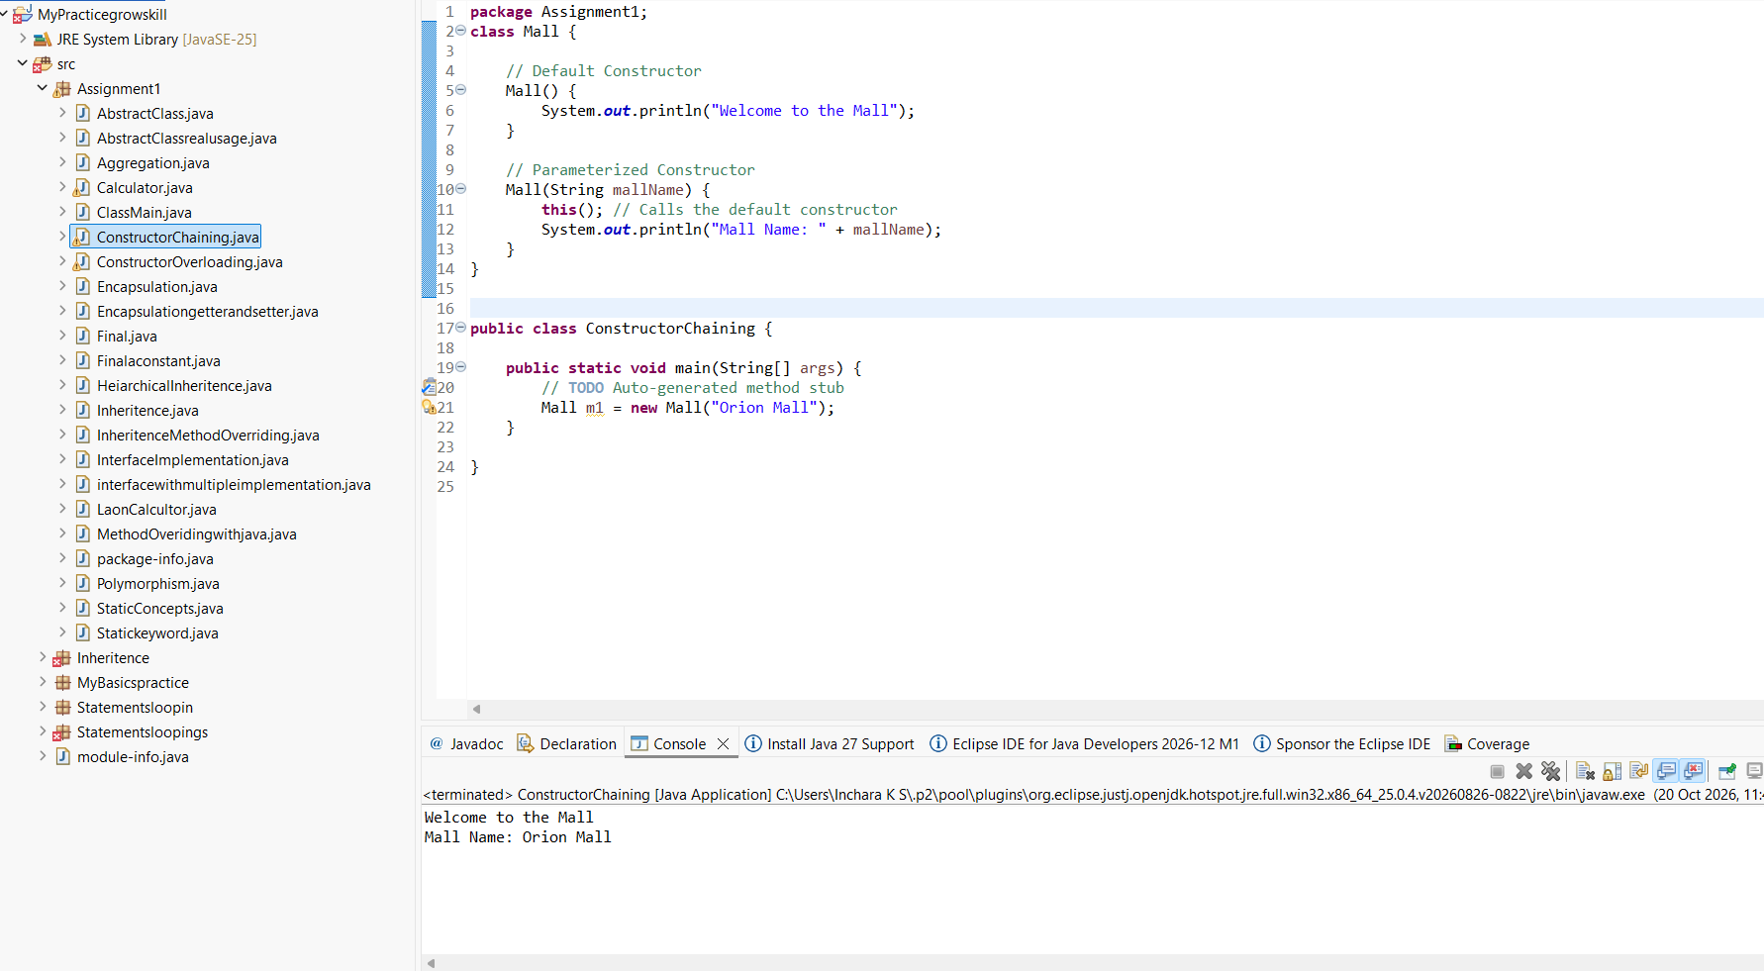

24. 24 > WAP in Java
Create a Class named Shape with length as instance variable , create three methods as square , rectangle , circle
and find out their respective areas
Create a object in main method and call these different methods with the instance of object

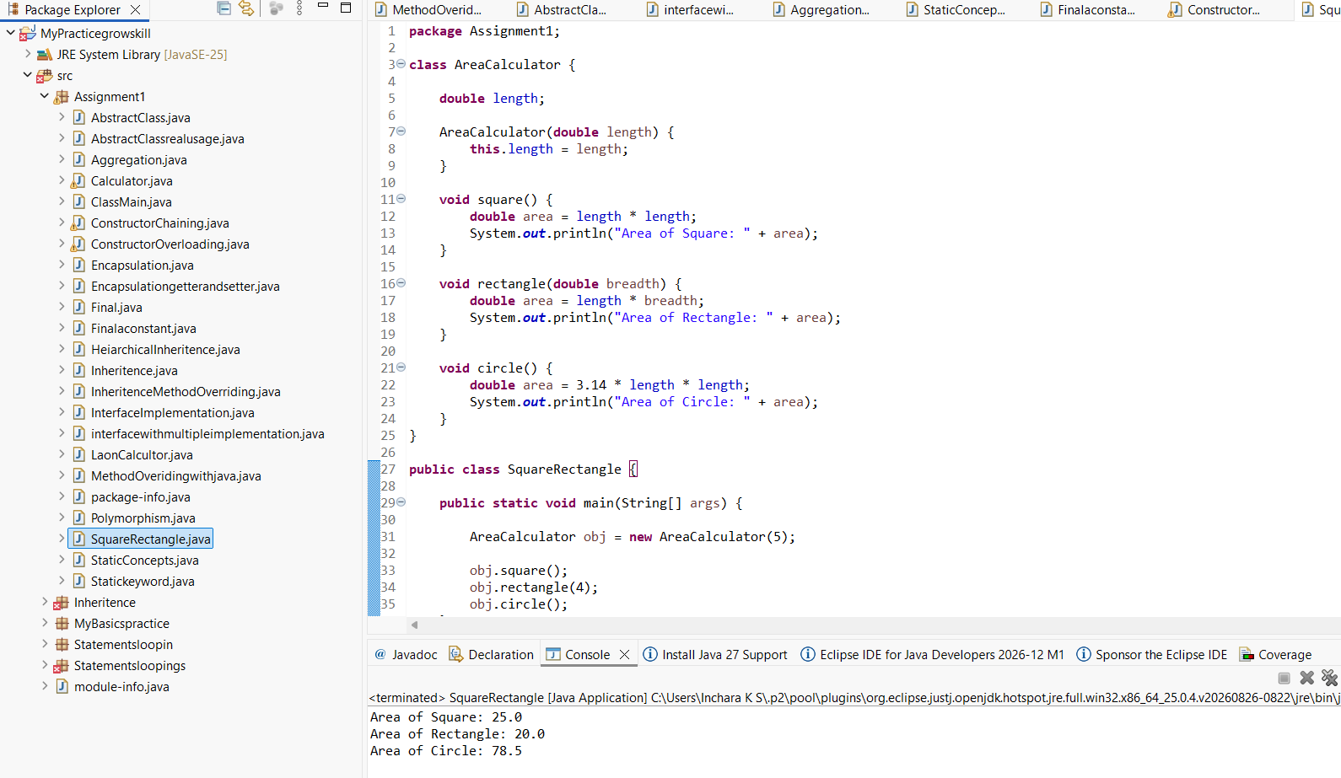

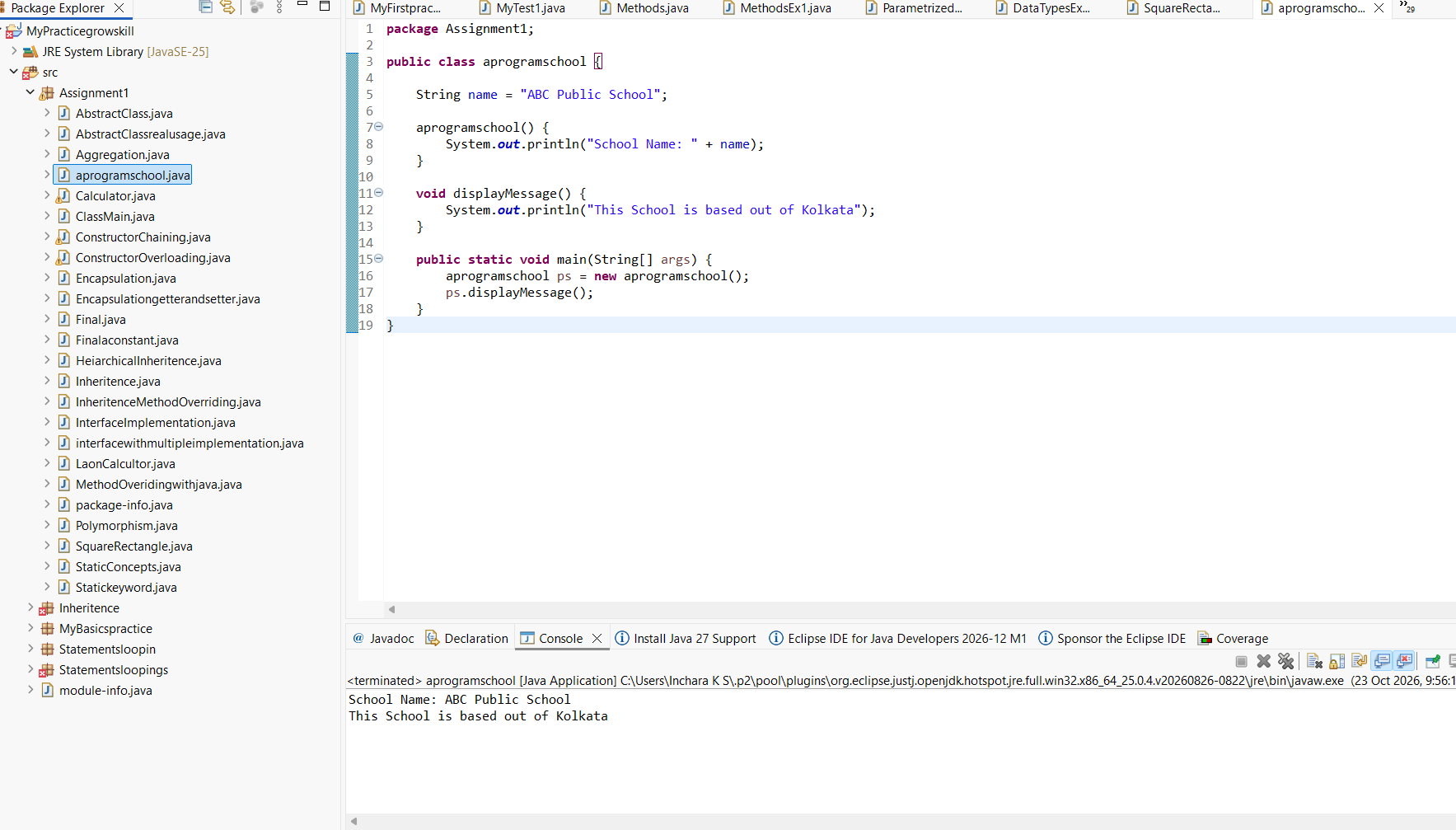

26> WAP in Java to create a class named school
create name, address,strength as their instance variables
Create two constructor one with two variables and one with all the three variables
Create a method that will display all the three parameters
create two object of this class and call the respective methods

