**MongoDB -Aggregation Exercises**

Import the zips.json file into your MongoDB. Database name is "population" and collection name is "zipcodes".

**mongoimport --db population --collection zipcodes --file zip.json**

**Section-1: -Atlanta Population**

1.use db.zipcodes.find() to filter results to only the results where city is ATLANTA and state is GA.

**Output:**

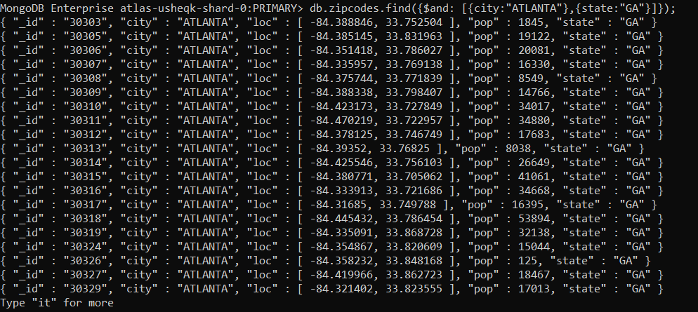

2. use db.zipcodes.aggregate with $match to do the same as above.

**Output:**

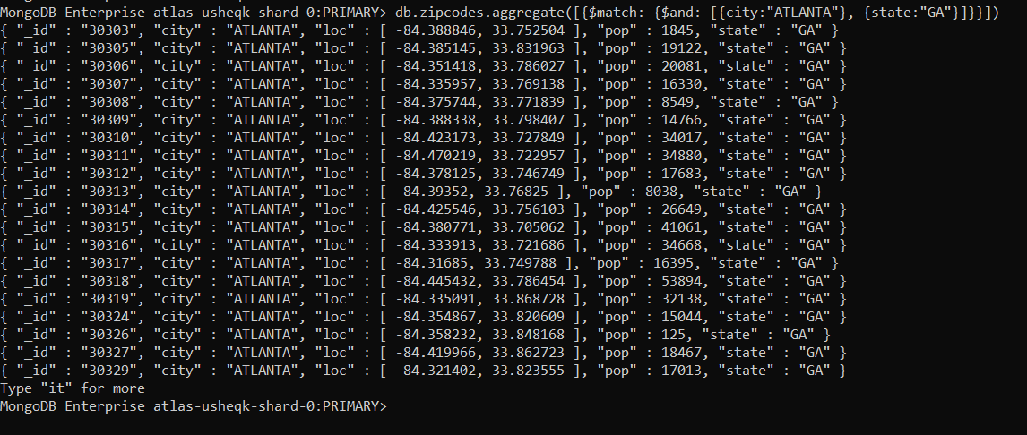

3. use $group to count the number of zip codes in Atlanta.

**Output:**



4. use $group to find the total population in Atlanta.

**Output:**



**Section-2: -Populations by State**

1. use aggregate to calculate the total population for each state.

**Output:**

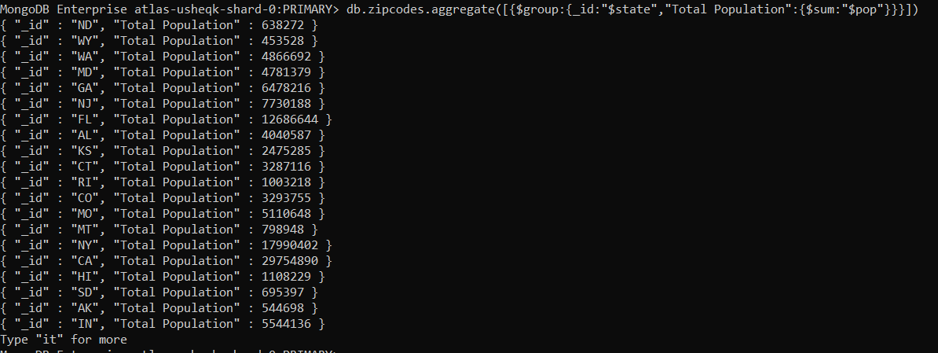

2. sort the results by population, highest first.

**Output:**

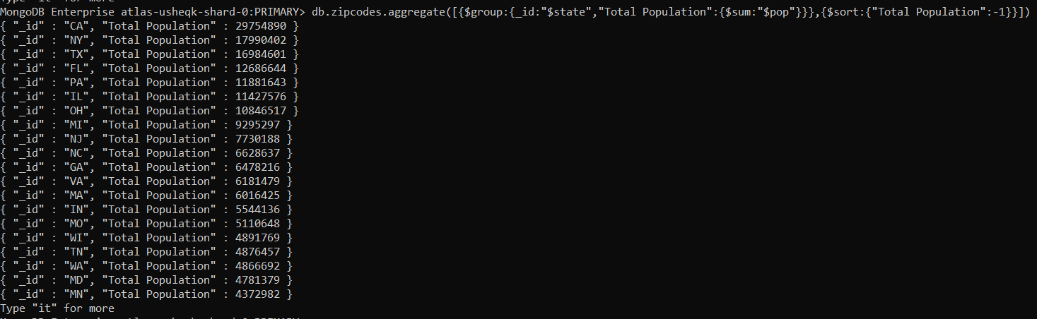

3. limit the results to just the first 3 results. What are the top 3 states in population?

**Command:**

db.zipcodes.aggregate([{$group:{_id:"$state","Total Population":{$sum:"$pop"}}},{$sort:{"Total Population":-1}},{$limit: 3}]);

**Output:**



**Section-3: -Populations by City**

1. use aggregate to calculate the total population for each city (you have to use city/state combination). You can use a combination for the _id of the $group: { city: '$city', state: '$state' }

**Output:**

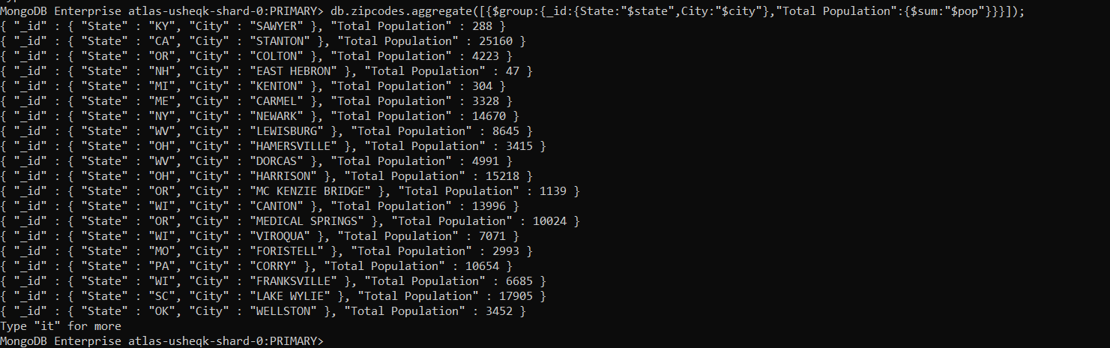

2. sort the results by population, highest first .

**Output:**

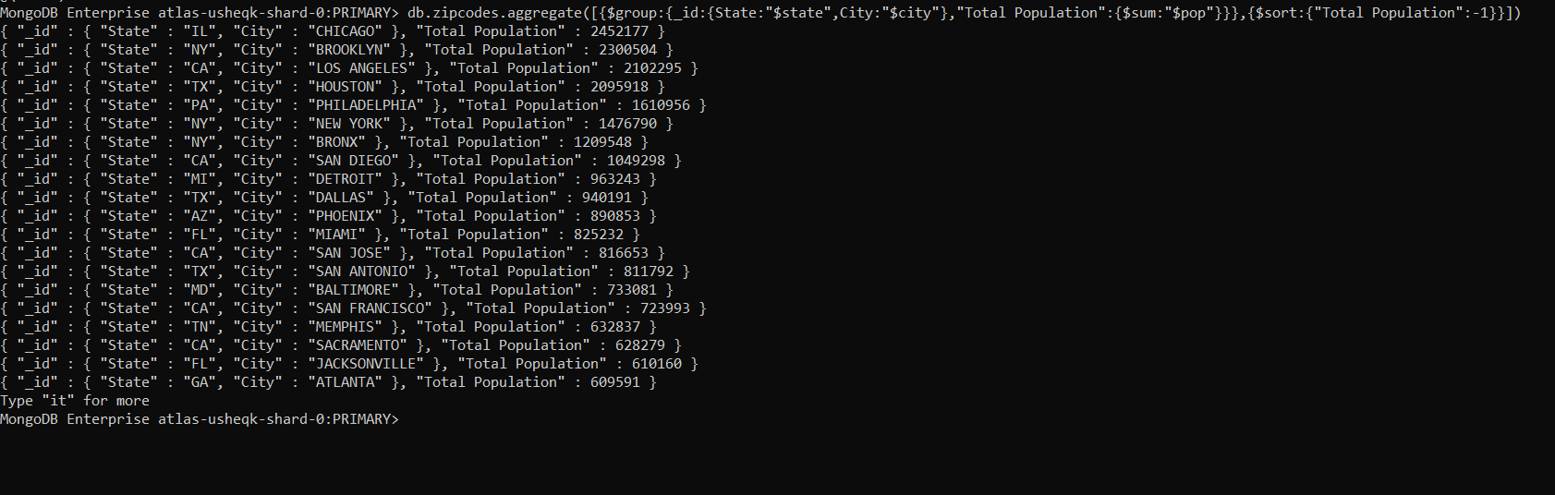

3. limit the results to just the first 3 results. What are the top 3 cities in population?

**Output:**



**Population" : 4268 }**

4. What are the top 3 cities in population in Texas?

**Command:**

db.zipcodes.aggregate([{$match:{state:"TX"}},{$group:{_id:{State:"$state",City:"$city"},"Total Population":{$sum:"$pop"}}},{$sort:{"Total Population":-1}},{$limit:3}]);

**Output:**

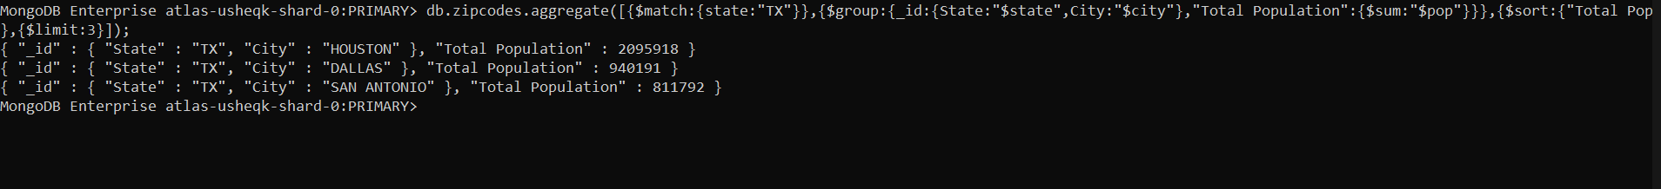

**Section-4: -Bonus**

1. Write a query to get the average city population for each state.

**Command:**

db.zipcodes.aggregate([{$group:{_id:"$state","Average Population":{$avg:"$pop"}}}]);

**Output:**

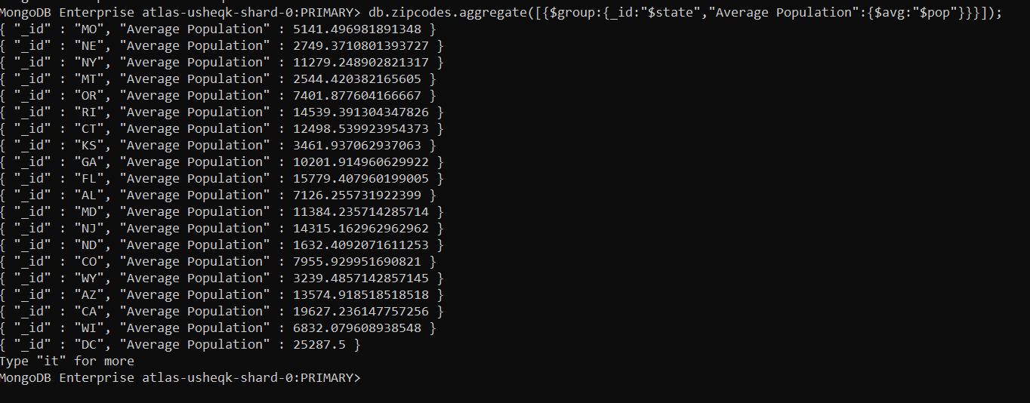

2. What are the top 3 states in terms of average city population?

**Command:**

db.zipcodes.aggregate([{$group:{_id:"$state","Average Population":{$avg:"$pop"}}},{$sort:{"Average Population":-1}},{$limit: 3}]);

**Output:**

