**Transit-Gateway**

Transit gateways are used to communicate among multiple VPCs, Instead of doing VPC Peering.  
VPC peering is point to point to point , it will get complex for each connection.

**1.Create VPC-01—10.0.0.0/16**

Create Subnet-10.0.1.0/24

Create an internet gateway and attach toVPC01   
 Allow the communication to VPC in Route table -using internet gateway  
 Allow all traffic in Security group

Create a VM in this VPC

2. **Create VPC-02—172.16.0.0/16**

Create Subnet-172.16.1.0/24

Create an internet gateway and attach toVPC02  
 Allow the communication to VPC in Route table -using internet gateway  
Allow all traffic in Security group

Create a VM in this VPC

Before creating transit gateway-Tty to ping servers-  
NO COMMUNICATION.  
  
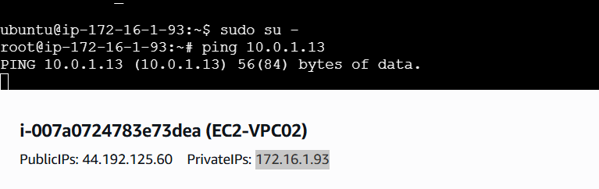

Now Seclet transit gateway -Create

Transitgateway-01

Now Select-Transitgatewayattachements- Select VPC01-attach to transitgateway1

Add the route in Route-table  
 from 172.16.0.0/16 to Transitgaatway-Select-connection

Create one more Transitgatewayattachements- Select VPC02-attach to transitgateway1

Add the route in Route-table  
 from 10.0.0.0/16 to Transitgaatway-Select-connection

Now try to ping  


