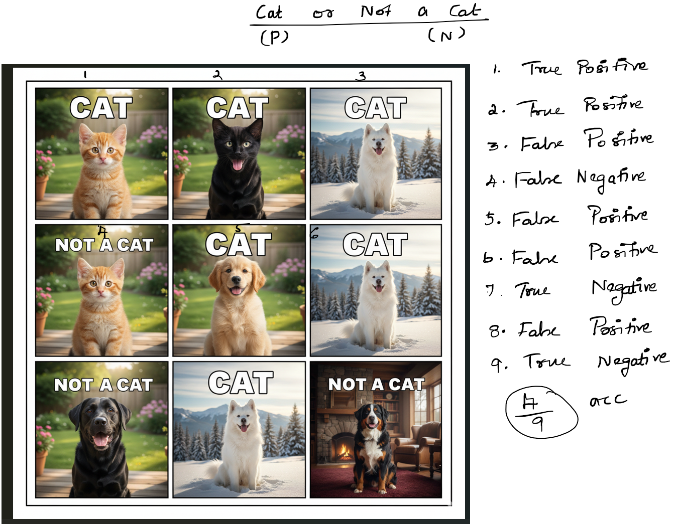

Ink Drawings
Ink Drawings
Ink Drawings
Ink Drawings
Ink Drawings
Ink Drawings
Ink Drawings
Ink Drawings
Ink Drawings
Ink Drawings
Ink Drawings
Ink Drawings
Ink Drawings
Ink Drawings
Ink Drawings
Ink Drawings
Ink Drawings
Ink Drawings
Ink Drawings
Ink Drawings
Ink Drawings
Ink Drawings
Ink Drawings
Ink Drawings
Ink Drawings
Ink Drawings
Ink Drawings
Ink Drawings
Ink Drawings
Ink Drawings
Ink Drawings
Ink Drawings
Ink Drawings
Ink Drawings
Ink Drawings
Ink Drawings
Ink Drawings
Ink Drawings
Ink Drawings
Ink Drawings
Ink Drawings
Ink Drawings
Ink Drawings
Ink Drawings
Ink Drawings
Ink Drawings
Ink Drawings
Ink Drawings
Ink Drawings
Ink Drawings
Ink Drawings
Ink Drawings
Ink Drawings
Ink Drawings
Ink Drawings
Ink Drawings
Ink Drawings
Ink Drawings
Ink Drawings
Ink Drawings
Ink Drawings
Ink Drawings
Ink Drawings
Ink Drawings
Ink Drawings
Ink Drawings
Ink Drawings
Ink Drawings
Ink Drawings
Ink Drawings
Ink Drawings
Ink Drawings
Ink Drawings
Ink Drawings
Ink Drawings
Ink Drawings
Ink Drawings
Ink Drawings
Ink Drawings
Ink Drawings
Ink Drawings
Ink Drawings
Ink Drawings
Ink Drawings
Ink Drawings
Ink Drawings
Ink Drawings
Ink Drawings
Ink Drawings
Ink Drawings
Ink Drawings
Ink Drawings
Ink Drawings
Ink Drawings
Ink Drawings
Ink Drawings
Ink Drawings
Ink Drawings
Ink Drawings
Ink Drawings
Ink Drawings
Ink Drawings
Ink Drawings
Ink Drawings
Ink Drawings
Ink Drawings
Ink Drawings
Ink Drawings
Ink Drawings
Ink Drawings
Ink Drawings
Ink Drawings
Ink Drawings
Ink Drawings
Ink Drawings
Ink Drawings
Ink Drawings
Ink Drawings
Ink Drawings
Ink Drawings
Ink Drawings
Ink Drawings
Ink Drawings
Ink Drawings
Ink Drawings
Ink Drawings
Ink Drawings
Ink Drawings
Ink Drawings
Ink Drawings
Ink Drawings
Ink Drawings
Ink Drawings
Ink Drawings
Ink Drawings
Ink Drawings
Ink Drawings
Ink Drawings
Ink Drawings
Ink Drawings
Ink Drawings
Ink Drawings
Ink Drawings
Ink Drawings
Ink Drawings
Ink Drawings
Ink Drawings
Ink Drawings
Ink Drawings
Ink Drawings
Ink Drawings
Ink Drawings
Ink Drawings
Ink Drawings
Ink Drawings
Ink Drawings
Ink Drawings
Ink Drawings
Ink Drawings
Ink Drawings
Ink Drawings
Ink Drawings
Ink Drawings
Ink Drawings
Ink Drawings
Ink Drawings
Ink Drawings
Ink Drawings
Ink Drawings
Ink Drawings
Ink Drawings
Ink Drawings
Ink Drawings
Ink Drawings
Ink Drawings
Ink Drawings
Ink Drawings
Ink Drawings
Ink Drawings
Ink Drawings
Ink Drawings
Ink Drawings
Ink Drawings
Ink Drawings
Ink Drawings
Ink Drawings
Ink Drawings
Ink Drawings
Ink Drawings
Ink Drawings
Ink Drawings
Ink Drawings
Ink Drawings
Ink Drawings
Ink Drawings
Ink Drawings
Ink Drawings
Ink Drawings
Ink Drawings
Ink Drawings
Ink Drawings
Ink Drawings
Ink Drawings
Ink Drawings
Ink Drawings
Ink Drawings
Ink Drawings
Ink Drawings
Ink Drawings
Ink Drawings
Ink Drawings
Ink Drawings
Ink Drawings
Ink Drawings
Ink Drawings
Ink Drawings
Ink Drawings
Ink Drawings
Ink Drawings
Ink Drawings
Ink Drawings
Ink Drawings
Ink Drawings
Ink Drawings
Ink Drawings
Ink Drawings
Ink Drawings
Ink Drawings
Ink Drawings
Ink Drawings
Ink Drawings
Ink Drawings
Ink Drawings
Ink Drawings
Ink Drawings
Ink Drawings
Ink Drawings
Ink Drawings
Ink Drawings
Ink Drawings
Ink Drawings
Ink Drawings
Ink Drawings
Ink Drawings
Ink Drawings
Ink Drawings
Ink Drawings
Ink Drawings
Ink Drawings
Ink Drawings
Ink Drawings
Ink Drawings
Ink Drawings
Ink Drawings
Ink Drawings
Ink Drawings
Ink Drawings
Ink Drawings
Ink Drawings
Ink Drawings
Ink Drawings
Ink Drawings
Ink Drawings
Ink Drawings
Ink Drawings
Ink Drawings
Ink Drawings
Ink Drawings
Ink Drawings
Ink Drawings
Ink Drawings
Ink Drawings
Ink Drawings
Ink Drawings
Ink Drawings
Ink Drawings
Ink Drawings
Ink Drawings
Ink Drawings
Ink Drawings
Ink Drawings
Ink Drawings
Ink Drawings
Ink Drawings
Ink Drawings
Ink Drawings
Ink Drawings
Ink Drawings
Ink Drawings
Ink Drawings
Ink Drawings
Ink Drawings
Ink Drawings
Ink Drawings
Ink Drawings
Ink Drawings
Ink Drawings
Ink Drawings
Ink Drawings
Ink Drawings
Ink Drawings
Ink Drawings
Ink Drawings
Ink Drawings
Ink Drawings
Ink Drawings
Ink Drawings
Ink Drawings
Ink Drawings
Ink Drawings
Ink Drawings
Ink Drawings
Ink Drawings
Ink Drawings
Ink Drawings
Ink Drawings
Ink Drawings
Ink Drawings
Ink Drawings
Ink Drawings
Ink Drawings
Ink Drawings
Ink Drawings
Ink Drawings
Ink Drawings
Ink Drawings
Ink Drawings
Ink Drawings
Ink Drawings
Ink Drawings
Ink Drawings
Ink Drawings
Ink Drawings
Ink Drawings
Ink Drawings
Ink Drawings
Ink Drawings
Ink Drawings
Ink Drawings
Ink Drawings
Ink Drawings
Ink Drawings
Ink Drawings
Ink Drawings
Ink Drawings
Ink Drawings
Ink Drawings
Ink Drawings
Ink Drawings
Ink Drawings
Ink Drawings
Ink Drawings
Ink Drawings
Ink Drawings


Ink Drawings
Ink Drawings
Ink Drawings
Ink Drawings
Ink Drawings
Ink Drawings
Ink Drawings
Ink Drawings
Ink Drawings
Ink Drawings
Ink Drawings
Ink Drawings
Ink Drawings
Ink Drawings
Ink Drawings
Ink Drawings
Ink Drawings
Ink Drawings
Ink Drawings
Ink Drawings
Ink Drawings
Ink Drawings
Ink Drawings
Ink Drawings
Ink Drawings
Ink Drawings
Ink Drawings
Ink Drawings
Ink Drawings
Ink Drawings
Ink Drawings
Ink Drawings
Ink Drawings
Ink Drawings
Ink Drawings
Ink Drawings
Ink Drawings
Ink Drawings
Ink Drawings
Ink Drawings
Ink Drawings
Ink Drawings
Ink Drawings
Ink Drawings
Ink Drawings
Ink Drawings
Ink Drawings
Ink Drawings
Ink Drawings
Ink Drawings
Ink Drawings
Ink Drawings
Ink Drawings
Ink Drawings
Ink Drawings
Ink Drawings
Ink Drawings
Ink Drawings
Ink Drawings
Ink Drawings
Ink Drawings
Ink Drawings
Ink Drawings
Ink Drawings
Ink Drawings
Ink Drawings
Ink Drawings
Ink Drawings
Ink Drawings
Ink Drawings
Ink Drawings
Ink Drawings
Ink Drawings
Ink Drawings
Ink Drawings
Ink Drawings
Ink Drawings
Ink Drawings
Ink Drawings
Ink Drawings
Ink Drawings
Ink Drawings
Ink Drawings
Ink Drawings
Ink Drawings
Ink Drawings
Ink Drawings
Ink Drawings
Ink Drawings
Ink Drawings
Ink Drawings
Ink Drawings
Ink Drawings
Ink Drawings
Ink Drawings
Ink Drawings
Ink Drawings
Ink Drawings
Ink Drawings
Ink Drawings
Ink Drawings
Ink Drawings
Ink Drawings
Ink Drawings
Ink Drawings
Ink Drawings
Ink Drawings
Ink Drawings
Ink Drawings
Ink Drawings
Ink Drawings
Ink Drawings
Ink Drawings
Ink Drawings
Ink Drawings
Ink Drawings
Ink Drawings
Ink Drawings
Ink Drawings
Ink Drawings
Ink Drawings
Ink Drawings
Ink Drawings
Ink Drawings
Ink Drawings
Ink Drawings
Ink Drawings
Ink Drawings
Ink Drawings
Ink Drawings
Ink Drawings
Ink Drawings
Ink Drawings
Ink Drawings
Ink Drawings
Ink Drawings
Ink Drawings
Ink Drawings
Ink Drawings
Ink Drawings
Ink Drawings
Ink Drawings
Ink Drawings
Ink Drawings
Ink Drawings
Ink Drawings
Ink Drawings
Ink Drawings
Ink Drawings
Ink Drawings
Ink Drawings
Ink Drawings
Ink Drawings
Ink Drawings
Ink Drawings
Ink Drawings
Ink Drawings
Ink Drawings
Ink Drawings
Ink Drawings
Ink Drawings
Ink Drawings
Ink Drawings
Ink Drawings
Ink Drawings
Ink Drawings
Ink Drawings
Ink Drawings
Ink Drawings
Ink Drawings
Ink Drawings
Ink Drawings
Ink Drawings
Ink Drawings
Ink Drawings
Ink Drawings
Ink Drawings
Ink Drawings
Ink Drawings
Ink Drawings
Ink Drawings
Ink Drawings
Ink Drawings
Ink Drawings
Ink Drawings
Ink Drawings
Ink Drawings
Ink Drawings
Ink Drawings
Ink Drawings
Ink Drawings
Ink Drawings
Ink Drawings
Ink Drawings
Ink Drawings
Ink Drawings
Ink Drawings
Ink Drawings
Ink Drawings
Ink Drawings
Ink Drawings
Ink Drawings
Ink Drawings
Ink Drawings
Ink Drawings
Ink Drawings
Ink Drawings
Ink Drawings
Ink Drawings
Ink Drawings
Ink Drawings
Ink Drawings
Ink Drawings
Ink Drawings
Ink Drawings
Ink Drawings
Ink Drawings
Ink Drawings
Ink Drawings
Ink Drawings
Ink Drawings
Ink Drawings
Ink Drawings
Ink Drawings
Ink Drawings
Ink Drawings
Ink Drawings
Ink Drawings
Ink Drawings
Ink Drawings
Ink Drawings
Ink Drawings
Ink Drawings
Ink Drawings
Ink Drawings
Ink Drawings
Ink Drawings
Ink Drawings
Ink Drawings
Ink Drawings
Ink Drawings
Ink Drawings
Ink Drawings
Ink Drawings
Ink Drawings
Ink Drawings
Ink Drawings
Ink Drawings
Ink Drawings
Ink Drawings
Ink Drawings
Ink Drawings
Ink Drawings
Ink Drawings
Ink Drawings
Ink Drawings
Ink Drawings
Ink Drawings
Ink Drawings
Ink Drawings
Ink Drawings
Ink Drawings
Ink Drawings
Ink Drawings
Ink Drawings
Ink Drawings
Ink Drawings
Ink Drawings
Ink Drawings
Ink Drawings
Ink Drawings
Ink Drawings
Ink Drawings
Ink Drawings
Ink Drawings
Ink Drawings
Ink Drawings
Ink Drawings
Ink Drawings
Ink Drawings
Ink Drawings
Ink Drawings
Ink Drawings
Ink Drawings
Ink Drawings
Ink Drawings
Ink Drawings


Ink Drawings
Ink Drawings
Ink Drawings
Ink Drawings
Ink Drawings
Ink Drawings
Ink Drawings
Ink Drawings
Ink Drawings
Ink Drawings
Ink Drawings
Ink Drawings
Ink Drawings
Ink Drawings
Ink Drawings
Ink Drawings
Ink Drawings
Ink Drawings
Ink Drawings
Ink Drawings
Ink Drawings
Ink Drawings
Ink Drawings
Ink Drawings
Ink Drawings
Ink Drawings
Ink Drawings
Ink Drawings
Ink Drawings
Ink Drawings
Ink Drawings
Ink Drawings
Ink Drawings
Ink Drawings
Ink Drawings
Ink Drawings
Ink Drawings
Ink Drawings
Ink Drawings
Ink Drawings
Ink Drawings
Ink Drawings
Ink Drawings
Ink Drawings
Ink Drawings
Ink Drawings
Ink Drawings
Ink Drawings
Ink Drawings
Ink Drawings
Ink Drawings
Ink Drawings
Ink Drawings
Ink Drawings
Ink Drawings
Ink Drawings
Ink Drawings
Ink Drawings
Ink Drawings
Ink Drawings
Ink Drawings
Ink Drawings
Ink Drawings
Ink Drawings
Ink Drawings
Ink Drawings
Ink Drawings
Ink Drawings
Ink Drawings
Ink Drawings
Ink Drawings
Ink Drawings
Ink Drawings
Ink Drawings
Ink Drawings
Ink Drawings
Ink Drawings
Ink Drawings
Ink Drawings
Ink Drawings
Ink Drawings
Ink Drawings
Ink Drawings
Ink Drawings
Ink Drawings
Ink Drawings
Ink Drawings
Ink Drawings
Ink Drawings
Ink Drawings
Ink Drawings
Ink Drawings
Ink Drawings
Ink Drawings
Ink Drawings
Ink Drawings
Ink Drawings
Ink Drawings
Ink Drawings
Ink Drawings
Ink Drawings
Ink Drawings
Ink Drawings
Ink Drawings
Ink Drawings
Ink Drawings
Ink Drawings
Ink Drawings
Ink Drawings
Ink Drawings
Ink Drawings
Ink Drawings
Ink Drawings
Ink Drawings
Ink Drawings
Ink Drawings
Ink Drawings
Ink Drawings
Ink Drawings
Ink Drawings
Ink Drawings
Ink Drawings
Ink Drawings
Ink Drawings
Ink Drawings
Ink Drawings
Ink Drawings
Ink Drawings
Ink Drawings
Ink Drawings
Ink Drawings
Ink Drawings
Ink Drawings
Ink Drawings
Ink Drawings
Ink Drawings
Ink Drawings
Ink Drawings
Ink Drawings
Ink Drawings
Ink Drawings
Ink Drawings
Ink Drawings
Ink Drawings
Ink Drawings
Ink Drawings
Ink Drawings
Ink Drawings
Ink Drawings
Ink Drawings
Ink Drawings
Ink Drawings
Ink Drawings
Ink Drawings
Ink Drawings
Ink Drawings
Ink Drawings
Ink Drawings
Ink Drawings
Ink Drawings
Ink Drawings
Ink Drawings
Ink Drawings
Ink Drawings
Ink Drawings
Ink Drawings
Ink Drawings
Ink Drawings
Ink Drawings
Ink Drawings
Ink Drawings
Ink Drawings
Ink Drawings
Ink Drawings
Ink Drawings
Ink Drawings
Ink Drawings
Ink Drawings
Ink Drawings
Ink Drawings
Ink Drawings
Ink Drawings
Ink Drawings
Ink Drawings
Ink Drawings
Ink Drawings
Ink Drawings
Ink Drawings
Ink Drawings
Ink Drawings
Ink Drawings
Ink Drawings
Ink Drawings
Ink Drawings
Ink Drawings
Ink Drawings
Ink Drawings
Ink Drawings
Ink Drawings
Ink Drawings
Ink Drawings
Ink Drawings
Ink Drawings
Ink Drawings
Ink Drawings
Ink Drawings
Ink Drawings
Ink Drawings
Ink Drawings
Ink Drawings
Ink Drawings
Ink Drawings
Ink Drawings
Ink Drawings
Ink Drawings


Ink Drawings
Ink Drawings
Ink Drawings
Ink Drawings
Ink Drawings
Ink Drawings
Ink Drawings
Ink Drawings
Ink Drawings
Ink Drawings
Ink Drawings
Ink Drawings
Ink Drawings
Ink Drawings
Ink Drawings
Ink Drawings
Ink Drawings
Ink Drawings
Ink Drawings
Ink Drawings
Ink Drawings
Ink Drawings
Ink Drawings
Ink Drawings
Ink Drawings
Ink Drawings
Ink Drawings
Ink Drawings
Ink Drawings
Ink Drawings
Ink Drawings
Ink Drawings
Ink Drawings
Ink Drawings
Ink Drawings
Ink Drawings
Ink Drawings
Ink Drawings
Ink Drawings
Ink Drawings
Ink Drawings
Ink Drawings
Ink Drawings
Ink Drawings
Ink Drawings
Ink Drawings
Ink Drawings
Ink Drawings
Ink Drawings
Ink Drawings
Ink Drawings
Ink Drawings
Ink Drawings
Ink Drawings
Ink Drawings
Ink Drawings
Ink Drawings
Ink Drawings
Ink Drawings
Ink Drawings
Ink Drawings
Ink Drawings
Ink Drawings
Ink Drawings
Ink Drawings
Ink Drawings
Ink Drawings
Ink Drawings
Ink Drawings
Ink Drawings
Ink Drawings
Ink Drawings
Ink Drawings
Ink Drawings
Ink Drawings
Ink Drawings
Ink Drawings
Ink Drawings
Ink Drawings
Ink Drawings
Ink Drawings
Ink Drawings
Ink Drawings
Ink Drawings
Ink Drawings
Ink Drawings
Ink Drawings
Ink Drawings
Ink Drawings
Ink Drawings
Ink Drawings
Ink Drawings
Ink Drawings
Ink Drawings
Ink Drawings
Ink Drawings
Ink Drawings
Ink Drawings
Ink Drawings
Ink Drawings
Ink Drawings
Ink Drawings
Ink Drawings
Ink Drawings
Ink Drawings
Ink Drawings
Ink Drawings
Ink Drawings
Ink Drawings
Ink Drawings
Ink Drawings
Ink Drawings
Ink Drawings
Ink Drawings
Ink Drawings
Ink Drawings
Ink Drawings
Ink Drawings
Ink Drawings
Ink Drawings
Ink Drawings
Ink Drawings
Ink Drawings
Ink Drawings
Ink Drawings
Ink Drawings
Ink Drawings
Ink Drawings
Ink Drawings
Ink Drawings
Ink Drawings
Ink Drawings
Ink Drawings
Ink Drawings
Ink Drawings
Ink Drawings
Ink Drawings
Ink Drawings
Ink Drawings
Ink Drawings
Ink Drawings
Ink Drawings
Ink Drawings
Ink Drawings
Ink Drawings
Ink Drawings
Ink Drawings
Ink Drawings
Ink Drawings
Ink Drawings
Ink Drawings
Ink Drawings
Ink Drawings
Ink Drawings
Ink Drawings
Ink Drawings
Ink Drawings
Ink Drawings
Ink Drawings
Ink Drawings
Ink Drawings
Ink Drawings
Ink Drawings
Ink Drawings
Ink Drawings
Ink Drawings
Ink Drawings
Ink Drawings
Ink Drawings
Ink Drawings
Ink Drawings
Ink Drawings
Ink Drawings
Ink Drawings
Ink Drawings
Ink Drawings
Ink Drawings
Ink Drawings
Ink Drawings
Ink Drawings
Ink Drawings
Ink Drawings
Ink Drawings
Ink Drawings
Ink Drawings
Ink Drawings
Ink Drawings
Ink Drawings
Ink Drawings
Ink Drawings
Ink Drawings
Ink Drawings
Ink Drawings
Ink Drawings
Ink Drawings
Ink Drawings
Ink Drawings
Ink Drawings
Ink Drawings
Ink Drawings
Ink Drawings
Ink Drawings
Ink Drawings
Ink Drawings
Ink Drawings
Ink Drawings
Ink Drawings
Ink Drawings
Ink Drawings
Ink Drawings
Ink Drawings
Ink Drawings
Ink Drawings
Ink Drawings
Ink Drawings
Ink Drawings
Ink Drawings
Ink Drawings
