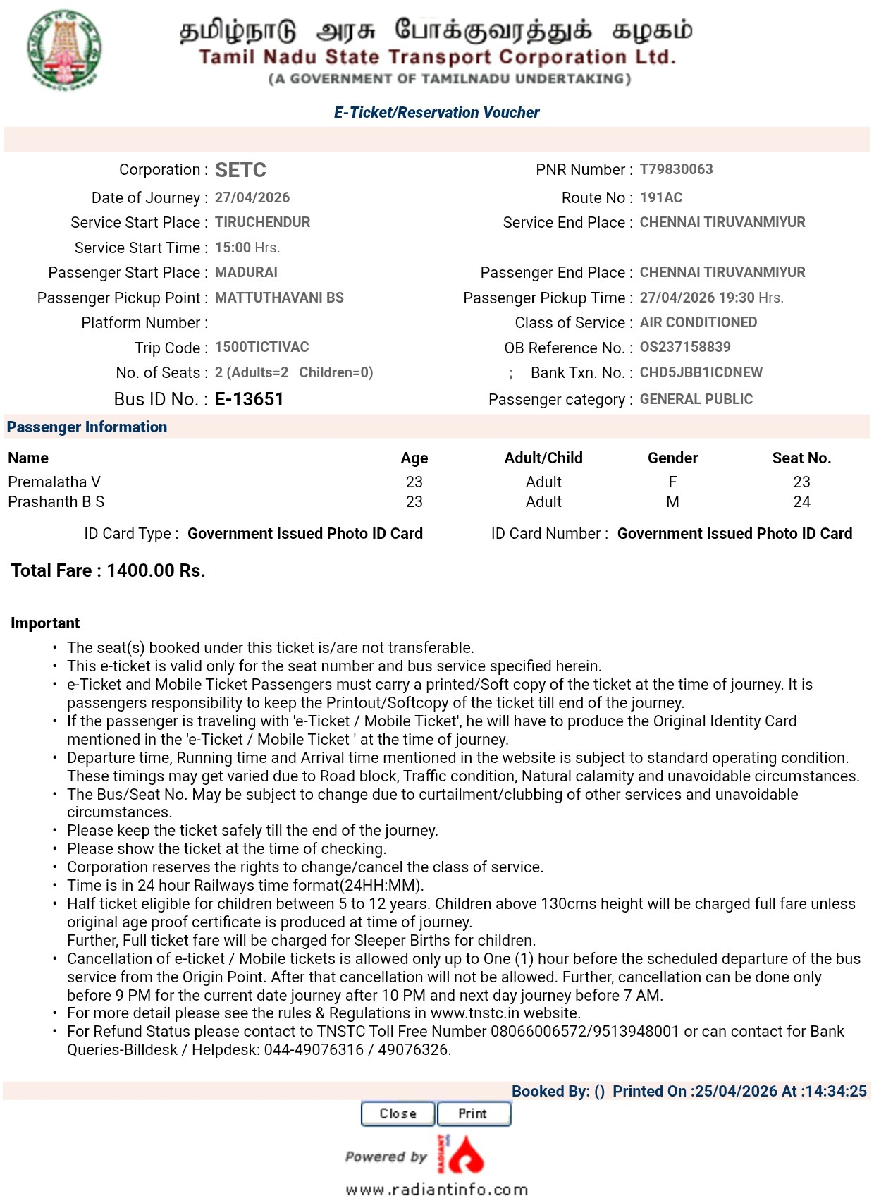



Amirtha Varshini J 23 Adult F 25

Premalatha V 23 Adult F 25
Prasanth B S 23 Adult F 25


Total Fare: 2100.00 Rs.


