**Prerequisites:**

1. **fastqc (quality check):**

Installation:

sudo apt update

sudo apt -y install fastqc

fastqc –help (verify installation)

1. **BWA(Alignment)**

Installation:

git clone <https://github.com/lh3/bwa.git>

cd bwa

make

./bwa

1. **Samtools (Manipulation)**

Installation:

sudo apt-get update

sudo apt-get upgrade

sudo apt-get install -y libncurses-dev libbz2-dev liblzma-dev

wget https://github.com/samtools/samtools/releases/download/1.20/samtools-1.20.tar.bz2

tar xvjf samtools-1.20.tar.bz2

cd samtools-1.20/

./configure

Make

sudo make install

pwd

export PATH="$PATH:/home/premananda/samtools-1.20"

sudo gedit ~/.bashrc

bash

**#samblaster:**

Installion :conda install bioconda::samblaster

**#bcftools (Variant Calling)**

Installation: conda install bioconda::bcftools

**Basic pipeline of NGS analysis:**

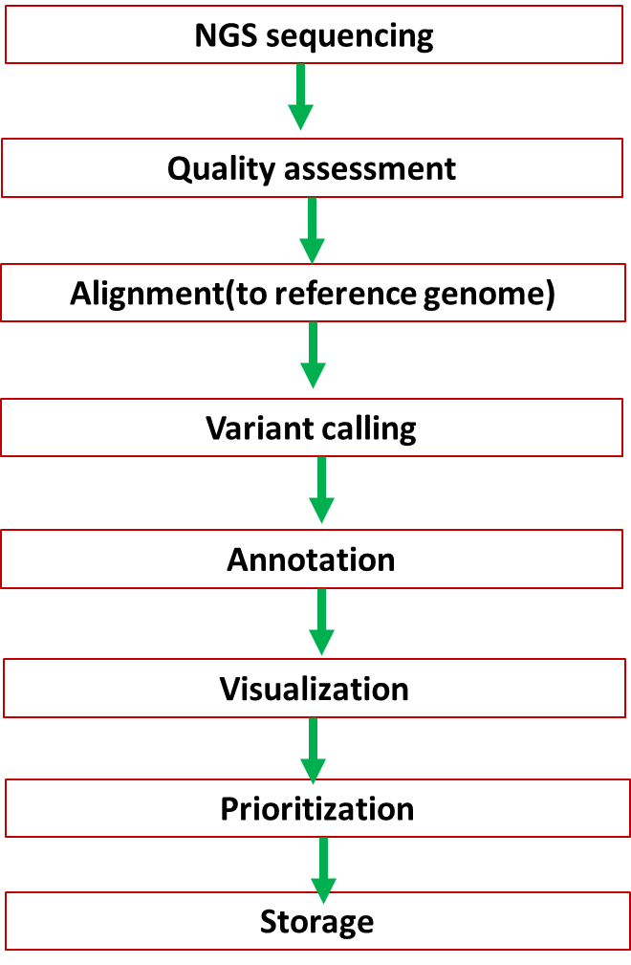

**#Quality check using fastqc:**

>fastqc raw_dataset.fastq

**#Download the reference dataset (fasta format) from NCBI:**

**#Align the fastqc files to the reference genome using BWA**

>bwa index reference.fa

>bwa mem -M -R reference.fa raw_pairend1.fastq raw_pairend2.fastq > aligned_read.sam

**#Manipulation of the aligned genome using samtools:**

>samblaster -m -I normal_aligned.sam normal_alignediread_marked.sam

>samtools view -S -b alignediread_marked.sam > alignedread_marked.bam

>samtools sort alignedread_marked.bam -o aligned_marked_sorted.bam

**# Check alignment statistics**

> samtools flagstat sample_sorted.bam

**#Variant Calling using bcftools:**

>bcftools mpileup -f reference.fa cancer_sample.sorted.bam | bcftools call -mv -Oz -o variants.vcf.gz