Python Pandas

Youtube

<https://youtu.be/qrMnoY8qBJM?si=OI8LKcAKaR3NrpnY>

[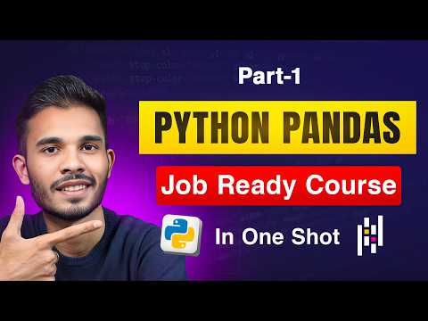](https://youtu.be/qrMnoY8qBJM?si=OI8LKcAKaR3NrpnY)

<Notes:->

How to install pandas  
~> pip install pandas   
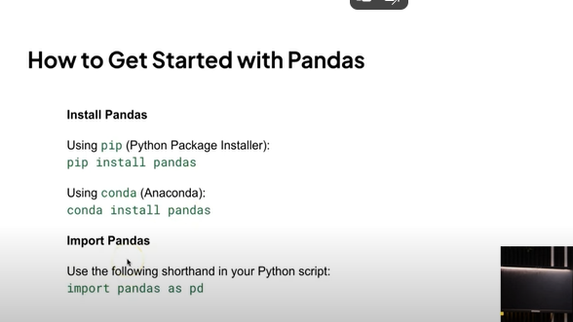  
  
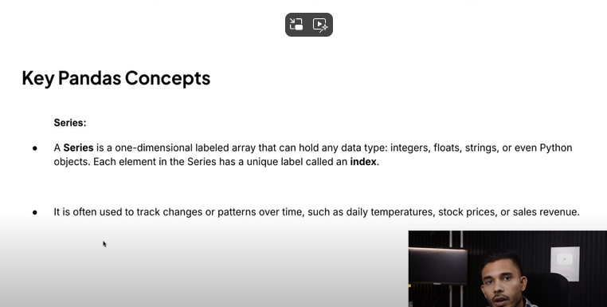  
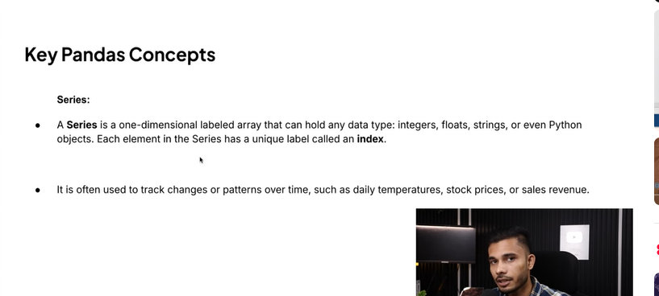  
  
**How to read file (for large file we can create batch we can use for loop)**

import pandas as pd

df=pd.read_excel("Pandas_Prac/Book.xlsx")

dl= pd.read_csv("Pandas_Prac/Book_CSV.csv")

ds= pd.read_json("Pandas_Prac/emp.json")

print(df)

print("printed df=excel")

print(dl)

print("printed dl=csv")

print(ds)

print("printed ds=json")

print("pandas is successfully imported")

**How to load data / create file format**

import pandas as pd

data= {"Name":['Ram','Shyam','Puja'],

"Age":['12','15','13'],

"City":['Delhi','Mumbai','Kolkata']

}

df=pd.DataFrame(data)

print(df)

# df.to_csv("pandas_output.csv",index=False)

# df.to_excel("pandas_output.xlsx",index=False)

df.to_json("pandas_output.json",index=False)