LGB-GBOOST
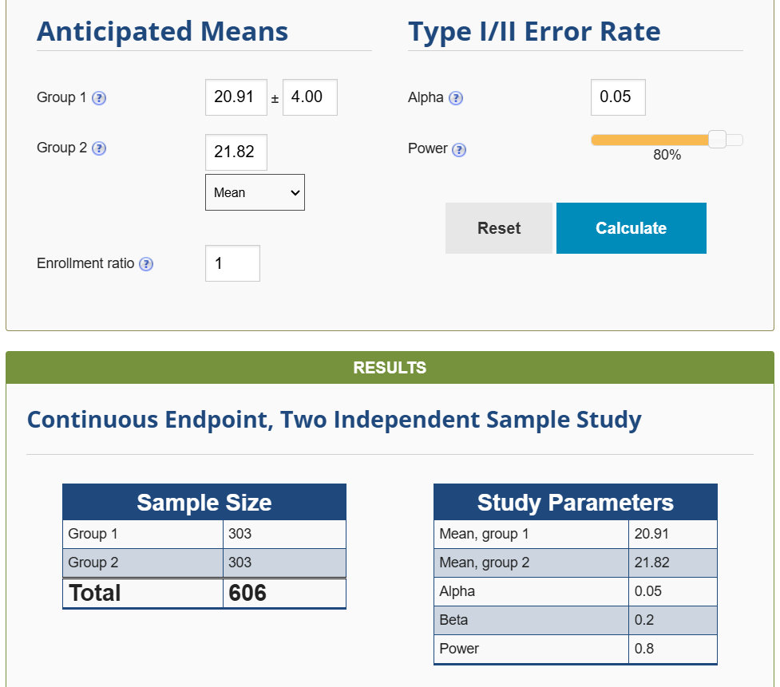

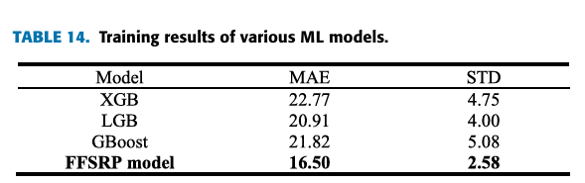

XGB-GBOOST
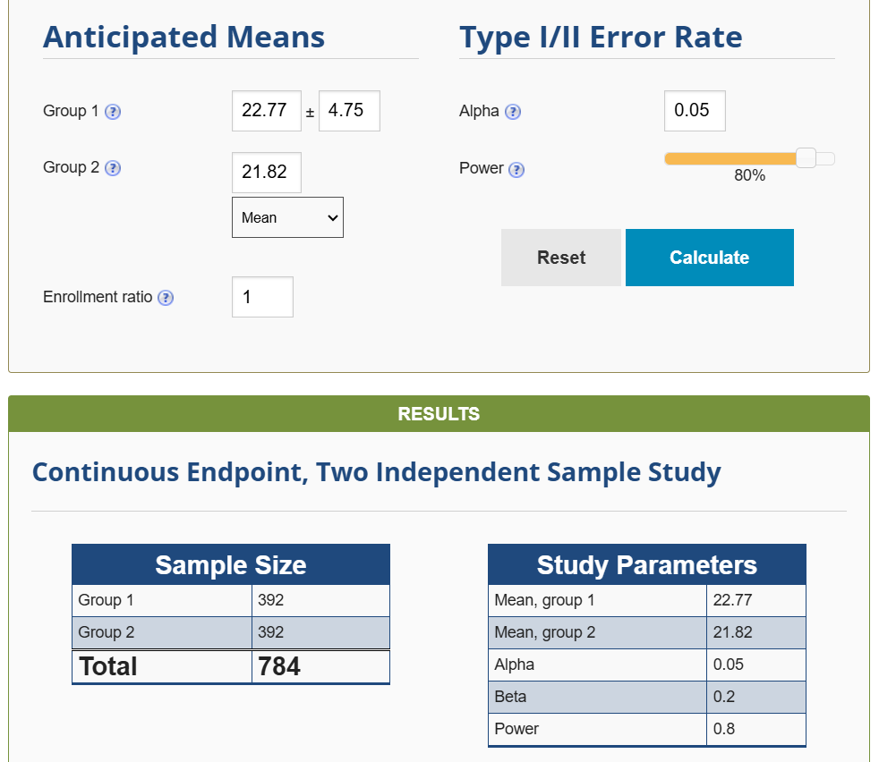
https://docs.google.com/spreadsheets/d/1zd2HxhUPONHz6gDISND7TpgDbfGmnYZv/edit?gid=1098304076#gid=1098304076
-Title 1
Accuracy code:
import pandas as pd
import numpy as np
from sklearn.model_selection import train_test_split
from sklearn.ensemble import GradientBoostingClassifier
from xgboost import XGBClassifier
from sklearn.metrics import accuracy_score
from sklearn.preprocessing import LabelEncoder

# Load dataset
file_path = "/content/gds_fire_30mm.csv"
df = pd.read_csv(file_path)

# Drop unnecessary columns
df.drop(columns=[col for col in ['system:index', '.geo', 'labels'] if col in df.columns], inplace=True, errors='ignore')

# Convert all columns to numeric if possible
df = df.apply(pd.to_numeric, errors='coerce')

# Handle missing values
df.fillna(df.mean(), inplace=True)

# Identify the target variable
target_col = 'risk' if 'risk' in df.columns else df.columns[-1]
X = df.drop(columns=[target_col])
y = df[target_col]

# Check if y contains dates instead of categories
if y.dtype == 'object' or y.dtype == 'int64':
if y.min() > 19000000: # Example check for YYYYMMDD format
print("Warning: Target variable contains dates. Converting to categorical labels...")
y = pd.qcut(y.rank(method='first'), q=5, labels=False) # Bin into 5 classes

# Encode categorical target variable if needed
if not np.issubdtype(y.dtype, np.number):
le = LabelEncoder()
y = le.fit_transform(y)

# Remove classes with only one occurrence
value_counts = pd.Series(y).value_counts()
valid_classes = value_counts[value_counts > 1].index
valid_idx = y.isin(valid_classes)

X, y = X[valid_idx], y[valid_idx]

# Train-test split
X_train, X_test, y_train, y_test = train_test_split(X, y, test_size=0.2, random_state=42, stratify=y)

# Train XGBoost model
xgb_model = XGBClassifier(use_label_encoder=False, eval_metric='logloss')
xgb_model.fit(X_train, y_train)
y_pred_xgb = xgb_model.predict(X_test)
xgb_accuracy = accuracy_score(y_test, y_pred_xgb)

# Train Gradient Boosting model
gb_model = GradientBoostingClassifier()
gb_model.fit(X_train, y_train)
y_pred_gb = gb_model.predict(X_test)
gb_accuracy = accuracy_score(y_test, y_pred_gb)

# Print accuracy results
print("XGBoost Accuracy:", xgb_accuracy)
print("Gradient Boosting Accuracy:", gb_accuracy)

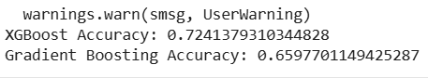
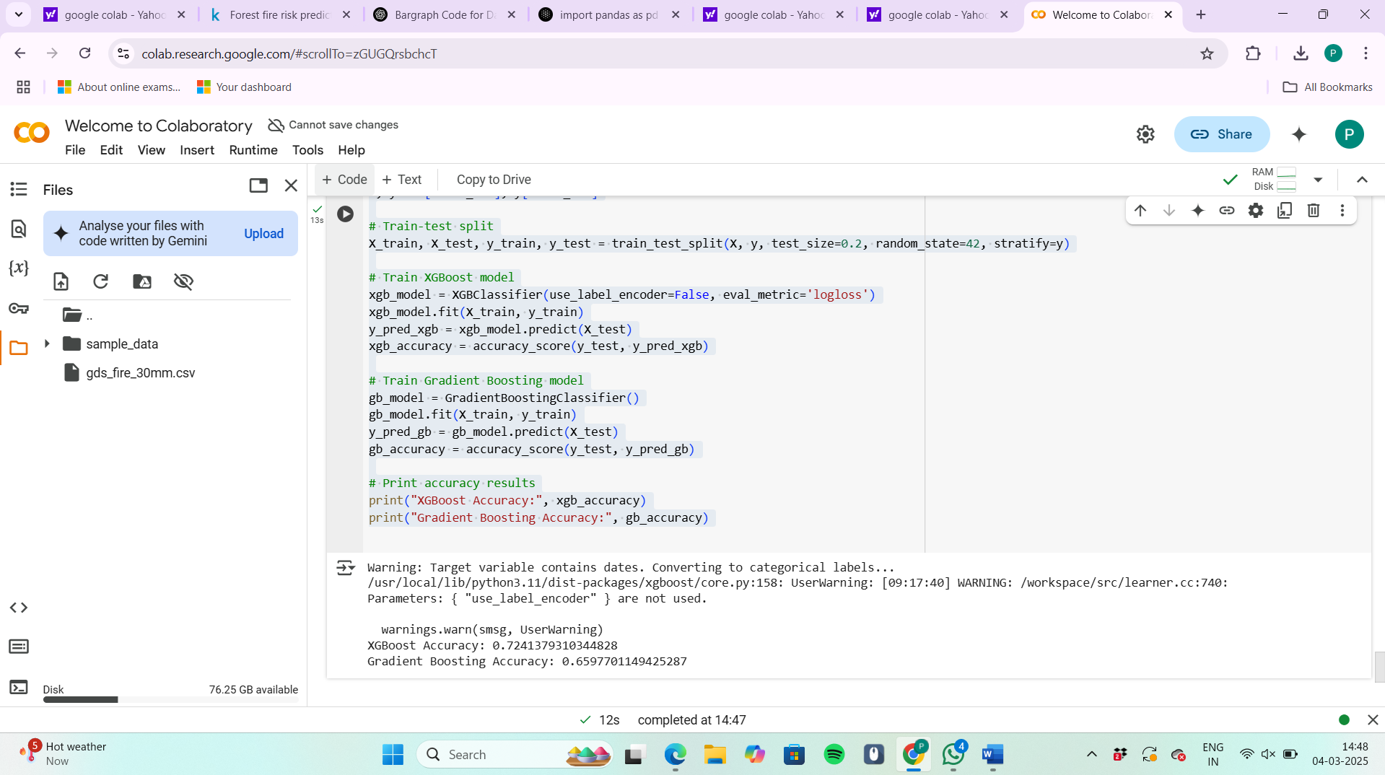
Graph code:
import pandas as pd
import numpy as np
import matplotlib.pyplot as plt
from IPython.display import display, clear_output
from sklearn.model_selection import train_test_split
from sklearn.ensemble import GradientBoostingClassifier
from xgboost import XGBClassifier
from sklearn.metrics import accuracy_score
from sklearn.preprocessing import LabelEncoder
import time # To simulate real-time updates

# Load dataset
file_path = "/content/gds_fire_30mm.csv"
df = pd.read_csv(file_path)

# Drop unnecessary columns
df.drop(columns=[col for col in ['system:index', '.geo', 'labels'] if col in df.columns], inplace=True, errors='ignore')

# Convert all columns to numeric if possible
df = df.apply(pd.to_numeric, errors='coerce')

# Handle missing values
df.fillna(df.mean(), inplace=True)

# Identify the target variable
target_col = 'risk' if 'risk' in df.columns else df.columns[-1]
X = df.drop(columns=[target_col])
y = df[target_col]

# Check if y contains dates instead of categories
if y.dtype == 'object' or y.dtype == 'int64':
if y.min() > 19000000: # Example check for YYYYMMDD format
print("Warning: Target variable contains dates. Converting to categorical labels...")
y = pd.qcut(y.rank(method='first'), q=5, labels=False) # Bin into 5 classes

# Encode categorical target variable if needed
if not np.issubdtype(y.dtype, np.number):
le = LabelEncoder()
y = le.fit_transform(y)

# Remove classes with only one occurrence
value_counts = pd.Series(y).value_counts()
valid_classes = value_counts[value_counts > 1].index
valid_idx = y.isin(valid_classes)

X, y = X[valid_idx], y[valid_idx]

# Train-test split
X_train, X_test, y_train, y_test = train_test_split(X, y, test_size=0.2, random_state=42, stratify=y)

# Initialize accuracy values
xgb_accuracy, gb_accuracy = 0, 0

# Function to update bar graph
def update_bar_graph(xgb_acc, gb_acc):
clear_output(wait=True)
models = ['XGBoost', 'Gradient Boosting']
accuracies = [xgb_acc, gb_acc]

plt.figure(figsize=(6, 4))
plt.bar(models, accuracies, color=['blue', 'green'])
plt.xlabel("Model")
plt.ylabel("Accuracy")
plt.title("Real-time Accuracy Update")

# Show accuracy values on top of bars
for i, acc in enumerate(accuracies):
plt.text(i, acc + 0.02, f"{acc:.2f}", ha='center', fontsize=12, fontweight='bold')

plt.ylim(0, 1) # Accuracy is between 0 and 1
plt.show()

# Train XGBoost model with real-time update
xgb_model = XGBClassifier(use_label_encoder=False, eval_metric='logloss')
xgb_model.fit(X_train, y_train)
y_pred_xgb = xgb_model.predict(X_test)
xgb_accuracy = accuracy_score(y_test, y_pred_xgb)
update_bar_graph(xgb_accuracy, gb_accuracy)
time.sleep(1) # Pause to simulate real-time update

# Train Gradient Boosting model with real-time update
gb_model = GradientBoostingClassifier()
gb_model.fit(X_train, y_train)
y_pred_gb = gb_model.predict(X_test)
gb_accuracy = accuracy_score(y_test, y_pred_gb)
update_bar_graph(xgb_accuracy, gb_accuracy)

# Print final accuracy
print("Final XGBoost Accuracy:", xgb_accuracy)
print("Final Gradient Boosting Accuracy:", gb_accuracy)

Output:
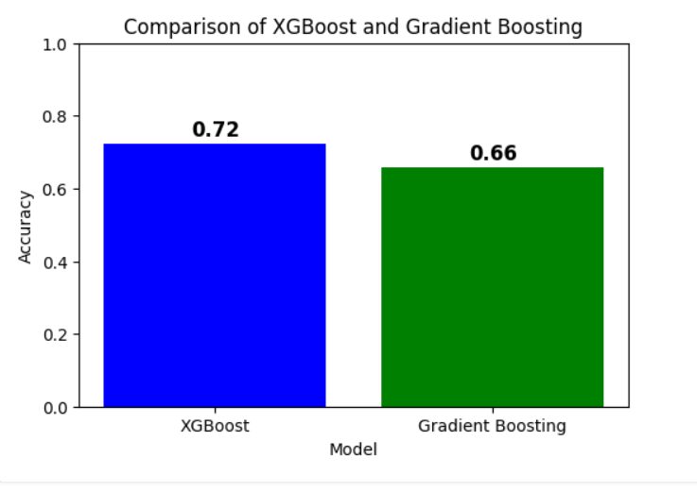
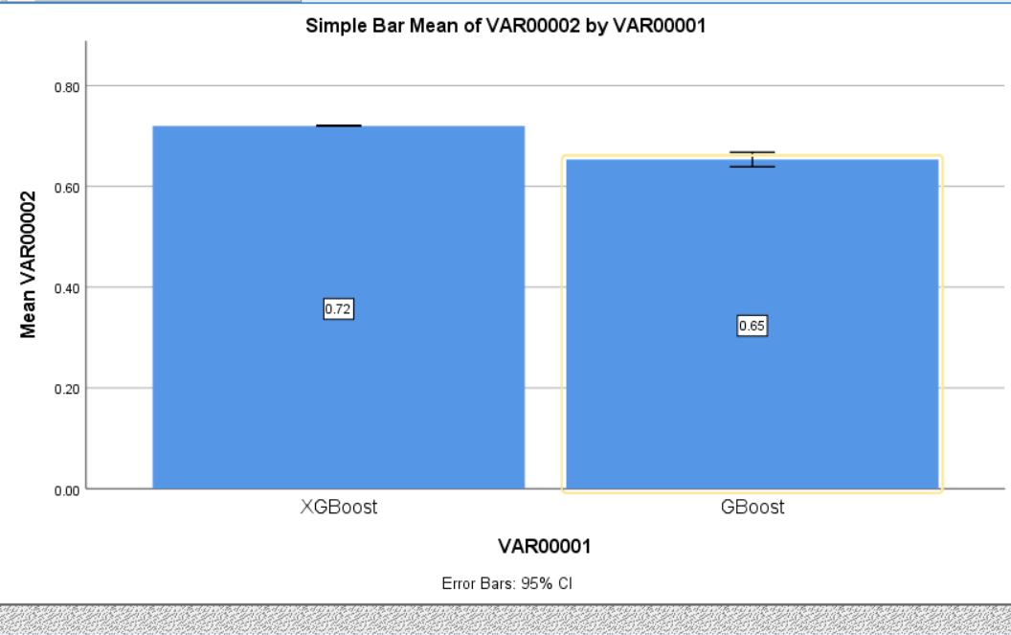

Group Statistics

Tables SPSS:

Title 2:

