**1.Display the top rates dishes by cost:**

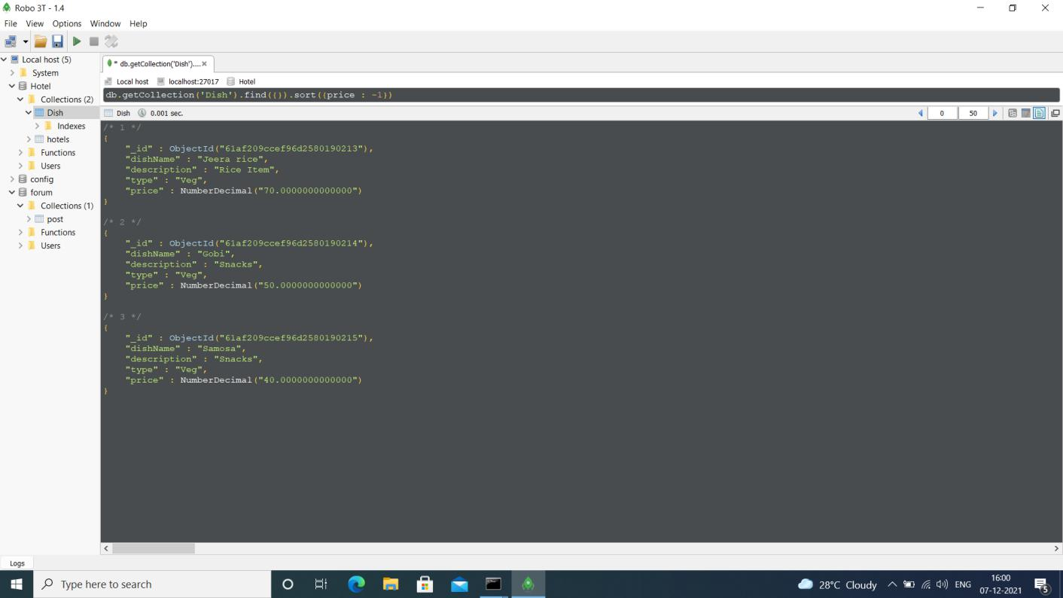

**2.Modify the collection to include GST percentage for every dish.**

**3.Include the cost of GST value in the cost of the dish .**

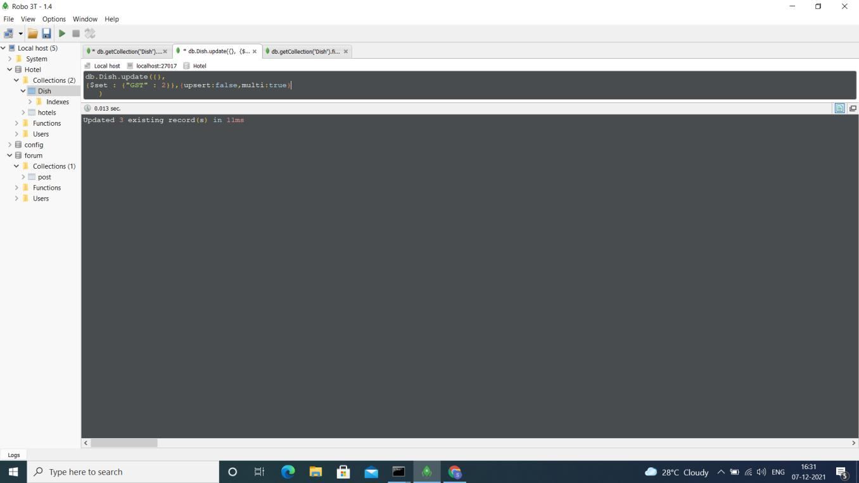

**Updated Values:**

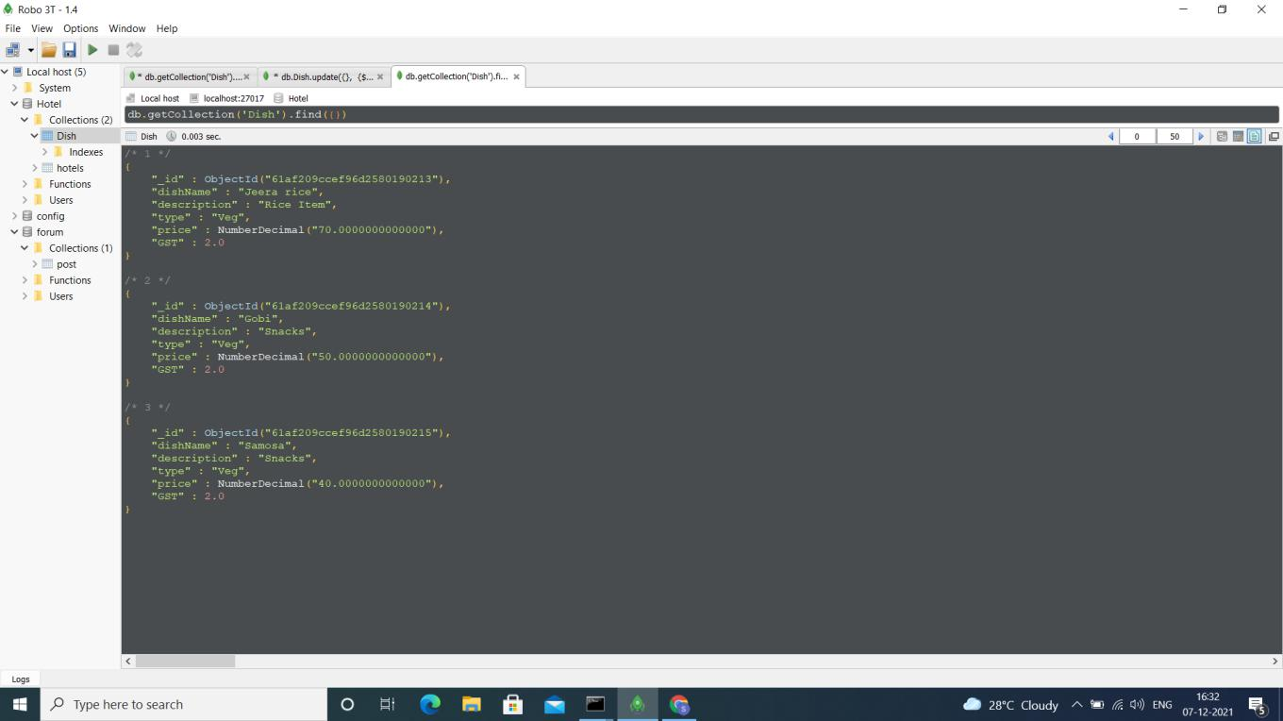

**4.Display the names of the dishes , the GST values and new rates of the dishes.**

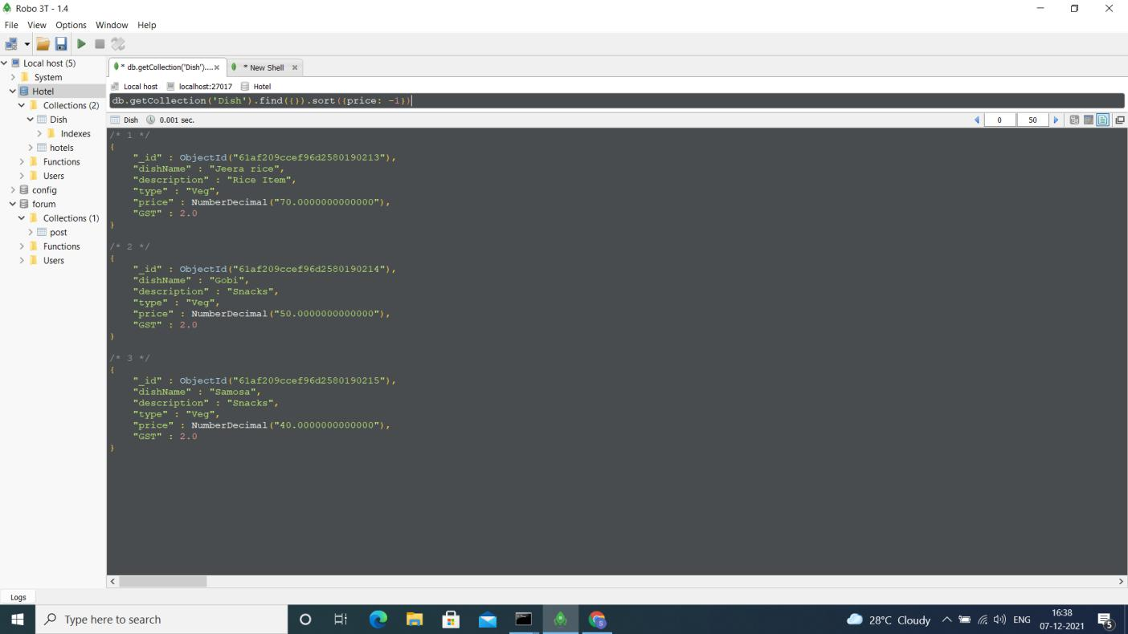

**5.Delete the 2 low rated(cost) dishes from the collection**

