Credit card fraud detection system using Deep Learning Technique

Abstract
Today, fraudulent card payments continue to be a problem for e-commerce businesses and online banking operations, resulting in billions of dollars in annual losses. The development of an efficient algorithm is one of the most difficult challenges in this subject. Using the following models LSTM and auto-encoder, the goal of this research is to provide an effective approach for automatically detecting credit card fraud involving financial institutions. Credit card transaction data was gathered from Kaggle, a data repository, and includes a total of 284,808 credit card transactions from a European bank data collection. It classifies fraudulent transactions as the "positive class" and non-fraudulent transactions as the "negative class." The data set is significantly skewed; around 0.172 per- cent of transactions are fraudulent, while the remainder are genuine. Two deep learning algorithms are used to analyze the dataset, and the work is carried out in Python using the Jupyter notebook IDE. The methods’ performance is assessed for a variety of factors, including accuracy, execution time, and loss rate. The result indicates that the LSTM and Auto-Encoders have an accuracy of 99.98 and 70.24, respectively. The comparison findings indicate that the LSTM approach outperforms the Auto-Encoder technique.

Keywords: deep learning; clustering

- INTRODUCTION
Over the previous few decades, Internet usage has exploded, resulting in an explosion of E-commerce, online services, online advertising, and online shopping. Essentially, the majority of businesses have migrated to the Internet, and electronic payment transactions occur on a regular basis around the world, more frequently than alternative payment methods such as money transfer via online banking systems or crypto-currency. Individuals may now book appointments online, pay bills online, and enroll in paid programs online, which simplifies our lives significantly by eliminating the need to queue at the bank or carry cash around. Nonetheless, all of these thieves have infiltrated the e-commerce system using futuristic methods of credit card theft. On a daily basis, there is either a theft of credit card information, an illegal transaction, or the use of a counterfeit card. Globally, this increasing fraud has resulted in huge losses, necessitating the creation of mechanisms to identify it. While machine learning and data mining techniques are being utilized to identify credit card fraud, they are still in need of development due to their inability to produce significantly realistic results. However, statistically significant methods that are efficient and realistic should be created. In this example, a deep learning method is utilized to identify fraudulent transactions before they are approved by the appropriate authorities [1].
Credit card fraud detection is a more sophisticated form of theft; it occurs when an unauthorized individual steals information from a credit card or gains access to the credentials of another cardholder for illegal purposes, impersonation, and dubious activities. These fraudulent activities can be physical, in which the fraudster physically uses the credit card to make purchases, or virtual, in which the fraudster uses the credit card to make virtual purchases. Fraudsters commit such acts through the following methods: misplaced or stolen cards, card cloning and scanning, in which fraudsters copy information from the magnetic strip and create a card that looks identical to the original card, hijacked account, in which fraudsters take complete control of the user’s account in order to commit fraud, stolen credit card id, card holder not present [2]. Additionally, fraudsters employ additional techniques on the Internet, such as site copying, misleading trade sites, and illicit credit card manufacturing [3].
Global financial losses incurred as a result of credit card theft were 22.8 billion US dollars in 2017 and were expected to continue increasing [4]. Additionally, the Nilson research claimed that gross losses from credit card theft are anticipated to exceed forty billion US dollars in 2027, up from 28.65 billion in 2019 [5]. To mitigate these losses, detection and preventive mechanisms should be implemented. Mechanisms for distinguishing fraudulent from genuine transactions have been created utilizing machine learning and data mining techniques. Machine learning (ML) is the study of algorithms that improve automatically as a result of training data, such that a computer can perform a task by testing the trained data.
Machine learning is the most widely used technology because it is more accurate, consumes less time, and is applicable to a wide variety of applications. On the other hand, deep learning is a subset of machine learning that consists of neural networks that analyze data and make decisions in a manner similar to the human brain. Several deep learning models include the convolutional neural network (CNN), the recurrent neural network (RNN), the artificial neural network (ANN), the long short term memory (LSTM) network, stack auto-encoders, the deep boltzman machine, multilayered perceptions, and the radial basis function network, among others.
The illegal financial operations are very sophisticated and difficult to detect. Frauds are rising significantly as a result of recent technological advancements, most notably in the financial industry [6]. Fraud offenses cost financial institutions billions of dollars each year, eroding the institution’s financial health and, therefore, consumer confidence [7]. Worldwide, financial institutions and companies are suffering significant losses as a result of many financial scams.
Credit card fraud is on the rise, as it is a widely utilized payment method. This is due to the progress of technology and the growth of online payment systems, which has resulted in a massive loss globally. As a result, there is a need for effective methods of mitigating the loss. Additionally, fraudsters have devised several methods for illegal access to credit card user information, including spoofing SMS and phone calls, duplicating websites, impersonating attacks, and spoofing applications utilizing Google forms [8]. In Nigeria, there has been a dramatic surge in the unlawful solicitation of sensitive information such as passwords and Bank Verification Numbers (BVNs) via phone calls, SMS message reset or code verification, and phishing email communications. Due to the increased pace at which products and services are purchased digitally using credit cards, credit card fraud has grown. The development of a viable model capable of reliably detecting fraudulent monetary transactions is critical.

- BACKGROUND
  - PREVIOUS APPROACHES TO CREDIT CARD FRAUD DETECTION
Although machine learning (ML) approaches have been used to detect credit card fraud, no fraud detection system has yet to achieve exceptional performance due to the fact that the distribution of data changes over time due to new attack approaches and seasonality, as well as the fact that a very small percentage of all credit card transactions are fraudulent [9]. Recent advancements in deep learning have been made to address challenging challenges in a variety of fields.
Machine learning is a subset of Artificial Intelligence (AI) that develops models to make judgments about the end or consequence of a notion. ML algorithms largely rely on historical data (prior data) to anticipate and predict the outcome of a new set of values. There are two primary approaches for identifying fraudulent credit card transactions using machine learning algorithms: supervised and unsupervised learning. Credit card transactions from the past are assessed as genuine or fraudulent using supervised learning algorithms. Then, this approach begins training on the data in order to develop a model capable of categorizing fresh datasets. By contrast, unsupervised learning algorithms are entirely dependent on the direct categorization of credit card transactions using what are considered to be typical patterns. The system then categorizes transactions that do not conform to these patterns as fraudulent credit card transactions. Both supervised and unsupervised learning techniques were used to identify credit card fraud [10] [11].
The most well-known algorithms for detecting credit card fraud employ supervised learning and use categorized transactions to train their classifiers. Credit card fraud is identified using categorized characteristics derived from credit card transactions. Numerous machine learning techniques were used to identify fraudulent credit card transactions [12]. Numerous classification methods have been developed for the purpose of detecting fraudulent credit card transactions, including the following [13]: Decision Tree, Autoencoder, Hidden Markov Models (HMMs), K-Means Clustering, K-nearest neighbor (KNN) algorithm, Logistic Regression (LR), Nave Bayes (NB), Random Forest (RF), Support Vector Machine (SVM).
  - PROPOSED DEEP LEARNING-BASED CLASSIFIERS
Deep learning will be used to do research on credit card fraud detection. Deep learning is a sophisticated machine learning approach in artificial intelligence that use neural networks to learn unsupervised from unstructured or unlabeled data. While many machine learning algorithms have been used for credit card fraud detection in a variety of scenarios and have produced reliable results, the restriction is that machine learning algorithms are entirely dependent on historical data, and due to the sensitive nature of financial data, protecting user privacy is critical. As a result, publicly available datasets are scarce, limiting the breadth of the study. As a result, any study in this field is limited to a subset of datasets. Additionally, credit card fraud detection systems confront a class imbalance, since the number of fraudulent transactions relative to the hundred thousand regular transactions may be significantly smaller. Addressing class imbalance appropriately is a significant issue for conventional machine learning methods. Deep learning methods are suggested due to their capacity to handle big datasets. With an accuracy of 97-99 percent, Support Vector Machines (SVM), K-Nearest Neighbor (k-NN), and K-means are the most frequently used anomaly detection algorithms in Machine Learning. However, due to the enormous quantity of data to be processed, deep learning techniques will be employed and the Long Short Term Memory Network (LSTM) method will be used.
The Long Short-Term Memory (LSTM) network is a kind of Recurrent Neural Network (RNN). A typical neural network cannot retain past knowledge and must execute the learning job from scratch each time. In the simplest terms, an RNN is a neural network that includes memory. Due to the fading gradient problem, RNNs have a tendency to exhibit short term memory. Back propagation is the foundation of neural networks since it minimizes loss by changing the network's weights based on gradients. In RNNs, when the gradient returns to the network, it decreases, resulting in a very tiny weight update. The previous layers of the network are unaffected by this little update, and the RNN loses its capacity to recall early instances in extended sequences, converting it to a short-term memory network.
The accuracy, loss rate, and execution time of the LSTM-based credit card fraud detection model will be compared to those of an existing machine learning-based model, such as the Support Vector Machine (SVM). Similarly, with the method of deep learning, Autoencoder.

- RELATED WORKS
[8] Stated that credit card fraud is prevalent these days due to the increased usage of credit card payment methods. This is due advancement in technology and the growth of online transactions, which has resulted in frauds causing significant economic damage. They presented a technique for forecasting the occurrence of fraud by combining several machine learning methods, including support vector machine (SVM), k-nearest neighbor (KNN), and artificial neural network (ANN). Additionally, a distinction of the acquired supervised machine learning and deep learning techniques for detecting fraud and non-fraud transactions was done, yielding an accuracy score of 0.9349, 0.9982, and 0.9992, respectively.
[14] Said that advancements in e-commerce and communication technologies have increased the popularity of credit card use as a method of payment, but fraud associated with transactions has also increased. They utilized an improved light gradient boosting machine, in which Bayesian hyper-parameter optimization is combined with the light gradient boosting machine's parameters (LightGBM). They employed two sets of real-world public datasets, comprising both fraudulent and non-fraudulent transactions, in their technique. After evaluating their suggested device using several approaches, they discovered that it outperformed in terms of its accuracy. The suggested model achieves 98.40 percent accuracy, 92.88 percent area under the receiver operating characteristic curve (AUC), 97.34 percent precision, and 56.95 percent F1-score.
[15] Investigated a novel technique for detecting several types of fraud. The technique, which consists of classification, clustering, and regression, was studied in order to ascertain the contribution and efficacy of each strategy. The authors assert that machine-learning techniques play a critical role in fraud detection and are used to extract and find hidden data. Additionally, hybrid fraud detection systems were the most important due to their ability to combine the characteristics of several conventional methods of detection. However, the majority of hybrid methods failed in real time.
Additionally, [15] explain that financial transactions such as internet transactions, credit card transactions, and smartphone transactions have been popular in recent years as a consequence of everyone's preference for digital and cashless transactions. Numerous transactions are conducted, and each one is susceptible to some form of fraud. Numerous researchers investigated, constructed, and built the machine learning model for identifying fraud. They conducted a comparison of all machine-learning algorithms in order to determine which model is the best at detecting fraud in card transactions.
[16] Created a software that utilized machine learning techniques such as decision trees (DT), k-nearest neighbor (kNN), extreme learning machine (ELM), multilayer perceptron (MLP), and support vector machine (SVM) to determine the accuracy of fraud detection. They presented a model by combining the approaches of DT, SVM, and KNN. They utilized web-based protocols such as simple object access protocol (SOAP) and representational state transfer (REST) to facilitate data interchange across a variety of disparate platforms. A comparison of the outputs of five machine learning algorithms using the accuracy metric. SVM outperformed other algorithms by 81.63 percent, but the hybrid system they suggested had a greater accuracy of 82.58 percent.
Additionally, the writers in [17] examined the overall performance of three ways to financial or personal gain through unlawful or illegal deceit. On credit card data, we used naive Bayes, k-nearest neighbor, and logistic regression. The results revealed that naive Bayes, k-nearest neighbor, and logistic regression all had an accuracy of 97.92, 97.69, and 54.86 percent, respectively. In a comparative research, k-nearest neighbors outperformed naive bayes and logistic regression methods. Additionally, k-nearest neighbor requires training data in order to categorize. As a result, this algorithm is inefficient in detecting anomalous activity because it requires prior training to recognize patterns.
[18] Proposed the Hidden Markov Model as a tool for detecting fraudulent transactions. The Hidden Markov Model uses various transaction ranges such as low, medium, and high as observation symbols. The Hidden Markov model simplified fraud detection systems to the point that they no longer take as long as they used to despite their sophisticated operations. Typically, Hidden Markov Models require training on annotated data. Additionally, this model requires human annotation. As a result, this approach is ineffective in detecting undiscovered patterns of fraud and is ineffective at identifying new fraud patterns. In [19] [20] [21], a study suggested a fraud detection model for unsupervised credit card fraud detection that was entirely built on Self-Organizing Map (SOM) neural networks. This approach made use of visualization of user accounts and a type of threshold detection. The pros of this method include the fact that no prior information is required and that the version is continually updated with new credit card transactions; the disadvantage may be the difficulty of identifying fraudulent credit card transactions with maximum accuracy. The SOM method is constrained by a number of constraints, including sluggish processing and a lack of parallelism capacity for large datasets [22].
[23] Employed Logistic Regression to demonstrate the enhanced overall performance of a transaction accumulation method for the purpose of generating suitable derived characteristics for the purpose of detecting credit card fraud. They created a system to improve credit card fraud detection using real-world data/information from credit card transactions. The findings demonstrated the critical nature of classifying information such as product categories, transaction types, and location in order to detect credit card fraud. Additionally, using a Logistic Regression technique to identify fraud is a bad idea because it can only presume a categorical conclusion. Additionally, this set of criteria is criticized for its susceptibility to overfitting [24].
[25] Identified fraud in monetary transactions by utilizing Bayesian perception networks (BNNs) and decision trees (DTs). A dataset of monetary transactions from seventy-six Greek business entities was used in this study. The dataset included 38 instances of monetary transactions that were determined to be fraudulent by assessors. The BNNs had the highest accuracy (90.3 percent), while the DTs earned 73.6 percent accuracy.

- METHODOLOGY
The primary algorithm to be utilized in this research is Long Short Term Memory (LSTM), which will be compared to Autoencoder in this part. The design technique also includes a comparison of LSTM to another deep learning algorithm for cross assessment.
The overall framework of the proposed approach for credit card fraud detection is illustrated in figure 1.
The experiment was performed using an Intel Core i7 processor with 8GB RAM. The proposed technique and other machine learning techniques were implemented and tested using Python. The proposed model include four major steps, which are explained below in the following subsection.
Pre processing
Historical data
Structured
Data
Training set
Model training / building
Deep learning algorithm (LSTM & Auto-encoder)
Deploy model
Test model prediction
Prediction

Fig. 1. Overall framework of the proposed Credit card fraud detection system Using LTSM and Auto-Encoder Algorithm.
  - DATASET AND PREPROCESSING
The statistics contain credit card transactions performed by European cardholders in September 2013. This dataset contains transactions that happened over the course of two days and contains 492 frauds out of 284,807 total transactions. The dataset is very asymmetrical; positive transactions (frauds) account for 0.172 percent of all transactions. Additionally, this dataset has 31 variables, including time, quantity, class, and other critical characteristics. Numerous researchers have utilized it as a benchmark dataset [26] [27].
The experimental process begins with data pre-processing. In this stage, data sets are thoroughly examined by manually querying them and performing statistical procedures. The goal of data pre-processing is to offer a refined input to classifiers in order to obtain the best output possible. Missing values, categorical features, changing scale, and a high degree of dimensionality can all have an effect on the classifier's performance. Data exploration, data scaling, and test-train split are the two pre-processing approaches used in this study.
Three processes should be performed before to applying the model to the dataset: data validation, normalization, and division.
a) Validation of Data
This phase is used to validate the data contained inside the dataset, such as a negative time value, empty values, or a negative quantity.
b) Normalization
To provide an accurate result, the model rescales the variables between -1 and 1. This step is required to convert the numeric column values in the dataset to a common scale without distorting the value ranges or erasing data.
c) Division of the dataset's sample
It is critical to divide the data samples into training and testing in order to obtain a meaningful assessment of performance. The suggested model uses 70% of the dataset for training and 30% for testing.
  - DATA SCALING AND STANDARDIZATION
Deep learning algorithms perform poorly when the input characteristics are not reasonably comparable in size. Scaling and standardization approaches reduce the scale of the characteristics to a near-identical value in order to make the input more understandable to the classifier. The StandardScaler class from the sklearn pre-processing package in Python is utilized in this investigation. The standard scaler converts each feature in the dataset to have a mean of zero and a standard deviation of one. After applying the conventional scaler to the dataset, the mean value for the same two characteristics described previously was reset to zero.
  - AUTO-ENCODERS
An autoencoder in its simplest form is a feedforward, non-recurrent neural network resembling single layer perceptions that participate in multilayer perceptions (MLP) – utilizing an input layer and an output layer coupled through one or more hidden layers. The output layer is identical to the input layer in terms of nodes (neurons). Rather than forecasting a target value Y given inputs X, its aim is to rebuild its inputs (minimizing the difference between the input and the output). Thus, autoencoders are models of unsupervised learning. (Learning does not require labeled inputs.)
Table 1: Auto-Encoder Pseudo-coding.

Steps | Processes
Step 1: Prepare the input data | Input Matrix X // input dataset  Parameter of the matrix // parameter (w, bx, bh)  where: w : Weight between layers, bx Encoder’s parameters , bh Decoder’s Parameters
Step 2: initial  Variables | h ← null // vector for hidden layer  X ← null // Reconstructed x  L ← null // vector for Loss Function  l ← batch number  i ← 0
Step 3: loop  statement | While i < l do  // Encoder function maps an input X to hidden representation h:  𝗵 = (Wx + b)  Decoder function maps hidden representation h back to a  Reconstruction X) :*/  x^{i} = (W^{i} 𝗵 + b^{i}),  /*For nonlinear reconstruction, the reconstruction loss is generally  from cross-entropy :*/  L(x, x') = || x-x ||² = ||x - ||²  /* For linear reconstruction, the reconstruction loss is generally from the squared error:*/  L  End while  Return θ
Step 4: output | θ ← <null matrix>//objective function  /*Training an autoencoder involves finding parameters =  (W,bx , bh) that minimize the reconstruction loss on the given  dataset X and the objective function*/

  - LONG-SHORT TERM MEMORY
LSTM model is useful in the detection of anomalies in the finance domain. Functions from the Sklearn library of Python is used for programming the different tasks, such as pre-processing and model selection. Keras library is used for the implementation of the LSTM model. The aim is to measure the accuracy, loss rates, and execution time for financial detection fraud. Also, it shows that the LSTM model can detect known and unknown patterns of fraud.
Table 2: LSTM Pseudo-coding
Steps | Processes
Step 1 | Set ipunits, lstmunits, opunits and optimizer to define LSTM Network (L)
Step 2 | Normalize the dataset(Di) into values from 0 to 1 using (4)
Step 3 | Select training window size (tw) and organize Di accordingly
Step 4 | for n epochs and batch size do  Train the Network (L)  end for
Step 5 | Run Predictions using L
Step 6 | Calculate the loss function using (9)

- EXPERIMENTAL RESULTS AND DISCUSSION

LSTM and Autoencoders are the two Deep learning techniques used for the implementation of the program. Long Short-Term Memory (LSTM) and Autoencoders gives more finite and accurate results compared to SVM, RandomForest algorithm which are Machine learning based techniques.

Table 3: Result of experiment with different optimizers
Optimizer | Training Accuracy (%) | Validation Accuracy (%) | Loss (%) | Number of Iterations
Adam | 99.98% | 99.97 | 0.32 | 100
Adagrad | 91.99% | 93% | 0.65 | 100

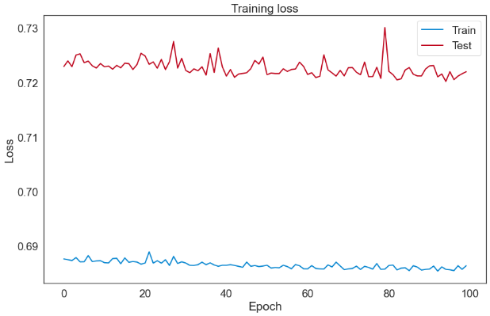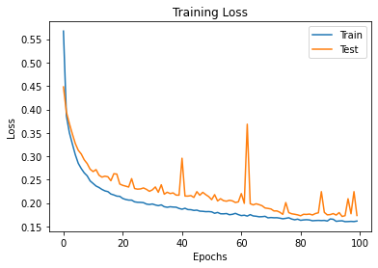
Fig. 2. (a) Model Loss Graph; vs (b) Epoch Graph for Train and Train data
The model efficiently and effectively predicts credit card fraud detection based on applying the LSTM cells. Although this model supports a huge number of optimizers, picking the optimal optimizer leads in a substantial increase in outcomes. The number of layers and iterations used in the implementation had little effect on the outcomes. Additionally, the findings demonstrate that the number of iterations and the number of layers have an effect on the time required. The results established a substantial connection between accuracy and iteration count. Additionally, there is an inverse connection between loss rates and iteration count. There is a negative link between accuracy and loss rates, as illustrated in Figure 2, as when accuracy improves, loss rates drop.

Table 4: Comparison of LSTM and auto-encoder

The model efficiently and effectively predicts credit card fraud detection based on applying the LSTM cells. Although this model supports a huge number of optimizers, picking the optimal optimizer leads in a substantial increase in outcomes. The number of layers and iterations used in the implementation had little effect on the outcomes. Additionally, the findings demonstrate that the number of iterations and the number of layers have an effect on the time required. The results established a substantial connection between accuracy and iteration count. Additionally, there is an inverse connection between loss rates and iteration count. There is a negative link between accuracy and loss rates, as illustrated in Figure 2, as when accuracy improves, loss rates drop.

Table 4: Comparison of LSTM and auto-encoder
Model | Optimizer | Training Accuracy (%) | Validation Accuracy (%) | Loss (%) | Number of Iterations
LSTM | Adam | 99.98% | 99.97 | 0.32 | 100
Auto-Encoder | Adam | 70.24% | 70.20% | 0.69 | 100

Comparison of the two model; LSTM and Auto-Encoder is targeted to determine the efficiency of each models. Adam optimizer show high accuracy, low loss accuracy and speed over other optimizers in Table 3. The LSTM model gives the most accuracy result compare to Auto-Encoder. LSTM model gives 99.98% accuracy, 0.32% loss rate in 500s then Auto-Encoder gives 70.24% accuracy, 0.69% loss rate on 395s. This shows that LSTM can be used for big and complex data for data mining and analysis.

Table 5: Comparison with existing machine learning based techniques
Model | Accuracy | Comments
SVM | 99.87 | - SVM required training by use of annotated data which means not effective to identify new patterns of fraud  - SVM has lack of results transparency.
Random Forest | 97.95% | - RF can achieve good results with small number of data
Logistic Regression | 99.89 | - Its weakness to over-fitting  - Logistic Regression it can expect only a definite outcome.
LSTM | 99.98%

Table 5 shows performance comparison of the proposed model with other machine learning techniques based on the accuracy metrics. The proposed model gives the highest accuracy of 99.98%, while Random Forest gives the low accuracy of 97.95%. Though the machine learning technique yield high results but they are unable to process big data and also detects new pattern and features. Nevertheless, deep learning-based methods can learn even through complex data patterns and dynamically adapt with new patterns of frauds.

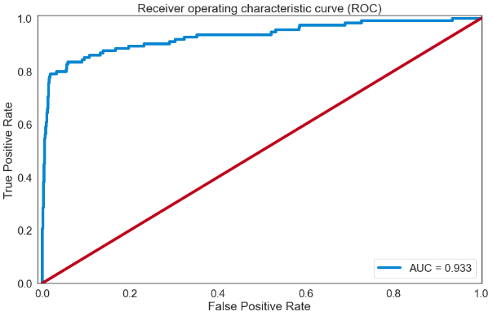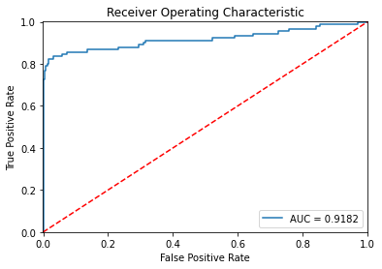
Figure 3: ROC graph for LSTM and Autoencoder

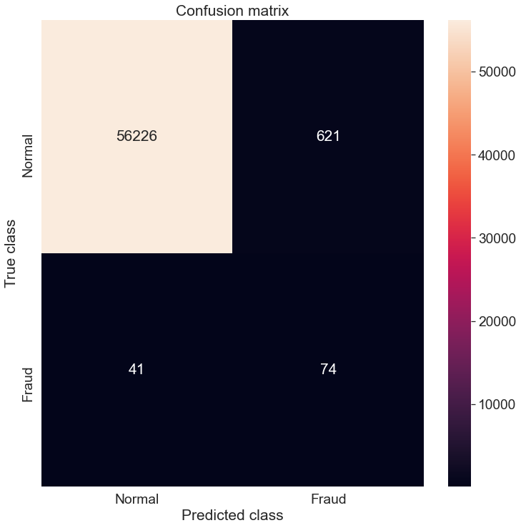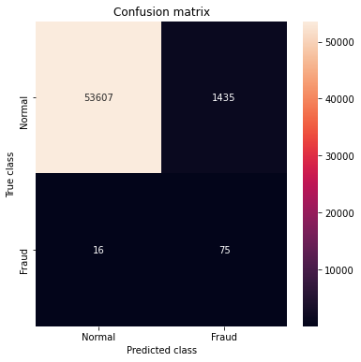
Figure 4: Confusion Matrix graph for LSTM and Autoencoder

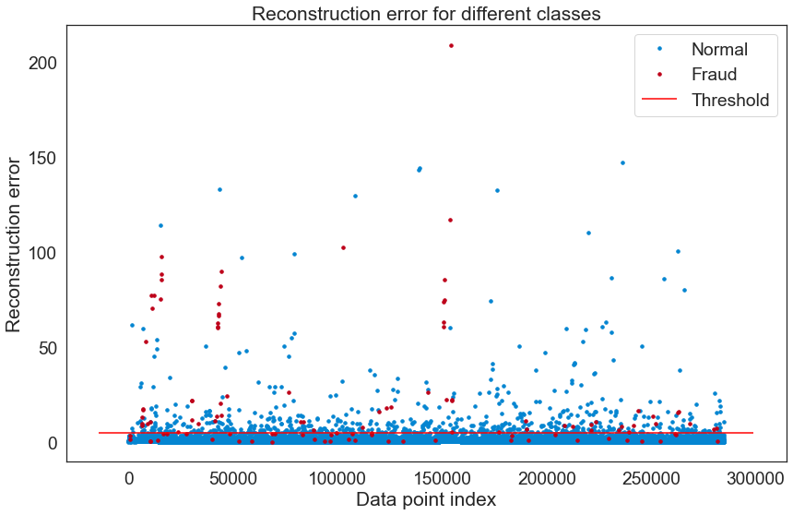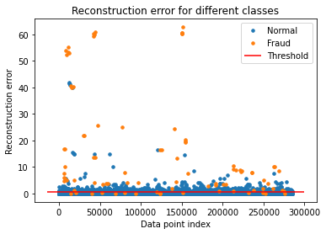
Figure 5: Reconstruction Error for LSTM and Auto-Encoder

- CONCLUSION
The credit card fraud detection model using Autoencoder and LSTM were successfully implemented and ROC curve, Reconstruction error and Training model loss were plotted. The result obtained in case of the LSTM is higher than the others. This fraud detection model is trained using the European credit card fraud data. The data availability in case of credit card fraud detection is scarce. Since model learn from data and not from labels it can be transferred to other dataset too.
Two optimizers were used; Adam and Adagrad for result comparison, training accuracy, validation accuracy and loss model evaluation. Adam optimizer gives the best and reliable result accuracy. Accuracy value of 99.98% is derived using LSTM while 70.24% of accuracy was derived using Auto-Encoder model.
References
[1] Yomas, J., & Kiran, C. N. (2018). Critical analysis on the evolution in the e-payment system, security risk, threats and vulnerability. Communications on Applied Electronics, 7(23), 21–29. https://doi.org/10.5120/cae2018652800
[2] Andrea, D. P., 2015. Adaptive Machine Learning for Credit Card Fraud Detection. PhD Thesis, Department of Computer Science, Université Libre de Bruxelles.
[3] Odumuyiwa, T., Kennedy, M., Norman, A., Holloway, M., Suffeld, F., Forrest, H. and Dicks, H., 2019. Improving Access to Social Care Services Following Acquired Brain Injury: A Needs Analysis. Journal of Long-Term Care, 164 -175.
[4] Lebichot, Bertrand, Yann-Aël Le Borgne, Liyun He-Guelton, Frédéric Oblé, and Gianluca Bontempi, 2019. “Deep-Learning Domain Adaptation Techniques for Credit Cards Fraud Detection.” in Proc. INNS Big Data and Deep Learning conference. Genoa, Italy, 2019. pp. 78-88.
[6] Tripathi K and Pavaskar M, 2012. Survey on credit card fraud detection methods International Journal of Emerging Technology and Advanced Engineering 2, 721-726
[7] West, J., Bhattacharya, M. (2016). Intelligent financial fraud detection: a comprehensive review. Computers & Security, 57, 47 –66. https://doi.org/10.1016/j.cose.2015.09.005
[8] Asha RB, Suresh Kumar KR, 2021. Credit card fraud detection using artificial neural network, Global Transitions Proceedings, Volume 2, Issue 1, 2021, Pages 35-41.
[9] Dal Pozzolo, A., Boracchi, G., Caelen, O., Alippi, C., & Bontempi, G. “Credit card fraud detection: a realistic modeling and a novel learning strategy”. IEEE Trans. Neural Netw. Learn. Syst. vol 29,no 8, pp 1–14 .3784-3797,Sep.2017.
[10] Bhattacharyya, S., Jha, S., Tharakunnel, K., & Westland, J.C., “Data mining for credit card fraud: A comparative study,” Decis. Support Syst., vol. 50, no. 3, pp. 602–613, 2011
[11] Carminati, M., Caron, R., Maggi, F., Epifani, I., & Zanero, S., BankSealer: “A Decision Support System for Online Banking Fraud Analysis and Investigation” Computers & Security, vol 53, no 1, pp. 175-86.Sep.2015.
[12] R. Bolton and D. Hand, “Statistical fraud detection: A review” Stat. Sci., vol. 17, no. 3, pp. 235–249, Aug.2002.
[13] Ravisankar, P., Ravi, V., Rao, G.R., & Bose, I. “Detection of financial statement fraud and feature selection using data mining techniques”' Decis. Support Syst., vol. 50, no. 2, pp. 491-500, Jan.2011.
[14] Taha, A.A., Malebary, S.J., An intelligent approach to credit card fraud detection using an optimized light gradient boosting machine, IEEE Access, 8 (2020), pp. 25579-25587, 10.1109/ACCESS.2020.2971354
[15] Sadgali, I., Sael, N., and Benabbou, F. 2019. Performance of machine learning techniques in the detection of financial frauds. Procedia Computer Science, 148, 45–54.
[16] Prusti, D., Rath, S.K., Web service based credit card fraud detection by applying machine learning techniques, in: Proceedings of the TENCON 2019 - 2019 IEEE Region 10 Conference (TENCON), Kochi, India (2019), pp. 492-497, 10.1109/TENCON.2019.8929372
[17] Awoyemi, J., 2017. Credit card fraud detection using machine learning techniques: comparative analysis. Conference on Computing Networking and Informatics (ICCNI), International, IEEE.
[18] Bhusari, V., & Patil, S. (2016). Study of hidden markov model in credit card fraudulent detection. ld Conference on Futuristic Trends in Research and Innovation for Social Welfare (Startup Conclave)., 2016 Wor, IEEE. https://doi.org/10.1109/STARTUP.2016.7583942
[19] Olszewski, D., 2014. “Fraud detection using self-organizing map visualizing the user profiles” Knowledge.-Based Systems., vol. 70, pp. 324– 334.
[20] Quah, J.T., & Sriganesh, M., “Real-time credit card fraud detection using computational intelligence,” Expert Syst. Appl., vol. 35, no. 4, pp. 1721–1732, 2008.
[21] Zaslavsky, V., and Strizhak, A., “Credit card fraud detection using self-organizing maps” Inf. Secur., vol. 18, p. 48, 2006.
[22] Fort, J.-C. (2002). Advantages and drawbacks of the Batch Kohonen algorithm. ESANN. journal of applied security research 17
[23] Jha, S., Guillen, M., & Christopher Westland, J., 2012. Employing transaction aggregation strategy to detect credit card fraud. Expert Systems with Applications, 39(16), 12650–12657.
[24] Patil, S., Nemade, V., & Soni, P. K. (2018). Predictive modelling for credit card fraud detection using data analytics. Procedia Computer Science, 132, 385–395. https://doi.org/10. 1016/j.procs.2018.05.199
[25] Kirkos E., C. Spathis, and Y. Manolopoulos, 2007 “Data mining techniques for the detection of fraudulent financial statements,” Expert Syst. Appl., vol. 32, no. 4, pp. 995-1003.
[26] Carcillo, F., Dal Pozzolo, A., Le Borgne, Y.-A., Caelen, O., Mazzer, Y., & Bontempi, G. (2018). Scarff: A scalable framework for streaming credit card fraud detection with spark. Information Fusion, 41, 182–194. https://doi.org/10.1016/j.inffus.2017.09.005
[27] Dal Pozzolo, A., Caelen, O., Le Borgne, Y.-A., Waterschoot, S., & Bontempi, G. (2014). Learned lessons in credit card fraud detection from a practitioner perspective. Expert Systems with Applications, 41(10), 4915–4928. https://doi.org/10.1016/j.eswa.2014.02.026

