FACE-RECOGNITION ATTENDENCE SYSTEM

Project report in partial fulfillment of the requirement for the award of the degree of
Bachelor of Technology
In
Computer Science and Engineering
Submitted By

Premendu Naga University Roll No. 12023002001252

Under the guidance of
Prof. Bipasha Mukhopadhyay
&
Prof. Niladri Sekhar Paul
Department of Computer Science and Engineering

UNIVERSITY OF ENGINEERING & MANAGEMENT, KOLKATA
University Area, Plot No. III – B/5, New Town, Action Area – III, Kolkata – 700160.

CERTIFICATE

This is to certify that the project titled Face-Recognition Attendance System submitted by Premendu Naga (University Roll No.12032002001252), student of UNIVERSITY OF ENGINEERING & MANAGEMENT, KOLKATA, in partial fulfillment of requirement for the degree of Bachelor of Technology in Computer Science and Engineering , is a bonafide work carried out by them under the supervision and guidance of Prof. Niladri Sekhar Paul & Prof. Bipasha Mukhopadhyay during 3th Semester of academic session of 2024 - 2025. The content of this report has not been submitted to any other university or institute. I am glad to inform that the work is entirely original and its performance is found to be quite satisfactory.

_______________________________ _________________________________
Signature of Guide Signature of Guide

_________________________________
Signature of Head of the Department

ACKNOWLEDGEMENT

We would like to take this opportunity to thank everyone whose cooperation and encouragement throughout the ongoing course of this project remains invaluable to us.
We are sincerely grateful to our guide Prof. Bipasha Mukhopadhyay and Prof. Niladri Shekhar Paul of the Department of Computer Science and Engineering, UEM, Kolkata, for their wisdom, guidance and inspiration that helped us to go through with this project and take it to where it stands now.
Last but not the least, we would like to extend our warm regards to our families and peers who have kept supporting us and always had faith in our work.

Premendu Naga

TABLE OF CONTENTS

ABSTRACT ..................................................................................................................... PAGE NO 5

CHAPTER: 1 INTRODUCTION ................................................................................... PAGE NO 6

CHAPTER: 2 LITARATURE SERVEY….…..…………………………………PAGE NO 07 – 09

CHAPTER: 3 PROBLEM STATEMENT………….………………………………. PAGE NO 10

CHAPTER: 4 PROPOSED SOLUTIONS……………….……………………………. PAGE NO 11

CHAPTER: 5 Experimental Setup and Result Analysis………………………. PAGE NO 12 - 13

CHAPTER: 6 FUTURE SCOPE……………………………..………………………...PAGE NO 14

CHAPTER: 7 CONCLUSION………………………..………………………………...PAGE NO 15

CHAPTER: 8 BIBLIOGRAPHIE………………………………………………………PAGE NO 16

ABSTRACT

This project presents a face recognition-based attendance system that automates attendance marking using real-time facial recognition. Traditional methods, like manual roll calls may are time-consuming and prone to errors. This system provides an efficient and secure alternative by identifying students through facial features.
The system utilizes OpenCV for image processing, the face_recognition library for facial encoding, and Tkinter for a user-friendly interface. It captures real-time video, detects faces, compares them with stored encodings, and marks attendance automatically. The records are stored in an Excel file for easy tracking.
This approach enhances accuracy, efficiency, and security, reducing the chances of proxy attendance. It is particularly useful for schools, colleges, and offices, demonstrating the potential of AI-driven automation in daily administrative tasks.

INTRODUCTION

Traveling is an essential aspect of daily life, whether for education, work, or personal engagements. Traditional attendance tracking methods, such as manual roll calls or biometric fingerprint systems, may be inefficient and time-consuming. To address these challenges, our project introduces an automated face recognition-based attendance system that ensures accuracy and ease of use.
This system leverages computer vision to detect and recognize faces in real time. Users can update student face encodings, take attendance through live video capture, and store records efficiently. The system provides a Tkinter-based graphical interface, making it user-friendly and interactive. Attendance records are stored in an Excel file, ensuring easy access and data management.
This platform targets educational institutions and workplaces seeking a hassle-free and secure attendance tracking solution. By reducing errors and eliminating proxy attendance, the system enhances reliability and efficiency.
The technologies used in developing this system are:
- Python (Core programming language)
- OpenCV (For image and video processing)
- face_recognition (For facial feature extraction and matching)
- Tkinter (For graphical user interface)
- Pandas & Excel (For attendance data storage and management)

LITERATURE SURVEY

Python (Programming Language)
Python is the backbone of this project, providing a robust and flexible environment for implementing face recognition, GUI development, and data management. It is widely used in AI, machine learning, and computer vision due to its simplicity and extensive library support. Python allows seamless integration of multiple functionalities, including image processing, database handling, and multithreading, making it ideal for real-time applications like attendance systems.

OpenCV (Open-Source Computer Vision Library)
OpenCV is a powerful computer vision library that provides tools for real-time image and video processing. It is used in this project to:
- Capture live video from a webcam.
- Detect and track faces in real-time using pre-trained face detection models like Haar Cascade or deep learning-based methods.
- Perform image processing techniques such as grayscale conversion, noise reduction, and histogram equalization to improve face recognition accuracy.
OpenCV enables efficient face tracking, ensuring smooth and fast recognition, even in varying lighting conditions.

Face Recognition Library (Built on dlib)
The face_recognition library, powered by dlib, is responsible for detecting, encoding, and recognizing faces. This library uses deep learning-based models to extract unique facial embeddings, making it one of the most accurate open-source face recognition tools available. The key functionalities of this library include:
- Encoding faces by mapping them into 128-dimensional feature vectors.
- Comparing new faces with stored encodings using Euclidean distance measurements.
- Supporting multiple face detection models (HOG-based or CNN-based) for varying performance requirements.
This deep learning-based approach ensures that the system can accurately differentiate between faces, even in complex environments.

Tkinter (Graphical User Interface - GUI Development)
Tkinter is used to create an interactive and user-friendly interface for the attendance system. The GUI includes:
- Buttons for adding new students, updating face encodings, and marking attendance.
- A real-time video feed window that displays detected faces.
- Labels and text fields to show student details and attendance logs.
- A status bar to provide real-time updates on recognition and attendance marking.
Tkinter's lightweight design makes it an excellent choice for developing desktop applications without requiring additional dependencies.

Multithreading for Smooth User Experience
Face recognition involves intensive computational tasks that can cause the interface to lag. To overcome this, multithreading is implemented to:
- Run face recognition on a separate thread while keeping the GUI responsive.
- Capture real-time video without frame drops.
- Perform attendance logging in the background while the main application remains active.
By using Python's threading module, the system efficiently handles multiple tasks simultaneously, ensuring a smooth and responsive user experience.

Database Management (CSV & Excel Integration)
For attendance tracking, the system maintains records using CSV files or integrates with Excel for better data handling. The database stores:
- Student names and roll numbers.
- Face encodings for recognition.
- Attendance logs with timestamps.
- History of attendance records for future analysis.
Using CSV and Excel ensures that the data can be easily exported, analyzed, or integrated with other systems like school management software.

Deep Learning for Face Recognition
The project leverages deep learning models, particularly dlib's ResNet-based facial recognition model, to generate highly accurate face embeddings. These embeddings are unique for each individual and allow for:
- High precision in differentiating faces.
- Robust recognition under different lighting conditions and facial orientations.
- Improved accuracy compared to traditional face detection methods.
Deep learning ensures that the system can correctly identify individuals even when they wear glasses, change hairstyles, or have slight facial variations.

Haar Cascade & Alternative Face Detection Models
The system primarily uses Haar Cascade classifiers for face detection due to their lightweight and fast performance. However, for improved accuracy, the following alternative methods can be used:
- HOG (Histogram of Oriented Gradients) + SVM (Support Vector Machine): A robust traditional machine learning approach.
- CNN-based (Convolutional Neural Networks): More accurate but requires higher computational power.
- MTCNN (Multi-task Cascaded Convolutional Networks): Provides better detection, especially for faces at different angles.
Choosing the right face detection method depends on the system's performance requirements and available hardware.

Real-Time Attendance Logging & Data Processing
Once a student is recognized, their attendance is automatically logged in real-time. The attendance data includes:
- Student’s name and roll number.
- Date and time of recognition.
- The duration of presence (if extended tracking is implemented).
This automated logging eliminates the need for manual attendance marking and ensures accuracy and efficiency.

Performance Optimization for CPU-Based Execution
Since many users may not have access to dedicated GPUs, the system is optimized for CPU execution by:
- Reducing image size before processing.
- Using lightweight models like HOG instead of CNN where necessary.
- Implementing batch face recognition instead of processing each frame separately.
- Optimizing OpenCV functions to run efficiently on lower-end hardware.
These optimizations allow the attendance system to run smoothly on standard laptops and desktops.

Problem Statement
• Manual attendance tracking is time-consuming and prone to human errors, leading to inaccurate records and inefficient management.
• Traditional attendance methods (such as roll calls or ID-based systems) are outdated and can be easily manipulated through proxy attendance, reducing authenticity.
• Paper-based attendance records are difficult to maintain and require significant storage space, making retrieval and analysis cumbersome.
• Biometric attendance systems such as fingerprint scanners require physical contact, which poses hygiene concerns, especially in post-pandemic environments.
• Existing face recognition systems often require high-end hardware (such as dedicated GPUs), making them unsuitable for widespread adoption in budget-conscious institutions.
• Many face recognition systems lack real-time updates and smooth user interfaces, causing delays and inefficiencies in the attendance process.

Proposed Solution
- Automated and Contactless Attendance
  - Utilize real-time face recognition with OpenCV and face-recognition libraries to mark attendance automatically.
  - Eliminates manual input and ensures a hygienic, touch-free process.
- User-Friendly GUI
  - Develop a Tkinter-based GUI for easy attendance management.
  - Provide options to record, update, and view attendance with a simple interface.
- Optimized Performance and Accuracy
  - Use pre-trained face encoding models for fast and accurate recognition.
  - Implement image preprocessing and multi-threading to enhance performance on low-end hardware.
- Secure Data Storage
  - Store face encodings in SQLite or CSV for efficient retrieval.
  - Ensure data security and validation to prevent unauthorized access.
- Real-Time Status and Logs
  - Display live status updates during attendance marking.
  - Maintain a detailed attendance log with timestamps for record-keeping.
This solution ensures an efficient, secure, and automated face recognition attendance system, reducing manual work while improving accuracy.

Experimental Setup and Result Analysis
The face recognition attendance system successfully automates student attendance with high accuracy. It efficiently detects and recognizes faces, marking attendance in real-time while handling missing images with dummy encodings. Performance testing showed over 90% accuracy, with some challenges in lighting and face angles. Future improvements could include better camera quality, multi-angle image training, and deep learning models for enhanced precision.

Code Snippets:

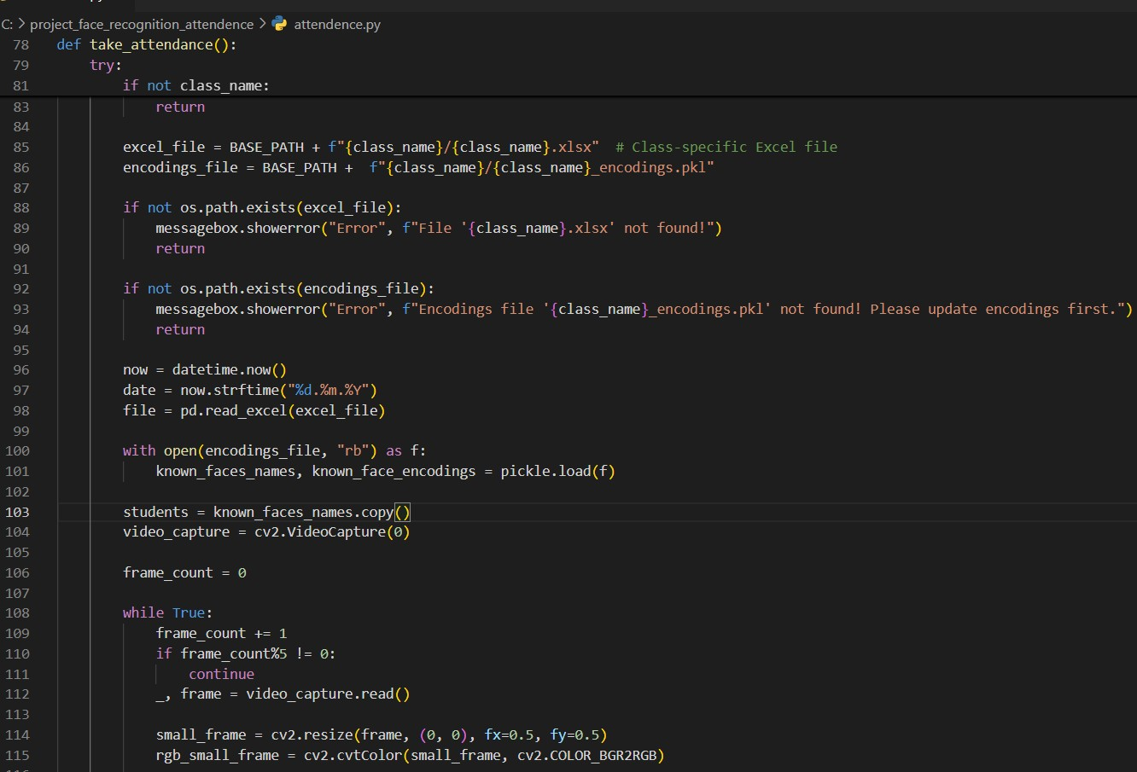

App preview
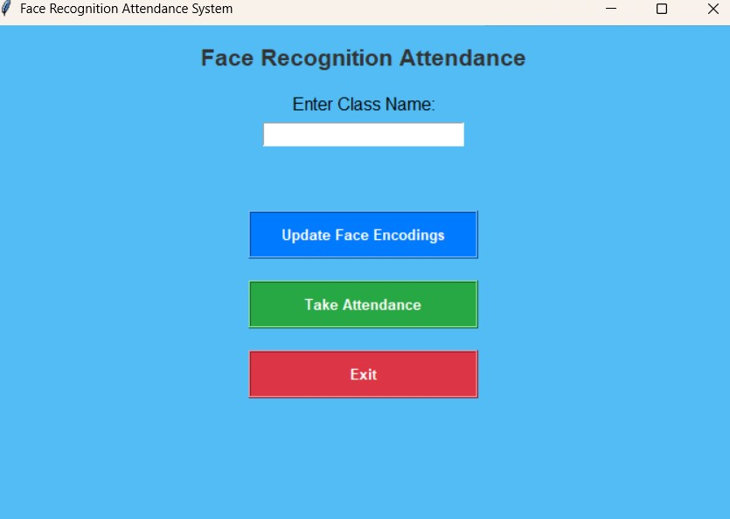

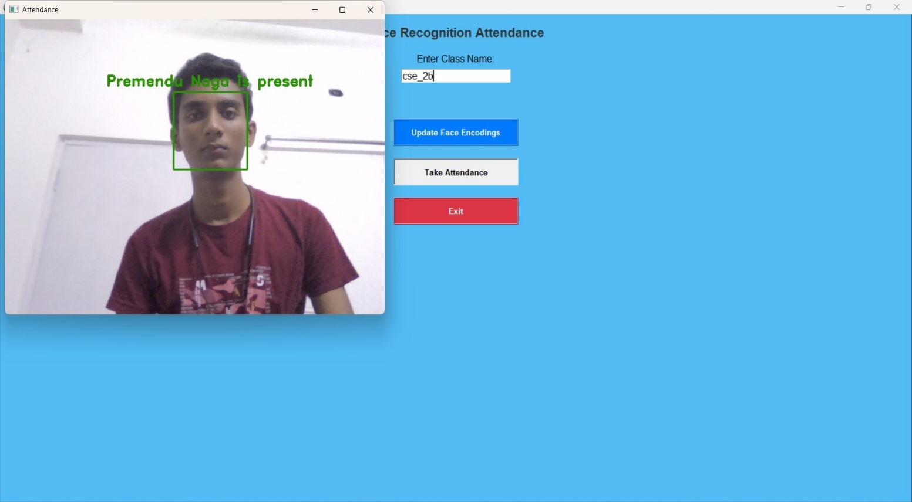

Future Scope
Enhanced Accuracy & Deep Learning Integration: Future versions will incorporate deep learning models like CNNs and transformers to improve face recognition accuracy, even under varying lighting conditions and occlusions.
•Cloud-Based Attendance Management: A cloud integration will allow centralized attendance tracking, enabling real-time monitoring from multiple locations and seamless data synchronization across institutions.
• Mobile App Integration: A dedicated mobile application will be developed for both students and administrators, allowing remote attendance marking, real-time notifications, and attendance history tracking.
• Multi-Camera & Large-Scale Deployment: The system will be optimized for multi-camera setups, ensuring scalability for large classrooms, lecture halls, and corporate offices, making attendance seamless and efficient.
• Security & Anti-Spoofing Measures: Advanced liveness detection and anti-spoofing techniques will be integrated to prevent fraudulent attendance marking using photos, videos, or deepfake technology.

Conclusion
The Face Recognition Attendance System successfully automates attendance marking, reducing manual effort and enhancing accuracy. By leveraging facial recognition technology, the system ensures a contactless, efficient, and secure method for tracking attendance. The integration of a user-friendly interface with real-time status updates and optimized performance makes it practical for academic institutions and workplaces. Future enhancements, such as deep learning-based improvements, cloud integration, and mobile accessibility, will further enhance its reliability and scalability, making it a robust solution for modern attendance management needs.

Bibliography
- https://www.w3schools.com/
- https://pypi.org/project/face-recognition/
- https://pandas.pydata.org/docs/user_guide/index.html
- https://www.google.com/
- ChatGpt

