Script Execution Guide: CheckServerStatus.ps1

Location:
The script 'CheckServerStatus.ps1' is in the following directory on c3piinfra1/2: ‘C:\Scripts’
Steps to Execute the Script:

1. Launch PowerShell ISE & Run the Script.
RDP into either 'c3piinfra1' or 'c3piinfra2' and Open PowerShell ISE (preferred over standard PowerShell for compatibility with interactive scripts).
Run the script using the following command:
PS C:\Scripts> .\CheckServerStatus.ps1

2. vCenter Connection Prompt.
If you are not already connected to the vCenters, you will be shown this prompt.
Enter 'y' to run 'PremierVCConnect.ps1' and get connected first.
Use your T1 account credentials from CyberArk to connect to the vCenters.
If you are already connected to vCenters, you will see the prompt below.
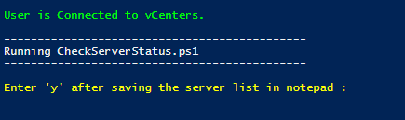

3. Update the Server List Input File.
A reusable file is automatically generated using your user ID and the script name. When prompted in the Notepad window, click ‘Yes’ to create it.
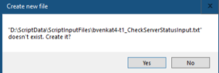
If the file already exists, it will automatically open each time you run the script, allowing you to update the server list as needed.
This is created inside “D:\ScriptData\ScriptInputFiles\”.
Update the server list and save the file.
Enter 'y' to proceed after ensuring you have saved the file.
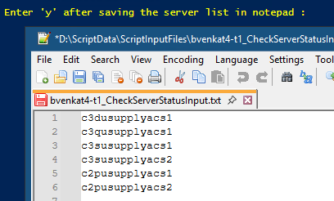

4. Confirmation Script and Server List.
Confirm the server list and script name.
If the server list is incorrect, you may stop the script. Re-run the script to save the correct entries in file.
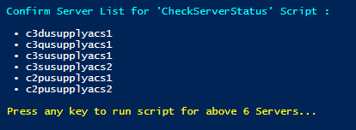
Press 'Enter' to continue.
The script will begin collecting server status details. Please wait until this is completed.

5. Output & Options.
The server data will be displayed as a table.
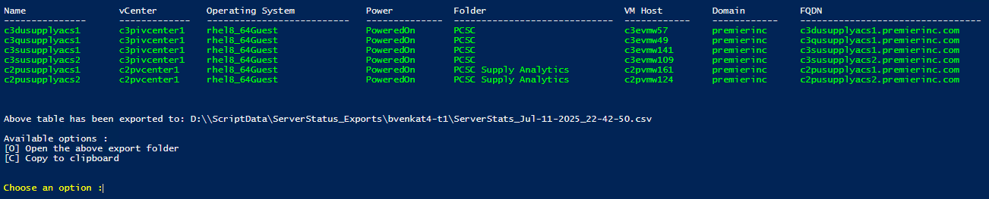
Color coding is applied to the output to easily identify server states and power status.
Color | Server Status | Power State
Green | Active Server | Powered On
Red | Active Server | Powered Off
Yellow | Decommissioned Server | Powered On
DarkYellow | Decommissioned Server | Powered Off

You will be prompted with two options:
• Enter - 'o' to open the export folder and view the generated .csv file.
• Enter - 'c' to copy the data as a table for pasting into an Excel sheet.
We have opened the exported folder below and can see the .csv file here with a time stamp for future reference.
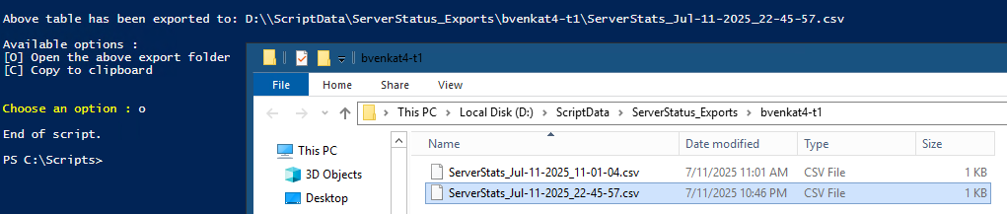

7. Additional Information for Decommission Process.
Color | Server Status | Power State
Green | Active Server | Powered On
Red | Active Server | Powered Off
Yellow | Decommissioned Server | Powered On
DarkYellow | Decommissioned Server | Powered Off

Visually Group servers by vCenter and OS type (Linux/Windows) using the provided script. This minimizes changes made to the Ansible input file, vm_user_entry.yml between each playbook run during decommissions.
In most cases, only the RITM and server name need to be updated between runs, while vCenter and OS details rarely need to be updated.

After running the decommission playbook, you can re-run the script to validate the changes.

You can check the following server data:
- Power – Verify if the server was powered off automatically.
- Folder – Confirm that the server was moved to the ‘Decommission’ folder.
- vCenter– Re-run the script after 7 days to verify that the decommission process is complete by checking whether the server is no longer found in any vCenter.

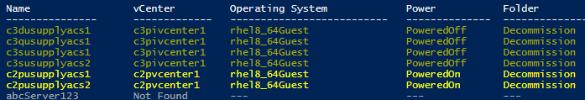
You can compare the current output with the screenshot shown in Step 6 for reference.
Observation:
- 4 servers are powered off and moved to the "Decommission" folder in vCenter.
- 2 servers are in the "Decommission" folder but are still powered on.
- 1 sample server (abcServer123) is not found in any vCenter.

Sample server abcServer123 can be – Decommissioned / Physical / Non-existent.

After 7 days, we can use the script output to close the decommission tickets together on multiple servers with the same closing date.

