///TIME_GENERATOR

module aclk_timegen(clk,reset,reset_count,fast_watch,one_second,one_minute);

input clk,reset,reset_count,fast_watch;

output reg one_second,one_minute;

reg [13:0]count;

reg one_minutereg;

always@(posedge clk or posedge reset)

begin

if(reset)

begin

count<=14'b0;

one_minutereg<=1'b0;

end

else if(reset_count)

begin

count<=14'b0;

one_minutereg<=1'b0;

end

else if(count[13:0]==14'd15359)

begin

count<=14'b0;

one_minutereg=1'b1;

end

else

begin

count<=count+1'b1;

one_minutereg=1'b0;

end

end

always@(posedge clk or posedge reset)

begin

if(reset)

begin

one_second<=1'b0;

end

else if(reset_count)

begin

one_second<=1'b0;

end

else if(count[7:0]==8'd255)

begin

one_second<=1'b1;

end

else

begin

one_second<=1'b0;

end

end

always@(*)

begin

if(fast_watch)

one_minute<=one_second;

else

one_minute<=one_minutereg;

end

endmodule

//TIME_GENERATOR_TESTBENCH

`timescale 1ms/1ns

module tb_aclk_timegen;

reg clk,reset,reset_count,fast_watch;

wire one_second,one_minute;

integer k,l;

aclk_timegen DUT(clk,reset,reset_count,fast_watch,one_second,one_minute);

always

begin

#1.953125 clk=1'b0;

#1.953125 clk=1'b1;

end

task rst_all;

begin

@(negedge clk) reset=1;

@(negedge clk) reset=0;

end

endtask

task rst_count;

begin

@(negedge clk) reset_count=1;

@(negedge clk) reset_count=0;

end

endtask

task fas_watch(input a);

begin

fast_watch=a;

end

endtask

initial

begin

rst_all;

fas_watch(1'b1);

for(k=0;k<120;k=k+1)

begin

if(k==60)

fas_watch(1'b0);

for(l=0;l<256;l=l+1)

#3.906250;

end

#50 $finish;

end

endmodule

TIME_GENERATOR_SIMULATION

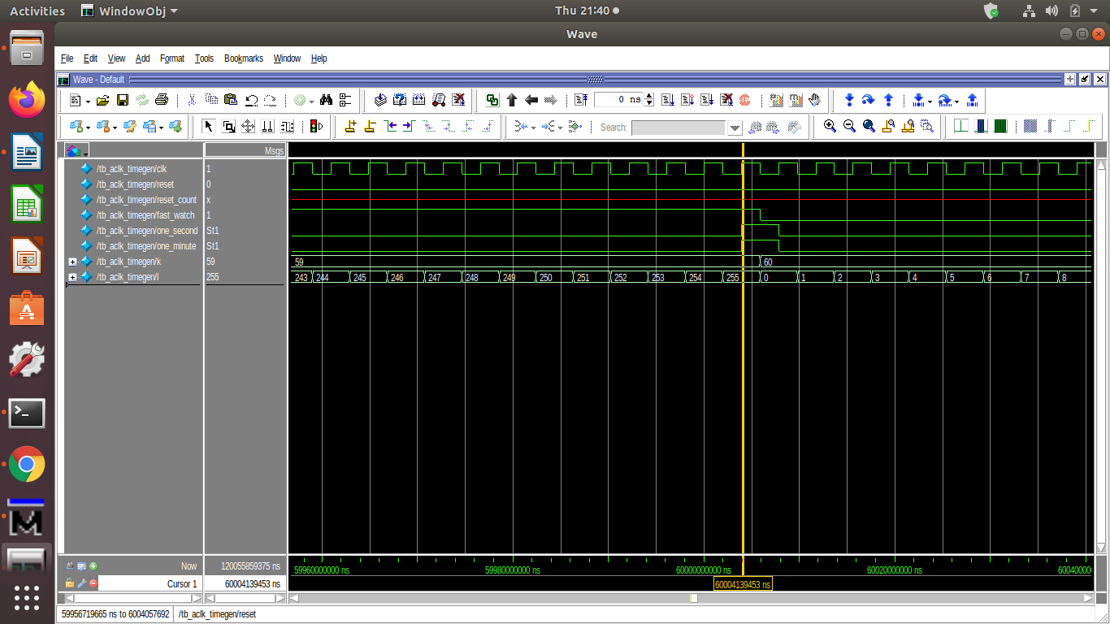

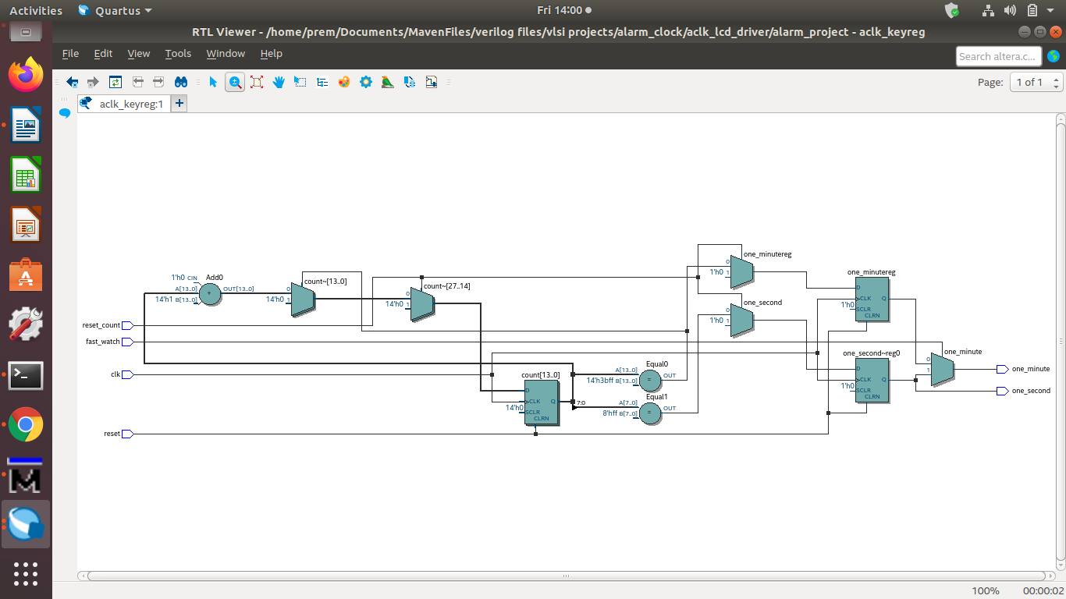TIME_GENERATOR_SYNTHESIS

//CONTROLLER

module aclk_controller(clk,reset,one_second,alarm_button,time_button,key,

reset_count,load_new_c,show_new_time,show_a,load_new_a,shift);

input clk,reset,one_second,alarm_button,time_button;

input [3:0]key;

output reset_count,load_new_c,show_new_time,show_a,load_new_a;

output wire shift;

reg [6:0]state,nextstate;

reg [3:0] count1,count2;

wire time_out;

parameter SHOW_TIME=7'd1,KEY_STORED=7'd2,KEY_WAITED=7'd4,KEY_ENTRY=7'd8,

SET_ALARM_TIME=7'd16,SET_CURRENT_TIME=7'd32,SHOW_ALARM=7'd64;

//sequential logic

always@(posedge clk or posedge reset)

begin

if(reset) state<=SHOW_TIME;

else state<=nextstate;

end

//next state decoding logic

always@( alarm_button or time_button or key or state or time_out)

begin

case(state)

SHOW_TIME : begin

if(alarm_button) nextstate<=SHOW_ALARM;

else if(key!=4'd10) nextstate<=KEY_STORED;

else nextstate<=SHOW_TIME;

end

KEY_STORED : nextstate=KEY_WAITED;

KEY_WAITED : begin

if(key==4'd10) nextstate=KEY_ENTRY;

else if(time_out==0) nextstate=SHOW_TIME;

else nextstate=KEY_WAITED;

end

KEY_ENTRY : begin

if(alarm_button) nextstate=SET_ALARM_TIME;

else if(time_button) nextstate=SET_CURRENT_TIME;

else if(time_out==0) nextstate=SHOW_TIME;

else if(key!=4'd10) nextstate=KEY_STORED;

else nextstate=KEY_ENTRY;

end

SET_ALARM_TIME : nextstate=SHOW_TIME;

SET_CURRENT_TIME: nextstate=SHOW_TIME;

SHOW_ALARM : begin

if(!alarm_button) nextstate=SHOW_TIME;

else nextstate=SHOW_ALARM;

end

default : nextstate=SHOW_TIME;

endcase

end

//output logic

assign reset_count=(state==SET_CURRENT_TIME)?1:0;

assign load_new_c=(state==SET_CURRENT_TIME)?1:0;

assign show_new_time=(state==KEY_ENTRY || state==KEY_STORED || state==KEY_WAITED)?1:0;

assign show_a=(state==SHOW_ALARM)?1:0;

assign load_new_a=(state==SET_ALARM_TIME)?1:0;

assign shift=(state==KEY_STORED)?1:0;

//timers

always@(posedge clk or posedge reset)

begin

if(reset)

count1<=4'd0;

else if(!(state==KEY_WAITED))

count1<=4'd0;

else if(count1==9)

count1<=4'd0;

else if(one_second)

count1=count1+1'b1;

end

always@(posedge clk or posedge reset)

begin

if(reset)

count2<=4'd0;

else if(!(state==KEY_ENTRY))

count2<=4'd0;

else if(count2==9)

count2<=4'd0;

else if(one_second)

count2=count2+1'b1;

end

assign time_out=((count1==9) || (count2==9))?0:1;

endmodule

//CONTROLLER_TESTBENCH

module tb_aclk_controller;

reg clk,reset,one_second,alarm_button,time_button;

reg [3:0]key;

wire reset_count,load_new_c,show_new_time,show_a,load_new_a,shift;

aclk_controller control(clk,reset,one_second,alarm_button,time_button,key,

reset_count,load_new_c,show_new_time,show_a,load_new_a,shift);

always

begin

#5 clk=1'b0;

#5 clk=1'b1;

end

task rst;

begin

@(negedge clk)reset=1;

@(negedge clk) reset=0;

end

endtask

task stimulus(input a,t,s);

begin

alarm_button=a;

time_button=t;

@(negedge clk) one_second=s;

@(negedge clk) one_second=1'b0;

end

endtask

initial

begin

rst;

#10 key=4'h0;

#10 key=4'hA;

#20 key=4'h9;

#10 key=4'hA;

#20 key=4'h5;

#10 key=4'hA;

#20 key=4'h3;

#10 key=4'hA;

#10 stimulus(1'b1,1'b0,1'b0);

#40 stimulus(1'b0,1'b1,1'b0);

#10 key=4'h0;

#10 key=4'hA;

#20 key=4'h9;

#10 key=4'hA;

#20 key=4'h5;

#10 key=4'hA;

#20 key=4'h3;

#10 key=4'hA;

#50 stimulus(1'b1,1'b0,1'b0);

#10 $finish;

end

endmodule

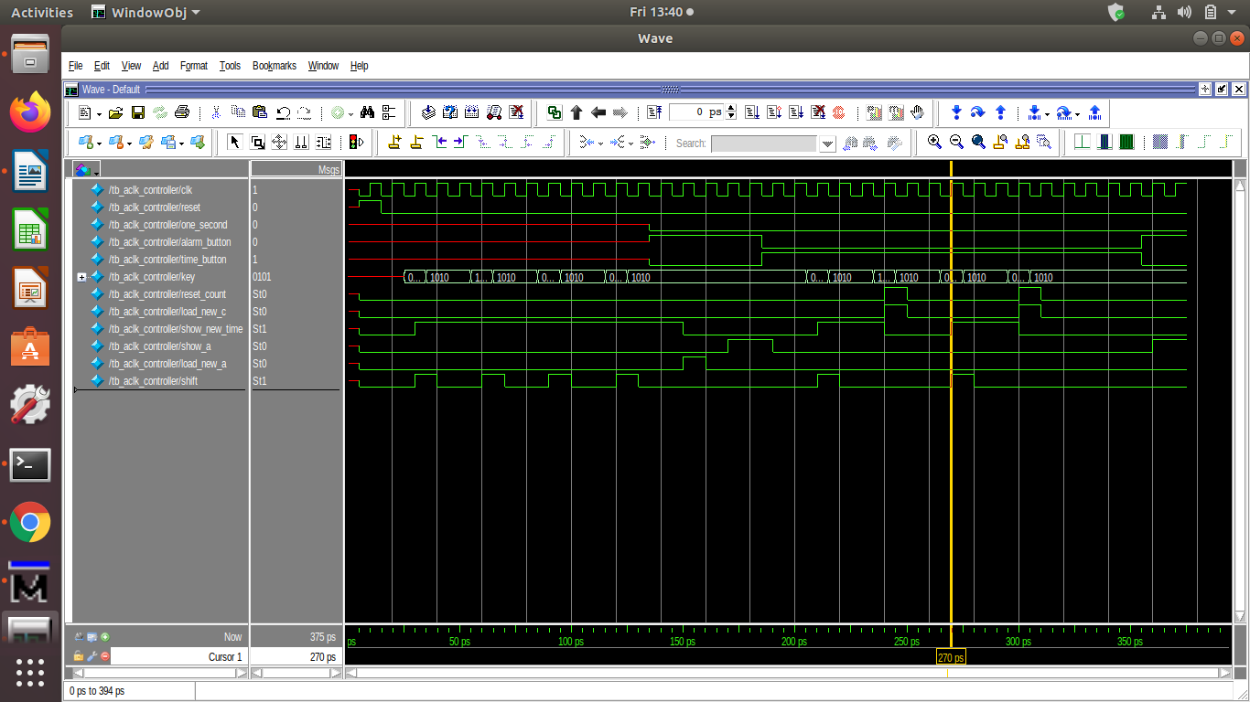CONTROLLER_SIMULATION

CONTROLLER_SYNTHESIS

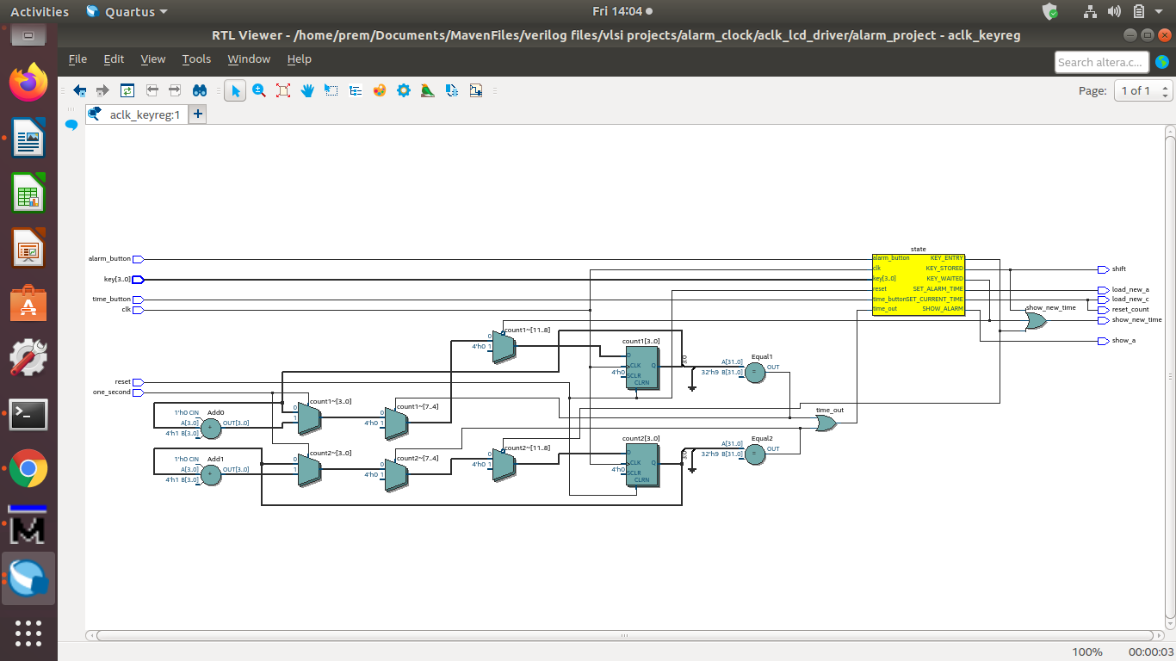

//KEY_REGISTER

module aclk_keyreg(clk,reset,key,shift,

key_buffer_ms_hr,key_buffer_ms_min,key_buffer_ls_hr,key_buffer_ls_min);

input clk,reset,shift;

input[3:0] key;

output reg[3:0] key_buffer_ms_hr,key_buffer_ms_min,key_buffer_ls_hr,key_buffer_ls_min;

always@(posedge clk or posedge reset)

begin

if(reset)

begin

key_buffer_ms_hr<=0;

key_buffer_ms_min<=0;

key_buffer_ls_hr<=0;

key_buffer_ls_min<=0;

end

else

begin

if(shift)

begin

key_buffer_ms_hr<=key_buffer_ls_hr;

key_buffer_ls_hr<=key_buffer_ms_min;

key_buffer_ms_min<=key_buffer_ls_min;

key_buffer_ls_min<=key;

end

end

end

endmodule

//KEY_REGISTER_TESTBENCH

module tb_aclk_keyreg;

reg clk,reset,shift;

reg[3:0] key;

wire[3:0] key_buffer_ms_hr,key_buffer_ms_min,key_buffer_ls_hr,key_buffer_ls_min;

aclk_keyreg DUT(clk,reset,key,shift,key_buffer_ms_hr,key_buffer_ms_min,

key_buffer_ls_hr,key_buffer_ls_min);

always

begin

#5 clk=1'b0;

#5 clk=1'b1;

end

task rst;

begin

@(negedge clk) reset=1;

@(negedge clk) reset=0;

end

endtask

task _shift;

begin

@(negedge clk) shift=1;

@(negedge clk) shift=0;

end

endtask

initial

begin

rst;

key=4'd0;

_shift;

key=4'd9;

_shift;

key=4'd5;

_shift;

key=4'd7;

_shift;

#10 $finish;

end

endmodule

KEY_REGISTER_SIMULATION

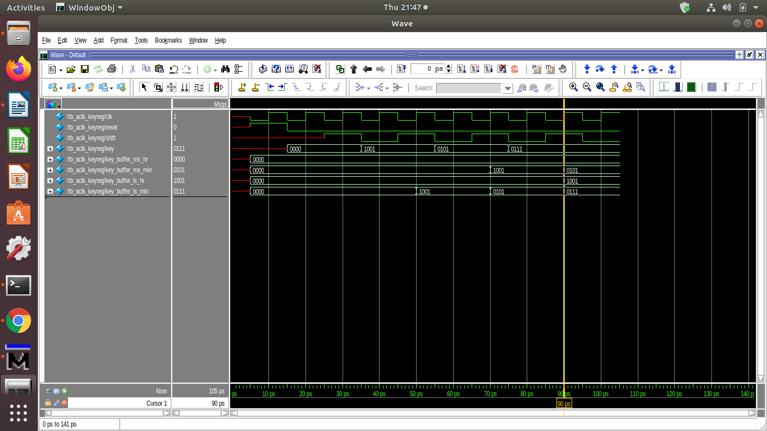

KEY_REG_SYNTHESIS

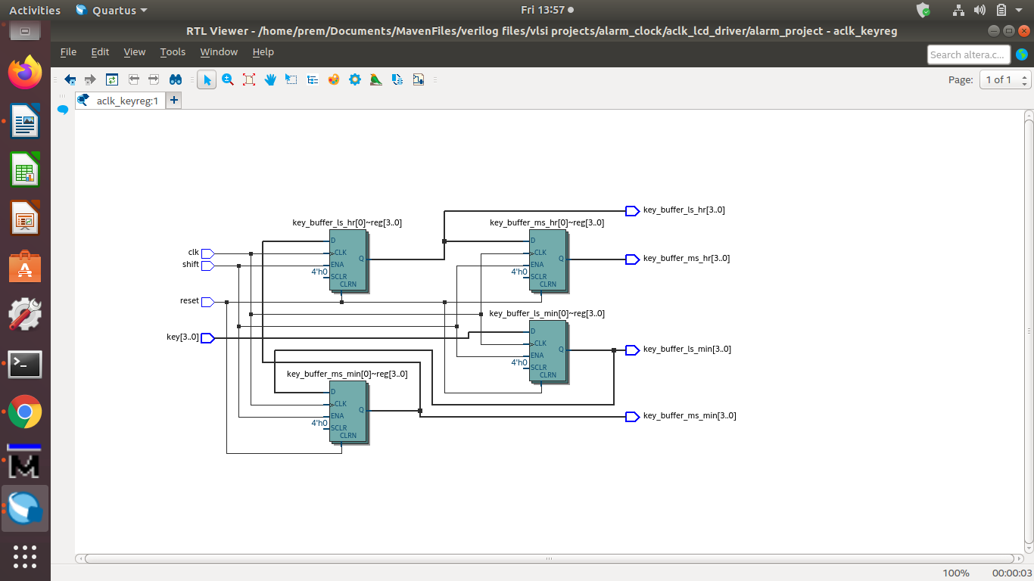

//ALARM_REGISTER

module aclk_areg(input clk,reset,load_new_a,

input[3:0]new_alarm_ms_hr,new_alarm_ms_min,

new_alarm_ls_hr,new_alarm_ls_min,

output reg[3:0]alarm_time_ms_hr,alarm_time_ms_min,

alarm_time_ls_hr,alarm_time_ls_min);

always@(posedge clk or posedge reset or posedge load_new_a)

begin

if(reset)

begin

alarm_time_ms_hr<=0;alarm_time_ms_min<=0;

alarm_time_ls_hr<=0;alarm_time_ls_min<=0;

end

else if(load_new_a)

begin

alarm_time_ms_hr<=new_alarm_ms_hr;alarm_time_ms_min<=new_alarm_ms_min;

alarm_time_ls_hr<=new_alarm_ls_hr;alarm_time_ls_min<=new_alarm_ls_min;

end

end

endmodule

//ALARM_REG_TESTBENCH

module tb_aclk_areg;

reg clk,rst,load;

reg [3:0]n_a_ms_hr,n_a_ms_min,n_a_ls_hr,n_a_ls_min;

wire [3:0]a_t_ms_hr,a_t_ms_min,a_t_ls_hr,a_t_ls_min;

aclk_areg DUT(.clk(clk),.reset(rst),.load_new_a(load),

.new_alarm_ms_hr(n_a_ms_hr),.new_alarm_ms_min(n_a_ms_min),

.new_alarm_ls_hr(n_a_ls_hr),.new_alarm_ls_min(n_a_ls_min),

.alarm_time_ms_hr(a_t_ms_hr),.alarm_time_ms_min(a_t_ms_min),

.alarm_time_ls_hr(a_t_ls_hr),.alarm_time_ls_min(a_t_ls_min));

task _rst;

begin

@(negedge clk)

rst=1'b1;

@(negedge clk)

rst=1'b0;

end

endtask

task _load(input[3:0]ms_hr,ms_min,ls_hr,ls_min);

begin

@(negedge clk)

load=1'b1;

n_a_ms_hr=ms_hr;n_a_ms_min=ms_min;

n_a_ls_hr=ls_hr;n_a_ls_min=ls_min;

@(negedge clk)

load=1'b0;

end

endtask

always

begin

#5 clk=1'b0;

#5 clk=1'b1;

end

initial

begin

_rst;

_load(1,2,4,8);

#20 $finish;

end

endmodule

ALARM_REGISTER_SIMULATION

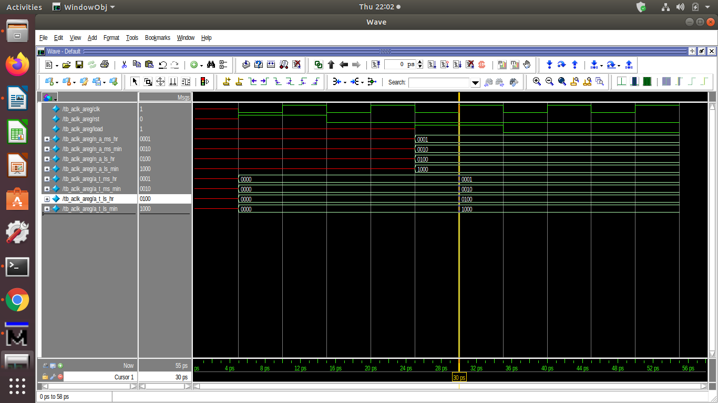

ALARM_REGISTER_SYNTHESIS

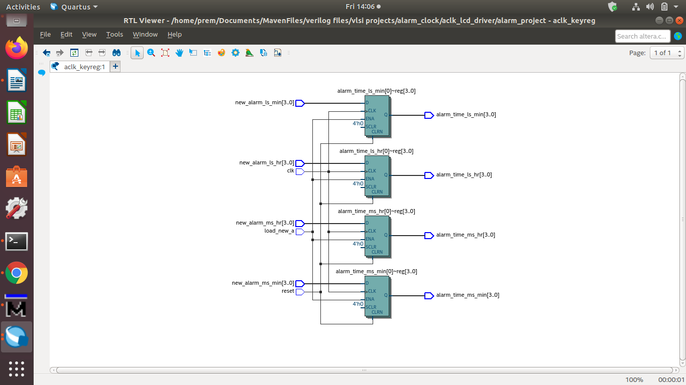

//COUNTER

module aclk_counter(clk,reset,one_minute,load_new_c,

new_current_ms_hr,new_current_ms_min,new_current_ls_hr,new_current_ls_min,

current_time_ms_hr,current_time_ms_min,current_time_ls_hr,current_time_ls_min);

input clk,reset,one_minute,load_new_c;

input[3:0] new_current_ms_hr,new_current_ms_min,new_current_ls_hr,new_current_ls_min;

output reg[3:0] current_time_ms_hr,current_time_ms_min,current_time_ls_hr,current_time_ls_min;

always@(posedge clk or posedge reset )

begin

if(reset)

begin

current_time_ms_hr<=4'd0;current_time_ms_min<=4'd0;

current_time_ls_hr<=4'd0;current_time_ls_min<=4'd0;

end

else if(load_new_c)

begin

current_time_ms_hr<=new_current_ms_hr;current_time_ms_min<=new_current_ms_min;

current_time_ls_hr<=new_current_ls_hr;current_time_ls_min<=new_current_ls_min;

end

else

begin

if(one_minute)

begin

if(current_time_ms_hr==4'd2 && current_time_ls_hr==4'd3 && current_time_ms_min==4'd5 && current_time_ls_min==4'd9)

begin

current_time_ms_hr<=4'd0;current_time_ls_hr<=4'd0;

current_time_ms_min<=4'd0;current_time_ls_min<=4'd0;

end

else if(current_time_ls_hr==4'd9 && current_time_ms_min==4'd5 && current_time_ls_min==4'd9)

begin

current_time_ms_hr<=current_time_ms_hr+1'd1;current_time_ls_hr<=4'd0;

current_time_ms_min<=4'd0;current_time_ls_min<=4'd0;

end

else if(current_time_ms_min==4'd5 && current_time_ls_min==4'd9)

begin

current_time_ls_hr<=current_time_ls_hr+1'd1;

current_time_ms_min<=4'd0;current_time_ls_min<=4'd0;

end

else if(current_time_ls_min==4'd9)

begin

current_time_ms_min<=current_time_ms_min+1'd1;current_time_ls_min<=4'd0;

end

else

current_time_ls_min<=current_time_ls_min+1'd1;

end

end

end

endmodule

//COUNTER_TESTBENCH

module tb_aclk_counter;

reg clk,reset,one_minute,load_new_c;

reg[3:0] new_current_ms_hr,new_current_ms_min,new_current_ls_hr,new_current_ls_min;

wire[3:0] current_time_ms_hr,current_time_ms_min,current_time_ls_hr,current_time_ls_min;

integer i;

aclk_counter DUT(clk,reset,one_minute,load_new_c,

new_current_ms_hr,new_current_ms_min,new_current_ls_hr,new_current_ls_min,

current_time_ms_hr,current_time_ms_min,current_time_ls_hr,current_time_ls_min);

always

begin

#5 clk=1'b0;

#5 clk=1'b1;

end

task rst;

begin

@(negedge clk) reset=1;

@(negedge clk) reset=0;

end

endtask

task load(input [3:0]ms_hr,ls_hr,ms_min,ls_min);

begin

@(negedge clk) load_new_c=1;

new_current_ms_hr<=ms_hr;new_current_ms_min<=ms_min;

new_current_ls_hr<=ls_hr;new_current_ls_min<=ls_min;

@(negedge clk) load_new_c=0;

end

endtask

task minute;

begin

@(negedge clk) one_minute=1;

@(negedge clk) one_minute=0;

end

endtask

initial

begin

rst;

for(i=0;i<1440;i=i+1)

minute;

load(1,1,1,1);

#50 $finish;

end

endmodule

COUNTER_SIMULATION

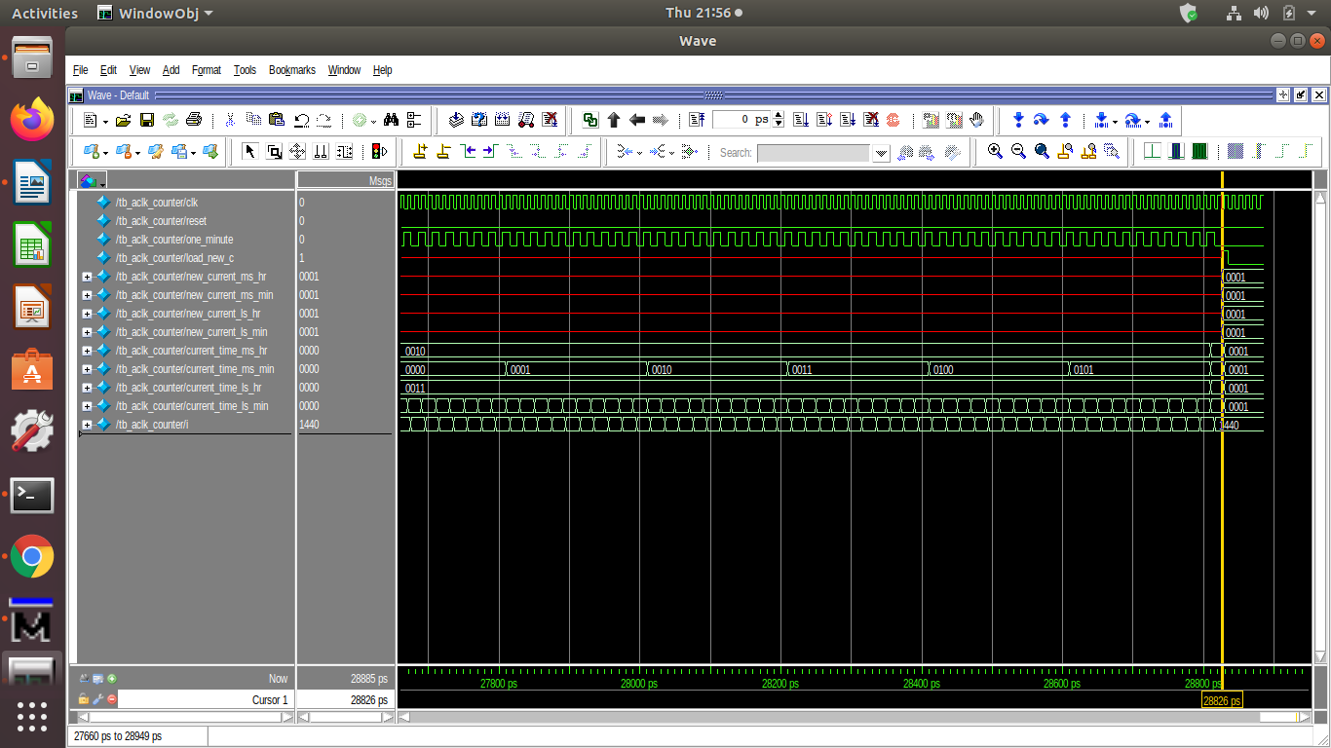

COUNTER_SYNTHESIS

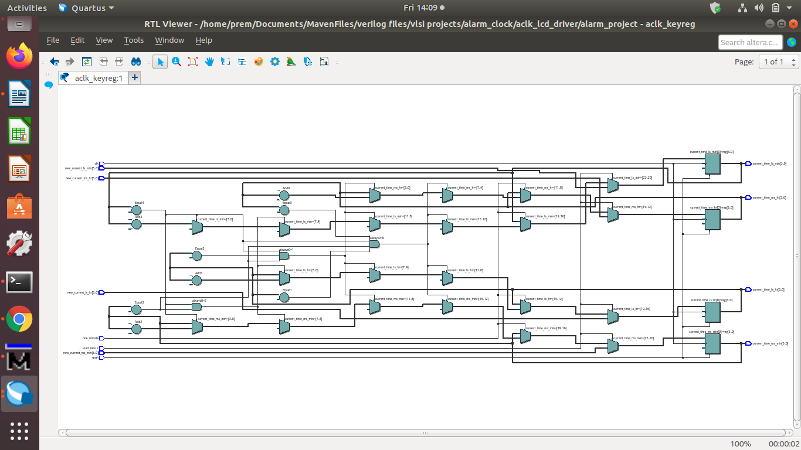

//LCD_DRIVER_MODULE

module aclk_lcd_driver(show_a,show_new_time,alarm_time,current_time,key,

display_time,sound_alarm);

input show_a,show_new_time;

input [3:0]alarm_time,current_time,key;

output reg[7:0]display_time;

output reg sound_alarm;

function [7:0]_display_time(input[3:0] in_time);

parameter ZERO=4'b0000,ONE=4'b0001,TWO=4'b0010,THREE=4'b0011,FOUR=4'b0100,

FIVE=4'b0101,SIX=4'b0110,SEVEN=4'b0111,EIGHT=4'b1000,NINE=4'b1001;

begin

case(in_time)

ZERO : _display_time=8'h30;

ONE : _display_time=8'h31;

TWO : _display_time=8'h32;

THREE : _display_time=8'h33;

FOUR : _display_time=8'h34;

FIVE : _display_time=8'h35;

SIX : _display_time=8'h36;

SEVEN : _display_time=8'h37;

EIGHT : _display_time=8'h38;

NINE : _display_time=8'h39;

default: _display_time=8'h3A;

endcase

end

endfunction

always@(*)

begin

if(!show_a && !show_new_time)

display_time=_display_time(current_time);

else if(!show_a && show_new_time)

display_time=_display_time(key);

else if(show_a && !show_new_time)

display_time=_display_time(alarm_time);

else

display_time=_display_time(current_time);

if(alarm_time==current_time)

sound_alarm=1'b1;

else

sound_alarm=1'b0;

end

endmodule

//LCD_DRIVER_TESTBENCH

module tb_aclk_lcd_driver;

reg show_a,show_new_time;

reg [3:0]alarm_time,current_time,key;

wire [7:0]display_time;

wire sound_alarm;

aclk_lcd_driver dut(.show_a(show_a),.show_new_time(show_new_time),

.alarm_time(alarm_time),.current_time(current_time),.key(key),

.display_time(display_time),.sound_alarm(sound_alarm));

initial

begin

show_a=0;show_new_time=0;

current_time=4'b0010;

alarm_time=4'b0011;

key=4'b0100;

#10 show_a=0;show_new_time=1;

current_time=4'b0010;

alarm_time=4'b0011;

key=4'b0100;

#10 show_a=1;show_new_time=0;

current_time=4'b0010;

alarm_time=4'b0011;

key=4'b0100;

#10 show_a=1;show_new_time=1;

current_time=4'b0010;

alarm_time=4'b0011;

key=4'b0100;

#10 show_a=1;show_new_time=1;

current_time=4'b0010;

alarm_time=4'b0010;

key=4'b0100;

#10 show_a=1;show_new_time=0;

current_time=4'b0110;

alarm_time=4'b0011;

key=4'b0100;

#10 $finish;

end

endmodule

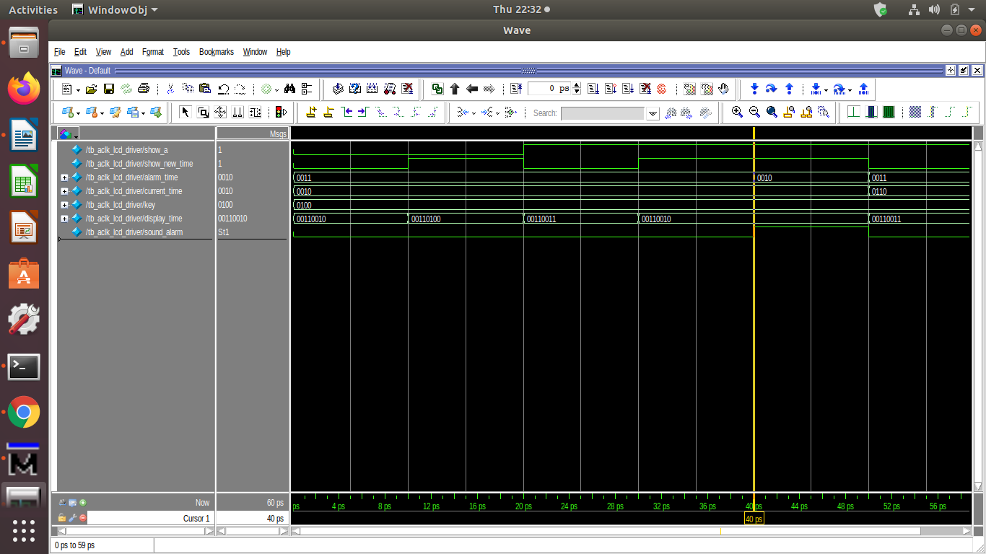LCD_DRIVER_SIMULATION

LCD_DRIVER_SYNTHESIS

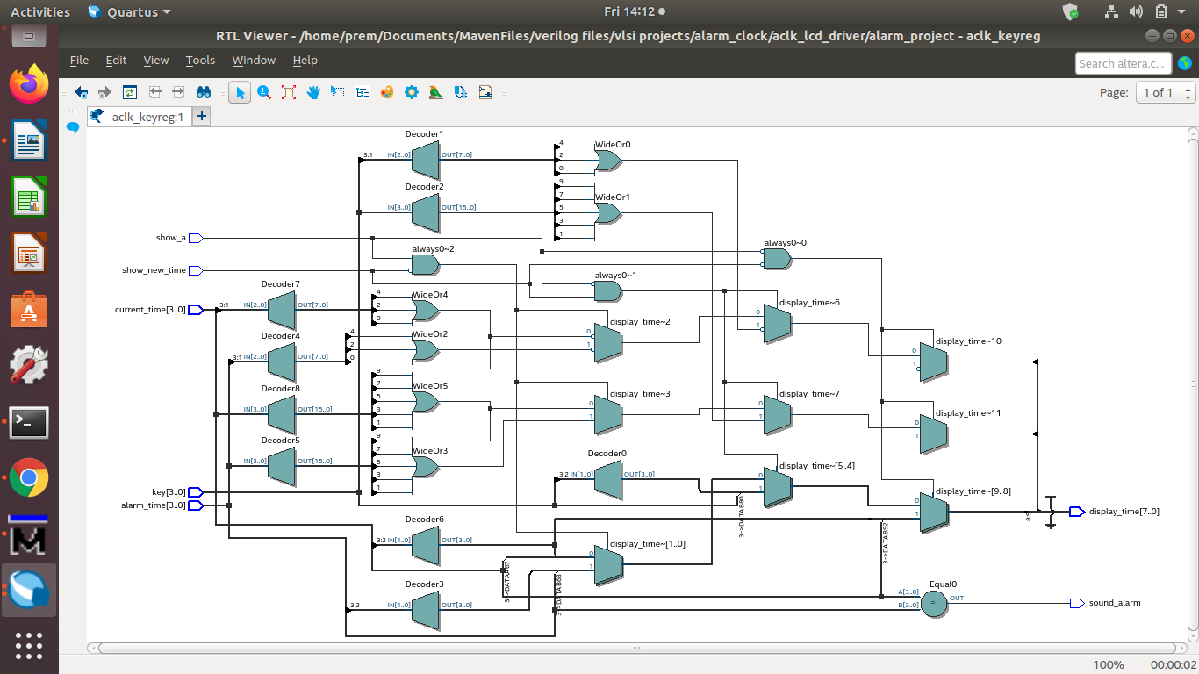

//LCD_DRIVER_UNIT

module aclk_lcd_driver_unit(show_a,show_new_time,

alarm_time_ms_hr,current_time_ms_hr,key_ms_hr,

alarm_time_ms_min,current_time_ms_min,key_ms_min,

alarm_time_ls_hr,current_time_ls_hr,key_ls_hr,

alarm_time_ls_min,current_time_ls_min,key_ls_min,

display_time_ms_hr,display_time_ms_min,

display_time_ls_hr,display_time_ls_min,

sound_alarm);

input show_a,show_new_time;

input [3:0] alarm_time_ms_hr,current_time_ms_hr,key_ms_hr;

input [3:0] alarm_time_ms_min,current_time_ms_min,key_ms_min;

input [3:0] alarm_time_ls_hr,current_time_ls_hr,key_ls_hr;

input [3:0] alarm_time_ls_min,current_time_ls_min,key_ls_min;

output [7:0]display_time_ms_hr,display_time_ms_min;

output [7:0]display_time_ls_hr,display_time_ls_min;

output wand sound_alarm;

wire sound_alarm1,sound_alarm2,sound_alarm3,sound_alarm4;

aclk_lcd_driver LCD_DR1(show_a,show_new_time,

alarm_time_ms_hr,current_time_ms_hr,key_ms_hr,

display_time_ms_hr,sound_alarm1);

aclk_lcd_driver LCD_DR2(show_a,show_new_time,

alarm_time_ms_min,current_time_ms_min,key_ms_min,

display_time_ms_min,sound_alarm2);

aclk_lcd_driver LCD_DR3(show_a,show_new_time,

alarm_time_ls_hr,current_time_ls_hr,key_ls_hr,

display_time_ls_hr,sound_alarm3);

aclk_lcd_driver LCD_DR4(show_a,show_new_time,

alarm_time_ls_min,current_time_ls_min,key_ls_min,

display_time_ls_min,sound_alarm4);

assign sound_alarm=sound_alarm1 && sound_alarm2 && sound_alarm3 && sound_alarm4;

endmodule

//LCD_DRIVER_UNIT_TESTBENCH

module tb_aclk_lcd_driver_unit;

reg show_a,show_new_time;

reg[3:0] a_t_ms_hr,c_t_ms_hr,k_ms_hr;

reg[3:0] a_t_ms_min,c_t_ms_min,k_ms_min;

reg[3:0] a_t_ls_hr,c_t_ls_hr,k_ls_hr;

reg[3:0] a_t_ls_min,c_t_ls_min,k_ls_min;

wire[7:0] disp_t_ms_hr,disp_t_ms_min;

wire[7:0] disp_t_ls_hr,disp_t_ls_min;

wire sound_alarm;

aclk_lcd_driver_unit DUT(.show_a(show_a),.show_new_time(show_new_time),

.alarm_time_ms_hr(a_t_ms_hr),.current_time_ms_hr(c_t_ms_hr),.key_ms_hr(k_ms_hr),

.alarm_time_ms_min(a_t_ms_min),.current_time_ms_min(c_t_ms_min),.key_ms_min(k_ms_min),

.alarm_time_ls_hr(a_t_ls_hr),.current_time_ls_hr(c_t_ls_hr),.key_ls_hr(k_ls_hr),

.alarm_time_ls_min(a_t_ls_min),.current_time_ls_min(c_t_ls_min),.key_ls_min(k_ls_min),

.display_time_ms_hr(disp_t_ms_hr),.display_time_ms_min(disp_t_ms_min),

.display_time_ls_hr(disp_t_ls_hr),.display_time_ls_min(disp_t_ls_min),

.sound_alarm(sound_alarm));

task stimulus_alarm(input[3:0]i,j,k,l);

begin

a_t_ms_hr=i;

a_t_ms_min=k;

a_t_ls_hr=j;

a_t_ls_min=l;

end

endtask

task stimulus_current(input[3:0]i,j,k,l);

begin

c_t_ms_hr=i;

c_t_ms_min=k;

c_t_ls_hr=j;

c_t_ls_min=l;

end

endtask

task stimulus_key(input[3:0]i,j,k,l);

begin

k_ms_hr=i;

k_ms_min=k;

k_ls_hr=j;

k_ls_min=l;

end

endtask

task delay;

#10;

endtask

task sel_time(input[1:0]i);

begin

show_a=i[0];show_new_time=i[1];

end

endtask

initial

begin

//initialize

sel_time(0);

stimulus_current(0,0,0,0);

stimulus_alarm(0,0,0,0);

stimulus_key(0,0,0,0);

delay;

//current time

sel_time(0);

stimulus_current(0,9,0,0);

stimulus_alarm(0,0,8,0);

stimulus_key(0,0,4,0);

delay;

//alarm time

sel_time(1);

delay;

//key time

sel_time(2);

delay;

//testing alarm sound

stimulus_current(0,0,1,0);

stimulus_alarm(0,0,1,0);

delay;

//testing alarm sound

stimulus_current(0,1,1,0);

stimulus_alarm(0,0,1,0);

delay;

$finish;

end

endmodule

LCD_DRIVER_UNIT_SIMULATION

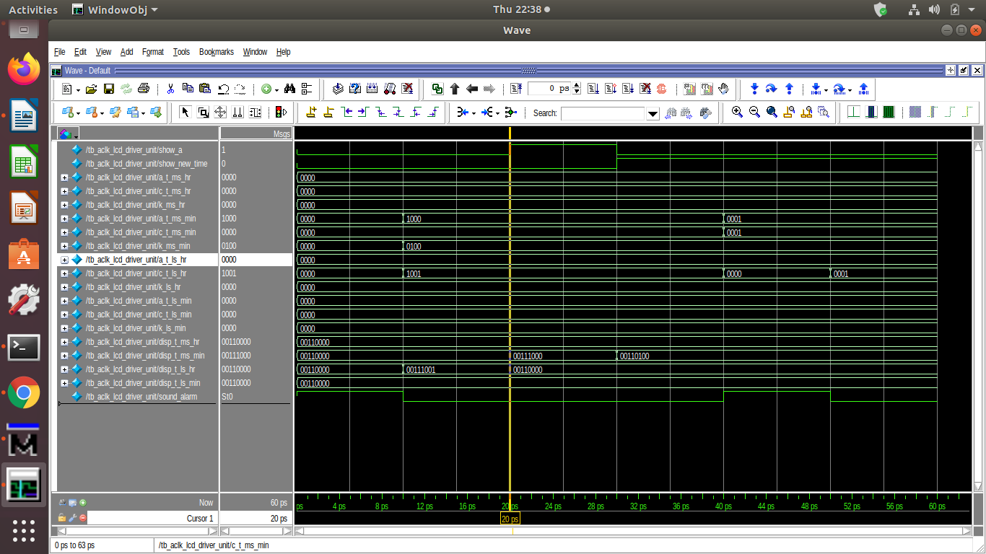

LCD_DRIVER_UNIT_SYNTHESIS

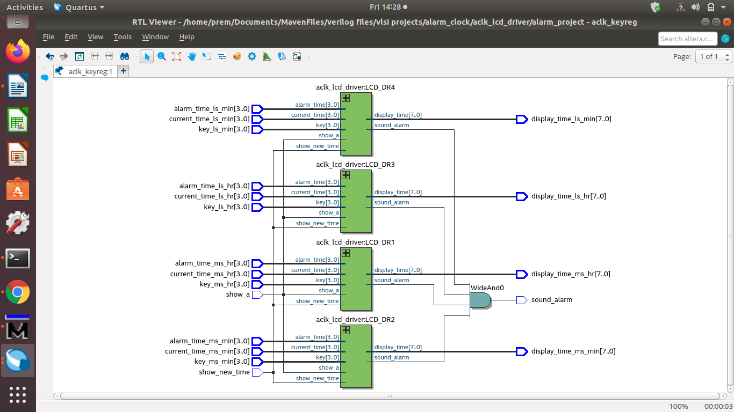

//ALARM_TOP

module alarm_clk_rtl(clk,reset,alarm_button,time_button,key,fast_watch,

sound_alarm,

display_ms_hr,display_ls_hr,display_ms_min,display_ls_min);

input clk,reset,alarm_button,time_button,fast_watch;

input [3:0]key;

output reg sound_alarm;

output reg [7:0]display_ms_hr,display_ls_hr,display_ms_min,display_ls_min;

wire sound_alarm1;

wire show_a,show_new_time;

wire [3:0] alarm_time_ms_hr,current_time_ms_hr,key_ms_hr;

wire [3:0] alarm_time_ms_min,current_time_ms_min,key_ms_min;

wire [3:0] alarm_time_ls_hr,current_time_ls_hr,key_ls_hr;

wire [3:0] alarm_time_ls_min,current_time_ls_min,key_ls_min;

wire [7:0]display_time_ms_hr,display_time_ms_min;

wire [7:0]display_time_ls_hr,display_time_ls_min;

wire load_new_a;

wire new_alarm_ms_hr,new_alarm_ms_min;

wire new_alarm_ls_hr,new_alarm_ls_min;

wire one_minute,reset_count;

wire[3:0] new_current_ms_hr,new_current_ms_min,new_current_ls_hr,new_current_ls_min;

wire load_new_c;

wire[3:0] key_buffer_ms_hr,key_buffer_ms_min,key_buffer_ls_hr,key_buffer_ls_min;

wire shift;

aclk_lcd_driver_unit LCD_DRIVER(show_a,show_new_time,

alarm_time_ms_hr,current_time_ms_hr,key_ms_hr,

alarm_time_ms_min,current_time_ms_min,key_ms_min,

alarm_time_ls_hr,current_time_ls_hr,key_ls_hr,

alarm_time_ls_min,current_time_ls_min,key_ls_min,

display_time_ms_hr,display_time_ms_min,

display_time_ls_hr,display_time_ls_min,

sound_alarm1);

aclk_areg ALARM_REG(clk,reset,load_new_a,

new_alarm_ms_hr,new_alarm_ms_min,

new_alarm_ls_hr,new_alarm_ls_min,

alarm_time_ms_hr,alarm_time_ms_min,

alarm_time_ls_hr,alarm_time_ls_min);

aclk_timegen TIME_GEN(clk,reset,reset_count,fast_watch,one_second,one_minute);

aclk_counter COUNTER(clk,reset,one_minute,load_new_c,

new_current_ms_hr,new_current_ms_min,new_current_ls_hr,new_current_ls_min,

current_time_ms_hr,current_time_ms_min,current_time_ls_hr,current_time_ls_min);

aclk_keyreg KEY_REG(clk,reset,key,shift,

key_buffer_ms_hr,key_buffer_ms_min,key_buffer_ls_hr,key_buffer_ls_min);

aclk_controller CONTROLLER(clk,reset,one_second,alarm_button,time_button,key,

reset_count,load_new_c,show_new_time,show_a,load_new_a,shift);

always@(*)

begin

if(reset)

begin

sound_alarm<=0;

display_ms_hr<=0;display_ls_hr<=0;

display_ms_min<=0;display_ls_min<=0;

end

else

begin

sound_alarm<=sound_alarm1;

display_ms_hr<=display_time_ms_hr;display_ls_hr<=display_time_ls_hr;

display_ms_min<=display_time_ms_min;display_ls_min<=display_time_ls_min;

end

end

assign one_minute=(fast_watch)?one_second:one_minute;

endmodule

//ALARM_TOP_TESTBENCH

`timescale 1ms/1ns

module tb_alarm_clk;

reg clk,reset,alarm_button,time_button,fast_watch;

reg [3:0]key;

wire sound_alarm;

wire [7:0]display_ms_hr,display_ls_hr,display_ms_min,display_ls_min;

alarm_clk_rtl DUT(clk,reset,alarm_button,time_button,key,fast_watch,sound_alarm,

display_ms_hr,display_ls_hr,display_ms_min,display_ls_min);

integer l,k;

always

begin

#1.953125 clk=1'b0;

#1.953125 clk=1'b1;

end

task rst;

begin

reset=1;

@(negedge clk) reset=0;

end

endtask

task _key(input [3:0]a);

begin

@(negedge clk);

key=a;

@(negedge clk) ;

end

endtask

task _ta_button(input t,a);

begin

@(negedge clk) time_button=t;

alarm_button=a;

@(negedge clk) time_button=1'b0;

alarm_button=1'b0;

end

endtask

initial

begin

rst;

_key(4'd0);

_key(4'd10);

_key(4'd9);

_key(4'd10);

_key(4'd5);

_key(4'd10);

_key(4'd3);

_key(4'd10);

_ta_button(1'b1,1'b0);

_key(4'd0);

_key(4'd10);

_key(4'd9);

_key(4'd10);

_key(4'd5);

_key(4'd10);

_key(4'd5);

_key(4'd10);

_ta_button(1'b0,1'b1);

fast_watch=1'b1;

for(k=0;k<3;k=k+1)

begin

for(l=0;l<256;l=l+1)

#3.906250;

end

_key(4'd0);

_key(4'd10);

_key(4'd9);

_key(4'd10);

_key(4'd5);

_key(4'd10);

_key(4'd3);

_key(4'd10);

_ta_button(1'b1,1'b0);

fast_watch=1'b0;

for(k=0;k<122;k=k+1)

begin

for(l=0;l<256;l=l+1)

#3.906250;

end

$finish;

end

endmodule

ALARM_TOP_SIMULATIONS

(fast_watch=1)

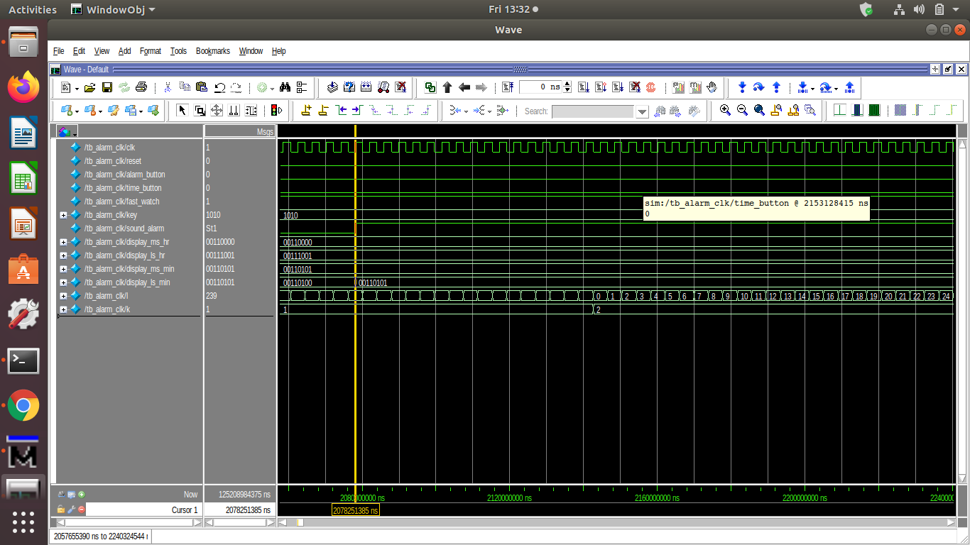

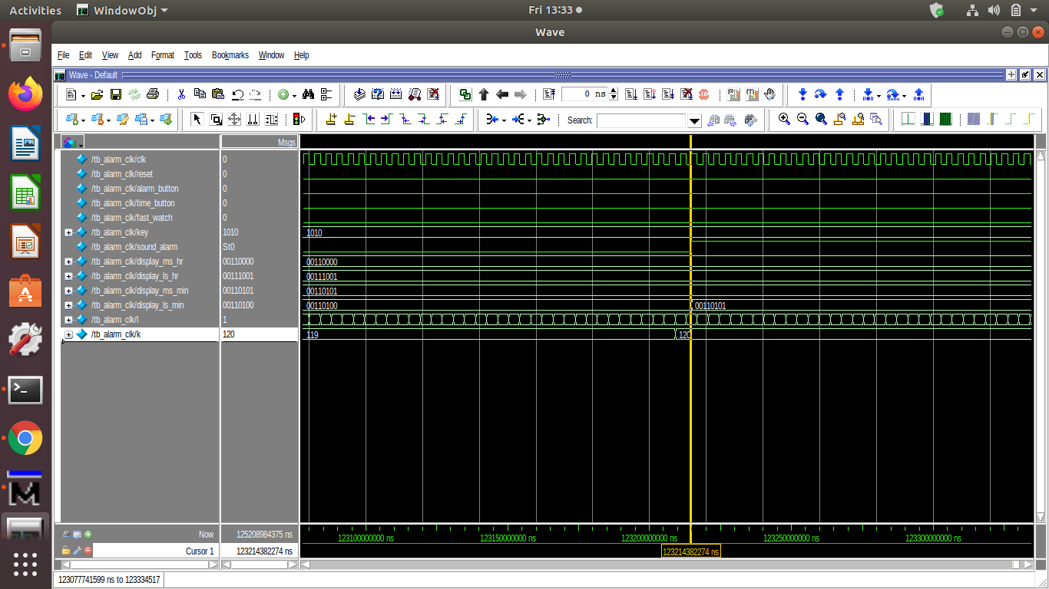(fast_watch=0)

ALARM_TOP_SYNTHESIS

