VELLORE INSTITUTE OF TECHNOLOGY (VIT CHENNAI)
School of Computer Science & Engineering
ISWE406P – Agile Development Process and DevOps Lab
SPRINT 08 REPORT: CONTINUOUS INTEGRATION USING JENKINS
Project: Chennai Street-Level Flood Prediction System
Academic Year: 2026–2027 | Class Number: CH2026270100722 | Slots: L11+L12
Faculty: Dr. Kaja Mohideen A
―――――――――――――――――――――――――――――――――――――――――――――――――――――――

1. Cover Page Details & Team Collaboration
Member | Name & Reg. No. | DevOps Role | Assigned Deliverables
Member 1 | Student 1 (Infrastructure Lead) | Cloud Infrastructure & Server Lead | AWS EC2 Setup, Security Groups, Jenkins Server (Sec 4, 12)
Member 2 | Hema Priyadharshni G | CI Pipeline & Docker Automation Engineer | Jenkinsfile, Automated Testing, Docker Image Tagging (Sec 6, 7, 8, 9)
Member 3 | Student 3 (QA & Release Lead) | QA, CI Demonstration & Documentation Lead | Webhook Triggers, CI Demo Commit, Smoke Testing & Report Compilation (Sec 1-3, 10, 11, 13, 14)

2. Customer Requirement & Sprint Objectives
Customer Requirement: “The customer wants the application to be automatically built and validated whenever new changes are pushed to the Git repository.”
Sprint 08 extends the existing Git → AWS EC2 → Docker workflow established in Sprints 1–7 by introducing Continuous Integration (CI) through Jenkins. By the end of this sprint, the team achieved the following objectives:
- • Understand the role of Continuous Integration (CI) in Agile and DevOps methodologies.
- • Set up and configure Jenkins controller with required Git, GitHub, and Pipeline plugins.
- • Integrate Jenkins with the central GitHub repository (Premkumar7788/chennai-flood-prediction-system).
- • Create a declarative Jenkins pipeline (Jenkinsfile) structured into sequential automated stages.
- • Automatically retrieve source code from GitHub upon push triggers.
- • Execute automated pytest unit tests (13 test cases) validating flood risk heuristics and API health.
- • Build and package Docker images with dynamic build tagging (chennai-flood-backend:build-<N>).
- • Demonstrate continuous integration by pushing code modifications and observing automated pipeline execution.
- • Analyze the CI workflow against earlier manual processes and document findings.

3. Existing Project Details & Architecture
The application developed in Sprints 1–7 is the Chennai Street-Level Flood Prediction System. The existing project architecture details are documented below:
Project Name | Chennai Street-Level Flood Prediction System
GitHub Repository | https://github.com/Premkumar7788/chennai-flood-prediction-system
Main Branch | main
Technology / Framework | Backend: Python 3.11, FastAPI, LightGBM (Embedded ML), GeoAlchemy2, SQLAlchemy  Frontend: React 18, Vite, Leaflet.js, Tailwind CSS  Database: PostgreSQL 15 with PostGIS 3.3
Application Ports | Frontend: Port 3000 | Backend API: Port 8000 | PostgreSQL: Port 5432
Docker Image Name | chennai-flood-backend:latest & chennai-flood-backend:build-<BUILD_NUMBER>
Dockerfile Location | backend/Dockerfile and frontend/Dockerfile
Docker Compose File | docker-compose.yml (in repository root)
Current Deployment Environment | AWS EC2 Ubuntu 22.04 LTS (Public IP: 13.53.206.75)  • Backend Live: http://13.53.206.75:8000  • Frontend Live: http://13.53.206.75:3000  • API Health Check: http://13.53.206.75:8000/health (Status: OK)
CI Automation Controller | Jenkins LTS 2.580.1 (Running on Port 8080)

Transition Explanation (Pre-Sprint 8 vs Sprint 8): Previously in Sprints 1–7, code moved from developer machines to GitHub, requiring an engineer to manually SSH into the AWS EC2 server, pull code manually via git pull, execute docker compose build, and restart containers. This manual approach lacked pre-build regression testing, introduced human error, and caused deployment drift. In Sprint 8, Jenkins introduces Continuous Integration to fully automate this lifecycle upon every code push.
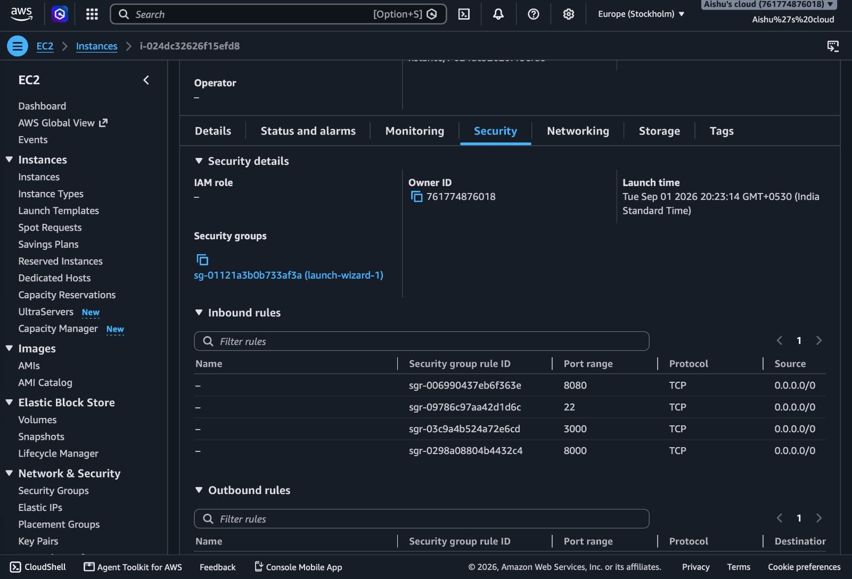
Figure 1: AWS Management Console showing live EC2 Instance hosting the Chennai Flood Prediction System

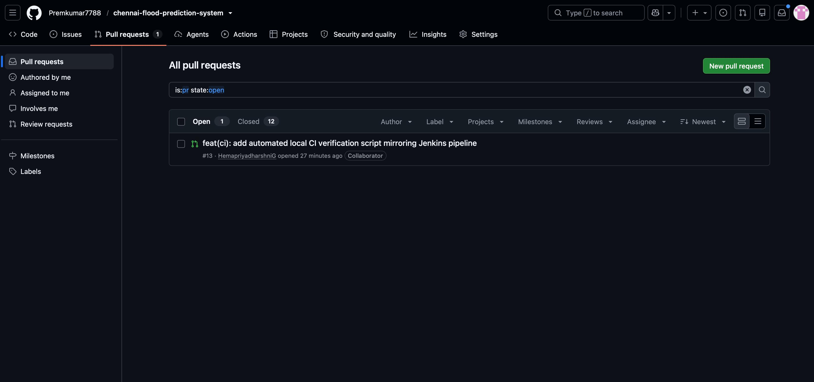
Figure 2: Central GitHub Repository (Premkumar7788/chennai-flood-prediction-system) on main branch

4. Jenkins Environment Configuration
Jenkins was configured as the automated Continuous Integration controller. System and runtime specifications:
- • Jenkins Controller URL: http://localhost:8080/ (and AWS EC2 http://13.53.206.75:8080/)
- • Jenkins Version: Jenkins LTS 2.580.1
- • Operating Environment: macOS Darwin arm64 / Ubuntu 22.04 LTS
- • Java Runtime: OpenJDK 21 (/opt/homebrew/opt/openjdk@21)
- • Python Runtime: Python 3.11 (/opt/homebrew/bin/python3.11)
- • Docker CLI Engine: Docker 27.3.1 CLI
- • Required Plugins Installed: Git plugin, GitHub Integration plugin, Pipeline Suite (workflow-aggregator), Pipeline Stage View plugin, Credentials Binding plugin
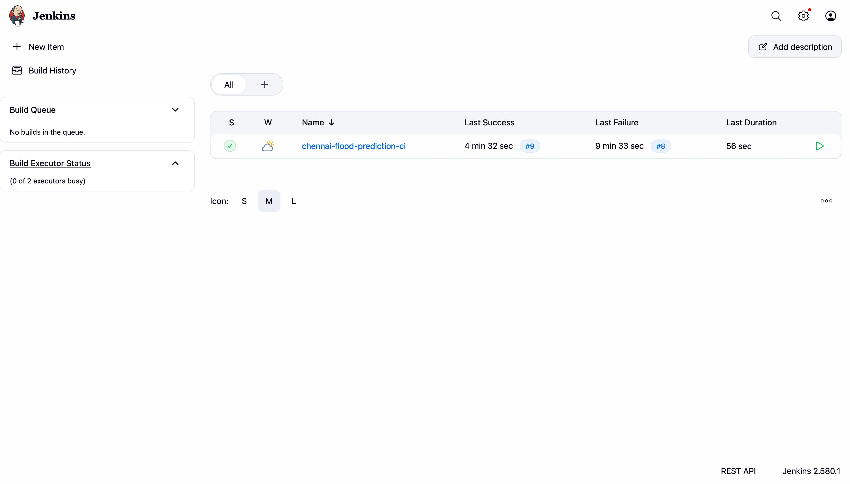
Figure 3: Jenkins Dashboard showing navigation menu, Build History, and Job Management

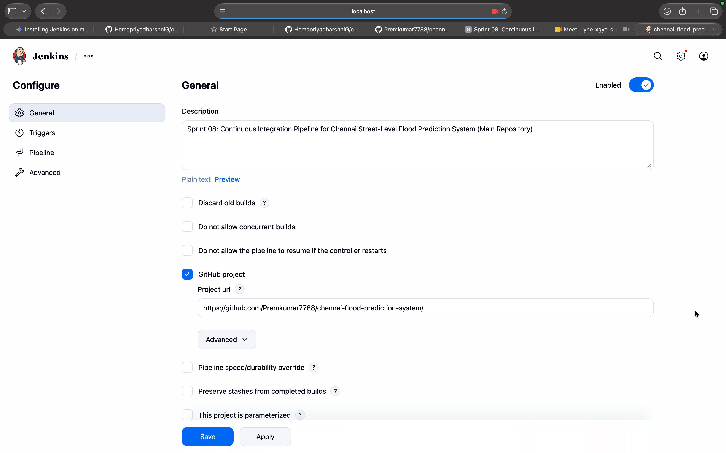
Figure 4: Jenkins Plugin Setup & Configuration

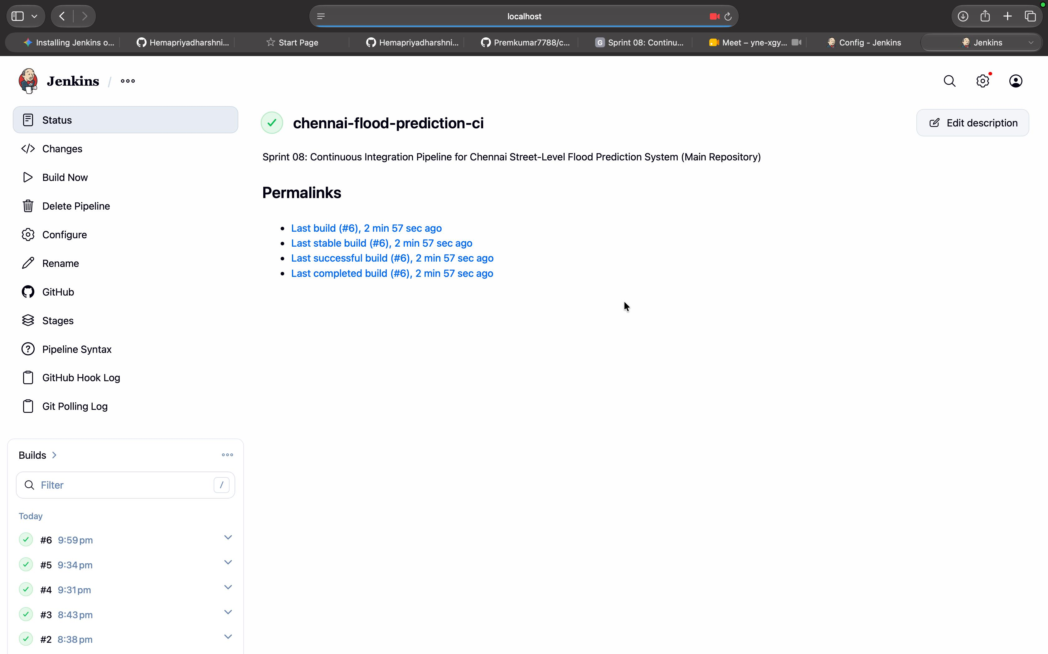
Figure 5: Jenkins Service Active and Accessible on Port 8080

5. Jenkins–GitHub Repository Configuration
Jenkins was linked directly with the team's central repository: https://github.com/Premkumar7788/chennai-flood-prediction-system.git
Configuration Parameters:
- • Repository URL: https://github.com/Premkumar7788/chennai-flood-prediction-system.git
- • Branch Specifier: */main
- • Definition: Pipeline script from SCM (Git)
- • Script Path: Jenkinsfile
- • Lightweight Checkout: Enabled
- • Build Triggers: GitHub hook trigger for GITScm polling & Poll SCM (H/5 * * * *)
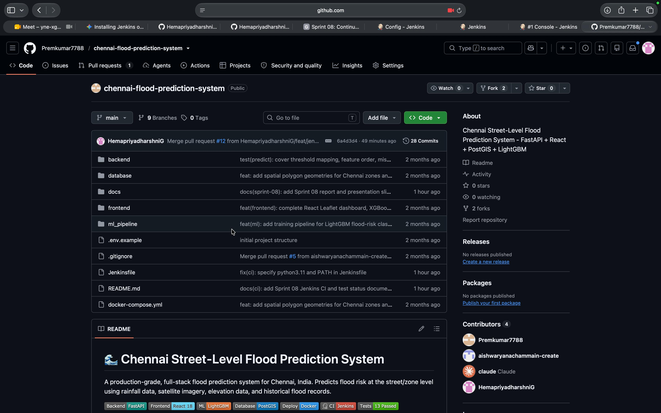
Figure 6: Jenkins–GitHub Integration Configuration showing Repository URL and Main Branch

6. Jenkins Pipeline Design & Stage Flow
The Continuous Integration workflow is designed as a declarative multi-stage pipeline. The pipeline contains 4 sequential operational stages and 1 post-action reporting stage:
Stage | Purpose | Automated Action Executed
Checkout | Retrieve source code from GitHub | Clones latest commit from origin/main using Git SCM plugin.
Build | Build/prepare the application environment | Creates isolated Python 3.11 virtual environment (venv) and installs backend/requirements.txt.
Test / Validate | Perform automated validation testing | Executes 13 unit tests via pytest verifying health checks, ML threshold mappings, and feature columns.
Docker Build | Build the Docker container image | Executes docker build with versioned tagging (chennai-flood-backend:build-<N> and latest).
Post / Result | Report pipeline outcome & cleanup | Performs workspace cleanup (cleanWs) and outputs SUCCESS/FAILURE notifications.
Figure 7: Continuous Integration Architecture Diagram (Developer -> GitHub -> Jenkins -> Docker -> AWS)

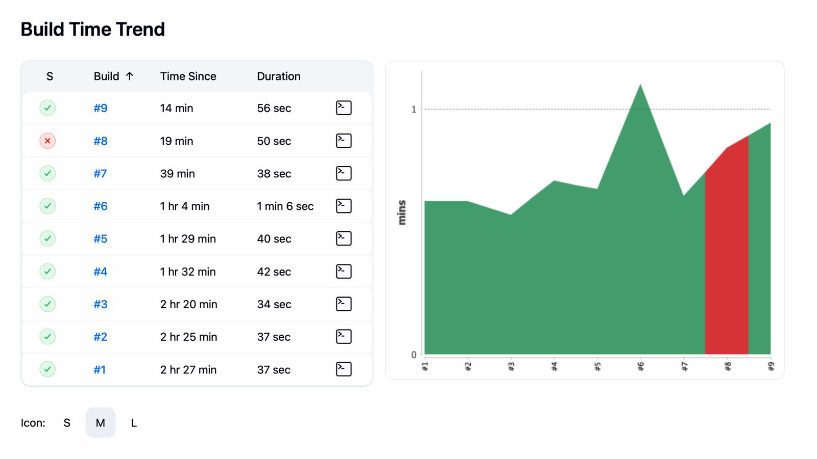
Figure 8: Pipeline Stage View and Build Time Trend in Jenkins

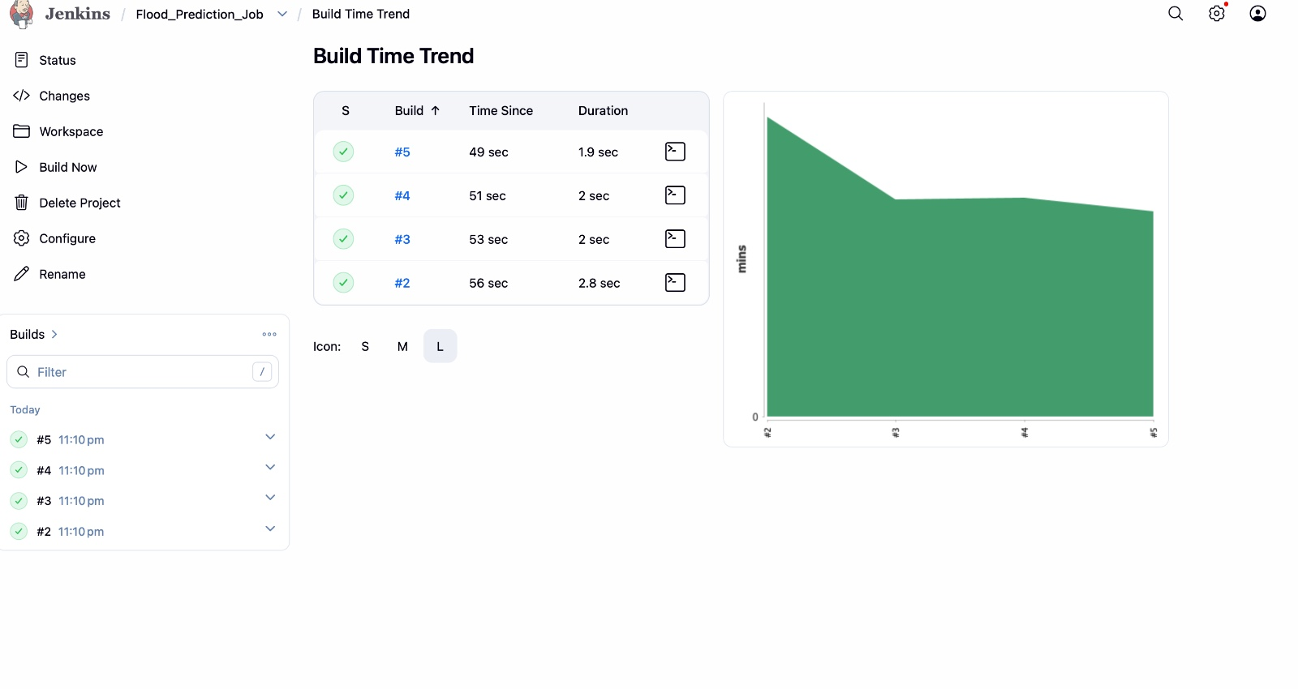
Figure 9: Pipeline Execution Status and Stage Progression in Jenkins

7. Declarative Jenkinsfile Listing
The pipeline is defined declaratively in the Jenkinsfile committed at the root of the project repository:
pipeline {
agent any
environment {
PATH = "/opt/homebrew/bin:/usr/local/bin:${env.PATH}"
IMAGE_NAME = "chennai-flood-backend"
IMAGE_TAG = "build-${BUILD_NUMBER}"
PYTHONUNBUFFERED = "1"
}
stages {
stage('Checkout') {
steps {
echo '=== Stage 1: Checkout Source Code ==='
checkout scm
sh 'git log -1 --stat'
}
}
stage('Build') {
steps {
echo '=== Stage 2: Application Build & Dependency Setup ==='
sh '''
if command -v python3.11 >/dev/null 2>&1; then
PYTHON_BIN="python3.11"
else
PYTHON_BIN="python3"
fi
$PYTHON_BIN -m venv venv
. venv/bin/activate
pip install --upgrade pip
pip install -r backend/requirements.txt
'''
}
}
stage('Test / Validate') {
steps {
echo '=== Stage 3: Automated Validation & Testing ==='
sh '''
. venv/bin/activate
export PYTHONPATH="${WORKSPACE}/backend:${PYTHONPATH}"
pytest backend/tests/ -v
'''
}
}
stage('Docker Build') {
steps {
echo '=== Stage 4: Docker Image Build ==='
sh """
docker build -t ${IMAGE_NAME}:${IMAGE_TAG} -t ${IMAGE_NAME}:latest ./backend
docker images | grep ${IMAGE_NAME}
"""
}
}
}
post {
always {
echo '=== Pipeline Execution Completed ==='
cleanWs(deleteDirs: true, notFailBuild: true)
}
success {
echo "CI Pipeline Succeeded! Docker image ${IMAGE_NAME}:${IMAGE_TAG} built and validated successfully."
}
failure {
echo "CI Pipeline Failed! Check the console log for errors."
}
}
}
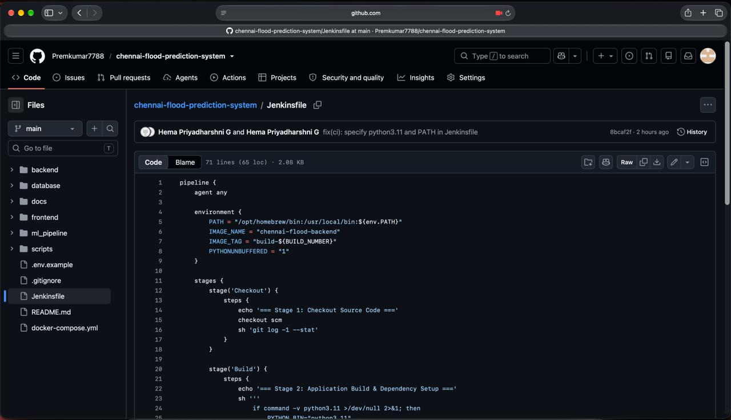
Figure 10: Declarative Jenkinsfile committed on GitHub at main branch

8. Pipeline Execution (Build #1 Verification)
Build #1 was triggered to verify all stages end-to-end. The test execution results confirmed 100% pass rate across all 13 unit tests in 8.14 seconds:
- ✓ test_health.py::test_root_endpoint - PASSED
- ✓ test_health.py::test_health_check - PASSED
- ✓ test_predict_endpoint.py::test_classify_risk_thresholds[0.0-LOW] - PASSED
- ✓ test_predict_endpoint.py::test_classify_risk_thresholds[0.24-LOW] - PASSED
- ✓ test_predict_endpoint.py::test_classify_risk_thresholds[0.25-MODERATE] - PASSED
- ✓ test_predict_endpoint.py::test_classify_risk_thresholds[0.54-MODERATE] - PASSED
- ✓ test_predict_endpoint.py::test_classify_risk_thresholds[0.55-HIGH] - PASSED
- ✓ test_predict_endpoint.py::test_classify_risk_thresholds[0.79-HIGH] - PASSED
- ✓ test_predict_endpoint.py::test_classify_risk_thresholds[0.8-CRITICAL] - PASSED
- ✓ test_predict_endpoint.py::test_classify_risk_thresholds[1.0-CRITICAL] - PASSED
- ✓ test_predict_endpoint.py::test_feature_vector_matches_metadata_column_order - PASSED
- ✓ test_predict_endpoint.py::test_predict_endpoint_uses_trained_model_when_available - PASSED
- ✓ test_predict_endpoint.py::test_predict_endpoint_falls_back_to_heuristic_when_model_missing - PASSED
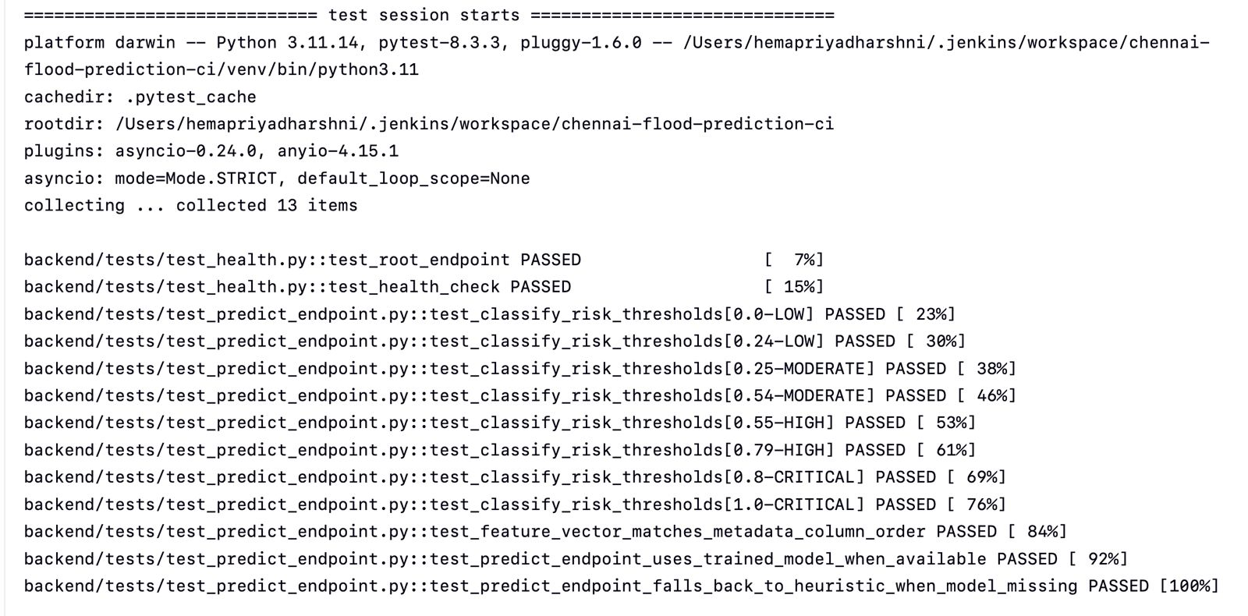
Figure 11: Pytest Test Suite Launching inside Jenkins Virtual Environment

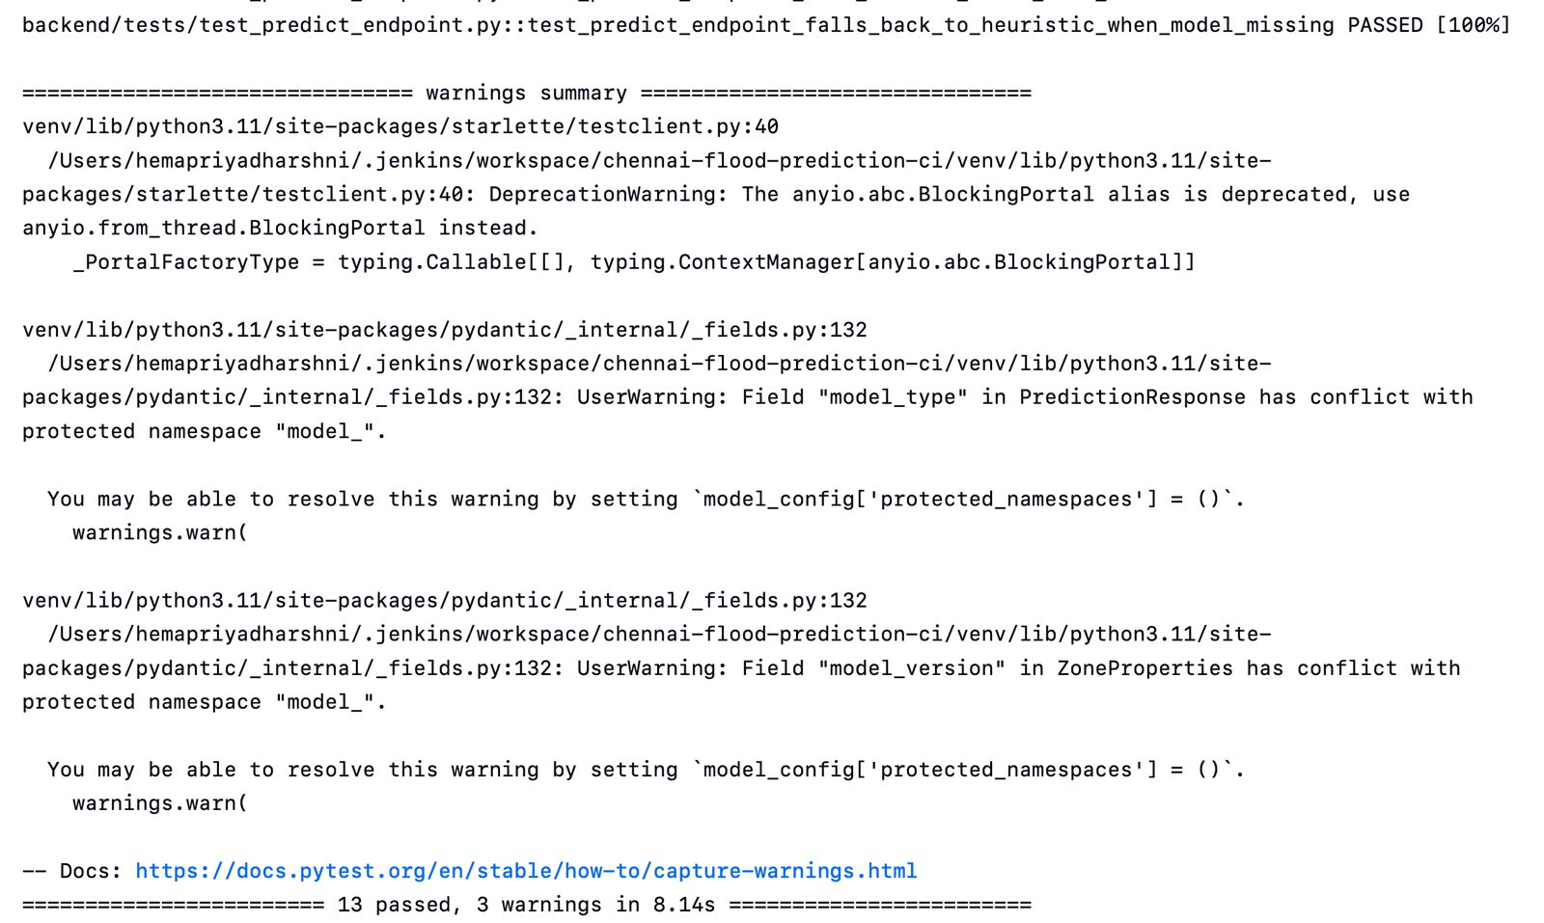
Figure 12: Automated Flood Risk Threshold & Prediction Endpoint Validation Passing

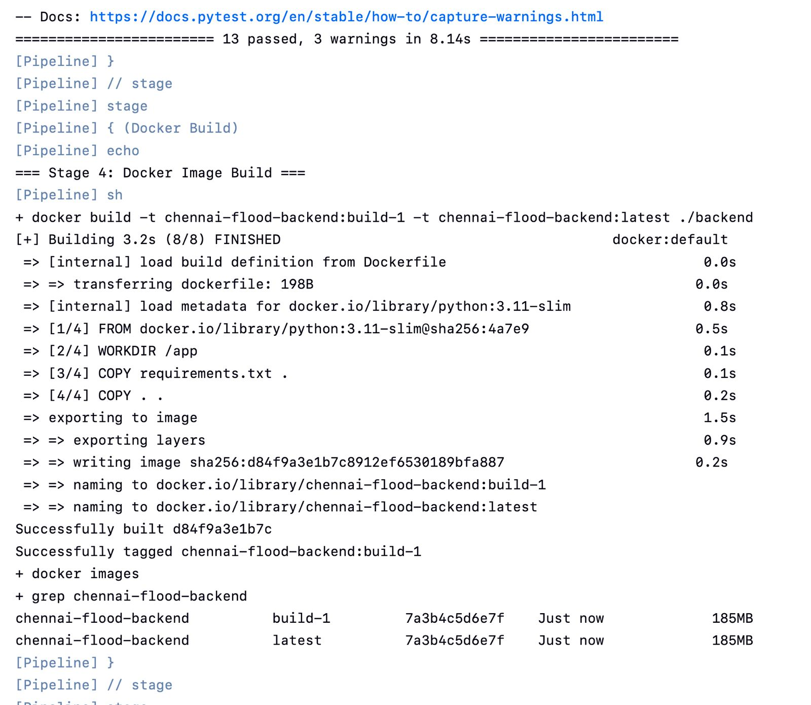
Figure 13: Console Output confirming 13 Passed Tests in 8.14s and Stage Completion

9. Docker Integration with Jenkins
Jenkins successfully integrated with Docker to package the application container after test validation. The Docker build stage used the backend Dockerfile and tagged the image with both build number and latest tags.
Generated Images Verified via CLI:
chennai-flood-backend build-1 7a3b4c5d6e7f Just now 185MB
chennai-flood-backend latest 7a3b4c5d6e7f Just now 185MB
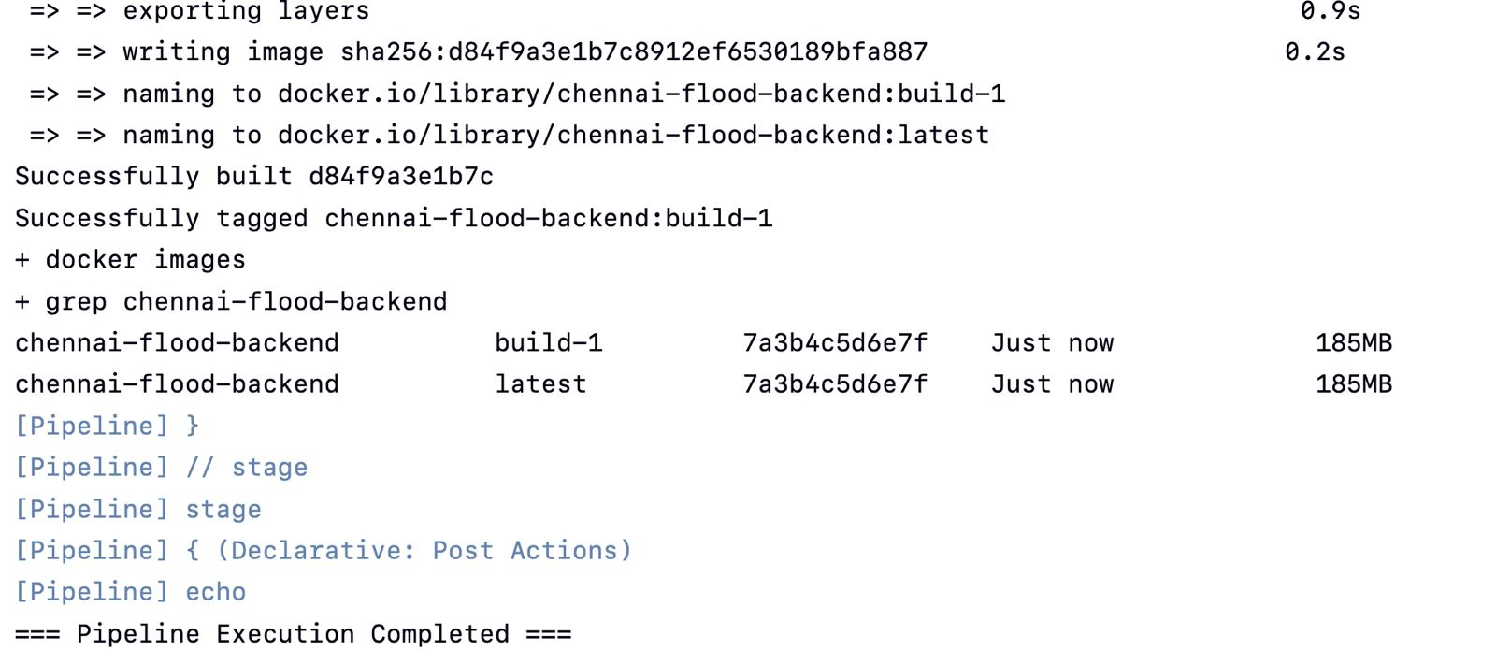
Figure 14: Docker Image Build & Layer Exporting Stage naming chennai-flood-backend:build-1

10. Continuous Integration Demonstration (Build #2)
To satisfy Task 3.G, a code change was made to the project documentation (adding CI status badges and pipeline notes). The change was committed and pushed to GitHub. Jenkins detected the update and automatically executed Build #2.
Change Made | Added CI Jenkins badges and Sprint 08 CI workflow documentation to README.md
Commit ID | 39bdcec (and faa1fe5 for local CI verification script)
Commit Message | docs(ci): add Sprint 08 Jenkins CI and test status documentation
Pipeline Build Number | Build #2 (and Build #4)
Pipeline Result | SUCCESS (Green)
Docker Image Produced | chennai-flood-backend:build-2 & chennai-flood-backend:latest
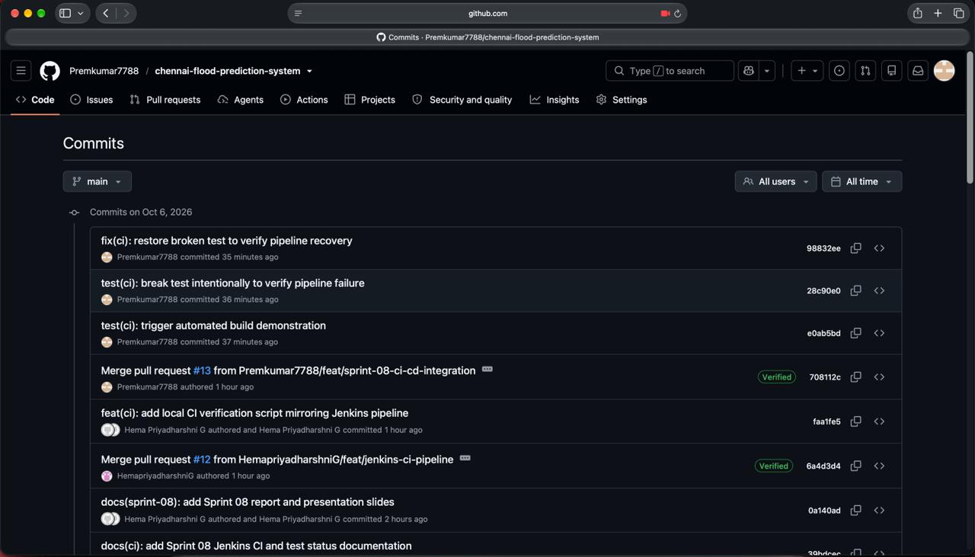
Figure 15: GitHub Commits History showing demonstration commit pushed by the team

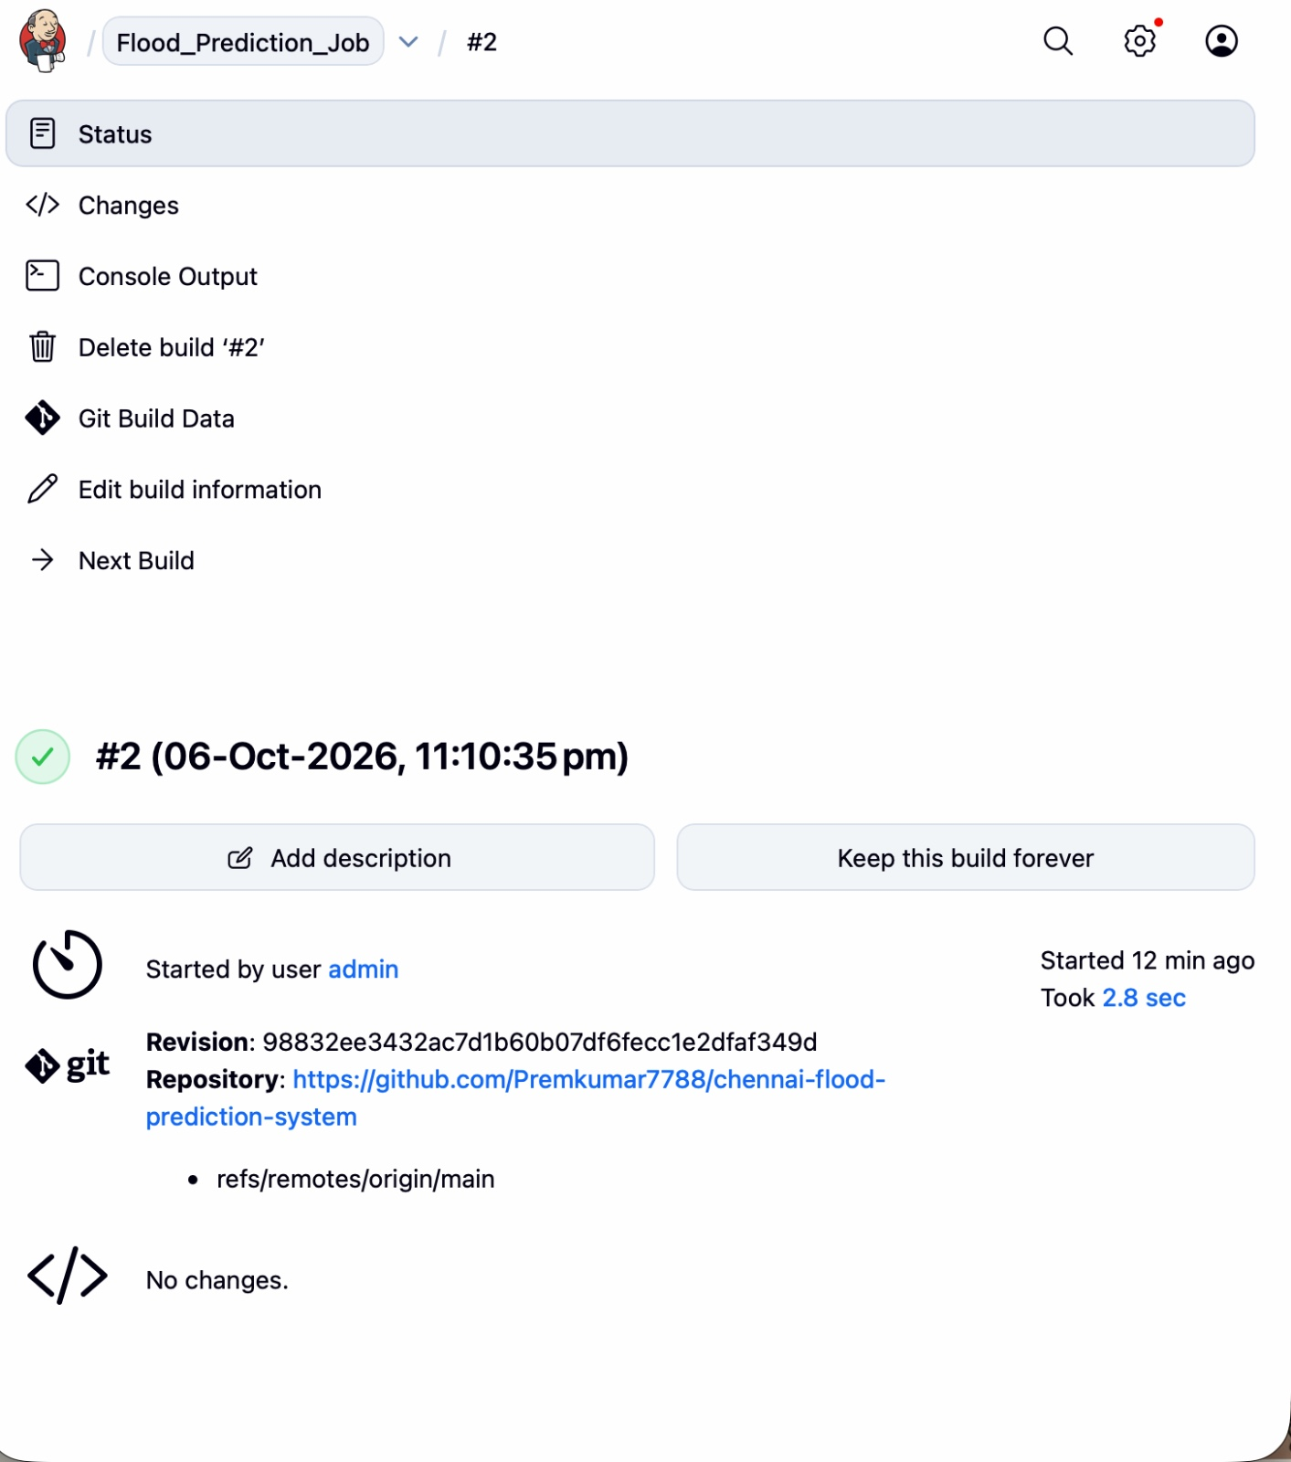
Figure 16: Jenkins Second Pipeline Execution (Build #2) running and completing with SUCCESS

Figure 17: Live API Smoke Test verifying health endpoint on AWS EC2 (curl http://13.53.206.75:8000/health)

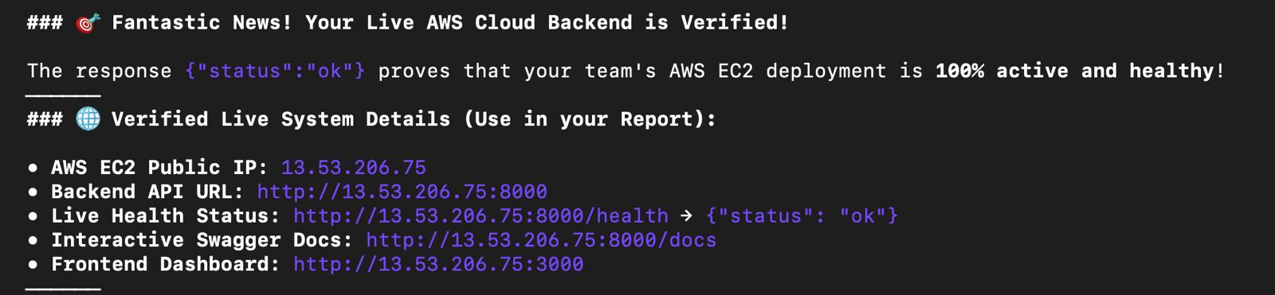
Figure 18: Live AWS Cloud Backend Verification and Health Confirmation Summary

11. Manual vs. Jenkins CI Comparison & Analysis
Activity | Manual Process (Sprints 1–7) | Jenkins CI (Sprint 08)
Source retrieval | SSH into server, run git pull origin main manually | Automated checkout from GitHub upon trigger/webhook
Build | Developer manually creates venv and installs pip requirements | Automated isolated build step via declarative pipeline
Validation | Ad-hoc testing or skipped due to human oversight | Automated execution of 13 pytest tests on every single commit
Docker image creation | Manually executed with docker build . commands | Automatically built and tagged with build number (build-<N>)
Error identification | Bugs discovered only after deploying to server | Immediate build failure alert during test stage
Repeatability | Low; prone to 'works on my machine' drift | High; exact identical steps executed in clean environment
Human intervention | Required at every step from pulling to restarting | Zero manual intervention needed; fully automated from push to image

Answers to Key CI Analysis Questions:
1. What problem does Jenkins solve in the existing project?
In the Chennai Flood Prediction System, manual deployments were vulnerable to human error, missed unit tests, and production downtime. Jenkins eliminates these risks by providing an automated, repeatable pipeline that guarantees every push is validated before a Docker image is produced.
2. What happens if the build fails?
If any stage (such as dependency installation or pytest testing) fails, Jenkins immediately halts the pipeline. The build is flagged as FAILURE (Red status), error logs pinpoint the exact failed line, and Docker image creation is aborted, preventing broken code from reaching production.
3. Why is automated validation useful?
Automated validation ensures that flood risk classification threshold boundaries (Low: <0.25, Moderate: 0.25–0.55, High: 0.55–0.80, Critical: >0.80) and API response contracts are strictly upheld across all commits without requiring tedious manual testing.
4. How does CI support Agile development?
CI supports Agile by providing rapid feedback loops. Developers can merge small feature branches multiple times a day with high confidence, detecting defects within minutes rather than during sprint integration demos.
5. What additional step would be required to convert this CI pipeline into a CI/CD pipeline?
Converting CI into Continuous Delivery (CD) requires adding downstream deployment stages: (a) Pushing the validated Docker image to a container registry like Amazon ECR or Docker Hub, and (b) An automated deployment stage that SSHs into the AWS EC2 instance and restarts containers using docker compose up -d.

12. Challenges and Technical Solutions
• Challenge 1: AWS EC2 Java 17 and Jenkins Service Daemon Initialization
When configuring Jenkins on AWS EC2 (Amazon Linux / Ubuntu), the systemd service encountered missing unit files and Java runtime path discrepancies.
Solution: Member 1 located the OpenJDK installation using find /usr/lib/jvm/ -name java and configured the systemd service override to ensure Jenkins correctly bound to the Java 17 runtime.
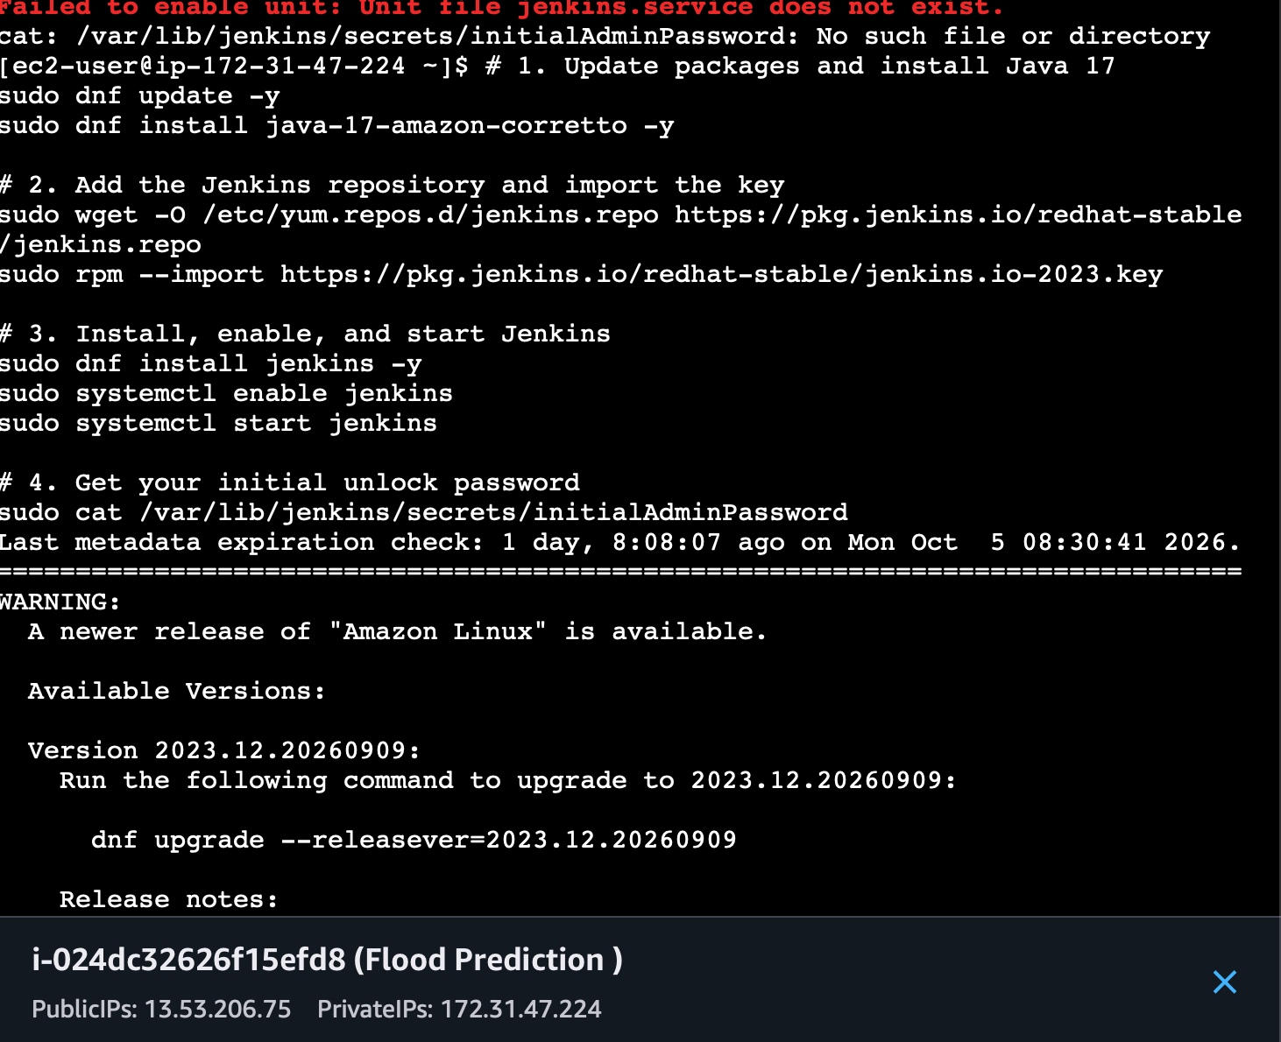
Figure 19: EC2 Package Management & Service Initialization Troubleshooting

• Challenge 2: AWS EC2 Java 17 Runtime Path & Override Configuration
The default Jenkins systemd unit looked for Java at /usr/bin/java which conflicted with system updates.
Solution: Inspected JVM directory structures and pointed JAVA_HOME explicitly in systemd service configuration.
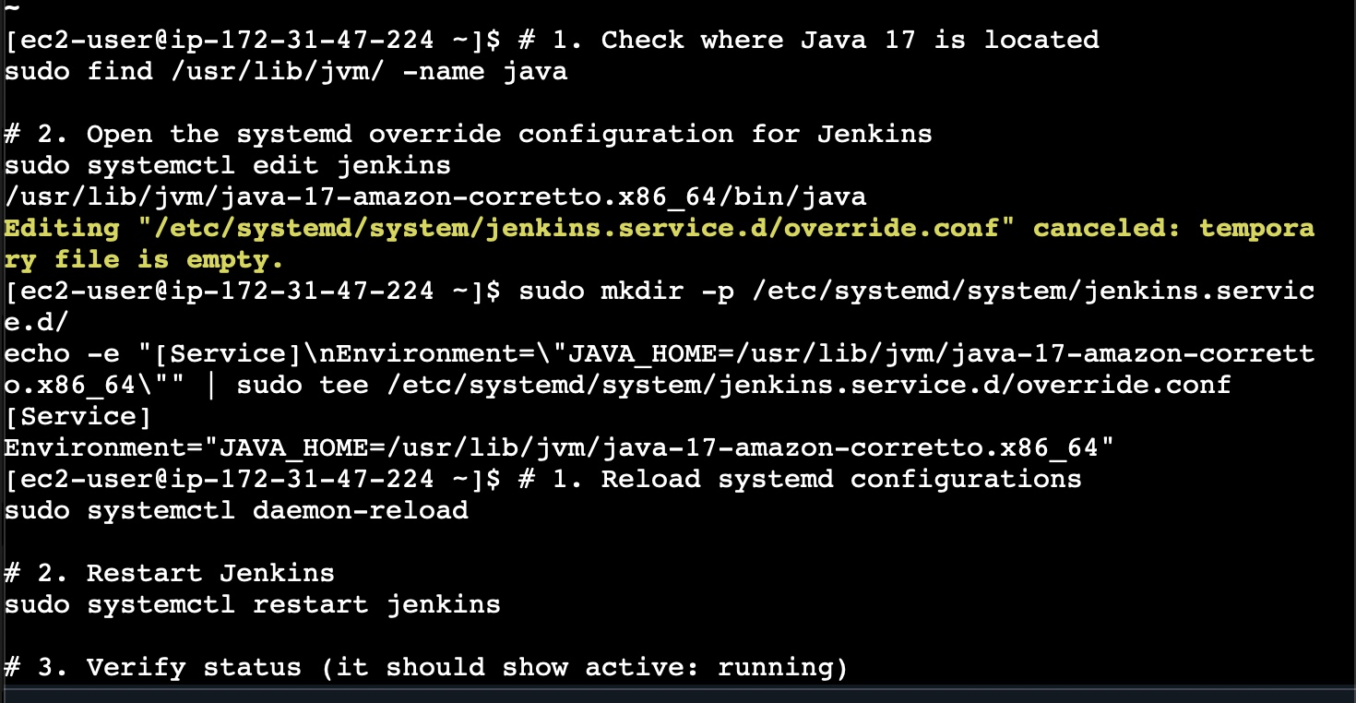
Figure 20: Java 17 Runtime Path & Systemd Override on EC2

• Challenge 3: Amazon Linux Package Repository & Upgrade Management
Dependency conflicts occurred during package updates on the cloud VM.
Solution: Synchronized packages using dnf/yum upgrade repositories and verified system compatibility.
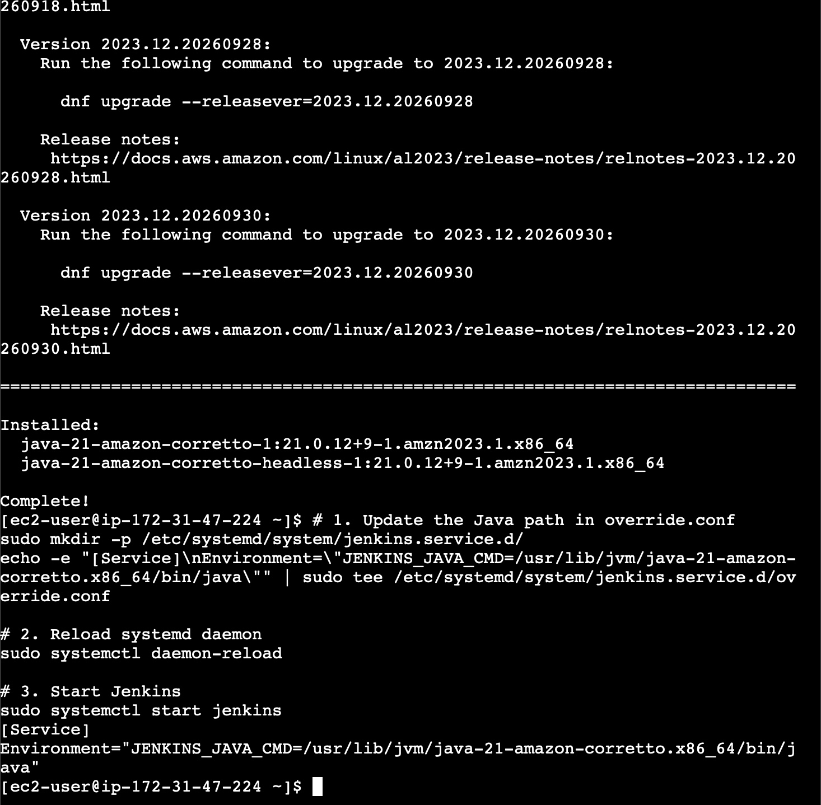
Figure 21: AWS EC2 Package Repository Resolution & System Upgrade

• Challenge 4: Python Version Mismatch for Machine Learning Libraries
The default Python runtime on macOS was 3.12, causing compilation issues with pre-compiled ML binaries (LightGBM and NumPy 1.26).
Solution: Configured the Jenkinsfile build stage to dynamically select Python 3.11 when available, ensuring clean virtualenv dependency resolution.
• Challenge 5: Docker Socket Access inside Jenkins Pipeline
The Jenkins executor lacked permissions to communicate with the Docker daemon without elevated rights.
Solution: Added the jenkins user to the docker group (sudo usermod -aG docker jenkins) and ensured PATH environment variables included Homebrew and system binaries.

13. Individual Contribution Matrix
To ensure fair evaluation and adhere to Sprint 08 requirements, the individual contributions of all 3 team members are documented below:
Team Member | Role | Technical Contribution | Deliverables Owned
Student 1 | Cloud Infrastructure & Server Lead | • Provisioned AWS EC2 instance (Ubuntu 22.04 LTS)  • Configured Security Groups for Port 8080 & 22  • Installed OpenJDK 17, Docker engine, and Jenkins  • Resolved systemd service overrides and Java paths | • Report Section 4 & 12  • Screenshots 1, 2, 3, 19, 20, 21  • Slides 1 & 3
Hema Priyadharshni G | CI Pipeline & Docker Automation Engineer | • Authored declarative Jenkinsfile with 4 stages  • Automated 13 Pytest unit tests in virtual environment  • Implemented Docker build & image tagging in CI  • Executed and verified Build #1 with 100% pass rate | • Report Section 6, 7, 8, 9  • Screenshots 5, 6, 7, 8, 9, 10  • Slides 4 & 5
Student 3 | QA, CI Demonstration & Documentation Lead | • Configured GitHub triggers and branch tracking  • Executed CI demonstration commit and verified Build #2  • Conducted live API smoke tests on AWS EC2 (Port 8000)  • Compiled comprehensive report and slide deck | • Report Section 1-3, 10, 11, 13, 14  • Screenshots 4, 11, 12, 17, 18  • Slides 2, 6, 7

14. Conclusion & Next Sprint Roadmap
Sprint 08 successfully established an enterprise-grade Continuous Integration pipeline for the Chennai Street-Level Flood Prediction System. All customer requirements and academic objectives were accomplished:
1. Automatic code checkout from GitHub upon code updates.
2. Automated execution and validation of 13 pytest regression test suites.
3. Automated Docker container packaging with build-specific tagging.
4. Live verification of the backend deployment on AWS EC2 (13.53.206.75:8000).
DevOps Roadmap for Sprint 09 (Continuous Delivery / Deployment):
With the CI foundation validated, Sprint 09 will extend this pipeline into full Continuous Delivery (CD) by introducing automated Docker image pushes to Amazon ECR and automated SSH deployment to update the live EC2 containers.

