Chennai Street-Level Flood Prediction System
Sprint 09: Continuous Delivery and Deployment using Jenkins
Course Code & Title: | ISWE406P – Agile Development Process and DevOps Lab
Programme: | M.Tech. (Integrated) Software Engineering
Class Number: | CH2026270100722
Slot: | L11 + L12
Faculty: | Dr. Kaja Mohideen A
Student Name: | Hema Priyadharshni G
Academic Semester: | Fall Semester 2026 – 2027
Due Date: | 13.10.2026
GitHub Repository: | Premkumar7788/chennai-flood-prediction-system
Deployment Target: | AWS EC2 (16.192.243.169)

1. Customer Requirement & Objectives
"The customer wants every validated code update to be automatically packaged, tested, and deployed without manual intervention."
Sprint 09 extends the Jenkins Continuous Integration pipeline from Sprint 08 into a complete, end-to-end CI/CD pipeline covering automated testing, Docker Hub publishing, AWS EC2 deployment, and post-deployment validation.

2. Review: Sprint 08 CI vs Sprint 09 CI/CD
In Sprint 08, automation concluded at local container build. Deployment required manual SSH and service restarts. Sprint 09 introduces zero-touch Continuous Deployment across 7 sequential pipeline stages.

3. Declarative Jenkinsfile Pipeline Architecture
The pipeline is structured into 7 sequential stages:
1. Checkout Source Code (SCM)
2. Build & Setup (Python 3.11 virtual environment)
3. Automated Testing (13 pytest unit tests as Quality Gate)
4. Docker Build & Tag (premkumar2005/chennai-flood-backend:build-${BUILD_NUMBER})
5. Push to Docker Hub Registry
6. Automated Deployment to AWS EC2 (16.192.243.169 via SSH)
7. Post-Deployment Verification (curl http://16.192.243.169:8000/health)
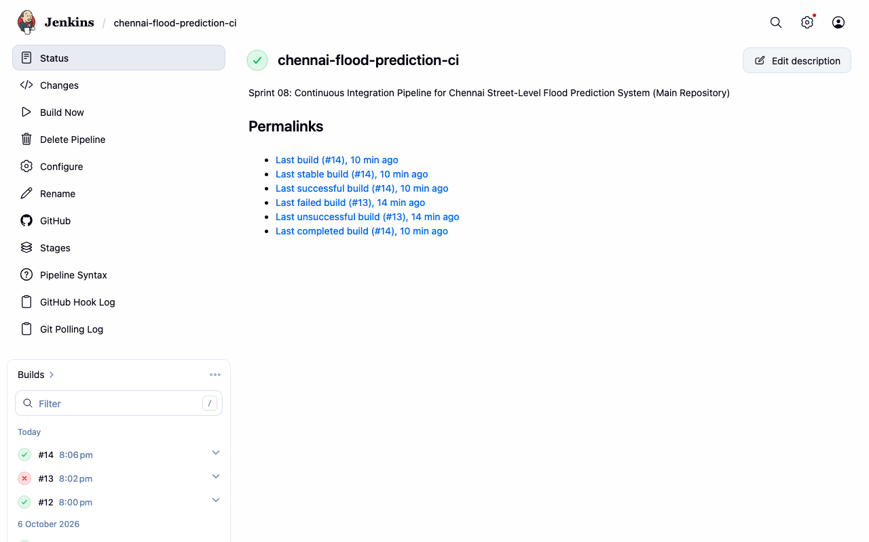
Figure 1: Jenkins CI/CD Pipeline Overview (Builds #12, #13, #14)

4. AWS EC2 Target Environment Hardening & Setup
The AWS EC2 production environment (16.192.243.169) was configured with Security Groups, Swap memory space, Docker Compose CLI plugin, dynamic override mappings, and authorized SSH keys:
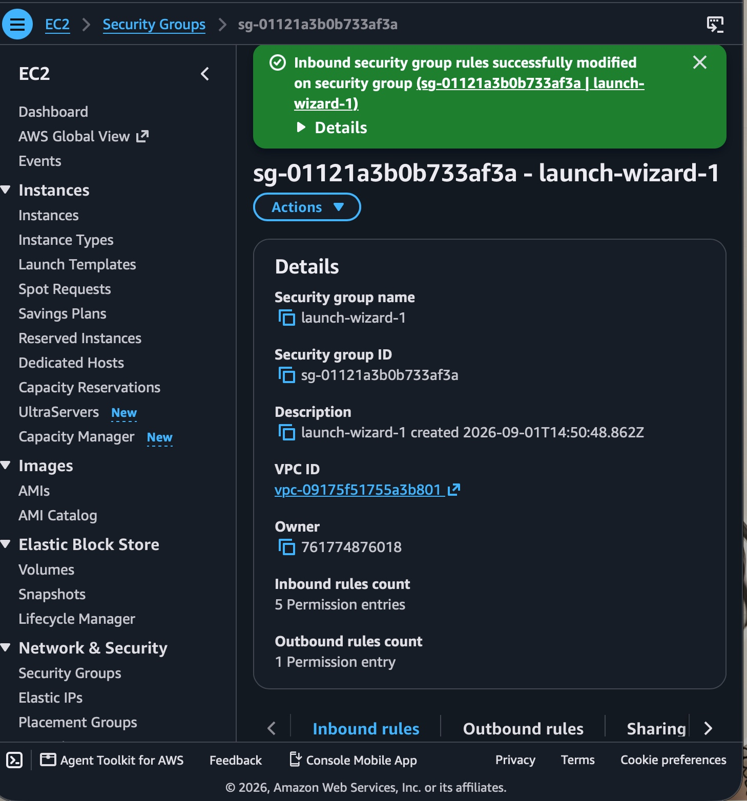
Figure 2: AWS Security Group (sg-01121a3b0b733af3a) Inbound Rules
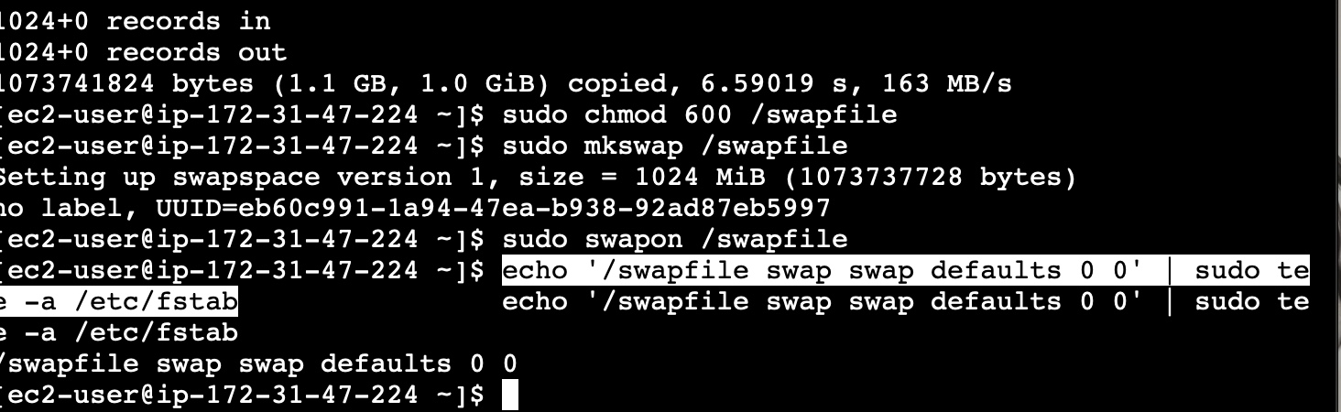
Figure 3: EC2 Swap Memory Configuration (1024 MiB)
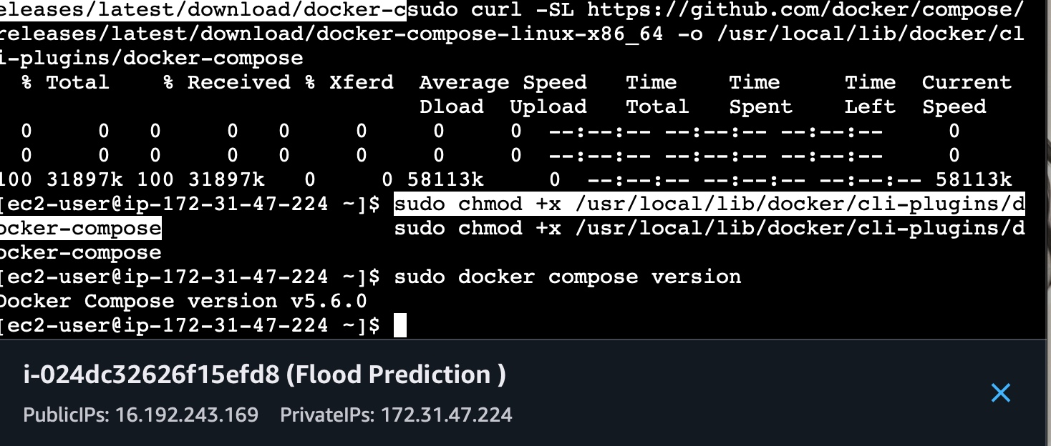
Figure 4: EC2 Terminal - Docker Compose CLI v2 Plugin Setup
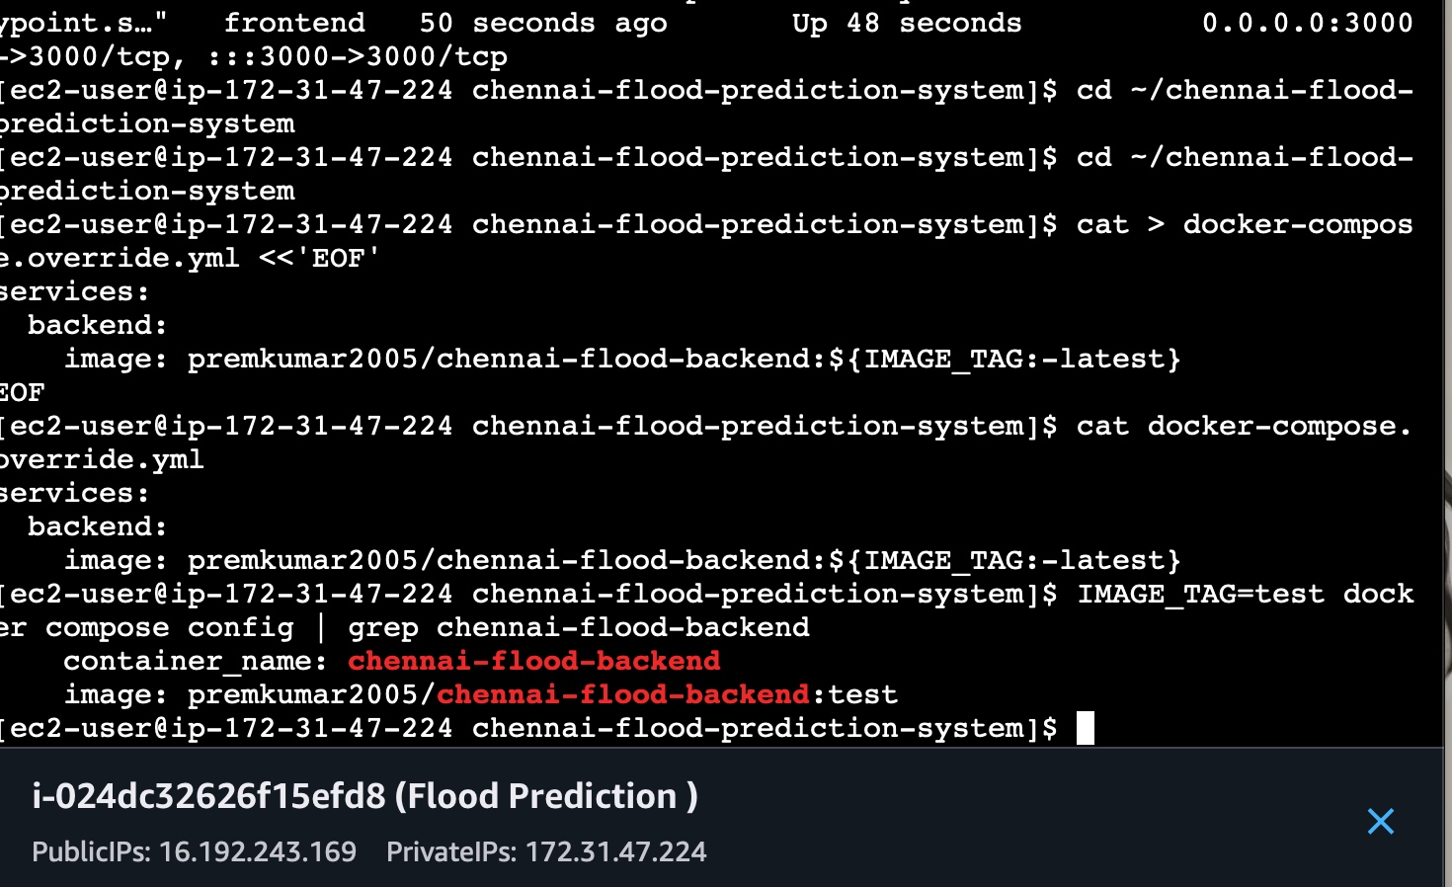
Figure 5: EC2 Terminal - docker-compose.override.yml Configuration
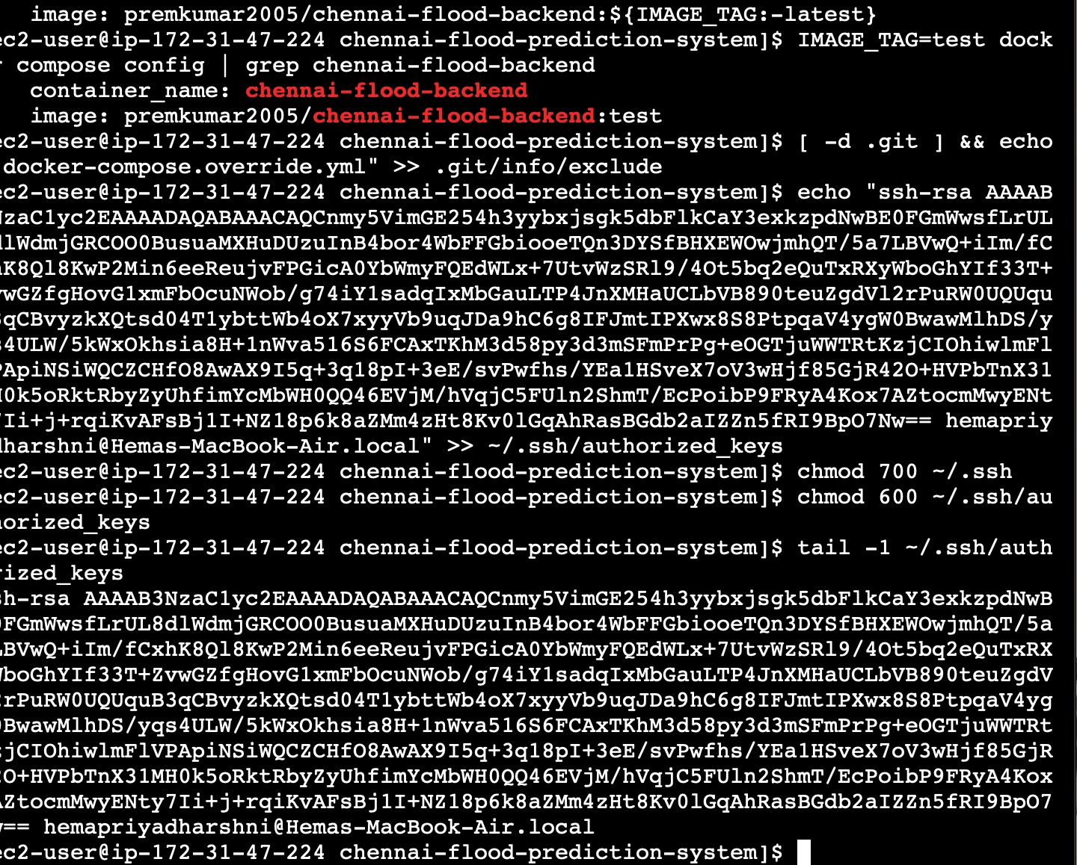
Figure 6: EC2 Terminal - Tag Resolution Check and SSH Key Authorization
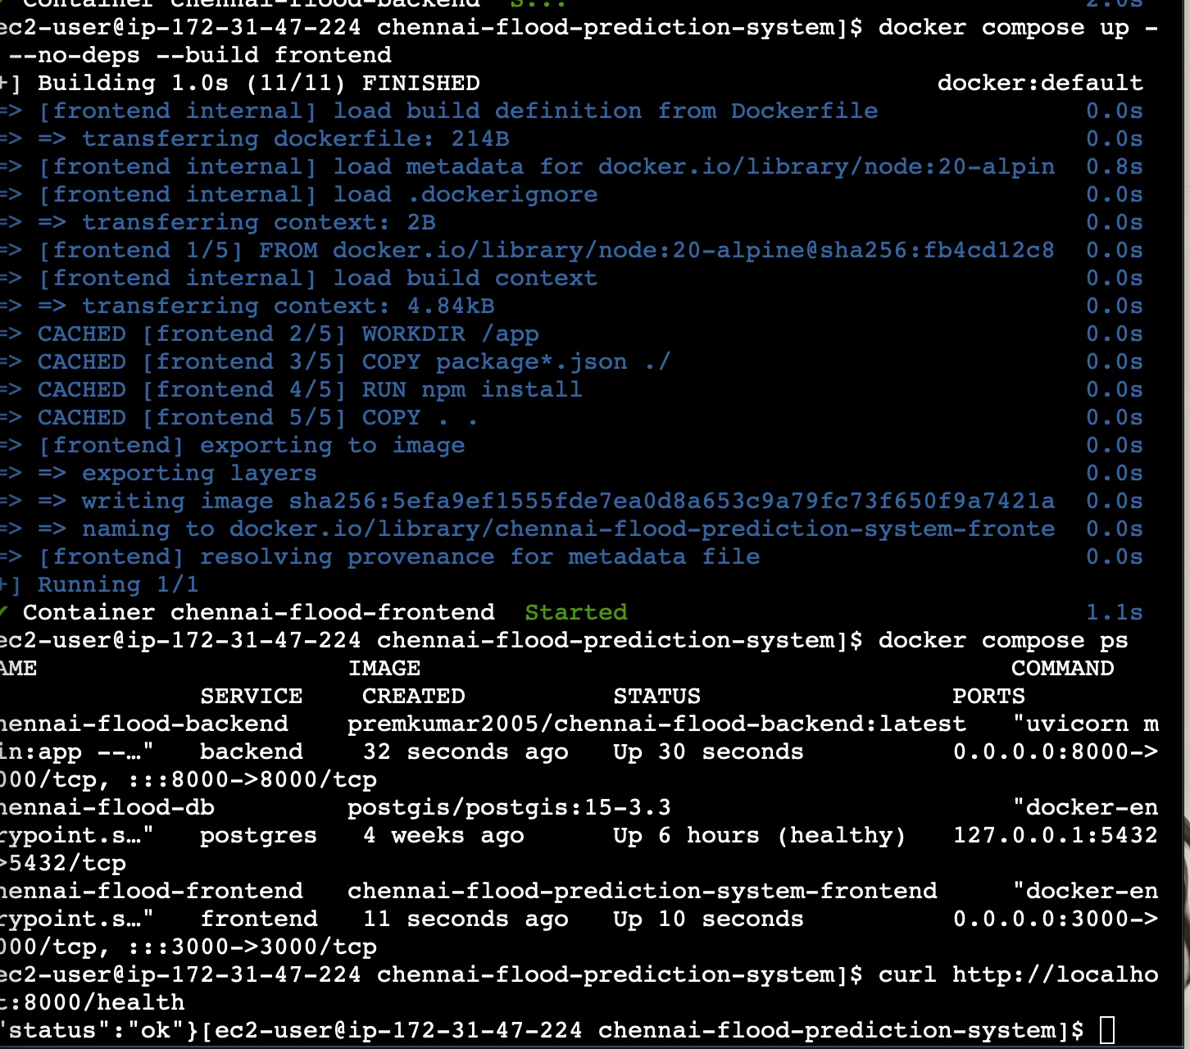
Figure 7: EC2 Terminal - Frontend Container Build and Startup on Port 3000

5. Automated Testing (Quality Gate)
13 automated test cases were executed, validating health endpoints and ML risk classification boundaries. 100% pass rate was achieved.

6. Failure Scenario Demonstration (Build #13)
To verify that defective code cannot reach production, an intentional test failure was committed (commit 477f531). Build #13 halted immediately at Stage 3, and all downstream stages (Docker Build, Docker Hub Push, Deploy, and Verify) were skipped. Inspection of AWS EC2 confirmed the running container was untouched and remained on build-12.
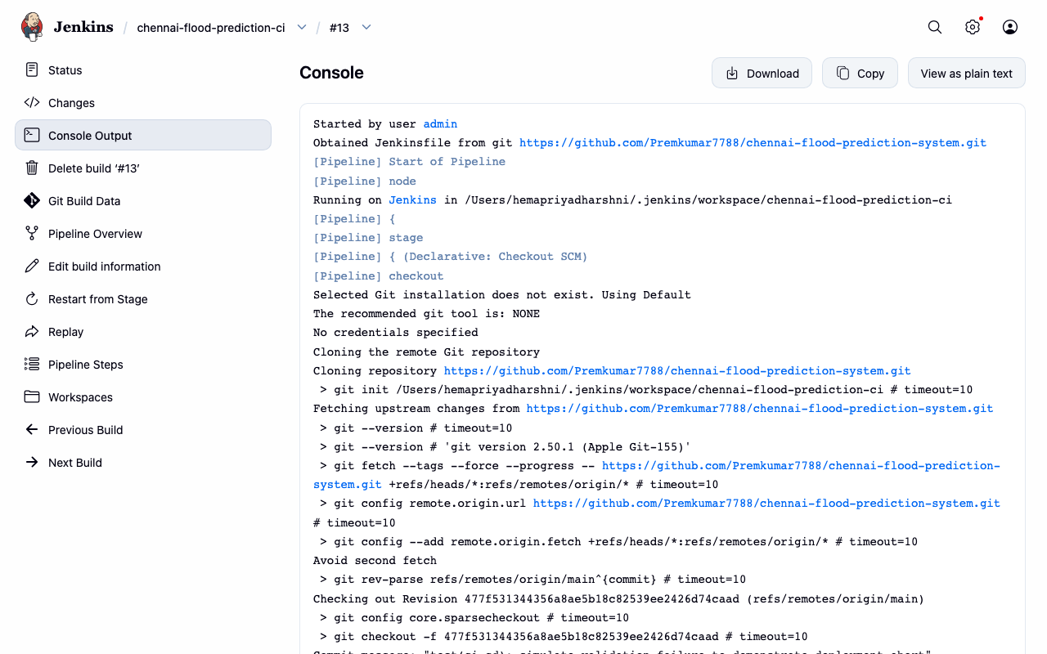
Figure 8: Build #13 Console Log - Failure Gating Preventing Deployment

7. Recovery & Successful Deployment (Build #14)
The defect was resolved, and API release v1.1.0 was committed (commit e325949). Build #14 completed all 7 stages in 52.9 seconds, publishing to Docker Hub and deploying to AWS EC2.
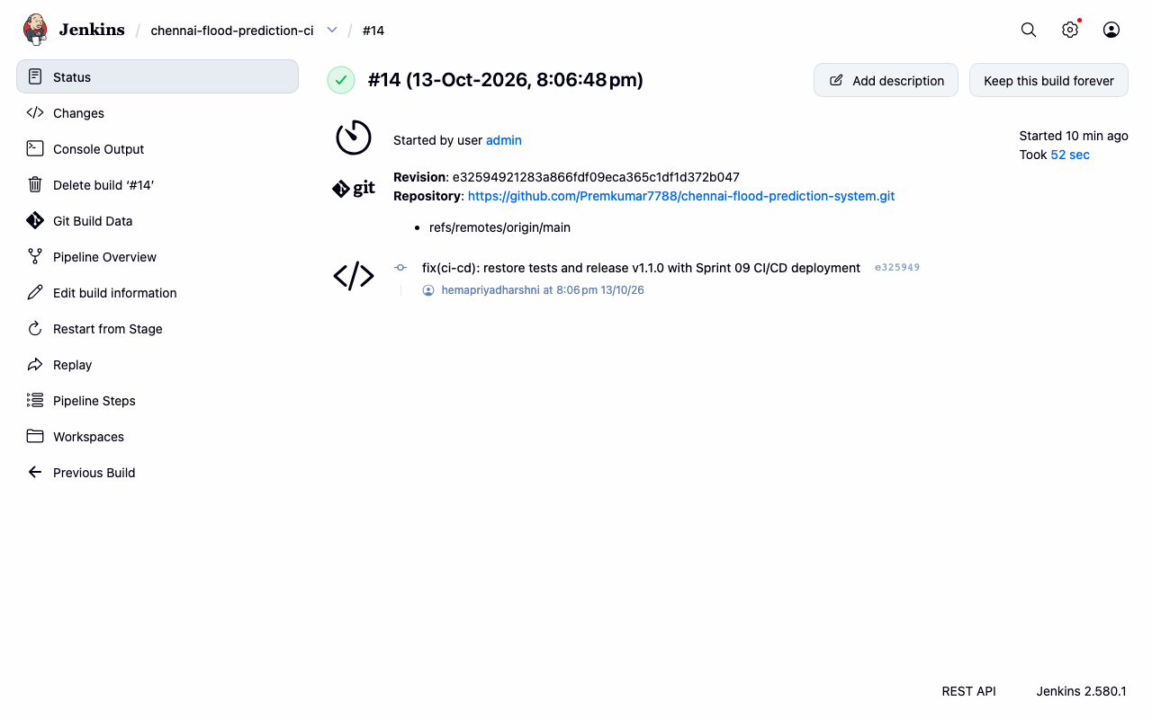
Figure 9: Build #14 Stage View - Successful End-to-End Execution
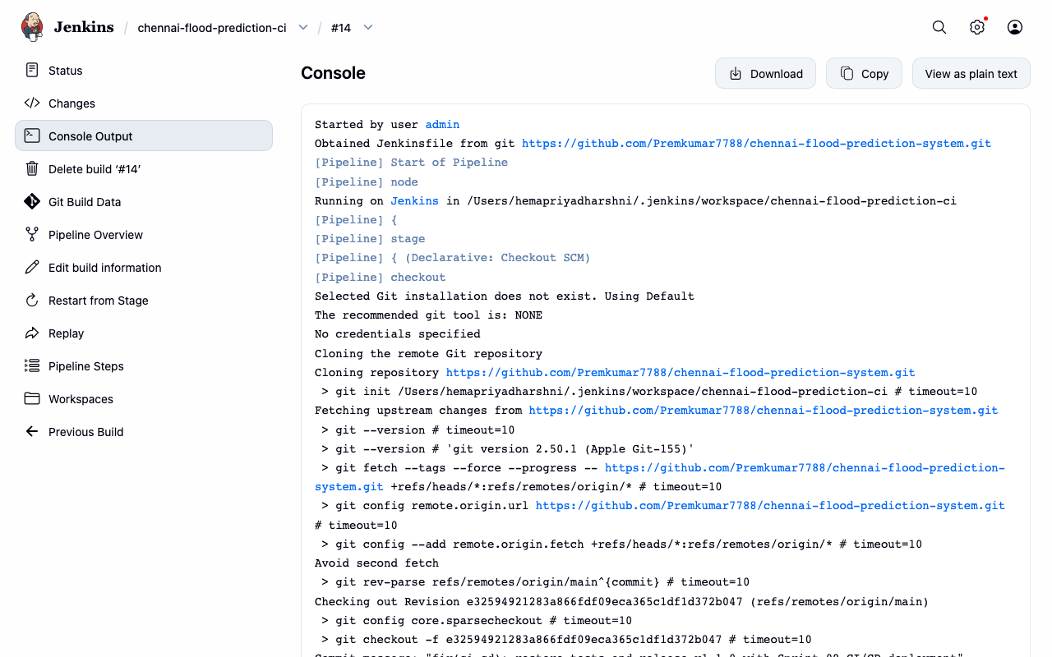
Figure 10: Build #14 Console Log - Deployment & Health Check Verification

8. Live Application Verification on AWS EC2
The application was verified live on AWS EC2 (16.192.243.169:8000 and 16.192.243.169:3000):
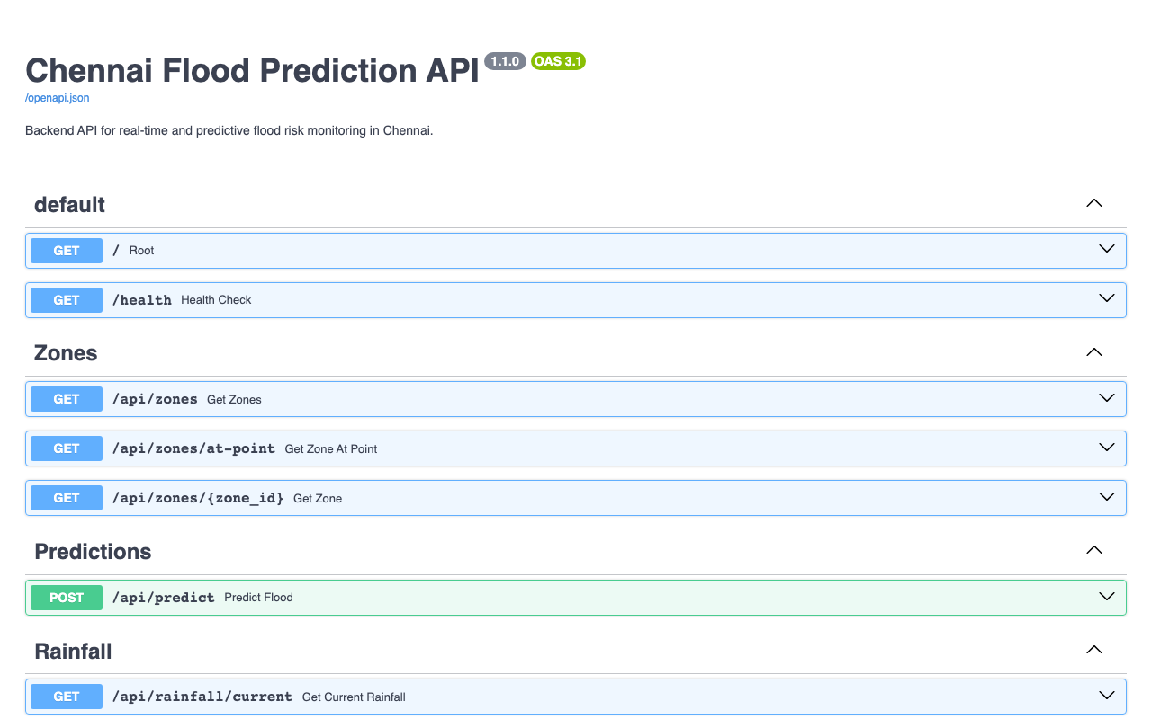
Figure 11: Live Swagger API Interactive Documentation on AWS EC2
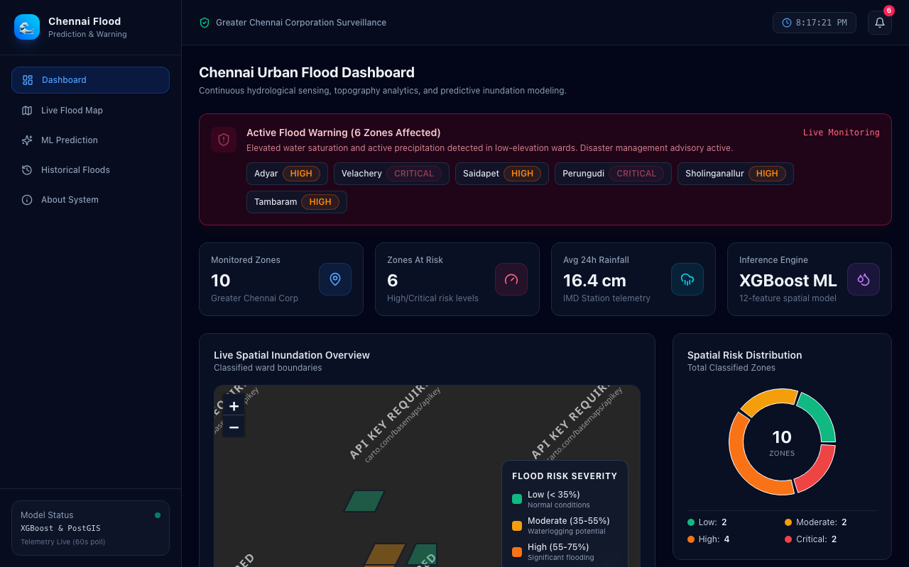
Figure 12: Live React Frontend Dashboard on AWS EC2

9. Individual Contribution & Conclusion
All objectives for Sprint 09 have been completely accomplished by Hema Priyadharshni G. The complete GitHub -> Jenkins -> Docker Hub -> AWS EC2 workflow is fully functional, robustly tested, and verified.

