1) Docker container

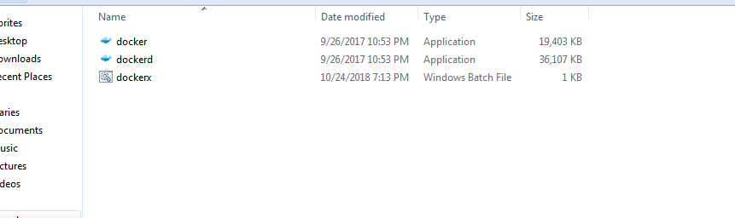

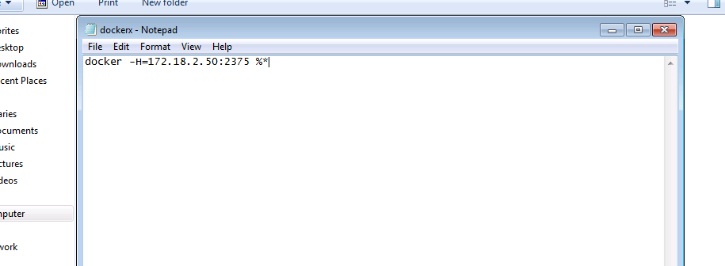

2) Navigate to the folder in command prompt and run the below command to list the available images

dockerx image ls

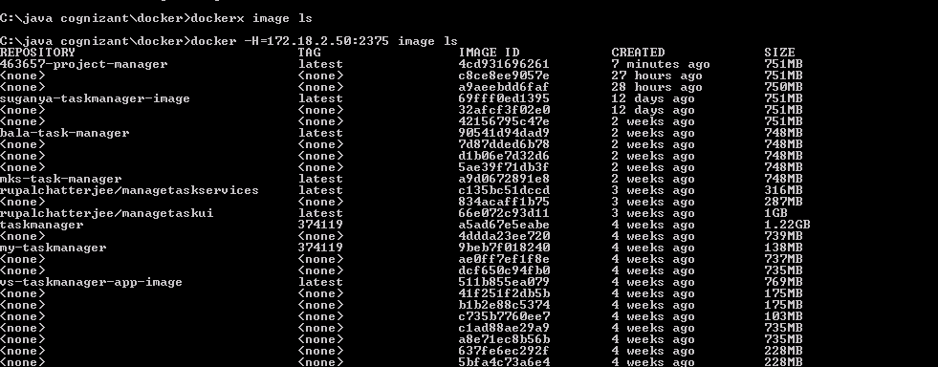

Check if the image is created after the jenkins CI build

**premkumar-project-manager** is the image created

.

3) Run the created image using the below command

dockerx run -p 8090:8095 premkumar-project-manager:latest

4) To check whether the image is running in docker[open new cmd prompt and run the cmd]

dockerx ps

5) To validate whether the application is working fine using curl command

i) connect to bash shell in the container. [take container id of the image created from dockers ps]

dockerx exec -it [CONTAINER_ID] bash

ii) Check whether application is working [it will return custom techincal error from the service exposed since mysql db is not available in docker]

curl http://localhost:8090/project-manager/getUserInfo

