Week 1:

Week 2:-

Code:import pandas as pd

url = "https://archive.ics.uci.edu/ml/machine-learning-databases/adult/adult.data"
columns = [
'age', 'workclass', 'fnlwgt', 'education', 'education-num',
'marital-status', 'occupation', 'relationship', 'race', 'sex',
'capital-gain', 'capital-loss', 'hours-per-week', 'native-country', 'income'
]
df = pd.read_csv(url, header=None, names=columns, na_values=' ?')

sid = 2435375
n = sid % 10
if n == 0:
n = 10

grouped_original = df.groupby(['relationship', 'hours-per-week'], sort=True).size().reset_index(name='count')
print("Original Grouping:")
print(grouped_original)

def reduce_hours(x):
return x - n

df['hours-per-week'] = df['hours-per-week'].apply(reduce_hours)
grouped_reduced = df.groupby(['relationship', 'hours-per-week'], sort=True).size().reset_index(name='count')
print("\nReduced Grouping:")
print(grouped_reduced)

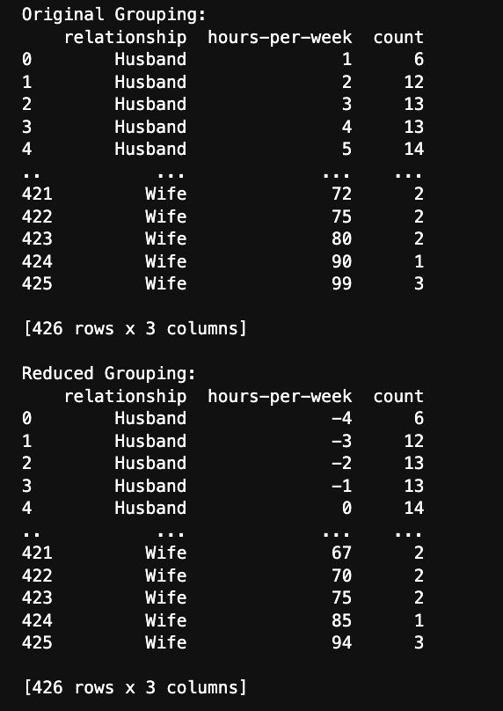

Week_3:-

import seaborn as sns
import matplotlib.pyplot as plt
import pandas as pd
data = pd.read_csv('telecom_churn.csv')

col1 = 'Total eve charge'
col2 = 'Total night charge'

plt.figure(figsize=(8,6))
sns.scatterplot(data=data, x=col1, y=col2, hue='Customer service calls', palette='coolwarm')
plt.title(f'Bicolour Interaction: {col1} vs {col2}')
plt.xlabel(col1)
plt.ylabel(col2)
plt.legend(title='Customer Service Calls')
plt.show()

Output:-
