**Name**: Prem Kumawat

**Use Case**: Develop an Application to display the Employees in an Organization,  We should be able to filter by department, sort by attributes. Create a dashboard to show charts like Employees by Dept etc.

**Technologies Used**:

* **Frontend**: React, JavaScript, CSS
* **Backend**: .net
* **Database**: SQL Server Management Studio

**Frontend:**

**Home Page:**

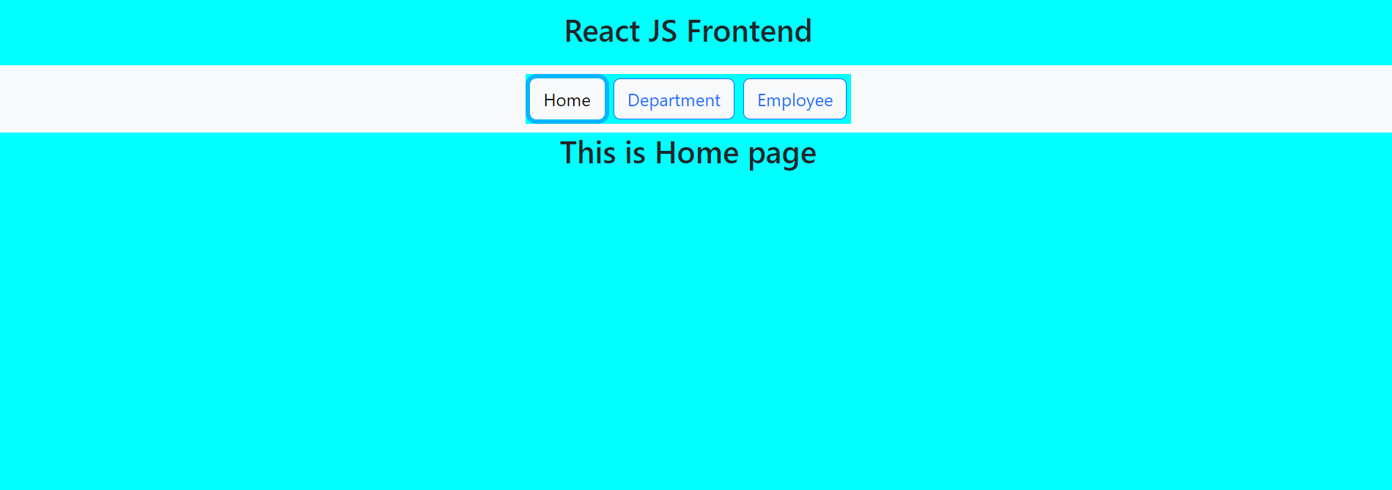

* The above image is the frontend part of the application which has a navbar with Home, Employee and Department. The home page is the active page, and it displays the text “This is Home page”.

**Department Page:**

* In department page we will fetch the data using ASP.net core API and displaying department ID and department name and there is one functionality to add the department dynamically. The user interface of add department is displayed below.

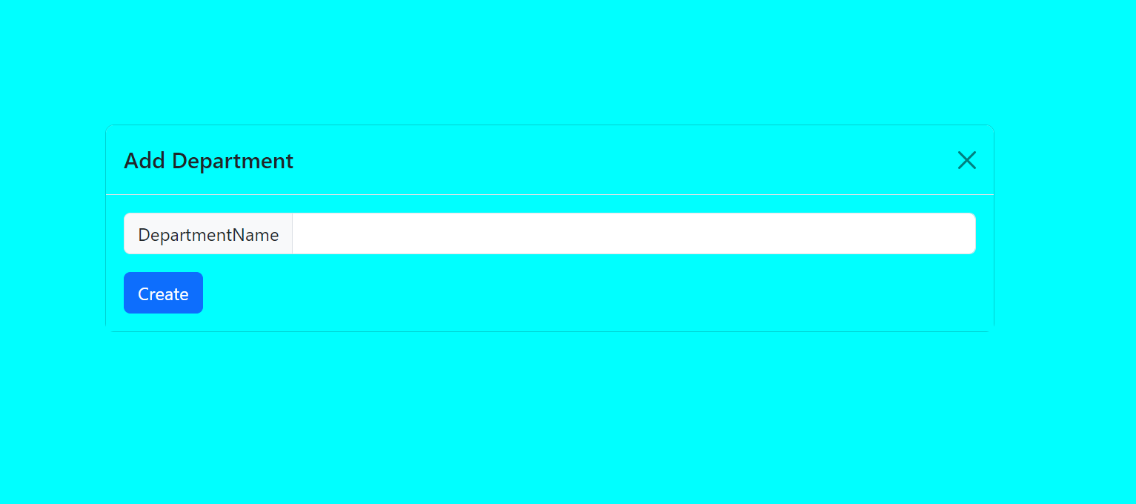

* When we add the department name example: IT the data will be added in frontend department as well as in the table department in the database.

**Employee** **Page:**

* In employee page we have four attributes Employee Id, Employee Name, Department, Date of Joining.
* We can add more Employee as there is a button which adds new employee in the Employee table.
* The user interface when we click the button is shown as below.

**Flow Chart**

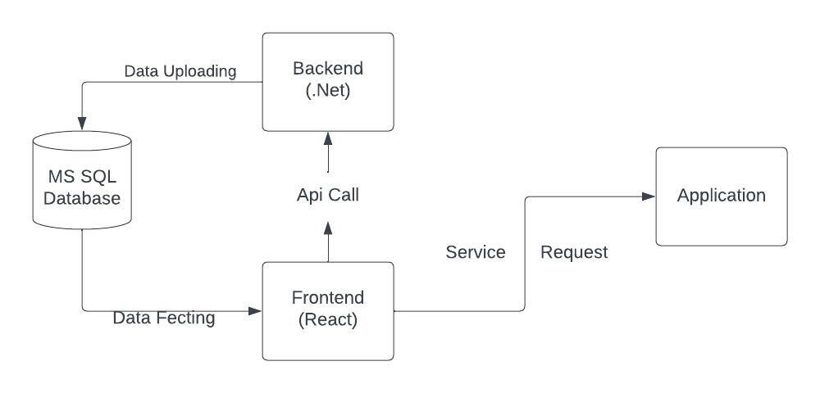

**Rest API**

**Backend:**

* For backend we have used .net and SQL server management studio.

**Database Structure:**

**Database**: mysqlsb02

**Tables**: Department and Employee

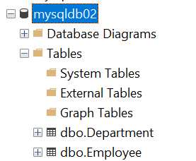

* In visual studio we have created ASP.net core web API with two controllers as Department Controller and Employee Controller.

**Department Controller:**

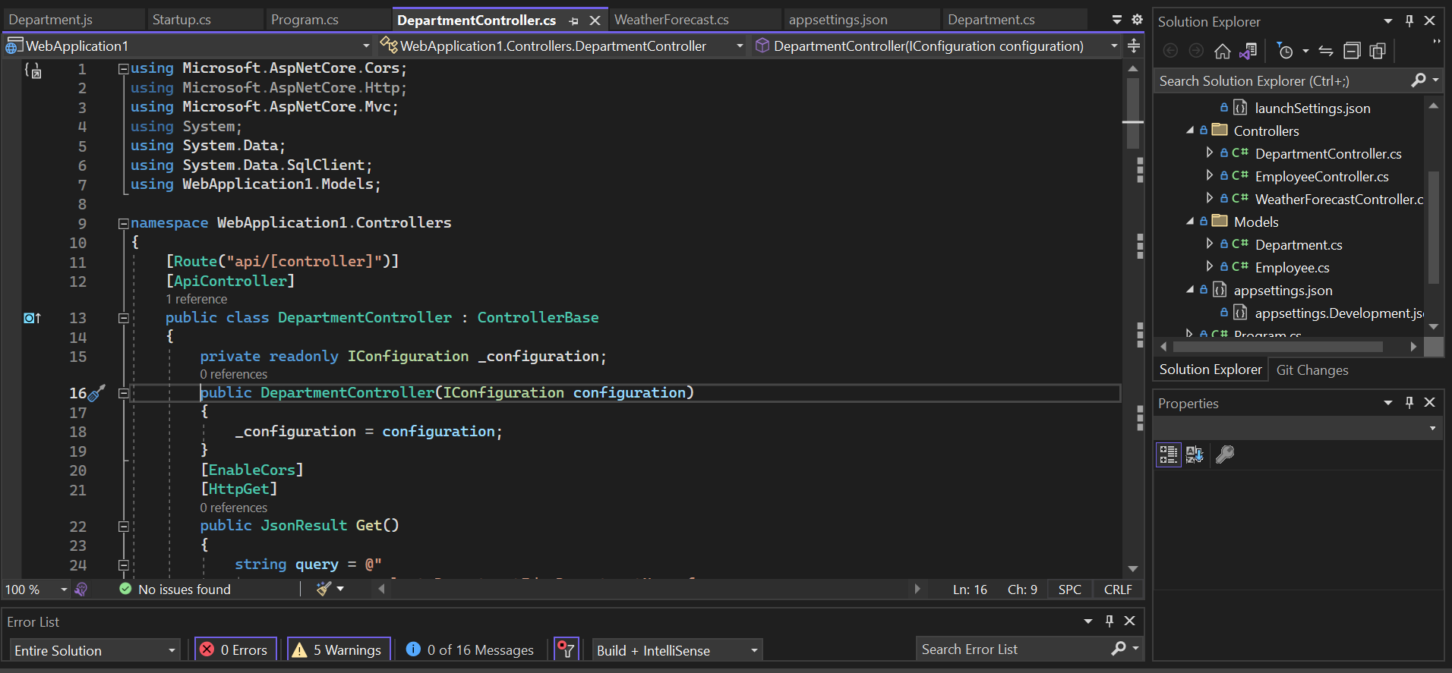

**Employee Controller:**

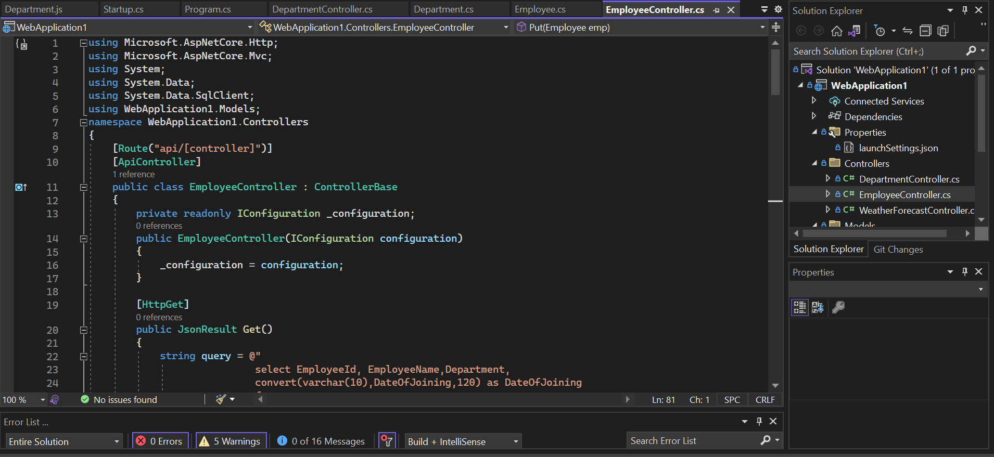

The working process of our application.

