Assignment 3 Report
A Practical Application with a Graphical User Interface (GUI)
Module 1 – Image Processing Fundamentals & Computer Vision
Your Name: Y. Sathwik
Roll Number: 22671A73B3
B.Tech (AIML)
Contents
1 Introduction 2
2 Objectives 3
3 System Design 4
4 Implementation 5
5 Results and Screenshots 6
5.1 Single Image Example 6
5.2 Two Images Side by Side 7
5.3 Four Images in Grid 8
5.4 More than Four Images 8
6 Discussion 10
7 Conclusion 11
8 Future Scope 12
9 References 13

Chapter 1

Introduction
The objective of this assignment is to design and implement a GUI-based application in
Python that demonstrates fundamental image processing operations using OpenCV. The GUI was developed using Streamlit, and the application allows the user to upload an image and apply various transformations and filters interactively.
Chapter 2

Objectives
- To implement a user-friendly GUI for image processing.
- To demonstrate fundamental operations like grayscale, HSV, rotation, resizing, translation, and edge detection.
- To visualize the results side by side with the original image.
Chapter 3

System Design
The system was designed with the following components:
- Frontend: Streamlit framework for building an interactive GUI.
- Backend: Python with OpenCV and NumPy for image processing.
- Notebook: Jupyter Notebook (ImageToolkit.ipynb) for experimenting and explaining the concepts.
Chapter 4

Implementation
The following image processing operations were implemented:
- Show Image Information
- Grayscale Conversion
- HSV Color Space Conversion
- YCbCr Color Space Conversion
- Rotation
- Resizing
- Translation
- Canny Edge Detection
Chapter 5

Results and Screenshots
This section presents multiple screenshots of the GUI and processed images.

5.1 Single Image Example
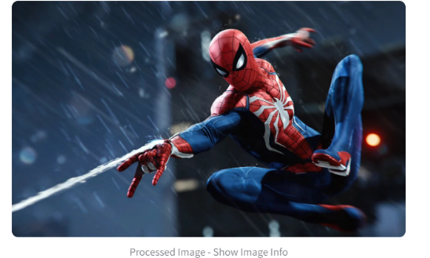
Figure 5.1: Original Uploaded Image

5.2 Two Images Side by Side
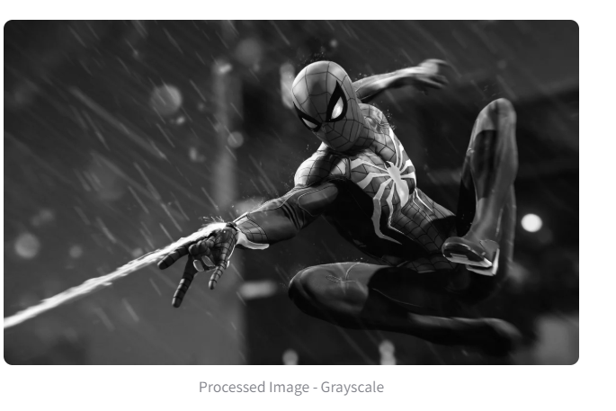 |  | images/hsv.jpg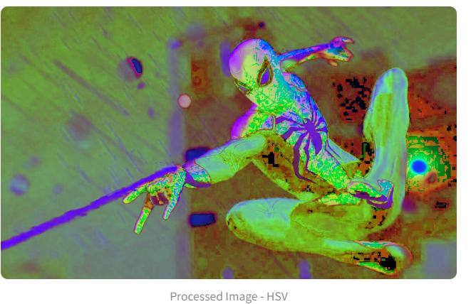
(a) Grayscale Conversion (b) hsv Conversion
Figure 5.2: Comparison of Two Conversions

5.3 Four Images in Grid
images/rotation.jpg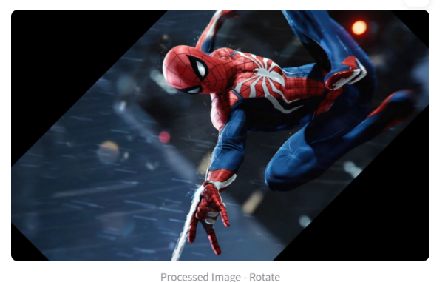 |  | images/resizing.jpg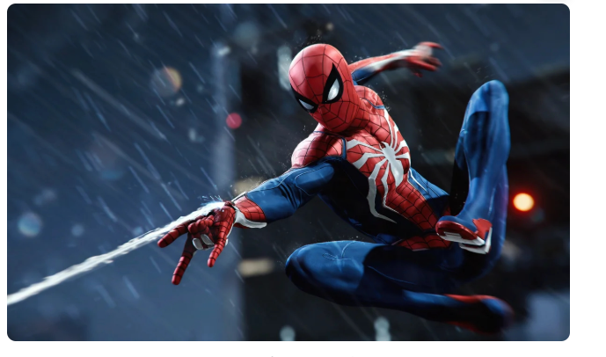
(a) Rotation (b) Resizing
images/translation 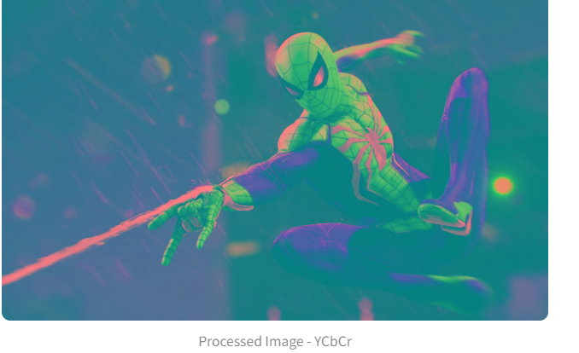on.jpg |  | images/canny.jpg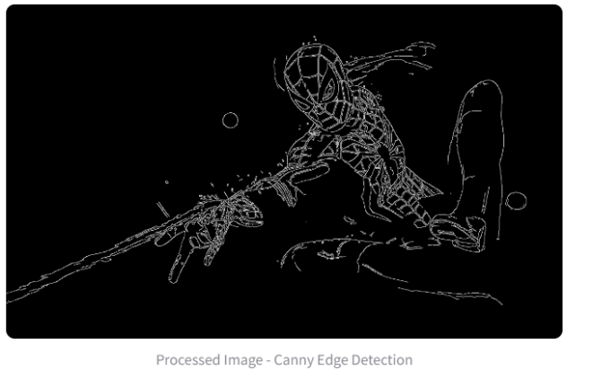
(c) Translation (d) Canny Edge Detection
Figure 5.3: Examples of Multiple Operations

Chapter 6

Discussion
The GUI application was successfully implemented. The following points were observed:
- Users can easily apply transformations without writing code.
- Real-time visualization helps in better understanding of image processing.
- Edge detection and rotation were the most visually distinct transformations.
Chapter 7

Conclusion
The project demonstrated fundamental image processing operations using an interactive GUI built with Streamlit. It served as a bridge between theory and practice in computer vision.
Chapter 8

Future Scope
- Add more advanced filters (Gaussian blur, sharpening).
- Support for batch image processing.
- Integrate deep learning models for classification and segmentation

