# **A Robot to do your Groceries**

## **Assignment 1: Artificial Neural Network**

### **Introduction**

This first assignment is to make an Artificial Neural Network (ANN). This is made to make the robot determine what kind of product it is by determining its features and therefor recognizing what specific class it belongs to. We have a total of 10 features and 7 classes.

### **Architecture**

We will explain our code by answering the questions on the assignment given to us through blackboard. First of all we will have to determine how many neurons our ANN will have to use. These neurons are divided into 3 different groups: Input, Output and Hidden neurons. The amount of Input neurons is the same as the amount of features, therefore there are 10 input neurons. The classes are the output of the ANN and so we know that there have to be 7 Output neurons. The hidden neurons are something different, these neurons connect the input neurons with the output neurons, and since there is no limit to the amount of connections, there is not just one good answer. At the start of this assignment we determined we would have to use 5 hidden neurons, when we tested our code and changed the hidden neurons we figured out how many to use in the final code, and that amount was…………………………………

The activation function that we used is the Sigmoid activation function. The reason that we have chosen for this activation function is because we are using a Backpropagation neural network, the topology of these networks is that they are fully connected and multi-layer feedforward. To calculate the weights for the hidden neurons the derrivativ of the activation function is needed, and since the Sigmoid activation function has a derrivaive, it was the best option for our ANN.

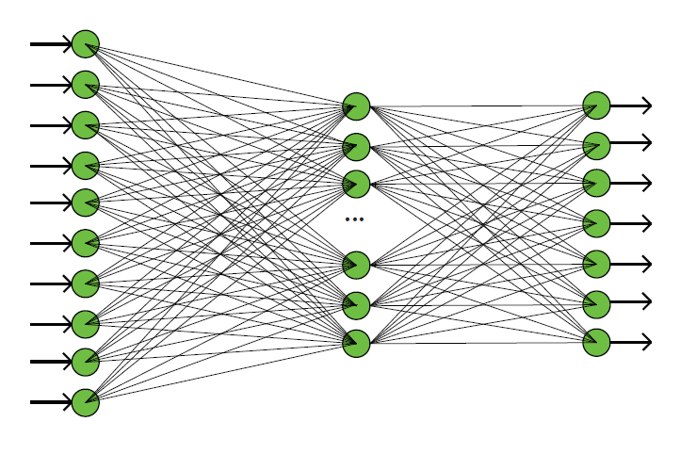

### **Training**

*6. how and why did you divide your data into a training, validation and test set.*

The data set that we have is huge and therefore to easily mine the data it is good to divided the data into these three sets, training, validation and test set. The training set is used to create the model and make the neural network learn. The validation set is used to check to see if the model that the ANN made to learn is accurate enough or not. And finally the test set is used to determine will perform as expected with unknown data.

*7. how do you evaluate the performance of your network*

The evaluation of the neural network….

*8. when and why do you decide to end the training*

The training of the neural network ends when the Meansquarederror (MSE) is as low as possible. Eventually the MSE will be just above 0 and won’t go up anymore, that is when it has reached a point where the learning has stopped and the ANN knows how to use the given data and give the right output.

*9. train your network 10 times, each with different initial weights. How does the initialization impact the performance*

### **Optimization**

*10. Train your network with different amounts of hidden neurons. At least 3 times chosen within the range of 7-30 hidden neurons. Generate a plot of the final performance versus the number of hidden neurons in the network. (hint: you can use the MATLAB command boxplot or errorbar)*

*11. Pick the architecture with the best result and show a plot of the performance of the training set and the validation set during training, across epochs*

### **Evaluation**

*12. What is the success rate of your network on the test set? How does it compare to the results of the validation set?*

*13. Show a confusion matrix of your test set. How should it be read? Where did your network make the most mistakes? (Search for the meaning and purpose of a confusion matrix and use the function plotconfusion from MATLAB).*

*14. Feed the unknown set (provided on Blackboard) to the network. Export the resulting classes as a comma-separated file exactly as detailed in section 1.2.*

### **MATLAB’s Toolbox**

*15. Use the Toolbox to create a network similar to the one you’ve just made. (You can start the toolbox GUI with nnstart or directly go to pattern recognition with nprtool).*

*16. Comment on the differences between your network’s performance and the Toolbox.*

### **Conclusion**