Agile development and devops lab

Lab Assessment-1

Name:Premnath.E

Regno:23MIS0149

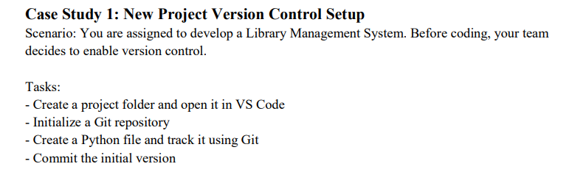
Solution:

Repository link:https://github.com/Premnath0210/Library-management-system.git
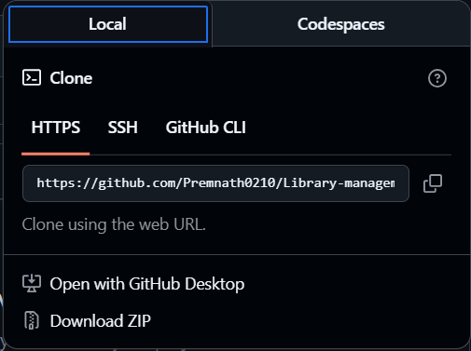

Steps:
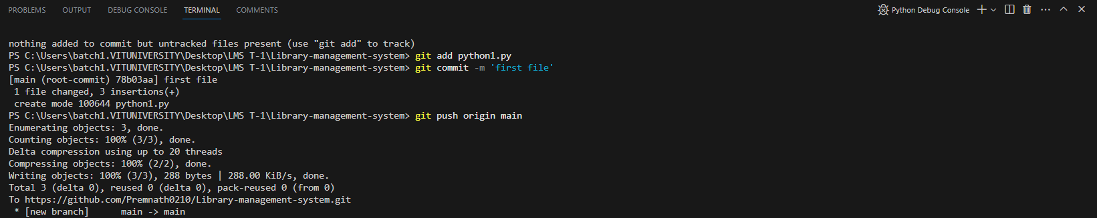
Modified file:

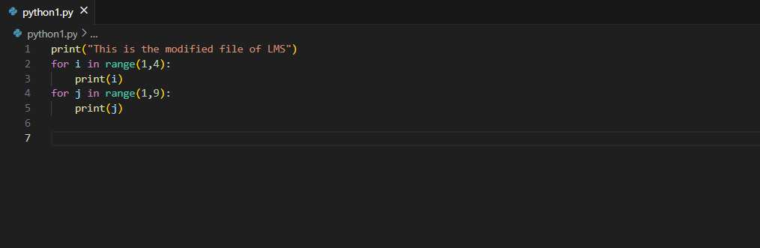

Steps:
