POSTMAN PROCESS FLOW

1. SIGNUP

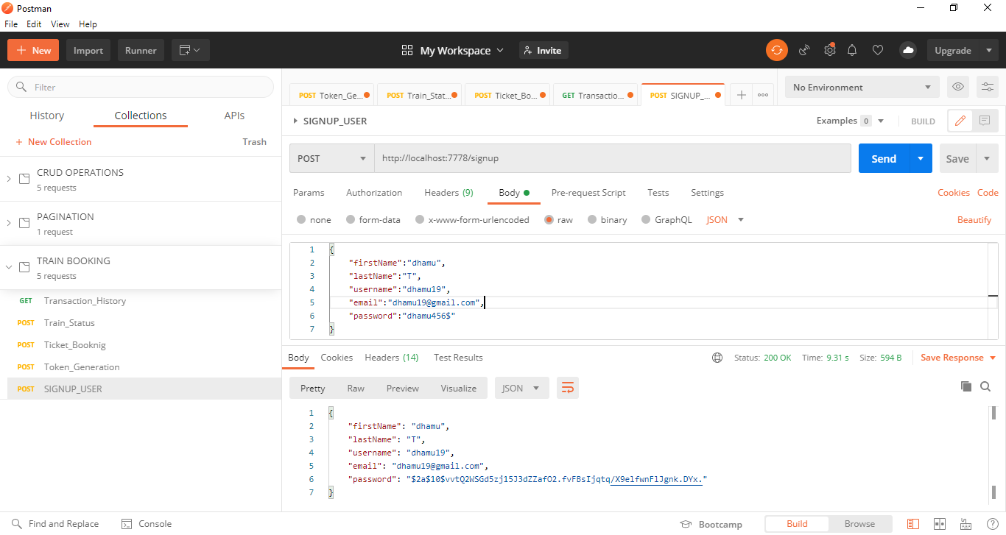

2.TOKEN GENERATION

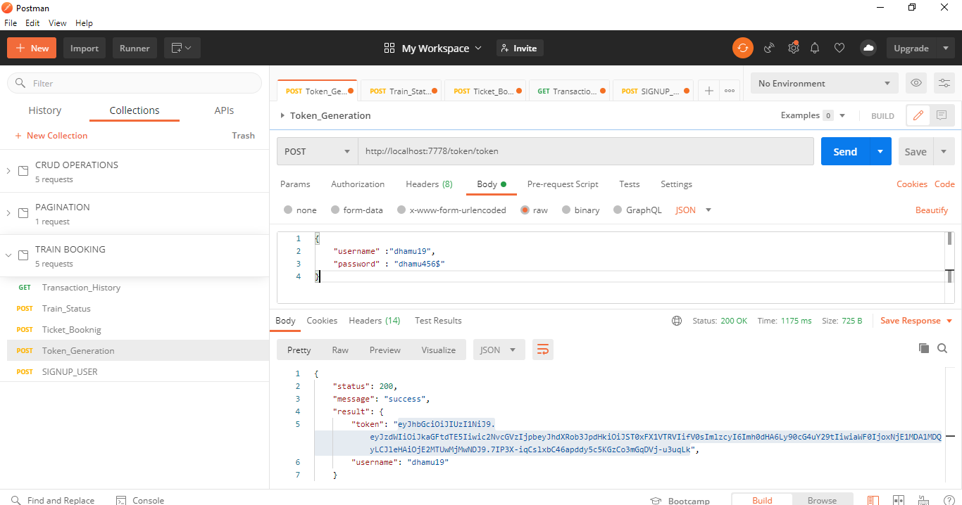

3. TRAIN STATUS (AUTHORIZATION AND PROCESS)

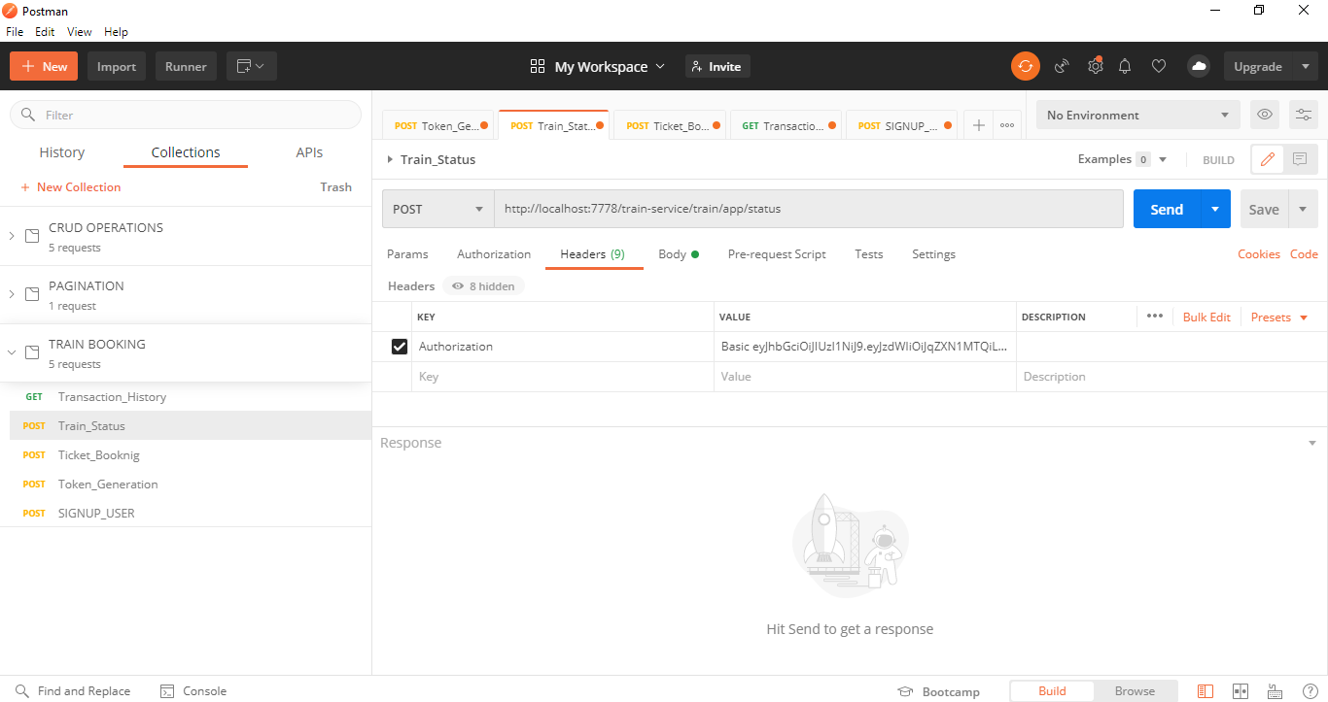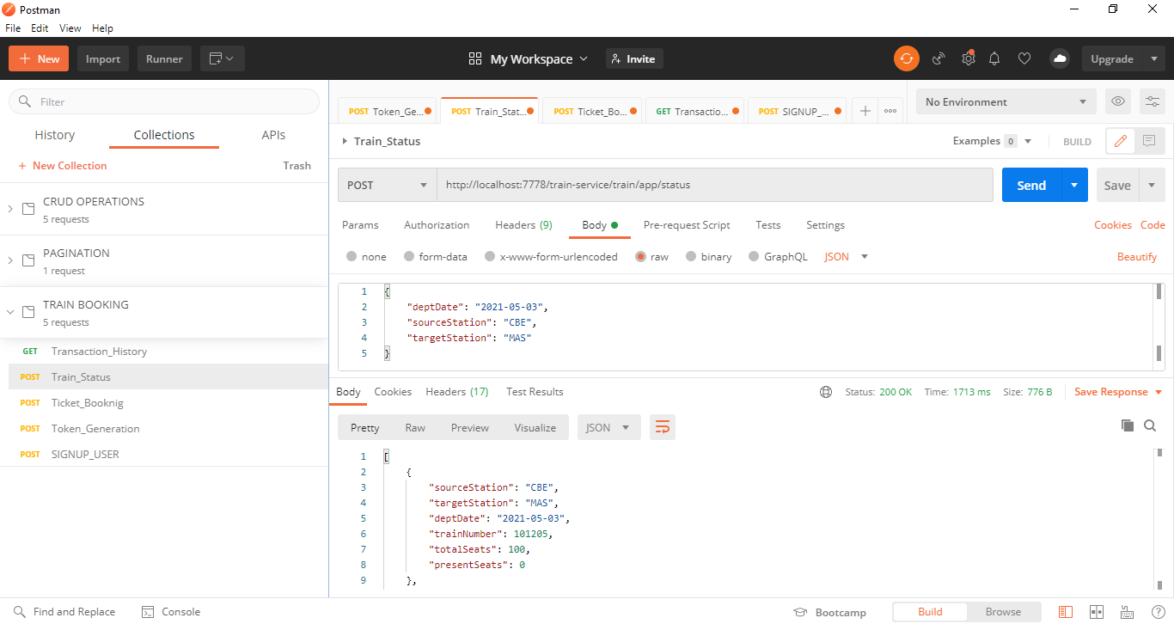

4. TICKET BOOK (AUTHORIZATION AND PROCESS)

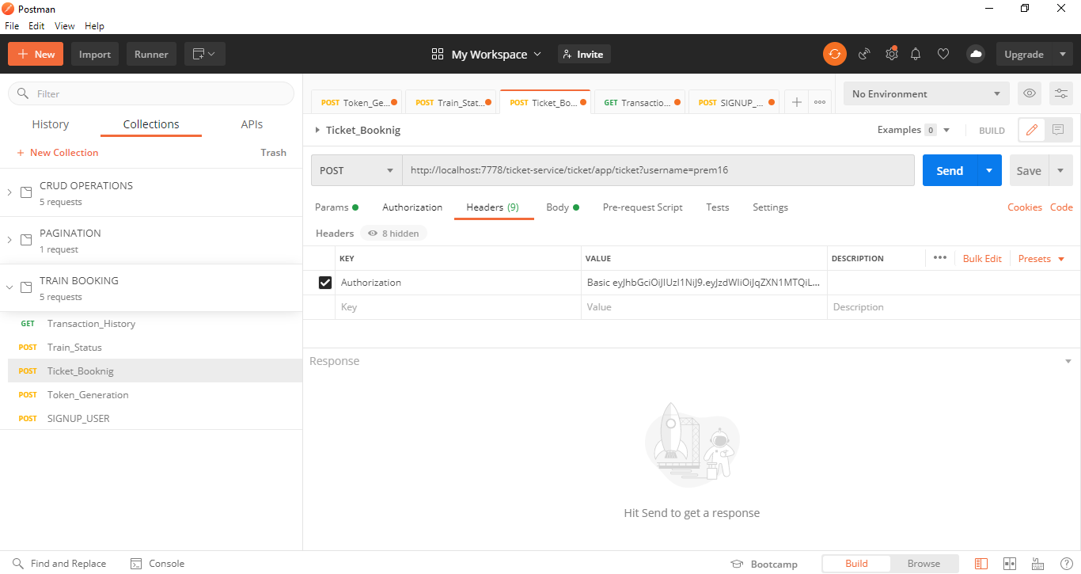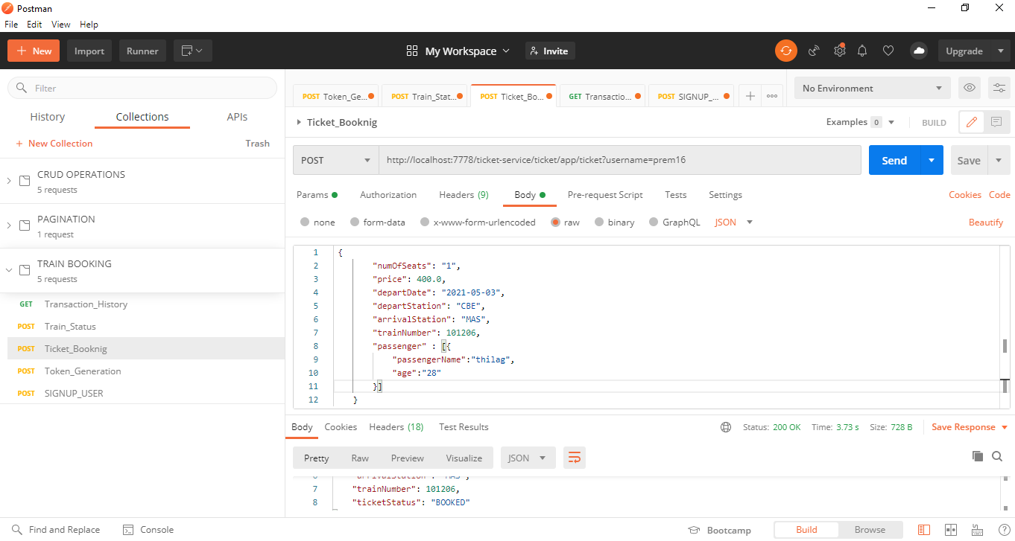

5. HISTORY (AUTHORIZATION AND PROCESS)

