**1.INTRODUCTION:**

**1.1 OVERVIEW:**

A podcast is a digital audio file that can be downloaded or streamed online. Podcasts have become increasingly popular in recent years, as they provide a convenient way for people to consume content while on-the-go, such as while commuting or exercising. They also offer a platform for individuals or organizations to share their ideas and perspectives with a globalaudience. Starting a podcast can involve a variety of steps, such as selecting a topic and format, recording and editing episodes, and promoting your podcast to build an audience. However, with the right tools and resources, it is possible to create a successful podcast and share your message with the world.The use of this project. What can be achieved using this.

**1.2 PURPOSE**

• News and current events: Podcasts can be a great way to stay informed about current events and news, as many news outlets produce regular podcasts covering the latest headlines.

• Education and learning: Podcasts can also be used for educational purposes, as there are many shows that cover topics like science, history, or language learning.

• Personal development: Podcasts focused on personal development, self-improvement, and mindfulness are also popular, providing listeners with advice, motivation, and strategies for improving their life.

• Business and entrepreneurship: Many business leaders and entrepreneurs use podcasts to share insights and strategies for success, providing listeners with valuable advice and inspiration.

• Sports: Sports fans can listen to podcasts to keep up with the latest news and analysis in their favorite sports as well as hear interviews with athletes and coaches.

• Music: Music fans can find podcasts that discuss the latest music trends, or that feature interviews with musicians and industry insiders.

**2. PROBLEM DEFINITION AND THINKING:**

**2.1 EMPATHY MAP:**

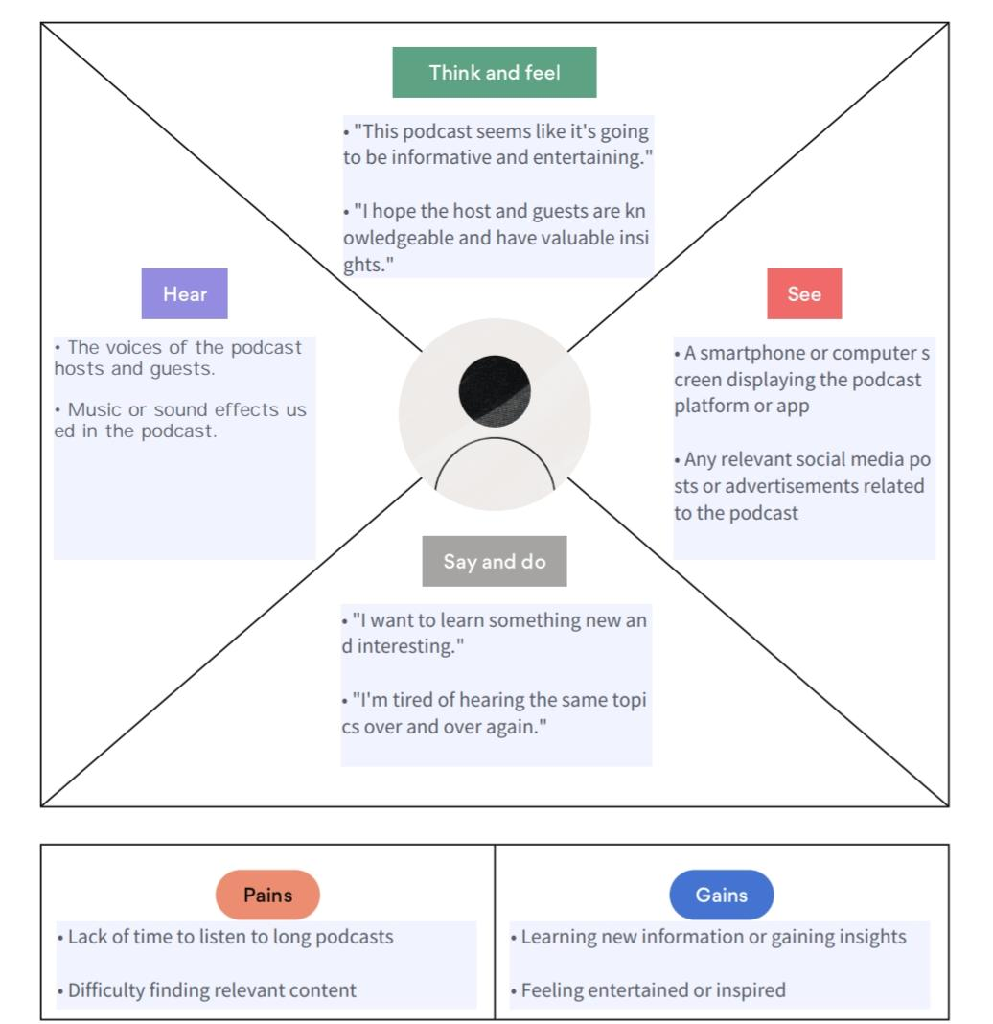

**2.2 IDEATION AND BRAINSTORMING MAP:**

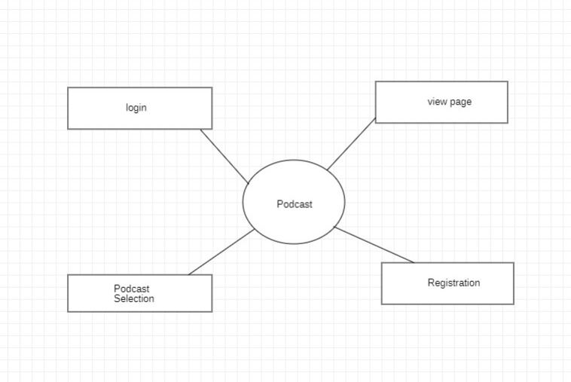

**3. RESULT:**

**3.1 DATA MODEL:**

|  |  |
| --- | --- |
| OBJECT | FIELD IN THE OBJECT |
| Obj 1 | |  |  | | --- | --- | | **Field initial** | **Data type** | | Username | Varchar | |
| Obj 2 | |  |  | | --- | --- | | **Field initial** | **Data type** | | Password | Varchar | |

**3.2 ACTIVITY AND SCREENSHOT:**

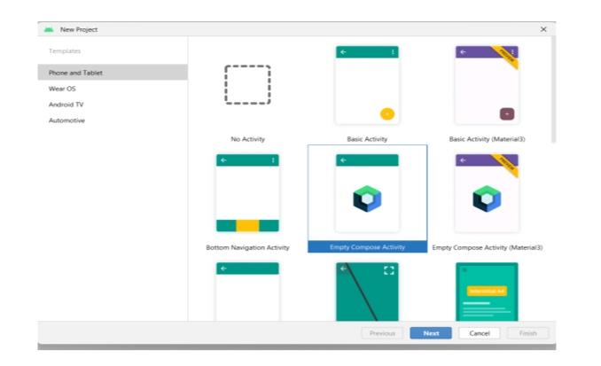 **Creating new project:**

**Main Activity class:**

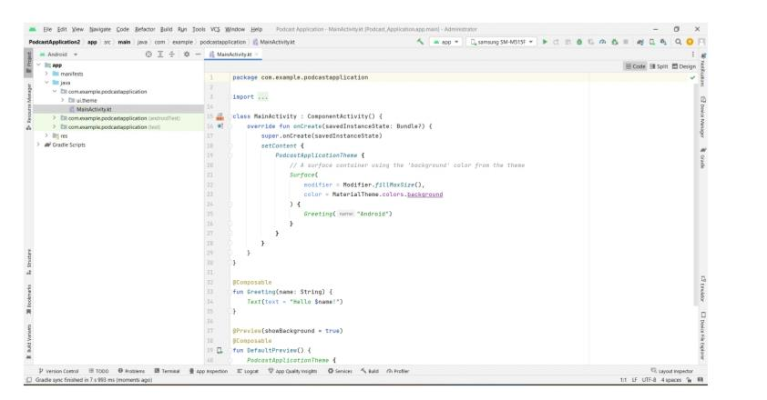

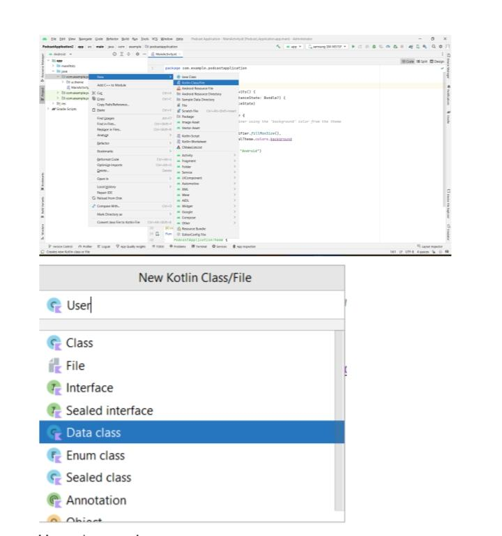 **User class:**

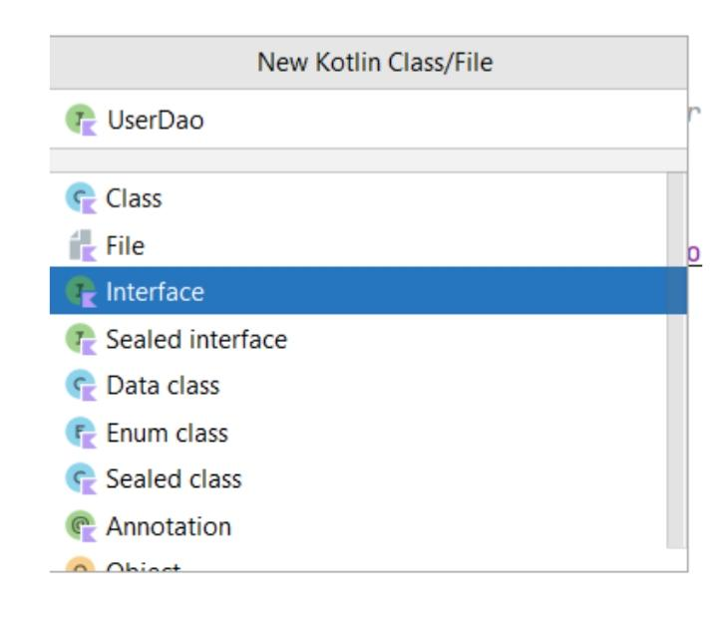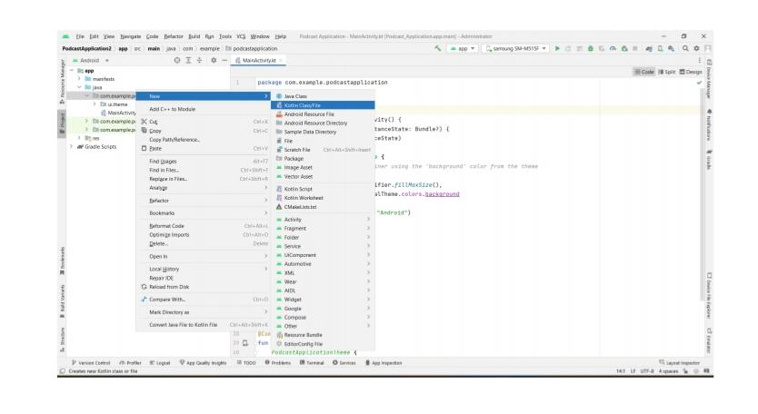 **User Dao interface:**

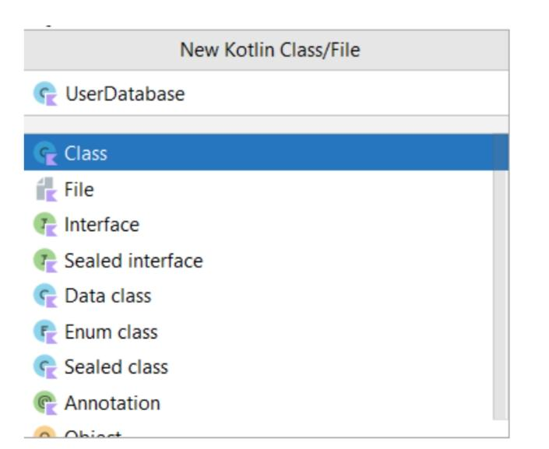 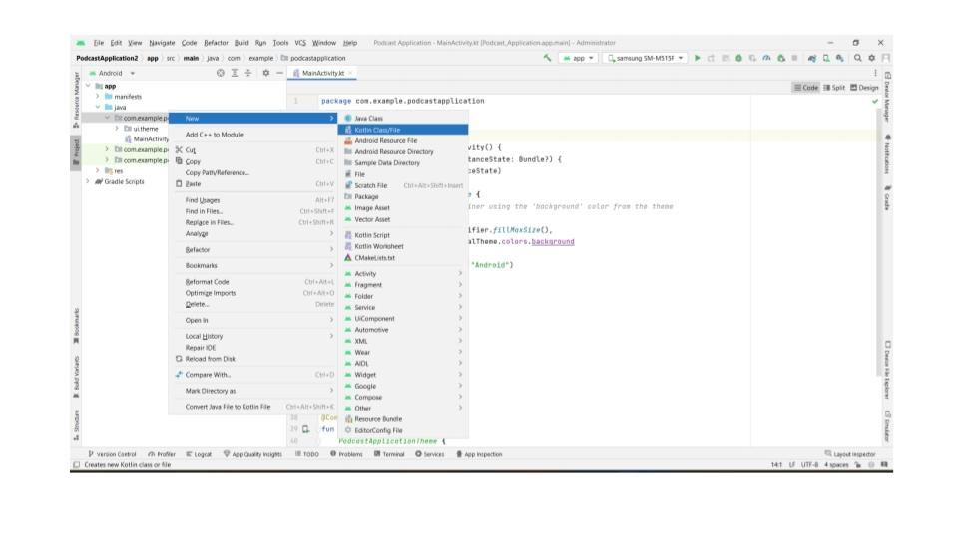 **User Database class:**

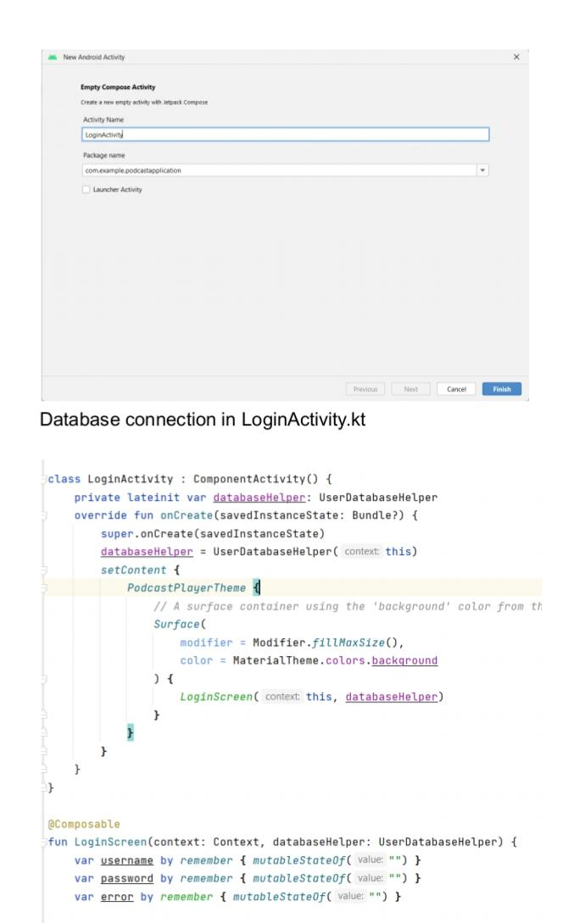 **Login Activity :**

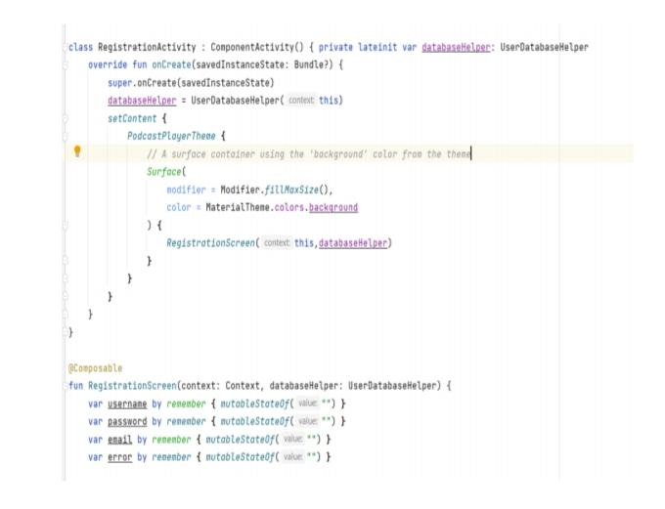 **Registration Activity:**

**Required drawables:**

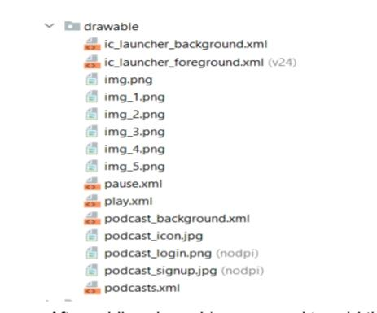

**Required audio:**

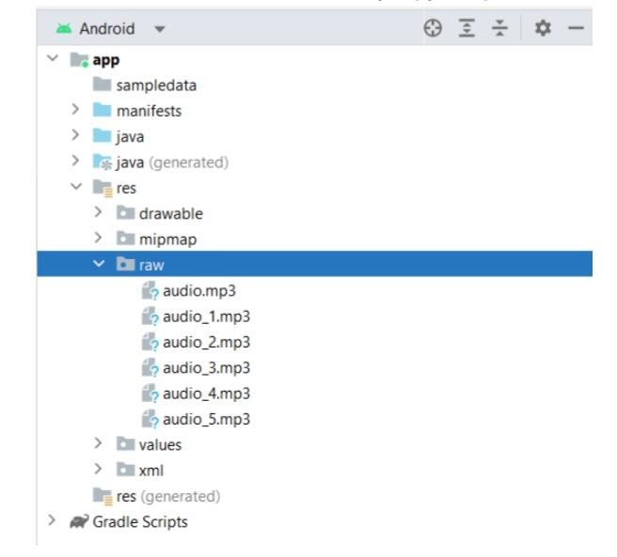

**Login:**

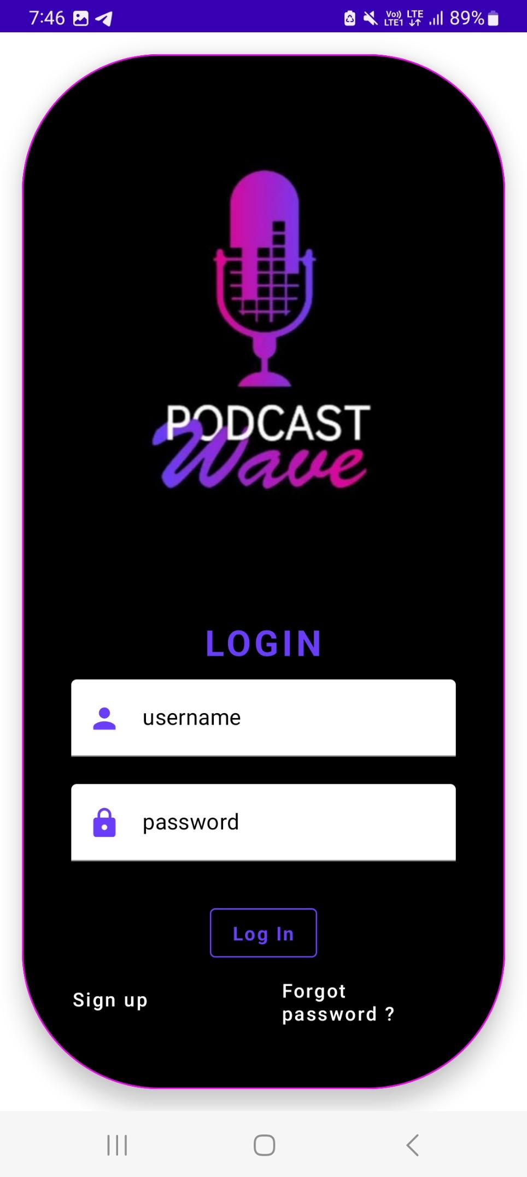

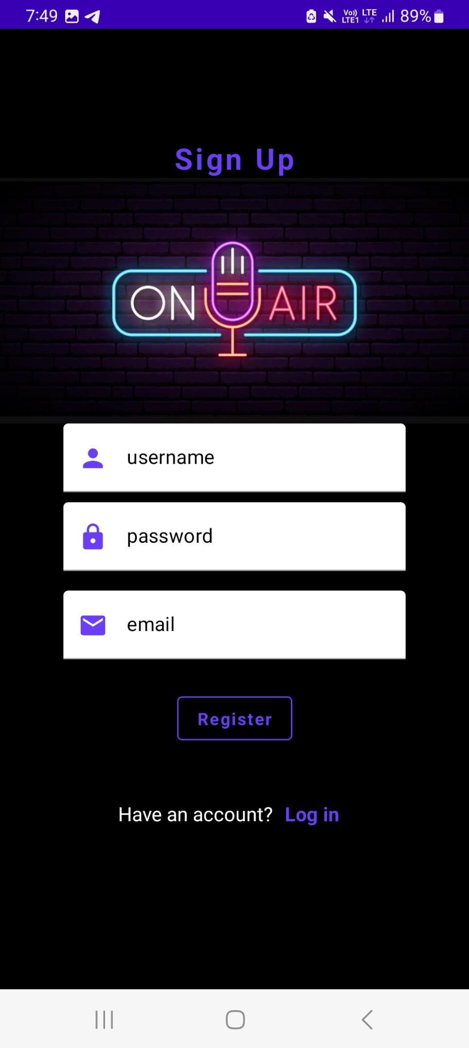 **Registration:**

**Podcast:**

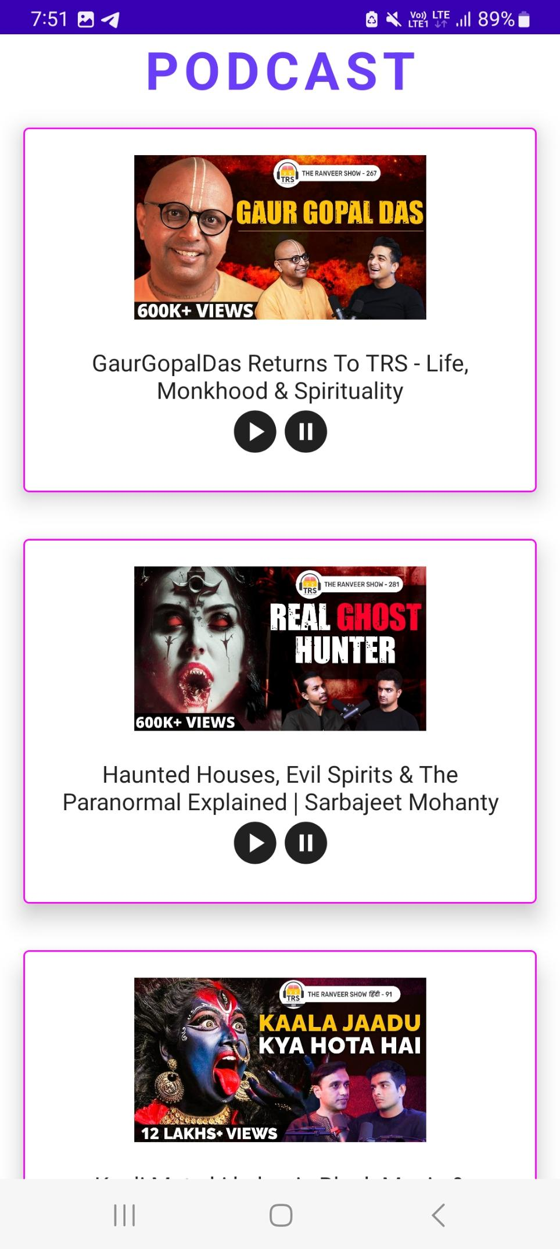

**4. GOOGLE DEVELOPER PROFILE URL :**

**Team Lead** - https://developers.google.com/profile/u/Ashwin20h223   
  
**Team Member 1** -https://developers.google.com/profile/u/102067536862715624536   
  
**Team Member 2** -https://developers.google.com/profile/u/115992731988604637788   
  
**Team Member 3** –https://developers.google.com/profile/u/111612696031551474657

**5. i. ADVANTAGES:**

• Convenience: Podcasts are extremely convenient as they can be accessed and listened to from anywhere at any time, making them ideal for people who are always on the go.

• Diverse Content: There are podcasts on virtually every topic, from news and current events to entertainment, education, and sports. This means that listeners can find a podcast that caters to their interests and preferences.

• Engaging Format: Podcasts are often more engaging than other forms of media as they allow listeners to connect with the host and guests on a personal level. The conversational tone of podcasts can make listeners feel like they are part of the conversation.

• Learning and Education: Podcasts are an excellent resource for learning and education, as many podcasts cover topics in-depth and feature experts in various fields.

**ii.DISADVANTAGES:**

• Requires active listening: Podcasts require listeners to actively listen to the content, which means they can't multitask as easily as they can while reading or watching videos.

• Limited accessibility: Podcasts can be inaccessible to people with hearing impairments or those who are deaf, as they rely solely on audio content.

• Technology barriers: Some people may not have access to the technology required to listen to podcasts, such as a smartphone, computer, or reliable internet connection.

**6.APPLICATIONS:**

• Entertainment: Podcasts can be a source of entertainment for listeners, offering a range of content from comedy and fiction to true crime and interviews.

• Education: Podcasts can be used as a tool for education, providing listeners with informative content on a wide range of topics, such as history, science, and technology.

• Marketing: Podcasts can be used as a marketing tool, allowing businesses to promote their products or services to a targeted audience.

• News and current events: Podcasts can be used as a source of news and current events, offering listeners a convenient and accessible way to stay informed.

**7.CONCLUSION:**

Podcasts have become an increasingly popular medium for consuming audio content in recent years. They offer a convenient way for people to access information, entertainment, and news on a wide range of topics, from politics and business to personal development and hobbies

**8.FUTURE SCOPE:**

In future more podcast will be added in this project. There is a wide variety of content available in the podcasting world. This includes news, comedy, true crime, sports, history, and more. Search option also be include in future, so the user can easily find their desire podcast whenever they need.