**MongoDB Day 1**

**Product JSON:** <https://github.com/rvsp/database/blob/master/mongodb/product.json>

For the following question write the corresponding MongoDB queries

1. Find all the information about each products

Query

>db.MongoDB_Day1.find();

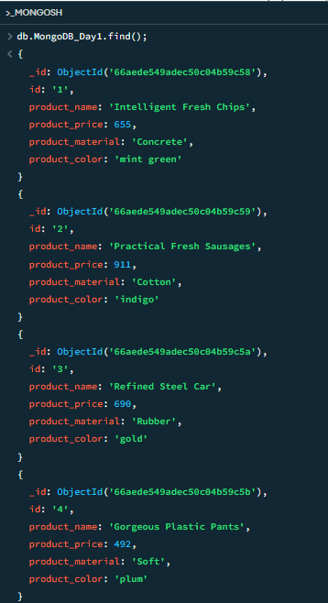

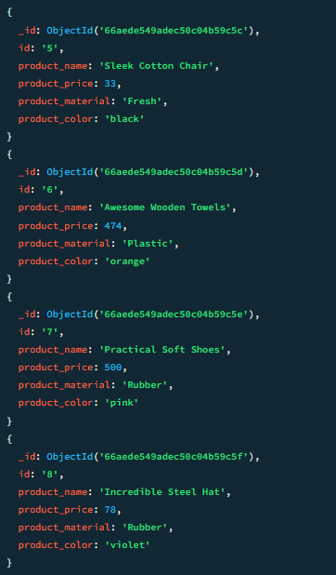

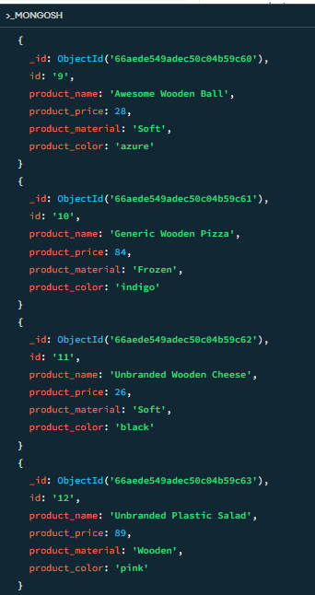

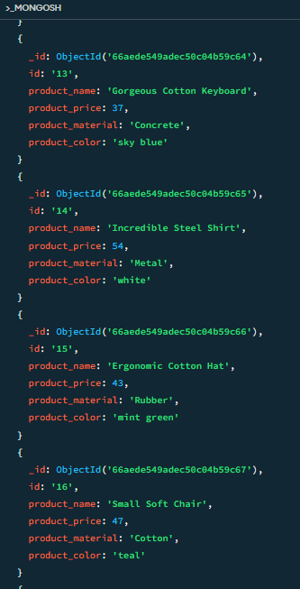

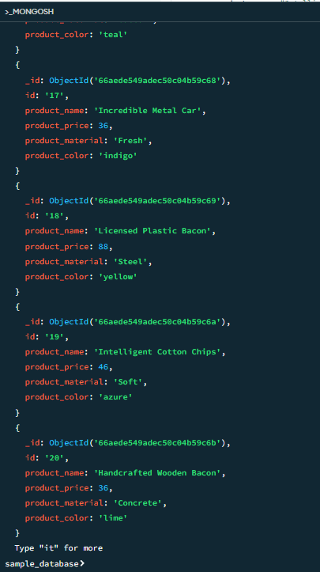

1. Find the product price which are between 400 to 800

Query

>db.MongoDB_Day1.find(

{

“product_price”:{$gt:400,$lt:800}

}

);

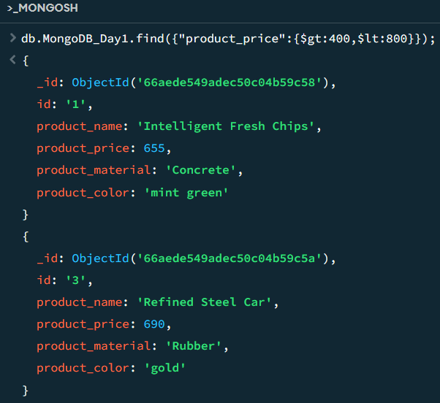

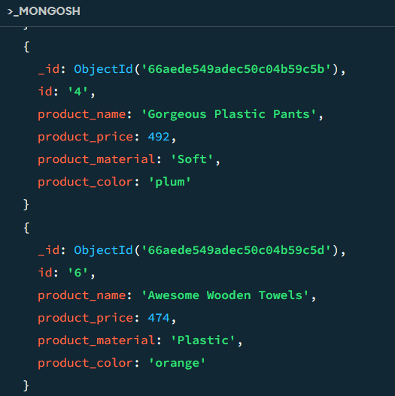

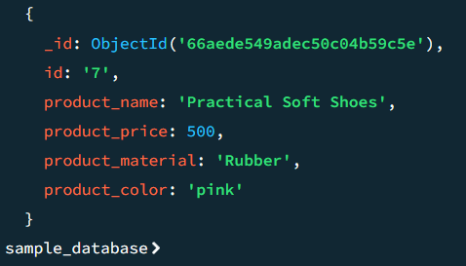

1. Find the product price which are not between 400 to 600

Query

>db.MongoDB_Day1.find(

{

“product_price”: $not: { $gt: 400, $lt: 600 }

}

);

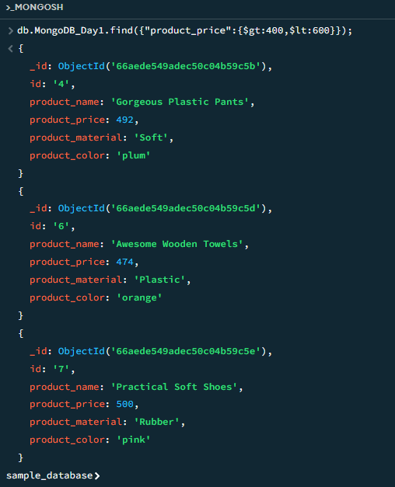

1. List the four product which are greater than 500 in price

Query

>db.MongoDB_Day1.find(

{“product_price”:{$gt:500} }

);

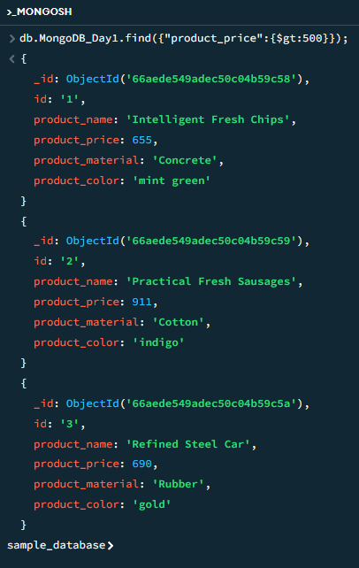

1. Find the product name and product material of each products

Query  
>db.MongoDB_Day1.find(

{ },{“product_name”:1,”product_material”:1}

);

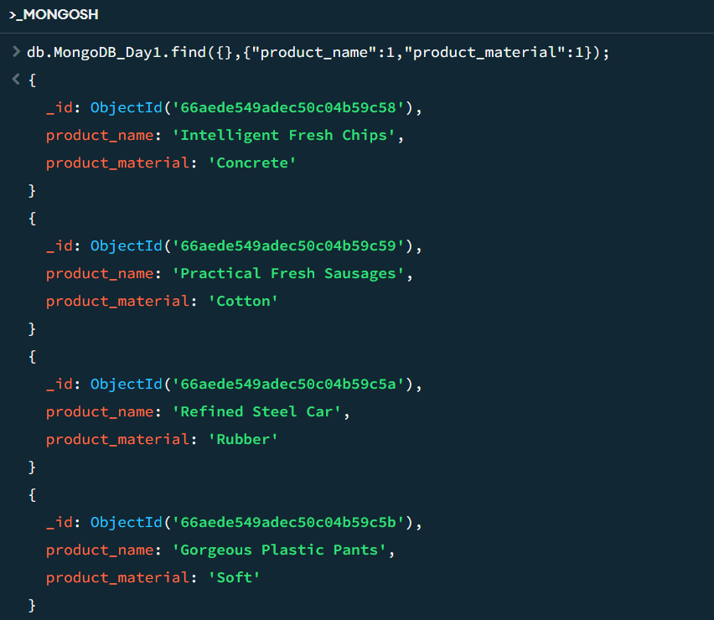

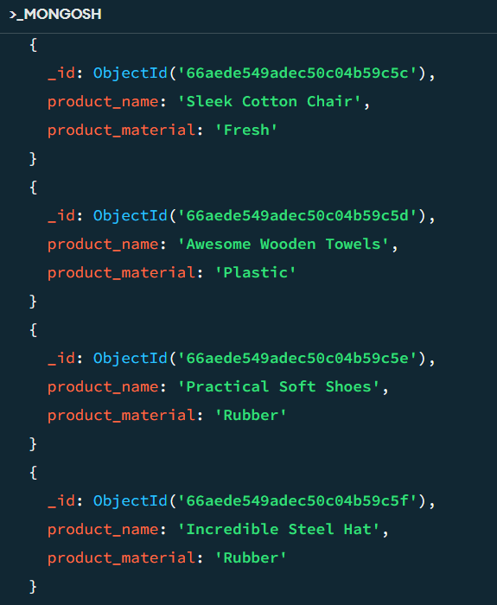

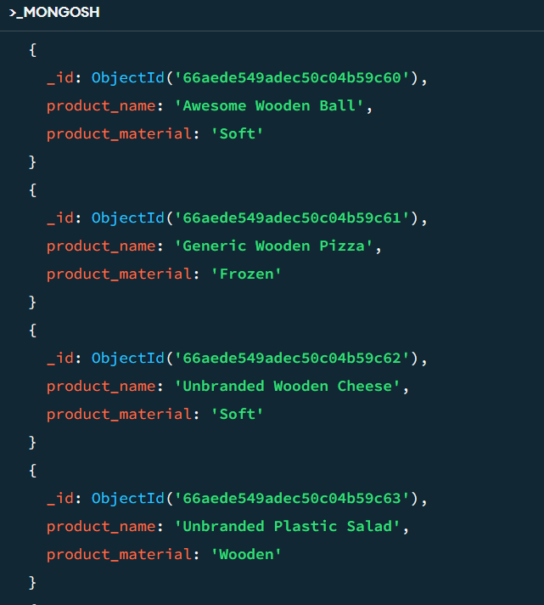

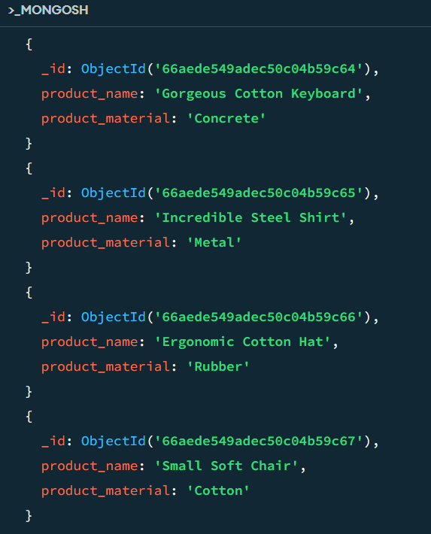

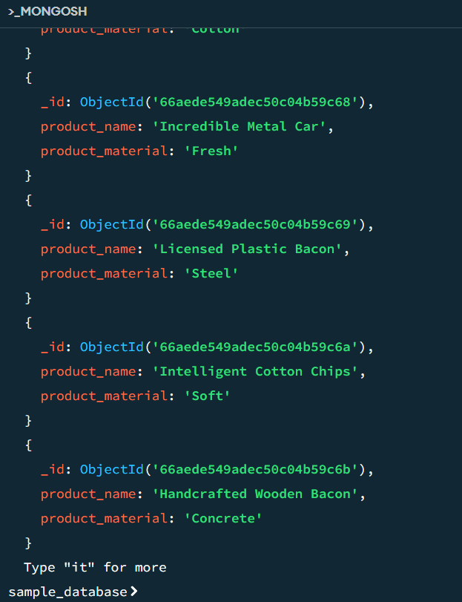

1. Find the product with a row id of 10

Query

>db.MongoDB_Day1.find(

{“id”:”10}

);

Otherwise

>db.MongoDB_Day1.find(

{“id”:{$eq:”10”} }

);

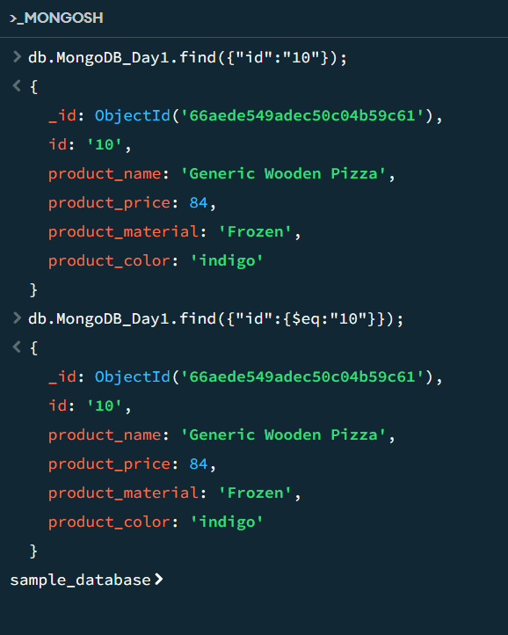

1. Find only the product name and product material

Query  
>db.MongoDB_Day1.find(

{ },{“product_name”:1,”product_material”:1,”_id”:0}

);

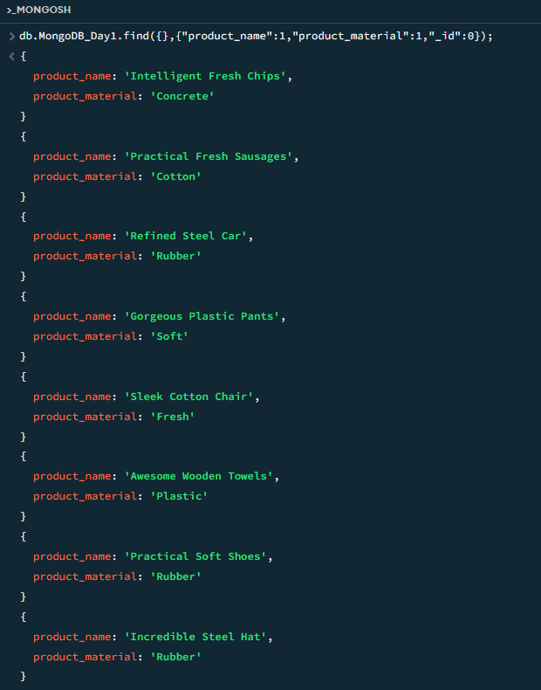

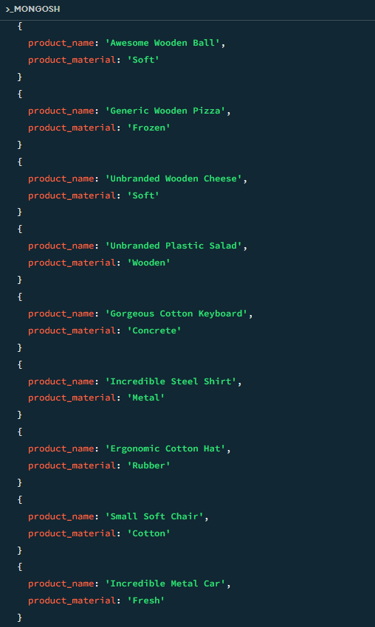

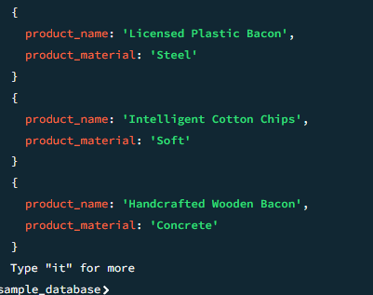

1. Find all products which contain the value of soft in product material

Query

> db.MongoDB_Day1.find({"product_material":"Soft"});

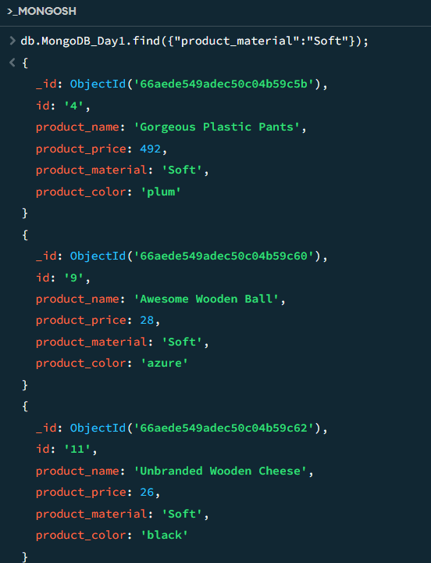

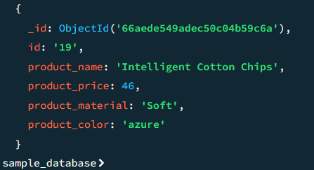

1. Find products which contain product color indigo  and product price 492.00

Query

>db.MongoDB_Day1.find(

{"product_color":"indigo","product_price":492}

);

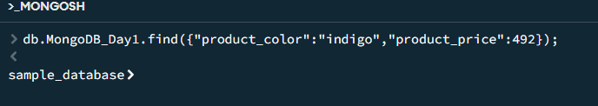

1. Delete the products which product price value are 28

Query

> db.MongoDB_Day1.deleteOne({"product_price":28});

