# Mongo DB Day 2 Task

Users collection

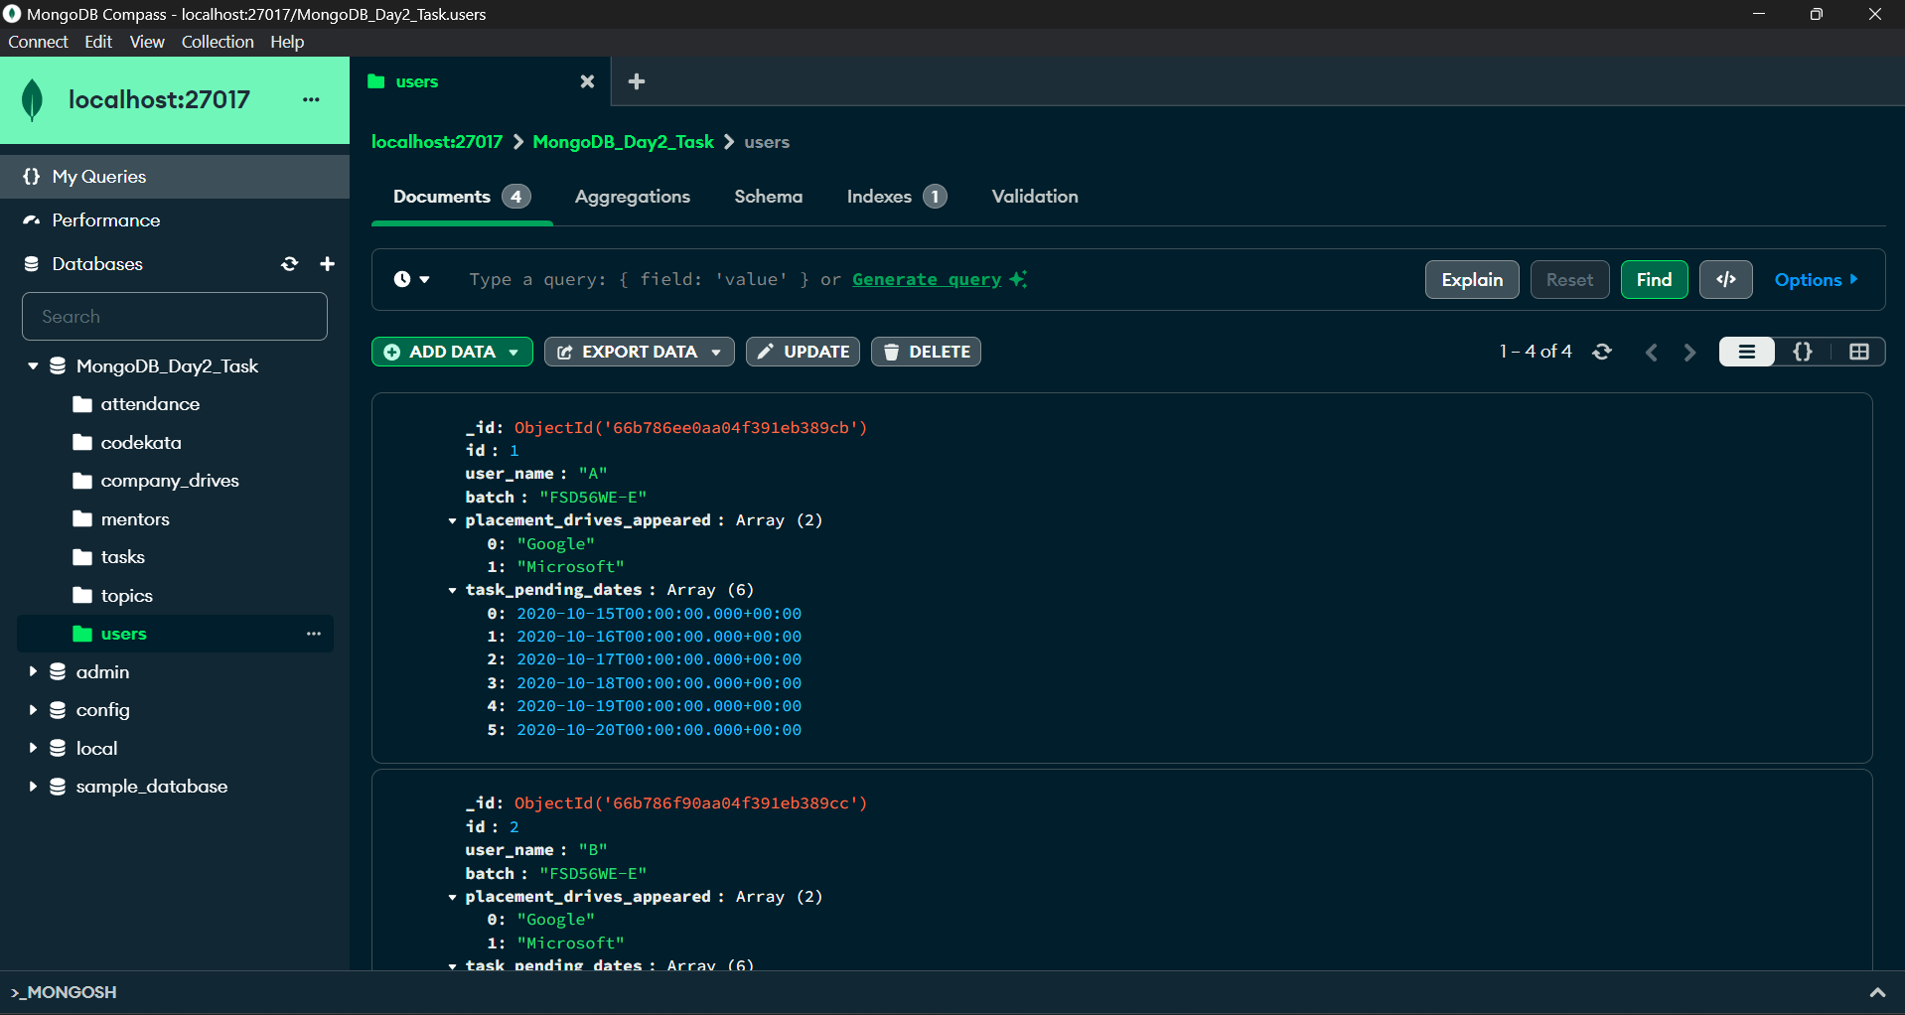

Codekata collection

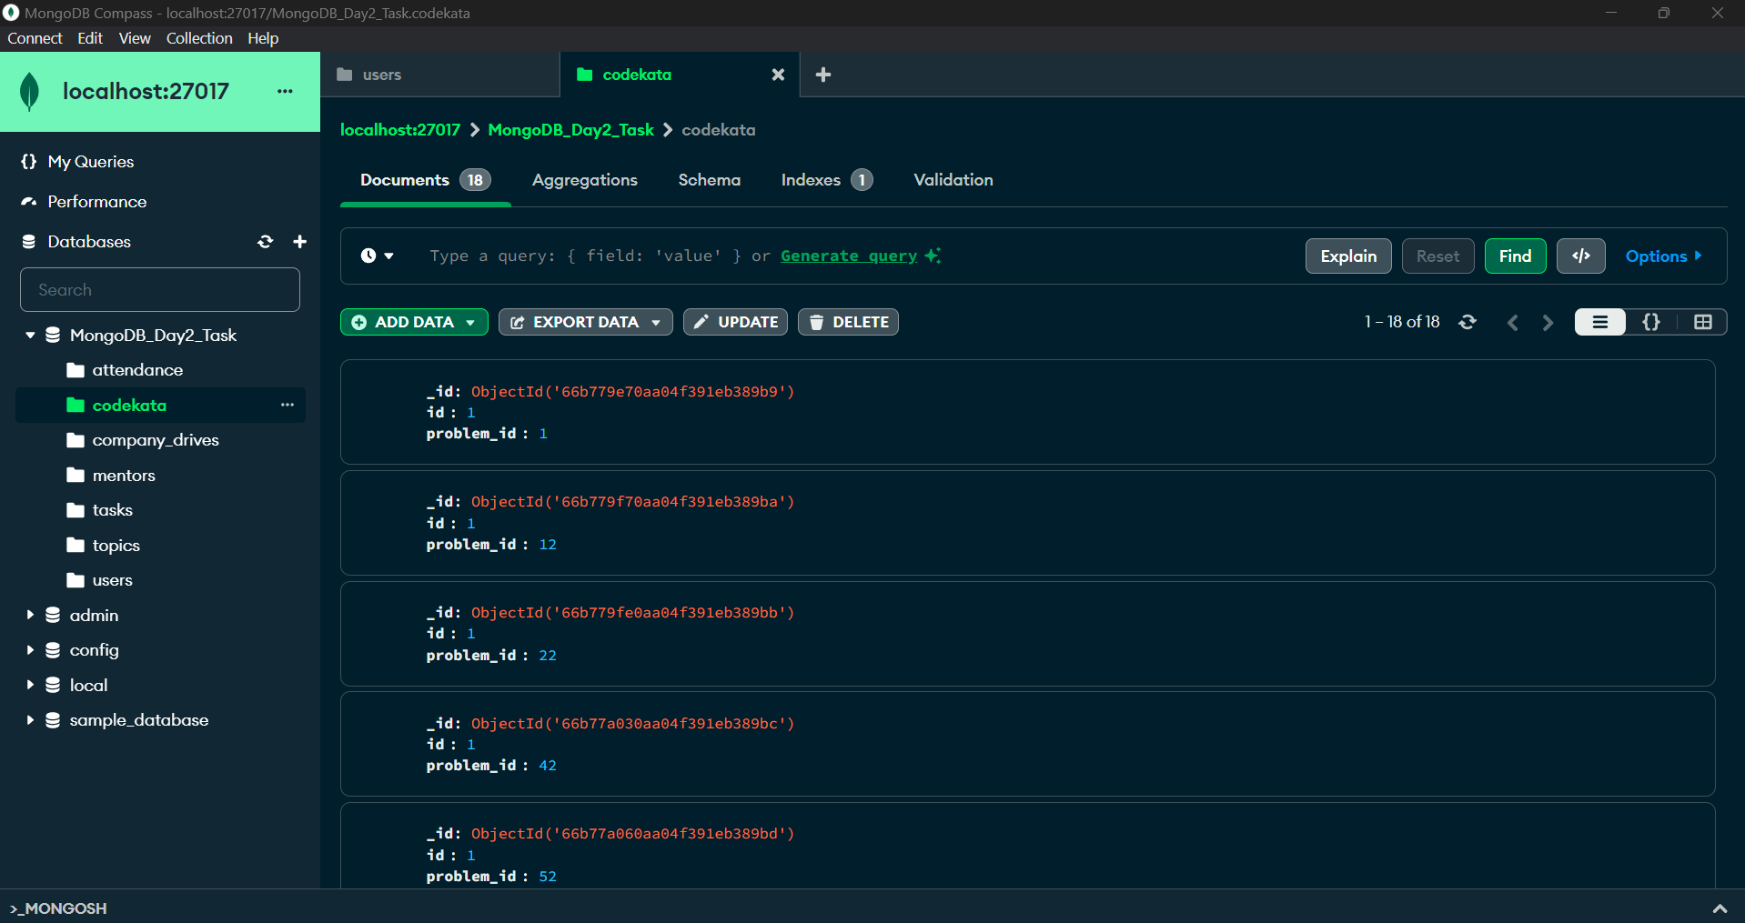

Attendance collection

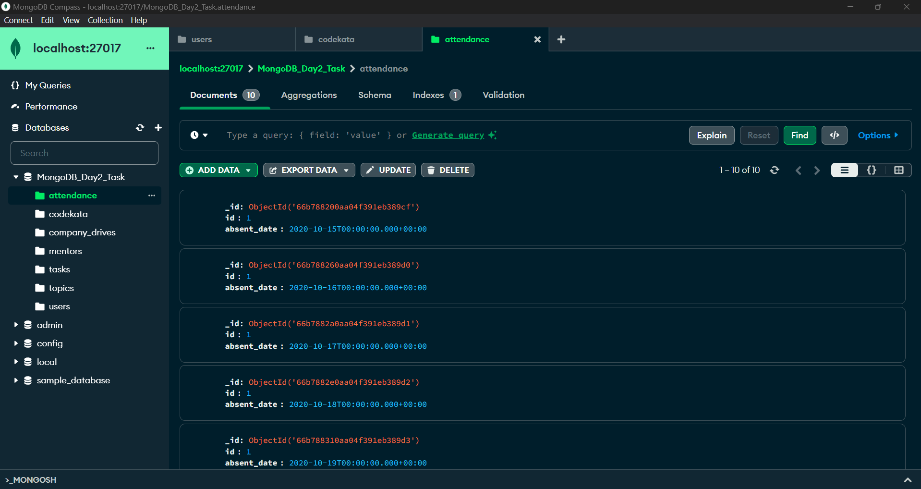

Topics collection

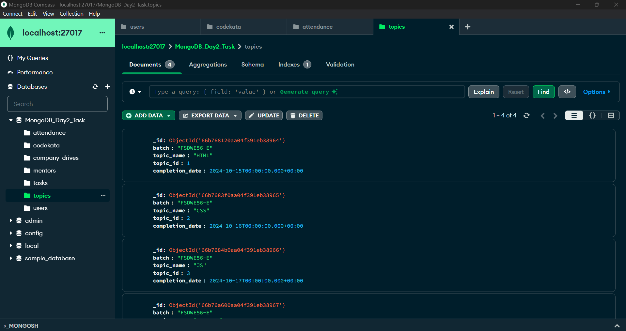

Tasks collection

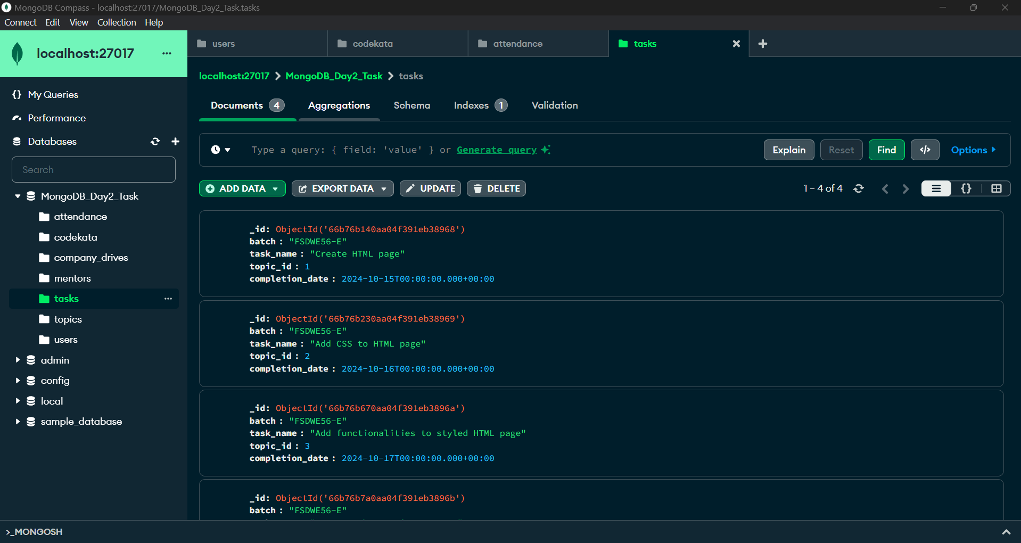

Company_drives collection

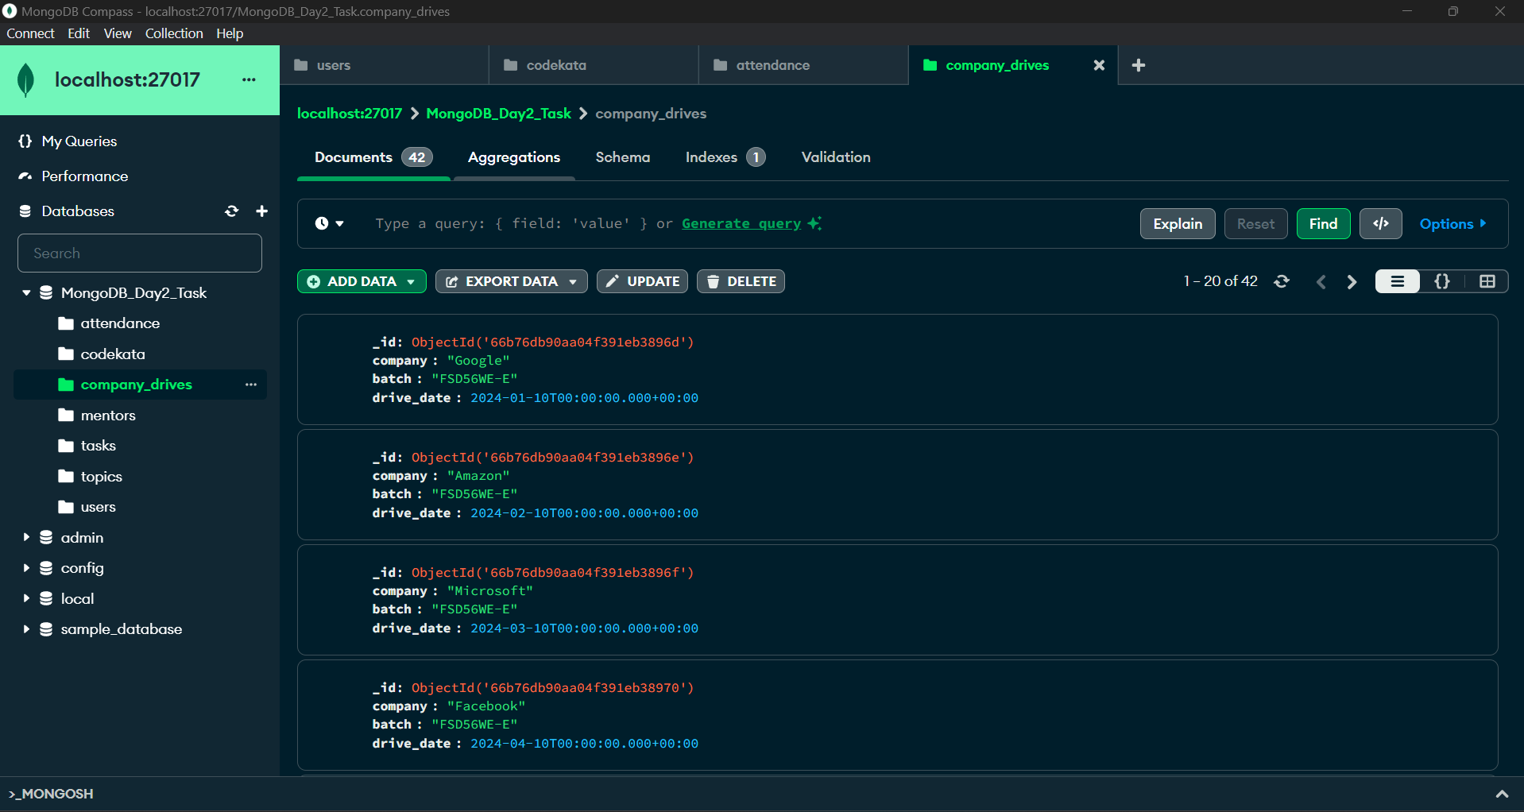

Mentors collection

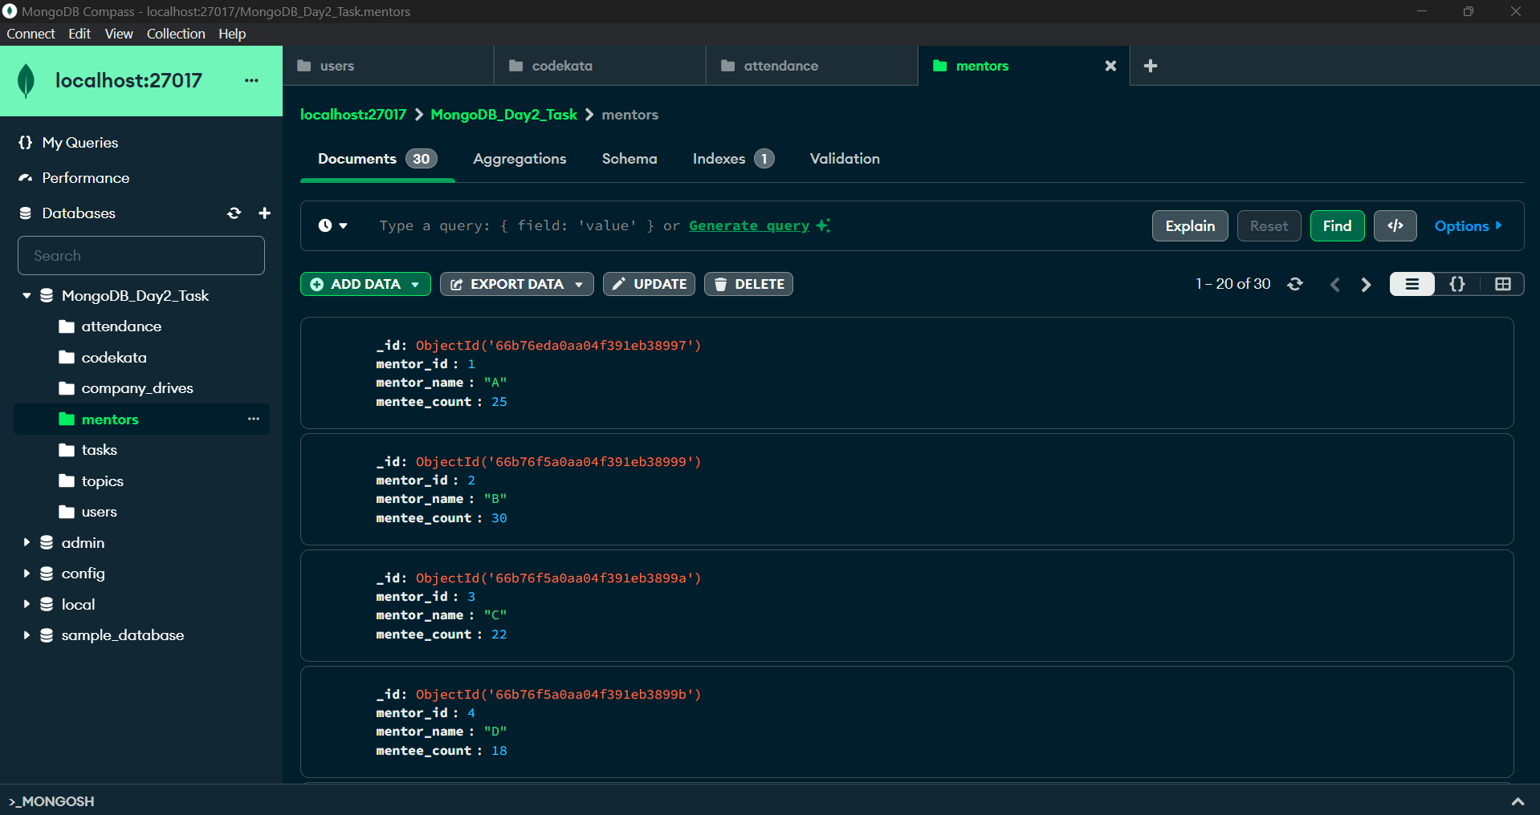

1. Find all the topics and tasks in the month of October

All the topics which were taught in the month of October

QUERY:

db.topics.find({

completion_date: {

$gte: ISODate("2024-10-01T00:00:00.000Z"),

$lt: ISODate("2024-11-01T00:00:00.000Z")

}

},{topic_name:1,completion_date:1,_id:0});

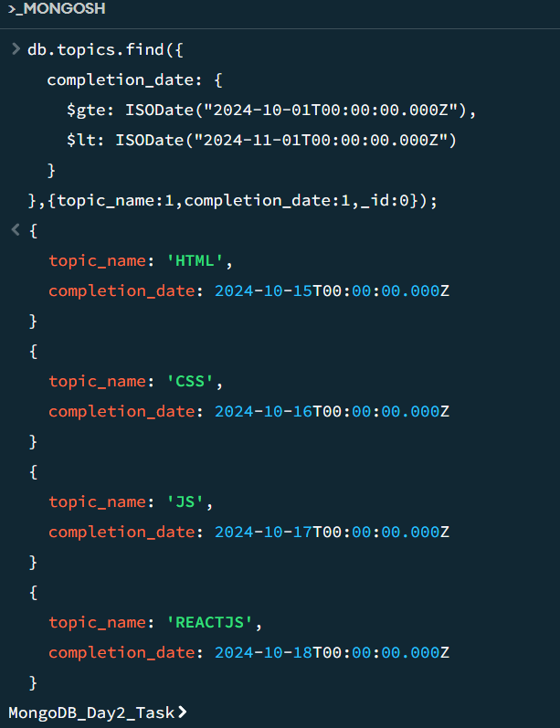

Tasks given in the month of October

QUERY:

db.tasks.find({

completion_date: {

$gte: ISODate("2024-10-01T00:00:00.000Z"),

$lt: ISODate("2024-11-01T00:00:00.000Z")

}

},{task_name:1,completion_date:1,_id:0});

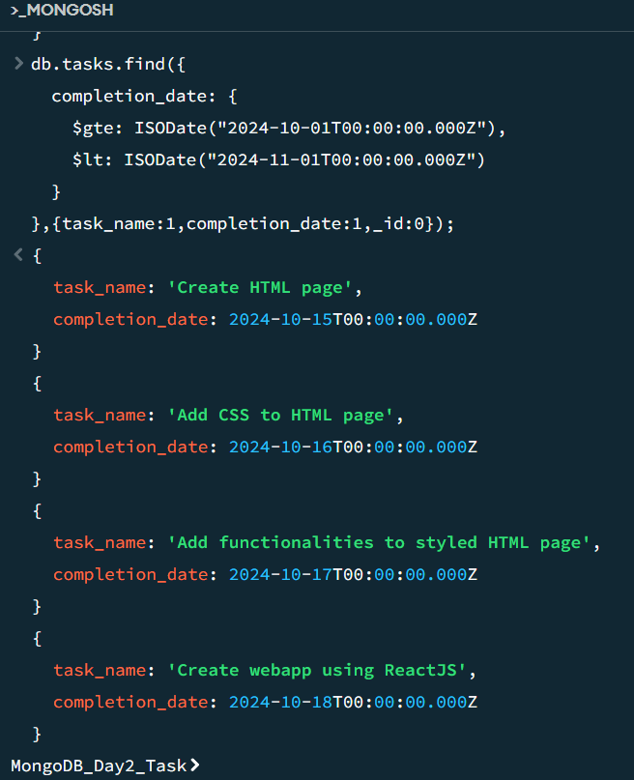

1. Find all the company drives which appeared between 15 oct-2020 and 31-oct-2020

QUERY:

db.company_drives.find({"drive_date":{$gte: ISODate("2020-10-15T00:00:00.000Z"),

$lt: ISODate("2020-11-01T00:00:00.000Z")}},{company:1,drive_date:1,_id:0});

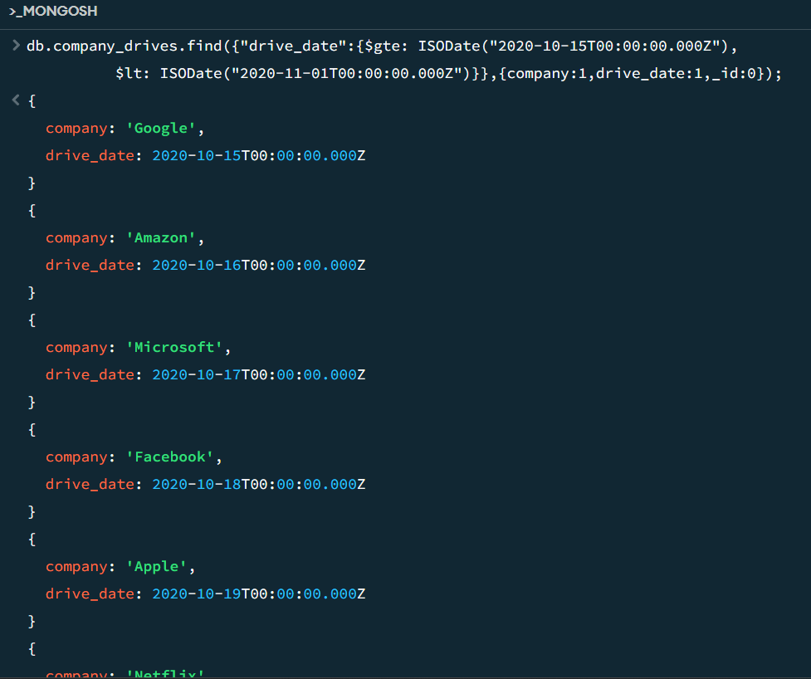

1. Find all the company drives and students who are appeared for the placement.

All the company drives   
QUERY:

db.company_drives.distinct("company");



Students who appeared for placement  
QUERY:

db.users.aggregate([

{

$project: {

user_name: 1,

placement_drives_appeared: 1,

_id:0

}

}

]);

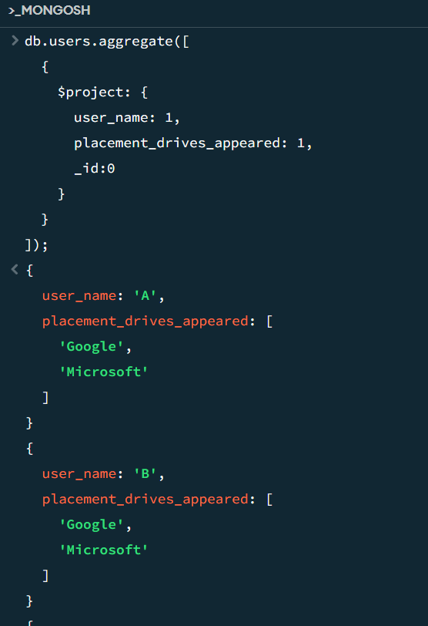

1. Find the number of problems solved by the user in codekata

db.codekata.aggregate([

{

$group: {

_id: "$id",

solvedCount: { $sum: 1 }

}

},

{

$project: {

userId: "$_id",

solvedCount: 1,

_id: 0

}

},

{

$sort: { userId: 1 }

}

]);

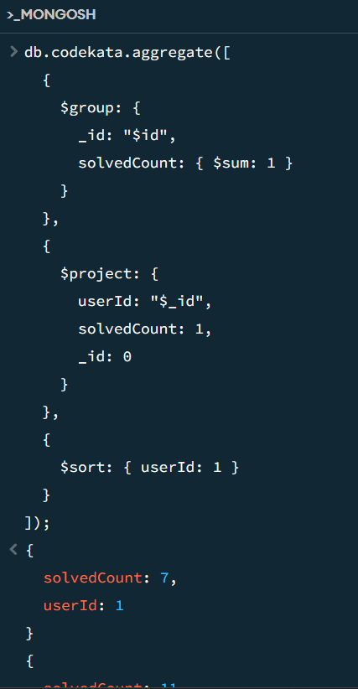

1. Find all the mentors with who has the mentee's count more than 15

QUERY:

db.mentors.find({mentee_count:{"$gt":15}},{mentor_name:1,mentee_count:1,_id:0});

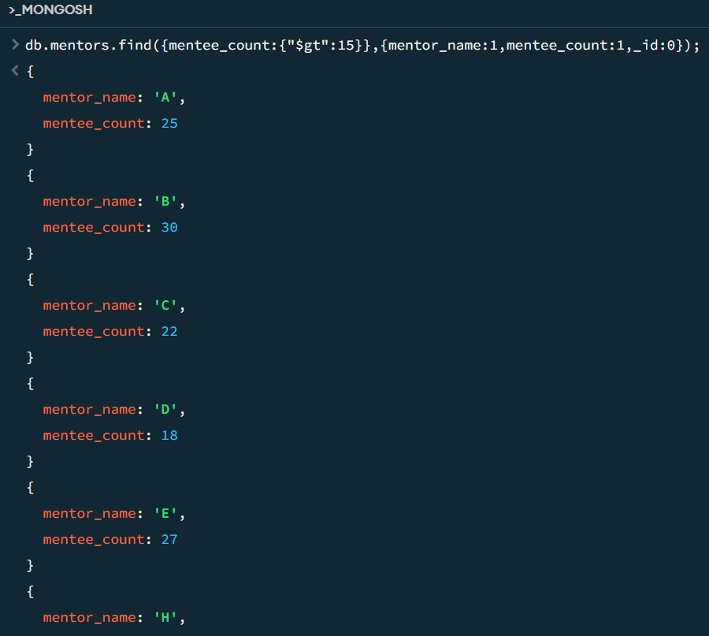

1. Find the number of users who are absent and task is not submitted  between 15 oct-2020 and 31-oct-2020

Users who have not submitted task absent between 15th October and 31st October

QUERY:

db.users.find({

"task_pending_dates": {

"$elemMatch": {

"$gte": ISODate("2020-10-15T00:00:00.000Z"),

"$lte": ISODate("2020-10-31T23:59:59.999Z")

}

}

}, {

"user_name": 1,

"_id": 0

});

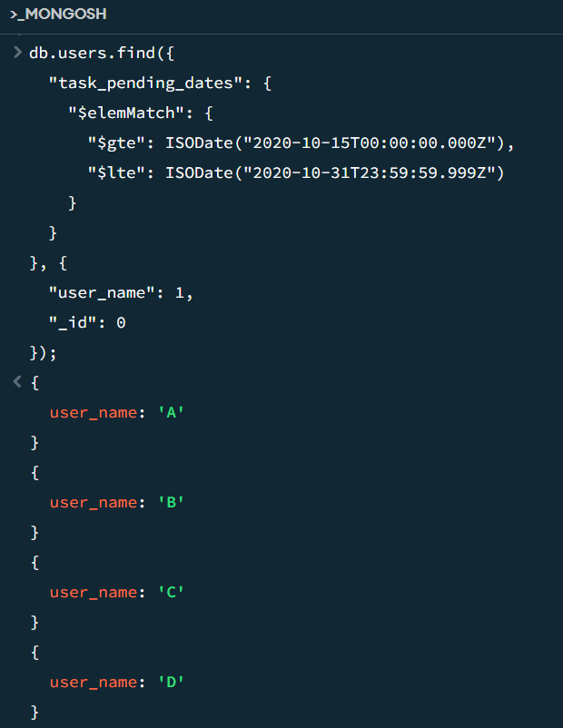

Users who were absent between 15th oct 2020 to 31st oct 2020

QUERY:

db.attendance.aggregate([

{

$match: {

absent_date: {

$gte: new ISODate("2020-10-15T00:00:00.000Z"),

$lte: new ISODate("2020-10-31T23:59:59.999Z")

}

}

},

{

$group: {

_id: "$id"

}

},

{

$count: "total_absent_users"

}

]);

