MySQL Day 2 Task

# Design DB Model for Guvi Zen class

## Steps to create a DB model for Guvi Zen class

1. Identify the entities
2. Identify the attributes
3. Identify the relationships
4. Identify the cardinality
5. Identify the primary key
6. Identify the foreign key
7. Create tables
8. Insert Data

1.Identify the entities

The following are the entities that are required:

1. Students
2. Mentors
3. Attendance
4. Codekata
5. Topics
6. Tasks
7. Company Drives

2.Identify the attributes

1.Student table has the column names as id, user_name, batch, placement_drives _appeared, task_pending_dates

2.Codekata table has the column names as id, problem_id

3.Attendance table has the column names as id, absent_dates

4.Topics table has the column names as batch, topic_name, topic_id, completion_date

5.Tasks table has the column names as batch, task_name, topic_id, completion_date

6.Company drive table has the column names as company_name, batch, month

7.Mentors table has the column names as id, mentor_name, mentee count

3.Identify the relationships

* Each student has a single mentor
* A mentor can have many students
* A student can attend many drives
* One drive can hire many students
* Student can solve many codekata problems

4.Identify the cardinality

* Each student has a single mentor ( 1:1)
* A mentor can have many students (1:many)
* A student can attend many drives (1:many)
* One drive can hire many students (1:many)
* Student can solve many codekata problems (1:many)

5.Identify the primary keys

|  |  |
| --- | --- |
| Table name | Primary key |
| 1.Students | id |
| 2.Codekata | id |
| 3.Attendance | id |
| 4.Topics | Topic_id |
| 5.Tasks | Topic_id |
| 6.Company drive | Company_name |
| 7.Mentor | id |

6. Identify the foreign keys

|  |  |
| --- | --- |
| Table name | Primary key |
| 1.Students | Batch |
| 2.Codekata | id |
| 3.Attendance | id |
| 4.Topics | Batch |
| 5.Tasks | Batch |
| 6.Company drive | Batch |
| 7.Mentor | None |

7.Create tables

1. Create Student Table

CREATE TABLE Student (

id INT PRIMARY KEY,

user_name VARCHAR(255) NOT NULL,

batch VARCHAR(50),

placement_drives_appeared INT DEFAULT 0,

task_pending_dates DATE

);

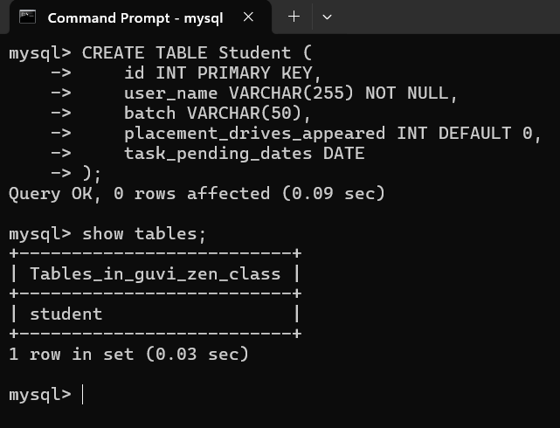

2.Create Codekata Table

CREATE TABLE Codekata (

id INT,

problem_id INT,

PRIMARY KEY (id),

FOREIGN KEY (id) REFERENCES Student(id)

);

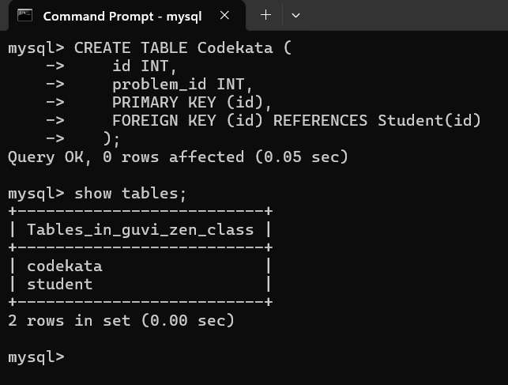

3.Create Attendance Table

CREATE TABLE Attendance (

id INT PRIMARY KEY,

absent_dates DATE,

FOREIGN KEY (id) REFERENCES Student(id)

);

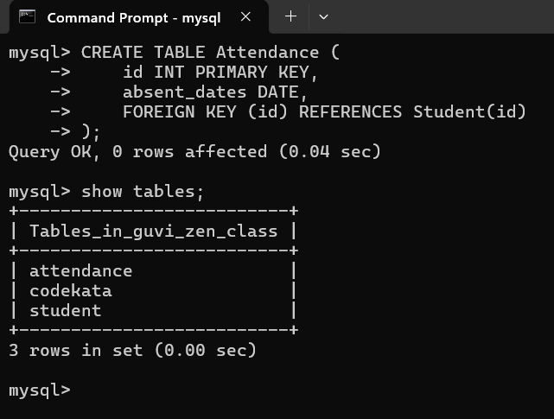

4. Create Topics Table

CREATE TABLE Topics (

topic_id INT PRIMARY KEY,

batch VARCHAR(50),

topic_name VARCHAR(255) NOT NULL,

completion_date DATE,

FOREIGN KEY (batch) REFERENCES Student(batch)

);  
  
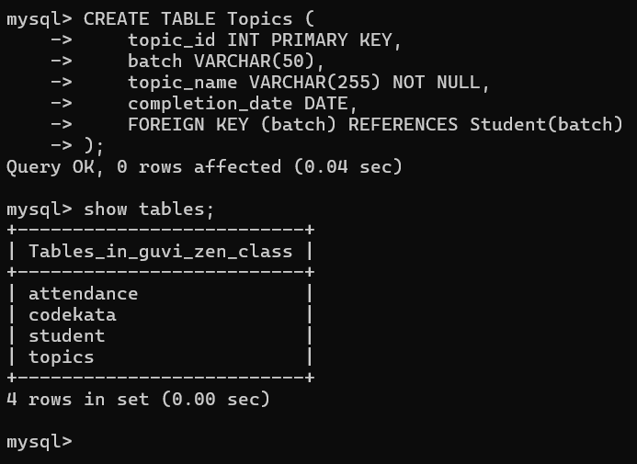

5. Create Tasks Table

CREATE TABLE Tasks (

batch VARCHAR(50),

task_name VARCHAR(255),

topic_id INT,

completion_date DATE,

PRIMARY KEY (topic_id),

FOREIGN KEY (batch) REFERENCES Student(batch)

);

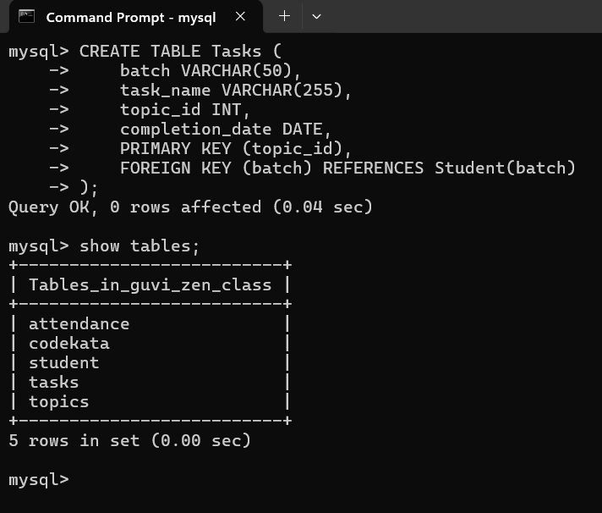

6.Create Company Drive Table

CREATE TABLE CompanyDrive (

company_name VARCHAR(255),

batch VARCHAR(50),

month VARCHAR(20),

PRIMARY KEY (company_name),

FOREIGN KEY (batch) REFERENCES Student(batch)

);

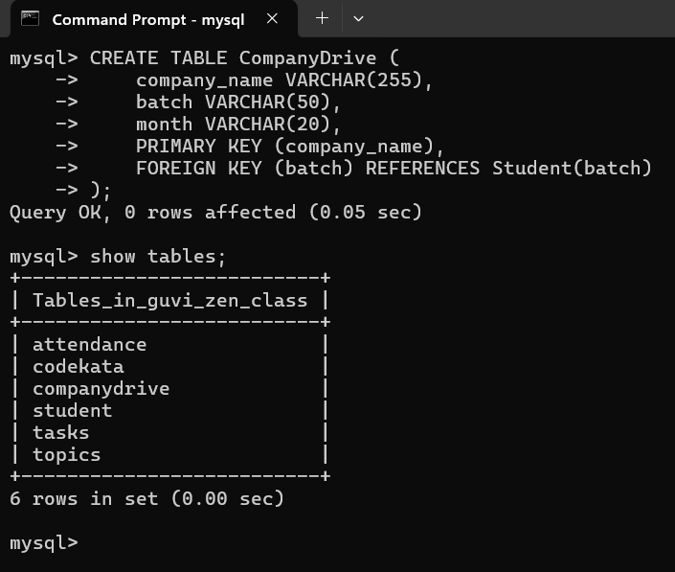

7.Create Mentors Table

CREATE TABLE Mentors (

mentor_id INT PRIMARY KEY,

mentor_name VARCHAR(255) NOT NULL,

mentee_count INT DEFAULT 0

);

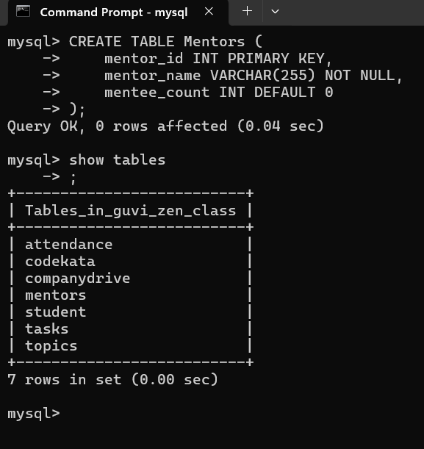

8.Insert Data

1.Insert data into Student Table

INSERT INTO Student (id, user_name, batch, placement_drives_appeared, task_pending_dates) VALUES

(1, 'Alice', 'Batch2024', 2, '2024-08-15'),

(2, 'Bob', 'Batch2024', 1, '2024-08-20'),

(3, 'Charlie', 'Batch2023', 0, '2024-08-25'),

(4, 'David', 'Batch2023', 3, '2024-08-30');

2. Insert data into Codekata Table

INSERT INTO Codekata (id, problem_id) VALUES

(1, 101),

(2, 102),

(1, 103),

(3, 101);

3. Insert data into Attendance Table

INSERT INTO Attendance (id, absent_dates) VALUES

(1, '2024-08-01'),

(2, '2024-08-02'),

(3, '2024-08-05'),

(4, '2024-08-10');

4. Insert data into Topics Table

INSERT INTO Topics (topic_id, batch, topic_name, completion_date) VALUES

(1, 'Batch2024', 'Data Structures', '2024-07-20'),

(2, 'Batch2024', 'Algorithms', '2024-07-25'),

(3, 'Batch2023', 'Databases', '2024-07-15'),

(4, 'Batch2023', 'Networking', '2024-07-18');

5. Insert data into Tasks Table

INSERT INTO Tasks (batch, task_name, topic_id, completion_date) VALUES

('Batch2024', 'Task1', 1, '2024-07-22'),

('Batch2024', 'Task2', 2, '2024-07-26'),

('Batch2023', 'Task1', 3, '2024-07-17'),

('Batch2023', 'Task2', 4, '2024-07-20');

6. Insert data into Company Drive Table

INSERT INTO CompanyDrive (company_name, batch, month) VALUES

('CompanyA', 'Batch2024', 'August'),

('CompanyB', 'Batch2024', 'August'),

('CompanyC', 'Batch2023', 'July'),

('CompanyD', 'Batch2023', 'July');

7. Insert data into Mentors Table

INSERT INTO Mentors (mentor_id, mentor_name, mentee_count) VALUES

(1, 'Eve', 5),

(2, 'Frank', 4),

(3, 'Grace', 3),

(4, 'Hannah', 6);