REJUVONIX

Agent Experience Specification
Version 1.0.0
Presentation, interaction, handoff, safety, and role experience contract for the Rejuvonix Intelligence Layer
Document ID | RAI-UX-002
Version | 1.0.0
Status | APPROVED EXPERIENCE BASELINE
Owner | Rejuvonix Product / Clinical Governance
Effective Date | 2026-08-24

Experience thesis
The Rejuvonix AI should not feel like a generic chatbot. It should feel like a governed care intelligence layer that changes its presentation, permissions, language, and available actions according to the stakeholder, context, and stage of the care journey.

1. Purpose and Experience Vision
The Rejuvonix Intelligence Layer is one governed intelligence foundation expressed through multiple role-specific experiences.
- Visitors and patients experience a calm care guide that helps them understand, navigate, prepare, and escalate.
- Practitioners experience a clinical copilot that reduces search and documentation burden while preserving human clinical authority.
- Pharmacists and medication-support users experience a medication-aware assistant grounded in approved medication and pharmacy knowledge.
- Operations users experience a workflow assistant focused on scheduling, coordination, notifications, and service delivery.
- All agents share a common knowledge, authorization, audit, and safety foundation.
Non-negotiable interaction rule
AI authority must never exceed the authenticated human user's authority. A user should never gain access to information or actions through the AI that they could not access through the platform directly.

2. Visual Concept
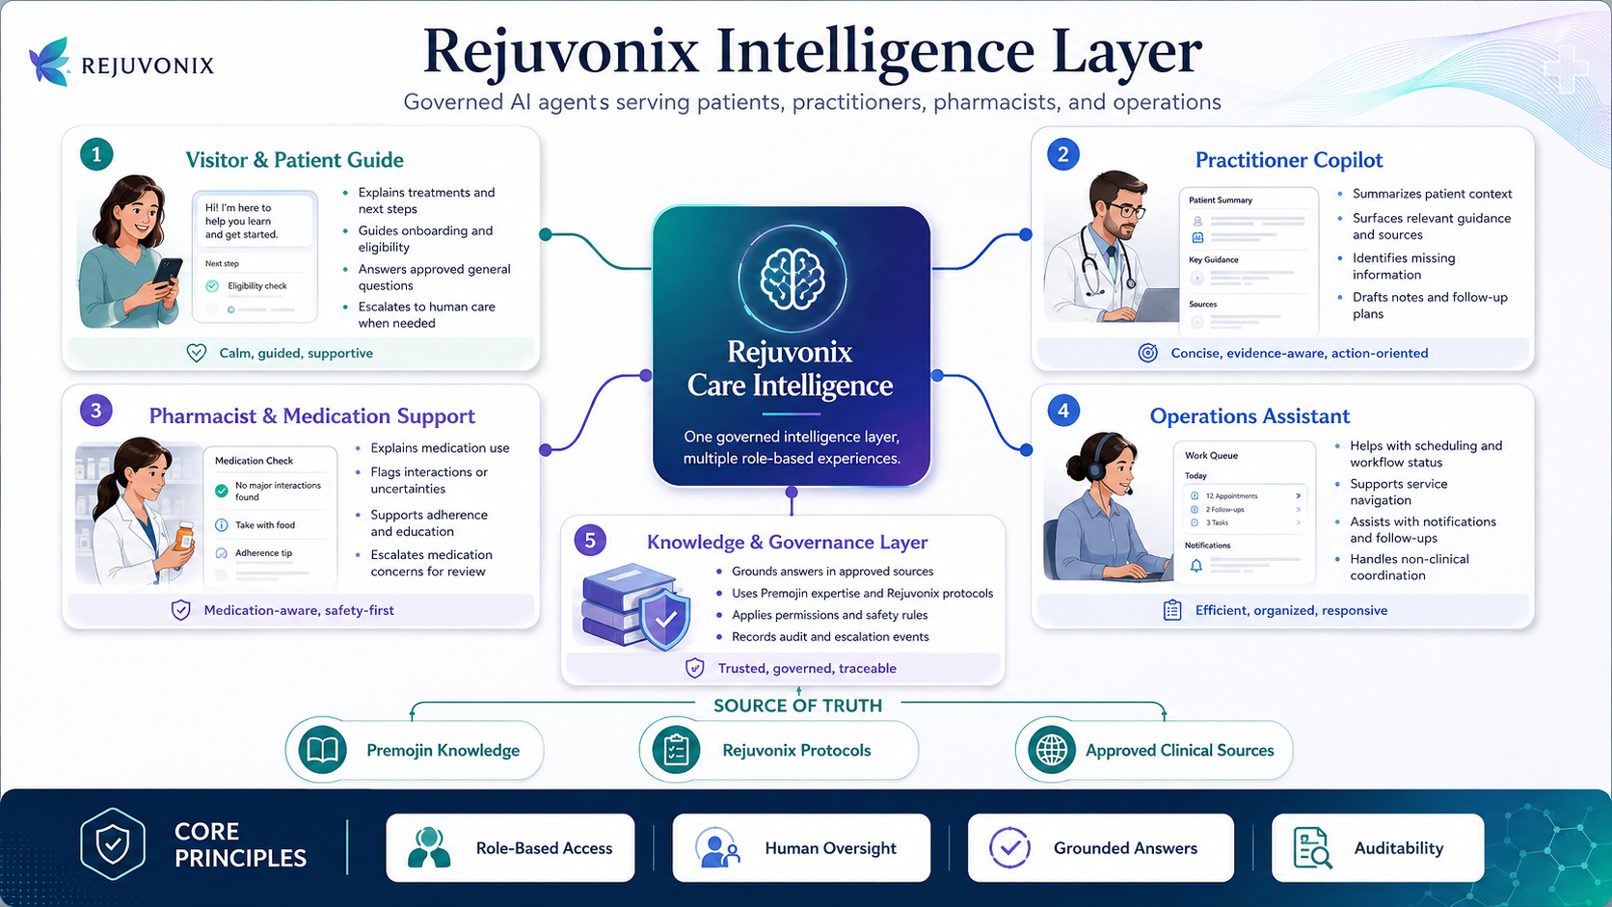
Figure 1. Rejuvonix Intelligence Layer role concept.

3. Shared Interaction Principles
Experience Element | Expected Behavior
Healthcare first | The interface should feel like a premium care platform first. AI branding is secondary and restrained.
Context aware | The assistant should understand the current page, workflow stage, and authorized record context without requiring the user to repeatedly explain it.
Guided before open chat | Use task chips, suggested actions, and contextual prompts before presenting a blank chat field.
Structured responses | Prefer cards, actions, statuses, source panels, checklists, and review controls over long paragraphs.
Visible mode | Always make the active role or mode understandable: Patient Guide, Clinical Copilot, Medication Support, or Operations Assistant.
Grounded | Clinical, medication, policy, and Rejuvonix-specific responses should be linked to approved sources where relevant.
Escalation is useful | A safety boundary should lead to a helpful next step, not a dead end.
Human accountability | Consequential clinical actions remain under qualified practitioner review.
Transparent memory | Persistent memory should be explicit, reviewable, permissioned, and separate from the authoritative clinical record.

4. Visitor & Patient Guide Experience
Experience character: Calm, guided, supportive, non-diagnostic, and confidence-building.
Experience Element | Expected Behavior
Primary entry | A contextual “Ask Rejuvonix” or care-guide entry point integrated into the page, not an intrusive floating chatbot.
First view | Begin with guided choices such as Explore treatment options, Check my next step, Understand medication, Prepare for consultation, or Ask a question.
Anonymous state | General approved education and navigation only. Personal-care questions should prompt sign-in before accessing personal context.
Authenticated state | May use authorized patient context to explain next steps, appointments, care-plan information, and workflow status.
Treatment pages | Offer context-aware questions such as who may qualify, how it works, common side effects, and what happens next.
Onboarding | Use progress-oriented guidance: current step, what is needed, why it matters, and next action.
Response style | Short explanation plus structured cards, links, or action buttons. Avoid dense clinical prose unless specifically requested.
Safety escalation | When clinical review is needed, present options such as Send to care team, Request consultation, or View urgent-care guidance.
Source visibility | Show a compact “Sources” affordance when answers rely on governed clinical or medication knowledge.
Mobile | Use a bottom sheet or full-height conversational panel that can be dismissed without losing the underlying page.

4.1 Patient Journey Continuity
Intended journey
Homepage -> Treatment Education -> Eligibility / Get Started -> Account -> Onboarding -> Consent -> Intake -> Consultation -> Treatment -> Follow-up. The assistant changes its guidance at each stage rather than behaving as one static chatbot.

5. Practitioner Copilot Experience
Experience character: Concise, evidence-aware, patient-contextual, reviewable, and action-oriented.
Experience Element | Expected Behavior
Placement | Integrated beside the authorized patient chart or encounter workspace, not as a generic global chat window.
Context header | Clearly display the current patient, encounter, and relevant treatment/workflow context.
Task starters | Summarize intake, Identify missing information, Review medication considerations, Compare approved pathways, Draft note, Prepare follow-up.
Information separation | Visually distinguish Patient Record facts, Approved Guidance, and AI Consideration.
Sources | Show detailed provenance: knowledge source, version, effective/review dates where available.
Recommendation controls | Material AI suggestions should support Accept into plan, Modify, or Dismiss, with the clinician action auditable.
Natural language | Allow questions such as “What changed since the last consultation?” or “What information is still missing?”
Authorization | The copilot may only retrieve patients and resources the clinician is permitted to access.
Clinical authority | The copilot supports reasoning but does not independently diagnose, prescribe, change dose, discontinue medication, or finalize treatment decisions.
Audit | Material AI assistance should record the interaction, sources, tools used, and clinician disposition where appropriate.

6. Pharmacist & Medication Support Experience
Experience character: Medication-aware, safety-first, source-grounded, and escalation oriented.
Experience Element | Expected Behavior
Primary tasks | Medication education, administration guidance, adherence support, source retrieval, and identification of issues requiring pharmacist/clinician review.
Presentation | Use medication summary cards with approved use, administration, common concerns, source references, and escalation markers.
Uncertainty | Potential interactions, contraindications, adverse reactions, or conflicting information should be explicitly flagged for review.
Scope | Do not allow an AI-only medication assistant to independently modify prescriptions or dosage.
Source priority | Use Premojin/Rejuvonix approved medication guidance, official product information, and approved clinical references before model general knowledge.
Patient-facing variant | Use plain language and avoid overloading the user with professional terminology.
Professional variant | Allow more structured detail, citations, interaction context, and pharmacy workflow actions subject to permissions.

7. Operations Assistant Experience
Experience character: Efficient, organized, responsive, and non-clinical unless explicitly authorized.
Experience Element | Expected Behavior
Primary surface | Workflow queue, scheduling, status, notifications, follow-up coordination, and service navigation.
Typical prompts | What requires attention today? Which appointments need follow-up? Which notifications failed? What tasks are overdue?
Action cards | Use queues, counts, due dates, status indicators, and confirmable actions instead of free-form chat where possible.
Clinical separation | Operations/support users must not receive unrestricted encounter notes or treatment details simply because the AI can retrieve them.
Handoff | Clinical questions should route to an authorized clinician/pharmacist workflow rather than being answered through operations context.
Notifications | Support notification preparation and workflow state, respecting consent, channel preferences, and sensitivity rules.

8. Knowledge & Governance Layer Experience
Experience character: Mostly invisible to users, but its effects should be visible through trustworthy behavior.
Experience Element | Expected Behavior
Grounding | Answers should be based on approved Premojin knowledge, Rejuvonix protocols, and approved external clinical sources.
Source labels | Expose source provenance in a role-appropriate manner.
Permissions | Apply role, permission, resource scope, and patient relationship before retrieval or tool execution.
Versioning | Use approved and current source versions. Superseded knowledge should not appear as current guidance.
Safety | Apply escalation and human-oversight rules before high-risk responses or actions.
Audit | Capture interaction metadata, tool use, source versions, authorization outcome, escalation, and reviewer action where relevant.
Failure behavior | If grounding, authority, or context is insufficient, the system should say so and provide a safe next step.

9. Agent State and Context Presentation
Experience Element | Expected Behavior
Mode indicator | Show the active experience, e.g., Patient Guide, Clinical Copilot, Operations Assistant.
Working-with chips | For protected professional workflows, show context chips such as Patient #, Encounter #, or Treatment Program.
Anonymous vs signed-in | Clearly distinguish public general guidance from authenticated personal guidance.
General vs personalized | Use labels such as GENERAL EDUCATION, BASED ON YOUR REJUVONIX CARE PLAN, and CLINICIAN REVIEW REQUIRED.
Memory | Ask before retaining user preferences that are not already part of the governed record. Provide a way to view/manage remembered preferences.
Session continuity | Preserve active task context across page navigation where safe, but do not allow stale patient context to bleed into another patient record.

10. Three Levels of Interaction
Experience Element | Expected Behavior
Level 1 - Inform | Explain, define, navigate, retrieve approved information. Lowest operational risk.
Level 2 - Assist | Summarize, compare, prepare, draft, identify missing information, structure next steps.
Level 3 - Act | Request appointment, send message, save draft, submit intake, or invoke another authorized tool. Requires explicit authorization and confirmation where appropriate.

Action pattern
AI proposes action -> User confirms where required -> Authorized tool executes -> Success/failure state is shown -> Audit/event is written.

11. Escalation and Human Handoff Experience
Experience Element | Expected Behavior
Clinical uncertainty | State that the issue requires human review and provide a direct path to the appropriate care role.
Urgent concern | Present approved urgent/emergency guidance appropriate to the platform policy; do not improvise.
Medication concern | Offer pharmacist or clinician review path based on the nature of the issue.
Technical/support issue | Transfer context to operations/support without exposing unnecessary clinical content.
Failed action | Explain what failed in user-safe language, preserve correlation ID internally, and offer retry or alternate path where appropriate.
No source | Do not fabricate. State that no sufficiently verified source is available and escalate when the question is consequential.

12. Visual Language and Component Contract
Experience Element | Expected Behavior
Branding | Premium healthcare aesthetic with restrained teal/blue/violet accents. Avoid novelty AI visuals dominating the care experience.
Desktop | Assistant rail or contextual side panel aligned with the active workflow.
Mobile | Bottom-sheet or full-screen assistant that preserves underlying page state.
Cards | Use appointment cards, medication cards, progress cards, source cards, review cards, and queue cards.
Action chips | Use concise, role-specific suggested actions before open-ended prompting.
Status colors | Use semantic status treatment consistently; do not rely on color alone.
Accessibility | Keyboard support, focus states, clear labels, buttons for actions, links for navigation, readable contrast, and screen-reader meaningful naming.
AI markers | Use subtle labels such as AI CONSIDERATION rather than decorative “sparkles” everywhere.

13. Role Experience Matrix
Role | Primary Mode | Personal Data | Clinical Support | May Execute
Visitor | Public Guide | No private record | General education only | Public navigation
Patient | Patient Guide | Own authorized data | Explain own care context; no autonomous diagnosis | Own authorized workflow actions
Clinician | Clinical Copilot | Assigned/authorized patients | Decision support with sources and review | Authorized clinical workflow actions; consequential decisions remain human
Pharmacist | Medication Support | Authorized medication/patient context | Medication-focused support and escalation | Authorized pharmacy workflow actions
Operations | Operations Assistant | Minimum necessary operational data | No unrestricted clinical reasoning | Scheduling, coordination, notifications
Support | Restricted Support | Minimum necessary troubleshooting data | None by default | Support actions only

14. Experience Acceptance Criteria
- A visitor can identify what Rejuvonix does and reach the next logical step without needing to invent a prompt.
- A patient can distinguish general education from personalized information.
- A clinician can always see which patient/context the copilot is working with.
- AI-generated clinical considerations are visually distinguishable from record facts and approved guidance.
- High-risk or uncertain questions produce a safe escalation path rather than an unsupported answer.
- All Level 3 actions pass through authorization and produce a clear success/failure state.
- No role can access data or actions through AI beyond its platform permissions.
- Source provenance is available for governed clinical/medication guidance.
- The experience works on desktop and mobile without hiding primary navigation or workflow state.
- Agent continuity never becomes a substitute for the authoritative patient or clinical record.

15. Codex Build Contract
Mandatory governance relationship
Codex should treat this document as the UX/interaction companion to the AI Governance and API/Integration Governance packs. AI-only work loads the AI governance index; integration/tool work loads the integration governance index; agent experience work that spans both must load both governance sets plus this experience specification.

- Document ID: RAI-UX-002, Version 1.0.0.
- Any change to role behavior, presentation of authority, clinical review controls, escalation flow, memory behavior, or action-confirmation policy requires an explicit document update and version increment.
- Implementation must not silently diverge from this experience contract.
- Where this document conflicts with clinical safety, security, privacy, or regulatory controls, the stricter higher-authority control prevails.

16. Version History
Version | Date | Status | Summary
1.0.0 | 2026-08-24 | Approved baseline | Initial unified agent experience specification covering patient, practitioner, pharmacist, operations, governance, handoff, state, visual interaction, and acceptance criteria.

