

PREPACE-AI
Report 3 – Software Requirement Specification

– Danang , Jun 2024 –
Table of Contents

I. Record of Changes 7
II. Software Requirement Specification 8
1. Product Overview 8
2. User Requirements 9
2.1 Actors 9
2.2 Use Cases 10
2.2.1 Diagram(s) 10
2.2.1.1 Use Case Overview 10
2.2.1.2 Use Case for Authentication 11
2.2.1.3 Use Case for Student 12
2.2.1.4 Use Case for Teacher 13
2.2.1.5 Use Case for Admin 13
2.2.2 Descriptions 14
3. Functional Requirements 17
3.1 System Functional Overview 17
3.1.1 Screens Flow 17
3.1.2 Screen Descriptions 17
3.1.3 Screen Authorization 19
3.1.4 Non-Screen Functions 21
3.1.5 Entity Relationship Diagram 21
3.2 Authentication feature 25
3.2.1 Sign in 25
3.2.2 Sign out 27
3.2.3 Forgot Password 27
3.3 Manage common User’s feature 29
3.3.1 View Profile 29
3.3.2 Update Profile 30
3.3.3 Searching 32
3.3.4 View Notification 33
3.3.5 Change password 34
3.3.6 Create Personal Calendar 36
3.3.7 View Personal Calendar 37
3.3.8 Update Personal Calendar 38
3.3.8 Delete Personal Calendar 39
3.3.9 Creating Report 41
3.3.10 View Notification 42
3.4 Manage Class/Slot Feature 43
3.4.1 Create Answer slot question 43
3.4.2 Update Answer slot question 45
3.4.3 View Answer slot question 47
3.4.4 Delete Answer slot question 49
3.4.5 View Class 51
3.4.6 Join Class 52
3.4.7 Leave Class 54
3.4.8 Join Class Chat 56
3.4.9 Download Materials 56
3.4.10 Create Materials 57
3.4.11 View Materials 59
3.4.12 Update Materials 61
3.4.13 Delete Materials 63
3.4.14 Create Slot question 64
3.4.15 View Slot question 66
3.4.16 Update Slot question 68
3.4.17 Delete Slot question 70
3.4.18 View list members of class 71
3.4.19 Export List Members Of Class 72
3.5 Manage Quiz/Question feature 74
3.5.1 Create Quiz 74
3.5.2 View Quiz 75
3.5.3 Update Quiz 76
3.5.4 Delete Quiz 78
3.5.5 Create Question 79
3.5.6 View Question 81
3.5.7 Update Question 83
3.5.8 Delete Question 84
3.5.9 View List Points 86
3.5.10 Take Quizzes 87
3.5.11 View Quiz Answer 88
3.5.12 Create Chapter Question 90
3.5.13 Import Question 91
3.5.14 Export Question File 93
3.6 Manage Note feature 94
3.6.2 View Note 96
3.6.3 Update Note 97
3.6.4 Delete Note 98
3.6.4 Share Note 100
3.7 Manage Admin feature 101
3.7.1 View Dashboard 101
3.7.2 Create Class/slot 103
3.7.3 Update Class/slot 105
3.7.4 Delete Class/slot 107
3.7.5 Import List User 110
3.7.6 Update List User 112
3.7.7 Delete Members Of Class 114
3.7.8 View List Users 116
3.7.8 View List Reports 118
3.7.9 Manage List Members Of Class 120
4. Non-Functional Requirements 121
4.1. External Interfaces 121
4.1.1 User Interface 121
4.1.2 Software Interface 121
4.1.3 Hardware Interface 121
4.2. Quality Attributes 121
4.2.1 Availability 121
4.2.2 Usability 121
4.2.3 Reliability 121
4.2.4 Performance 122
4.2.5 Security 122
4.2.6 Maintainability and Extensibility 122
5. Requirement Appendix 122
5.1 Business Rules 122
5.2 Common Requirements 123
5.3 Application Messages List 124

Table of Tables

Table 1. All actors in the system 14
Table 2. Use case Description 21
Table 3. Screen Descriptions 24
Table 4. Screen Authorization 26
Table 5. Non-Screen Functions 26
Table 6. Entities Description 30
Table 7. Business Rule 129
Table 8. Common Requirements 130
Table 9. Application Message List 133
Table of Figures

Figure 1. Context diagram 11
Figure 2. AskVolt System Use Case Diagram 13
Figure 3. Use Case for Authentication 14

Figure 4. Use Case for Student 15
Figure 5. Use Case for Teacher 16
Figure 6. Use Case for Admin 17
Figure 7. Screen flow diagram 20
Figure 8. ERD digram 25
Figure 9. Sign in 29
Figure 10.Forgot password 31
Figure 11.View Profile 33
Figure 12.Update Profile 34
Figure 13.Searching 36
Figure 14.View Notification 38
Figure 15.Change Password 39
Figure 16.Create Personal Calendar 40
Figure 17.View Personal Calendar 42
Figure 18.Update Personal Calendar 43
Figure 19.Delete Personal Calendar 44
Figure 20.Creatign report 46
Figure 21.View Notification 47
Figure 22.Create answer slot question 48
Figure 23.Update answer slot question 50
Figure 24 View answer slot question 52
Figure 25.Delete answer slot question 54
Figure 27.Forgot password 57
Figure 28.Leave class 59
Figure 29.Join Class Chat 60
Figure 30.Download Material 62
Figure 31.View materials 64
Figure 32.Update Materials 66
Figure 33.Delete Materials 68
Figure 34.Create Slot question 70
Figure 35.View Slot Question 71
Figure 36.Update Slot question 73
Figure 37. View list member of class 76
Figure 38.Export list member of class 77
Figure 39.Create quiz 78
Figure 40.View Quiz 80
Figure 41.Update Quiz 81
Figure 42.Delete Quiz 83
Figure 43.Create question 84
Figure 44.View Question 86

Figure 45.Update Question 87
Figure 46.Delete question 89
Figure 47.View List Point 90
Figure 48.Take Quiz 92
Figure 49.Forgot password 93
Figure 50.Forgot Chapter Question 95
Figure 51.Import Question 96
Figure 52.Export Question 97
Figure 53.Forgot password 99
Figure 54.View Note 100
Figure 55.Update Note 102
Figure 56 .Delete Note 103
Figure 57 . Share Note 104
Figure 58.View Dashboard 106
Figure 59.Create Class/slot 108
Figure 60.Update Class/Slot 110
Figure 61.Delete Class/Slot 112
Figure 63.Update List user 117
Figure 64.Delete Member 120
Figure 65.View List Users 122
Figure 66.View List Reports 123
Figure 67.Manage list Member of class 124

I. Record of Changes
Date | A*  M, D | In charge | Change Description
11/8/2024 | A | TamMV | Update ERD diagram
*A - Added M - Modified D - Deleted

II. Software Requirement Specification

1. Product Overview
The PrepAce AI – Adaptive Learning Management System is an advanced, AI-powered educational software platform specifically designed for high school students preparing for the National High School Graduation Exam and University Entrance Exams. The system eliminates the constraints of traditional learning methodologies by offering highly personalized, adaptive learning paths tailored to each student's specific knowledge gaps.
Integrated with a 24/7 AI Support Assistant, PrepAce AI provides automated grading, predictive score modeling, instant academic query resolution, and course recommendations. Simultaneously, the platform provides teachers with automated lesson management and test generation matrices, while offering administrators robust data auditing and revenue tracking dashboards. The system also interfaces with external services, such as a secure Email Service for identity verification and notification delivery.
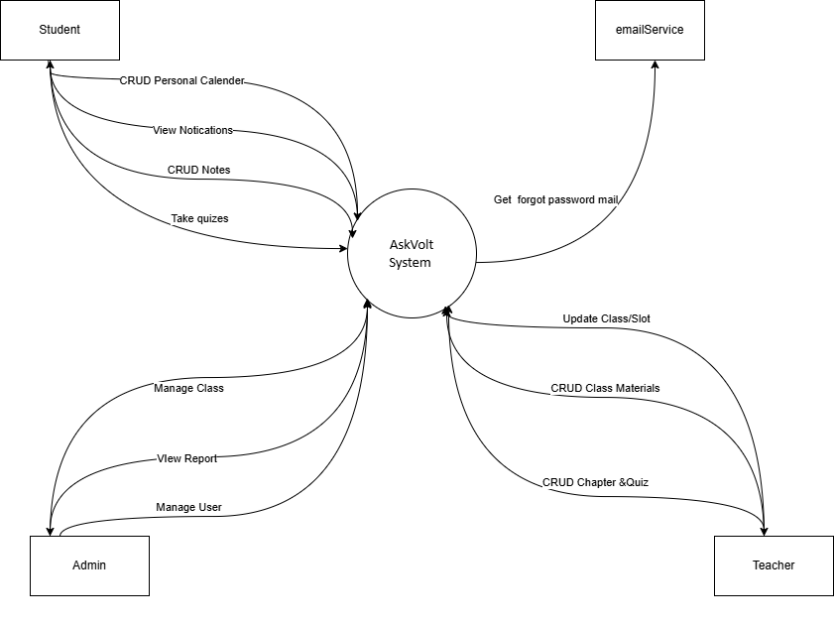

Figure 1. Context diagram

2. User Requirements

2.1 Actors

# | Actor | Description
1 | Administrator | Administrators with full rights to manage the system such as user accounts, …etc in the AskVolt system will be called Administrators.
3 | Teacher | Users are individuals who have accounts in the AskVolt system. They can manage their profiles, create classes and manage students in their classes, create and manage tests and lessons, and manage class learning materials, and participate in chat.
4 | Student | Users are individuals who have accounts in the AskVolt system. They can manage their profiles, join classes, take notes, take quizzes, leave comments for each study slot, view class schedules and upload documents, and participate in chat.
5 | Guest | A guest is someone who accesses the AskVolt system without logging in. They have access to the landing page and can see an introductory overview of the system's features.

Table 1. All actors in the system

2.2 Use Cases

2.2.1 Diagram(s)

2.2.1.1 Use Case Overview
Below is an overview of the use cases for the AskVolt system.
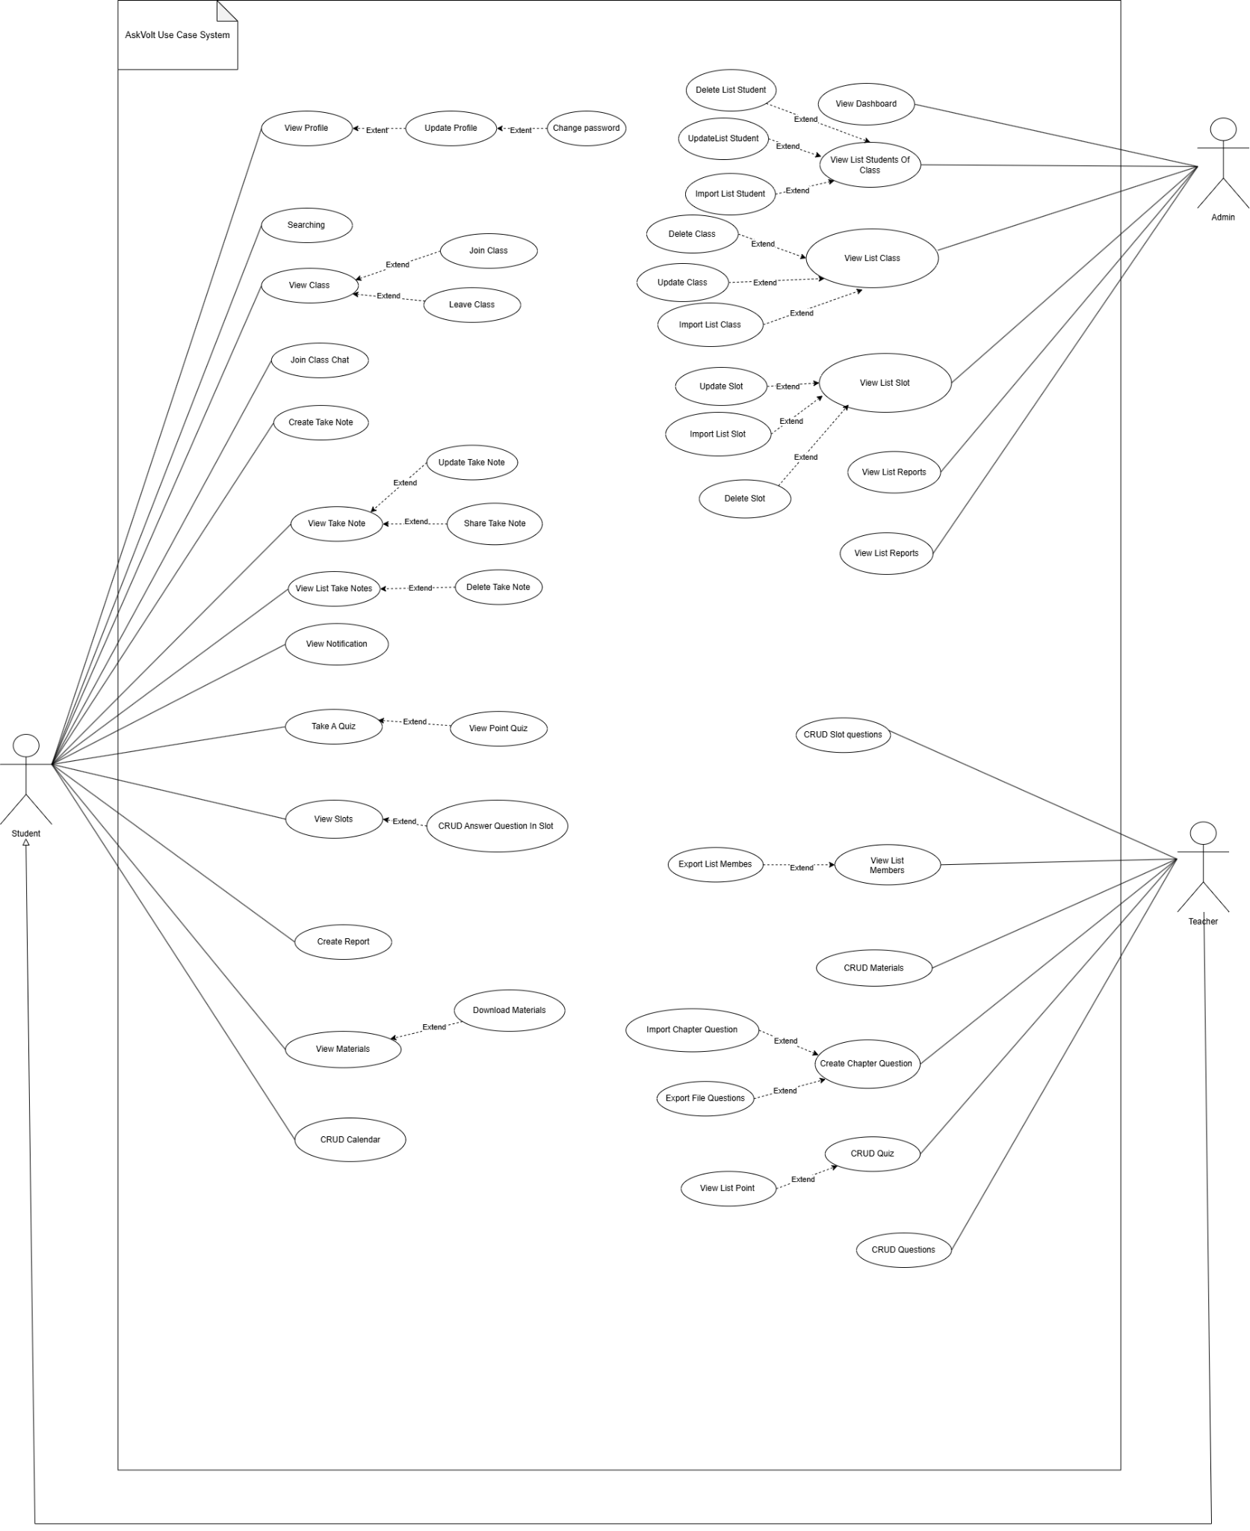

Figure 2. AskVolt System Use Case Diagram

2.2.1.2 Use Case for Authentication
In the AskVolt system, all users are required to undergo an authentication process when they enter the platform. This process verifies the user's identity and ensures that only authorized individuals are granted access. The system can safeguard sensitive information and prevent unauthorized entry by implementing authentication.
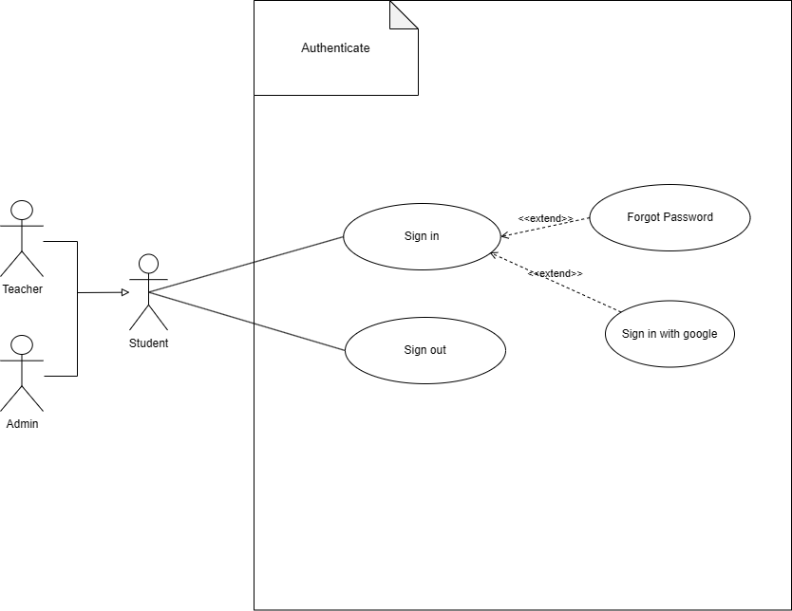

Figure 3. Use Case for Authentication

2.2.1.3 Use Case for Student
Below is a subsystem use case for the Student actor.
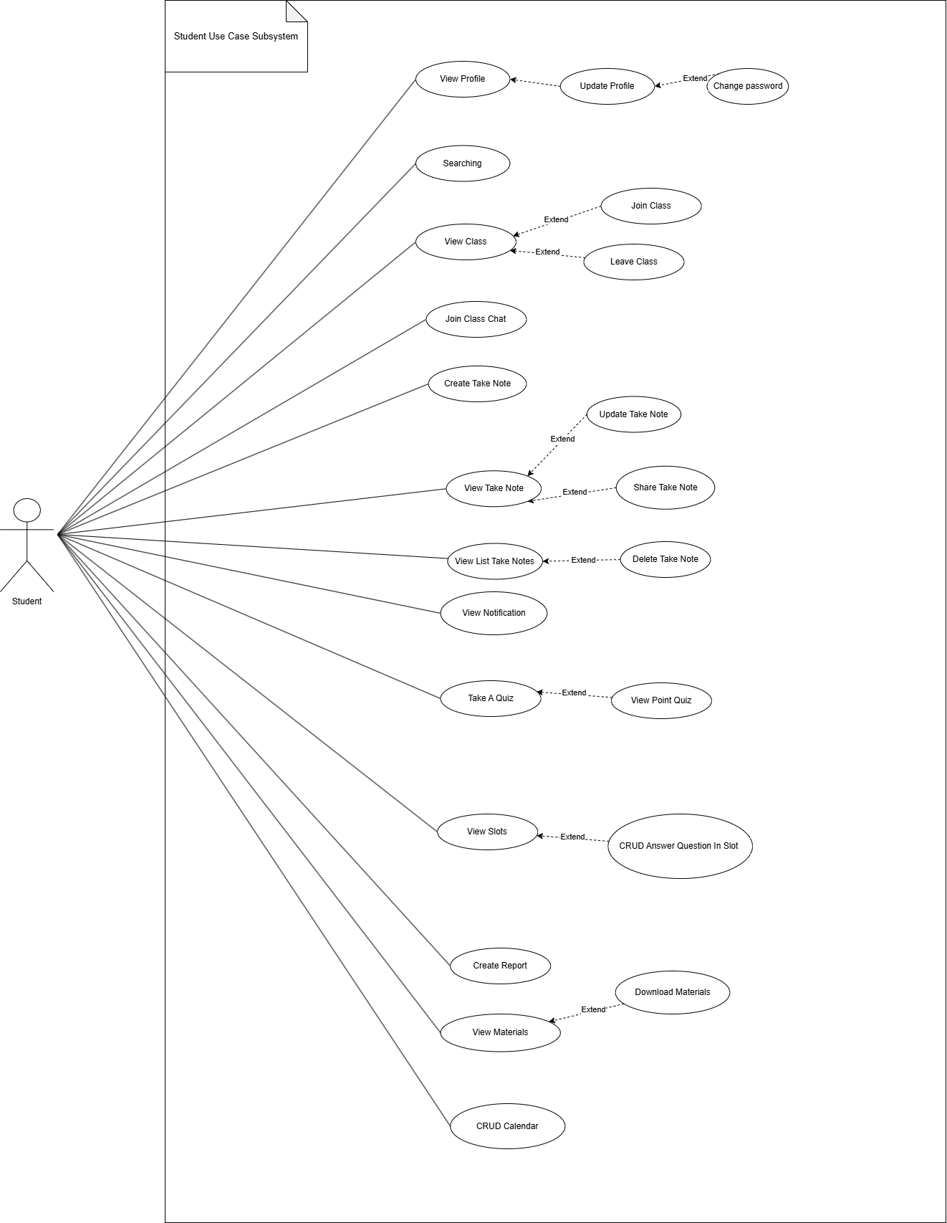

Figure 4. Use Case for Student

2.2.1.4 Use Case for Teacher
Below is a subsystem use case for the Teacher actor.
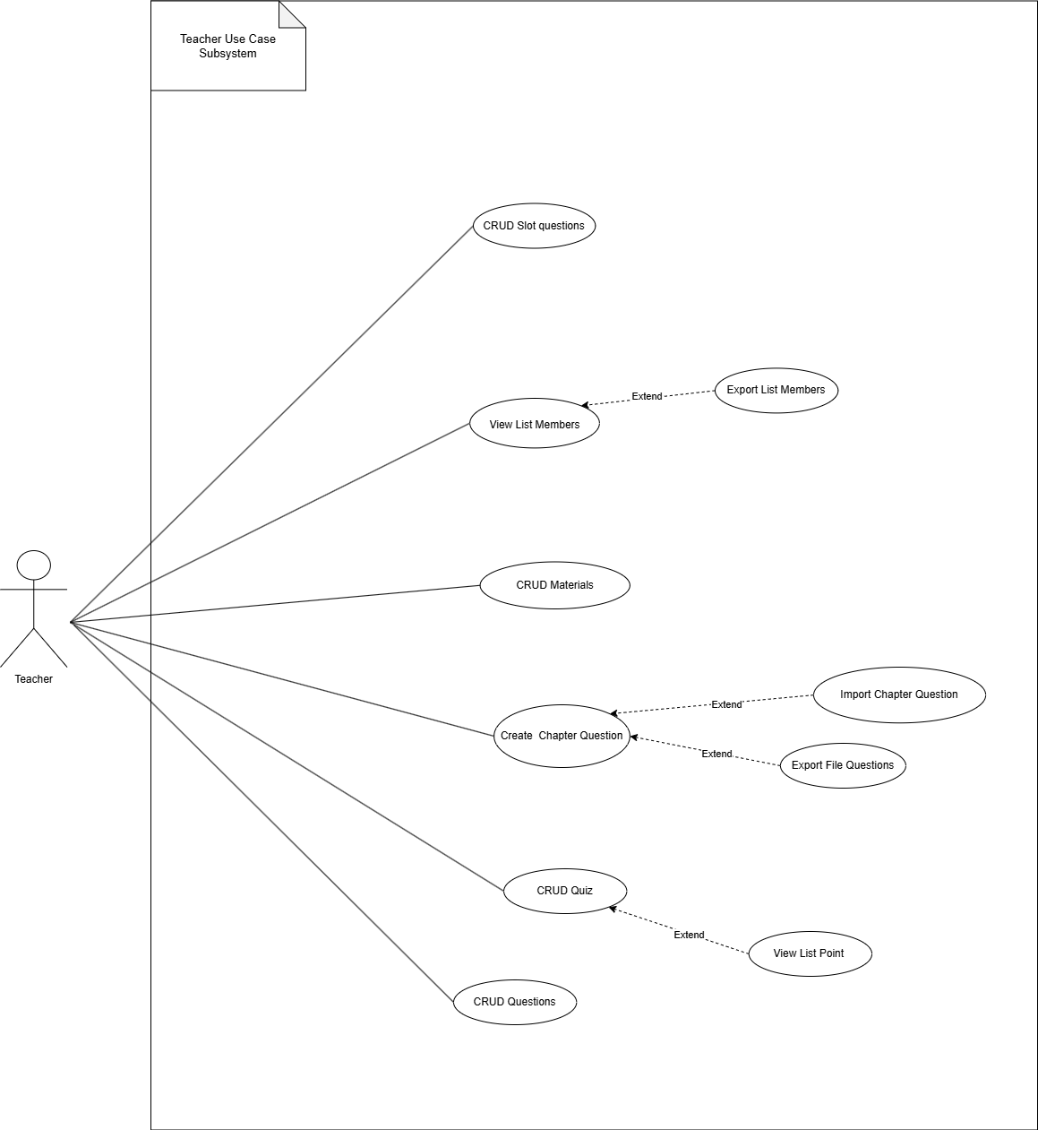

Figure 5. Use Case for Teacher

2.2.1.5 Use Case for Admin
Below is a subsystem use case for the Admin actor.
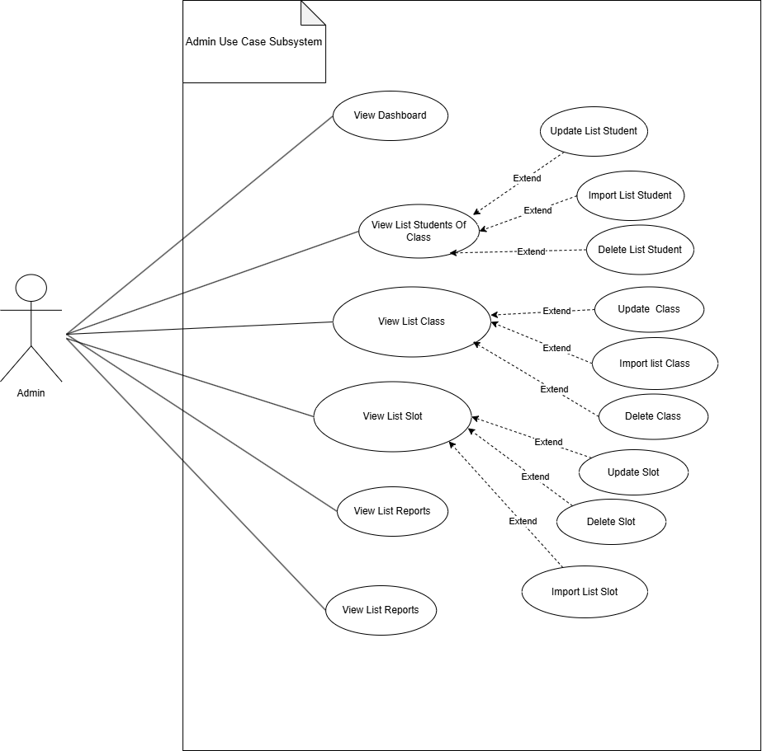

Figure 6. Use Case for Admin

2.2.2 Descriptions
Below is a summary of the use cases present in the AskVolt system:

ID | Use Case | Actors
1 | Sign In | Student, Teacher, Admin
2 | Sign Out | Student, Teacher, Admin
3 | Forgot Password | Student, Teacher
4 | View Profile | Student, Teacher
5 | Update Profile | Student, Teacher
6 | Change Password | Student, Teacher
7 | Searching | Student, Teacher
8 | Create personal Calendar | Student, Teacher
9 | View personal Calendar | Student, Teacher
10 | Update personal Calendar | Student, Teacher
11 | Delete personal Calendar | Student, Teacher
12 | Creating Report | Student, Teacher
13 | View Notification | Student, Teacher,Admin
14 | Create Note | Student, Teacher
15 | View Note | Student, Teacher
16 | Update Note | Student, Teacher
17 | Share Note | Student, Teacher
18 | Delete Note | Student, Teacher
19 | Create Answer slot question | Student
20 | Update Answer slot question | Student
21 | View Answer slot question | Student
22 | Delete Answer slot question | Student
23 | View Class | Student, Teacher
24 | Join Class | Student, Teacher
25 | Leave Class | Student, Teacher
26 | Join Class Chat | Student, Teacher
27 | Download Materials | Student, Teacher
28 | Create Materials | Teacher
29 | View Materials | Teacher,Student
30 | Update Materials | Teacher
31 | Delete Materials | Teacher
32 | Create Slot question | Teacher
33 | View Slot question | Teacher, Student
34 | Update Slot question | Teacher
35 | Delete Slot question | Teacher
36 | View list member of class | Teacher
37 | Export List Members Of Class | Admin, Teacher
38 | Create Quiz | Teacher
39 | View Quiz | Teacher, Student
40 | Update Quiz | Teacher
41 | Delete Quiz | Teacher
42 | Create Question | Teacher
43 | View Question | Teacher
44 | Update Question | Teacher
45 | Delete Question | Teacher
46 | View List Points | Teacher
47 | Take Quizzes | Student
48 | View Quiz answers | Student, Teacher
49 | Create Chapter Question | Teacher
50 | Import Question | Teacher
51 | Export Question File | Teacher
52 | View Dashboard | Admin
53 | Create Class/slot | Admin
54 | Delete Class/slot | Admin
55 | Import list Student | Admin
56 | Update list Student | Admin
57 | Delete Members Of Class | Admin
58 | View List Users | Admin
59 | View List Reports | Admin
60 | Manage List Members Of Class | Admin

Table 2. Use case Description

3. Functional Requirements

3.1 System Functional Overview

3.1.1 Screens Flow
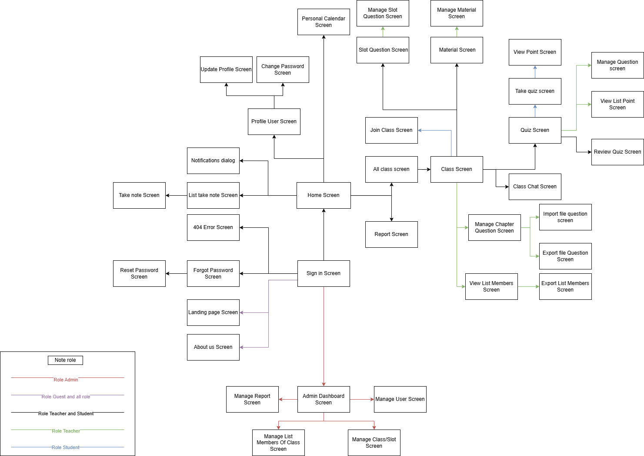

Figure 7. Screen flow diagram

3.1.2 Screen Descriptions

# | Feature | Screen | Description
1 | Authentication | Sign In Screen | Users can sign in using Google authentication or the AskVolt email/password combination.
2 | Authentication | Forgot Password Screen | Users can reset their password by entering their registered email and receiving instructions to recover their account.
3 | Profile | Profile User Screen | Users can view their profile information, including full name, birthday, email, and other personal details.
4 | Profile | Update Profile Screen | Users can update their profile information, such as changing their full name, birthday, or personal data.
5 | Profile | Change Password Screen | Users can change their current password to a new one by providing the old one and confirming the new one.
6 | Calendar | Personal Calendar Screen | Students and teachers can manage their personal schedules, add reminders, and track class deadlines.
7 | Reporting | Report Screen | Students and teacher can submit reports about community standard violations, which are sent to the admin system for review and action.
8 | Note Management | Take Note Screen | Students can create, edit or update their notes and share them with others if needed.
9 | Question slot | Slot Question Screen | Students can take short tests given by teachers to review for each slot.
10 | Class/Slot Management | Join Class Screen | Students can search for and join classes using a class code or invitation.
11 | Class/Slot Management | Class Screen | Students can view class details and leave classes when needed.
12 | Join Class chat | Class Chat Screen | Teacher and students can participate in and manage class chat activities.
13 | Note Management | Manage Materials Screen | Teachers can upload and manage materials for a class, make them available to students, and review materials
14 | Note Management | Material Screen | Students can download class materials for offline access and better learning convenience.
15 | Class/Slot Management | Manage Slot Question Screen | Teachers can create short tests for students to review for each slot.
16 | Class/Slot Managements | View List Member Screen | Teachers and admin can view the list of class members
17 | Class/Slot Management | Export List Member Screen | Teachers and admins can export the list of class members for easier management and record-keeping.
18 | Quiz Participation | Quiz Screen | Teachers can create and manage quizzes for a class
19 | Question Management | Manage Question Screen | Teachers can create, update, delete, and manage questions within each quiz
20 | Quiz Participation | View List Point Screen | Teachers can view the list of student points to monitor performance and track progress.
21 | Quiz Participation | Take Quiz Screen | Students can take quizzes assigned by teachers for review or testing purposes.
22 | Quiz Participation | Review Quiz Screen | Students can review their completed quizzes when enabled by the teacher, allowing them to analyze their performance and learn from mistakes.
23 | Quiz and Material Management | Chapter Question Management Screen | Teachers can create questions and import them into the chapter for quizzes
24 | Quiz and Material Management | Import Question Screen | Teachers can import questions from external sources for classroom testing purposes.
25 | Quiz and Material Management | Export Question Screen | Teachers can download quiz questions for offline use or record-keeping.
26 | System Management | View Dashboard Screen | Admins can view an overview of system metrics, including user activity, reports, and other relevant system information.
27 | Account Creation | Manage Users Screen | Admins can view and manage user accounts and edit their information if needed.
28 | Class/Slot Management | Manage Class/Slot Screen | Admins can view and manage Class/Slot and edit their information if needed.
29 | Account Creation | Import User List | Admins can import class list for system, and edit their information if needed.
30 | Class/Slot Management | Import Class List | Admins can import class list for system, and edit their information if needed.
31 | Report Management | View List Reports Screen | Admins can view and manage reports submitted by users about violations of community standards, review details, and take appropriate actions.

Table 3. Screen Descriptions

3.1.3 Screen Authorization
Screen | Guest | Student | Teacher | Admin
Landing Page Screen | X | X | X | X
About Us Screen | X | X | X | X
Sign In Screen | X | X | X | X
Forgot Password Screen |  | X | X
Reset Password Screen |  | X | X
404 Error Screen |  | X | X
List take note Screen |  | X | X
Take Note Screen |  | X | X
Profile User Screen |  | X | X | X
Update Profile Screen |  | X | X | X
Change Password Screen |  | X | X | X
Personal Calendar Screen |  | X | X
Report Screen |  | X | X
All Class Screen |  | X | X
Class Screen |  | X | X
Join Class Screen |  | X
Slot Question Screen |  | X | X
Manage Slot Question Screen |  |  | X
Material Screen |  | X | X
Manage Material Screen |  |  | X
Class Chat Screen |  | X | X
Quiz Screen |  | X | X
Manage Quiz Screen |  |  | X
Take quiz Screen |  | X
View Point Screen |  | X
Review Quiz Screen |  | X | X
View List Point Screen |  |  | X
Manage Question Screen |  |  | X
Manage Chapter Question Screen |  |  | X
Import File Question Screen |  |  | X
Export File Question Screen |  |  | X
View list members Screen |  |  | X
Export list members Screen |  |  | X
Admin Dashboard Screen |  |  |  | X
Manage Report Screen |  |  |  | X
Manage User Screen |  |  |  | X
Manage List Members Of Class Screen |  |  |  | X
Manage Class/Slot Screen |  |  |  | X

Table 4. Screen Authorization

3.1.4 Non-Screen Functions

# | Feature | System Function | Description
1 | User Authentication | Sign in with Google | Sign in to the system Askvolt by account Google
2 | Email Sending | Forgot Password | When the user wants to recover the password, the password reset link will be emailed.
3 | Upload Image Service | Create File | When a user makes a quiz bank or materials creation with file , the upload image service will run in background to handle the photo.
 |  | Import File | When a user import data to the system will run in background to handle the data.

Table 5. Non-Screen Functions

3.1.5 Entity Relationship Diagram

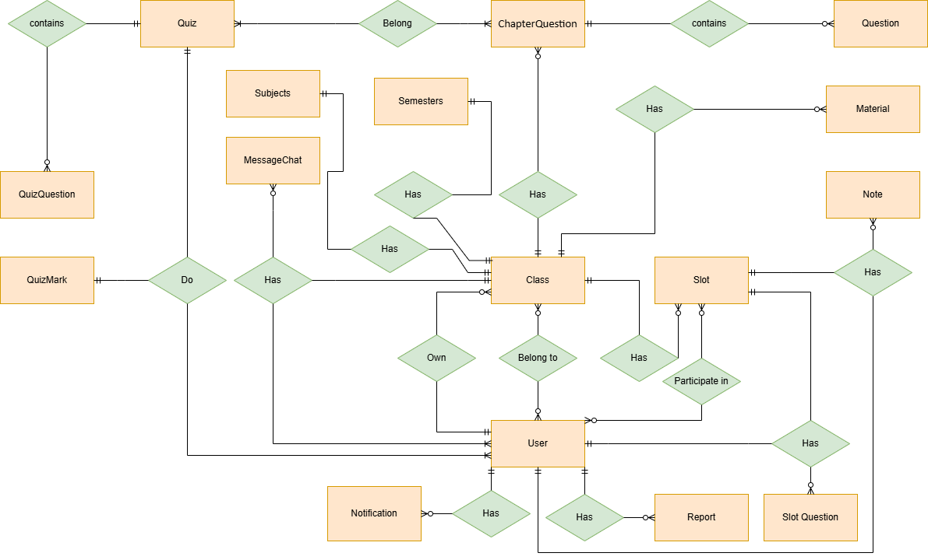

Figure 8. ERD digram
Entities Description
# | Entity | Description
1 | User | The class represents storage of the user's information for identity in the system.  - Properties:  - Id (Primary Key)  - Name  - Email  - Username  - Password  - BirthDate  - PhoneNumber  - Identification  - Address  - Neo4JUserID  - RoleId  - ClassId  - UpdateAt  - CreateAt
2 | Class | The class represents a group of students learning a particular subject.  - Properties:  - Id (Primary Key)  - SubjectId  - SemesterId  - TeacherId  - ClassName  - StartTime  - EndTime  - Description  - UpdateAt  - CreateAt
3 | Slot | Slot Represents a scheduled time for a class or event.  - Properties:  - Id (Primary Key)  - ClassId (Foreign Key to Class entity)  - DateTimeStart  - DateTimeEnd  - CreateAt  - UpdateAt
4 | Notification | Notification represents a message sent to a user or group of users.  - Properties:  - NotificationId (Primary Key)  - UserId (Foreign Key to User entity)  - Title  - Message  - IsRead  - CreateAt  - UpdateAt
5 | Report | Report represents a comment or rating given by a user.  - Properties:  - UserId (Primary Key, Foreign Key to User entity)  - Rating  - Comment  - CreateAt  - UpdateAt
6 | Comment | Comment represents a text-based response to a slot.  - Properties:  - Id (Primary Key)  - UserId (Foreign Key to User entity)  - SlotId (Foreign Key to Post entity)  - Message  - CreateAt  - UpdateAt
7 | MessageChat | MessageChat represents a private message exchange between two users.  - Properties:  - MessageChatId (Primary Key)  - SenderId (Foreign Key to User entity)  - SlotId (Foreign Key to Slot entity)  - Message  - CreateAt  - UpdateAt
8 | ChapterQuestion | A quiz represents a set of questions used for assessment.  - Properties:  - Id (Primary Key)  - ClassId (Foreign Key to Class entity)  - Name  - Description  - CreateAt  - UpdateAt
9 | Question | A question represents a single question within a quiz.  - Properties:  - Id (Primary Key)  - QuestionBankId(Foreign Key to QuestionBank entity)  - QuestionText  - AnswerOptions  - CreateAt  - UpdateAt
10 | Quiz | The exam represents a formal assessment event.  - Properties:  - ExamId (Primary Key)  - ClassId (Foreign Key to Class entity)  - Name  - Description  - DateTimeStart  - CreateAt  - UpdateAt
11 | QuizQuestion | ExamQuestion represents a question within an exam.  - Properties:  - Id (Primary Key)  - ExamId (Foreign Key to Exam entity)  - QuestionText  - AnswerOptions  - CreateAt  - UpdateA
12 | QuizMark | ExamMark represents a student's score on an exam.  - Properties:  - Id (Primary Key)  - UserId (Foreign Key to User entity)  - ExamId (Foreign Key to Exam entity)  - Mark  - CreateAt  - UpdateAt
13 | Note | A keyword represents a word or phrase used to note in a slot while studying  - Properties:  - ClassId (Primary Key)  - Name  - StatusId  - Description  - Password  - UpdateAt  - CreateAt
14 | Material | In Class,Users can participate in a class created by the teacher.  - Properties:  - Id (Primary Key)  - ClassId (Foreign Key to Slot entity)  - Name  - Description  - URL  - CreateAt  - UpdateAt
15 | Role | Role of users, that can allow users access resources  - Properties:  - Id (Primary Key)  - Name  - Description  - CreateAt  - UpdateAt
16 | SlotQuestions | Role of Teacher, that can allow users access resources  - Properties:  + Id(Primary)  + SlotId  + Description  + StartTime  + EndTime
17 | Subjects | - Properties:  + Id(Primary)  + Description
18 | Semesters | - Properties:  + Id(Primary)  + Name

Table 6. Entities Description

3.2 Authentication feature

3.2.1 Sign in
- Function trigger:
  - Primary Trigger: The user clicks on the "Sign In" button in the navigation bar or when they attempt to access features that require login.
  - Secondary Trigger: The user may be automatically redirected to the sign-in page when trying to access pages that require authentication, but they are not logged in.
- Function description:
  - Role : Student, Teacher, Admin
  - Purpose: Allows users to log into their accounts using either their email and password or their Google account.
  - Interface: The sign-in interface includes the following fields:
    - Email: Input field where users enter their registered email.
    - Password: Input field where users enter their account password.
    - Google Sign-In Button: A button to log in using a Google account.
- - Screen layout:
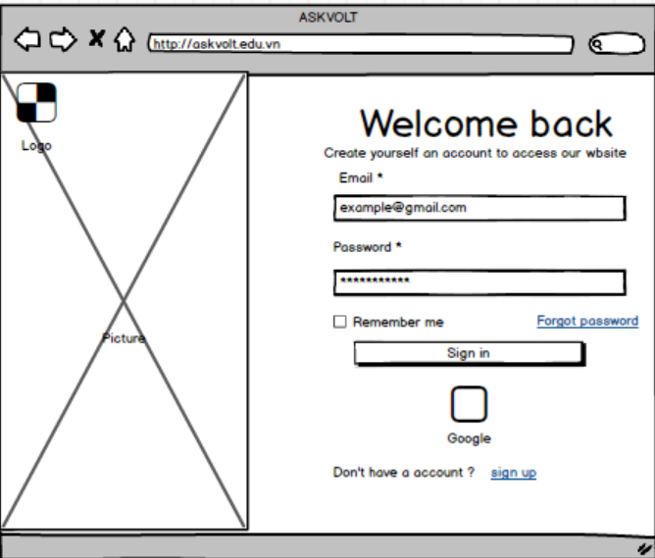

Figure 9. Sign in
- Function detail (Traditional Sign-In Flow):
  - Data Validation:
    - Email: Must be a valid email address containing “@” and a valid domain.
    - Password: Must match the password registered with the account.
    - Validation and Business Rules:
- In Normal Cases:
  - If the email and password are valid:
    - The system sends a login request to the server.
    - If successful, the user is logged in and redirected to the homepage or the intended page.
- In Abnormal Cases:
  - If the email or password is incorrect:
    - The system displays an error message like "Invalid email or password."
  - If the server is unresponsive or there's a connection issue:
    - The system will notify the user of the issue and allow them to try again later.
  - Sign In with Google uses the OAuth2 process to authenticate the user through their Google account.
    - The system will display an error message such as "Google sign-in failed, please try again".

3.2.2 Sign out
- Function trigger:
- Primary Trigger :The user clicks on the "Sign Out" button or link, which is typically located in the navigation bar, user profile dropdown, or settings menu.
- Automatic Trigger: The system may automatically log out the user after a period of inactivity for security purposes (session timeout).
- Function description:
- Role: Student , Teacher, Admin
- Purpose: Allow users to safely and securely log out of their account, ending their session in the system.
- Interface:
  - A simple button or link labeled "Sign Out" that the user can click to initiate the sign-out process.
  - Optional: A confirmation dialog might appear to ask if the user is sure they want to log out, depending on design preferences.
-Screen layout: N/A
- Function Details:
Validation and Business Rules:
- In Normal Cases:
  - Once the sign-out request is sent, the system invalidates the session or token.
  - The user is redirected to the Landing Page.
- In Abnormal Cases:
  - If there’s an issue with signing out (e.g., server unresponsiveness):
    - The system will display a message such as "Unable to sign out. Please try again."
    - The user can attempt to sign out again.
  - If the user remains inactive for a predetermined period, the system automatically logs them out.

3.2.3 Forgot Password
- Function trigger:
  - The Forgot Password function can be triggered via a "Forgot Password" link from the login page.
  - Additionally, it can be accessed from a direct link sent to the user’s email when they request password recovery.
- Function description:
  - Actors/Roles: Unauthenticated users who have forgotten their password or users who wish to reset their password.
  - Purpose: To allow users to recover or reset their account password in case they forget it.
  - Interface: The system displays a form asking the user to enter the email associated with their account.
  - Data processing: After the user submits their email, the system verifies if the email exists in the database. If it does, the system sends a password reset link to the provided email.
- Screen layout:
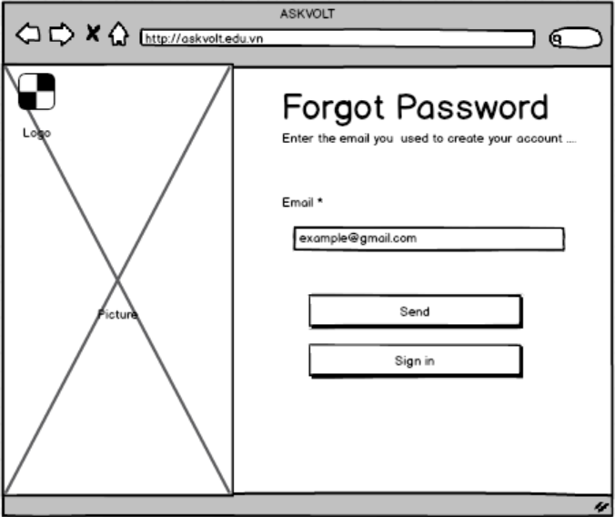

Figure 10.Forgot password
- Function detail:
  - Data:
    - Email: Required, must be a valid email format.
  - Validation and business rules:
    - In normal cases:
      - If the provided email is valid and exists in the system, the system will send a password reset link to the user's email address.
      - The user will receive an email with a link to a page to enter a new password.
      - The new password must meet the system’s password strength requirements (e.g.,at least 8 characters, must include at least 1 uppercase letter, 1 lowercase letter, 1 number and 1 special character).
  - In abnormal cases:
    - If the email does not exist in the system, the user will receive an error message like "Email not found in our records."
    - If the system encounters a failure in sending the reset email (e.g., server issue or network error), an error message will be displayed, and the user will be advised to try again later.
    - If the user tries to reset their password multiple times within a short period, the system may lock the reset function temporarily as a security measure to prevent abuse.

3.3 Manage common User’s feature

3.3.1 View Profile
- Function Trigger:
  - User-initiated: The user accesses their profile by selecting the "Profile" option from the navigation bar or a dropdown menu linked to their account.
  - System-initiated: After registration or login, the system may automatically redirect users to the profile page to encourage updating incomplete profile information.
- Function Description:
  - Actors/Roles: Any authenticated user (Student, Teacher).
  - Purpose: To allow users to view and manage their account information, including their name, email, role, and any additional details provided.
  - Interface:
  - Displays essential user details such as:
    - Full Name
    - Username
    - Email Address
    - Role (Student, Teacher)
    - Optional fields like phone number, address, etc.
- Data Processing:
  - The system retrieves the user's profile information from the database and displays it in a clear, readable format.
- Screen Layout:
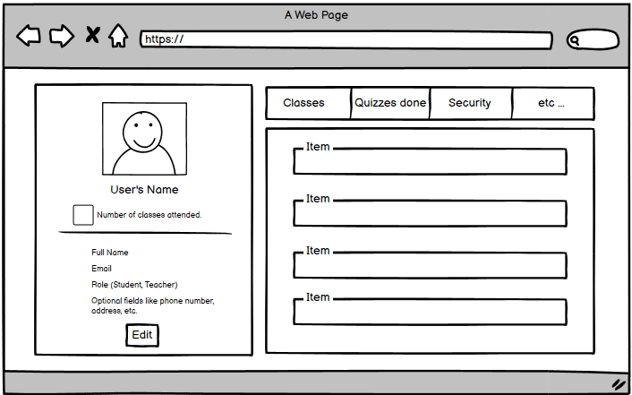

Figure 11.View Profile
- Function Details:
  - Data Requirements: The system must retrieve the necessary user data from the database (e.g., full name, username, email, role, optional fields).
- Actions:
  - View personal information: Users can review their stored details on the profile page.
  - Update Profile: Users can navigate to the "Update Profile" section to modify or add new information.
- Validation and Business Rules:
  - In normal cases:
    - The user profile information is retrieved and displayed correctly.
    - All profile details must be consistent with the data stored in the database.
  - In abnormal cases:
    - If the system fails to retrieve the profile data (e.g., due to a server issue), an error message will be displayed along with a "Retry" option.
    - If the user’s session has expired or is invalid, the system will automatically redirect the user to the login page to re-authenticate.

3.3.2 Update Profile
- Function Trigger: Users access the "Update Profile" option from their profile page.
- Function Description:
  - Actors/Roles: Any authenticated user (Student, Teacher).
  - Purpose: To allow users to update their personal information, such as name, email, phone number, and other relevant details.
  - Interface:
    - Full Name
    - Email
    - Phone Number
    - Address (if applicable)
    - Additional optional information (depending on the role and user needs)
- Data Processing:
  - When the user submits their changes, the system sends the updated data to the server, which validates and stores the new information in the database.
- Screen Layout:
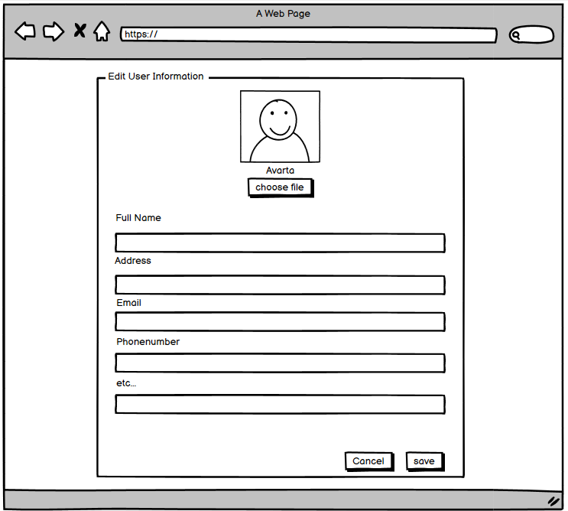

Figure 12.Update Profile
- Function Details:
  - Data Requirements: The system needs the updated user information to be submitted by the user.
- Actions:
  - Edit profile information: Users can modify fields like name, email, and phone number.
  - Save Changes: The system validates and stores the updated information.
  - Cancel Changes: Users can discard changes and return to the profile view without saving.
- Validation and Business Rules:
  - In normal cases:
    - The system successfully updates and saves the profile information after validation.
    - Any changes made are immediately reflected in the user's profile view.
  - In abnormal cases:
    - Invalid input: If the user provides invalid data (e.g., incorrectly formatted email or missing required fields), an error message will appear, prompting the user to correct the issue before resubmitting.
    - Failed update attempts: If the system fails to process the update (e.g., due to a server issue), the user will be informed of the failure and given the option to retry or cancel the changes.

3.3.3 Searching
- Function Trigger: Users can access the search feature from the navigation bar about classes, materials, or other content.
- Function Description:
  - Actors/Roles: Any authenticated user (Student, Teacher).
  - Purpose: To allow users to search for content within the system like subjects, class name, or system resources.
  - Interface: A search bar or input field where users can enter queries related to:
    - Class name
- Data Processing:
  - The system processes the user's search input, retrieves matching data from the server, and displays relevant results based on the query.
- Screen Layout:
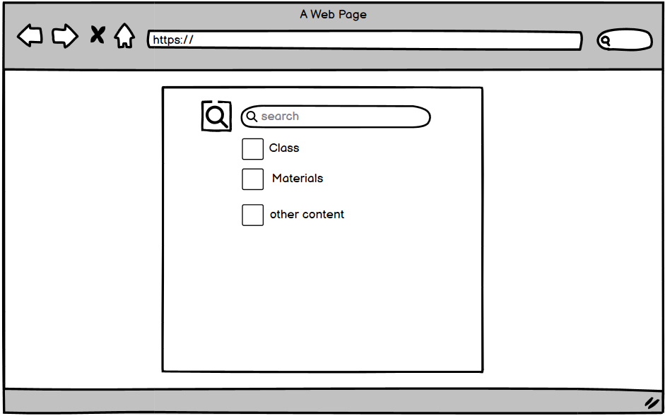

Figure 13.Searching
- Function Details:
  - Data Requirements: The system requires the search query and access to corresponding data from the server (e.g., user profiles, notifications, or content repositories).
  - Actions:
    - Enter search query: Users input keywords or phrases into the search bar.
    - View results: The system displays results related to the query, such as users, content, or notifications.
- Validation and Business Rules:
  - In normal cases:
    - The system successfully retrieves and displays search results that match the query.
    - Results are filtered based on the user's role and access permissions (e.g., Admins may see broader data than Students).
- In abnormal cases:
  - No results found: If the search returns no matches, the system will display a message such as "No results found."
  - System errors: If server or connection issues are preventing the search from completing, an error message will appear with a "Retry" option or instructions to try again later.

3.3.4 View Notification
- Function Trigger:The user selects the notifications icon or tab from the dashboard or the navigation bar.
- Function Description:
  - Actors/Roles: Any authenticated user (Student, Teacher).
  - Purpose: To allow users to view notifications related to their account, such as alerts of system or class messages.
  - Interface:
    - Notification Title
    - Date and Time (when the notification was generated)
    - Description (a brief summary of the notification)
- Data Processing:
  - The system retrieves notifications from the server and displays them in reverse chronological order, with the most recent notifications appearing first.
- Screen Layout:
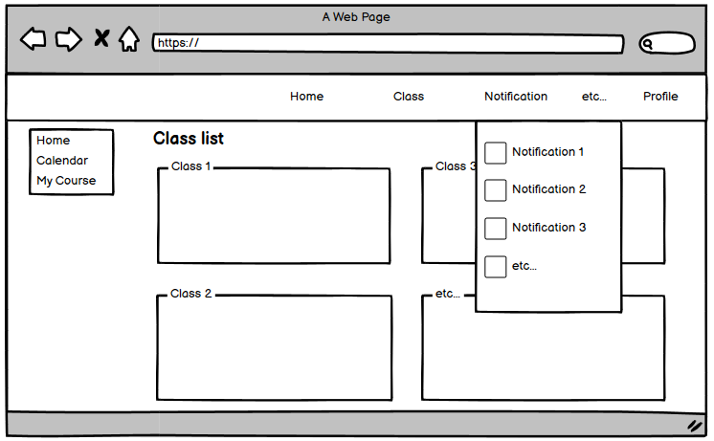

Figure 14.View Notification
- Function Details:
  - Data Requirements: The system needs to retrieve notifications linked to the user's account from the database or server.
  - Actions:
    - View notification details: Users can select a notification to see more information.
    - Mark as read/unread: Users can toggle notifications between "read" and "unread" states to manage their inbox.
- Validation and Business Rules:
  - In normal cases:
    - The system successfully retrieves and displays all notifications associated with the user’s account.
    - Notifications are listed in the correct order and displayed with the appropriate details.
  - In abnormal cases:
    - Failure to retrieve notifications: If the system encounters an error retrieving notifications (e.g., server issues), an error message will be shown with an option to retry or refresh.

3.3.5 Change password
- Function Trigger:The user selects the "Change Password" option from their profile settings or a security section.
- Function Description:
  - Actors/Roles: Any authenticated user (Student, Teacher, Admin).
  - Purpose: To allow users to securely change their account password.
  - Interface:
    - Current Password
    - New Password
    - Confirm New Password
- Data Processing:
  - The system validates the user’s current password and ensures the new password meets security and complexity requirements (e.g., length, special characters) before saving the changes.
- Screen Layout:
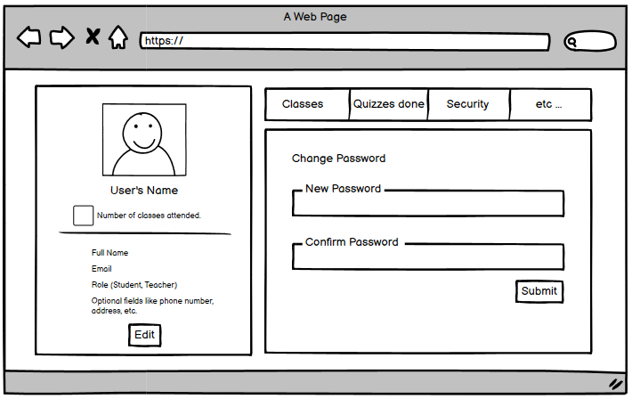

Figure 15.Change Password
- Function Details:
  - Data Requirements: The system needs the user’s current password and the new password they wish to set.
- Actions:
  - Change password: Users must enter their current password, and new password, and confirm the new password.
  - Save Changes: After validation, the new password is saved and updated.
  - Cancel Changes: Users can cancel the process and return without making any changes.
- Validation and Business Rules:
  - In normal cases:
    - The system verifies and updates the current password with the new one, notifying the user of the successful change.
  - In abnormal cases:
    - Incorrect current password: If the user enters the wrong one, an error message prompts them to try again.
    - New password validation failure: If the new password does not meet security criteria (e.g., too short, missing required characters), the user will receive a validation error message with guidelines for correcting the issue.

3.3.6 Create Personal Calendar
- Function Trigger:Users access the calendar feature from their profile to create events
- Function Description:
  - Actors/Roles: Students, Teachers.
  - Purpose: To allow users to manage their personal schedules, track deadlines, and organize study plans effectively.
  - Interface:
    - Add events (e.g., exams, assignments, study sessions)
    - Edit existing events
    - Delete events
- Data Processing:
  - The system stores, retrieves, and updates calendar events based on user interactions, ensuring that all changes are reflected accurately.
- Screen Layout:
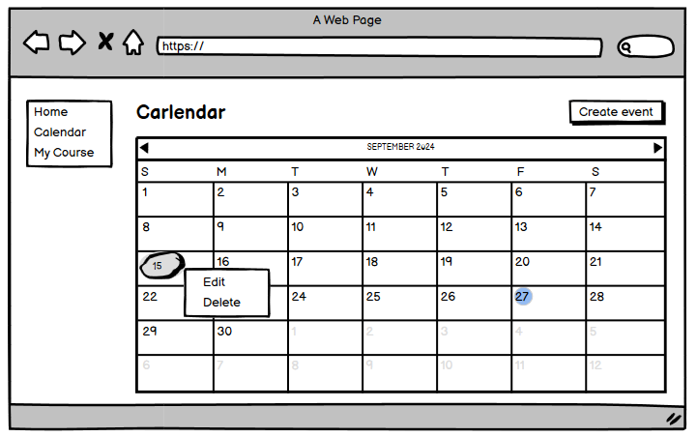

Figure 16.Create Personal Calendar
- Function Details:
  - Data Requirements: The system requires event details, including:
    - Title
    - Date
    - Time
    - Optional fields for additional information (e.g., location, description).
- Actions:
  - Create new calendar events: Users can input details to add new events.
- Validation and Business Rules:
- In normal cases:
  - Calendar events are successfully created, updated, or deleted, with changes accurately reflected in the interface.
- In abnormal cases:
  - Modification errors: If an error occurs while modifying the calendar (e.g., due to a network issue), the user is prompted with an error message and given the option to retry the action.

3.3.7 View Personal Calendar
- Function Trigger:Users access the calendar feature from their profile to view events.
- Function Description:
  - Actors/Roles: Students, Teachers.
  - Purpose: To allow users to manage their personal schedules, track deadlines, and organize study plans effectively.
  - Interface:
    - Add events (e.g., exams, assignments, study sessions)
    - Edit existing events
    - Delete events
- Data Processing:
  - The system stores, retrieves, and updates calendar events based on user interactions, ensuring that all changes are reflected accurately.
- Screen Layout:


Figure 17.View Personal Calendar
- Function Details:
  - Data Requirements: The system requires event details, including:
    - Title
    - Date
    - Time
    - Optional fields for additional information (e.g., location, description).
- Actions:
  - View scheduled events: Users can see their upcoming events in the calendar interface.
- Validation and Business Rules:
- In normal cases:
  - Calendar events are successfully created, updated, or deleted, with changes accurately reflected in the interface.
- In abnormal cases:
  - Modification errors: If an error occurs while modifying the calendar (e.g., due to a network issue), the user is prompted with an error message and given the option to retry the action.

3.3.8 Update Personal Calendar
- Function Trigger:Users access the calendar feature from their profile to update events.
- Function Description:
  - Actors/Roles: Students, Teachers.
  - Purpose: To allow users to manage their personal schedules, track deadlines, and organize study plans effectively.
  - Interface:
    - Add events (e.g., exams, assignments, study sessions)
    - Edit existing events
    - Delete events
- Data Processing:
  - The system stores, retrieves, and updates calendar events based on user interactions, ensuring that all changes are reflected accurately.
- Screen Layout:


Figure 18.Update Personal Calendar
- Function Details:
  - Data Requirements: The system requires event details, including:
    - Title
    - Date
    - Time
    - Optional fields for additional information (e.g., location, description).
- Actions:
  - Edit or delete existing events: Users can modify or remove events as needed.
- Validation and Business Rules:
- In normal cases:
  - Calendar events are successfully created, updated, or deleted, with changes accurately reflected in the interface.
- In abnormal cases:
  - Modification errors: If an error occurs while modifying the calendar (e.g., due to a network issue), the user is prompted with an error message and given the option to retry the action.

3.3.9 Delete Personal Calendar
- Function Trigger:Users access the calendar feature from their profile to delete events.
- Function Description:
  - Actors/Roles: Students, Teachers.
  - Purpose: To allow users to manage their personal schedules, track deadlines, and organize study plans effectively.
  - Interface:
    - Add events (e.g., exams, assignments, study sessions)
    - Edit existing events
    - Delete events
- Data Processing:
  - The system stores, retrieves, and updates calendar events based on user interactions, ensuring that all changes are reflected accurately.
- Screen Layout:


Figure 19.Delete Personal Calendar
- Function Details:
  - Data Requirements: The system requires event details, including:
    - Title
    - Date
    - Time
    - Optional fields for additional information (e.g., location, description).
- Actions:
  - Create new calendar events: Users can input details to add new events.
  - Edit or delete existing events: Users can modify or remove events as needed.
- Validation and Business Rules:
- In normal cases:
  - Calendar events are successfully created, updated, or deleted, with changes accurately reflected in the interface.
- In abnormal cases:
  - Modification errors: If an error occurs while modifying the calendar (e.g., due to a network issue), the user is prompted with an error message and given the option to retry the action.

3.3.10 Creating Report
- Function Trigger:Users can create reports related to assignments, performance, or system issues such as crashes or violations by other users.
- Function Description:
  - Actors/Roles: Students, Teachers.
  - Purpose: To allow users to generate various types of reports, such as performance summaries, or issue reports related to technical problems or user violations.
  - Interface:
    - Select the report type (e.g., performance, grades, issues).
    - Specify date ranges or other filters to narrow down the report content.
    - Choose specific items like system logs to include.
- Data Processing:
  - The system gathers the necessary data from the server, processes the requested report, and provides the user with either a downloadable or viewable format (e.g., PDF, Excel).
- Screen Layout:
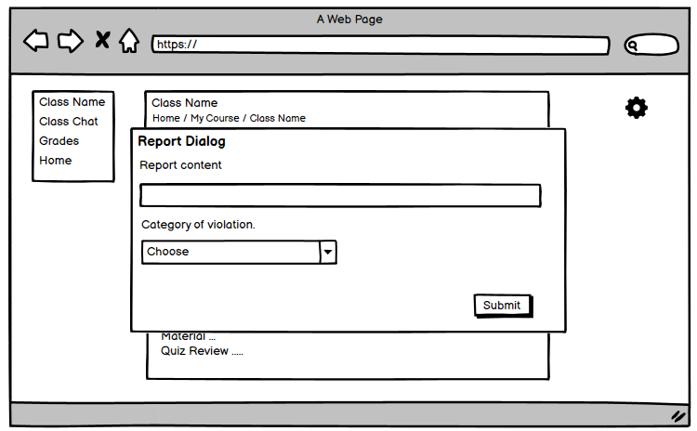

Figure 20.Creatign report
- Function Details:
  - Data Requirements: The system must access the relevant content, such as performance data, system logs, or issue details, based on user input.
  - Actions:
    - Create report: Users can select the type of report, configure parameters (date range, specific content), and submit the request.
    - View or download report: After generating, the report is either displayed on-screen or made available for download.
- Validation and Business Rules:
  - In normal cases:
    - Reports are generated successfully, and the user can view or download them as needed.
  - In abnormal cases:
    - Report generation errors: If the system fails to generate the report (e.g., due to missing data or system issues), the user is prompted with an error message and given the option to retry.

3.3.11 View Notification
- Function Trigger:The user selects the notifications icon or tab from the dashboard or the navigation bar.
- Function Description:
  - Actors/Roles: Any authenticated user (Student, Teacher).
  - Purpose: To allow users to view notifications related to their account, such as alerts of system or class messages.
  - Interface:
    - Notification Title
    - Date and Time (when the notification was generated)
    - Description (a brief summary of the notification)
- Data Processing:
  - The system retrieves notifications from the server and displays them in reverse chronological order, with the most recent notifications appearing first.
- Screen Layout:
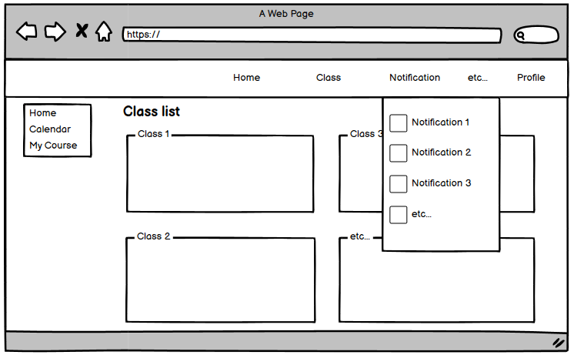

Figure 21.View Notification
- Function Details:
  - Data Requirements: The system needs to retrieve notifications linked to the user's account from the database or server.
  - Actions:
    - View notification details: Users can select a notification to see more information.
    - Mark as read/unread: Users can toggle notifications between "read" and "unread" states to manage their inbox.
- Validation and Business Rules:
  - In normal cases:
    - The system successfully retrieves and displays all notifications associated with the user’s account.
    - Notifications are listed in the correct order and displayed with the appropriate details.
  - In abnormal cases:
    - Failure to retrieve notifications: If the system encounters an error retrieving notifications (e.g., server issues), an error message will be shown with an option to retry or refresh.

3.4 Manage Class/Slot Feature

3.4.1 Create Answer slot question
- Function trigger:
  - Primary Trigger: The student accesses the Answer Slot Question page and edits their answers before submitting. They enter the updated content and click the button to submit their updated answer.
- Function description:
  - Role : Student
  - Purpose: Allow students to create their answers in a previously answered Answer Slot.
  - Interface:
    - Question List: A list of questions to be answered in the Slot Question.
    - Answer Field: An input field where the student can type or select answers
    - Submit Button: A button to submit all the answers once completed.

- Screen layout:
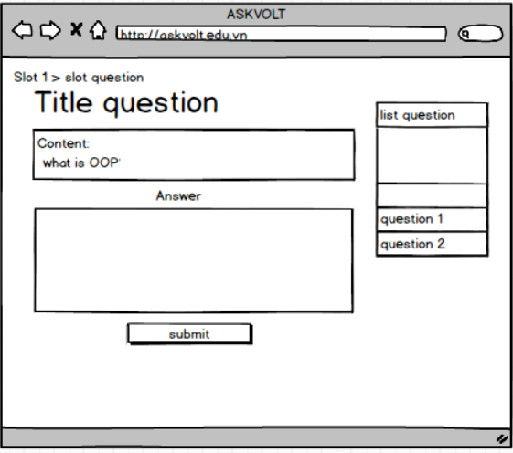

Figure 22.Create answer slot question

- In Normal Cases:
  - After the student has answered all the questions, they click the Submit Answers button.
  - The system validates the answers and confirms successful submission with a message: "Your answers have been successfully submitted."

- In Abnormal Cases:
  - Missing or Invalid Fields:
    - The system will display an error message if any required field is missing or invalid (e.g., "Please enter the answer,").
  - Connection Issues:
    - If there's a server issue, the system will notify the teacher: "Unable to create answer slot due to a technical issue. Please try again later."

3.4.2 Update Answer slot question
- Function trigger:
  - Primary Trigger: The student accesses the Answer Slot Question page and edits their answers before submitting. They enter the updated content and click the button to submit their updated answer.
- Function description:
  - Role : Student
  - Purpose: Allow students to modify or update their answers in a previously answered Answer Slot.
  - Interface:
    - Question List: A list of questions in the Answer Slot that the student needs to update answers for.
    - Answer Field: An input field where students can modify or change their previously entered answers.
    - Submit Button: A button that allows the student to submit their updated answers after editing.
- Screen layout:


Figure 23.Update answer slot question

- In Normal Cases:
  - After the student has updated their answers, they click the Submit Updated Answers button.
  - The system validates the answers and confirms the successful submission with the message:
"Your answers have been successfully updated and submitted."
  - The student is redirected to the assignment/quiz overview page or they see a confirmation page with their updated answers.
- In Abnormal Cases:
  - Missing or Invalid Fields:
    - No Answer Provided:
If the student leaves any required question unanswered after editing, the system will display:
"Please answer all the questions before submitting."
    - Invalid Answer Format:
If the student enters an answer that does not match the required format (e.g., a non-numeric answer for a numeric question), the system will show:
"Please enter a valid answer for question X."
  - Connection Issues:
    - Server Error:
If there is an issue with the server when submitting the updated answers, the system will notify the student:
"There was an issue submitting your updated answers. Please try again later."
    - Timeout:
If the session times out or if the student tries to submit after the time limit has expired (if applicable), the system will show:
"Time’s up! You can no longer update and submit your answers."

3.4.3 View Answer slot question
- Function trigger:
  - Primary Trigger: The student accesses the Answer Slot Question page to view the questions in the Answer Slot for a specific quiz, assignment, or exam.
- Function description:
  - Role :, Teacher,Student
  - Purpose: To allow the student to view the questions in the Answer Slot, along with their previously submitted answers, without making any changes.
  - Interface:
    - Question List: A list of questions that the student has answered in the Answer Slot.
    - Answer Display: An area where the student can see their previously submitted answers to each question.
- Screen layout:


Figure 24 View answer slot question

- In Normal Cases:
  - Successful Viewing:
    - After accessing the Answer Slot page, the system will display all questions along with the student’s submitted answers.
    - The student is able to review their answers and can see a confirmation message:
"You are viewing your submitted answers."
  - If no answers were submitted:
    - If the student has not yet answered a question or has not submitted any answers, the system will display:
"You have not submitted any answers yet."
- In Abnormal Cases:
  - Missing Answers or Data:
    - No Submitted Answer:
If the student has not yet answered any of the questions or no answers are available, the system will show:
"You have not submitted any answers yet. Please submit your answers before viewing them."
    - Data Retrieval Error:
If there is an issue retrieving the answers from the server, the system will display:
"Unable to load your answers at this moment. Please try again later."
  - Connection Issues:
    - Server Error:
If there is an issue with the server when trying to view the answers, the system will notify the student:
"There was an issue retrieving your answers. Please try again later."
    - Timeout or Session Expiry:
If the student’s session has expired or there is a timeout, the system will display:
"Your session has expired. Please log in again to view your answers."

3.4.4 Delete Answer slot question
- Function trigger:
  - Primary Trigger: The student clicks on the Delete Answer Slot Question button or option within the Answer Slot page to remove their submitted answers from the system for a specific question.
- Function description:
  - Role : Student
  - Purpose: To allow the student to delete a previously submitted answer for a specific question within the Answer Slot.
  - Interface:
    - Question List: A list of questions within the Answer Slot that the student has answered.
    - Delete Option: A button or link next to each answer, which allows the student to delete their answer for a specific question.
    - Confirmation Prompt: A prompt asking for confirmation before deleting the answer.
- Screen layout:
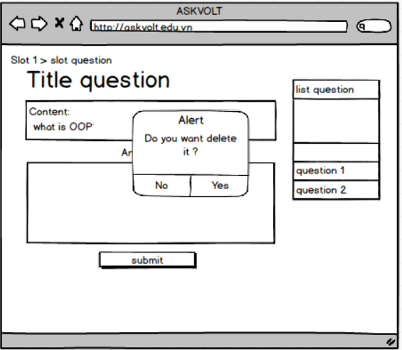

Figure 25.Delete answer slot question

- In Normal Cases:
  - Successful Deletion:
    - After the student confirms the deletion, the system will remove the answer for that specific question and display a success message:
"Your answer has been successfully deleted."
    - The system will update the interface to show that the answer field is now empty, allowing the student to re-enter an answer if desired.
  - No Answer to Delete:
    - If the student tries to delete an answer but the field is already empty (i.e., no answer was submitted), the system will display:
"No answer found to delete."
- In Abnormal Cases:
  - Missing or Invalid Data:
    - Answer Not Found:
      - If the student tries to delete an answer that is not present (e.g., no answer has been submitted for the question), the system will show:
"No answer found for this question."
      - Connection Issues:
    - Server Error:
      - If there is a failure when deleting the answer due to a server issue, the system will display:
"There was an issue deleting your answer. Please try again later."
  - Timeout or Session Expiry:
      - If the student's session has expired or the connection times out, the system will display:
"Your session has expired. Please log in again to delete your answer."
  - Confirmation Failure:
    - Cancellation:
      - If the student cancels the deletion process at the confirmation step, the system will display:
"The deletion of your answer has been canceled."

3.4.5 View Class
- Function trigger:
  - Primary Trigger: The student clicks on the "View Class" button or navigates to the Class Overview page through the navigation bar to view the detailed information of a specific class.
- Function description:
  - Role :, Teacher, Student
  - Purpose: To allow view essential information about a class, such as the class name, the teacher's name, and other relevant details, via a structured class overview page.
  - Interface:
    - Class Information: Displays key details about the class, including:
      - Class Name: The name of the class.
      - Teacher's Name: The instructor responsible for the class.
      - Class Schedule/Timings: The date and time the class meets.
      - Class Description (optional): A short description or objectives for the class.
      - Additional Resources: Links or materials related to the class (e.g., syllabus, resources, or notes).
    - Navigation Bar (Navbar):
A fixed or floating navigation bar that allows the student to navigate to different pages such as:
      - Mark Report
      - Quizzes
      - Material
- Screen layout:
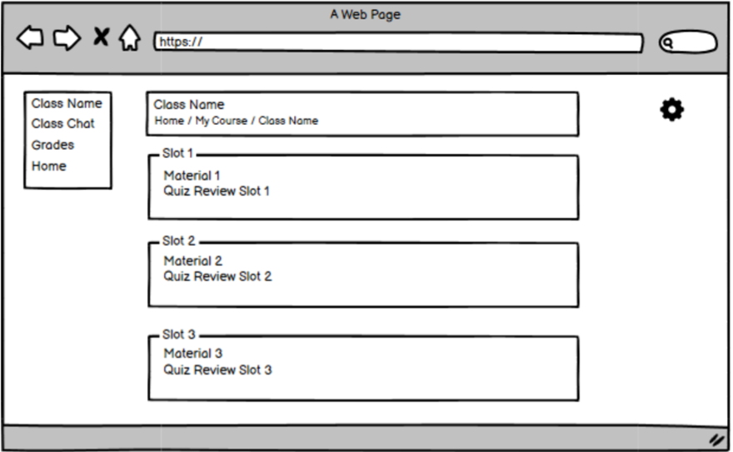
Figure 26.View Class

- In Normal Cases:
  - Successful Viewing:
    - After clicking on "View Class", the system displays all the detailed class information, such as the Class Name, Teacher’s Name, Schedule, and any relevant resources for the class.
    - The student is able to easily navigate to other sections of the platform using the Navbar.
- In Abnormal Cases:
  - Missing or Invalid Fields:
    - No Class Data Found
      - If any required field is missing or invalid, the system will display an error message (e.g., "Please enter the answer,").
  - Connection Issues:
    - If there's a server issue, the system will notify the teacher: "Unable to create answer slot due to a technical issue. Please try again later."
3.4.6 Join Class
- Function trigger:
  - Primary Trigger:
    - The student clicks on the "Join Class" button to join a class that requires enrollment.
    - The student is prompted to enter a Class Password if the class has restricted access.

- Function description:
  - Role: Student
  - Purpose: To allow the student to join a specific class by entering the correct password for the class, thereby gaining access to all associated resources and materials.
  - Interface:
    - Class Name: The class the student is trying to join.
    - Class Password Field: An input field where the student enters the password for the class.
    - Join Button: A button that allows the student to submit the password and join the class once the password is entered.
    - Error Message (if the password is incorrect): An error message will be displayed if the student enters an incorrect password.
- Screen layout:
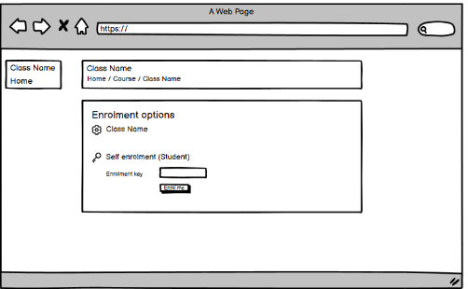

Figure 27.Forgot password
- In Normal Cases:
  - Successful Join:
    - After entering the correct password, the student clicks the Join Class button.
    - The system validates the password, and the student is enrolled in the class if it's correct.
    - The system confirms the action with the message:
"You have successfully joined the class."
    - The student is then redirected to the class's main page or dashboard to access resources, assignments, and other class materials.
- In Abnormal Cases:
  - Incorrect Password:
    - Wrong Password Entry:
If the student enters an incorrect password, the system will display the following error message:
"Incorrect password. Please try again."
    - If unsure, the student can attempt to re-enter the correct password or contact the instructor.
  - Connection Issues:
    - Server Error:
If there is a server failure or issue while processing the password, the system will notify the student:
"There was an issue joining the class. Please try again later."
    - Timeout or Session Expiry:
If the student’s session has expired or if there is a timeout, the system will show:
"Your session has expired. Please log in again to join the class."
  - Missing Class Password:
    - Password Not Provided:
If the student tries to join a class but the password field is left empty, the system will display:
"Please enter the class password to proceed."

3.4.7 Leave Class
- Function trigger:
  - Primary Trigger:
    - The student clicks on the "Leave Class" button or link within the class page.
    - The student is prompted to enter the Class Name they want to leave.
- Function description:
  - Role :,Student
  - Purpose: To allow the student to leave a specific class by entering the class name to confirm the action and remove themselves from the class roster.
  - Interface:
    - Class Name Input Field: A text input field where the student enters the Class Name to confirm they want to leave the class.
    - Leave Button: A button that submits the entered class name to process the leave request.
    - Error Message (if class name does not match): An error message displayed if the entered class name does not match the class the student is currently enrolled in.
    - Success Message (upon successful leave): A confirmation message displayed when the student successfully leaves the class.
- Screen layout:



Figure 28.Leave class
- In Normal Cases:
  - Successful Leave:
    - After entering the correct class name and confirming, the student will successfully leave the class.
    - The system will update the student’s enrollment status, remove them from the class roster, and show the message:
"You have successfully left the class [Class Name]."
    - The student is redirected to the Class Overview page or the Dashboard.
- In Abnormal Cases:
  - Incorrect Class Name:
    - Class Name Mismatch:
If the student enters a class name that does not match the current class they are enrolled in, the system will show:
"The class name entered does not match your current enrollment. Please try again."
  - Connection Issues:
    - Server Error:
If there is an issue with the server when attempting to leave the class, the system will display:
"There was an issue leaving the class. Please try again later."
  - Timeout or Session Expiry:
If the student’s session has expired or if there is a timeout, the system will show:
"Your session has expired. Please log in again to leave the class."
  - Confirmation Failure:
  - Cancellation:
If the student cancels the leave action, the system will show:
"The action to leave the class has been canceled."

3.4.8 Join Class Chat
- Function trigger:
  - The Download Materials function is triggered from the "Class Materials" section in the student’s dashboard. Students can click a Download button next to each material to download the file to their device.
- Function description:
  - Role :, Teacher, Student
  - Purpose: Allows teachers and admins to create a new class, which can then be used to add students, assign lessons, create quizzes, and manage course content. Allows class members to join a real-time chat for class discussions.
- Screen layout:
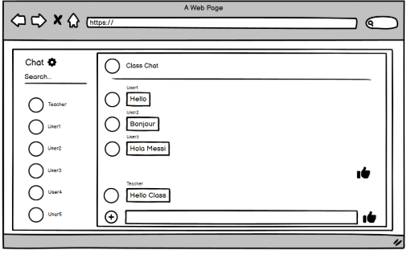

Figure 29.Join Class Chat
- In Normal Cases:
  - The user is connected to the chat, and they can participate in real-time discussions.
- In Abnormal Cases:
  - If the chat service is unavailable, an error message like "Unable to join chat, please try again later" is displayed.

3.4.9 Download Materials
- Function trigger:
  - The Download Materials function is triggered from the "Class Materials" section in the student’s dashboard. Students can click a Download button next to each material to download the file to their device.
- Function description:
  - Role :, Teacher,student
  - Purpose: To allow students to download learning materials (e.g., PDFs, Word documents, videos) that have been uploaded by their teacher for offline access.
  - Interface: The interface lists all available materials with a Download button next to each file, allowing students to download the material directly.
- Screen layout:N/A
- Data:
  - Material Name: The name of the file, displayed as a clickable link.
  - Material Type: The file type (e.g., PDF, DOCX, MP4).
  - Uploaded Date: The date the material was uploaded.
  - Download Link: Direct link to download the file from the server
- In Normal Cases:
  - Students click the Download button, and the system retrieves the file, initiating a download to the student’s device.
  - Files are downloaded in their original format (e.g., PDF, Word, video).
  - The system ensures that only students who are enrolled in the relevant class can download the material.
- In Abnormal Cases:
  - If the file fails to download (e.g., due to server issues or file corruption), an error message will appear, and the system will provide an option to retry.
  - If the student is not authorized to download the material (e.g., not enrolled in the class), the system will block access and display an error message.
  - If no materials are available for download, the system will display a message like "No materials available for download."

3.4.10 Create Materials
- Function trigger:
  - Primary Trigger: The teacher clicks on the " Materials" button or accesses the "Upload Materials" section within the class page to upload resources for the students.
- Function description:
  - Role :, Teacher
  - Purpose: To allow the teacher to upload and manage educational materials (e.g., PDFs, assignments, lecture notes, links) for students to access within the class.
  - Interface:
    - Material Name: A field for the teacher to provide a title or name for the uploaded material (e.g., "Week 1 Lecture Notes").
    - Upload Field: An area to upload files or add links to external resources (e.g., PDF, DOCX, YouTube video, etc.).
    - Description Field: An optional description or summary of the material.
    - Upload Time: The date and time when the material is uploaded (system-generated).
    - Save Button: A button to save/upload the material.
    - Cancel Button: A button to cancel the upload process.
- Screen layout:

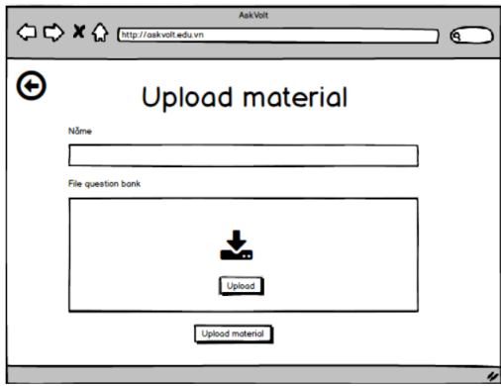

Figure 30.Download Material
- In Normal Cases:
Successful Material Upload:
    - After filling in the required fields and selecting a file, the teacher clicks Save.
    - The system validates the upload (e.g., file size, format) and, if successful, uploads the material.
    - The system will display a message:
"Material uploaded successfully."
The material will be visible in the class resources section, along with the material name, upload time, and other details.
    - Students can access the material in the class.
- In Abnormal Cases:
  - Missing or Invalid Fields:
    - Missing Material Name:
      - If the teacher does not provide a name for the material, the system will display:
"Please enter a material name."
    - Missing File or Link:
      - If the teacher fails to upload a file or provide a link, the system will display:
"Please upload a file or provide a link for the material."
    - Invalid File Type:
      - If the file uploaded is of an unsupported type (e.g., uploading an executable file), the system will show:
"Unsupported file type. Please upload a valid file (PDF, DOCX, etc.)."
    - File Size Limit Exceeded:
      - If the file exceeds the upload limit, the system will show:
"The file size exceeds the maximum allowed size. Please upload a smaller file."
  - Connection Issues:
    - Server Error:
      - If the system encounters an issue while uploading the material (e.g., server timeout), the system will display:
"There was an error uploading the material. Please try again later."
    - Timeout or Session Expiry:
      - If the teacher's session expires during the upload process, the system will show:
"Your session has expired. Please log in again to upload the material."

3.4.11 View Materials
- Function trigger:
  - Primary Trigger: The teacher or student clicks on the "View Materials" button or navigates to the "Materials" section within the class page.
- Function description:
  - Role :, Teacher, Student
  - Purpose: To allow both teachers and students to view the uploaded materials (documents, assignments, lecture notes, etc.) within the class, ensuring all class members have access to the resources.
  - Interface:
    - Material List: A list of all materials uploaded to the class, including the material's title, description, and upload date.
    - Download Button (for students): A button to download or view the material.
    - View/Manage Button (for teachers): Buttons allowing the teacher to edit or delete materials.
    - Pagination: If there are multiple materials, the list may be paginated to enhance user experience.

- Screen layout:
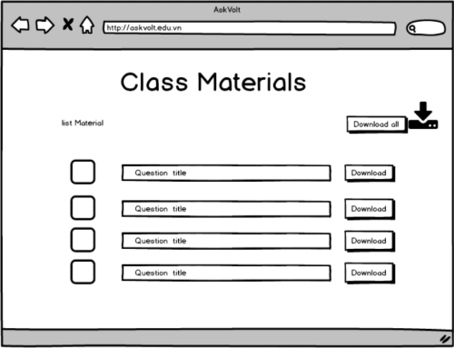

Figure 31.View materials
- In Normal Cases:
Teacher’s Experience:
- Viewing Materials:
  - The teacher can view a list of all materials uploaded to the class.
  - Each material entry will display the material title, description, and upload date.
  - The teacher can click on the View/Download button for any material to view or download it.
- Managing Materials:
  - The teacher can also edit or delete any material by clicking the Edit or Delete button next to the material.
  - Edit: The teacher can modify the material's name, description, or upload a new file.
  - Delete: The teacher can remove the material. Upon clicking delete, a confirmation prompt will appear:
"Are you sure you want to delete this material?" If confirmed, the material will be removed.
Student’s Experience:
- Viewing Materials:
  - The student can see a list of all materials uploaded by the teacher.
  - Each material entry will display the material title, description, and upload date.
  - The student can click on the Download or View button next to a material to download or view it (e.g., PDF, DOCX, video, etc.).
In Abnormal Cases:
Connection Issues:
- Network Error or Server Timeout:
  - If there is a problem with the network or server while loading the materials, the system will display:
"Unable to load materials due to connection issues. Please try again later."
- Session Expiry:
  - If the user’s session has expired while viewing the materials, the system will display:
"Your session has expired. Please log in again to view materials."
No Materials Available:
- No Materials Uploaded Yet:
  - If the teacher has not uploaded any materials yet, the system will display:
"No materials available for this class. Please check back later."
Permission Issues:
- Access Denied (for students):
  - If a student attempts to view materials for a class they are not enrolled in, the system will display:
"You do not have access to view materials for this class."
- Permission Denied (for unauthorized users):
  - If a non-logged-in user attempts to access materials, they will be prompted to log in:
"Please log in to view the class materials."

3.4.12 Update Materials
- Function trigger:
  - Primary Trigger: The teacher clicks on the "Update" button next to an existing material in the class materials section.
- Function description:
  - Role :, Teacher
  - Purpose: To allow the teacher to modify the details of a material (e.g., title, description) or replace the uploaded file (e.g., updating a document, uploading a new version).
  - Interface:
    - Material Title: A field to update the material's name or title (e.g., "Updated Week 1 Lecture Notes").
    - Material Description: A field to update the description or summary of the material.
    - Upload New File: A file upload section where the teacher can replace the existing file with a new one (optional).
    - Upload Time: Display the time when the material was last updated (system-generated).
    - Save Button: A button to save the updated material.
    - Cancel Button: A button to discard changes and return to the materials page.
- Screen layout:
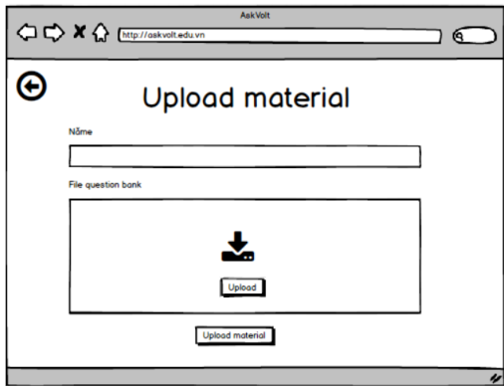

Figure 32.Update Materials

- In Normal Cases:
Successful Update:
- Material Updated Successfully:
  - The teacher updates the title, description, or file, and clicks Save.
  - The system validates the input (e.g., correct file type, non-empty title) and updates the material.
  - The system will display a confirmation message:
"Material updated successfully."
  - The updated material will be reflected in the class materials list, with the new title, description, and file (if updated).
  - The upload time will also be updated to reflect the time of the change.
Uploading New File:
- If the teacher uploads a new file, the previous file will be replaced with the new one. The system will display:
"File updated successfully."

- In Abnormal Cases:
  - Missing or Invalid Fields:
    - If any required field is missing or invalid, the system will display an error message (e.g., "Please enter the answer,").
  - Connection Issues:
    - If there's a server issue, the system will notify the teacher: "Unable to create answer slot due to a technical issue. Please try again later."

3.4.13 Delete Materials
- Function trigger:
  - Primary Trigger: The teacher clicks the Delete button next to a material they want to remove from the class resources.
- Function description:
  - Role :, Teacher
  - Purpose: To allow the teacher to remove materials that are no longer needed, outdated, or mistakenly uploaded, ensuring the class materials are up-to-date and relevant.
  - Interface:
    - Material List: Displays a list of materials available for the class, including the title, description, upload time, and available actions.
    - Delete Button (for Teacher): A button to delete a specific material from the list.
    - Confirmation Prompt: Before deleting, the system will ask for confirmation to avoid accidental deletions.
- Screen layout:
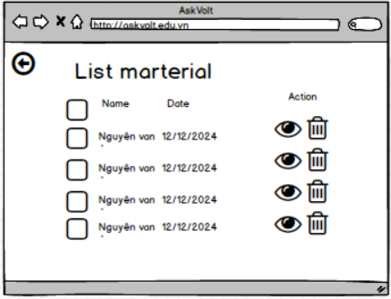

Figure 33.Delete Materials

- In Normal Cases:
Successful Deletion:
- Material Deletion:
  - The teacher clicks the Delete button next to a material.
  - The confirmation prompt appears asking the teacher to confirm the deletion.
  - If the teacher clicks Yes, Delete, the material is permanently removed from the class.
  - The system displays a confirmation message:
"Material deleted successfully."
  - The material is no longer visible in the Material List for the class.
No Deleted Materials Available:
- After Deletion:
  - If all materials are deleted, the system will display:
"No materials available for this class."
- In Abnormal Cases:
  - Missing or Invalid Fields:
    - If any required field is missing or invalid, the system will display an error message (e.g., "Please enter the answer,").
  - Connection Issues:
    - If there's a server issue, the system will notify the teacher: "Unable to create answer slot due to a technical issue. Please try again later."

3.4.14 Create Slot question
- Function trigger:
  - Primary Trigger: The teacher clicks on the Create Slot Question button while managing the class’s slot (session or lesson), to create questions for a specific slot.
- Function description:
  - Role :, Teacher
  - Purpose: To allow the teacher to create and manage questions associated with a particular slot or lesson, which can later be answered by students.
  - Interface:
    - Question Title: A field to enter the title or brief description of the question (e.g., "What is Object-Oriented Programming?").
    - Question Type: A dropdown to select the type of question (e.g., Multiple Choice, Short Answer, True/False).
    - Question Text: A field to enter the detailed question text.
    - Save Button: A button to save the created question.
    - Cancel Button: A button to discard the creation process and return to the slot page.
- Screen layout:
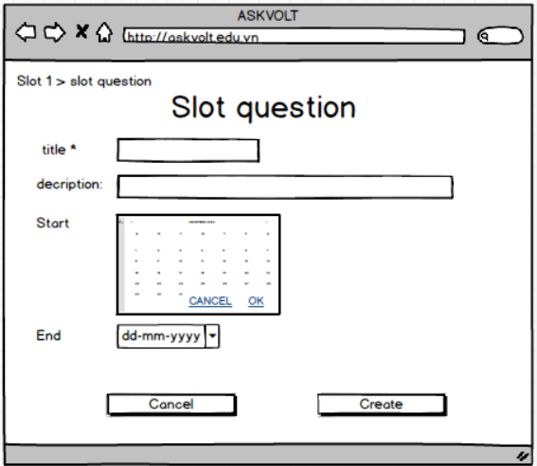

Figure 34.Create Slot question
- In Normal Cases:
Successful Question Creation:
- After entering all the required fields, the teacher clicks Save.
  - The system validates the input (e.g., ensuring a question title is provided, the correct answer is selected for multiple choice).
  - If the input is valid, the system saves the question.
  - The system will display a message:
"Question created successfully."
  - The question is now linked to the selected slot and will be visible in the list of questions for that slot.
Question List Display:
- After the question is created, it will appear in the list of questions for that particular slot, visible to the teacher and available for students to answer when the time comes.
- In Abnormal Cases:
  - Missing or Invalid Fields:
    - If any required field is missing or invalid, the system will display an error message (e.g., "Please enter the answer,").
  - Connection Issues:
    - If there's a server issue, the system will notify the teacher: "Unable to create answer slot due to a technical issue. Please try again later."

3.4.15 View Slot question
- Function trigger:
  - Primary Trigger: The teacher or student clicks on the View Slot Questions button or navigates to the "Slot Questions" section for a specific class and slot.
- Function description:
  - Role :, Teacher,Student
  - Purpose: To allow both teachers and students to view the questions that have been created for a specific class slot, ensuring students can review the questions and answer them, while teachers can monitor and manage the questions.
  - Interface:

Question List: A list of all questions for the selected slot, showing:
- Question Title: A brief description or title of the question.
- Question Type: The type of question (e.g., Multiple Choice, True/False, Short Answer).
- Question Text: The detailed text of the question.
- Options (if applicable): For multiple-choice questions, a list of answer options.
- Correct Answer Indicator (Teacher Only): The correct answer may be visible to the teacher or may be hidden until the answer submission.
- Answer Status (Student Only): Whether the student has answered the question or not (for tracking progress).
Action Buttons (Teacher only):
- Edit: A button to modify the question.
- Delete: A button to remove the question from the slot.
- Screen layout:


Figure 35.View Slot Question
- In Normal Cases:
Connection Issues:
- Server Error or Timeout:
  - If the system is unable to load the questions due to a server error or network issue, the system will display:
"Unable to load questions. Please check your connection and try again."
- Session Expiry:
  - If the session expires while the teacher or student is viewing the questions, the system will display:
"Your session has expired. Please log in again to continue viewing questions."
Missing Slot Questions:
- No Questions Available for the Slot:
  - If no questions have been created for the selected slot, the system will display:
"No questions have been created for this slot yet."
Permission Issues:
- Unauthorized User:
  - If a student tries to view questions for a slot they are not enrolled in, the system will display:
"You do not have access to view questions for this slot."
- Non-Teacher Trying to Delete or Edit:
  - If a student or unauthorized user attempts to click the Edit or Delete buttons, the system will display:
"You do not have permission to edit or delete this question."
- In Abnormal Cases:
  - Missing or Invalid Fields:
    - If any required field is missing or invalid, the system will display an error message (e.g., "Please enter the answer,").
  - Connection Issues:
    - If there's a server issue, the system will notify the teacher: "Unable to create answer slot due to a technical issue. Please try again later."

3.4.16 Update Slot question
- Function trigger:
  - Primary Trigger: The teacher clicks on the Update button next to an existing question in the "View Slot Question" section to edit or modify the question.
- Function description:
  - Role :, Teacher
  - Purpose: To allow teachers to modify previously created questions for a class slot, such as changing the title, question text, answer options
  - Interface:
    - Slot Selection: A dropdown or list to select the class slot for which the question will be updated (e.g., "Week 1 - Introduction to Programming").
    - Question Title: A text input field to edit the title or brief description of the question (e.g., "What is OOP?").
    - Question Text: A field to edit the detailed text of the question.
    - Save Button: A button to save the updated question.
    - Cancel Button: A button to discard changes and return to the question list.
- Screen layout:


Figure 36.Update Slot question
- In Normal Cases:
Successful Update:
- Updating Question:
  - The teacher clicks Update next to an existing question.
  - The system loads the question into editable fields.
  - The teacher makes changes to the question title, question text, answer options, or correct answer.
  - After clicking Save, the system validates the input.
  - If all inputs are valid (e.g., non-empty fields, correct options), the system saves the updated question.
  - The system displays a success message:
"Question updated successfully."
  - The updated question is reflected in the class slot's question list.
Updated Question Display:
- The updated question will appear in the list with the modified title, description, answer options (if applicable), and correct answer (if applicable).
  - The updated point value will also be reflected.
In Abnormal Cases:
  - Missing or Invalid Fields:
  - If any required field is missing or invalid, the system will display an error message (e.g., "Please enter the answer,").
  - Connection Issues:
  - If there's a server issue, the system will notify the teacher: "Unable to create answer slot due to a technical issue. Please try again later."

3.4.17 Delete Slot question
- Function trigger:
  - Primary Trigger: The teacher clicks on the Delete button next to an existing question in the "View Slot Questions" section to remove the question from the system.
- Function description:
  - Role :, Teacher
  - Purpose: To allow teachers to remove questions that were previously created for a specific class slot (e.g., when a question is no longer relevant or needs to be replaced).
  - Interface:
    - Slot Selection: A dropdown or list to select the class slot for which the question is being deleted (e.g., "Week 1 - Introduction to Programming").
    - Question List: A list displaying all questions for the selected class slot, with each question showing:
- Question Title: A brief title or description of the question.
- Question Type: The type of the question (e.g., Multiple Choice, Short Answer).
- Delete Button: A button next to each question for the teacher to delete it.
- Screen layout:

- In Normal Cases:
Successful Deletion:
- Teacher's Actions:
  - The teacher clicks the Delete button next to the question they want to remove.
  - A confirmation prompt appears:
"Are you sure you want to delete this question?"
  - If the teacher confirms the deletion, the question is permanently removed from the slot.
  - The system displays a success message:
"Question deleted successfully."
  - The deleted question is no longer shown in the question list for that class slot.
- In Abnormal Cases:
Connection Issues:
- Server Error or Timeout:
  - If the system is unable to delete the question due to a server error or timeout, the system will display:
"Unable to delete the question due to a technical issue. Please try again later."
Missing Question:
- Question Not Found:
  - If the question is no longer available in the database (e.g., already deleted by another teacher or during a previous session), the system will display:
"This question could not be found. It may have already been deleted."
Session Expiry:
- If the teacher’s session expires while attempting to delete the question, the system will display:
"Your session has expired. Please log in again to delete the question."
Permission Issues:
- Non-Teacher User Tries to Delete:
  - If a user who is not a teacher tries to delete a question, the system will display:
"You do not have permission to delete this question."

3.4.18 View list members of class
- Function trigger:
  - Primary Trigger: The teacher clicks on the View Members button or navigates to the "Class Members" section in the class dashboard.
- Function description:
  - Role :, Teacher
  - Purpose: To allow the teacher to view a list of all users (students and teachers) who are part of the class, helping the teacher keep track of enrollment and participation.
  - Interface:
    - Class Selection: A dropdown or list to select the class for which the members will be viewed (e.g., "Math 101 - Fall 2024").
    - Member List: A list displaying the class members, which includes:
- Name: The full name of the student or teacher.
- Role: The role of the user (Student, Teacher).
- Email: The email address of the user.
- Enrollment Date: The date the user joined the class.
- Actions (optional): Buttons or links for specific actions (e.g., sending an email, viewing profile).
Search and Filter: An option to search for a specific member by name or email
- Screen layout:
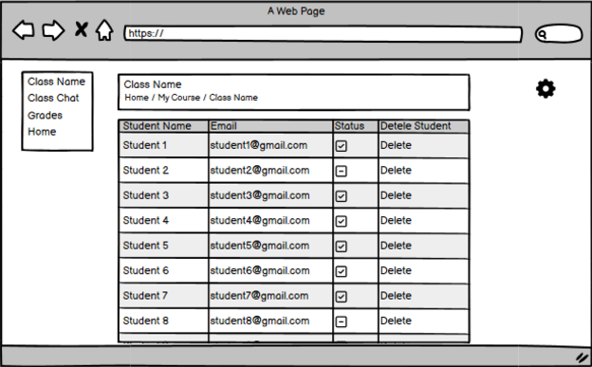

Figure 37. View list member of class
- In Normal Cases:

- In Abnormal Cases:
  - Missing or Invalid Fields:
    - If any required field is missing or invalid, the system will display an error message (e.g., "Please enter the answer,").
  - Connection Issues:
    - If there's a server issue, the system will notify the teacher: "Unable to create answer slot due to a technical issue. Please try again later."

3.4.19 Export List Members Of Class
- Function trigger:
  - Primary Trigger: The teacher clicks the "Export Members List" button on the class management page
- Function description:
  - Role :, Teacher
  - Purpose: Exports the list of class members to a downloadable format (CSV, Excel).
- Screen layout:
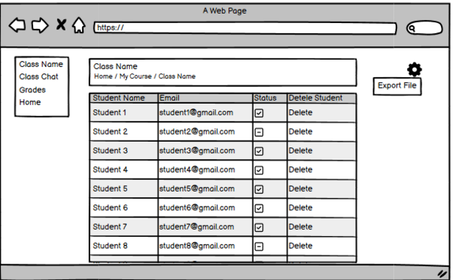

Figure 38.Export list member of class
- In Normal Cases:
Viewing Class Members:
- The teacher selects the class they want to view the members for (e.g., "Math 101 - Fall 2024").
- The system loads the list of all members enrolled in that class.
- The list includes the name, role, email, and enrollment date of each member.
- The teacher can use the search and filter options to find a specific member by name or email and can filter the members by their role (Student/Teacher).
Search and Filter:
- The teacher can search for a specific member by entering a name or email into the search box.
- The teacher can filter the list by role (Student or Teacher) to narrow down the results.
In Abnormal Cases:
Missing or Invalid Fields:
    - If any required field is missing or invalid, the system will display an error message (e.g., "Please enter the answer,").
Connection Issues:
    - If there's a server issue, the system will notify the teacher: "Unable to create answer slot due to a technical issue. Please try again later."
No Members Enrolled:
- No Class Members:
  - If no students or teachers are enrolled in the selected class yet, the system will display:
"No members are enrolled in this class yet."

3.5 Manage Quiz/Question feature

3.5.1 Create Quiz
- Function trigger:This function is accessed through the “Manage Quiz” section, where users can create, update, delete, and view quizzes.
- Function description:
  - Role :Teacher can create, edit, delete, or view quizzes.
  - Purpose: This feature allows authorized users to manage quizzes, ensuring that they can create, update, and delete quizzes efficiently within the system.
  - Interface: The interface provides a list of all quizzes, along with buttons for creating, editing, or deleting quizzes. Each quiz can be viewed in detail or modified through dedicated forms.
  - Data Processing: Once a quiz is created or modified, the system saves or updates the quiz data in the database. Deleting a quiz removes its related data.

- Screen layout:
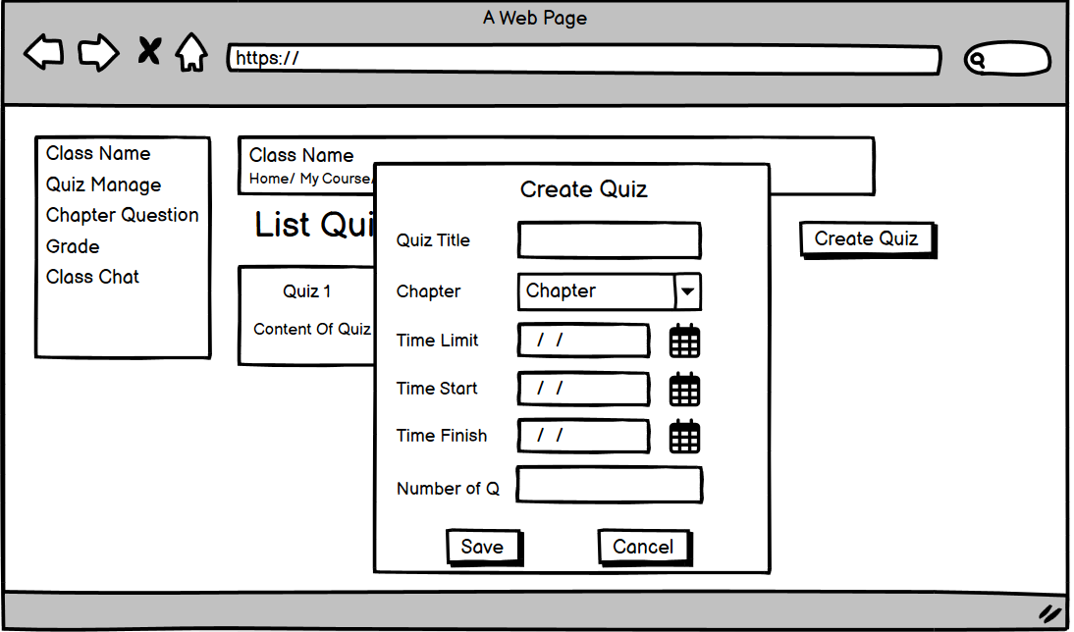

Figure 39.Create quiz
- Function detail:
  - Data:
    - Quiz Title: Required, must be a non-empty string.
    - Chapter: Optional, but recommended for clarity.
    - Time Limit: Required, must be a valid number in minutes.
    - Time start: Required, must be a valid number in minutes.
    - Time finish: Required, must be a valid number in minutes.
    - Number of question: Required, must be a valid number
  - Validation and Business Rules:
    - In normal cases:
      - When creating or updating a quiz, the system validates that the title is not empty and the time limit is a positive number.
      - If the quiz is marked as "Published," it becomes available to students; otherwise, it remains as a draft.
      - The system ensures that the quiz data is properly saved to the database and updates are reflected in real-time.
    - In abnormal cases:
      - If required fields (like title or time limit) are missing or invalid, the system displays an error message and prevents the quiz from being saved.
      - If an attempt is made to delete a quiz that is linked to active assessments, the system will block the deletion and show an appropriate error.
      - In case of server or network errors during quiz creation or modification, the user will receive a notification, and the system will advise trying again later.

3.5.2 View Quiz
- Function trigger:This function is accessed through the “Manage Quiz” section, where users can create, update, delete, and view quizzes.
- Function description:
  - Role :Teacher can create, edit, delete, or view quizzes.
  - Purpose: This feature allows authorized users to manage quizzes, ensuring that they can create, update, and delete quizzes efficiently within the system.
  - Interface: The interface provides a list of all quizzes, along with buttons for creating, editing, or deleting quizzes. Each quiz can be viewed in detail or modified through dedicated forms.
  - Data Processing: Once a quiz is created or modified, the system saves or updates the quiz data in the database. Deleting a quiz removes its related data.

- Screen layout:
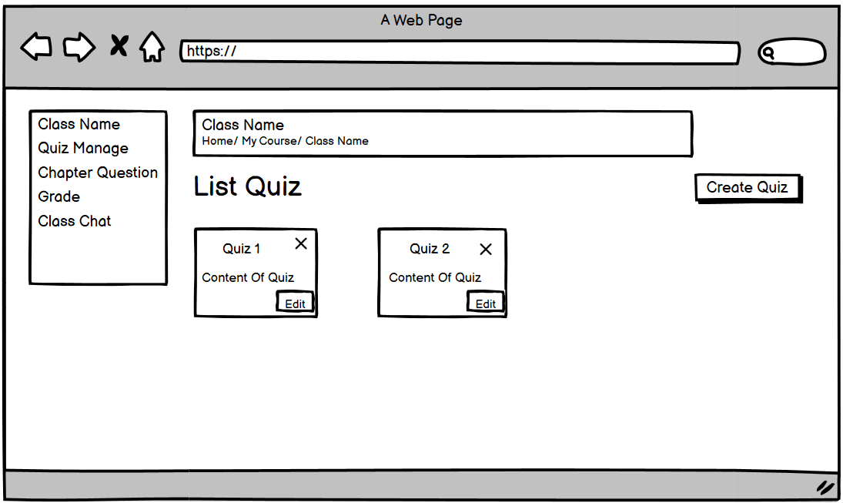

Figure 40.View Quiz
- Function detail:
  - Data:
    - Name: Required, must be a non-empty string.
    - Description: Required, must be a non-empty string.
  - Validation and Business Rules:
    - In normal cases:
      - When creating or updating a quiz, the system validates that the title is not empty and the time limit is a positive number.
      - If the quiz is marked as "Published," it becomes available to students; otherwise, it remains as a draft.
      - The system ensures that the quiz data is properly saved to the database and updates are reflected in real-time.
    - In abnormal cases:
      - If required fields (like title or time limit) are missing or invalid, the system displays an error message and prevents the quiz from being saved.
      - If an attempt is made to delete a quiz that is linked to active assessments, the system will block the deletion and show an appropriate error.
      - In case of server or network errors during quiz creation or modification, the user will receive a notification, and the system will advise trying again later.

3.5.3 Update Quiz
- Function trigger:This function is accessed through the “Manage Quiz” section, where users can create, update, delete, and view quizzes.
- Function description:
  - Role :Teacher can create, edit, delete, or view quizzes.
  - Purpose: This feature allows authorized users to manage quizzes, ensuring that they can create, update, and delete quizzes efficiently within the system.
  - Interface: The interface provides a list of all quizzes, along with buttons for creating, editing, or deleting quizzes. Each quiz can be viewed in detail or modified through dedicated forms.
  - Data Processing: Once a quiz is created or modified, the system saves or updates the quiz data in the database. Deleting a quiz removes its related data.
- Screen layout:
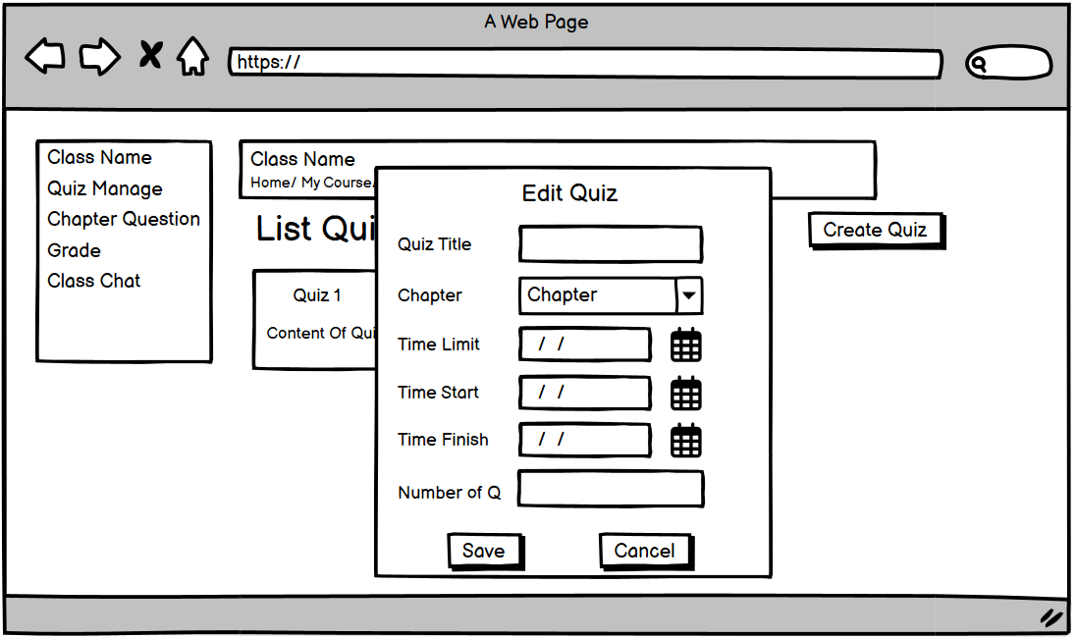

Figure 41.Update Quiz
- Function detail:
  - Data:
    - Quiz Title: Required, must be a non-empty string.
    - Chapter: Optional, but recommended for clarity.
    - Time Limit: Required, must be a valid number in minutes.
    - Time start: Required, must be a valid number in minutes.
    - Time finish: Required, must be a valid number in minutes.
    - Number of question: Required, must be a valid number

  - Validation and Business Rules:
    - In normal cases:
      - When creating or updating a quiz, the system validates that the title is not empty and the time limit is a positive number.
      - If the quiz is marked as "Published," it becomes available to students; otherwise, it remains as a draft.
      - The system ensures that the quiz data is properly saved to the database and updates are reflected in real-time.
    - In abnormal cases:
      - If required fields (like title or time limit) are missing or invalid, the system displays an error message and prevents the quiz from being saved.
      - If an attempt is made to delete a quiz that is linked to active assessments, the system will block the deletion and show an appropriate error.
      - In case of server or network errors during quiz creation or modification, the user will receive a notification, and the system will advise trying again later.

3.5.4 Delete Quiz
- Function trigger:This function is accessed through the “Manage Quiz” section, where users can create, update, delete, and view quizzes.
- Function description:
  - Role :Teacher can create, edit, delete, or view quizzes.
  - Purpose: This feature allows authorized users to manage quizzes, ensuring that they can create, update, and delete quizzes efficiently within the system.
  - Interface: The interface provides a list of all quizzes, along with buttons for creating, editing, or deleting quizzes. Each quiz can be viewed in detail or modified through dedicated forms.
  - Data Processing: Once a quiz is created or modified, the system saves or updates the quiz data in the database. Deleting a quiz removes its related data.

- Screen layout:
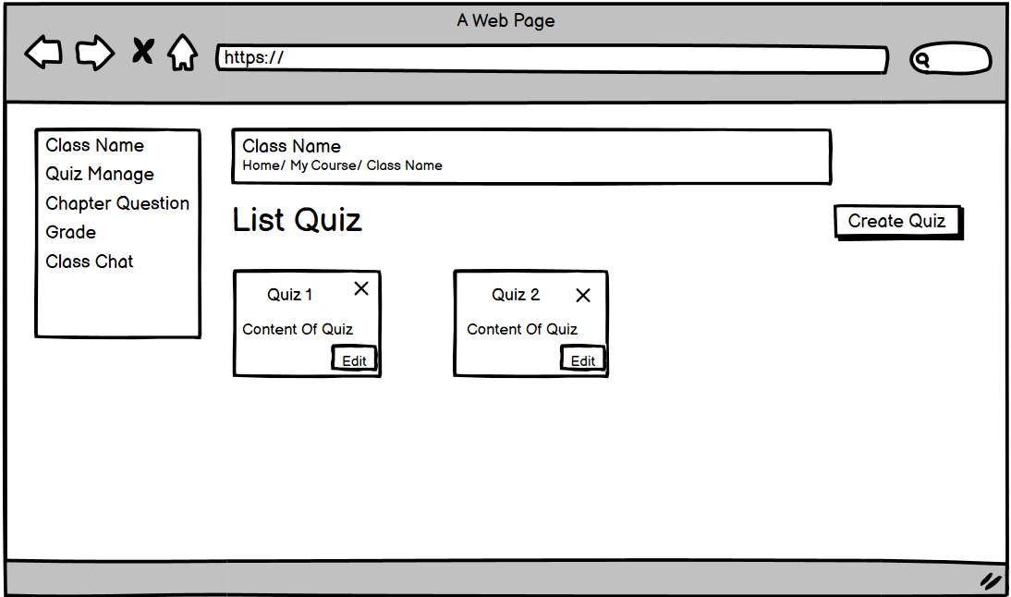

Figure 42.Delete Quiz

- Function detail:
  - Data:
    - Name: Required, must be a non-empty string.
    - Description: Required, must be a non-empty string.
  - Validation and Business Rules:
    - In normal cases:
      - When creating or updating a quiz, the system validates that the title is not empty and the time limit is a positive number.
      - If the quiz is marked as "Published," it becomes available to students; otherwise, it remains as a draft.
      - The system ensures that the quiz data is properly saved to the database and updates are reflected in real-time.
    - In abnormal cases:
      - If required fields (like title or time limit) are missing or invalid, the system displays an error message and prevents the quiz from being saved.
      - If an attempt is made to delete a quiz that is linked to active assessments, the system will block the deletion and show an appropriate error.
      - In case of server or network errors during quiz creation or modification, the user will receive a notification, and the system will advise trying again later.

3.5.5 Create Question
- Function trigger:
  - The CRUD Question function can be triggered from the "Quiz Management" section, where users can manage questions associated with a specific quiz. It allows authorized users to create, update, delete, and view questions within a quiz.
- Function description:
  - Roles: Teacher
  - Purpose: To allow users to manage questions for quizzes, ensuring that they can create, edit, or remove questions to update the quiz content.
  - Interface: The interface provides a list of questions for each quiz, with options to add new questions, edit existing ones, or delete them. Users can select different question types (e.g., multiple-choice, true/false).
  - Data Processing: Once a question is created, updated, or deleted, the system saves or updates the data in the database. Questions can be previewed before being saved to ensure accuracy.

- Screen layout:
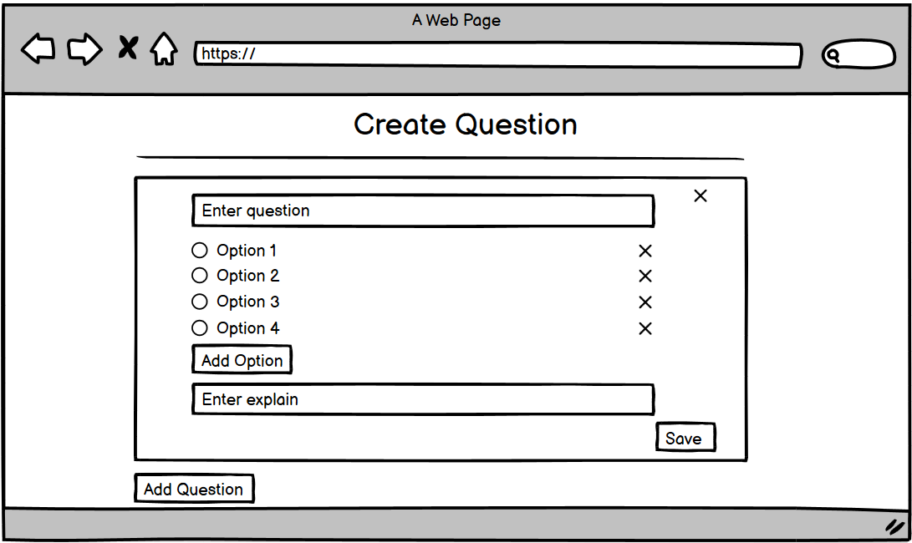

Figure 43.Create question
- Function detail:
  - Data:
    - Question Text: Required, must be a non-empty string.
    - Question Type: Required, must be selected from predefined types (e.g., multiple-choice, true/false, etc.).
    - Answer Options: For multiple-choice questions, at least two answer options are required.
    - Correct Answer: Required, based on the question type.
    - Points: Required, must be a positive number indicating the marks awarded for a correct answer.
    - Validation and Business Rules:
- In normal cases:
  - When adding or editing a question, the system checks that all required fields (Question Text, Type, Correct Answer) are filled out.
  - Multiple-choice questions require at least two answer options, and one must be marked as the correct answer.
  - The system saves the question in the database and ensures the changes are immediately reflected in the quiz.
- In abnormal cases:
  - If required fields are missing or invalid (e.g., no correct answer selected, question text is empty), the system will show an error message and prevent saving.
  - If a question is linked to an ongoing quiz attempt, the system will block its deletion or modification and show an error.
  - In the event of a network or server error during save or update operations, users will receive a notification with the option to retry or save later.

3.5.6 View Question
- Function trigger:
  - The CRUD Question function can be triggered from the "Quiz Management" section, where users can manage questions associated with a specific quiz. It allows authorized users to create, update, delete, and view questions within a quiz.
- Function description:
  - Roles: Teacher
  - Purpose: To allow users to manage questions for quizzes, ensuring that they can create, edit, or remove questions to update the quiz content.
  - Interface: The interface provides a list of questions for each quiz, with options to add new questions, edit existing ones, or delete them. Users can select different question types (e.g., multiple-choice, true/false).
  - Data Processing: Once a question is created, updated, or deleted, the system saves or updates the data in the database. Questions can be previewed before being saved to ensure accuracy.

- Screen layout:
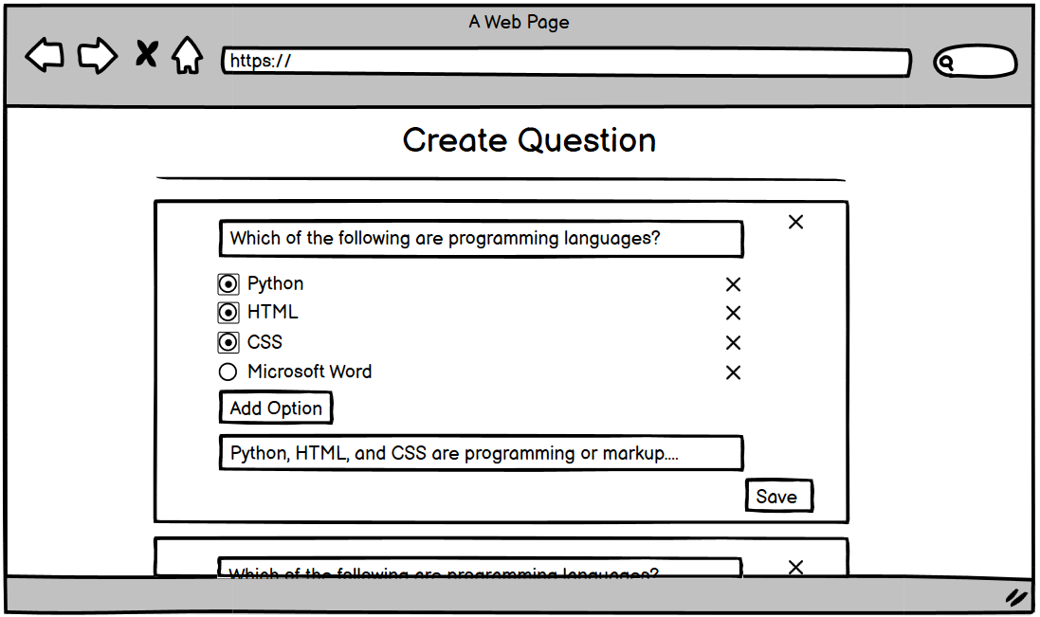

Figure 44.View Question
- Function detail:
  - Data:
    - Question Text: Required, must be a non-empty string.
    - Question Type: Required, must be selected from predefined types (e.g., multiple-choice, true/false, etc.).
    - Answer Options: For multiple-choice questions, at least two answer options are required.
    - Correct Answer: Required, based on the question type.
    - Points: Required, must be a positive number indicating the marks awarded for a correct answer.
    - Validation and Business Rules:
- In normal cases:
  - When adding or editing a question, the system checks that all required fields (Question Text, Type, Correct Answer) are filled out.
  - Multiple-choice questions require at least two answer options, and one must be marked as the correct answer.
  - The system saves the question in the database and ensures the changes are immediately reflected in the quiz.
- In abnormal cases:
  - If required fields are missing or invalid (e.g., no correct answer selected, question text is empty), the system will show an error message and prevent saving.
  - If a question is linked to an ongoing quiz attempt, the system will block its deletion or modification and show an error.
  - In the event of a network or server error during save or update operations, users will receive a notification with the option to retry or save later.

3.5.7 Update Question
- Function trigger:
  - The CRUD Question function can be triggered from the "Quiz Management" section, where users can manage questions associated with a specific quiz. It allows authorized users to create, update, delete, and view questions within a quiz.
- Function description:
  - Roles: Teacher
  - Purpose: To allow users to manage questions for quizzes, ensuring that they can create, edit, or remove questions to update the quiz content.
  - Interface: The interface provides a list of questions for each quiz, with options to add new questions, edit existing ones, or delete them. Users can select different question types (e.g., multiple-choice, true/false).
  - Data Processing: Once a question is created, updated, or deleted, the system saves or updates the data in the database. Questions can be previewed before being saved to ensure accuracy.

- Screen layout:


Figure 45.Update Question
- Function detail:
  - Data:
    - Question Text: Required, must be a non-empty string.
    - Question Type: Required, must be selected from predefined types (e.g., multiple-choice, true/false, etc.).
    - Answer Options: For multiple-choice questions, at least two answer options are required.
    - Correct Answer: Required, based on the question type.
    - Points: Required, must be a positive number indicating the marks awarded for a correct answer.
    - Validation and Business Rules:
- In normal cases:
  - When adding or editing a question, the system checks that all required fields (Question Text, Type, Correct Answer) are filled out.
  - Multiple-choice questions require at least two answer options, and one must be marked as the correct answer.
  - The system saves the question in the database and ensures the changes are immediately reflected in the quiz.
- In abnormal cases:
  - If required fields are missing or invalid (e.g., no correct answer selected, question text is empty), the system will show an error message and prevent saving.
  - If a question is linked to an ongoing quiz attempt, the system will block its deletion or modification and show an error.
  - In the event of a network or server error during save or update operations, users will receive a notification with the option to retry or save later.

3.5.8 Delete Question
- Function trigger:
  - The CRUD Question function can be triggered from the "Quiz Management" section, where users can manage questions associated with a specific quiz. It allows authorized users to create, update, delete, and view questions within a quiz.
- Function description:
  - Roles: Teacher
  - Purpose: To allow users to manage questions for quizzes, ensuring that they can create, edit, or remove questions to update the quiz content.
  - Interface: The interface provides a list of questions for each quiz, with options to add new questions, edit existing ones, or delete them. Users can select different question types (e.g., multiple-choice, true/false).
  - Data Processing: Once a question is created, updated, or deleted, the system saves or updates the data in the database. Questions can be previewed before being saved to ensure accuracy.

- Screen layout:


Figure 46.Delete question
- Function detail:
  - Data:
    - Question Text: Required, must be a non-empty string.
    - Question Type: Required, must be selected from predefined types (e.g., multiple-choice, true/false, etc.).
    - Answer Options: For multiple-choice questions, at least two answer options are required.
    - Correct Answer: Required, based on the question type.
    - Points: Required, must be a positive number indicating the marks awarded for a correct answer.
    - Validation and Business Rules:
- In normal cases:
  - When adding or editing a question, the system checks that all required fields (Question Text, Type, Correct Answer) are filled out.
  - Multiple-choice questions require at least two answer options, and one must be marked as the correct answer.
  - The system saves the question in the database and ensures the changes are immediately reflected in the quiz.
- In abnormal cases:
  - If required fields are missing or invalid (e.g., no correct answer selected, question text is empty), the system will show an error message and prevent saving.
  - If a question is linked to an ongoing quiz attempt, the system will block its deletion or modification and show an error.
  - In the event of a network or server error during save or update operations, users will receive a notification with the option to retry or save later.

3.5.9 View List Points
- Function trigger: The View List Point function is triggered from the "Quiz Results" section within the quiz management or course overview pages. It allows users (instructors or students) to view the scores of quizzes.
- Function description:
  - Actors/Roles:Teacher.
  - Purpose: To provide a detailed list of scores for quizzes, allowing users to view their own scores or instructors to monitor student performance.
  - Interface: The interface displays a table or list showing the quiz results, including user names, quiz names, scores, and completion status. Instructors may have additional filtering and sorting options.
  - Data Processing: The system retrieves quiz scores from the database, calculating final results and displaying them to the user in real-time. Instructors can also export the score list.
- Screen layout:
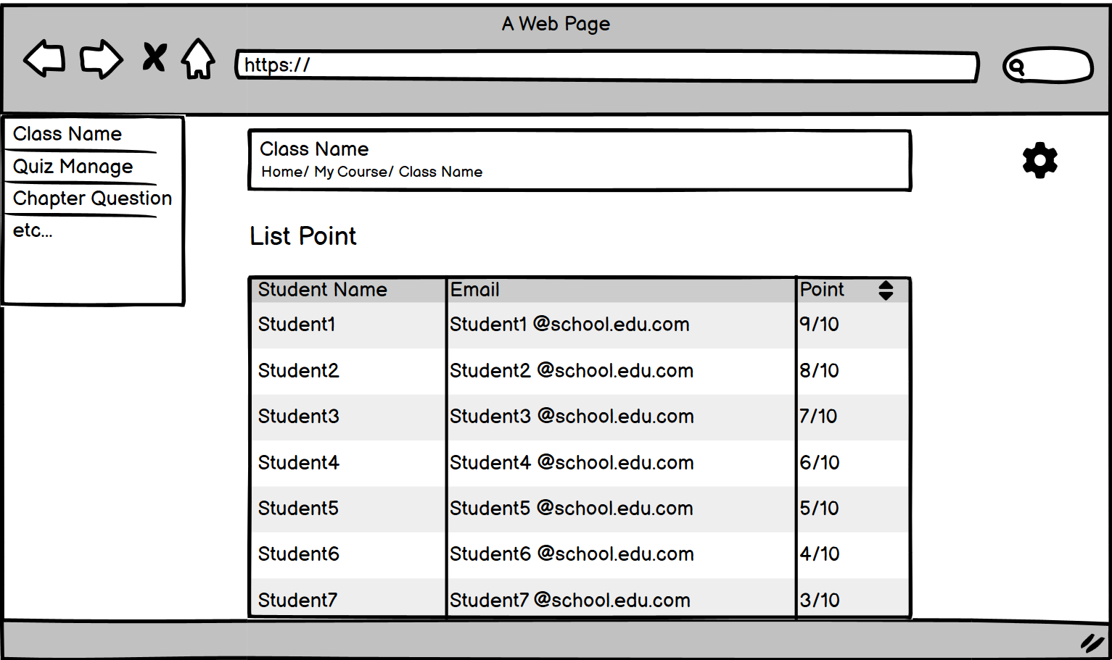

Figure 47.View List Point
- Function detail:
  - Data:
    - User Name: Displays the name of the student who took the quiz.
    - Quiz Name: The title of the quiz for which the score is displayed.
    - Score: The quiz score, typically shown as a percentage or points out of a total.
    - Completion Status: Indicates if the quiz is completed or still in progress.
    - Date Taken: The date and time the quiz was submitted.
  - Validation and Business Rules:
    - In normal cases:
      - The system fetches and displays the quiz scores from the database in real-time.
      - Instructors can view and sort the scores for an entire class or a specific quiz.
      - Students can view their own quiz scores and see completion details.
      - Export functionality allows instructors to download the list of scores in a file format (CSV or Excel).
    - In abnormal cases:
      - If no quiz scores are available (e.g., no one has taken the quiz yet), the system will display a message like "No results available."
      - If the system encounters errors while retrieving scores from the database, an error message is shown, and the user is advised to try again later.
      - In the case of a network failure during export, the system provides an error message and allows retrying the export.

3.5.10 Take Quiz
- Function Trigger:Users can access quizzes from the course page, dashboard, or notifications when a quiz is available.
- Function Description:
  - Actors/Roles: Students and Teachers.
  - Purpose:
    - For Students: To allow students to take quizzes as part of their coursework.
    - For Teachers: To review student quiz performance and manage grading.
- Interface:
  - A list of available quizzes with details like:
    - Quiz Title
    - Due Date
    - Time Limit
  - The quiz interface displays questions, answer options (for multiple choice), short-answer fields, and a Submit button.
- Data Processing:
  - The system retrieves the quiz questions from the server and stores the student's responses either in real-time or upon submission.
- Screen Layout:
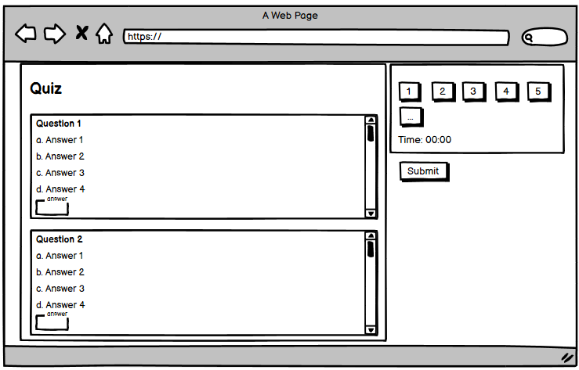

Figure 48.Take Quiz
- Function Details:
  - Data Requirements: The system needs access to the quiz questions, time limits, and the ability to store or record answers.
- Actions:
  - Answer quiz questions: Students can interact with the quiz by selecting or typing answers.
  - Submit quiz: Once complete, students can submit the quiz for grading.
- Validation and Business Rules:
- In normal cases:
  - The quiz is submitted successfully, and the system either automatically grades it (for multiple-choice) or stores it for manual grading (for other question types).
  - Results or feedback are provided to students based on the grading policy (immediate or delayed).
- In abnormal cases:
  - Submission failure: If the quiz submission fails due to server errors or network issues, a message will prompt the user to retry.
  - Time limit exceeded: If the quiz has a time limit, the system will automatically submit the quiz when time expires, whether or not the student has completed it.

3.5.11 View Quiz Answer
- Function Trigger: Students can access the Quiz Review feature from the course page, dashboard, or after quiz submission notifications.
- Function Description:
  - Actors/Roles: Students and Teachers.
  - Purpose:
    - For Students: Allow students to review their submitted quizzes, compare their answers with correct ones, and understand their mistakes.
    - For Teachers: Facilitate student understanding by providing detailed explanations or comments for each question.
- Interface:
  - A list of available quizzes with details like:
    - Quiz Title
    - Date Submitted
    - Final Grade
- Data Processing:
  - The system retrieves quiz review data from the server, including:
    - Questions and answers (both correct and submitted).
    - Scores per question.
    - Explain for answer
- Screen Layout:
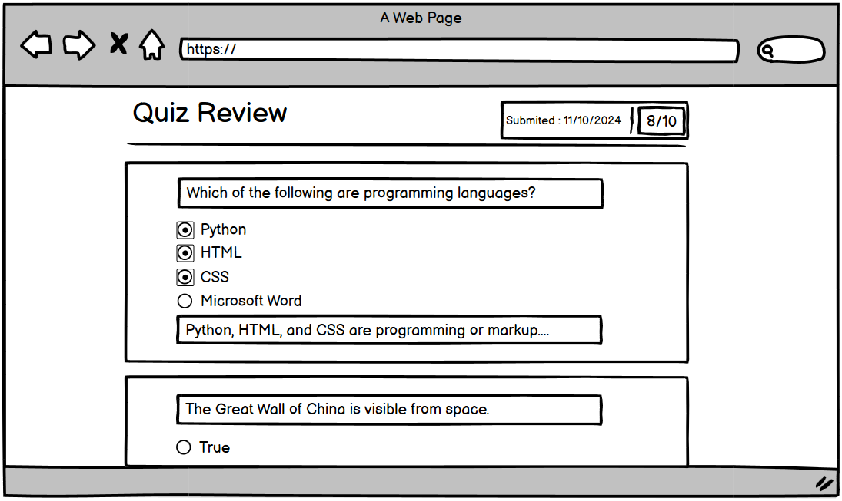

Figure 49.Forgot password
- Function Details:
  - Data Requirements:
    - Quiz ID and associated student responses.
    - Correct answers and grading policies.
    - Teacher explanations
- Actions:
  - View Question Details: Display question, student's answer, and correct answer.
  - Navigate Review: Move between questions or view a summary.
  - Feedback Section: Explanations from teachers.
- Validation and Business Rules:
- In normal cases:
  - Students successfully access their quiz review and see detailed results.
  - Feedback, grades, and performance analysis are displayed correctly.
- In abnormal cases:
  - Data Loading Failure: If the system fails to load review data due to server or network issues, display a retry prompt and troubleshoot instructions.
  - Unauthorized Access: If a user tries to access a quiz they didn't take, show an error message: "You are not authorized to view this quiz."

3.5.12 Create Chapter Question
- Function trigger: The Create Chapter Question function is triggered from the "Chapter Question" section within the teacher's dashboard. Teachers can access this section to create a repository of questions, which they can later use in quizzes, exams, or review sessions.
- Function description:
  - Actors/Roles: Teachers
  - Purpose: To allow teachers to create and store a library of questions that can be reused in different quizzes or assessments, saving time and ensuring consistency.
  - Interface: The interface provides a list of all questions in the chapter, with options to add new questions, edit existing ones, or categorize them based on subjects or difficulty levels.
  - Data Processing: Once a question is created, it is stored in the system's database and can be retrieved later to populate quizzes or assessments.

- Screen layout:
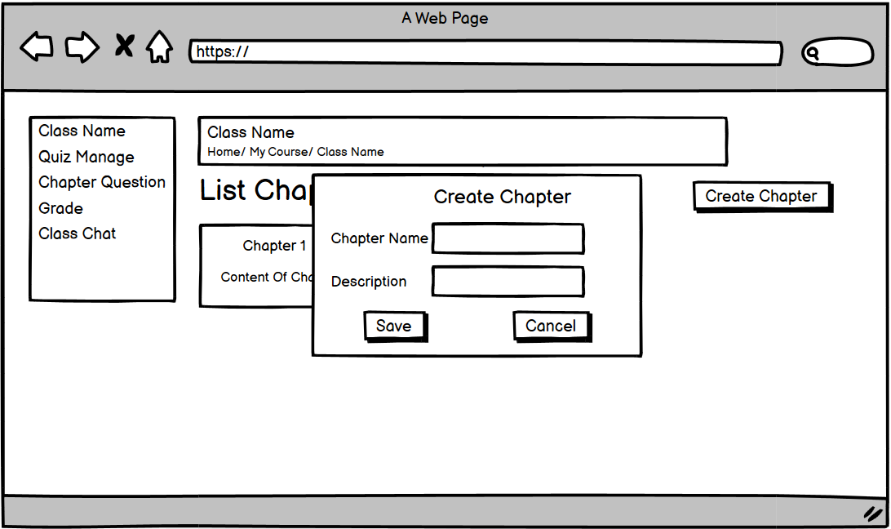

Figure 50.Forgot Chapter Question
- Function detail:
Data:
- Name: Required, must be a non-empty string.
- Description: Required, must be a non-empty string.
Validation and Business Rules:
- In normal cases:
  - The system validates that all required fields are filled out before allowing the question to be saved.
  - Teachers can categorize questions based on chapter, making it easier to filter and find questions when building quizzes.
- In abnormal cases:
  - If any required fields are missing, the system displays an error message and prevents the question from being saved.
  - In case of network or server errors during the saving process, the system provides an error notification and allows retrying later.
  - If the question is being used in an ongoing quiz, it cannot be deleted or edited, and the system will display a relevant error message.

3.5.13 Import Question
- Function trigger:
  - The Import Question chapter function is triggered from the "Question Chapter" section within the teacher's dashboard. Teachers can upload a file from their local machine to import a list of questions into the system.
- Function description:
  - Actors/Roles: Teachers for managing questions in the system.
  - Purpose: To enable teachers to efficiently upload large sets of pre-prepared questions from an Excel file, saving time when creating or updating their question bank.
  - Interface: The interface provides an option to select and upload an Excel file. The system processes the file, extracts the questions, and adds them to the question bank.
  - Data Processing: After uploading the Excel file, the system reads the file contents, validates the structure, and imports the questions into the database. Errors or invalid formats are highlighted for correction.

- Screen layout:
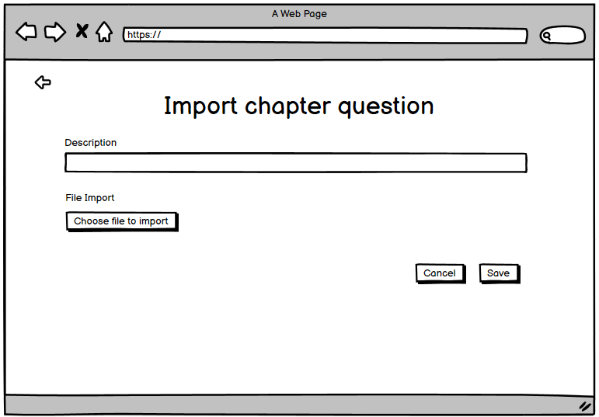

Figure 51.Import Question
- Function detail:
- Data:
  - Excel File: Required, must be in a valid format (.xlsx or .xls) with predefined columns for question details.
  - The system expects specific columns in the Excel file, such as:
    - Question Text: The text of the question.
    - Question Type: (e.g., multiple-choice, true/false, short answer).
    - Answer Options: For multiple-choice questions, the options must be listed (at least two).
    - Correct Answer: The correct option or answer.
    - Difficulty Level: (Easy, Medium, Hard).
    - Subject/Topic: (e.g., Math, History).
- Validation and Business Rules:
  - In normal cases:
    - The system checks that the uploaded file follows the correct structure and all necessary columns (Question Text, Type, Correct Answer) are filled out.
    - If the file is valid, the system imports all questions into the database and associates them with the teacher’s question bank.
    - Teachers can review the imported questions and edit or categorize them as needed.
  - In abnormal cases:
    - If the file format is invalid (e.g., wrong file type or incorrect column headers), the system displays an error message and prevents the import.
    - If any required fields (e.g., Question Text, Type) are missing from the file, the system will show an error and highlight the missing data.
    - If the system encounters a network error or server issue during the import process, it will show an error notification and allow users to retry.

3.5.14 Export Question File
Function trigger:
  - The Export File Question function is triggered from the "Question Chapter" section of the teacher’s dashboard. Teachers can use this feature to download their question bank into an Excel file for offline storage, sharing, or editing.
- Function description:
  - Actors/Roles: Teachers or admins responsible for managing and exporting questions.
  - Purpose: To allow teachers to export their question bank to an Excel file, enabling them to review, back up, or share the questions with other instructors.
  - Interface: The interface provides an Export button that generates and downloads an Excel file containing all questions in the bank.
  - Data Processing: When the export is triggered, the system retrieves the relevant question data from the database, formats it into an Excel file, and offers it as a downloadable file.
- Screen layout:
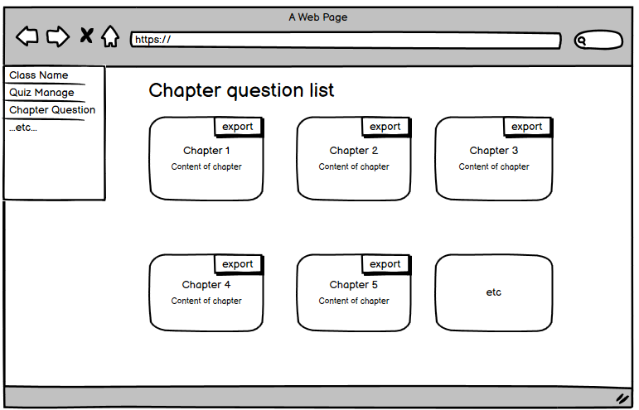

Figure 52.Export Question

- Function detail:
- Data:
  - Question Text: The text of each question.
  - Question Type: (e.g., multiple-choice, true/false, short answer).
  - Answer Options: If the question is multiple-choice, it includes the list of possible answers.
  - Correct Answer: The correct answer for each question.
  - Difficulty Level: The difficulty level of each question (Easy, Medium, Hard).
  - Subject/Topic: The subject or topic associated with each question.
- Optional: Teachers can apply filters to export only questions from certain subjects, difficulty levels, or specific quizzes.
  - Validation and Business Rules:
- In normal cases:
  - The system retrieves all question data and structures it into a well-formatted Excel file (.xlsx or .xls).
  - The generated file is immediately downloadable by the teacher.
  - The system allows exporting the full question bank or specific sets of questions based on filters (e.g., by subject, difficulty).
- In abnormal cases:
  - If there are no questions in the bank, the system will display a message like "No questions available for export."
  - In case of a server error or network issue during the export process, the system provides an error notification and allows retrying the export.

3.6 Manage Note feature
3.6.1 Create Note
- Function trigger:
  - Clicking the "+" button within a specific slot on the user interface.
- Function description:
  - Actors:Students who have access to the slot feature.
  - Purpose: Allows users to create a new note within a designated slot, providing a space for additional information, context, or reminders.
  - Interface: When a note is clicked, a dialog or modal window appears.
    - The dialog contains two input fields:
      - Note: For entering the main content of the note.
      - Description: For providing additional context or details related to the note.
    - A "Save", “Delete” or "Cancel" button is provided to confirm the note creation.
  - Data processing: When the user enters the note and description and clicks the "Save" button, the system validates the input to ensure it meets any predefined requirements (e.g., character limits, formatting). If the input is valid, the system creates a new note object, associating it with the current slot and storing the note content and description.
- Screen layout:
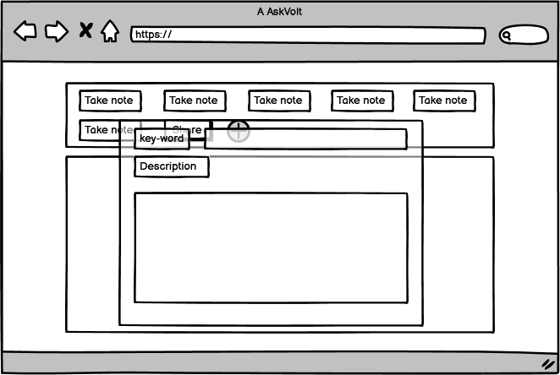

Figure 53.Forgot password

- Function detail:
  - Data Validation:
    - Note: Ensure the note input is not empty and adheres to any specific length or character restrictions.
    - Description: While optional, the description input may also have validation rules, such as maximum length or content restrictions.
  - Validation and Business Rules:
    - In Normal Cases:
      - If the note and description inputs are valid:
        - Create a new note object associated with the current slot.
        - Store the note content and description in the database or appropriate data storage.
        - Display the newly created note within the slot.
    - In Abnormal Cases:
      - If the note input is empty or invalid:
        - Display an error message indicating that the note field is required or invalid.
      - If the description input is invalid (if applicable):
        - Display an error message indicating that the description field is invalid.
      - If there are any other validation errors or unexpected issues:
        - Log the error for debugging purposes.
        - Display a generic error message indicating that the note creation failed.

3.6.2 View Note
- Function trigger:
  - Clicking on a specific slot within the user interface.
- Function description:
  - Actors: Students who have access to the slot feature.
  - Purpose: Allows users to view all notes that have been added to a particular slot.
  - Interface: When a slot is clicked, the system displays a detailed view of the slot.
    - The view includes a list of all notes associated with the slot.
    - Each note in the list should display the note name (or a truncated version if it's too long).
    - Users may be able to click on a note to view its full content and description.
  - Data processing:
    - When a user clicks on a slot, the system retrieves all notes associated with that slot from the database or data storage.
    - The retrieved notes are then displayed in the slot view, formatted in a clear and readable manner.
    - If the user clicks on a specific note, the system may display additional details or allow the user to edit or delete the note.
- Screen layout:
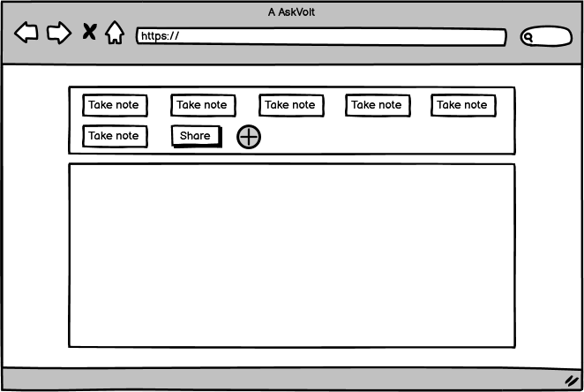

Figure 54.View Note

- Function detail:
  - Data Validation: N/A
  - Validation and Business Rules:
    - In Normal Cases:
      - If the slot is valid and notes are found:
        - Retrieve all notes associated with the slot.
        - Display the retrieved notes in the slot view, formatted in a clear and readable manner.
    - In Abnormal Cases:
      - If the slot is invalid or not associated with the current user:
        - Display an error message indicating that the slot is not accessible or does not exist.
      - If there are any errors retrieving or displaying the notes:
        - Log the error for debugging purposes.
        - Display a generic error message indicating that the slot view failed to load.
      - If no notes are found:
        - Display a message indicating that the note in the slot is empty.

3.6.3 Update Note
- Function trigger:
  - Clicking on a specific note within a slot.
- Function description:
  - Actors: Students who have access to the slot feature.
  - Purpose: Allows users to modify the content of an existing note within a slot.
  - Interface: When a note is clicked, a dialog or modal window appears.
    - The dialog pre-populates the note and description fields with the existing content of the selected note.
    - The dialog contains two input fields:
      - Note: For entering the main content of the note.
      - Description: For providing additional context or details related to the note.
    - A "Save", “Delete” or "Cancel" button is provided to confirm the changes.
  - Data processing: When the user enters the note and description and clicks the "Save" button, the system validates the input to ensure it meets any predefined requirements (e.g., character limits, formatting). If the input is valid, The updated note is then displayed within the slot, reflecting the changes made by the user.
- Screen layout:
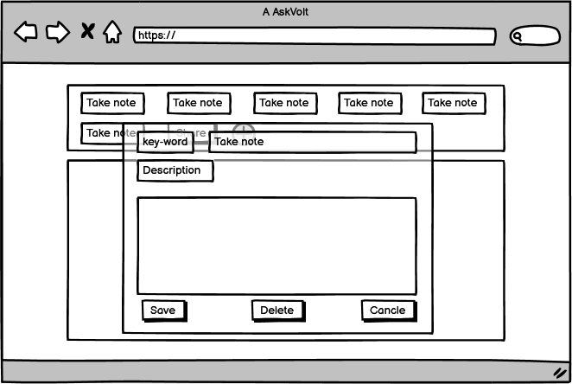

Figure 55.Update Note
- Data Validation:
  - Note: Ensure the note input is not empty and adheres to any specific length or character restrictions.
  - Description: While optional, the description input may also have validation rules, such as maximum length or content restrictions.
- Validation and Business Rules:
  - In Normal Cases:
    - If the note and description inputs are valid:
      - Update a new note object associated with the current slot.
      - Store the note content and description in the database or appropriate data storage.
      - Display the newly updated note within the slot.
  - In Abnormal Cases:
    - If the note input is empty or invalid:
      - Display an error message indicating that the note field is required or invalid.
    - If the description input is invalid (if applicable):
      - Display an error message indicating that the description field is invalid.
    - If there are any other validation errors or unexpected issues:
      - Log the error for debugging purposes.
      - Display a generic error message indicating that the note creation failed.

3.6.4 Delete Note
- Function trigger:
  - Clicking on a specific note within a slot.
- Function description:
  - Actors: Students who have access to the slot feature.
  - Purpose: Allows users to permanently delete an existing note within a slot.
  - Interface: When a note is clicked, a dialog or modal window appears.
    - After clicking the “Delete” button, the dialog displays a message asking the user to confirm if they want to delete the note.
    - A "Ok" button is provided to confirm the deletion, and a "Cancel" button is provided to return to the previous view.
  - Data processing: When the user clicks the "Delete" button, the system confirms the deletion by display model include “Ok” and “ "Cancel" button . If the confirmation is successful, the system deletes the selected note from the database or data storage. The deleted note is then removed from the slot view, indicating that it has been permanently deleted.
- Screen layout:


Figure 56 .Delete Note

- Data Validation: N/A
- Validation and Business Rules:
  - In Normal Cases:
    - If the user clicks the "OK" button:
      - The system deletes the selected note from the database or data storage.
      - The deleted note is then removed from the slot view, indicating that it has been permanently deleted.
  - In Abnormal Cases:
    - If the user clicks the "Cancel" button:
      - the user is returned to the previous view.
    - If there are any errors during the deletion process:
      - Log the error for debugging purposes.
      - Display a generic error message indicating that the note deletion failed.

3.6.4 Share Note
- Function trigger:
  - Clicking the "Share" button within a slot.
- Function description:
  - Actors: Students who have access to the slot feature.
  - Purpose: Allows users to export the notes within a slot to a downloadable file format.
  - Interface: When a note is clicked, a dialog or modal window appears.
    - When the "Share" button is clicked, a dialog or modal window appears.
    - The dialog provides options for selecting the desired file format (e.g., JSON, Excel).
    - A "Download" or "Export" button is provided to initiate the download.
  - Data processing:
    - When the user selects a file format and clicks the "Download" button, the system prepares the notes for export.
    - The notes are typically converted into the selected file format (e.g., JSON for structured data, Excel for tabular data).
    - The exported file is then made available for download.
- Screen layout:
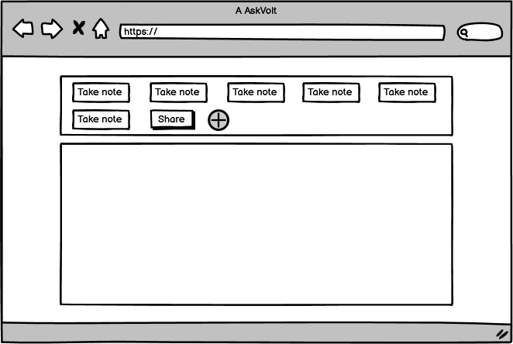

Figure 57 . Share Note
- Data Validation: N/A
- Validation and Business Rules:
  - If the notes in slot is exist:
    - If the user clicks the "OK" button:
      - Retrieve all notes associated with the slot.
      - Convert the notes into the selected file format (e.g., JSON, Excel).
      - Prepare the exported file for download.
  - In Abnormal Cases:
    - If the notes in slot is not exist:
      - Display an error message indicating that the note in the slot does not exist.

3.7 Manage Admin feature

3.7.1 View Dashboard
- Function Trigger:
  - User-initiated: The dashboard can be accessed by Admin after logging in by clicking the "Dashboard" link from the navigation bar.
  - System-initiated: After a successful login, Admin users may be automatically redirected to the dashboard as the default landing page.
- Function Description:
  - Actors/Roles: ADMIN: The Admin uses the dashboard interface to monitor system activities and manage key features.
  - Purpose: The dashboard provides Admin users with an overview of system performance, user activity, and access to administrative tools.
  - Interface: The dashboard typically displays the following sections:
    - System analytics (e.g., number of active users, system performance)
    - Administrative notifications (pending teacher approvals, reports)
    - Access to management tools (e.g., user management, content moderation)
  - Data Processing: Upon accessing the dashboard, the system retrieves relevant data from the server, displaying system-wide statistics, logs, and other administrative information.
- Screen Layout:
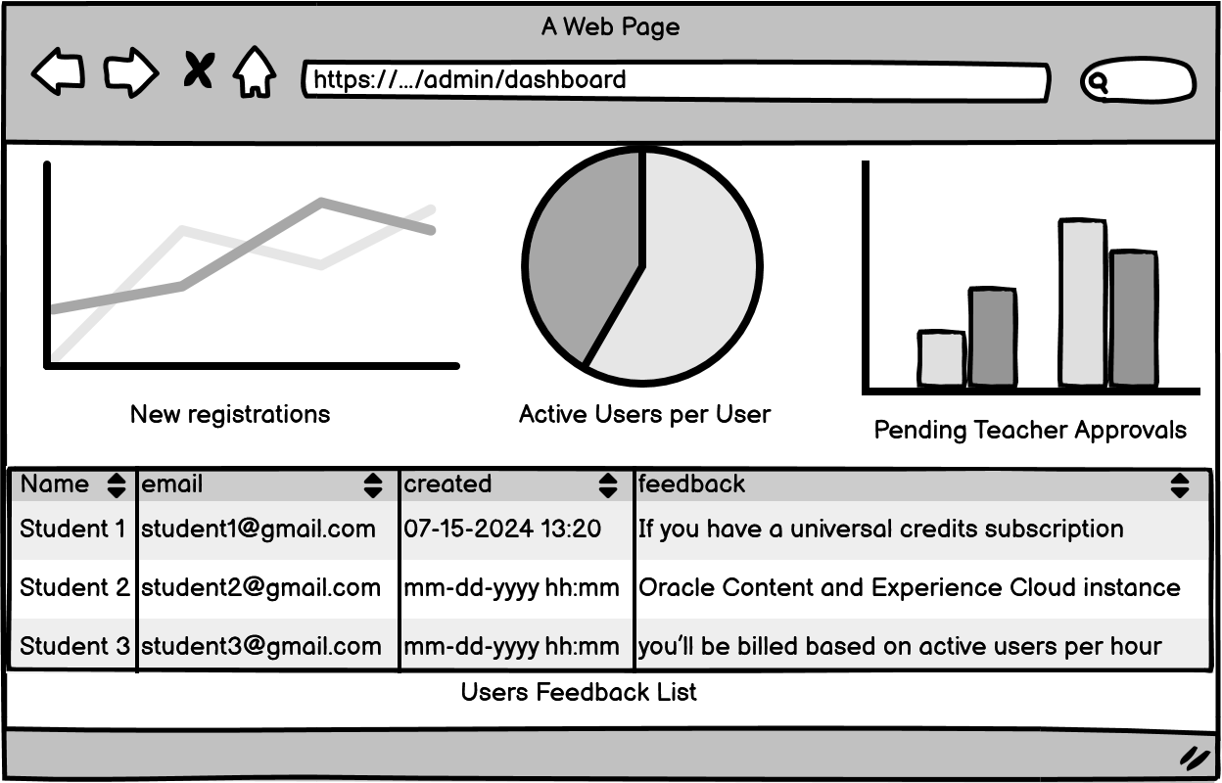

Figure 58.View Dashboard
- Function Details:
  - Data Requirements:
    - System Information: Overview of key system metrics:
      - Number of active users
    - User Management: List of recent user activities, including:
      - New registrations
      - User reports
      - Pending actions (e.g., account approvals, content flags)
    - Notifications:
      - Admin-specific notifications, such as:
      - Security alerts
      - Pending administrative actions (e.g., content moderation, user bans)
    - Quick Access Links:
      - Reports management
      - User management
      - Teacher account approvals
      - System settings
  - Validation and Business Rules:
    - Normal cases:
      - After logging in, the system retrieves and displays admin-relevant data and system performance metrics.
      - Admins can access tools for managing users and content directly from the dashboard.
    - Abnormal cases:
      - If system data cannot be retrieved, an error message will be displayed, and the Admin will be prompted to refresh the page or try again later.
      - If the admin’s session is invalid, they will be redirected to the login page.
      - In the case of server or connection issues, the system will notify the Admin and allow retries once the connection is restored.

3.7.2 Create Class/slot
Function Trigger:
- Primary Trigger: The admin clicks the "Create Class" button in the dashboard or navigation bar.
- Secondary Trigger: If the admin tries to access features related to class management (e.g., adding students, managing schedules) without any existing classes, they will be redirected to the "Create Class" page.
Function Description:
- Role: Admin
- Purpose: Enables admins to create a new class by entering basic details and importing class and slot lists. The created class can then be used to organize schedules, manage students, and allocate resources.
Interface:
The "Create Class" interface includes the following fields:
- Class Name:
Input field where the admin enters the name of the class.
- Class Description (Optional):
Input field for providing a brief description of the class.
- Class List (Upload):
File upload option to import a list of students associated with the class. Supported formats: .csv, .xlsx.
- Slot List (Upload):
File upload option to import class slots/schedule details. Supported formats: .csv, .xlsx.
Screen Layout:
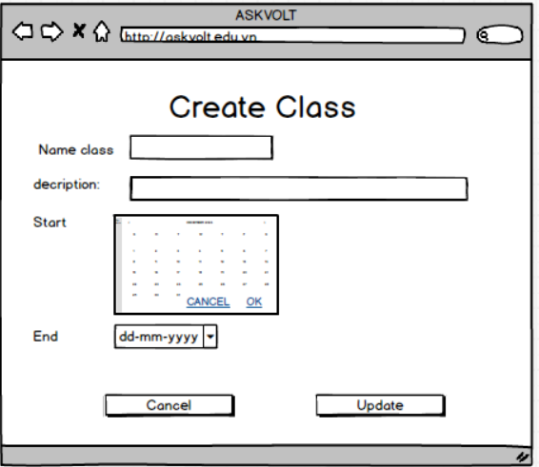

Figure 59.Create Class/slot
Function Details:
Data Validation:
- Class Name:
  - Required.
  - Must be unique (cannot duplicate an existing class name created by the same admin).
- Uploaded Files (Class List and Slot List):
  - Required.
  - File formats must be .csv or .xlsx.
  - The system checks for structural integrity (e.g., required columns like "Student Name" for Class List or "Day/Time" for Slot List).
Validation and Business Rules:
In Normal Cases:
- If all fields and files are valid:
  - The system sends a request to the server to create the class, including the uploaded lists.
  - If successful, the class is created, and the admin is redirected to the Class Management page.
  - The system generates a unique class ID for internal reference.
In Abnormal Cases:
- If Class Name is missing or not unique:
  - Display error: "Please provide a unique class name."
- If required files are missing or in an invalid format:
  - Display error: "Please upload valid files in .csv or .xlsx format."
- If the server is unresponsive or there's a connection issue:
  - Notify the admin: "There was an issue connecting to the server. Please try again later."
  - Provide the option to retry or save data locally for resubmission.

3.7.3 Update Class/slot
Function Trigger: Update Class/Slot
Primary Trigger:
The admin clicks the "Manage Classes" or "Manage Slots" button in the Dashboard or Class Management section.
Secondary Trigger:
If the admin attempts to modify a schedule, add students, or change slot details from related features, they will be redirected to the Update Class/Slot page.
Function Description:
Role: Admin
Purpose:
Enables the admin to view, update, and manage existing classes and their associated slots. This includes editing class details, modifying slot schedules, and updating the associated student list.
Interface Details:
Fields for Updating Classes:
- Class Name:
  - Editable input field to update the class name.
- Class Description:
  - Optional input field to update the class description.
- Class List (Upload):
  - File upload field to replace the current list of students.
  - Supported formats: .csv, .xlsx.
Fields for Updating Slots:
- Slot List:
  - Table view displaying the existing slots for the selected class.
  - Columns:
    - Slot ID (non-editable).
    - Day (dropdown with options for weekdays).
    - Time (editable field for time range).
    - Assigned Room (editable input field).
    - Action (buttons to Edit, Delete, or Add New Slot).
- Add Slot:
  - Button to open a modal where admins can create new slots by entering day, time, and room information.
Screen layout
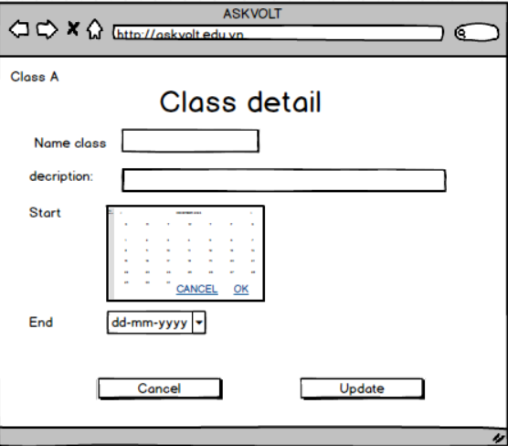

Figure 60.Update Class/Slot
Function Details:
Data Validation:
Class Updates:
- Class Name:
  - Required and must be unique.
  - Error if a duplicate name is found: "Class name already exists. Please choose a different name."
- Uploaded Files (Class List):
  - File formats must be .csv or .xlsx.
  - Check for required columns like "Student Name" and "Email".
  - Validate for duplicates or incorrect formatting.
Slot Updates:
- Day and Time:
  - Check for time conflicts with other slots in the same class.
  - Error: "Time conflict detected with another slot. Please adjust the schedule."
- Room Assignment:
  - Check for room availability at the selected time.
  - Error: "Room is already occupied during this slot. Please choose a different room."
Validation and Business Rules:
Normal Cases:
- If updates are valid:
  - The system sends a request to the server to save changes.
  - On success:
    - Display success message: "Class and slot details updated successfully."
    - Redirect to the Class Management page.
Abnormal Cases:
- Invalid Inputs:
  - Show inline errors next to the affected fields.
- Server Issues:
  - Notify admin: "There was an issue saving the updates. Please try again later."
  - Provide retry or save data locally for resubmission.

3.7.4 Delete Class/slot
Function Trigger: Delete Class/Slot
Primary Trigger:
The admin clicks the "Delete" button next to a class or slot in the Manage Classes or Manage Slots page.
Secondary Trigger:
If the admin attempts to delete a class or slot without confirmation, a warning message will appear asking for confirmation.
Function Description
Role: Admin
Purpose:
Allows admins to permanently delete classes or slots from the system. Deleted classes or slots are removed from the schedule and student lists, and this action cannot be undone.
Screen layout:
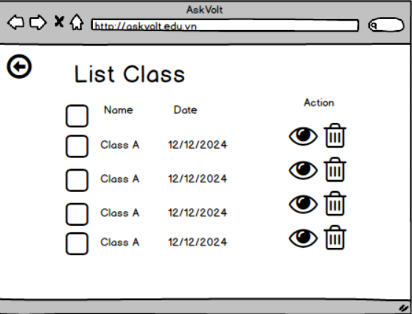

Figure 61.Delete Class/Slot

Interface Details:
Delete Class Interface:
- Class List:
  - Each class has a "Delete" button.
  - On click, a confirmation prompt appears:
"Are you sure you want to delete this class? All associated data (students, slots) will be lost."
    - Buttons: Confirm Delete, Cancel.
Delete Slot Interface:
- Slot List:
  - Each slot has a "Delete" button.
  - On click, a confirmation prompt appears:
"Are you sure you want to delete this slot? This action cannot be undone."
    - Buttons: Confirm Delete, Cancel.
Function Details:
Data Validation:
- Class Deletion:
  - Check if the class is currently active or if students are assigned to the class.
  - Display warning: "This class has students assigned. Deleting it will remove all student associations."
  - If there are no students or active schedules, proceed with deletion.
- Slot Deletion:
  - Check if the slot has any active student schedules assigned.
  - Display warning: "This slot has students scheduled. Deleting it will affect their timetable."
  - If no students are scheduled, proceed with deletion.
Validation and Business Rules:
Normal Cases:
- If deletion is confirmed:
  - Send a request to the server to delete the selected class/slot.
  - On success:
    - Display success message: "Class/Slot deleted successfully."
    - Redirect to the Class Management or Slot Management page.
Abnormal Cases:
- Server Issues:
  - Notify admin: "There was an issue deleting the class/slot. Please try again later."
  - Provide retry option.
- Delete Not Allowed:
  - If the class or slot has active assignments, display:
"Deletion cannot proceed due to active schedules or student associations."

3.7.5 Import List User
Function Trigger: Import User List
Primary Trigger:
The admin clicks the "Import User List" button in the User Management section or an equivalent feature.
Secondary Trigger:
If the admin attempts to access certain features (e.g., assigning roles or permissions) without importing a user list, they will be redirected to the Import User List interface.
Function Description:
Role: Admin
Purpose: Enables admins to import a list of users into the system by uploading files containing user data. The imported users can then be managed, assigned roles, and utilized in different administrative tasks.
Interface Details:
Fields:
- Upload User List:
  - Description: File upload field where the admin uploads a list of users.
  - Supported Formats: .csv, .xlsx.
- Default Role (Optional):
  - Description: Dropdown to select a default role (e.g., Student, Teacher, Admin) for the imported users.
  - Default Value: None (users must be manually assigned roles if this is left blank).
- Notification Settings (Optional):
  - Description: Checkbox to automatically send a welcome email or notification to imported users.
Screen Layout
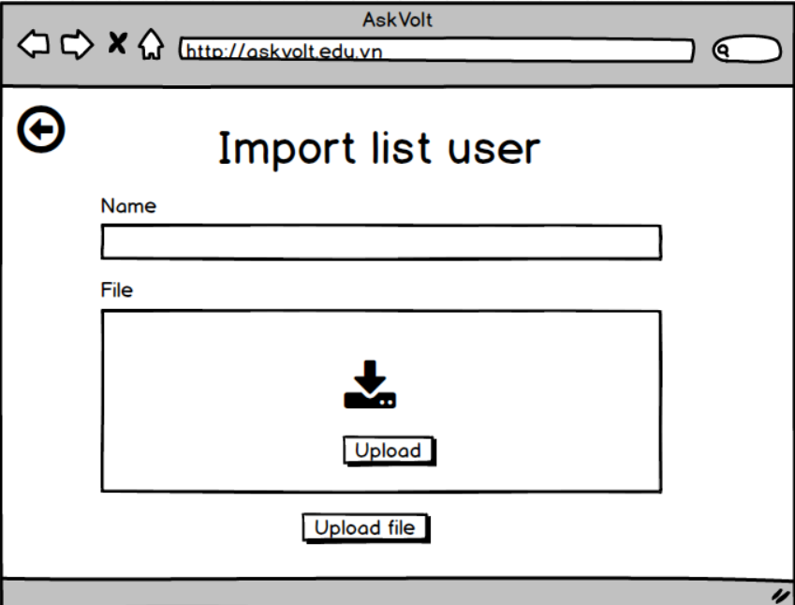

Figure 62.Import List User

Function Details:
Data Validation:
- Uploaded File:
  - Required: Yes.
  - Validation:
    - Must be in .csv or .xlsx format.
    - Check for mandatory columns (e.g., "Full Name," "Email," "Role").
    - Ensure no duplicate entries (e.g., duplicate emails).
- Default Role:
  - Optional field.
  - If selected, the role is automatically applied to all imported users.
Validation and Business Rules
Normal Cases
- If the uploaded file is valid:
  - Parse the file and validate its content.
  - Send a request to the server to import the user list.
  - If successful:
    - Display a success message: "Users have been successfully imported."
    - Redirect to the User Management page.
Abnormal Cases:
- Invalid File Format:
  - Display Error: "Please upload a valid file in .csv or .xlsx format."
- Missing Mandatory Columns:
  - Display Error: "The uploaded file is missing required columns. Please check and re-upload."
- Duplicate Entries in File:
  - Display Warning: "Duplicate entries found. Only unique entries were imported."
- Server Unresponsive or Connection Issue:
  - Notify Admin: "There was an issue connecting to the server. Please try again later."
  - Option: Retry or save data locally for later submission.

3.7.6 Update List User
Function Trigger: Update User List
Primary Trigger:
The admin clicks the "Update User List" button in the User Management section.
Secondary Trigger:
If the admin attempts to perform actions such as assigning roles or managing user permissions without updating the user list, they will be prompted to update the user list first.
Function Description:
Role: Admin
Purpose:
Allows admins to update the user list by modifying details of existing users, uploading new data, and making necessary changes to roles and assignments.
Interface Details:
Fields for Updating User List:
- User List (Upload):
  - File upload field to replace or update the existing user list.
  - Supported file formats: .csv, .xlsx.
  - Check for required columns like Name, Email, Role, and Status.
- Search and Filter Users:
  - Search bar to find specific users by name, email, or role.
  - Filters to sort users by role, status, or last updated date.
- Bulk Edit User Details:
  - Checkbox options to select multiple users for bulk updates (e.g., change role, set active/inactive status).
  - Action Button: "Apply Changes" for bulk updates.
- Role Assignment (Optional):
  - Dropdown to assign or update the role for individual users (e.g., Admin, Teacher, Student).
Screen Layout:
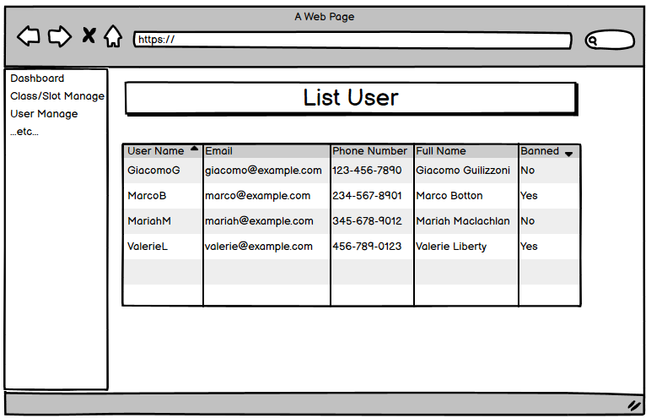

Figure 63.Update List user
Function Details:
Data Validation:
- Uploaded User List:
  - File formats must be .csv or .xlsx.
  - Check for missing or incorrect data (e.g., missing email addresses, invalid roles).
  - Ensure that there are no duplicates based on email.
  - Check for mandatory fields such as Name, Email, Role, and Status.
- User Role Updates:
  - Validate that the updated role exists in the system.
  - Ensure the admin cannot assign users to a non-existent or invalid role.
- Bulk Edit Validations:
  - Check that bulk changes (e.g., role assignments) are valid across all selected users.
  - If conflicts exist (e.g., invalid email or status), display an error message and prevent the update.
Validation and Business Rules:
Normal Cases:
- If the uploaded file is valid:
  - Parse the file and check for errors.
  - If no errors:
    - Update the system with the new user list.
    - Display success message: "User list updated successfully."
    - Redirect to User Management page.
- If individual user details are edited (name, email, role, or status):
  - Save changes and update the user database.
  - Show success message: "User details updated."

3.7.7 Delete Members Of Class
Function Trigger: Delete Members of Class
Primary Trigger:
The admin clicks the "Delete Members" button next to a class in the Class Management or Manage Students page.
Secondary Trigger:
If the admin attempts to perform actions related to student management (e.g., assigning schedules or roles) without removing students from a class, they will be prompted to delete the students from the class first.
Function Description:
Role: Admin
Purpose:
Allows admins to delete individual or multiple students from a class. This action removes the student from the class roster, and their schedule and other class-related data are updated accordingly.
Interface Details:
Fields for Deleting Members:
- Student List:
  - Display a table with students currently enrolled in the class.
  - Columns:
    - Student ID (Non-editable).
    - Student Name (Editable).
    - Email (Editable).
    - Assigned Schedule (Non-editable).
    - Action (buttons: Delete).
- Bulk Delete Option:
  - Checkbox next to each student for bulk deletion.
  - Action Button: "Delete Selected" for deleting multiple students at once.
- Search and Filter:
  - Search bar to find specific students by name, email, or status.
  - Filters to sort students by enrollment date or status (active/inactive).
- Confirmation for Deletion:
  - When the admin clicks "Delete" or "Delete Selected", a confirmation modal appears.
  - Message: "Are you sure you want to delete this student from the class? This action cannot be undone."
  - Buttons: Confirm Delete, Cancel.
Screen Layout: 

Figure 64.Delete Member

Manage Class Members Page:
- Page Title: "Delete Members from [Class Name]"
- Student List Table:
  - Columns:
    - Student ID
    - Name
    - Email
    - Assigned Schedule
    - Action (buttons: Delete).
- Buttons:
  - Delete Selected (button to delete selected students in bulk).
  - Cancel (button to discard changes and return to the Class Management page).
Function Details:
Data Validation:
- Student Deletion:
  - When a student is deleted, their association with the class and assigned schedules is removed.
  - Ensure that the student is removed from all future class slots.
- Bulk Delete Validation:
  - Check for selected students before performing bulk deletion.
  - If no students are selected, display an error message: "Please select at least one student to delete."
Validation and Business Rules:
Normal Cases:
- If the student(s) to be deleted are valid and the admin confirms deletion:
  - Remove the student(s) from the class and update the system.
  - Show success message: "Student(s) deleted successfully from the class."
  - Redirect to the Class Management page.
Abnormal Cases:
- Server Issues:
  - Notify the admin: "There was an issue deleting the student(s). Please try again later."
  - Option to retry or save data locally for resubmission.
- Delete Not Allowed:
  - If a student has important class data or is assigned to multiple schedules, display the error:
"This student cannot be deleted because they have active schedules. Please remove the student from their schedules first."

3.7.8 View List Users
- Function Trigger:
  - User-initiated: Admin can access the "List Users" page by selecting the "User Management" option from the navigation bar or the dashboard.
  - System-initiated: In certain cases, such as when there are flagged or pending user-related actions, the system may redirect the admin to the user list after login.
- Function Description:
  - Actors/Roles: ADMIN: This function is used by Admins to view, manage, and take actions on the registered users in the system.
  - Purpose: Allows Admin to view the list of all users and manage their accounts through various administrative actions.
  - Interface:
    - The page displays a list of users, showing details such as:
      - User ID
      - Full name or username
      - Email address
      - Registration date
      - Account status (e.g., Active, Suspended)
      - User role (Student, Teacher)
  - Data Processing: When the page is accessed, the system retrieves user data from the server, presenting it in a searchable, sortable, and filterable table format.
Screen Layout:


Figure 65.View List Users

- Function Details:
  - Data Requirements:
    - User Information
    - Actions: Admins can perform the following actions on each user:
      - View user details: Display a detailed view of the user's account and history.
      - Edit user: Modify user roles, statuses, or other account settings.
      - Delete/Ban/Activate user: Temporarily suspend or reactivate user accounts.
- Validation and Business Rules:
  - Normal cases:
    - The system successfully retrieves and displays all user data in a paginated format.
    - The Admin can search for users by name, email, or ID, and filter by role (e.g., Student, Teacher) or account status.
    - Any administrative actions taken, such as suspensions or deletions, will be processed immediately and reflected in the UI.
  - Abnormal cases:
    - If the system fails to retrieve user data, an error message will be displayed with an option to retry.
    - If a session expires or is invalid, the admin will be redirected to the login page.
    - In the case of a failed action (e.g., trying to suspend an already suspended account), the system will notify the Admin and provide an appropriate error message.

3.7.8 View List Reports
- Function Trigger:
  - User-initiated: The Admin can access the "List Reports" page by selecting the "System Reports" option.
  - System-initiated: If users report urgent system issues, the system may prompt the Admin to review the list of reports after login.
- Function Description:
  - Actors/Roles: ADMIN: The admin uses this function to view system-related reports submitted by users, such as bugs, performance issues, or feature requests.
  - Purpose: Allows the Admin to manage and review system-related reports, helping to identify and resolve technical issues or system malfunctions.
  - Interface:
    - The Reports list displays relevant information about each system-related report:
      - Report ID
      - Reporting user (who submitted the report)
      - Report category (e.g., Bug report, Performance issue, Feature request)
      - Date of the report submission
      - Report status (e.g., Pending, Reviewed, Resolved)
  - Data Processing: The system retrieves all system-related reports from the server and presents them in a searchable, filterable, and sortable table format.
- Screen Layout: 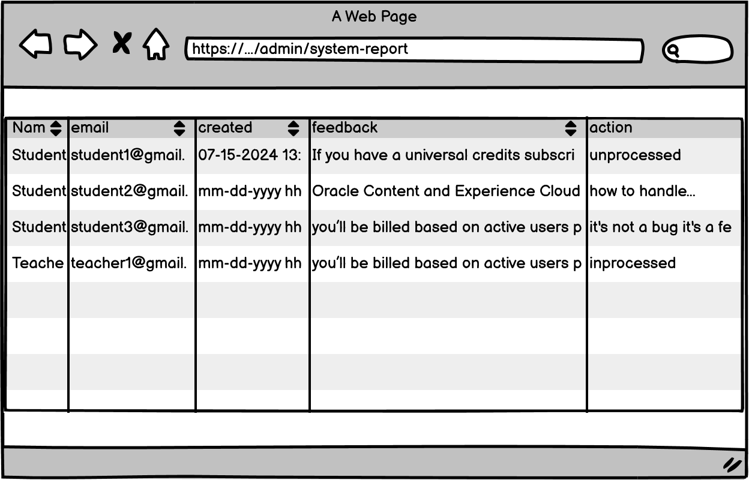

Figure 66.View List Reports

- Function Details:
  - Data Requirements:
    - Report Information:
      - Report ID
      - Reporting user (Full name or username of the user who submitted the report)
      - Report category (e.g., Bug report, Performance issue, Feature request)
      - Date of the report submission
      - Report description (if provided)
      - Current report status (Pending, Reviewed, Resolved)
  - Actions:
    - View report details: Access a more detailed view of the system issue or suggestion reported, including any steps to reproduce or additional comments.
    - Mark as reviewed: Change the report status from "Pending" to "Reviewed" once the issue or suggestion has been examined.
    - Resolve report: Mark the report as resolved after the issue has been addressed or the feature request has been acknowledged.
  - Validation and Business Rules:
    - Normal cases:
      - The system retrieves and displays all system-related reports in a paginated list.
      - The Admin can filter reports by status (Pending, Reviewed, Resolved) or by category (e.g., Bug report, Feature request).
      - When a report is marked as "Reviewed" or "Resolved," the system updates the server and reflects the change in the user interface in real time.
    - Abnormal cases:
      - If the system fails to retrieve reports, it will display an error message with an option to retry.
      - If there is a server issue preventing actions (e.g., marking a report as resolved), the system will notify the admin and allow them to try again later.
      - In case of a session timeout, the admin will be redirected to the login page.

3.7.9 Manage List Members Of Class
- Function trigger:
  - Primary Trigger: The admin clicks the "View Members" button in the class management page.
- Function
  - A list showing:
    - Student Name
    - Email description
    - Status
    - Delete Student
  - Role : Admin
  - Purpose: Displays a list of all members (students) enrolled in the class.
- Screen layout:
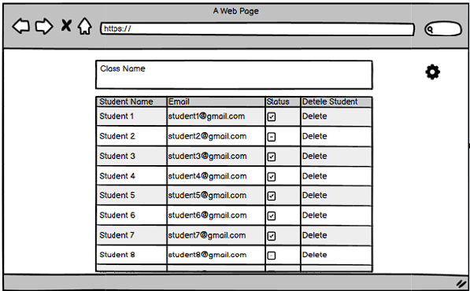

Figure 67.Manage list Member of class

- Function detail:
  - Data Validation:
    - Student name: Required, must be a string (only letters and spaces are allowed).
    - Email: Required, must be a valid email format (with '@' and a valid domain).
  - Validation and Business Rules:
    - In Normal Cases:
      - The system retrieves and displays the member list.
    - In Abnormal Cases:
      - If the list fails to load, an error message will appear saying "Unable to retrieve members list."

4. Non-Functional Requirements

4.1. External Interfaces

4.1.1 User Interface
- UI-01: When users complete any actions such as save, delete, create, etc… the system has to display a Success toast Message when completing an action.
- UI-02: Whenever a user wants to delete something, a popup Message will display and confirm (Yes/Cancel).
- UI-03: All pages in the user system must have a Header menu or a Navigation menu.

4.1.2 Software Interface
- SI-01: Users can use Google services to log in, which will help them authenticate their account.
- SI-02: The API should perform efficiently, handling requests quickly and without excessive resource consumption.
- SI-03: The API must include jwt in the header when accessing private or secure resources.
- SI-04: The API for each server must be independent and have little dependence on each other
- SI-05: The API should have a clear versioning strategy to manage changes and maintain compatibility with existing applications.

4.1.3 Hardware Interface
- HI-01: When connecting to the server, must connect using ssh-key, and do not use ip and password to increase security.
- HI-02: The server can increase the amount of RAM when it has to process many requests.

4.2. Quality Attributes

4.2.1 Availability
- The AskVolt system is operational and accessible to users accounting for 95%.
- The average time it takes to repair a system failure is a day.
- A strategy to recover from a major system failure or disaster.

4.2.2 Usability
- The system should be simple and easy for users to learn and operate, even if it is the first person taking part in the AskVolt system.
- Users should be able to remember how to use the system after a long time period.
- As new features become available, users can quickly adapt to working with the AskVolt system.

4.2.3 Reliability
- To avoid causing difficulties in access, the server must be available 28 days a month.
- User's personal information will be kept confidential and will not be accessed by others.

4.2.4 Performance
- The system response time to user input is 2 seconds at most.
- To ensure real-time communication, chat in groups with a time of <1 second.
- When user uploads of large files (<=25 MB) should be complete processing after 3s.
- System data must be backed up every 2 weeks.

4.2.5 Security
- Avoiding SQL injection, all data has to be added by a function that programming has instead of appending in string.
- The platform should implement appropriate security measures to protect user identities and ensure anonymous chatting remains confidential
- The web platform needs to ensure that it implements Argon2 for protecting the user's password.

4.2.6 Maintainability and Extensibility
- The project's documentation should be stored in a concise and organised manner so that it can be easily retrieved when needed.
- Coding ensures the solidity of the application for easy maintenance, modification and extension.

5. Requirement Appendix

5.1 Business Rules
# | Rule Definition
BR-01 | The email password reset link will expire after 20 minutes.
BR-02 | Password regulations: at least 8 characters, must include at least 1 uppercase letter, 1 lowercase letter, 1 number and 1 special character.
BR-03 | Only one account can be created per email account.
BR-04 | Passwords stored in the database must be hashed by the Agon2 algorithm.
BR-05 | Users cannot edit their username and email.
BR-06 | All deleting actions must have a confirmation popup before deleting.
BR-07 | The AskVolt Platform must maintain the privacy and security of user data and not use it for any other purpose.
BR-08 | The AskVolt Platform must have a user-friendly interface, allowing users to easily search and join classes.
BR-09 | The AskVolt Platform must support different types of multiple materials including images, PDF , and etc,...
BR-11 | Only the users engaging in classes can join group chat.
BR-12 | Teachers can create the enrollment key for class to limit users engaging in.
BR-13 | The AskVolt server system needs to be operational for 95% of a month and should be able to fix any problems that cause downtime within 6 hours on average.
BR-14 | All update actions must have a confirmation popup before updating.
BR-15 | In the AskVolt system, each slot is capable of accepting and processing file uploads of up to 25 MB in size.
BR-16 | The system supports files with extensions such as.png, img , .svg , pttx, ptt , xls, xlss, pdf,doc, docx,...etc
BR-17 | Files imported into the system must follow the format provided by the system.

Table 7. Business Rule

5.2 Common Requirements
# | Requirement | Description
1 | Functionality | Our platform integrates Edunext and FAP features, enabling students to join classes, collaborate, and take quizzes. Teachers can manage lessons and resources, while students access group chats, materials, and collaborative notes. Advanced review tools enhance the learning experience.
2 | Security | The web platform needs to ensure the security of all user information.
3 | Performance | The platform needs to optimize page load times and handle real-time responses without delays, ensuring fast responses without interruption.
4 | Scalability | Using microservices, the AskVolt web application can easily scale each service independently and handle large traffic volumes.
5 | Compatibility | The website supports compatibility with all user browsers.
6 | Maintainability | The system can be easily maintained, debugged, and upgraded during operation.
7 | Quality | The platform must undergo rigorous functional, load, and security testing, ensuring it meets high performance, usability, and stability standards.
8 | Usability | User-friendly interface, easy to use,  The web platform must also be compatible with mobile and tablet devices so that users can access the platform more easily.
9 | Availability | The web platform will operate stably and without problems so that users can access classes continuously.

Table 8. Common Requirements

5.3 Application Messages List
# | Message code | Message Type | Context | Content
01 | MSG01 | Inline message | There is no search result on search items | There are currently no {item’s name}.
02 | MSG02 | Inline message | Input-requirement fields are empty | {field's name} is required.
03 | MSG03 | Inline message | Input in the password field does not meet the requirement | Please enter a password that contains at least 8 characters, must include at least 1 uppercase letter, 1 lowercase letter, 1 number and 1 special character.
04 | MSG04 | Inline message | The user successfully update their password. | Update Password Successfully
05 | MSG05 | Inline message | The user successfully updates their personal information. | Update Profile Successfully
06 | MSG06 | Inline message | The user fail updates their personal information. | Update user profile because some fiel wrongs or other reasons
7 | MSG7 | Popup message | The admin wants to remove the user from the class | Are you sure you want to remove this person from the class?
8 | MSG8 | Popup message | The user exits without saving | Changes will not be saved.
9 | MSG9 | Inline message | AskVolt has no topics in the Class Management Page | There are no classes yet.
10 | MSG10 | Inline message | The user does not have any notifications | You don't have any new announcements yet.
11 | MSG11 | Inline message | Askvolt system does not have any user to show analyst data | There are currently no users.
12 | MSG12 | Toast message | The admin creates a Class successfully. | Create Class Successfully
13 | MSG13 | Toast message | The admin creates a class fail. | Create Class Fail
14 | MSG14 | Toast message | The adminr update a Class successfully. | Update Class Successfully
15 | MSG15 | Toast message | The admin Update s a class fail. | Update Class Fail
16 | MSG16 | Toast message | The admin Delete a class fail. | Delete class fail
17 | MSG17 | Toast message | The admin delete a class successfully | Delete class Successfully
18 | MSG18 | Toast message | Theadmin creates a slot successfully | Create slot successfully
19 | MSG19 | Toast message | The admin creates a slot fail | Create slot fail
20 | MSG20 | Toast message | The admin updates a slot successfully | Update slot successfully
21 | MSG21 | Toast message | The admin updates a slot fail | Update slot fail
22 | MSG22 | Toast message | The admin delete a slot successfully | Delete slot successfully
23 | MSG23 | Toast message | The admin delete a slot fail. | Delete slot fail
24 | MSG24 | Toast message | The teacher upload material successfully | Upload material successfully
25 | MSG25 | Toast message | The teacher upload material fail | Upload material fail
26 | MSG26 | Toast message | User send report successfully | Send report successfully
27 | MSG27 | Toast message | User send report fail | Send report fail
28 | MSG28 | Toast message | The teacher creates quiz successfully | Create quiz successfully
29 | MSG29 | Toast message | The teacher creates quiz fail | Create quiz fail
30 | MSG30 | Toast message | The teacher updates a slot successfully | Update slot successfully
31 | MSG31 | Toast message | The teacher updates quiz fail | Update quiz fail
32 | MSG32 | Toast message | The teacher delete quiz successfully | Delete quiz successfully
33 | MSG33 | Toast message | The teacher delete quiz fail. | Delete quiz fail
34 | MSG34 | Toast message | The teacher creates question bank successfully | Create question bank successfully
35 | MSG35 | Toast message | The teacher creates question bank fail | Create question bank fail
36 | MSG36 | Toast message | The teacher updates question bank successfully | Update question bank successfully
37 | MSG37 | Toast message | The teacher updates question bank fail | Update question bank fail
38 | MSG38 | Toast message | The teacher delete question bank successfully | Delete question bank successfully
39 | MSG39 | Toast message | The teacher delete question bank fail. | Delete question bank fail
40 | MSG40 | Toast message | The teacher export question bank successfully | Export question bank successfully
41 | MSG41 | Toast message | The teacher export question bank fail | Export question bank fail
42 | MSG42 | Inline message | The user successfully deletes the comment. | Delete comment successfully!
43 | MSG43 | Inline message | The user successfully update the comment. | Edit comment successfully!
44 | MSG44 | Toast message | The user add new event fail for invalid filed in calender | Add event fail
45 | MSG45 | Toast message | The user add new event successfully in calender | Add event successfully
46 | MSG46 | Toast message | The user update event fail for invalid filed in calender | Update event fail
47 | MSG47 | Toast message | The user update event successfully in calender | Update event successfully

Table 9. Application Message List

