9/25/2025
Team 7
University of windsor
ProjexGPT
Initial Setup Report

Table of Contents
1. Project Details 2
1.1 Challenge Description 2
1.2 User Journey 2
1.3 Q&A Prototype (Mock-up) 4
1.4 Solution Approach – Architecture & Design 4
A. User Interface Layer 5
B. Application Layer 5
C. Functional Modules 5
D. Data Storage Layer 5
E. API Integration 5
F. Review & Feedback 6
Trade-offs Considered 6
Alignment with Business Requirements 6
1.5 Solution Approach – Implementation Strategy 7
1.5.2 Project Timeline 7
1.5.3 Project Timeline (Gantt Chart) 7
1.6 Technologies Chosen & Justification 8
2. Team Details 8
2.1 Team Name 8
2.2 Member Details 8
2.3 Contribution Plan 10
2.4 Role Responsibilities 10
3. Team Agreements 10
4. Kickoff Meeting Summary 10
5. Sprint 1 Plan 12
5.1 User Stories for Sprint 1 12
5.2 Task Breakdown (Week 1 Sprint) 12
6. Other Details 12
6.1 Risks & Assumptions: 12

1. Project Details

1.1 Challenge Description
The construction industry generates extensive volumes of information distributed across multiple platforms such as Procore, Autodesk Docs, Dropbox, and email systems. This fragmentation often results in project managers and coordinators spending significant time locating documents, preparing RFIs and submittals, and cross-checking specifications. The lack of centralized access to critical information contributes to miscommunication, rework, schedule delays, and increased project costs.
To address these challenges, our team is developing a centralized knowledge system designed specifically for construction projects. This solution will consolidate information from diverse sources, enabling users to query project data in natural language and receive precise, context-based answers supported by references to the original documents. Furthermore, the system will facilitate the drafting of RFIs and submittals and provide automated detection of discrepancies across drawings, specifications, and related materials. By reducing time spent on repetitive tasks and minimizing errors, the solution aims to improve efficiency, support timely decision-making, and enhance overall project delivery.

1.2 User Journey
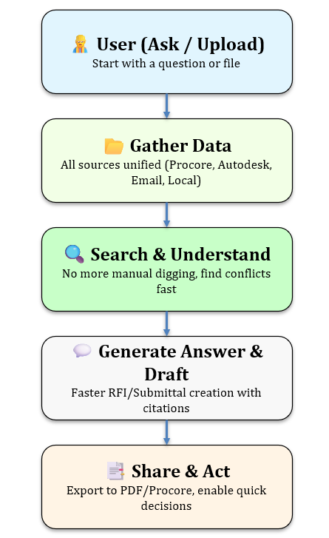
The user journey highlights how project stakeholders interact with the Construction Knowledge Engine to access and act on information efficiently.
- User (Ask/Upload): Project managers, coordinators, or engineers begin by either asking a natural-language question or uploading project files. This provides the entry point for engaging with the system.
- Gather Data: The system consolidates information from multiple sources, including Procore, Autodesk Docs, email, and local file uploads. By unifying fragmented data into a single workspace, users avoid switching between platforms.
- Search & Understand: Once the data is collected, the system quickly searches across documents and identifies relevant sections or potential conflicts. This eliminates the time-consuming task of manually digging through drawings and specifications.
- Generate Answer & Draft: Users receive clear, contextual answers that are supported by citations to the source documents. At the same time, the system can generate RFI or submittal drafts automatically, reducing the effort required for documentation.
- Share & Act: The final step enables users to export responses or drafts into formats such as PDF or directly into Procore. This allows teams to act promptly on accurate information, reducing delays and supporting faster, better-informed project decisions.
This journey illustrates the end-to-end flow from question to action, demonstrating how the solution reduces wasted time, prevents miscommunication, and ensures decisions are supported by verifiable project data.

1.3 Q&A Prototype (Mock-up)
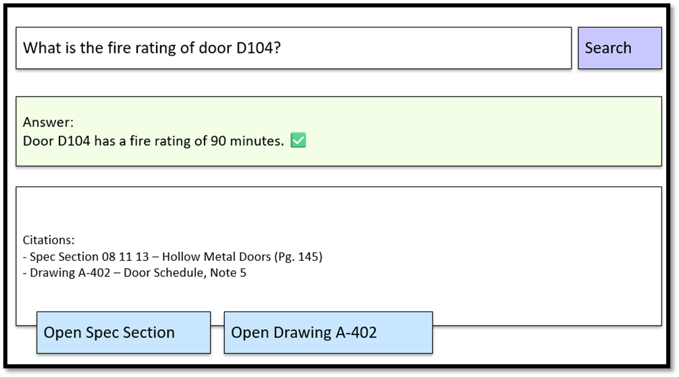

1.4 Solution Approach – Architecture & Design
Solution Architecture Diagram
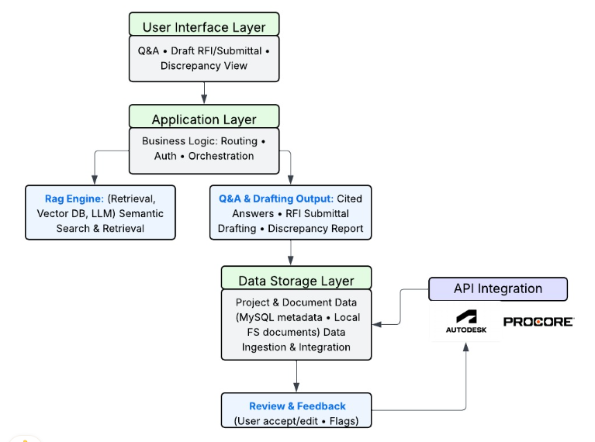
ProjexGPT is a “construction brain” that unifies project knowledge across Procore and Autodesk Docs to:
- answer questions with citations,
- draft RFIs/submittals with spec references, and
- surface discrepancies across documents.
The architecture follows a layered design for clarity, testability, and incremental delivery.

A. User Interface Layer
- Web app for three core views: Q&A, RFI/Submittal drafting, Discrepancy review.
- Shows cited passages, side-by-side comparisons, and export actions (PDF/Docx).
- Captures review & feedback (accept/edit/flag) and sends it to the app layer.

B. Application Layer
- FastAPI service that handles routing, authentication/authorization, and orchestration.
- Exposes REST endpoints for ingestion, search, answer, draft, discrepancy, export.
- Applies policies (rate limits, retries), validates payloads, and logs events.
- Coordinates calls to the RAG Engine, Drafting/Discrepancy modules, and persistence.

C. Functional Modules
- RAG Engine: ingestion + retrieval + generation.
  - Embedding and indexing of chunks into a Vector DB (e.g., Pinecone/FAISS).
  - Retrieval (top-k, re-ranking) + prompt assembly with guardrails.
- Q&A & Drafting Output:
  - Q&A returns cited answers (doc ID, page/section).
  - RFI/Submittal draft builder inserts spec citations, attachments list, and action items.
  - Discrepancy report compares values across specs/drawings/submittals and formats a reviewable diff.

D. Data Storage Layer
- Document registry & metadata (MySQL): project, file URI, version, source system, chunk map, checksum.
- File storage: local FS/S3 for original files and OCR text.
- Vector store: embeddings index for semantic search.
- Supports versioning, re-ingestion, and traceable citations.

E. API Integration
- Connectors to Autodesk Docs and Procore for documents, RFIs, submittals.
- Pulls files and metadata, handles pagination and rate limits.
- Normalizes into the document registry for consistent downstream use.

F. Review & Feedback
- User edits/accept/flags persisted.
- Signals feed evaluation dashboards and can be used to re-rank content or blacklist noisy sources.

Trade-offs Considered
- LLM Choice: OpenAI was selected for its strong semantic capabilities and easy integration with retrieval pipelines. Alternatives like Llama 2 were explored but deprioritized due to added complexity in deployment and fine-tuning requirements.
- Deployment Strategy: A Dockerized cloud deployment was chosen over local hosting. While this introduces initial complexity, it supports scalability, consistent environments, and easier collaboration across teams.
- Storage Approach: Centralizing documents in Blob Storage with metadata indexing was chosen instead of relying only on external APIs, trading higher upfront ingestion costs for faster and more reliable retrieval.

Alignment with Business Requirements
This architecture directly supports the business goal of reducing time wasted searching for project data and drafting documents:
- Q&A Service allows instant, cited answers across disconnected project documents.
- RFI/Submittal Drafting automates the preparation of key deliverables, reducing manual effort.
- Retriever + Vector Store ensure semantic search works effectively across structured and unstructured data.
- Admin/Sync with Procore and Autodesk Docs guarantees alignment with existing industry tools, preventing workflow disruption.

1.5 Solution Approach – Implementation Strategy
1.5.1 Project Milestones
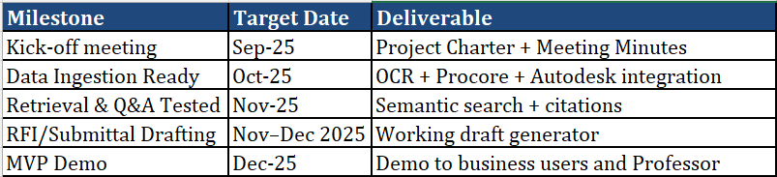

1.5.2 Project Timeline
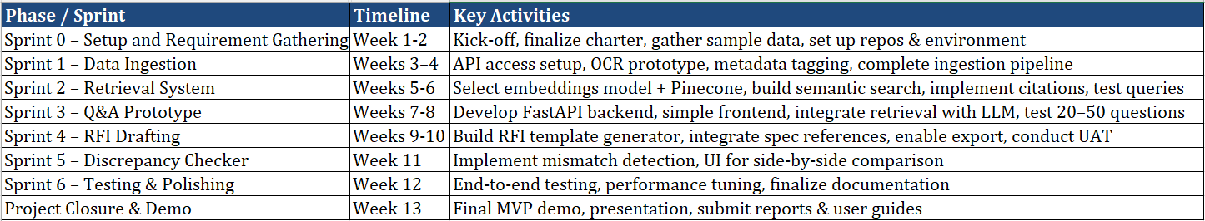

1.5.3 Project Timeline (Gantt Chart)
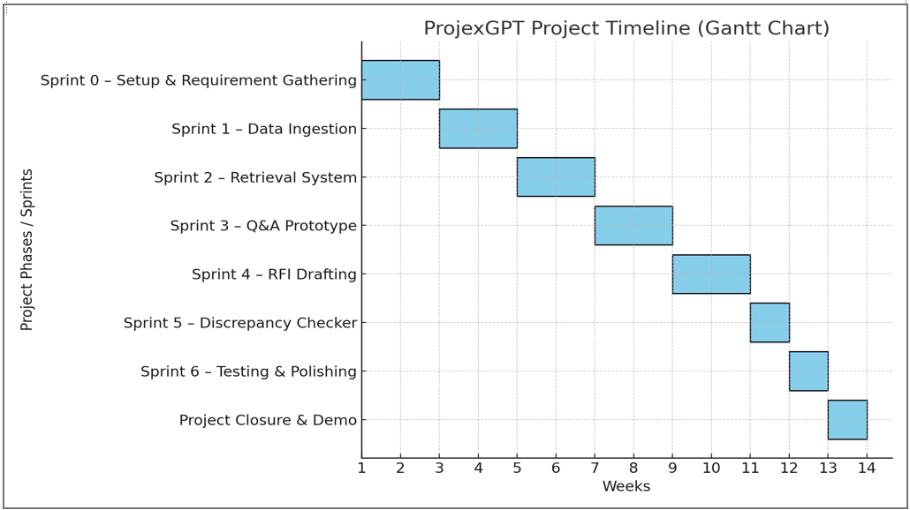
Deliverables: working prototype, user documentation, final presentation.

1.6 Technologies Chosen & Justification
Backend: FastAPI (Python), Celery/RQ for background jobs.
LLM & Embeddings: Provider API; LangChain/LlamaIndex for RAG glue.
Vector DB: Pinecone or FAISS (dev).
Storage: MySQL (metadata), S3/local FS (files).
Front-end: React/Vue single-page app.
Infra: Docker/Docker Compose; simple CI; cloud host (Railway/Render/AWS).
We selected FastAPI with Python for its lightweight, and LangChain/Pinecone for scalable RAG and semantic search. MySQL and S3 provide reliable storage of metadata and documents, while React ensures an intuitive UI. Docker-based deployment enables portability and quick MVP delivery on cloud platforms.

2. Team Details

2.1 Team Name
ProjexGPT

2.2 Member Details
No. | Name | Student Id | Bio & Strengths | GitHub | Roles
1 | Zin Mar Htwe | 110173043 | 13+ years in software engineering and IT project management with strong Agile/Scrum leadership. Skilled in Java, .NET, SQL and Python, with expertise in project planning, backlog management, and stakeholder communication. Certified PMI-PMP, PMI-ACP, ITIL, Scrum Master(CSM), and Product Owner(CSPO). | zin-mar-htwe | Lead
2 | Neela Priya Das | 101190678 | 7+ years in software quality assurance, test management, and Agile/Scrum leadership. Skilled in SQL, Power BI, Excel, and Python for data analysis, with proficiency in Jira, Confluence, and Visio. Certified Scrum Master (CSM) and Product Owner (CSPO) with strong analytical, documentation, and collaboration skills across QA, data analysis, and business/product management. | Neelapriya | Business/ Data Analyst
3 | JUNLIN CHEN | 110160084 | I hold a Bachelor’s degree in Software Engineering and have hands-on experience in software development through academic projects and internships. My technical strengths include Java, Python, and C++ for application development, web technologies (spring boot, Django ), cloud computing and Linux-based system programming. I also have applied knowledge of machine learning (CV). | jerrymaster-lab | AI/ML Engineer
4 | Yunfei Tang | 110189266 | I have a Bachelor’s degree in Computer Science and Technology and more than 2 years of hands-on experience in software development. I am skilled in Java, C++, Python, Scala, and SQL, with practical experience in application and web development, and Linux-based system programming. I have participated in projects such as e-commerce platform development(AJAX, Spring, Apache Tomcat) and big data analytics（Pandas, NumPy, PyEcharts）, gaining strong expertise in software development processes and collaborative project delivery. | Fynn317 | Data Engineer
5 | Tengfei Zhu | 110186840 | short bio: I hold a Bachelor’s degree in Computer Science and have 10 years of professional experience in software development. My technical strengths include Java web development and Linux-based system programming, with additional knowledge of Docker and Kubernetes. | Prepper88 | Backend Developer
6 | Ziji Liu | 110177949 | I hold a Bachelor’s degree in Computer Science and have hands-on experience in software development through academic projects and internships. My technical strengths include Java, Python, and C++ for application development, Java web technologies (Servlet, JSP, AJAX, Vue.js), and Linux-based system programming with socket communication. I also have applied knowledge of machine learning (CNN, LSTM) and database-driven applications. | ZIjiliu353 | Frontend/UX Developer

2.3 Contribution Plan
Zin Mar Htwe – Lead: 16.7%
Neela Priya Das – Business/Data Analyst: 16.7%
Junlin Chen – AI/ML Engineer: 16.7%
Yunfei Tang – Data Engineer: 16.7%
Tengfei Zhu – Backend Developer: 16.7%
Ziji Liu – Frontend/UX Developer: 16.7%

2.4 Role Responsibilities
- Zin: Manage project plan, timeline, weekly sprint (planning, standups, demo), team collaboration, stakeholders’ communication, architecture coordination, risk log
- Neela: Requirements, user stories & acceptance criteria, KPIs, benchmark Q&A set, analyzing data, test scenarios, stakeholder notes.
- Junlin: Embeddings, RAG orchestration, prompt/grounding, citation reliability checks, eval scripts.
- Yunfei: Ingestion (APIs, OCR), metadata/tagging, chunking, data quality & logging, storage schemas.
- Tengfei: FastAPI services, auth, integration wrappers (Procore/Autodesk), DB models, CI/CD.
- Ziji: Ask/Answer UI with citations, RFI draft form, discrepancy viewer, accessibility/UX tests.

3. Team Agreements
Primary Contact: Zin Mar Htwe (Team Lead)
Communication Tool: MS Teams (GA included)
Project Management Tool: uTrack, Excel
Contingency Planning:
* If a member drops: redistribute tasks, notify GA.
* If deadlines missed: escalate to lead → GA → instructor

4. Kickoff Meeting Summary
Meeting date: 11th September
Business Contact: Parm Shokar
Email: shokarsp@gmail.com
WEtech Alliance

Q&A (Our Questions):
- Q: Who are the stakeholders for this project?
A: The key stakeholders are project managers, coordinators, engineers, and admin staff who interact with Procore, Autodesk Docs, and other project data sources.
- Q: How do you discriminate between errors, and which data sources are followed to identify them?
A: Errors and discrepancies are identified by comparing specifications, drawings, RFIs, and submittals. The system should cross-check metadata (tags, versions) and file contents to highlight mismatches.
- Q: Will you provide us with the necessary data for building and testing the solution?
A: Yes, sample project documents and data (from Procore/Autodesk or shared files) will be provided for testing and benchmarking.
Q&A (Other Teams’ Questions):
- Q: Since we don’t have much idea about the construction domain, could you explain it a little?
A: Only a basic domain understanding is expected. The main focus is on handling documents and building the solution; the construction-specific knowledge will come from the provided data and stakeholder input.
- Q: Do we need to specifically use AI or something advanced?
A: Yes, the client expects us to build something like ChatGPT that can answer questions from project data, but tailored to construction documents with citations and drafting support.
Reflection:
- Initially, we understood the project as a simple Q&A tool for construction documents.
- After the meeting, we learned the client expects something like ChatGPT, with natural Q&A, citations, and drafting capabilities.
- We realized that deep construction expertise is not required; instead, the focus is on handling construction-specific documents (drawings, specs, RFIs, submittals).
- The importance of integration with Procore and Autodesk Docs became clearer.
- Our perspective shifted from building a basic prototype to designing an AI-driven assistant tailored for construction workflows.

5. Sprint 1 Plan

5.1 User Stories for Sprint 1
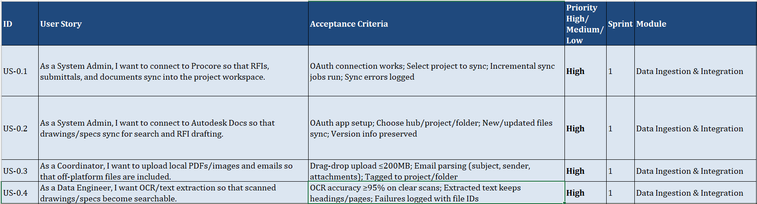
Please find the attached file here for the full user stories backlog.

5.2 Task Breakdown (Week 1 Sprint)
- Set up GitHub repo with CI/CD
- Configure FastAPI skeleton
- Connect Procore/Autodesk test APIs
- Draft initial DB schema (mySQL)
- Implement basic OCR pipeline (Tesseract)
- Create GitHub board and assign tasks

6. Other Details
6.1 Risks & Assumptions:
* Risk: Limited API access from business partner
* Risk: OCR may struggle with low-quality scans
* Assumption: Partner provides test data
6.2 Ethical Considerations:
* Ensure privacy of uploaded documents
* Restrict AI outputs to grounded content
* Secure storage and controlled access

