Session 2025-2026

Vision: To harness the power of artificial intelligence and data science to solve real-world problems and enhance human potential. | Mission: To acquire skills through coursework, projects, and internships, while actively engaging in research and collaboration with peers to innovate and apply AI solutions.

Program Educational Objectives of the program (PEO): (broad statements that describe the professional and career accomplishments)
PEO1 | Preparation | P: Preparation | Pep-CL abbreviation  pronounce as Pep-si-lL easy to recall
PEO2 | Core Competence | E: Environment (Learning Environment) | Pep-CL abbreviation  pronounce as Pep-si-lL easy to recall
PEO3 | Breadth | P: Professionalism | Pep-CL abbreviation  pronounce as Pep-si-lL easy to recall
PEO4 | Professionalism | C: Core Competence | Pep-CL abbreviation  pronounce as Pep-si-lL easy to recall
PEO5 | Learning Environment | L: Breadth (Learning in diverse areas) | Pep-CL abbreviation  pronounce as Pep-si-lL easy to recall

Program Outcomes (PO): (statements that describe what a student should be able to do and know by the end of a program)
Keywords of POs:
Engineering knowledge, Problem analysis, Design/development of solutions, Conduct Investigations of Complex Problems, Engineering Tool Usage, The Engineer and The World, Ethics, Individual and Collaborative Team work, Communication, Project Management and Finance, Life-Long Learning

PSO Keywords: Cutting edge technologies, Research

“I am an engineer, and I know how to apply engineering knowledge to investigate, analyse and design solutions to complex problems using tools for entire world following all ethics in a collaborative way with proper management skills throughout my life.” to contribute to the development of cutting-edge technologies and Research.

Integrity: I will adhere to the Laboratory Code of Conduct and ethics in its entirety.

Prerana Bijekar 30 October 2025
Name and Signature of Student and Date
(Signature and Date in Handwritten)

Session | 2025-26 (ODD) |  | Course Name | BDH Lab
Semester | 7 |  | Course Code | 22ADS704
Roll No | 11 |  | Name of Student | Prerana Bijekar
Practical Number |  | 7
Course Outcome |  | CO1: Understand big data analytics and its business applications.  CO2: Analyze the HADOOP and Map Reduce technologies associated with big data analytics.  CO3: Apply Big Data Analytics Using Pig and Hive.
Aim |  | Installation of Apache Pig on Linux with Hadoop Integration
Theory (100 words) |  | Apache Pig is a high-level platform built on top of Hadoop for processing and analyzing large datasets using a scripting language called Pig Latin. It simplifies the development of MapReduce programs by providing easy-to-understand commands for data transformation, filtering, and aggregation. Installing Pig on a Linux system integrated with Hadoop allows users to execute Pig scripts that run as MapReduce jobs on the cluster. This integration enables efficient handling of structured and semi-structured data without writing complex Java code, making Pig a powerful tool for big data analytics.
Procedure and Execution  (100 Words) |  | Steps of implementation:  - Ensure Hadoop is installed and running.  - Download and extract Apache Pig.  - Configure environment variables in .bashrc (set PIG_HOME and update PATH).  - Verify Java and Hadoop paths in Pig configuration.  - Start Pig in local or MapReduce mode using pig command.  - Run sample Pig Latin scripts to test Hadoop integration.
Code:
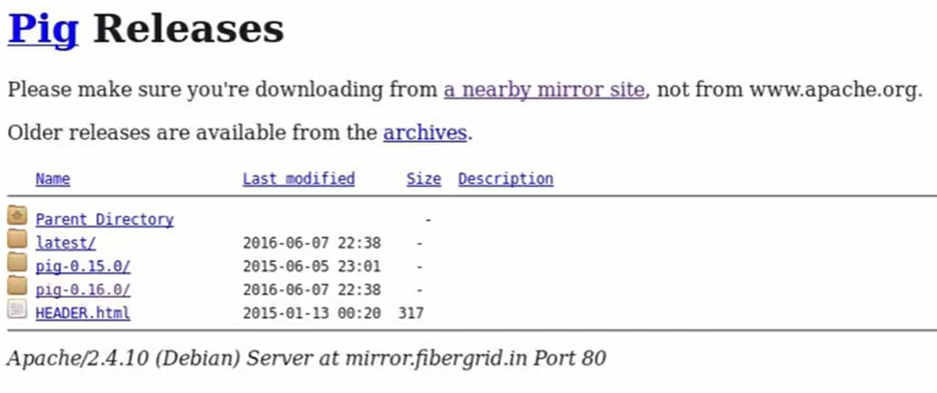
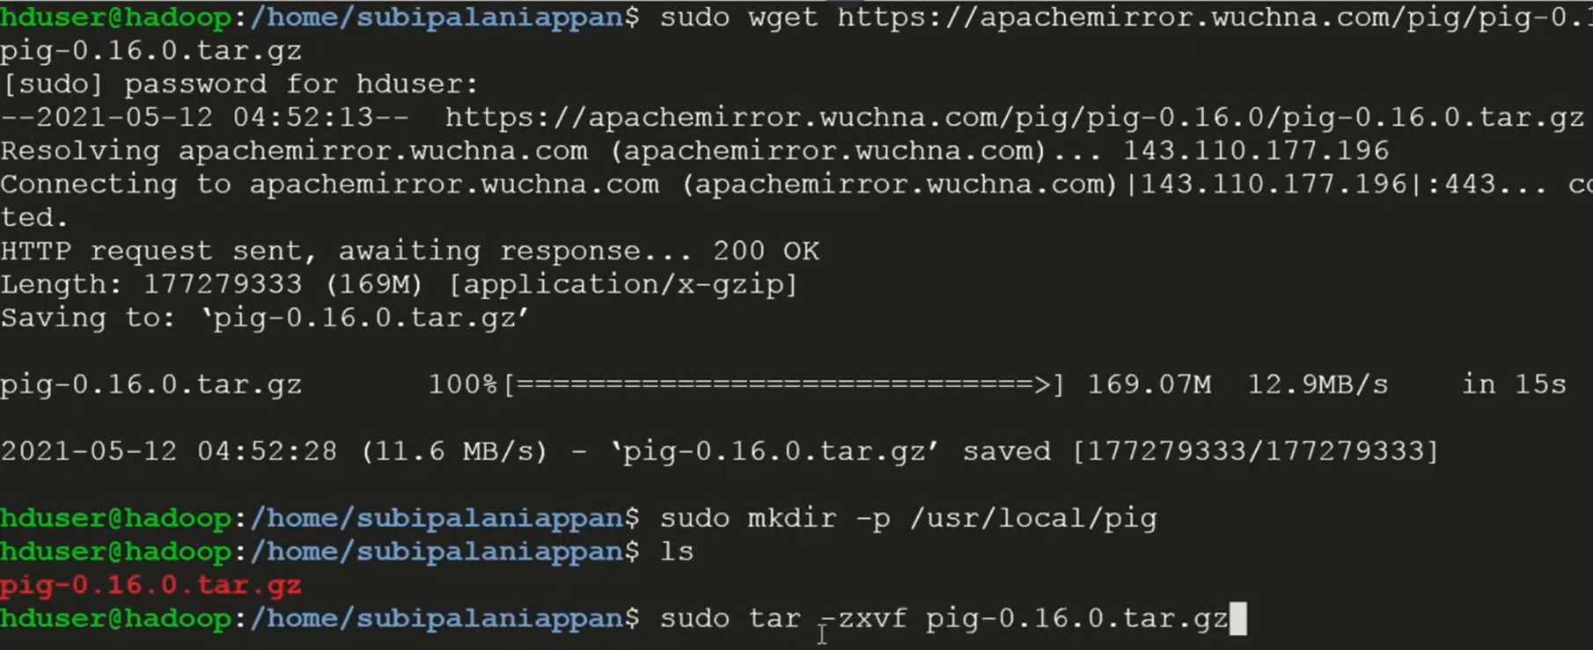
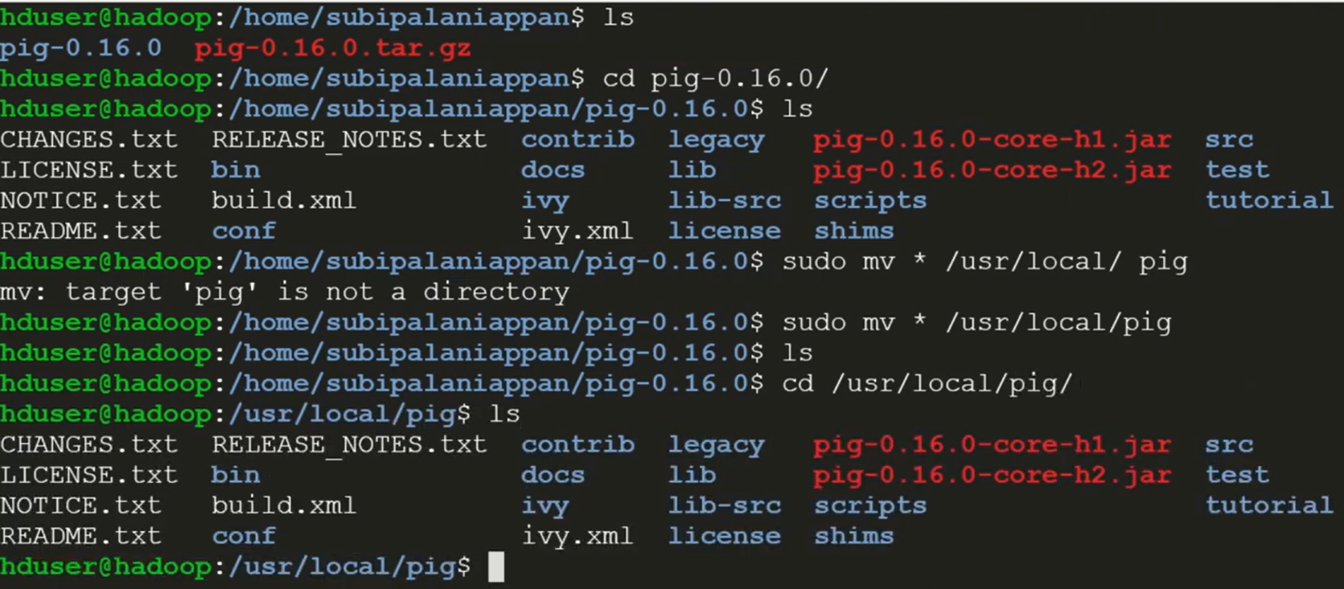
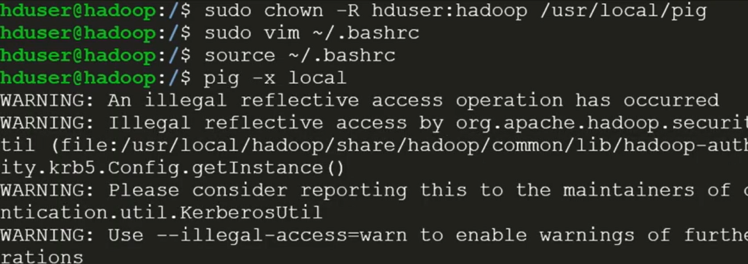
Output Analysis |  | After installation, the pig shell starts successfully, displaying the grunt> prompt. Executing Pig Latin scripts (like word count) produces output stored in HDFS. Successful job completion messages confirm that Pig is properly integrated with Hadoop and capable of running MapReduce tasks.
Github Link |  | https://github.com/Prerana-Bijekar/BDH
Conclusion |  | Installing Apache Pig on Linux with Hadoop integration provides a simplified way to process large datasets using Pig Latin scripts. This setup enhances productivity by abstracting complex MapReduce logic and enabling efficient big data analysis within the Hadoop ecosystem.
Plag Report (Similarity index < 12%) |  | 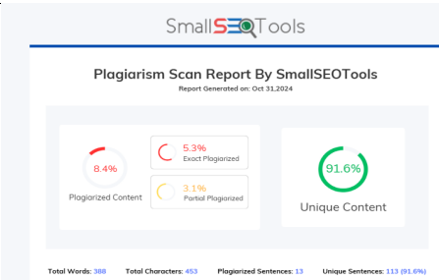
Date |  | 30 October 2025

