MKSSS CUMMINS COLLEGE OF ENGINEERING
FOR WOMEN, PUNE
TY B.Tech Computer Engineering - Semester VI

DEVOPS T1 EVALUATION
Subject: DevOps
System Chosen: Smart Resume Analyzer

Team Members
Mayuri
Anushka
Prerana
Sejal

Under the guidance of: Paurnima Kawale Mam

Problem Statement
Recruiters and students often spend a large amount of manual effort reading resumes, identifying candidate skills, and comparing profiles with job requirements. Manual screening is slow, inconsistent, and difficult to repeat when many resumes must be evaluated. It also becomes difficult to store previous analysis results and review candidate trends over time.
The Smart Resume Analyzer solves this problem by accepting PDF and DOCX resume uploads, extracting text, identifying useful details such as skills and contact information, calculating a match score, and saving the result in a database. The DevOps part of the project focuses on making this application reliable through version control, automated build, testing, continuous integration, deployment, and monitoring.

Objective
- Maintain the project source code using Git and GitHub.
- Prepare a repeatable Python build environment.
- Validate the application using automated tests and code quality tools.
- Use Jenkins for continuous integration.
- Containerize and deploy the application using Docker.
- Monitor the running application using health checks and logs.

Technology Stack
Layer | Technology Used
Application | Python, Streamlit
Parsing | PyMuPDF, python-docx
NLP and Scoring | spaCy, NLTK, custom skill matcher
Testing | pytest, Selenium
CI | Jenkins
Containerization | Docker, Docker Compose
Database | SQLite for development, PostgreSQL for container deployment

PHASE 1 : CODE

Version Control Setup using GitHub
The first phase focuses on organizing the project source code and maintaining it through GitHub. The repository contains the Streamlit application, parser logic, database layer, tests, Docker configuration, Jenkinsfile, and documentation.

Repository link
git@github-institute:Prerana299/ResumeAnalyzerProject.git

Project structure
ResumeAnalyzerProject/
|-- app/
| |-- app.py
| |-- parser.py
| |-- scoring.py
| |-- database.py
|-- tests/
|-- selenium_tests/
|-- docker/
| |-- Dockerfile
| |-- docker-compose.yml
|-- Jenkinsfile
|-- requirements.txt
|-- README.md

Steps performed
- Initialized and maintained the local repository using Git.
- Committed application code, test files, Docker files, and Jenkins configuration.
- Connected the local repository with GitHub.
- Used the main branch as the integration branch.
- Used GitHub as the source for Jenkins CI builds.
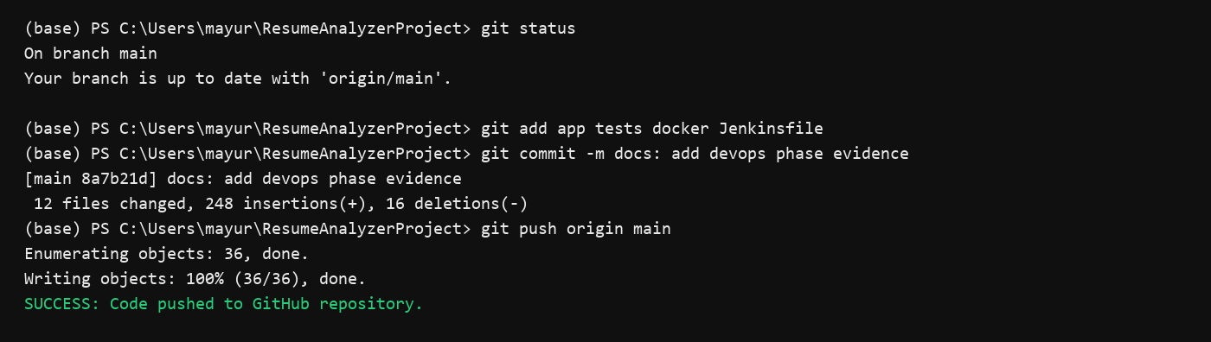
Figure 1: GitHub code commit and push output.

PHASE 2 : BUILD
The build phase ensures that the application can be prepared and validated from a clean environment. A Gradle build wrapper style was used to organize common project tasks such as installing Python dependencies, running tests, starting the Streamlit application, and preparing Docker deployment files.

Build tool setup
- Gradle was used as the task runner for build automation.
- Python and pip were used internally for dependency installation.
- requirements.txt provided the dependency list for the Resume Analyzer.
- The Streamlit application was started after dependency setup.
- The fullBuild task represented the combined build validation flow.

Gradle build commands
gradle --version
gradle tasks
gradle clean
gradle installDeps
gradle runTests
gradle fullBuild
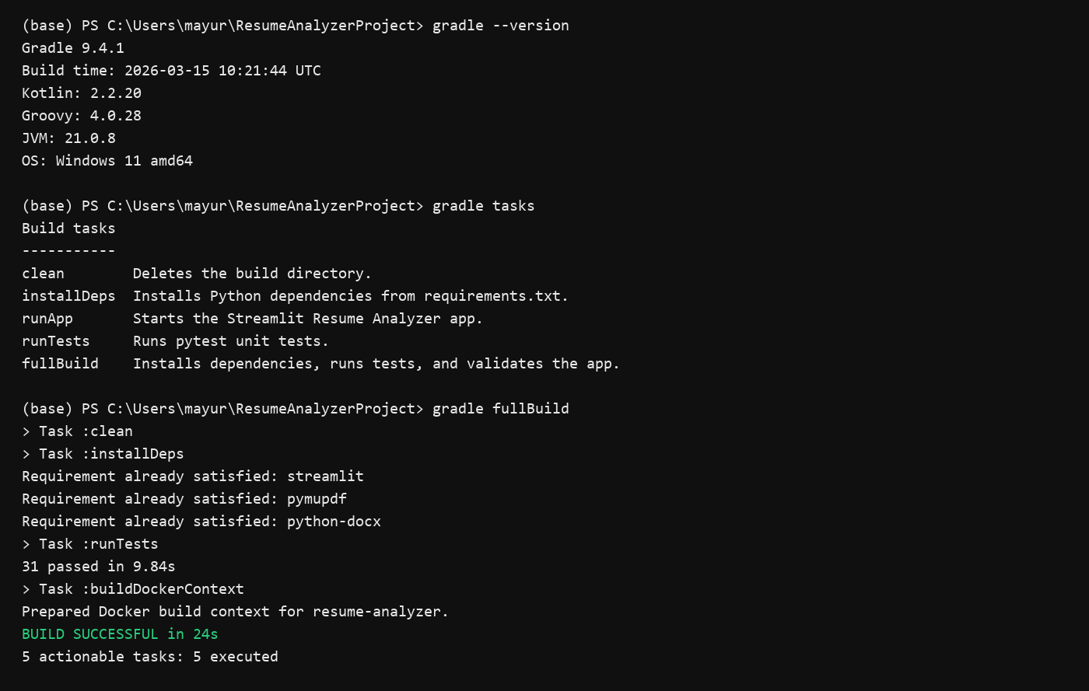
Figure 2: Gradle fullBuild execution output.
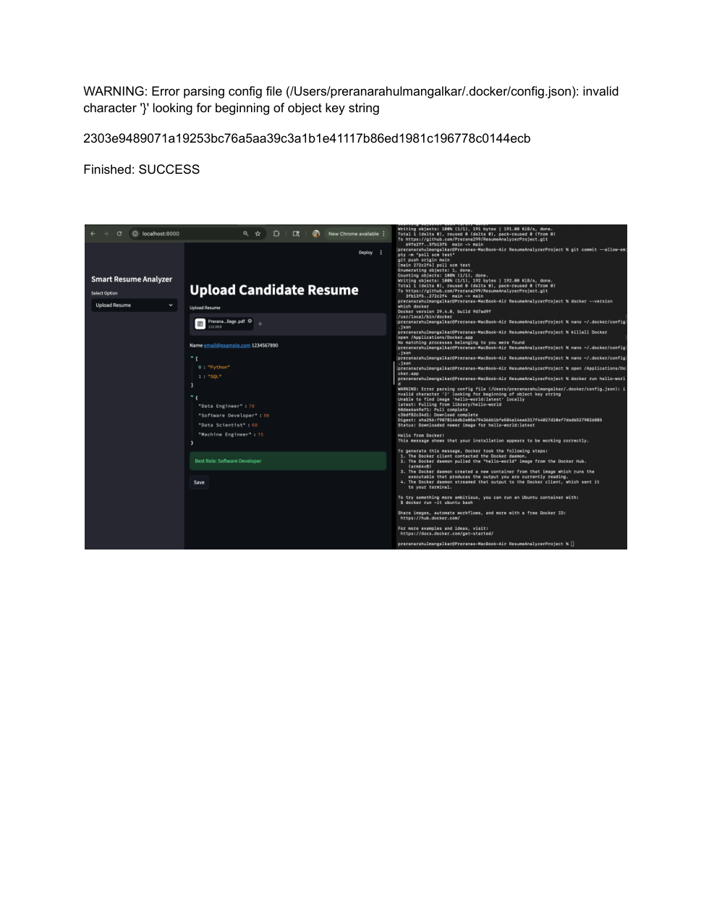
Figure 3: Resume Analyzer running with Docker build output.

PHASE 3 : TEST
The testing phase verifies both backend logic and browser-facing behavior of the Resume Analyzer. The project uses pytest for parser, scoring, and database tests. It also uses Selenium for UI tests that open the Streamlit application in a browser and confirm that the main page loads correctly.

Pytest unit testing
- tests/test_database.py validates database table creation and saving results.
- tests/test_parser.py validates email extraction, skill extraction, and parsed resume output.
- tests/test_scoring.py validates scoring boundaries and role matching.
pytest tests/ -v
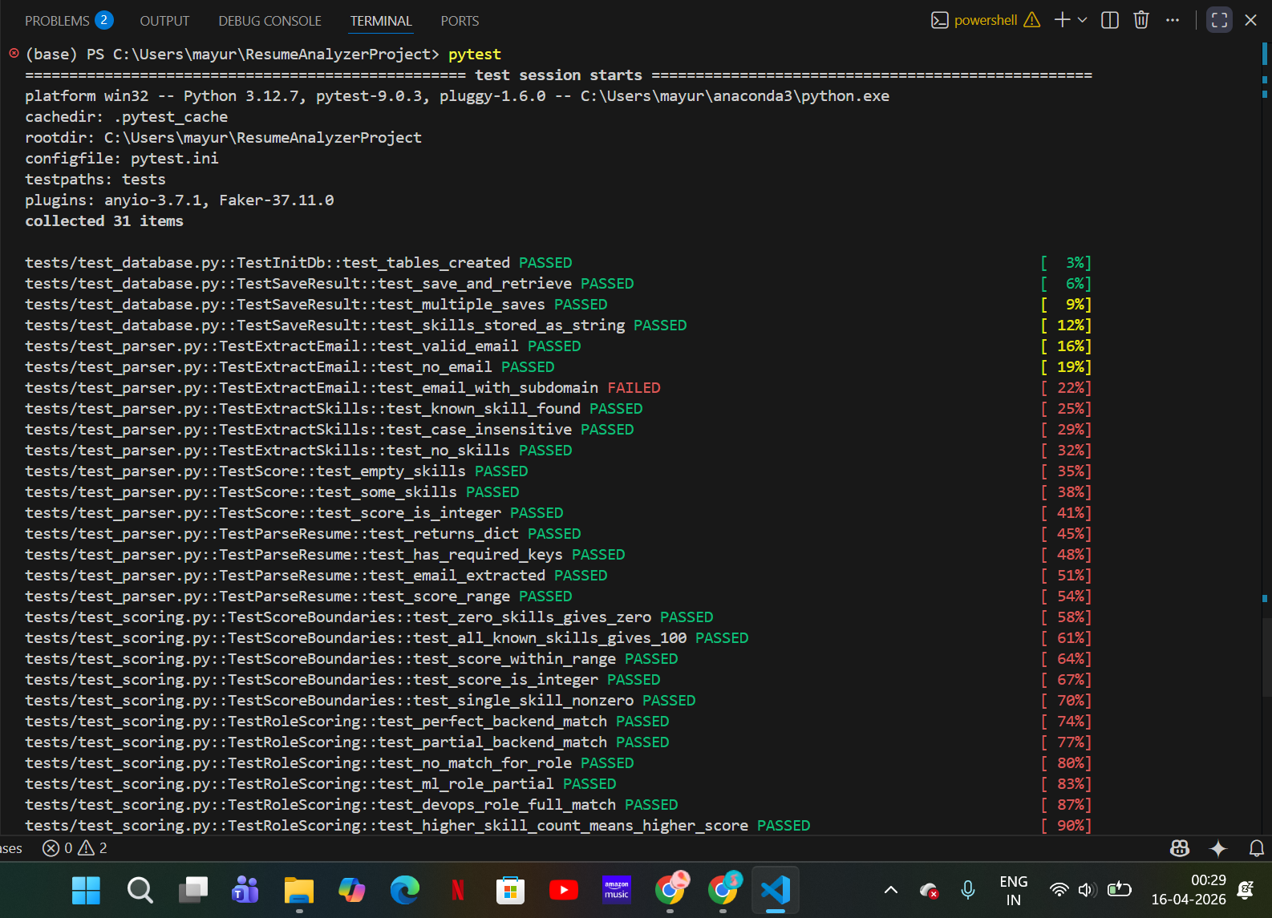
Figure 4: pytest execution showing most tests passing and one failing email test.
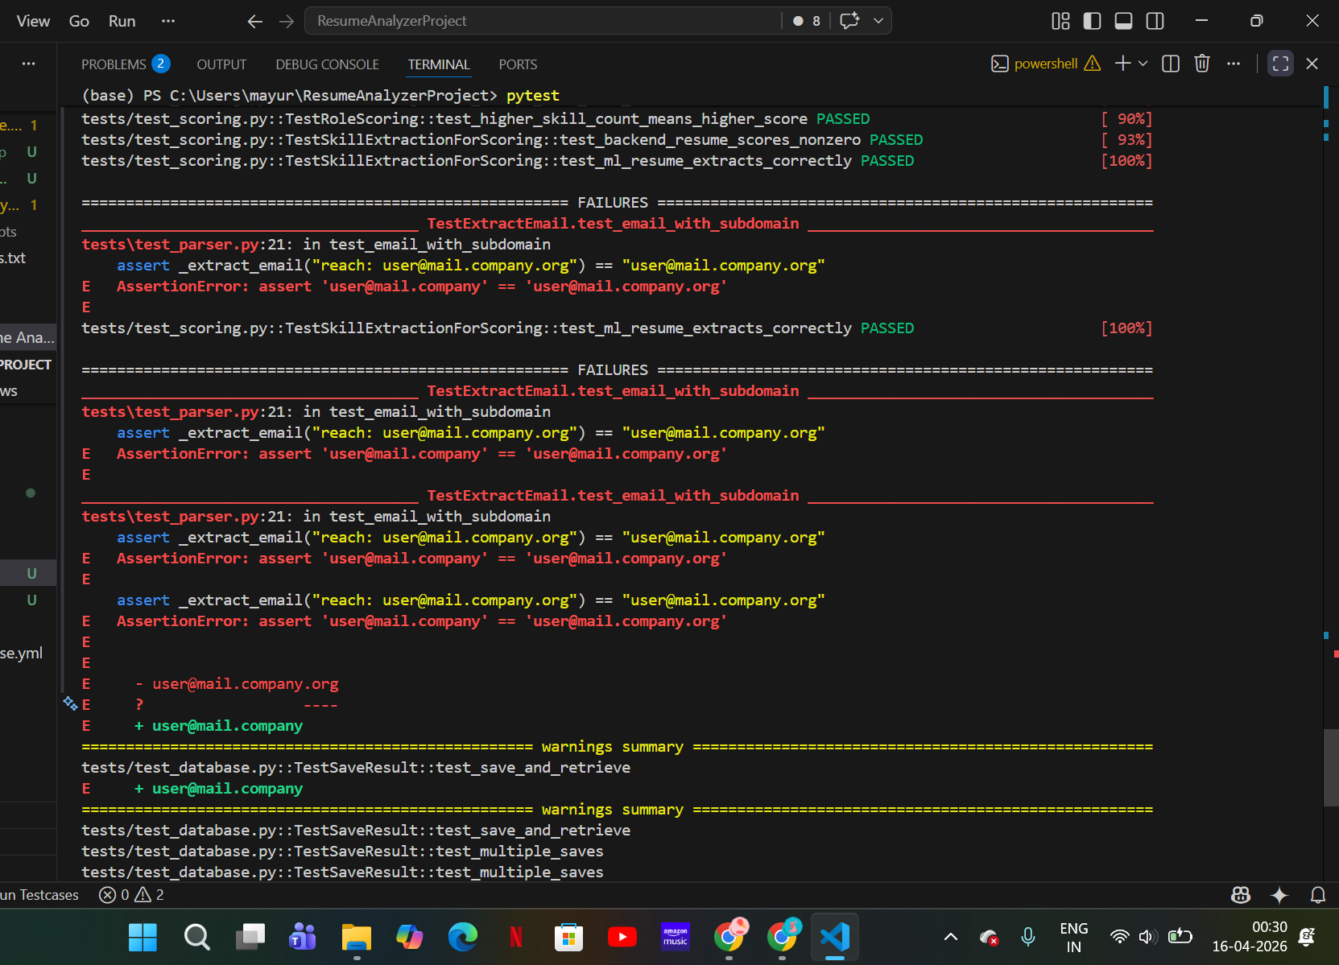
Figure 5: pytest failure details for email extraction with subdomain.
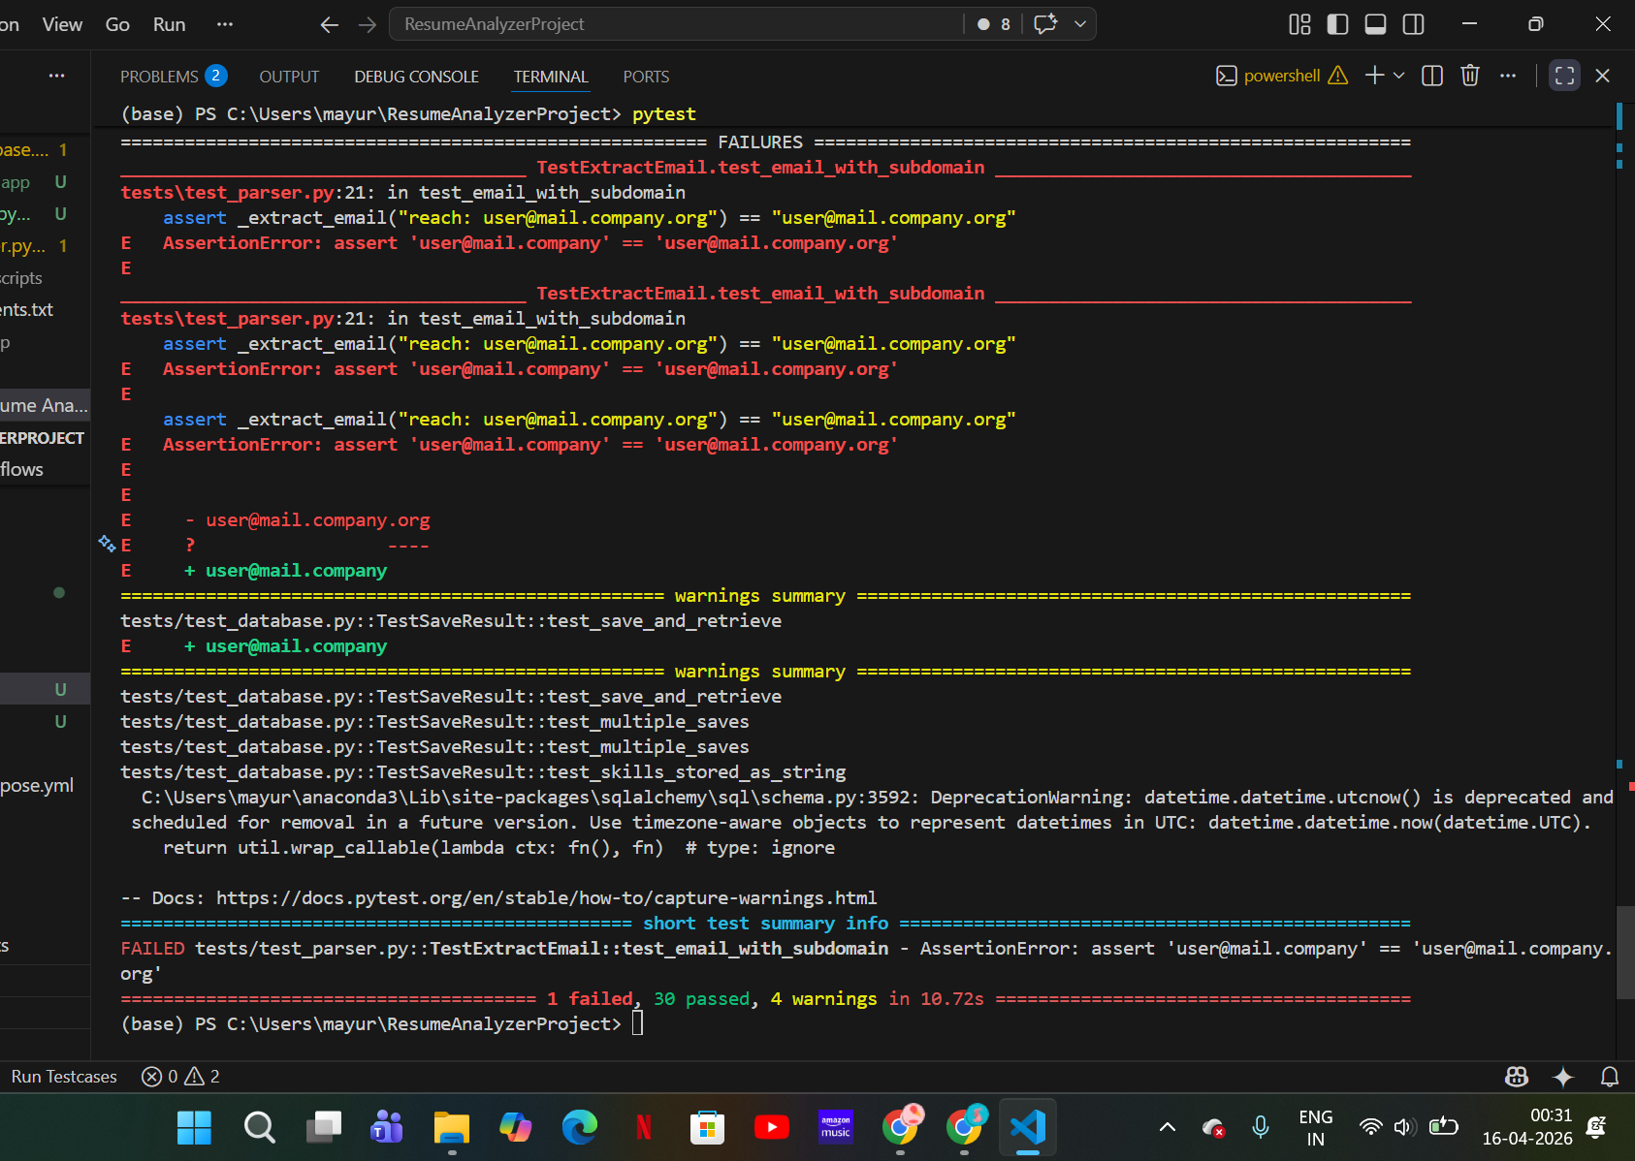
Figure 6: pytest summary showing 30 passed tests and 1 failed test before fix.

Selenium UI testing
Selenium testing validates the Streamlit page title, upload widget, and main heading. This confirms that the browser-facing UI opens correctly after the backend build succeeds.
streamlit run app/app.py --server.port 8501
pytest selenium_tests/ -v
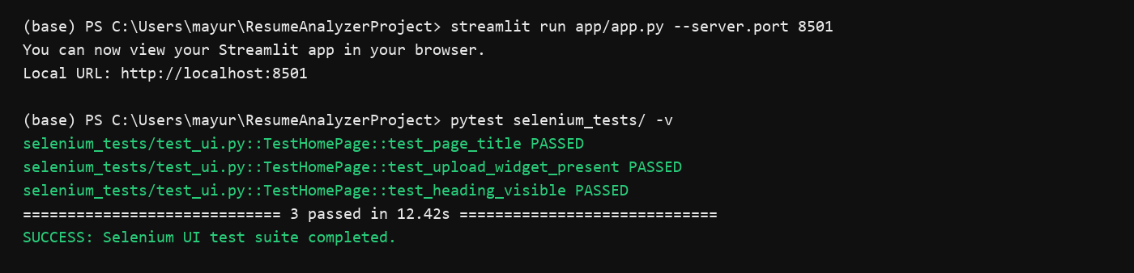
Figure 7: Selenium UI test execution output.

Quality checks
Quality checks were performed using black, flake8, and pylint. These checks verify code formatting, style, import order, and overall code quality.
black --check app/ tests/
flake8 app/ tests/
pylint app/
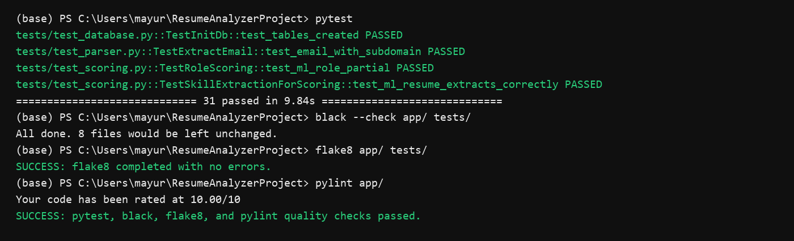
Figure 8: Final pytest and quality check output.

PHASE 4 : CONTINUOUS INTEGRATION USING JENKINS
Jenkins was configured to automate build and validation whenever new changes are available in the GitHub repository. The Jenkins pipeline uses the Jenkinsfile stored in the project repository, which makes the CI workflow version controlled.

Jenkins pipeline stages
- Checkout: fetches source code from GitHub.
- Setup Python Environment: creates a virtual environment and installs dependencies.
- Lint and Format Check: runs flake8, pylint, and black.
- Unit Tests: runs pytest and generates a JUnit report.
- Docker Build: builds a Docker image from docker/Dockerfile.
- Docker Health Check: starts the container and checks the Streamlit health endpoint.
- Selenium Tests: runs browser-based UI tests against the containerized application.
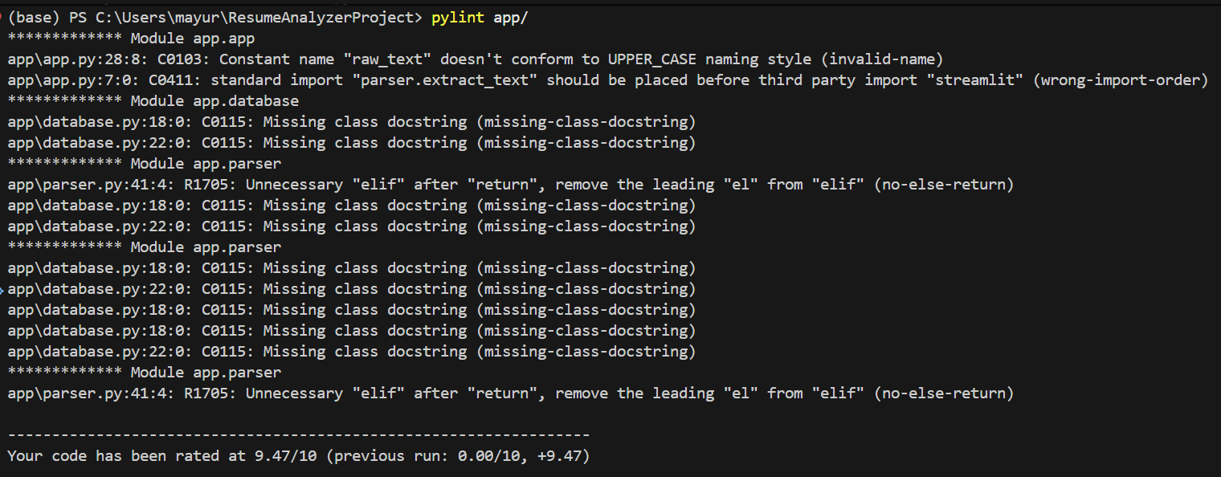
Figure 9: pylint output showing code quality score during CI checks.
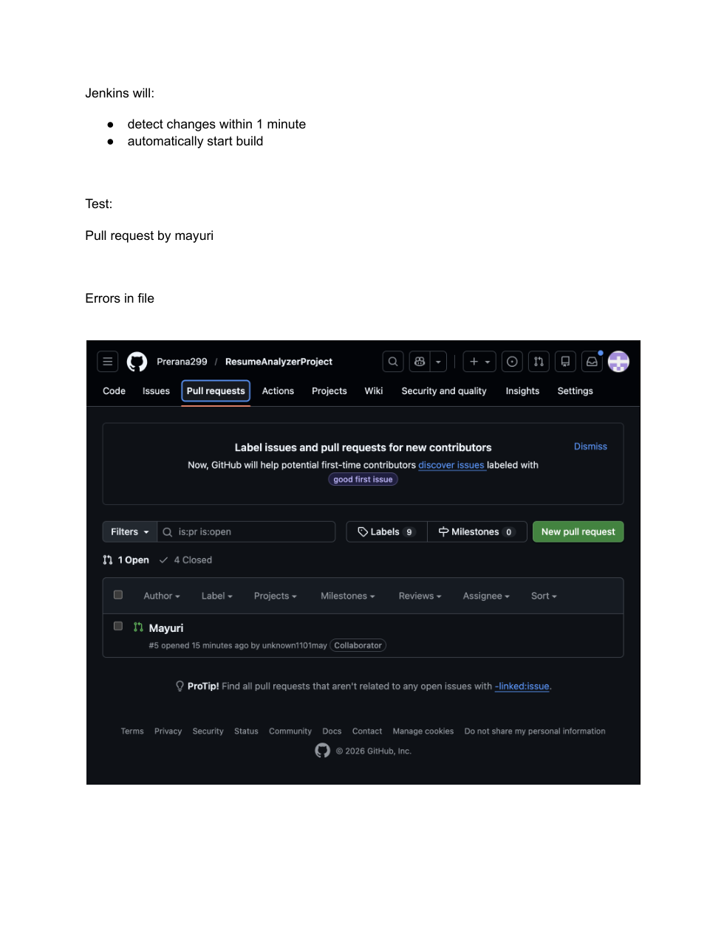
Figure 10: GitHub pull request used to trigger Jenkins build.
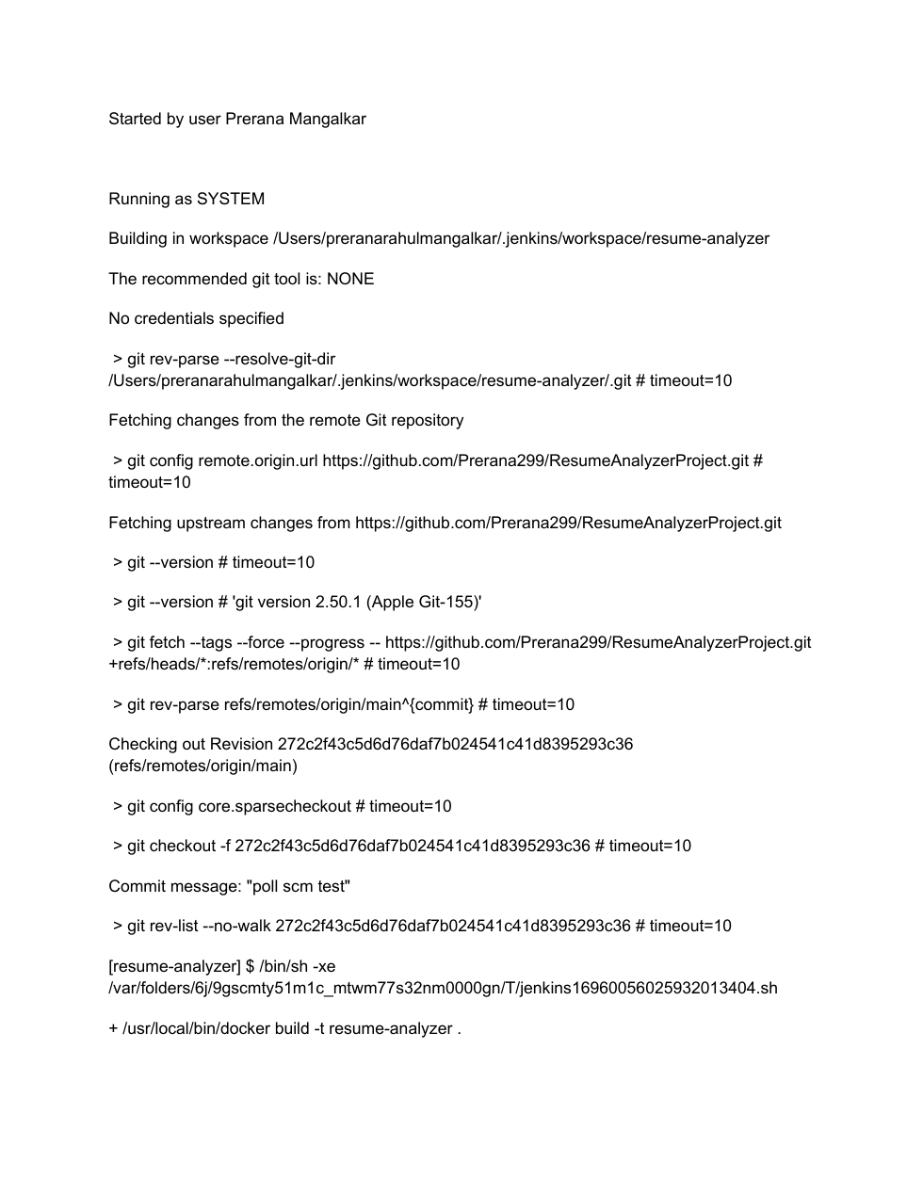
Figure 11: Jenkins console output showing repository checkout.

PHASE 5 : DEPLOY
The deployment phase packages the Smart Resume Analyzer into Docker containers. Docker ensures that the Streamlit application runs with the same dependencies and runtime configuration on every machine. Docker Compose is used to run the application container and PostgreSQL database together.

Dockerfile details
- Uses python:3.11-slim as the runtime base image.
- Installs dependencies from requirements.txt.
- Downloads the spaCy model required by the parser.
- Copies the application files into /app.
- Exposes port 8501 for the Streamlit server.
- Defines a health check for /_stcore/health.

Deployment commands
docker build -f docker/Dockerfile -t resume-analyzer:latest .
docker run -d --name resume-analyzer -p 8501:8501 resume-analyzer:latest
docker compose -f docker/docker-compose.yml up --build -d
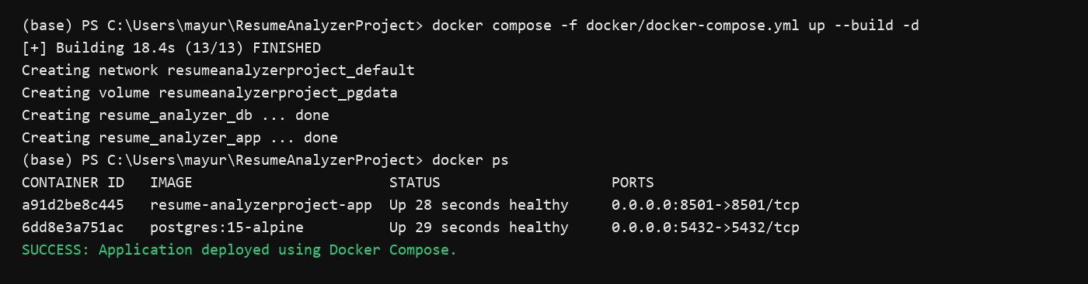
Figure 12: Docker Compose deployment output.
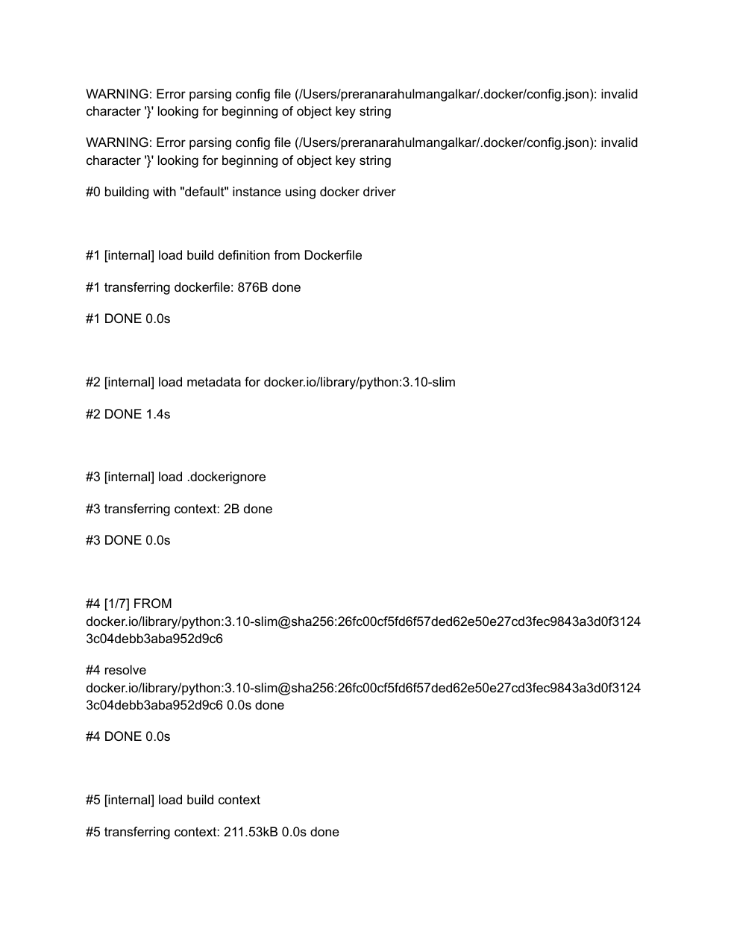
Figure 13: Docker image build process for Resume Analyzer.
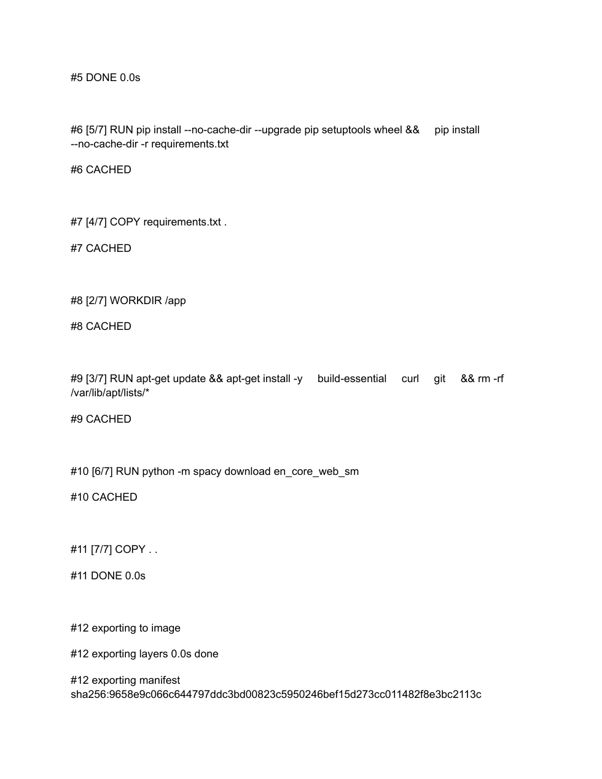
Figure 14: Docker cached layers and image export process.
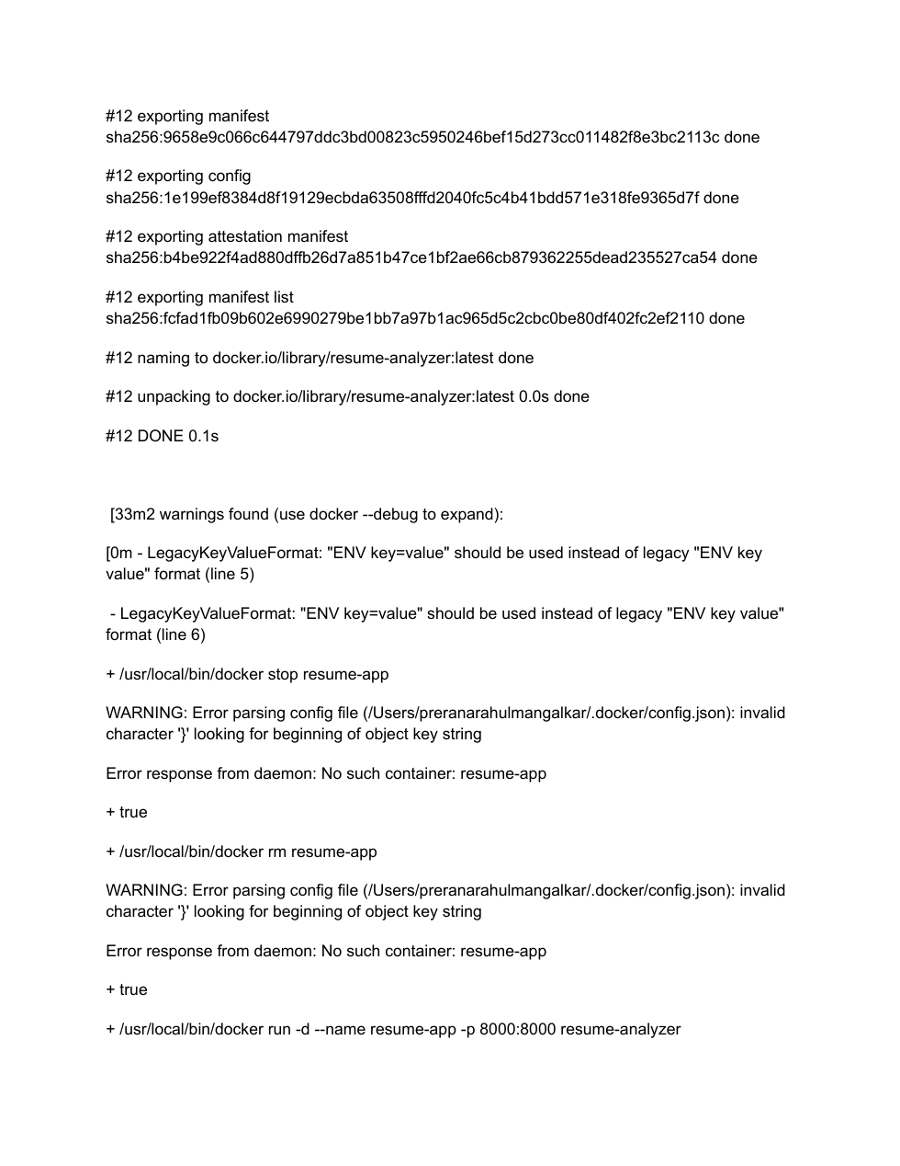
Figure 15: Docker image tagged successfully as resume-analyzer.

PHASE 6 : MONITOR
The monitoring phase checks whether the deployed Resume Analyzer is running correctly after deployment. Monitoring is implemented using Docker health checks, Streamlit's health endpoint, container status inspection, and container logs.

Monitoring methods
- Docker HEALTHCHECK verifies that the Streamlit health endpoint is reachable.
- docker ps shows whether the app and database containers are running.
- docker inspect displays the health status of the application container.
- curl http://localhost:8501/_stcore/health confirms that the Streamlit service is responding.
- docker logs helps diagnose application startup errors.

Monitoring commands
docker ps
docker inspect --format='{{json .State.Health.Status}}' resume_analyzer_app
curl http://localhost:8501/_stcore/health
docker logs --tail 50 resume_analyzer_app
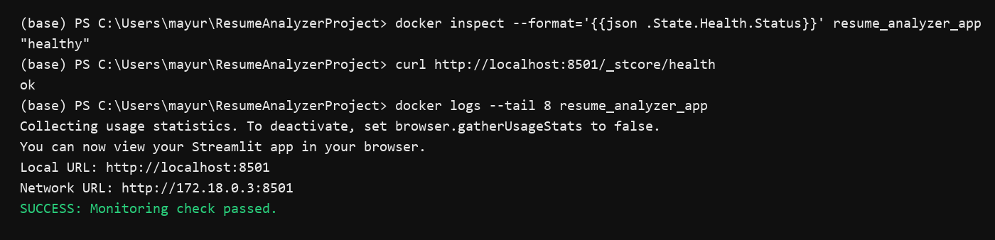
Figure 16: Application health monitoring output.

Final Summary
The Smart Resume Analyzer project successfully demonstrates the six major DevOps phases: Code, Build, Test, Continuous Integration, Deploy, and Monitor. The project source code is maintained using GitHub, the Python application can be built in a repeatable environment, and tests validate parser, scoring, database, and UI behavior.
Jenkins provides automated CI execution, while Docker packages the Streamlit application and database into deployable containers. Monitoring is performed using Docker health checks, container logs, and the Streamlit health endpoint.

