**Project Name: Rent N Go**

**Project Member:**

**Rinkiraj Prasad 210543181079**

**Aishwarya Pawar 210543181004**

**Prerana Bachhav 210543181011**

**Sainand Shitole 210543181101**

**Abstract:**

People need some good and comfortable essentials while relocating to a new place and our site helps to achieve them by providing all the daily essentials on rent .Buying furniture and appliances may not always be the best idea.

If you’re short on cash, or as an employee relocating to another branch in another region every few months, you might want to rent these things instead.

The good news is that you don’t have to go out to find stores that allow you to rent the items anymore.

Our website lets you rent beds, dressing tables, or even washing machines etc. for the amount of time that you specify. The vendors who are verified own these items and get these items from the store to you. our system will provide the direct interface between vendors/businesses to consumer i.e. you, by excluding the agent or middleman.

In order to develop an e- commerce website, a number of Technologies must be studied and understood. These include multi-tiered architecture, server and client side scripting techniques, implementation technologies such as Spring MVC, programming language (such as Core Java, Advance Java), relational databases (such as MySQL).

**Implementation Technologies:**

1. **Spring Boot:**

Spring Boot provides basic and advanced concepts of Spring Framework. Spring Boot is a spring module that provides the RAD (Rapid Application Development) feature to the spring framework.

Spring Boot is a project that is built on the top of the Spring Framework. It provides an easier and faster way to set up, configure, and run both simple and web-based applications.

Our Spring Boot Tutorial includes all topics of Spring Boot such, as features, project, maven project, starter project wizard, Spring Initializer , CLI, applications, annotations, dependency management, properties, starters, Actuator, JPA, JDBC, etc.

**1.1 Features of Spring Boot Framework:**

**1. Web Development**

It is a well-suited spring module for web application development. We can easily create a self-contained HTTP application that uses embedded servers like **Tomcat, Jetty,** or Undertow. We can use the **spring-boot-starter-web** module to start and run the application quickly.

**2. Spring Application**

The Spring Application is a class that provides a convenient way to bootstrap a spring application. It can be started from the main method. We can call the application just by calling a static run() method.

**3. Application Events and Listeners.**

Spring Boot uses events to handle the variety of tasks. It allows us to create factories file that is used to add listeners. We can refer it to using the **ApplicationListener key**.

Always create factories file in META-INF folder like **META-INF/spring.factories**.

**4. Admin Support.**

Spring Boot provides the facility to enable admin-related features for the application. It is used to access and manage applications remotely. We can enable it in the Spring Boot application by using **spring.application.admin.enabled** property.

**5. Externalized Configuration.**

Spring Boot allows us to externalize our configuration so that we can work with the same application in different environments. The application uses YAML files to externalize configuration.

**6. Properties Files**

Spring Boot provides a rich set of **Application Properties**. So, we can use that in the properties file of our project. The properties file is used to set properties like **server-port =8082** and many others. It helps to organize application properties.

**7.Type-safe Configuration**

The strong type-safe configuration is provided to govern and validate the configuration of the application. Application configuration is always a crucial task which should be type-safe. We can also use annotation provided by this library..

**1.2 Advantages of Spring Framework:**

**1. Solving difficulties of Enterprise application development**

Spring is solving the difficulties of development of complex applications, it provides Spring Core, Spring IoC and Spring AOP for integrating various components of business applications.

**2. Support Enterprise application development through POJOs**

Spring supports development of Enterprise application development using the POJO classes which removes the need of importing heavy Enterprise container during development. This makes application testing much easier.

**3. Easy integration other frameworks**

Spring designed to be used with all other frameworks of Java, you can use ORM, Struts, Hibernate and other frameworks of Java together. Spring framework do not impose any restriction on the frameworks to be used together.

**4. Application Testing**

Spring Container can be used to develop and run test cases outside enterprise container which makes testing much easier.

**5. Modularity**

Spring framework is modular framework and it comes with many modules such as Spring MVC, Spring ORM, Spring JDBC, Spring Transactions etc. which can used as per application requirement in modular fashion.

**6. Spring Transaction Management**

Spring Transaction Management interface is very flexible it can configure to use local transactions in small application which can be scaled to JTA for global transactions.

1. **The JDBC Template**

The central class of the Spring JDBC abstraction framework is the **JdbcTemplate** class that includes the most common logic in using the JDBC API to access data, such as handling the creation of connection, statement creation, statement execution, and release of resource. The**Jdbc-Template**class can be found in the **org.springframework.jdbc.core**package.

The **JdbcTemplate** class instances are thread-safe once configured. A single **JdbcTemplate** can be configured and injected into multiple DAOs.

We can use the **JdbcTemplate** to execute the different types of SQL statements. **Data Manipulation Language** (**DML**) is used for inserting, retrieving, updating, and deleting the data in the database such as **SELECT**, **INSERT**, or **UPDATE** statements

**2.1** **MySQL**

MySQL, the most popular Open Source SQL database management system, is developed, distributed, and supported by Oracle Corporation.

**Features of MySQL:**

* **MySQL is a database management system.**

A database is a structured collection of data. It may be anything from a simple shopping list to a picture gallery or the vast amounts of information in a corporate network. To add, access, and process data stored in a computer database, you need a database management system such as MySQL Server. Since computers are very good at handling large amounts of data, database management systems play a central role in computing, as standalone utilities, or as parts of other applications.

* **MySQL databases are relational.**

A relational database stores data in separate tables rather than putting all the data in one big storeroom. The database structures are organized into physical files optimized for speed. The logical model, with objects such as databases, tables, views, rows, and columns, offers a flexible programming environment.

* **MySQL software is Open Source.**

Open Source means that it is possible for anyone to use and modify the software. Anybody can download the MySQL software from the Internet and use it without paying anything.

* **The MySQL Database Server is very fast, reliable, scalable, and easy to use.**

MySQL Server was originally developed to handle large databases much faster than existing solutions and has been successfully used in highly demanding production environments for several years. Although under constant development, MySQL Server today offers a rich and useful set of functions. Its connectivity, speed, and security make MySQL Server highly suited for accessing databases on the Internet.

* **MySQL Server works in client/server or embedded systems.**

The MySQL Database Software is a client/server system that consists of a multithreaded SQL server that supports different back ends, several different client programs and libraries, administrative tools, and a wide range of application programming interfaces (APIs).

1. **Hardware and Software Requirements (Minimum):**

**Hardware:**

1. Intel i3 processor 3rd generation or later / AMD Ryzen 200 2nd generation or later

2. 2 GB ddr3 ram.

3. Windows 10 Home edition or later.

4. 200 GB Sata HDD Space

5. Data Connection 200 kbps

**Software:**

1. Eclipse 4.7 Oxygen
2. MySQL 5.7 with Workbench 8.0
3. Google Chrome version 79.0
4. Apache Tomcat Server 8.5
5. Maven Dependencies

**4.ER Diagram:**

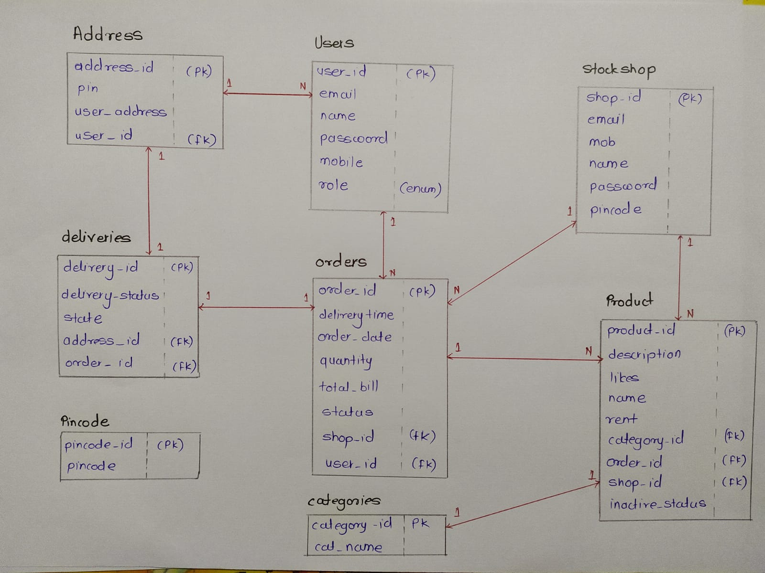

Figure 1: ER Diagram

1. **Table Structures:**
2. **Table name: users**

**Column name Type**

id int NO PRI auto_increment

Email varchar (20) YES

Mobile varchar (15) YES

Name varchar (20) YES

Password varchar (20) NO

Role varchar (255) YES

1. **Table name: address**

**Column name Type**

Id int NO PRI auto_increment

Pin varchar (10) YES

User_address varchar (255) YES

User_id int NO MUL

1. **Table name: stock_shops**

**Column name Type**

Id int NO PRI auto_increment

Email varchar (20) YES UNI

Mob varchar (15) YES

Name varchar (20) YES

Password varchar (20) YES

Pincode varchar (15) YES

1. **Table name: orders**

**Column name Type**

Id int NO PRI auto_increment

Delivery_time datetime YES

Order_date datetime YES

Pay_id int NO

Status varchar (255) YES

Duration datetime YES

Total_bill double NO

Shop_id int YES MUL

User_id int NO MUL

1. **Table name: deliveries**

**Column name Type**

Id int NO PRI auto_increment

Delivery_status int NO

State tinyint YES

Address_id int YES MUL

Order_id int YES MUL

1. **Table name: pincode**

**Column name Type**

Id int NO PRI auto_increment

Pincode varchar (10) YES

1. **Table name: categories**

**Column name Type**

Id int NO PRI auto_increment

Cat_name varchar (255) YES

1. **Table name: products**

**Column name Type**

Id int NO PRI auto_increment

description varchar (255) YES

inactive_status tinyint YES

likes int NO

Name varchar (50) YES

Rent double NO

Category_id int YES MUL

Order_id int YES MUL

Shop_id int NO MUL

1. **Table name: payments**

**Column name Type**

Id int NO PRI auto_increment

Amount double NO

Pay_method varchar (20) YES

Pay_time datetime YES

shop_id int YES MUL

user_id int YES MUL

1. **UML Diagrams:**

**Admin Module:**

1. User Registration, user deletion,
2. Shop Registration , deletion , list of shops
3. Showing order details, customer details
4. Statistics of sales, commission
5. Login, Logout and edit profile

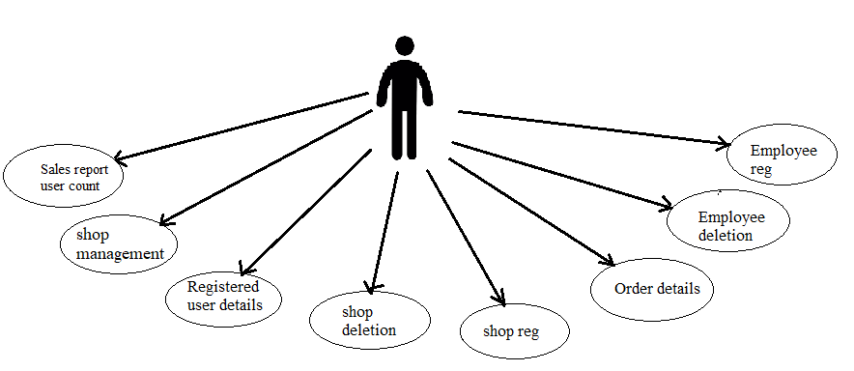

**Shop Owner Module:**

1)Add Product, Delete Product,

2) Update Product (in list- product list, rent ,active status)

3) show orders list

4) payment details or monthly sale

5) Login, Logout, edit profile

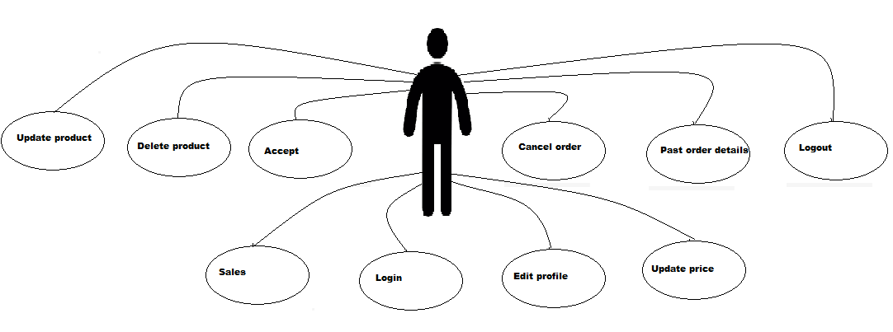

**Delivery Boy Module:**

1. Accept/decline order
2. Order details
3. Address to deliver
4. Take payment
5. Customer details

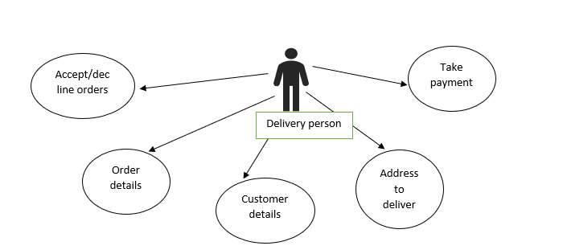

**Customer / User**

1. Registration, Login, Logout, edit profile
2. Searching – Product by name or category , searching shop by name
3. Ordering – adding order, changing status of order, showing order details list.
4. Payment options
5. Accept/delete order

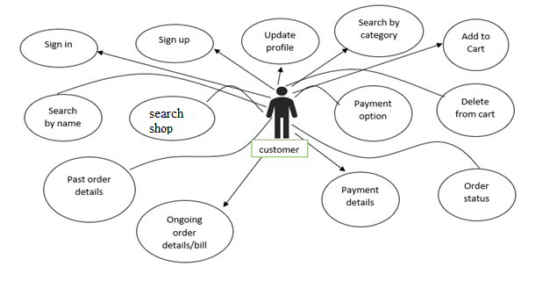

**6.Future Scope of Project**

India holds millions of stories, but we believe, thousands of them are somehow related to rentals in one way or another.

The concept of renting furniture is not yet properly settled in the mind of the old generation as owing the basic thing like furniture is often thought as the best option. But millennials are practical, they know the hardships that come with owing furniture. It’s not just practical for them to own a 40-50k sofa set when they know they would be in another city in the next 2-3 years and transportation is not cheap!

Today’s generation is more evolved and adapts to the modern lifestyle than its counterpart. With unique and individual preferences, this set of people are opting for modern furniture and flexible usage and hence makes for an important category to the retailers.

Indian furniture rental market can be divided into further categories as per the needs of the customers. For example , The "Bed" category is the most popular one and gets too many customers with respect to other categories like sofa, chair, tables etc.

**Thank You!**