Name: Vedant Tinkhede

Semester: 6th

Branch: CSE (Data Science)

Roll no.: 62

Subject: CV TA-2

GitHub Link: <https://github.com/VedantTinkhede/CV_TA-2>

**Aim-1:  Implement the SIFT algorithm to detect and match key points between two images.**

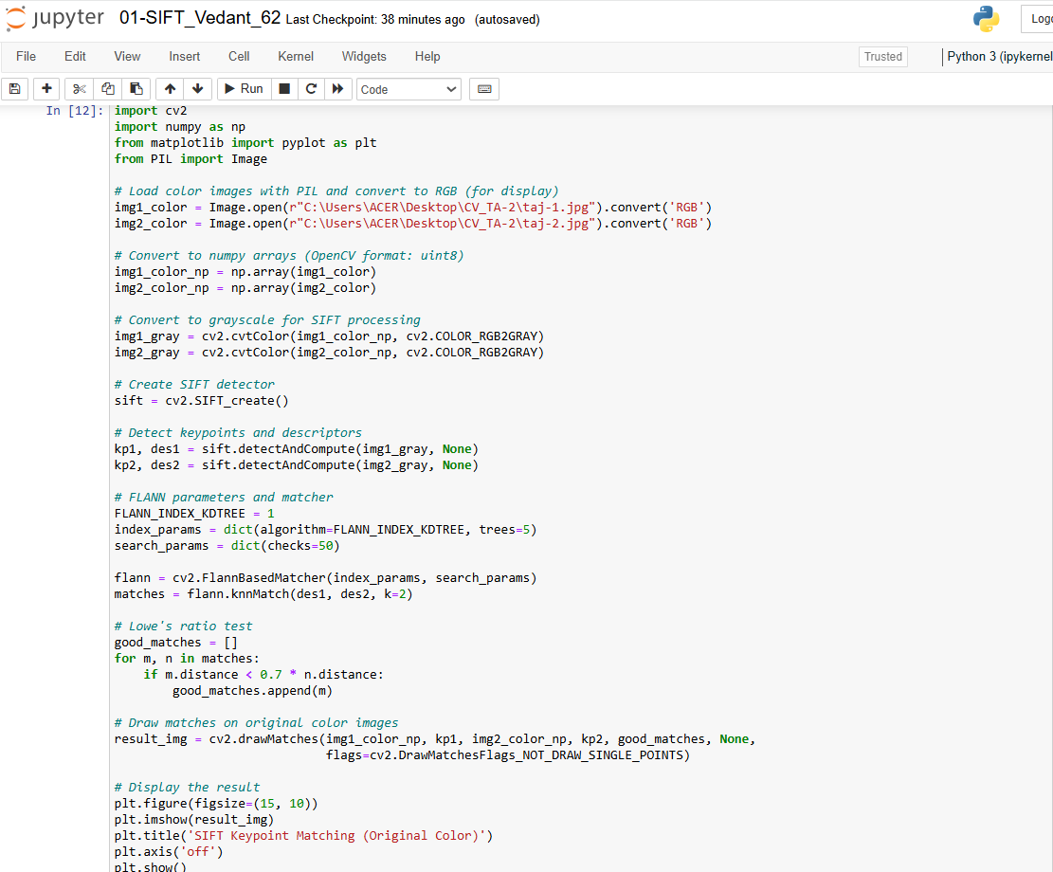

**Aim-2: Use RANSAC to remove outlier key point matches and fit a transformation model between two images.** 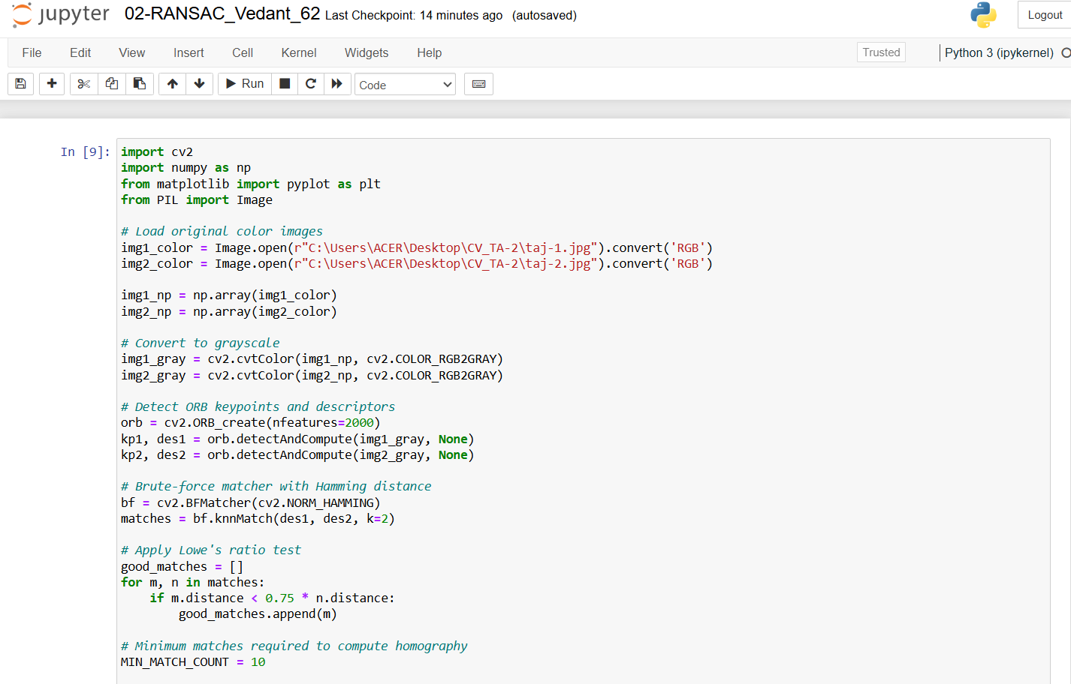

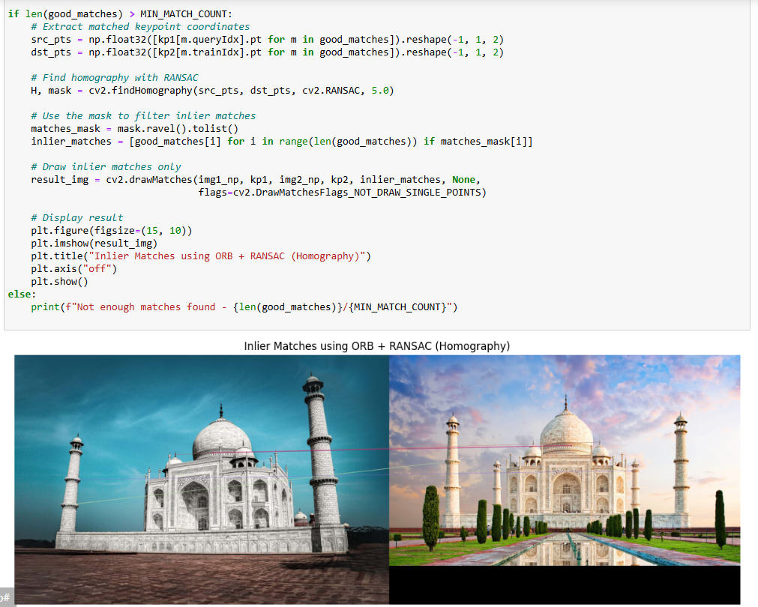

**Aim-3: Use the Shi-Tomasi corner detector to identify and mark corner points in an image.**

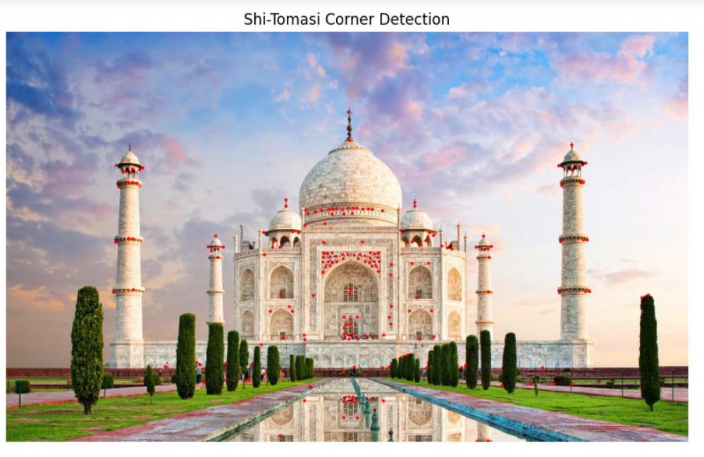

Git and GitHub:

