 

INSTITUTE FOR ADVANCED

COMPUTING AND

SOFTWARE DEVELOPMENT

AKURDI, PUNE

Documentation On

**“E-BANKING”**

PG-DAC FEB 2020

*Submitted By:*

**Group No: 25**

**Prerana Gholap (200241220142)**

**Megha Chaudhari (200241220033)**

Mr Prashant KarhaleMr Chetan Pardeshi

**Centre Coordinator Project Guide**

# Table of Contents

|  |  |  |
| --- | --- | --- |
| **Sr No** | **Topic Name** | **Page No** |
| 1 | Introduction | 04 |
| 1.1 | Problem Statement | 04 |
| 1.2 | Product Scope | 04 |
| 1.3 | Aim & Objective | 04 |
| 2. | Proposed System | 05 |
| 2.1 | Product Functionality | 05 |
| 2.2 | Benefits of E-Banking | 05 |
| 2.3 | Users and Characteristics | 06 |
| 3 | Specific Requirement | 07 |
| 3.1 | Operating Environment | 07 |
| 3.2 | External Interface Requirement | 07 |
| 4 | Non Functional Requirement | 08 |
| 5 | System Design | 11 |
| 6 | Table | 13 |
| 7.1 | Conclusion | 16 |
| 7.2 | Future Scope | 16 |
| 7.3 | References | 16 |

# List of Figures

|  |  |  |
| --- | --- | --- |
| **Figure No** | **Figure Name** | **Page No** |
| 01 | Use case Diagram | 11 |
| 02 | ER Diagram | 12 |

# List of Tables

|  |  |  |
| --- | --- | --- |
| **Table No** | **Table Name** | **Page No** |
| 01 | Appointment | 13 |
| 02 | Primary Account | 13 |
| 03 | Saving Account | 13 |
| 04 | Primary Transaction | 14 |
| 05 | Savings Transaction | 14 |
| 06 | Role | 14 |
| 07 | User Role | 15 |
| 08 | User | 15 |
| 09 | Recipient | 15 |

# Introduction

Internet banking (or E-banking) means any user with a personal computer and a browser can get connected to his bank –s website to perform any of the virtual banking functions. In internet banking system the bank has a centralized database that is web-enabled. All the services that the bank has permitted on the internet are displayed in menu. Any service can be selected and further interaction is dictated by the nature of service. Once the branch offices of bank are interconnected through terrestrial or satellite links, there would be no physical identity for any branch. It would a borderless entity permitting anytime, anywhere and anyhow banking.

## 1.1 Problem Statement

Existing system for a Bank is based on our traditional way keeping records and details on paper and registers. Access of these details and papers are not granted to common member in absence of the authority. It gets really hard to stay in a queue for longer times. Hence this system is proposed to overcome the flaws of the existing system and giving flexibility for the user and admin both to access the services of Bank without visiting the Bank.

## 1.2 Scope

This personalize banking portal will allows the users to access banking services 24x7 using internet on browser. Everything will be available sitting at any comfortable place instantly.

## 1.3 Aims & Objectives

Specific goals are : -

Find the customer satisfaction relating to E-banking service.

To study the awareness of internet banking among the customers of various banks.

# PROPOSED SYSTEM

**2.1 Product functionality:**

E-Banking System provides the features for Admin, User. It includes several functionalities describes as below:

A] User Front:

* It provides facility to Register to the Bank , as well as it can login to the Bank portal by giving the authenticated Username and Password.
* User can also Deposit and Withdraw amount to/from the Bank.
* It also can access the transaction history.
* Transfer amount from one account to another account by adding Recipient can also be done by User.

B] Appointment Scheduling:

* The User can schedule any appointment with the Bank instead of visiting the Bank prior.

C] Admin:

* Admin can view the Appointments list which users have made and can approve them which will be prompted to the User at its side .

## 2.2 Benefits of E-Banking System

* This online society management solution is fully functional and flexible.
* It is very easy to use.
* This online Banking system helps in back office administration by streamlining and standardizing the procedures.
* It saves a lot of time, money and labour.
* Eco-friendly: The monitoring of the Banking becomes easy and includes the least of paper work.
* The application acts as an office that is open 24/7.
* It increases the efficiency of the management at offering quality services to the customers.
* It provides custom features development and support with the application.

**2.3 Users and Characteristics:**

Users:

* Users can login to the system.
* Users can Register to the system.
* Withdraw money from their account
* Deposit money to their account
* Transfer money from their account to another recipient’s account
* Access the Passbook (transaction history)
* Schedule the Appointments instead of going to the Bank

Admin:

* Admin can login to the system.
* View the Appointments made by the Users and approve them.

# 

# SPECIFIC REQUIREMENT

**3.1 Operating Environment:**

A] Server Side:

* **Processor:** Intel® Xeon® processor 3500 series
* **HDD:** Minimum 500GB Disk Space
* **RAM:** Minimum 4GB
* **OS:** Windows 10, Linux 6
* **Database:** MySQL

B] Client Side (minimum requirement):

* **Processor:** Intel Dual Core
* **HDD:** Minimum 80GB Disk Space
* **RAM:** Minimum 4GB
* **OS:** Windows 10

**3.2 External Interface Requirements:**

A] User Interfaces:

* All the users will see the same page when they enter in this website. This page asks the users a username and a password.
* After being authenticated by correct username and password, user will be redirect to their corresponding profile where they can do various activities.
* The user interface will be simple and consistence, using terminology commonly understood by intended users of the system. The system will have simple interface, consistence with standard interface, to eliminate need for user training of infrequent users.

B] Hardware Interfaces:

* No extra hardware interfaces are needed.
* The system will use the standard hardware and data communication resources.
* This includes, but not limited to, general network connection at the server/hosting site, network server and network management tools.

C] Application Interfaces:

* **OS:** Windows 10
* **Web Browser:**

The system is a web-based application; clients need a modern web browser such as Mozilla Firebox, Internet Explorer, Opera, and Chrome. The computer must have an Internet connection in order to be able to access the system.

1. **NON-FUNCTIONAL REQUIREMENTS**

4.1 Security SSL

* The System use SSL (Secure Socket Layer) in all transactions that include any confidential customer information.
* The system must automatically log out all customers after a period of inactivity.
* The system should not leave any cookies on the customer’s computer containing users’ password.
* The system’s back-end servers shall only be accessible to authenticated administrators.
* Sensitive data will be encrypted before being sent over insecure connections like internet.
* The proper firewalls should be developed to avoid intrusions from the internal or external sources.

4.2 Reliability:

* The system provides storage of all databases on redundant computers with automatic switchover.
* The main pillar of reliability of the system is the backup of the database which is continuously maintained and update to reflect the most recent changes.

4.3 Availability:

* The system should be available at all times it means the user can access it using web browser, only restricted by the down time of the server on which the system runs.
* In case of a of a hardware failure or database corruption, a replacement page will be shown.
* uptime: It mean 24 * 7 availability

4.4 Maintainability:

* A commercial database is used for maintaining the database and application server takes care of the site.
* The maintainability can be done efficiently.

4.5 Portability:

* The application is HTML and scripting language based (JavaScript). So, the end user part is fully portable and any system using any web browser should be able to use the features of the system, including any hardware platform that is available or will be available in the future.
* An end-user is used this system on an OS; either it is Windows or Linux.
* The System shall run on PC, Laptops and PDA. Etc.
* The technology should be transferable to different environments easily.

4.6 Accessibility:

* Only registered users should be allowed to process the orders after authentications.
* Only GUI access of the system should be permitted to end users.

4.7 Policies:

* The system should adhere to all the legal formalities of the particular countries.
* The system should maintain security related to sensitive data.

4.8 Efficiency:

* The system should provide good throughput and response to multiple users without burdening the system by using appropriate number of servers.

4.9 Safety:

* Software should not harm ethical and environmental conditions of the end user’s machine.

4.10 Modularity:

* The system should have user friendly interface.
* It should be easily updated, modified and reused.

# SYSTEM DESIGN

5.1 Use Case Diagram:

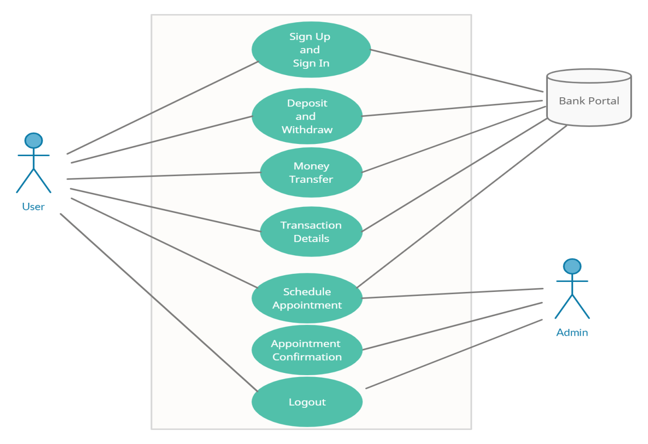

**Figure 1- Use-Case Diagram**

5.2 ER- Diagram

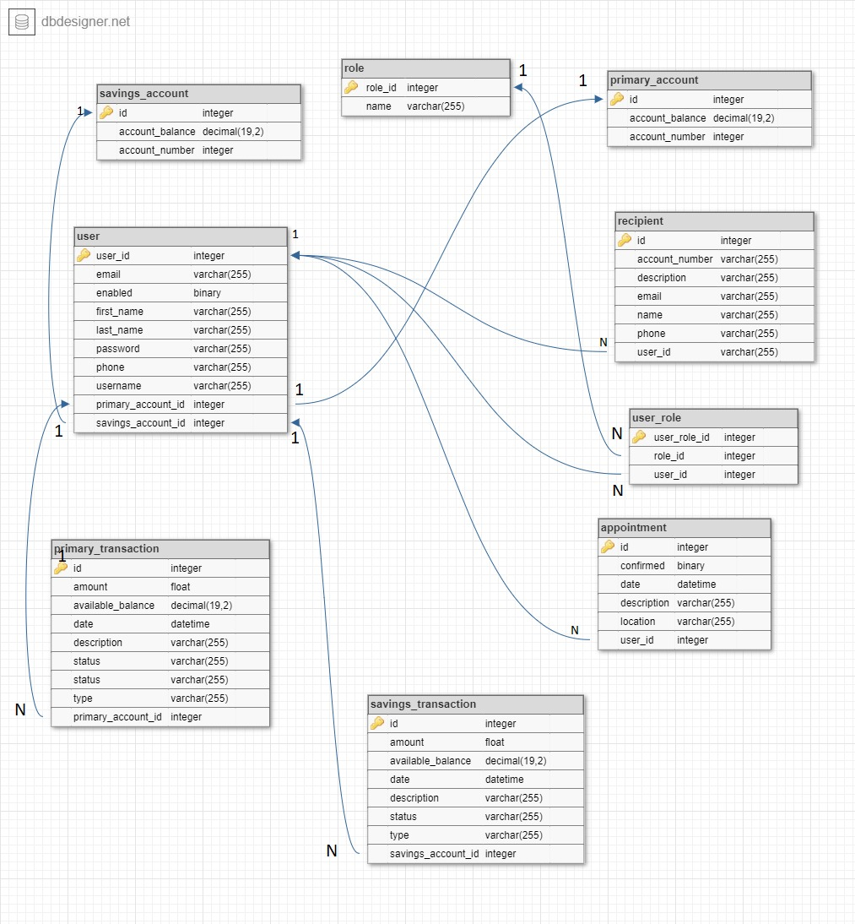

**Figure 2- ER-Diagram**

# TABLE STRUCTURE

**6.1 Appointment:**

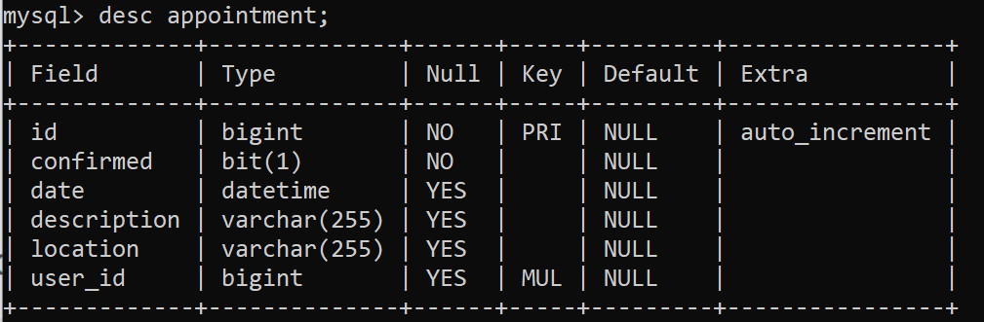

**Table 1 - Appointment**

**6.2 Primary Account:**

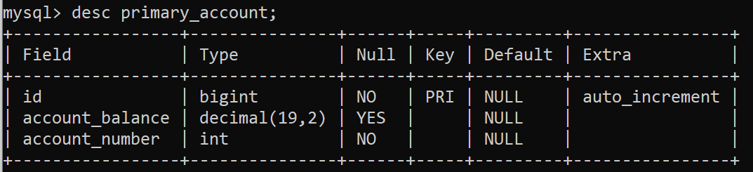

**Table 2 - Primary Account**

**6.3 Savings account:**

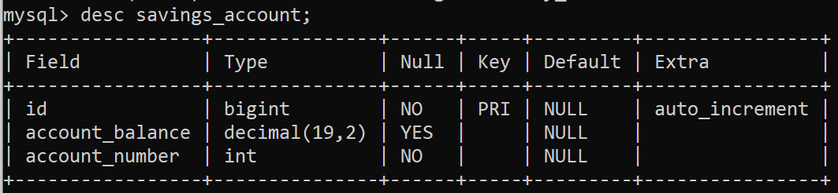

**Table 3 - Savings Account**

**6.4 Primary Transaction:**

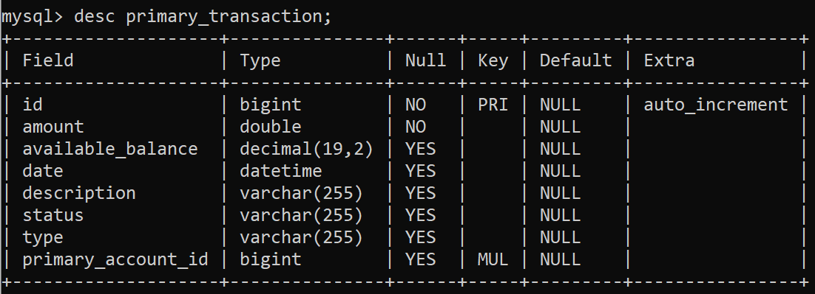

**Table 4 - Primary Transaction**

**6.5 Savings transaction:**

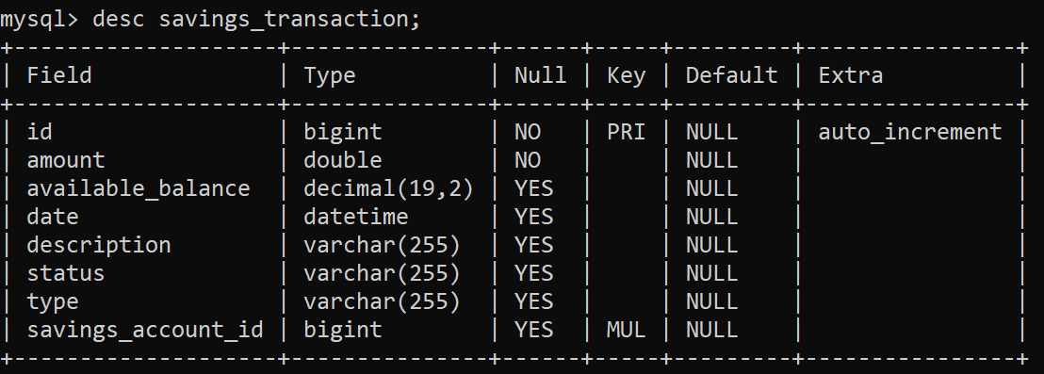

**Table 5 - Savings Transaction**

**6.6 Role:**

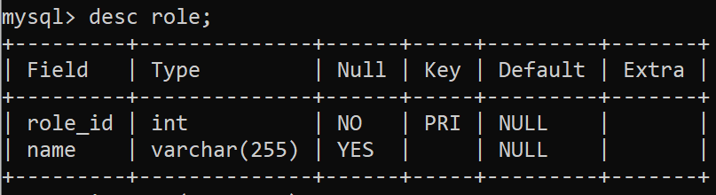

**Table 6 - Role**

**6.7 User role:**

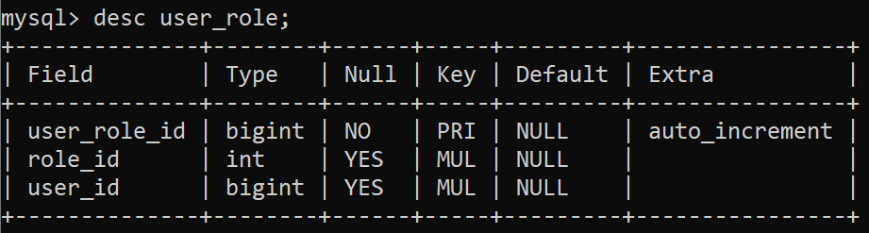

**Table 7- Role ID**

**6.8 User:**

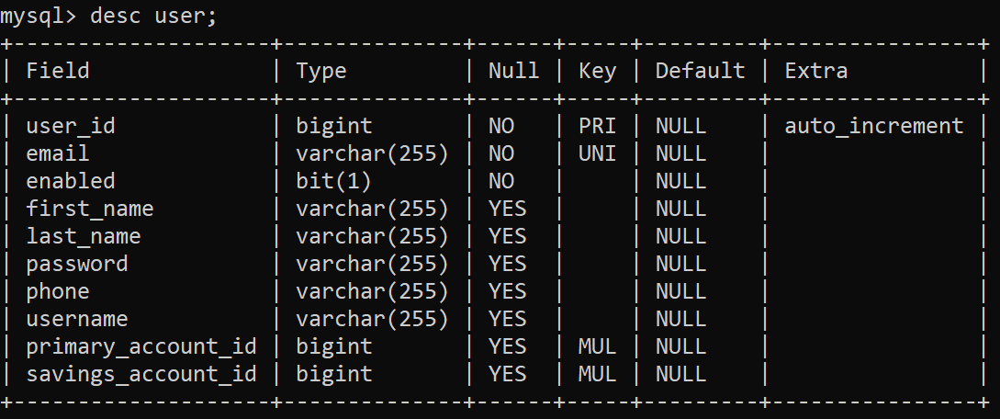

**Table 8 - User**

* 1. **Recipient:**

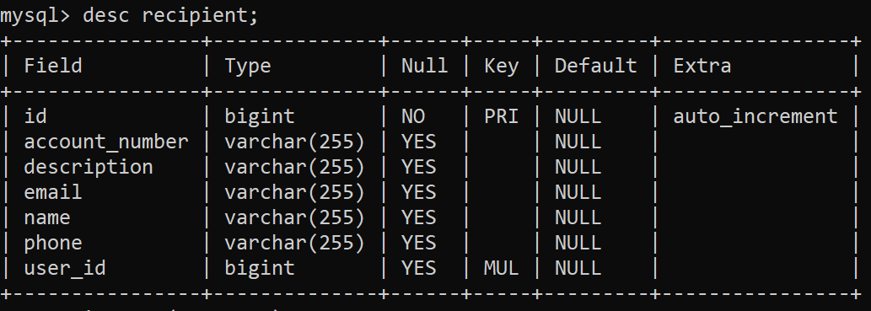

**Table 8 - Recipient**

# 7.1 Conclusion

The basic objective of my research was to analyse the awareness among customers for internet banking in INDIA. It gives direction to research tools, research types and techniques. Although the findings reveal that people know about the services but still many people are unaware and many of them are non – users so the bank should by promotion try to retain the customers. Banks should look forward to have some tie – ups with other financial institutions to increase the service base.

# 7.2 Future Scope

This project can be enhanced further by adding cheque book deposition, other card services, for the users to access through the portal so as to make them easier to access the bank while sitting at home. The software is flexible enough to be modified and implemented as per future requirements. We have tried our best to present this free and user–friendly website to Society members. Message and Email alerts for various happenings in the Banks can be added to the system so that users do not miss the updates and happenings of the society.

## 7.3 References

* 1. <https://docs.npmjs.com/downloading-and-installing-node-js-and-npm>
  2. <https://angular.io/guide/setup-local>
  3. <https://spring.io/projects/spring-boot>
  4. <http://hibernate.org/orm/documentation/getting-started/>
  5. <https://www.codejava.net/frameworks/spring-boot/spring-boot-error-handling-guide>
  6. <https://www.baeldung.com/common-hibernate-exceptions/>