SOFTWARE TESTING REPORT
ERASM
Enterprise Resource Allocation and Skill Management System
Project | Enterprise Resource Allocation and Skill Management System
Prepared By | Prerana Jagadish Santoshi
Qualification | Bachelor of Engineering, Artificial Intelligence & Machine Learning
Organization | Incture Technologies
Document Type | Software Testing Report
Date | 06 July 2026

1 Test Summary
This report documents a JUnit 5 / Mockito test execution run against the ERASM service layer, based on the IDE test-runner and console output captured for this run. The full suite completed in 6.78 seconds with every test passing.
Metric | Result
Total Tests Run | 28
Passed | 28
Errors | 0
Failures | 0
Pass Rate | 100%
Total Execution Time | 6.78 seconds
Test Framework | JUnit 5 (Jupiter), Mockito
Test Type | Service-layer unit tests (repositories mocked)
All 9 test classes reported zero errors and zero failures, shown by the solid green progress bar in the JUnit run panel (Figure 4.1) and the “Runs: 28/28, Errors: 0, Failures: 0” summary line.

2 Test Suite Composition
The suite is organized into nine test classes, one per major service. The table below lists each class as reported by the test runner, together with its execution time.
Test Class | Module Under Test | Duration
SkillServiceTest | Skill Management | 4.647 s
AllocationServiceTest | Resource Allocation | 0.436 s
EmployeeSkillServiceImplTest | Employee Skill Profile | 0.266 s
ResourceRequestServiceTest | Resource Request Management / Approval Workflow | 0.157 s
UserServiceTest | User Management | 0.252 s
AuthServiceTest | Authentication | 0.105 s
ProjectServiceTest | Project Management | 0.094 s
CertificationServiceImplTest | Certification Management | 0.117 s
DashboardServiceTest | Utilization Dashboard | 0.017 s
SkillServiceTest accounts for the majority of the total run time (4.647 of 6.78 seconds); this is consistent with it being the first test class executed, which typically absorbs the JVM and Spring context class-loading overhead for the whole run rather than indicating a slow test itself.

3 Test Execution Log Analysis
The console output produced during the run demonstrates that the tests are not merely checking trivial getters and setters, but are exercising real business rules and producing both successful (INFO) and intentionally rejected (WARN) outcomes. The log is grouped below by module; timestamps are as captured in the console output.

Skill Management
Time | Level | Module | Message
18:13:37.144 | INFO | SkillService | Skill added: Java

Resource Allocation
Time | Level | Module | Message
18:13:37.551 | WARN | AllocationService | Allocation rejected for employee id 1: current=70.0%, requested=40.0%, total would be 110.0%
18:13:37.620 | WARN | AllocationService | Allocation rejected for employee id 1: current=70.0%, requested=50.0%, total would be 120.0%
18:13:37.657 | INFO | AllocationService | Employee id 1 allocated 40.0% to project 'Healthcare Portal'
These three lines together demonstrate the 100% allocation cap rule working correctly: two attempts that would have pushed the employee's total allocation to 110% and 120% were both rejected, while a valid 40% allocation on top of an existing 70% (well within an allowed combination) was accepted.

Employee Skill Profile
Time | Level | Module | Message
18:13:37.904 | INFO | EmployeeSkillServiceImpl | Skill 'Java' added to employee id 1
18:13:37.914 | WARN | EmployeeSkillServiceImpl | Duplicate skill assignment attempted: employee id 1, skill id 1
Confirms both the successful path (assigning a new skill to an employee) and the duplicate-prevention rule (rejecting a second attempt to assign the same skill to the same employee).

Resource Request Management and Approval Workflow
Time | Level | Module | Message
18:13:38.062 | INFO | ResourceRequestService | Resource request id 1 transitioned from DRAFT to SUBMITTED
18:13:38.078 | WARN | ResourceRequestService | Rejected invalid workflow transition for resource request id 1: COMPLETED -> SUBMITTED
18:13:38.103 | WARN | ResourceRequestService | Rejected invalid workflow transition for resource request id 1: DRAFT -> APPROVED
Confirms the approval workflow state machine: a legal transition (DRAFT to SUBMITTED) succeeds, while two illegal transitions, moving backward from a terminal COMPLETED state, and skipping directly from DRAFT to APPROVED without the intermediate review stage, are both correctly rejected.

User Management
Time | Level | Module | Message
18:13:38.348 | INFO | UserService | Password changed for user: jane@erasm.com
18:13:38.359 | INFO | UserService | Role 'RESOURCE_MANAGER' assigned to user jane@erasm.com

Authentication
Time | Level | Module | Message
18:13:38.459 | INFO | AuthService | New user registered: jane@erasm.com

Project Management
Time | Level | Module | Message
18:13:38.555 | INFO | ProjectService | Project closed: Healthcare Portal
18:13:38.562 | INFO | ProjectService | Project created: Healthcare Portal
These two lines appear in this order because each test method runs independently with its own mocked setup; they are not evidence of a project being closed before it was created.

Certification Management
Time | Level | Module | Message
18:13:38.673 | WARN | CertificationServiceImpl | Attempt to update certification id 5 that does not belong to employee id 2
18:13:38.682 | INFO | CertificationServiceImpl | Certification 'Oracle Certified Java Programmer' added for employee id 1
Confirms an ownership check: an attempt to update a certification record under the wrong employee id is correctly rejected, while adding a new, correctly owned certification succeeds.

4 Screenshots

Console Output
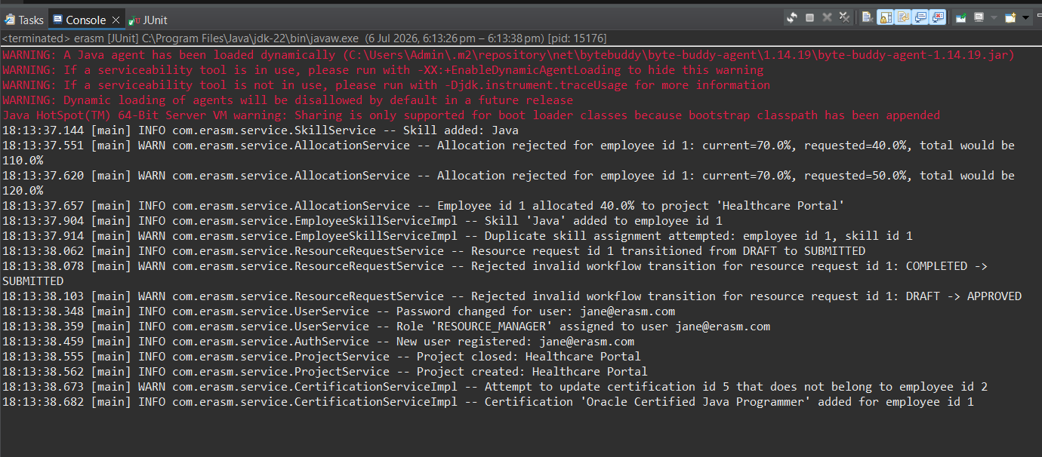
Figure 4.1 — Console output from the test run, showing INFO and WARN log lines from each service

JUnit Test Runner Summary
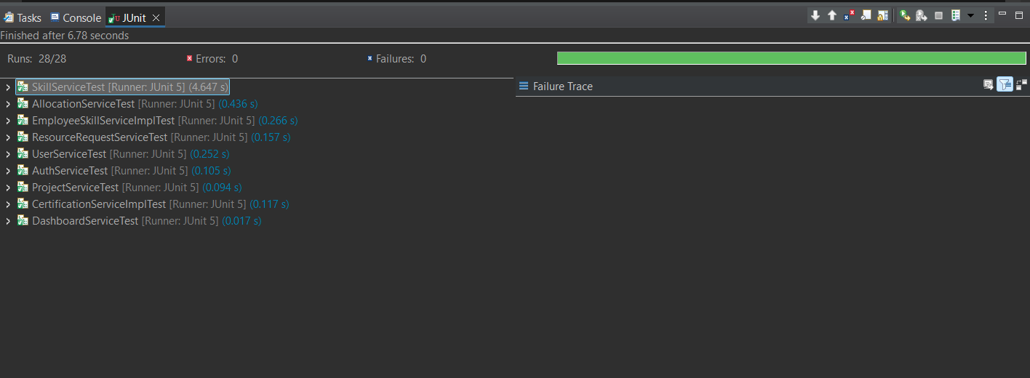
Figure 4.2 — JUnit run panel: 28/28 runs passed, 0 errors, 0 failures, finished after 6.78 seconds

5 Conclusion
The test run documented in this report shows a 100% pass rate across 28 tests spanning all nine core services in the ERASM application, with zero errors and zero failures. Beyond the raw pass count, the console log confirms that the tests are validating meaningful business rules rather than incidental behavior: the 100% allocation cap, duplicate skill and duplicate allocation prevention, the approval workflow's state machine (including rejection of both backward and skipped transitions), and certification ownership checks are all exercised and shown working as intended.
This provides a solid verification baseline for the service layer. As noted elsewhere in this project's documentation, extending this same style of coverage to any remaining service methods, and adding controller-level (MockMvc) or full end-to-end integration tests for the REST API surface, would further strengthen confidence ahead of deployment.

