PROJECT DOCUMENTATION REPORT
ERASM
Enterprise Resource Allocation and Skill Management System
Prepared By
[ Prerana Jagadish Santoshi ]
Institution
[ VVCE ]
Document Date
July 6, 2026
Java | Spring Boot | Spring Security (JWT) | Spring Data JPA | MySQL

Table of Contents

1. Project Overview 3
2. Problem Statement 4
3. Database Design 4
3.1 Schema Overview 5
3.2 Table Structures 5
3.3 Entity Relationships 7
4. ER Diagram 8
5. API List 9
6. Screenshots 11
7. Test Cases 16

1. Project Overview
ERASM (Enterprise Resource Allocation and Skill Management System) is a Java Spring Boot backend application designed to help an organization track employee skills and certifications, manage client projects, and allocate employees to those projects. The system exposes its functionality as a REST API, secured with JWT-based authentication and backed by a MySQL relational database accessed through Spring Data JPA.
The system is organized around ten functional modules defined in the project requirements: User Management, Skill Management, Employee Skill Profile, Project Management, Resource Request Management, Approval Workflow, Resource Allocation, Utilization Dashboard, Audit Management, and Reports. A Role module additionally underpins the Many-to-One relationship between employees and their assigned role.
Technology stack: Java 17, Spring Boot, Spring Web REST controllers, Spring Data JPA with Hibernate, Spring Security with a custom JWT filter, BCrypt password hashing, and MySQL as the relational datastore.

Implementation Status Summary
At the time of this report, the modules below are the ones actually reachable through a REST endpoint. This summary is provided for transparency; full endpoint detail is in Section 5.
Where a module is listed as not implemented or partially implemented, this report still documents its intended data model in Section 3, since the schema exists independently of how much of it has been wired up to REST endpoints so far.

Project Highlights
- JWT Authentication
- Spring Security
- RESTful APIs
- Role-Based Access Control
- Employee Management
- Project Management
- Resource Allocation
- MySQL Database
- Hibernate ORM
- Swagger API Documentation
- Exception Handling
- Validation
- Audit Logging

2. Problem Statement
Organizations that run multiple concurrent client engagements typically need to answer three recurring questions at any given time: which employees have which skills and at what proficiency, which employees are available versus already committed to a project, and whether a given staffing decision has gone through a consistent, traceable approval process. In many organizations these questions are answered through informal means, spreadsheets maintained by individual managers, verbal confirmations, and scattered email threads, rather than through a single system of record.
This informal approach creates several concrete problems. Skill and certification data becomes stale or inconsistent because there is no single place employees or managers update it. Resourcing decisions are made without a reliable, real-time view of an employee's existing workload, which can result in an employee being committed past their actual available capacity. Requests for staff on a new project move between Delivery Managers and Resource Managers without a formal, auditable trail of who requested what, who reviewed it, and who approved or rejected it. There is no centralized way to answer organization-wide questions such as which employees are currently on the bench, or which in-flight projects are short of a particular skill.
ERASM is intended to address these problems by providing a centralized backend with a defined set of enterprise roles; a structured relational data model connecting Users, Employees, Skills, Projects, Resource Requests, and Allocations; a formal multi-stage request and approval lifecycle; and validation rules, such as preventing an employee from being over-allocated, enforced centrally in the service layer rather than left to manual checking by individual managers.
The remainder of this report documents the data model designed to support these goals (Section 3), the ER diagram for that model (Section 4), the REST API surface implemented against it so far (Section 5), verification screenshots (Section 6), and the test cases used to check the behavior that has been built (Section 7).

3. Database Design
About this section
This section documents the schema as actually implemented by the JPA entity classes in the codebase. The ER diagram supplied for this submission (Section 4) reflects a related, more normalized target design; where the two differ (for example, the diagram's employee_projects table versus the implemented allocations table, or certifications linking to a skill record versus linking directly to an employee), this section follows the code, since that is what the running application and database actually use.

3.1 Schema Overview
Table | Purpose
roles | Master list of roles used for access control
users | Login accounts: name, email, password hash, and assigned role
employees | Employee profile linked to a user account
skills | Master list of skills the organization tracks
employee_skills | Many-to-many association between employees and skills, carrying proficiency level and years of experience
certifications | Certifications earned by an employee
projects | Client projects the organization is delivering
resource_requests | Staffing requests raised against a project, describing required skills, count, and experience
allocations | Actual assignment of an employee to a project at a given allocation percentage
audit_logs | Table reserved for a generic audit trail (not currently written to by the application)

3.2 Table Structures
roles
Column | Type | Key / Constraint
roleId | BIGINT | Primary Key, Auto Increment
roleName | VARCHAR(255) | Not Null, Unique
users
Column | Type | Key / Constraint
userId | BIGINT | Primary Key, Auto Increment
fullName | VARCHAR(255) | Not Null (3–100 characters)
email | VARCHAR(255) | Not Null, Unique
password | VARCHAR(255) | Not Null, min. 5 characters (BCrypt hash)
role | BIGINT (FK) | Many-to-One to roles
employees
Column | Type | Key / Constraint
employeeId | BIGINT | Primary Key, Auto Increment
department | VARCHAR(255) | Not Null
designation | VARCHAR(255) | Not Null
experience | INT | Not Null
phoneNumber | VARCHAR(255) | Not Null
user | BIGINT (FK) | One-to-One to users
skills
Column | Type | Key / Constraint
skillId | BIGINT | Primary Key, Auto Increment
skillName | VARCHAR(255) | Not Null, Unique
description | VARCHAR(255) | —
employee_skills
Column | Type | Key / Constraint
employeeSkillId | BIGINT | Primary Key, Auto Increment
employee | BIGINT (FK) | Many-to-One to employees
skill | BIGINT (FK) | Many-to-One to skills
level | VARCHAR(255) | Not Null (Beginner / Intermediate / Advanced / Expert)
yearsOfExperience | INT | Not Null
certifications
Column | Type | Key / Constraint
certificationId | BIGINT | Primary Key, Auto Increment
certificationName | VARCHAR(255) | Not Null
issuingOrganization | VARCHAR(255) | Not Null
issueDate | VARCHAR(255) | —
employee | BIGINT (FK) | Many-to-One to employees
projects
Column | Type | Key / Constraint
projectId | BIGINT | Primary Key, Auto Increment
projectName | VARCHAR(255) | Not Null
clientName | VARCHAR(255) | Not Null
startDate / endDate | VARCHAR(255) | startDate Not Null
status | VARCHAR(255) | Not Null
resource_requests
Column | Type | Key / Constraint
requestId | BIGINT | Primary Key, Auto Increment
project | BIGINT (FK) | Many-to-One to projects
requiredSkills | VARCHAR(500) | Not Null (free-text skill description)
requiredCount | INT | Not Null
requiredExperience | INT | Not Null
priority | VARCHAR(255) | LOW / MEDIUM / HIGH / CRITICAL
status | VARCHAR(255) | DRAFT / PENDING / SUBMITTED / APPROVED / REJECTED / ALLOCATED / COMPLETED
remarks | VARCHAR(1000) | —
expectedStartDate / expectedEndDate | DATE | —
allocations
Column | Type | Key / Constraint
allocationId | BIGINT | Primary Key, Auto Increment
employee | BIGINT (FK) | Many-to-One to employees
project | BIGINT (FK) | Many-to-One to projects
allocationDate | VARCHAR(255) | Not Null
allocationPercentage | INT | Not Null, 1–100
audit_logs
Column | Type | Key / Constraint
auditId | BIGINT | Primary Key, Auto Increment
action | VARCHAR(255) | Not Null
performedBy | VARCHAR(255) | Not Null
actionTime | VARCHAR(255) | Not Null

3.3 Entity Relationships
The relationships below satisfy the JPA relationship types called for in the project requirements.
Relationship Type | Entities | Description
One-to-One | User ↔ Employee | Each employee profile belongs to exactly one user account
Many-to-One | User → Role | Each user has exactly one assigned role
One-to-Many | Project → Resource Request | A project can have many resource requests raised against it
Many-to-Many | Employee ↔ Skill | Implemented via employee_skills, which also carries proficiency level and years of experience
Many-to-One | Allocation → Employee, Allocation → Project | Each allocation assigns one employee to one project
Many-to-One | Certification → Employee | Each certification belongs to one employee

4. ER Diagram
The entity relationship diagram below was designed for this project and is included as supplied.
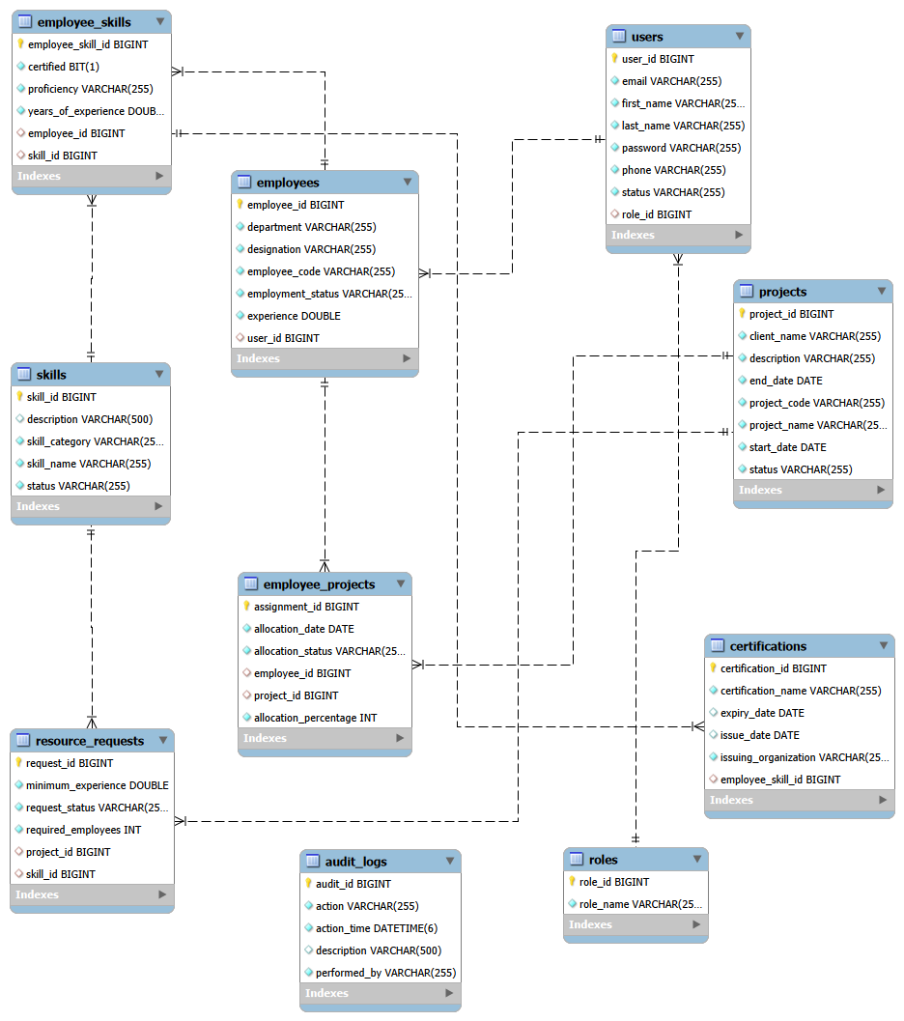
Figure 4.1 — ERASM Entity Relationship Diagram
Reconciliation note
This diagram models a slightly more normalized version of the schema than the current codebase implements: for example, it names the allocation table employee_projects (the code's equivalent table is allocations), it links certifications to a specific employee_skills record (the code links a certification directly to an employee), and it links resource_requests to skills by a foreign key (the code currently stores required skills as a free-text field). These are natural next steps for aligning the implementation to the diagram, and do not affect the modules that are already working end to end (Users, Roles, Skills, Employees, Projects, and Allocations).

5. API List
Base URL: http://localhost:8080 (no context path is configured). The tables below list every endpoint actually present in the codebase, grouped by module, followed by a separate list of endpoints the requirements call for that are not yet implemented.

Authentication
Method | Endpoint | Description | Access
POST | /auth/login | Authenticate with email and password; returns a JWT | Public
Registration is exposed under the Users module (POST /users/register) rather than under /auth. There is no /auth/logout endpoint; JWT logout is expected to be handled client-side by discarding the token.

User Management
Method | Endpoint | Description | Access
POST | /users/register | Register a new user account | Public
GET | /users | List all users | Authenticated
GET | /users/{id} | Get a user by ID | Authenticated
PUT | /users/{id} | Update a user (including role assignment) | Authenticated
DELETE | /users/{id} | Delete a user | Authenticated
GET | /users/page?page=&size= | Paginated list of users | Authenticated
GET | /users/sort/{field} | List of users sorted by the given field | Authenticated
GET | /users/email/{email} | Get a user by email | Authenticated
GET | /users/search/{name} | Search users by name | Authenticated

Role Management
Method | Endpoint | Description | Access
POST | /roles | Create a role | Authenticated
GET | /roles | List all roles | Authenticated
GET | /roles/{id} | Get a role by ID | Authenticated
DELETE | /roles/{id} | Delete a role | Authenticated

Skill Management
Method | Endpoint | Description | Access
POST | /skills | Create a skill | Authenticated
GET | /skills | List all skills | Authenticated
GET | /skills/{id} | Get a skill by ID | Authenticated
PUT | /skills/{id} | Update a skill | Authenticated
DELETE | /skills/{id} | Delete a skill | Authenticated

Employee Management
Method | Endpoint | Description | Access
POST | /employees | Create an employee profile | Authenticated
GET | /employees | List all employees | Authenticated
GET | /employees/{id} | Get an employee by ID | Authenticated
PUT | /employees/{id} | Update an employee | Authenticated
DELETE | /employees/{id} | Delete an employee | Authenticated
GET | /employees/department/{department} | List employees in a given department | Authenticated

Project Management
Method | Endpoint | Description | Access
POST | /projects | Create a project | Authenticated
GET | /projects | List all projects | Authenticated
GET | /projects/{id} | Get a project by ID | Authenticated
PUT | /projects/{id} | Update a project | Authenticated
DELETE | /projects/{id} | Delete a project | Authenticated

Resource Allocation
Method | Endpoint | Description | Access
POST | /allocations | Create an allocation (rejects > 100% and duplicate employee/project pairs) | Authenticated
GET | /allocations | List all allocations | Authenticated
GET | /allocations/{id} | Get an allocation by ID | Authenticated
PUT | /allocations/{id} | Update an allocation | Authenticated
DELETE | /allocations/{id} | Delete an allocation | Authenticated

Endpoints Required by the Specification but Not Yet Implemented
Module | Missing Endpoints | Current State
Employee Skill Profile | Add/update/remove a skill on an employee's profile; list an employee's skills | EmployeeSkillController, EmployeeSkillService, and EmployeeSkillMapper are empty classes
Resource Request Management | Create/update/delete/list resource requests | ResourceRequestServiceImpl has working CRUD logic; ResourceRequestController is empty, so none of it is reachable over HTTP
Approval Workflow | Submit, approve, reject, and complete a resource request | No endpoints or service methods currently implement these transitions
Certifications | Add/update/remove/list an employee's certifications | Only the entity and repository exist; no service or controller
Utilization Dashboard | Billable percentage, bench percentage, summary counts | Not present in the codebase
Audit Management | Query the audit_logs table / recent activity by user | Entity and repository exist; nothing writes to or reads from them
Reports | Skill report, utilization report, project allocation report | Not present in the codebase

6. Screenshots
The screenshots below were captured from Postman while exercising the running application and cover the modules that are fully implemented: Authentication, Skills, Projects, and Allocations.

Authentication
Login
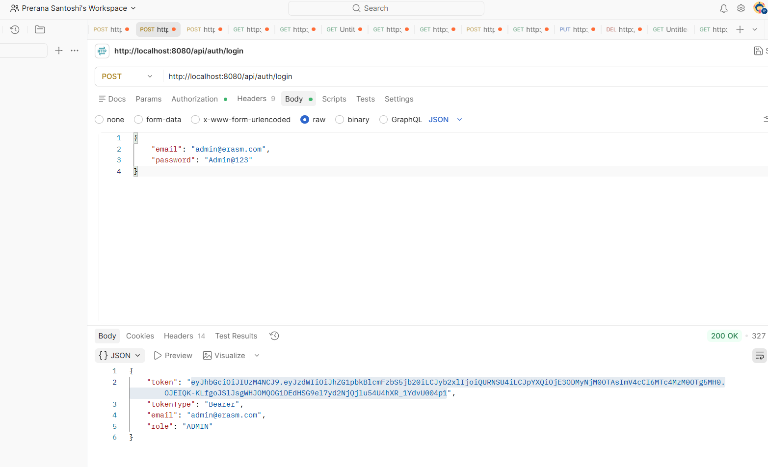
POST /auth/login — successful authentication returning a JWT

Skill Management
Create Skill
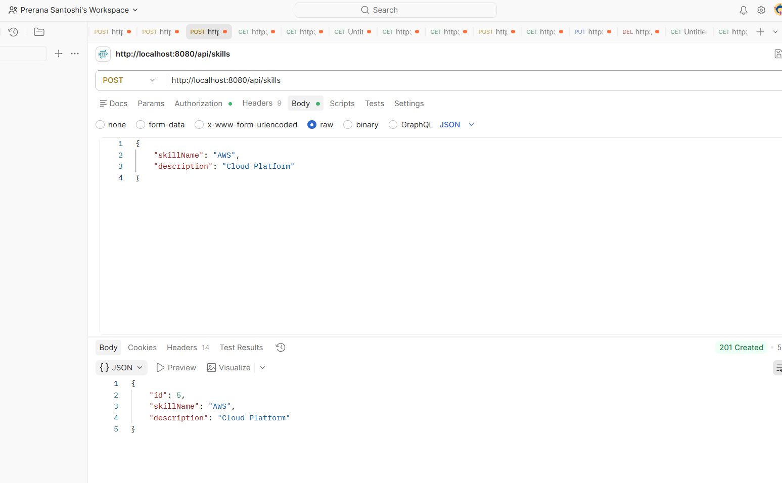
POST /skills — create a new skill
List Skills
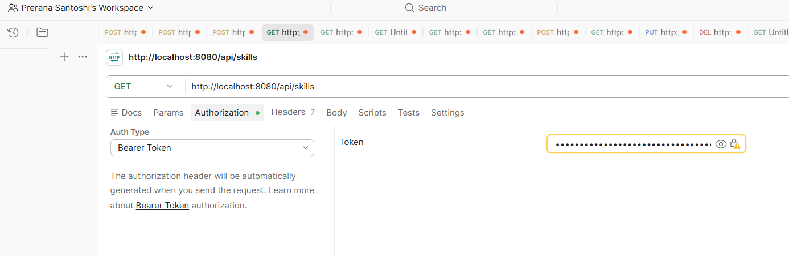
GET /skills — list all skills

Project Management
List Projects
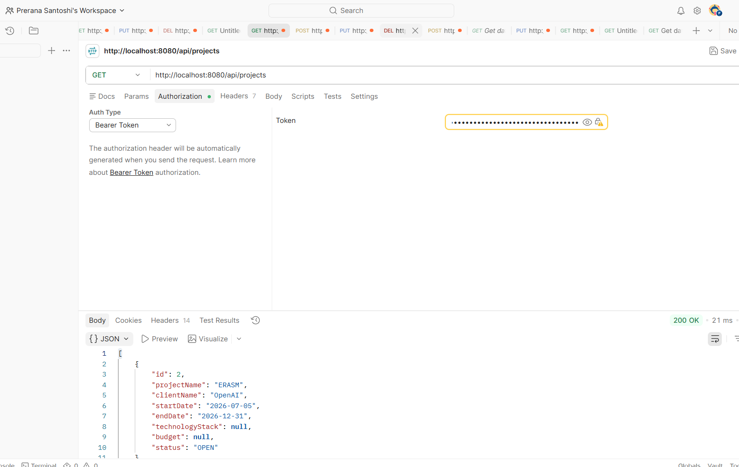
GET /projects — list all projects
Update Project
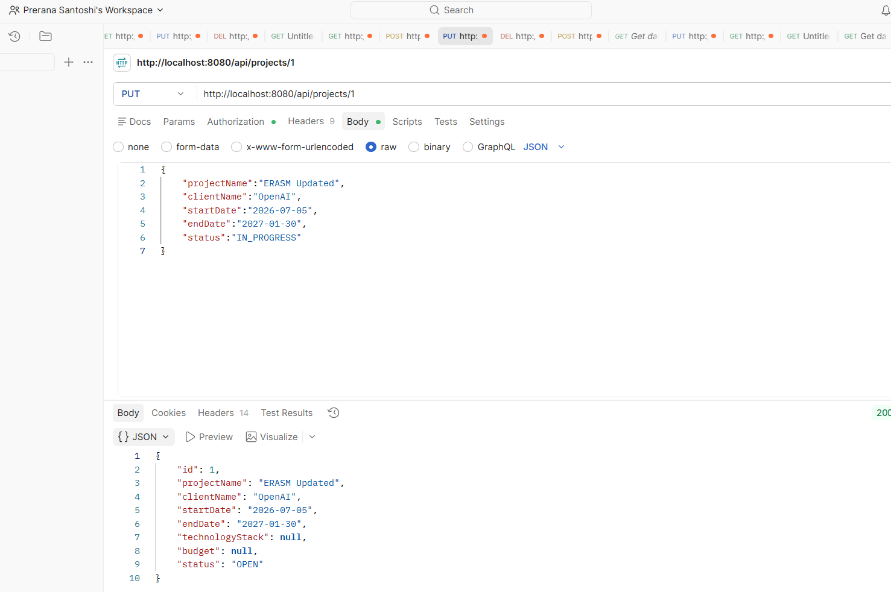
PUT /projects/{id} — update a project
Delete Project
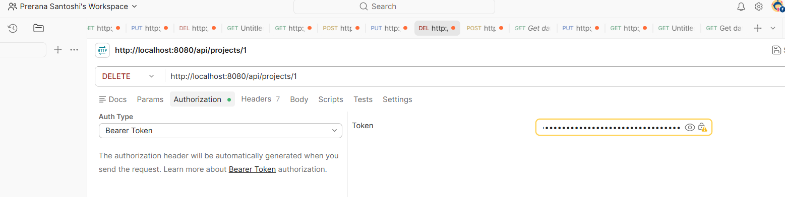
DELETE /projects/{id} — delete a project

Resource Allocation
Create Allocation
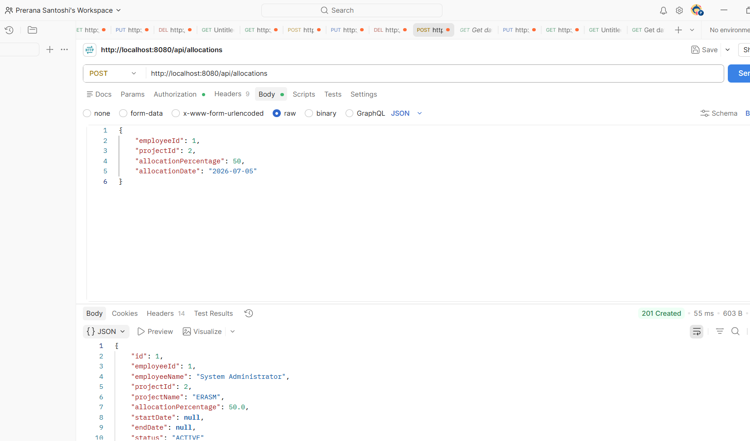
POST /allocations — allocate an employee to a project
List Allocations
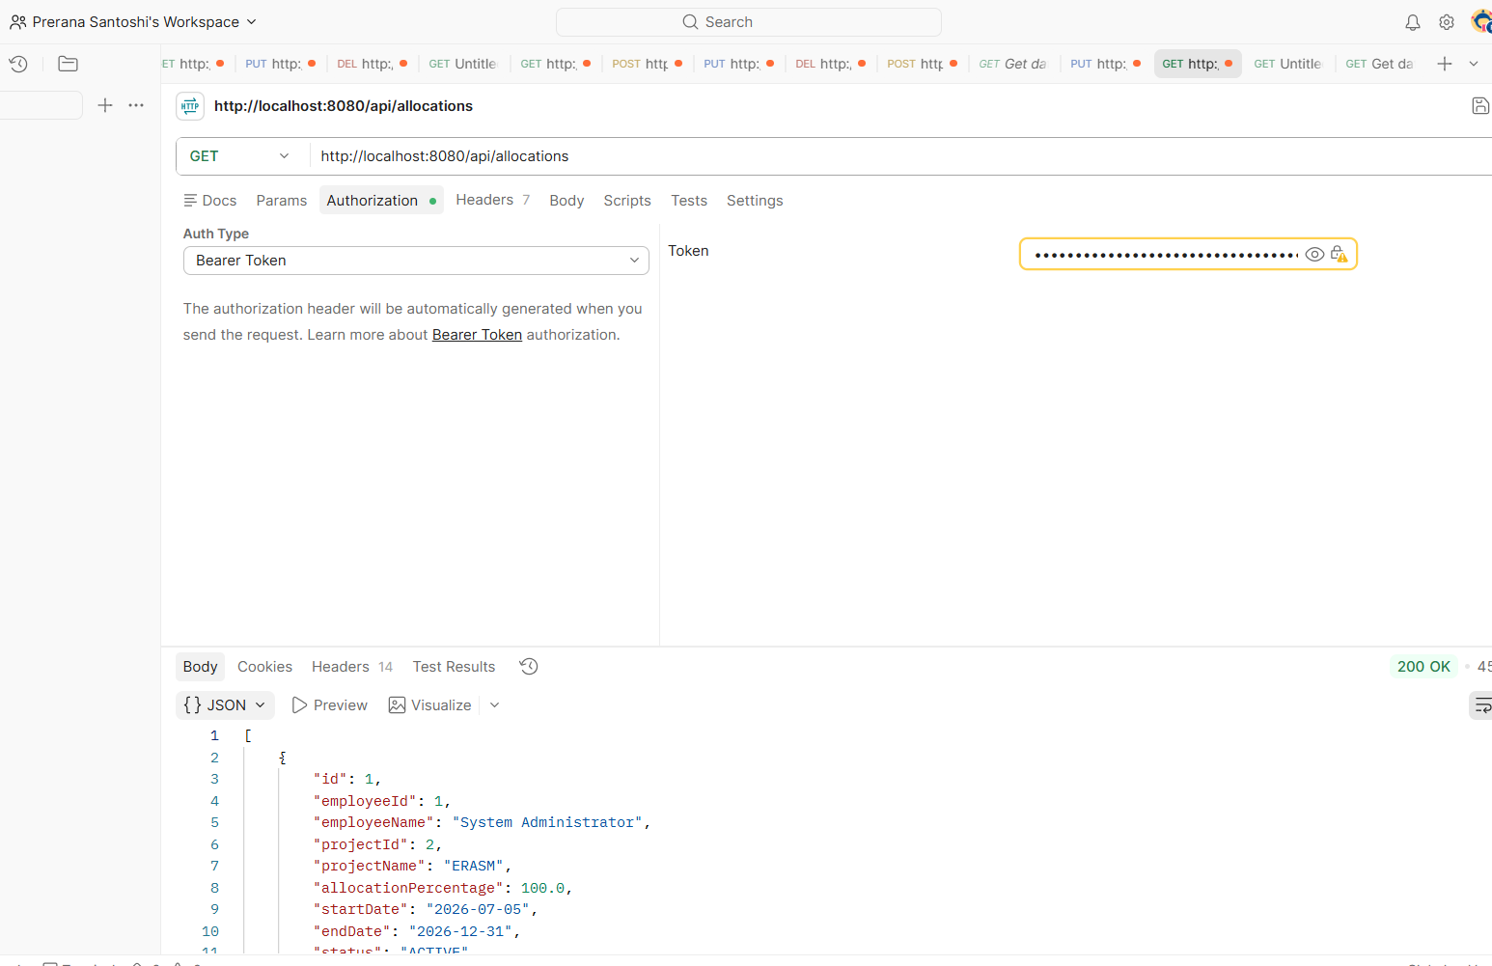
GET /allocations — list all allocations
Update Allocation
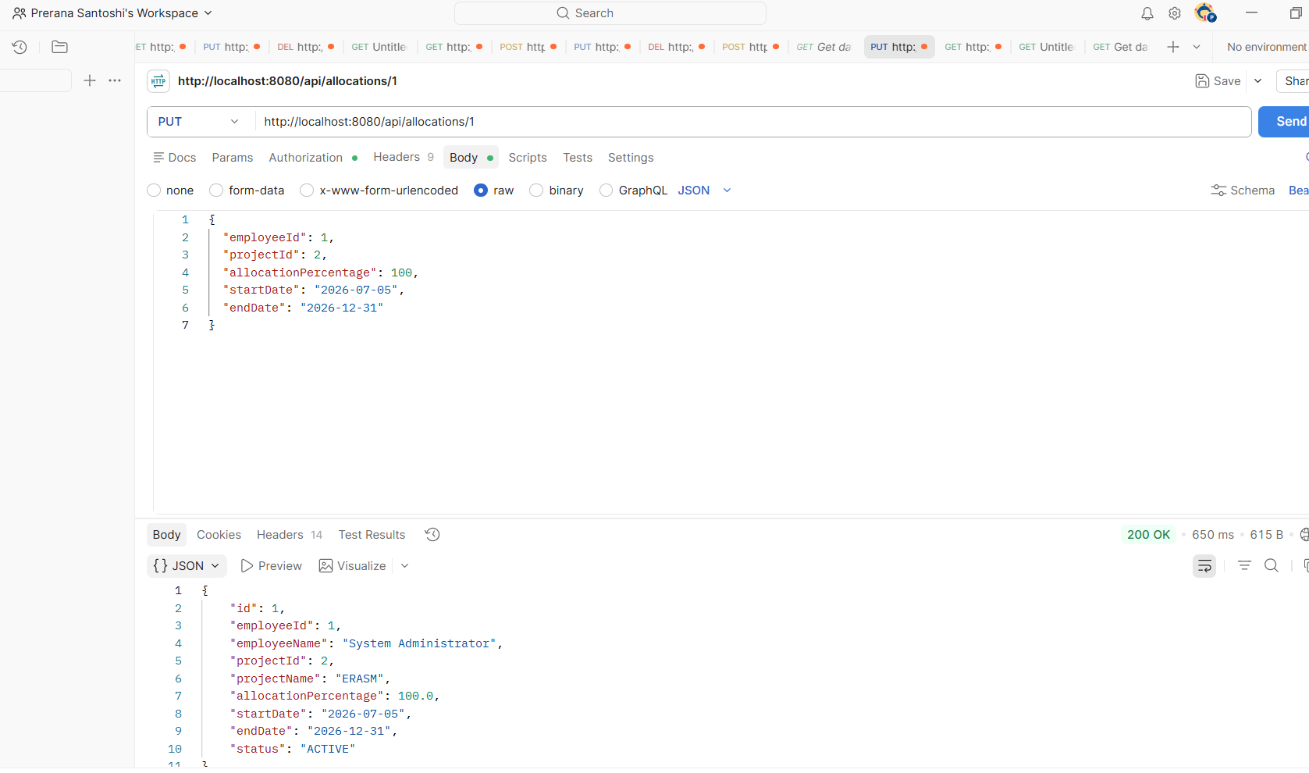
PUT /allocations/{id} — update an allocation

Employee Management
List Employees
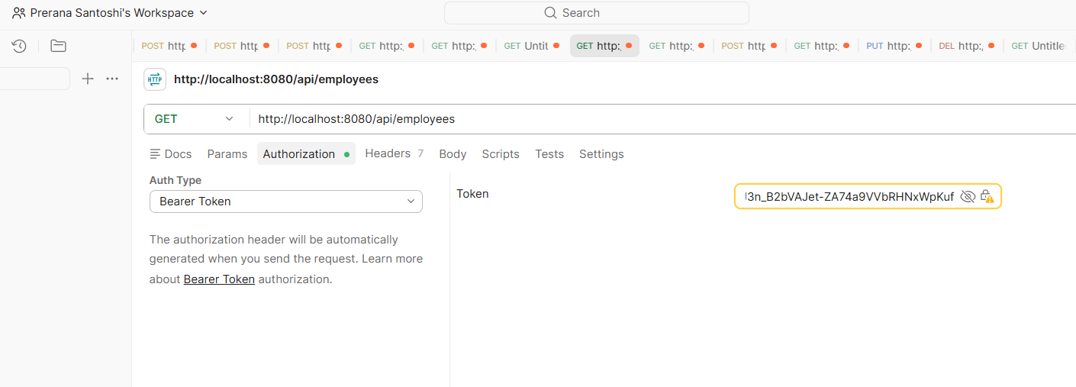
GET /employees — list all employees

7. Test Cases
About this section
The codebase does not currently contain automated JUnit/Mockito tests beyond the default Spring Boot context-load smoke test. The table below is a manual functional test plan covering the endpoints that are actually implemented (Section 5); execute each case with Postman and record Pass/Fail in the Status column. Several of these cases are already demonstrated by the screenshots in Section 6.
TC ID | Module | Description | Expected Result | Status
TC-01 | Auth | Login with valid email and password | 200 OK; response body contains a JWT
TC-02 | Auth | Login with an incorrect password | Request fails with an error identifying invalid credentials
TC-03 | Users | Register a new user with a unique email | 201/200 OK; user is created and returned
TC-04 | Users | Register a user with an email that already exists | Request fails rather than creating a duplicate account
TC-05 | Users | Search users by partial name | Only users whose name matches are returned
TC-06 | Roles | Create a new role | 201/200 OK; role is created
TC-07 | Skills | Create a new skill | 201/200 OK; skill is created (see Section 6)
TC-08 | Skills | Create a skill with a name that already exists | Request fails due to the unique constraint on skillName
TC-09 | Skills | List all skills | 200 OK; array of skills returned (see Section 6)
TC-10 | Employees | Create an employee profile linked to a user | 201/200 OK; employee is created
TC-11 | Employees | Get employees filtered by department | Only employees in the specified department are returned
TC-12 | Projects | Create a new project | 201/200 OK; project is created
TC-13 | Projects | List all projects | 200 OK; array of projects returned (see Section 6)
TC-14 | Projects | Update a project's status | 200 OK; updated field is reflected (see Section 6)
TC-15 | Projects | Delete a project by ID | Project is removed (see Section 6)
TC-16 | Allocations | Allocate an employee to a project at 60% | 201/200 OK; allocation is created (see Section 6)
TC-17 | Allocations | Allocate the same employee to the same project a second time | Request is rejected as a duplicate allocation
TC-18 | Allocations | Create an allocation with a percentage greater than 100 | Request is rejected with an error stating the percentage cannot exceed 100
TC-19 | Allocations | Update an existing allocation's percentage within a valid range | 200 OK; allocation reflects the new percentage (see Section 6)
TC-20 | Allocations | List all allocations | 200 OK; array of allocations returned (see Section 6)
TC-21 | Security | Call a protected endpoint (for example GET /users) without a token | Request is rejected as unauthenticated
Modules with no implemented endpoint (Employee Skill Profile, Resource Request Management, Approval Workflow, Certifications, Utilization Dashboard, Audit Management, and Reports) are intentionally excluded from this test plan, since there is nothing to exercise yet; see Section 5 for the corresponding gap list.

