Project Proposal

On

**Employee Payroll System**



EPS

Computing Project

Level 5 Diploma in Computing

Softwarica College of IT & E-Commerce

Kathmandu, Nepal

Submission Date: 9th April 2019

Submitted By: Submitted To:

Prerana Pandit Mr. Sudeep Lal Bajimaya

NCC ID: 00174363 Module Head

Batch: 22A

**Table of Contents**

**Table of Figures** 3

**Keywords** 4

**Chapter 1: Introduction** 5

1.1 Project Introduction 5

1.2 Justification of the project 6

1.3 Background of the project 6

1.4 Problem Statement 7

1.5 Description of the project 7

1.6 Feature of the project 8

1.7 Overview of the project 9

**Chapter 2: Scope of the project** 10

2.1 Scope 10

2.2 Limitation 10

2.3 Aims 10

2.4 Objectives 11

2.5 Overview of the scope 11

**Chapter 3: Development Methodology** 12

3.1 Description of the methodology 12

3.2 Design Pattern 14

3.3 System Architecture 15

**Chapter 4: Project Planning (WBS)** 16

4.1 About WBS (Work Breakdown Structure) 16

4.2 Milestone 17

4.3 Gantt chart 19

**Chapter 5: Risk Management** 22

**Chapter 6: Configuration Management** 25

**Chapter 7: Conclusion** 26

**Chapter 8: References** 27

# **Table of Figures**

**Figure 1: Modified Waterfall Model as development methodology** 12

**Figure 2: Model View Controller MVC as design pattern** 14

**Figure 3: 3-tier architecture as system architecture** 15

Figure 4: Work Breakdown Structure (WBS) 16

**Figure 5: Milestone of the project** 17

**Figure 6: Tasks and milestones of the EPS** 19

**Figure 7: Project Structure** 20

**Figure 8: Gantt chart of EPS** 21

**Figure 9: Lifecycle of Risk Management** 23

**Figure 10: Risk Management table** 24

**Figure 11: Directory** 25

# **Keywords**

EPS – Employee Payroll System

MVC – Model View Controller

Feasibility – the degree of being easily done

UI – User Interface

Focus groups – group of people those who are participated in an discussion for requirements gathering and overall development phases

Questionnaires – list of questions for statistical study where answers may be same or differ from one another

# **Chapter 1: Introduction**

## Project Introduction

Small business, Companies and Organizations are rapidly growing everywhere with higher competition than ever, where employees plays a vital role for the continuous success and progress. Similarly, management of accounts, maintaining proper records of all employees’ attendance and time for the preparation of payroll manually has always been challenging aspect which is very complex, time consuming, without up-to-date with taxes and most importantly not secured.

So, for the easy integration and access, **Employee Payroll System** can be developed to make tasks easier. **EPS** is a flexible, user-friendly and distributed application developed to evaluate the performance of employees. It assists the accounts department in many ways that includes calculating wages, keeping track of hours, withholding taxes and deductions, paying employee taxes to the government and generating the salary sheet. It is a window application that maintains employee details with unique information.

**EPS** is not only a payroll and tax compliance partner; it also provides an entire unified platform of solutions and services to help with all human capital management needs.

## Justification of the project

Minimizing the manual efforts and simplifying information, EPSprovides benefit to the organization or companiesin many waysthat helps in building trust among employees. It provides accurate calculations and complete solution of payroll needs which are also affordable. Outsourcing an EPS saves time and effort with keeping records secure and confidential. So, on the basis of company’s requirements, parameters and actions, the system must be implemented. Furthermore, the details can be known from the background of the project and problem statements.

## Background of the project

The term payroll processing refers to management of employee’s payment of wages or other compensation where salaries are paid on the basis of their working hours or their working intelligence. Thus, maintaining their salaries from overall deduction and taxes has been one of the challenging aspects for organizations or companies, so to overcome those challenges, employee payroll system can be developed with different payment methods. The benefit of an employee payroll system is to track the employee productivity in working environment. This makes easier in determining the performance and their productivity as shown on the Human Resources records or through similar methods of monitoring productivity. The recorded statistical details can be analyzed through various mediums which shows particular employees working details with their progression or degradation of performances.

On the other side, manual system of organizing records of the employees creates a lot of errors with maximum time consumption. Thus, the main motive of EPS is to improve the working methodology with secured backup files and records that leads to faster, shorter and lessen of processes and organized data.

## Problem Statement

Maximum number of companies or small business are still using a manual system for payment of employees and keeping tracks of their previous records that has slow down their effectiveness and time. As per time and trend, companies need to establish a computerized employee payroll system that can operate with ease and speed-up the storage of information. Manual system consumes a lot of time, similarly accountant finds very hard to search, edit and produce reports through a vast amount of data but with modernized payroll system, efficiency has been increased for producing reports and performance time has also become much more effective. With the new EPS, inconsistencies cannot be resolved immediately and effectively due to the distance between the departments of a single company. One cannot simply comply with the records immediately from another departments. The most significant situation is the errors in computation, non-secured files and database, no any back-ups in case of data-loss are all faced from the manual handling of the payroll system. So, Employee Payroll System has been integrated to overcome overall faults.

## Description of the project

Employee payroll system encompasses each employee those who receives regular payments with different methods calculated by a manager or payroll specialist. The payment is finalized with the employees working hour’s rate or gross income amount with the regular deduction of taxes, medical insurance, leave or many more. The remained balance is further revised and hence becomes the employee’s net payment amount for that time period. The overall setting up of an effective employee payroll system consumes time but becomes very much effective for the user. EPS involves every payment activities like filing of employment taxes, keeping track of hours, calculating salary, delivering checks, printing of pay-slips. Similarly, there occurs a possible deductions as health insurance, vacation days, sick days, employee loans, child support payments, workman’s compensation and many more. Its advantages includes extensive features and reports with its easy implementation.

## Feature of the project

Being a most important part of an organization, EPS features are used to streamline and handle the payments of overall employees along with automating several tasks which are highly helpful for saving cost of an accountant and calculating the exact amount of salary without any errors.

Some of the main integrated features of employee payroll system are as listed below:

1. **Integrated Accounting:**

It helps in eliminating miscalculations and placement of critical data in a wrong file that preserves a lot of time of human resources team and the accounting department.

1. **Recording files and pay-slips:**

The use of digital platform easily prints the pay-slips and can generate reports upon leave summary, salary benefits and salary statements.

1. **Reporting in EPS:**

We can customize the report criteria’s as timesheet reports, balancing audit reports, wage and liability audit-related reports, unemployment wage reports and many more.

1. **Keeping track of earning:**

Managing the earnings of the employee is the best feature of EPS where calculation rules, allocation rules, premium pay and basic pay, tax earnings, bonus tips or work performance elements are present.

1. **Tax management:**

It helps in executing tax filing and computing as automatic quarter-end updates on tax tables, pre-tax deductions, check tax deposit due dates, employee compensation taxes.

1. **Depositing directly to bank account:**

It provides depositing the respective salary to bank accounts within no time consumption.

1. **High level of security:**

The database encryption can be included as a primary security features along with control of access with the comprehensive audit trials.

1. **Error free and high level of accuracy:**

With the high level of skill and upgraded system, manual errors becomes very less and it becomes up-to-date.

## Overview of the project

EPS stores accurate information of the employees in an easily accessible database having an ability of updating and maintaining their information. Likewise, the system can generate required outputs including paychecks, reports to management and government. Data is entered and verified every week where data can be updated with additions, changes and deleted on the basis of their needs. Outputs can be easily generated with overall verification and no any errors. Having significant user friendly features it can handle multi transactions providing accurate calculations.

# **Chapter 2: Scope of the project**

## Scope

The scope of EPS begins with the individual information of employee’s and categorizing of employee based on contractual or permanent with adjusting salary while their promotion or demotion. Similarly, filtering the reports per department, import and export of attendance report and most important having an active or inactive indicator of employees who are either terminated, resigned or retired.

## Limitation

Each and every aspect has both pros and cons, so our EPS has also some of the limitations that includes expenses while purchasing the system and the required time and resources for training the staffs to operate the system. Some of the other limitations are as listed below:

* The information are required to archive constantly.
* It can only be accessed through the machine in which software is installed.
* Handling EPS requires full-time employee that makes addition of employees.

## Aims

The major aim of EPS is efficiency as the efficient system saves money and time by ensuring accurate paychecks at appropriate time to their employee. It is crucial to ensure that all are followed by laws and helps in indirect growth of the company. Simply, the aim implies to design record book for employees of firm.

## Objectives

The system has multiple objectives which are as listed below:

* Preparing detailed records of salary of employees.
* Generate pay-slips through calculation of salary.
* Proper usage of manpower.
* Maintaining allowance, loan, savings, deduction and arrears details for employees.
* To generate reports providing information to top-level management.

## Overview of the scope

Overall, EPS covers the solutions for all payroll problems faced from manual handling by generating salary automatically every month on time that is built to generate pay-slip and summary of payroll of the employees.

# **Chapter 3: Development Methodology**

## Description of the methodology

The project can be developed using **modified waterfall model** in software development phase that requires lesser need for revisions and documentation. Unlike traditional waterfall model, it allows overlapping of phases that shows there may occur many tasks concurrently. This allows overlapping of stages to incorporate changes on the basis of requirements during development process. This model can easily lead back to other phases whenever required as shown in the figure below:

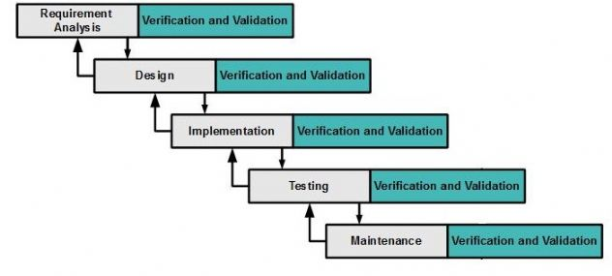

**Figure 1: Modified Waterfall Model as development methodology**

**Requirement Analysis:**

It focuses on gathering of information and requirements required by the user that describes overall functionality of the system which can be done through interviews, questionnaires, focus groups, etc.

**Design:**

It focuses on designing the output of the software which is based upon conceptual framework on the basis of model chosen.

**Implementation:**

It is the phase of execution of plan, model, design, standard, specification, algorithm and realization of an application. It covers overall project requirements and specification with code for the system.

**Testing:**

This phase checks whether the system is working properly or not or whether it meets the requirements or not. This results to changes if required.

**Maintenance:**

It is never ending phase of maintenance in a system during the occurrence of any issues or faults. The upgrades or addition of any level can be performed in this stage with the client’s verification and validation.

The reason behind choosing modified waterfall model are as listed below:

* The previous phases can be easily revisited during any problem solving process.
* It helps in increment of flexibility.
* Verifies patches and forks updates to next version.
* Having specific deliverables on each phase, it works well for any kind of projects where requirements are analyzed properly.

## Design Pattern

As for design pattern, I have chosen MVC **(Model View Controller)** design pattern which is an architectural pattern that relates to UI / interaction layer of system specifying data model, presentation information and control information.

**Model** representsthe business logic or application data only.

**View** is a GUI part that can beseen by user.

**Controller** controls the data flow that exist between view and model.

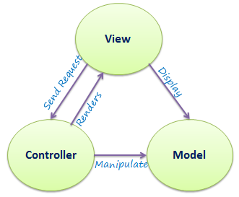

**Figure 2: Model View Controller MVC as design pattern**

The reason behind choosing MVC design pattern are as listed below:

* It is easier to maintain, upgrade and testing multiple system.
* It makes system extensible and scalable.
* It is a faster development process.

## System Architecture

Allowing an opportunity to modularize and extend the application, I have preferred using Layered **3-tier architecture** to keep up with the pace of change. It is a client-server architecture having three different layers or tier as **presentation layer**, **application layer** and **data layer**.

**Presentation layer:** It is the user interface of system that shows something understandable to the user.

**Application layer:** It is business logic layer that does calculations, logical decisions, data processing and many more.

**Data layer:** It is layer where information is store.

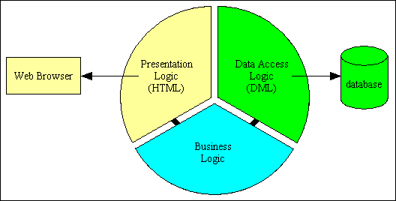

**Figure 3: 3-tier architecture as system architecture**

The reason behind choosing 3-tier architecture are as listed below:

* It provides easy updates without impacting other stages of the system.
* It becomes easy to develop and deploy.
* Scalability gets increased from distribution of application logic tier to many servers.
* It is more flexible to run on different application logic.

# **Chapter 4: Project Planning (WBS)**

## About WBS (Work Breakdown Structure)

A work breakdown structure (WBS) is a hierarchical decomposition of the work that are understandable and provides further definition and details of the project. The WBS for Employee Payroll System is as shown below:

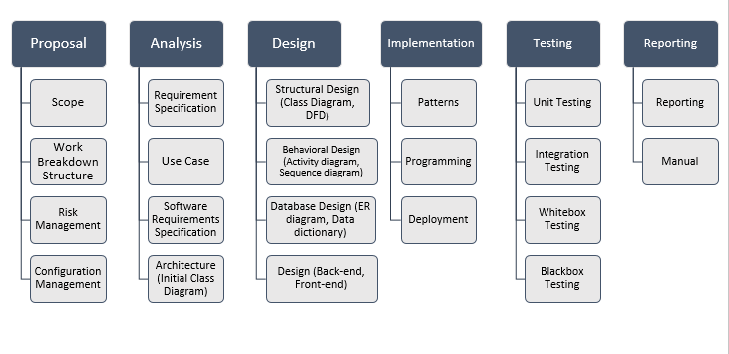

Figure 4: Work Breakdown Structure (WBS)

There are many benefits of WBS that includes simplifying project execution, defining the scopes of project and estimating cost, time and risk of the system. The core function of WBS is to depict project work graphically that provides complete structure of a system which can even help to manage the project.

## Milestone

Milestone is a project management tool that specifies points within time periods of an ultimate goals. It shows us appropriate dates as start or end date marking as major points within a project as shown in the figure below:

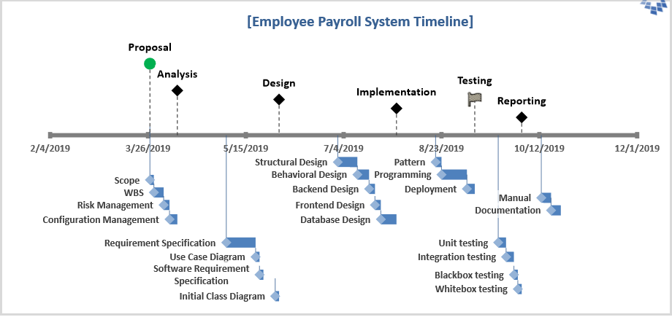

**Figure 5: Milestone of the project**

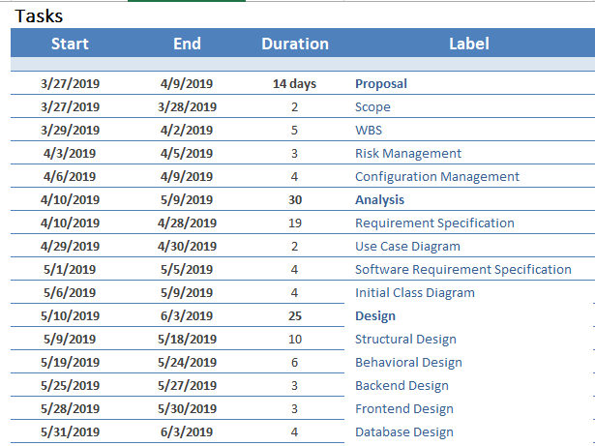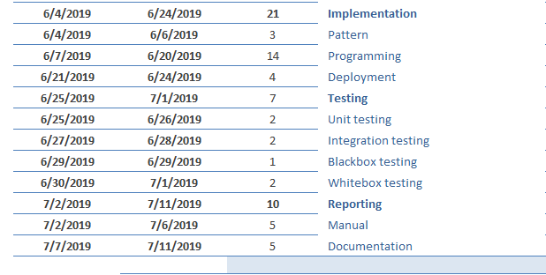

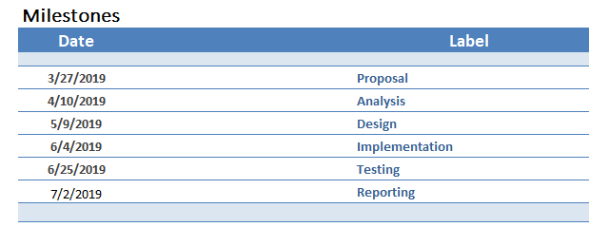

**Figure 6: Tasks and milestones of the EPS**

The above tables represents detailed information about the dates of major events to be done on respective time period. It helps in controlling the activities involved within project. It has start date and end date with total number of days that takes place during particular phases.

## Gantt chart

It is bar chart representing the project schedule that shows the duration of each activity. It is used for planning and scheduling the projects those are helpful for managing dependencies between tasks which are as listed below:

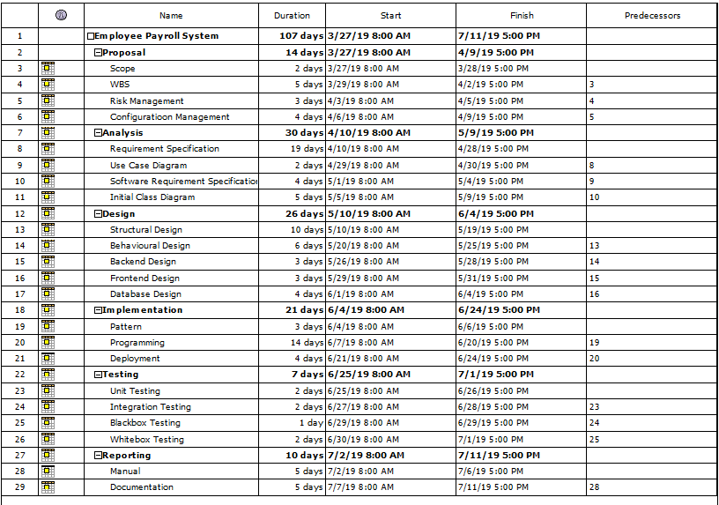

**Figure 7: Project Structure**

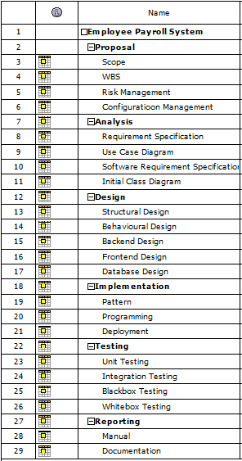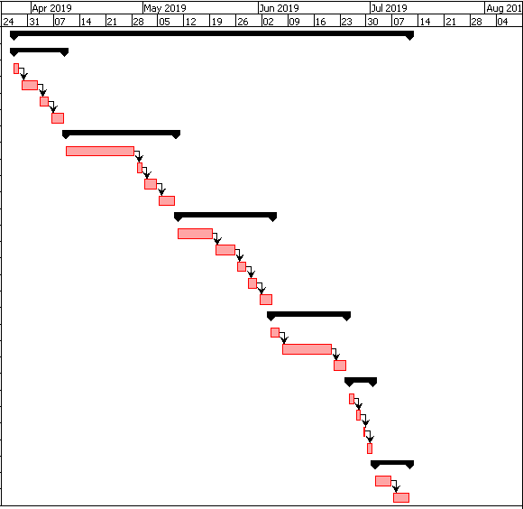

**Figure 8: Gantt chart of EPS**

The chart helps us to assess the timings of overall project for completion that determines resources and plans along with dependencies between each tasks. It simply represents visual view of each scheduled tasks with specific days and dates that represents timings of any task can be completed within certain time interval.

# **Chapter 5: Risk Management**

Risk management is a process of identifying threats occurring while investment and accessing tools to control their impacts on system. It can also be known as vulnerability assessment that focuses on prevention of raised problems. The three sections in risk management are risk likelihood, risk consequences and impact upon risk occurrence.

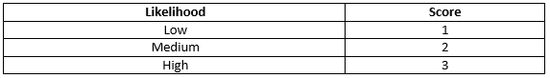

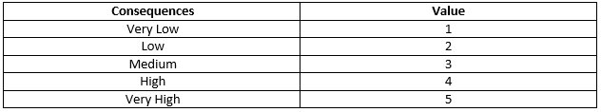

The impact upon risk management are calculated by the formula shown below:

**Impact = Risk Likelihood * Risk Consequences**

The diagram below shows the lifecycle of risk management.

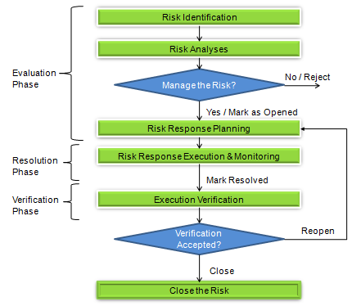

**Figure 9: Lifecycle of Risk Management**

The risk management life cycle includes risk identification, risk analysis, risk response planning, risk response execution and monitoring and execution verification. These are fundamental to effective risk management framework that generates and maintains a stream of data and information.

Similarly, the risk management table is as listed below:

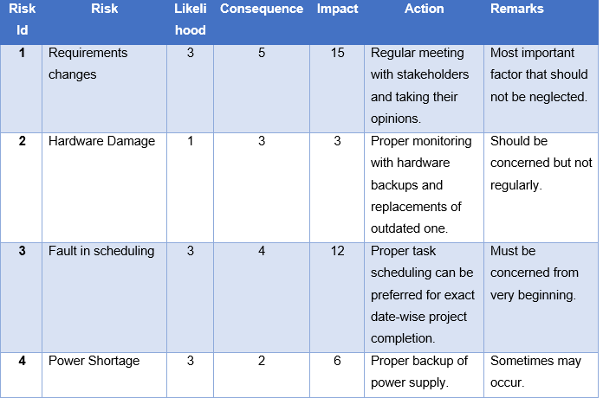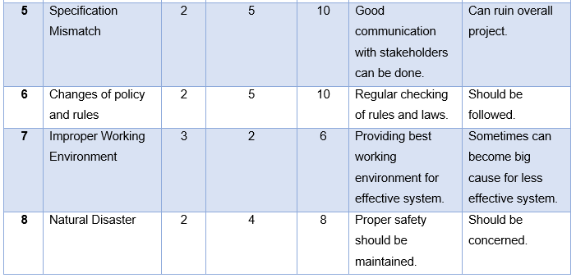

**Figure 10: Risk Management table**

# **Chapter 6: Configuration Management**

Configuration management is the system engineering process that helps in improvement of change-impact analysis and reducing the outages. Providing audit and compliance support in operating accounting, configuration management focuses on establishment of a system performance, cost, requirements, design and its physical attributes acting upon rules and regulations. Controlling the process of modification of source code and development of documentation can be easily represented from working directory that consists of steps with respect to sub-directories. Backup is an important aspect for any system which is also included during configuration management. For further backup, distributed version control ‘GitHub’ is being used where project is fully controlled with overall coding and proposals. The account named in GitHub is <https://github.com/Preranapandit> where project is handled securely.

The tree structure of the directory is as listed below:

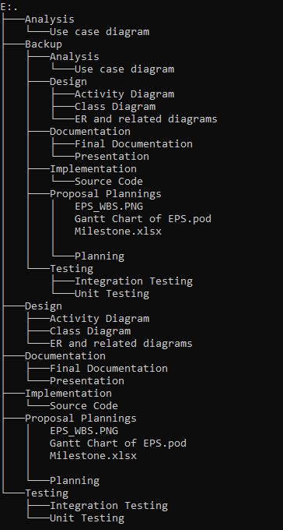

**Figure 11: Directory**

# **Chapter 7: Conclusion**

The Employee Payroll System overcomes overall difficulties faced by the companies and organizations caused from manual handling of payroll system of employees. The planning with proper implementation with organized methodology and with good coordination creates a successful EPS project. As in present, we are not able to search for reports of an employee but with modernized employee payroll system one can easily look after reports. Having maximum features in the system, the proposal completed with proper planning’s and appropriate designs methodology to solve the existing problems.

# **Chapter 8: References**

Griffiths, M., N.A. Project Smart*.* [Online] Available at: <https://www.projectsmart.co.uk/top-five-software-project-risks.php> [Accessed 1 April 2019].

Jhansi Bharati Madavarapu, Payroll Management System. [Online] Available at: <https://opus.govst.edu/cgi/viewcontent.cgi?article=1083&context=capstones> [Accessed 2 April 2019]

APM, N.A. *APM.* [Online]   
Available at: <https://www.apm.org.uk/body-of-knowledge/delivery/risk-management/>  
[Accessed 10 july 2018]