**EMPLOYEE PAYROLL SYSTEM**

**SOFTWARE USER’S MANUAL**

Version 1.0, June 26, 2019

**NOTE:**

It is a desktop-based application which will be handled by single user only. Either it can be handled by manager or a sales department officer or simply both can handle the system. As it is can be sophisticated for the users using it for the first time so this user manual is presented for your help. Thank You!

**Step 1: Starting with the homepage**

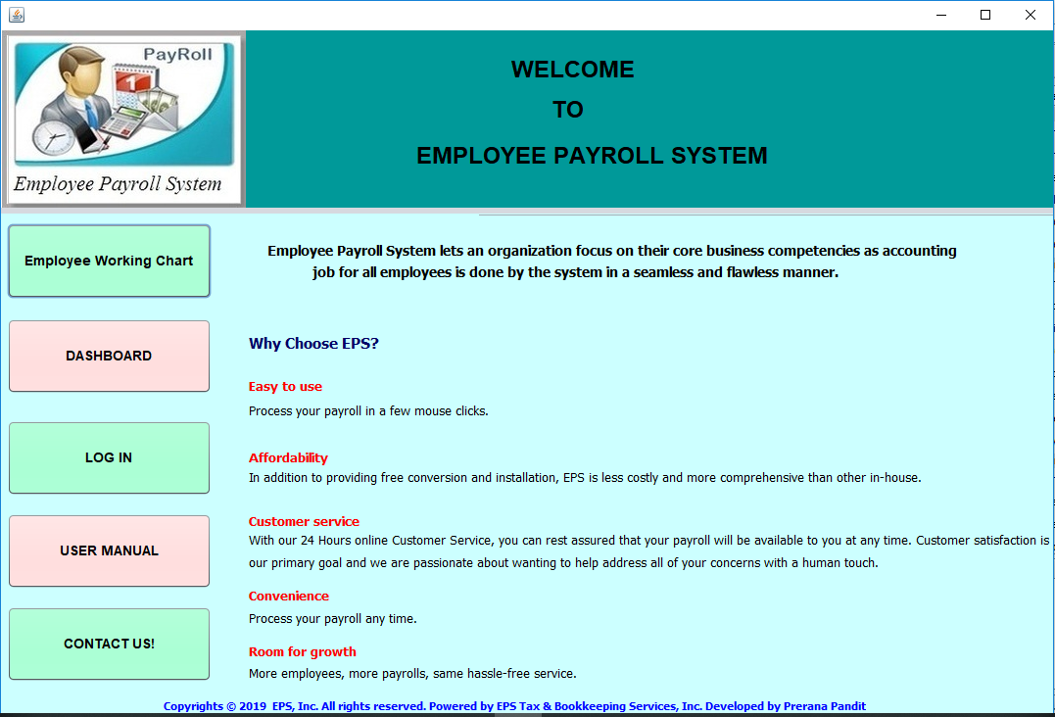

**Figure 1: Home Page of EPS**

The home page begins with introduction of **E**mployee **P**ayroll **S**ystem and its benefits for organization. The page leads to various pages which are as listed below:

* Clicking on **Employee Working Chart** leads to the pie-chart of employee’s number, their allowance, deductions and payments in average.
* Clicking on **Dashboard** leads to the alert message of restrictions to go for login page.
* Clicking on **Login** leadsto opening login page kept as a security for user.
* Clicking on **User Manual** leadsyouto openthis pdf made for your convenience and gaining experience about the system.
* Clicking on **Contact Us** leads to open contact page where contact numbers, email addresses and locations are available which are mentioned to help you.

**Step 2: Log-In Page**

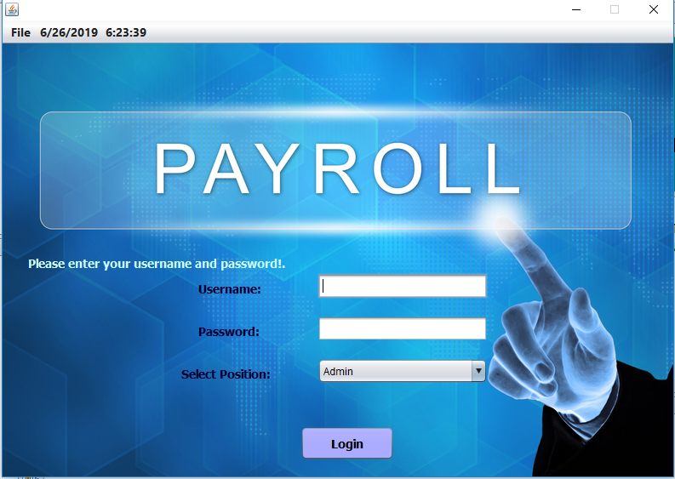

**Figure 2: Log-In Page of EPS**

The login page should be opened first for proper use of the system.

* Fill up the login credentials.
* Select the position either admin or sales officer.
* The credentials should be matched kept for security maintenance.
* Press Login button for proceeding to system.

**Step 3: Dashboard**

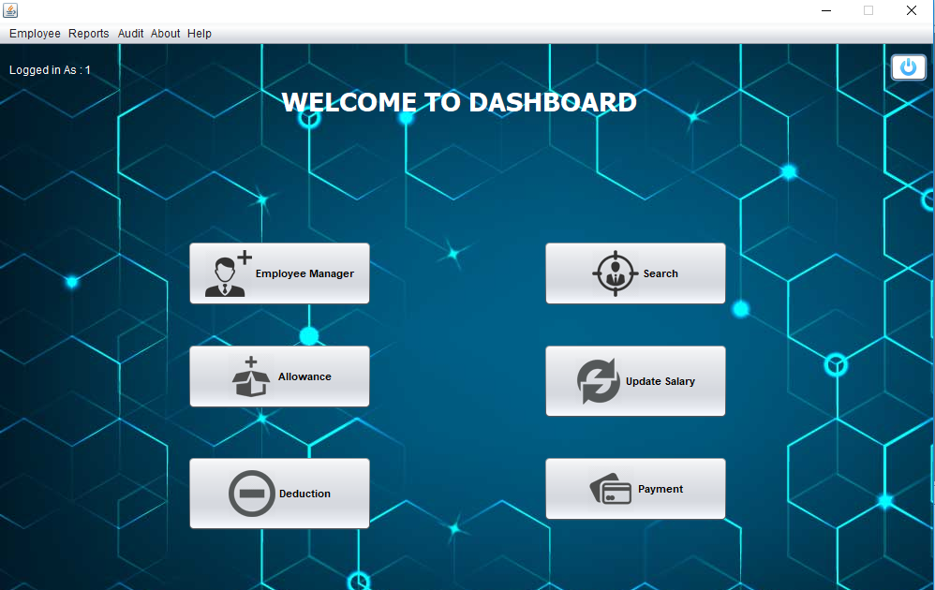

**Figure 3: Dashboard of EPS**

Dashboard will be opened only after successful login.

* Clicking on ‘Employee Manager’ leads to adding employee in the organization with their proper details or information.
* Clicking on ‘Search’ leads to searching of employees with their employee ID where update and delete will be available.
* Clicking on ‘Allowance’ leads to adding bonus, extra working timings and others to the salary of an employee.
* Clicking on ‘Deduction’ leads to subtracting overtime, leave or others reasons to the salary of respective employee.
* Clicking on ‘Update salary’ leads to updating salary of a respective employee on the basis of their employee id.
* Clicking on Payment leads to generating payment slip and providing salary to the employee.

**Step 4: Employee Registration Page**

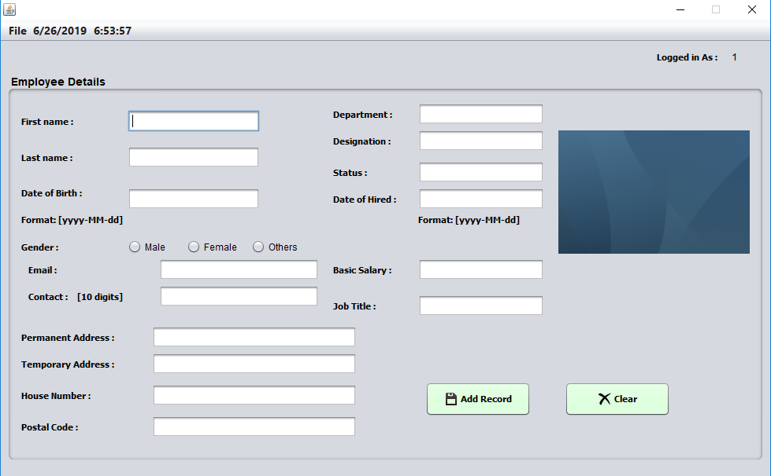

**Figure 4: Employee Registration Page**

The employee registration page can be reached directly from the dashboard.

* Click on the ‘Employee Manager’ button or ‘Employee Registration’ menu-item from Employee menu in dashboard.
* Enter the correct information or employee details with detailed job verification and salary. [The employee registration form is kept with proper validations as

10 digits contact number,

Email-format,

Numeric value only for salary,

Dates in ‘yyyy-MM-dd’ format,

Names in alphabets only, etc.]

* Person image can be kept but not mandatory.
* Click on Add Record button leads to adding employee to the database.

**Step 5: Search Employee**

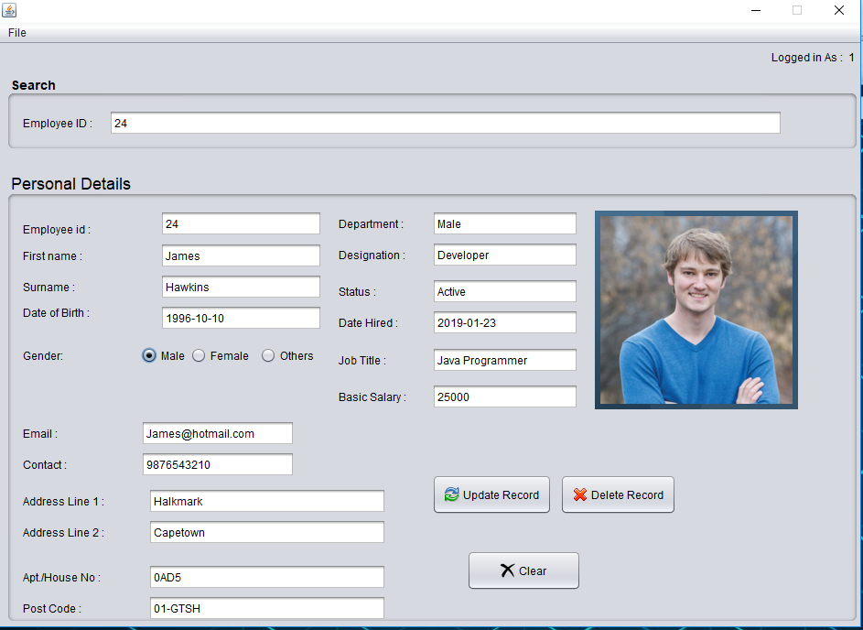

**Figure 5: Search Employee Page**

The search employee page can be reached from dashboard after log-in.

* Enter the employee Id of the employee where you can update his/her record and delete them incase of leaving the job.
* With proper validation, you need to update or edit the records and save them by clicking on update record button.
* The records or the particular employee can be deleted from clicking on Delete record button.
* The clear button clears all entries of text boxes.

**Step 6: Allowance Page**

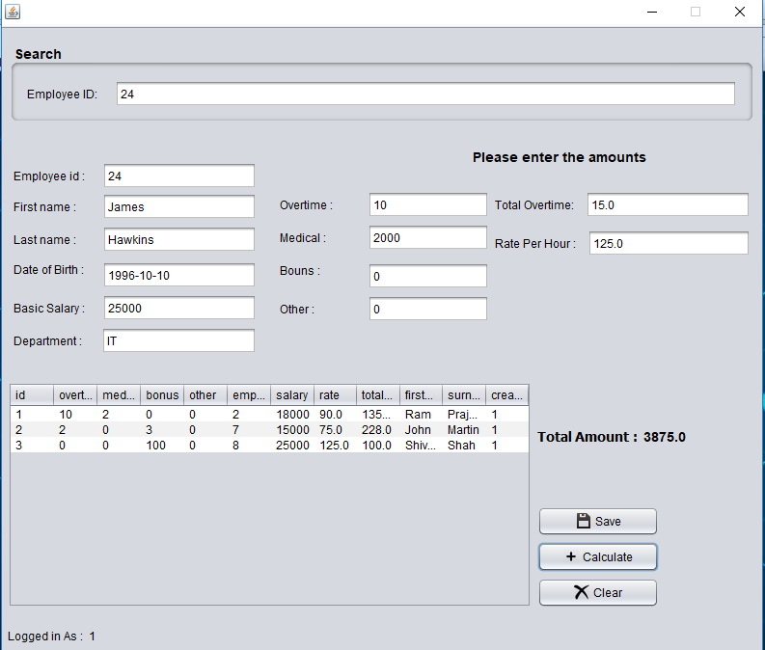

**Figure 6: Allowance page of EPS**

Allowance page can be directly reached from dashboard.

* Enter the employee ID of the respective employee to whom you want to add allowance.
* Enter the amounts of the rights side and overtime hours if he/she did.
* Click on the calculate button.
* Click on save, the data will be saved and can be seen on the tables below.
* Clear button clears the inputs written on the text boxes.

**Step 7: Deduction Page**

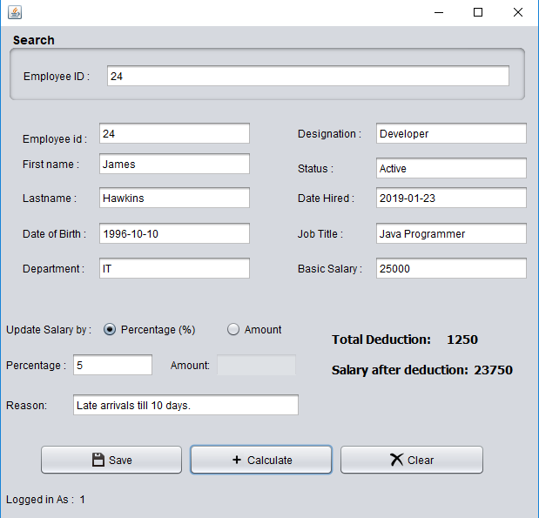

**Figure 7: Deduction Page of EPS**

Deduction page leads to degrades on salary of an individual employee.

* Employee id must be written on the provided text box to pop-up their details.
* Deduction can be done by percentage or by amount by clicking on respective radio buttons.
* The particular percentage gets enabled by clicking on percentage radio button else amount gets enabled and percentage gets disabled by clicking on amount radio button.
* You can simply write the reason for deduction from salary.
* Click on calculate button to calculate the deduction amounts from salary at the right side.
* Click on save button if you want to save the record.
* Clear button clears the inputs of the text fields.

**Step 8: Update Salary Page**

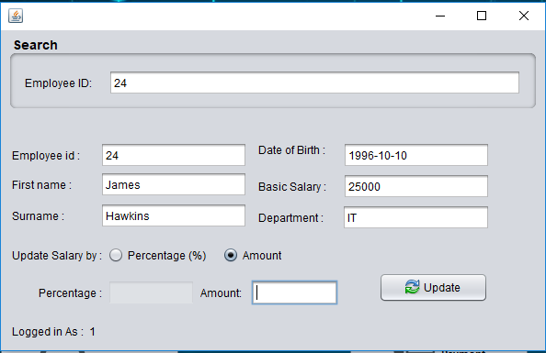

**Figure 8: Update Salary Page of EPS**

Update salary can be reached from dashboard which works for increasing or decreasing the salary amount of the respective employee.

* Employee id must be written on the provided text box to pop-up their details.
* Updates can be done by percentage or by amount by clicking on respective radio buttons.
* The particular percentage gets enabled by clicking on percentage radio button else amount gets enabled and percentage gets disabled by clicking on amount radio button.
* Click on update button to update/edit the salary amount on individual employee.

**Step 9: Payment Page**

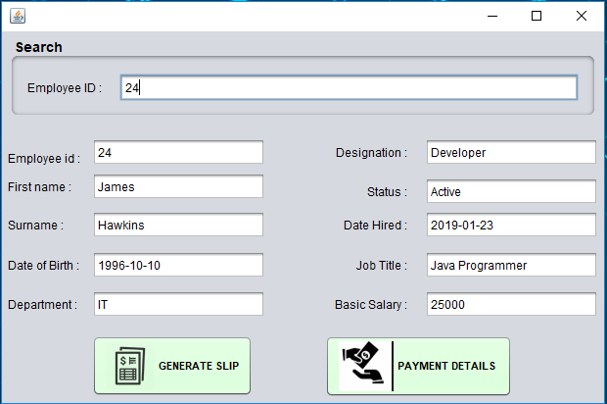

**Figure 9: Payment Page of EPS**

The payment page can be reached from dashboard which is the main page of employee payroll system. It is an important functional point of system.

* Employee id must be written in the text box for their particular details.
* Click on generate slip proceeds the salary providence to the employee with full details as:

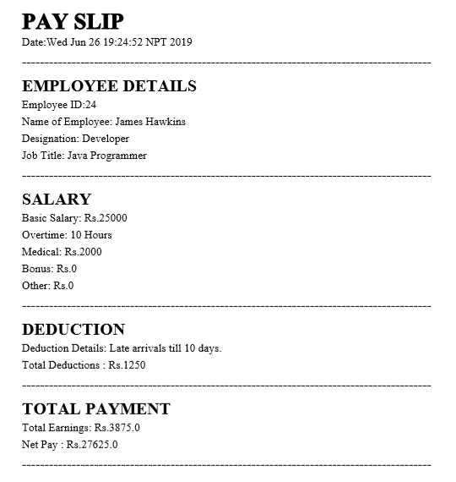

* Likewise, clicking on Payment details generates the individual payment details as:

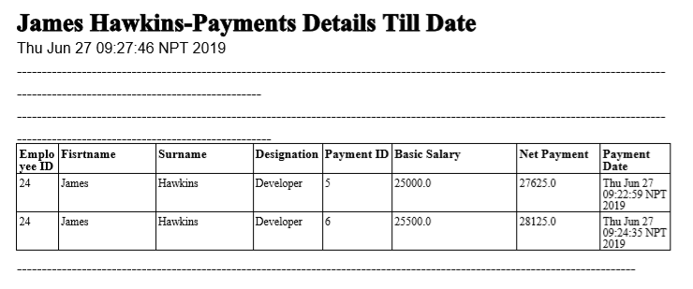

**Step 10: Reports on Menu Bar**

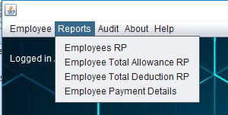

**Figure 10: Reports Option on Menu Bar**

The reports on the menu bar leads to open and create various reports as:

* Employee RP can also be termed as employee reports that generates total number of employees working in the organization with their detailed information.

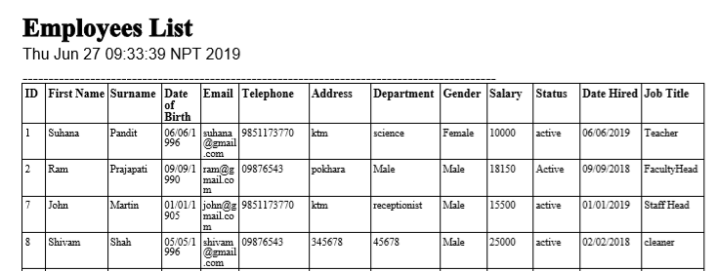

* Employee Total Allowance RP also known to be reports which generates total allowance allowed to different employees.

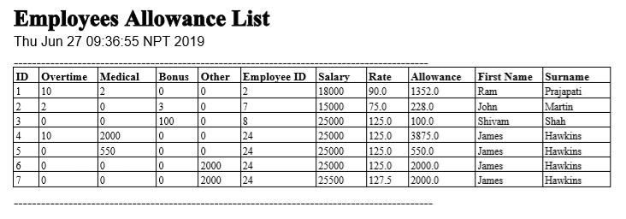

* Employee Total Deduction RP generates total deduction done to employees of an organization in a tabular format.

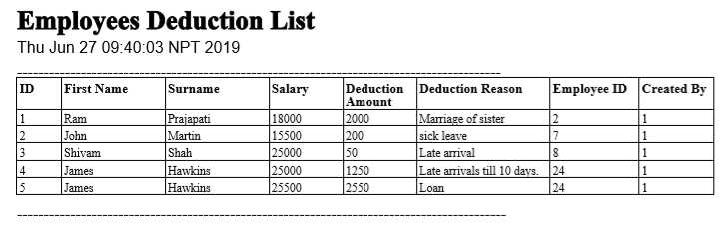

* Employee Payment RP generates a total payment provided to the employees till date in a PDF format which can be stored anywhere in a desktop.

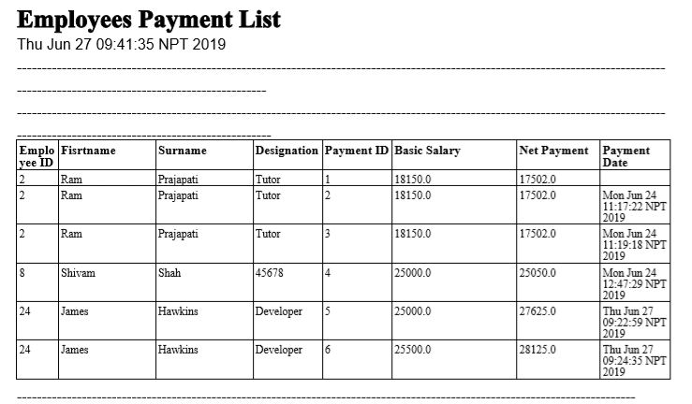

**Step 11: Audit on Menu Bar**

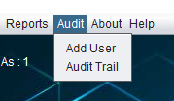

**Figure 11: Audit Menu on Menu Bar of Dashboard**

Audit on the menu bar of dashboard represents two different menu items as Add User and Audit Trial.

* **‘Add User’** Click event pop-ups the form that represents the users where their username and password can be updated and also can be deleted. The users can be added which can simply login the system.

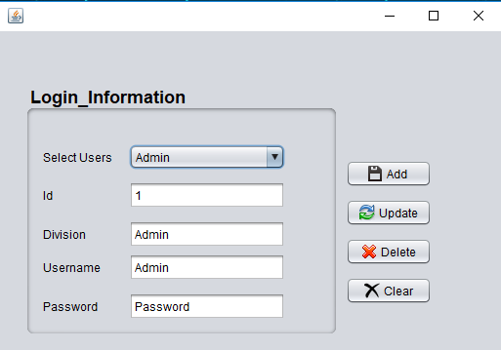

**Figure 12: Add User Form from Menu Bar**

* **‘Audit Trial’** how the detailed information about the users performed after their successful login till their logout phases. Or simply, we can call it as a tracking events or actions operated by the admin or manager or some respective task-oriented users.

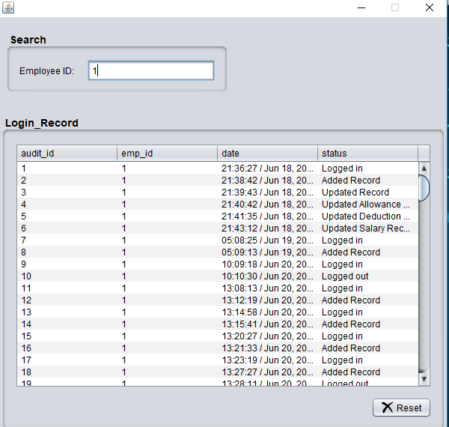

**Figure 13: Audit Trail Report as tracking Operations**

**Step 12: About on Menu Bar**

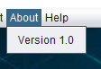

**Figure 14: About on Menu Bar**

About on the menu bar of dashboard represents the version of the system which is Version 1.0.

**Step 13: Help on Menu Bar**

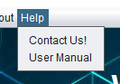

**Figure 15: Help on Menu Bar**

Help on the menu bar button helps you to resolve your problems in any way within limited hours.

* Click on Contact Us button opens the contact page where you can easily get location, address with google map and contact numbers.

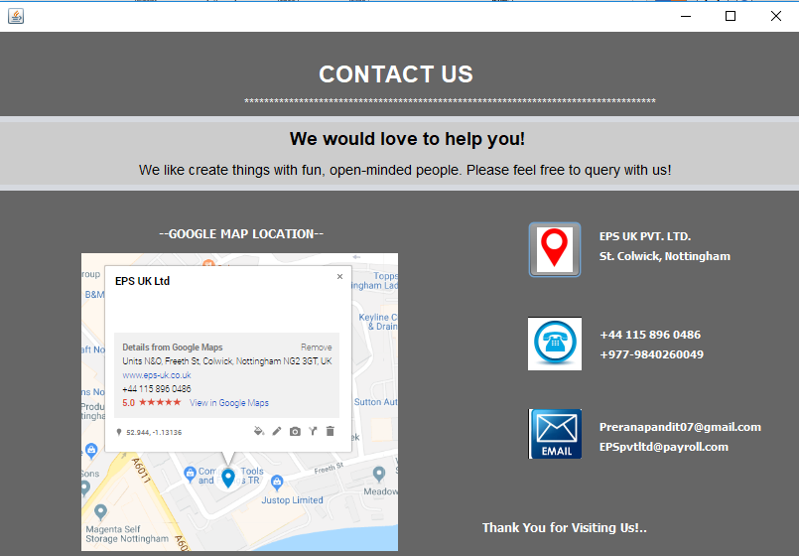

**Figure 16: Contact Us Page For HELP**

* Clicking on User Manual menu item leads you to this page where you are fully guided about the system working mechanisms that would be beneficial for you. It can make your work more efficient and makes ease to use the employee payroll system.

**Step 14: Employee Working Chart on Home Page**

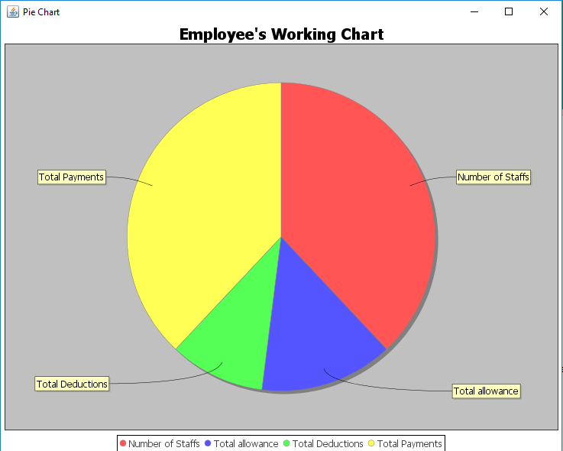

**Figure 17: Employee Working Chart or Progress Reports**

The employee working chart displays the total number of employees, their allowance, their deductions and total number of employees’ payments provided in a particular range that describes about the performance of the employee for the betterment of the organization.

***Thank You! For Choosing Our Employee Payroll System...***