Car Sales Analysis Dashboard

Presented by Prerana Patil

Dashboard Objective

🞄 Provide a unified view of car sales performance.

🞄 Identify profitable segments by model, year,

condition, and location.

🞄 Enable data-driven decision-making through visual insights.

🞄 Track time-series trends in vehicle sales, condition,

and pricing.

Problem Statement

🞄 Car sales data is scattered across brands, states,

and time.

🞄 Lack of clarity on which models, colors, or years are most profitable.

🞄 Difficult to detect market trends and customer

preferences.

🞄 Business users lack real-time insights to drive strategic decisions.

Key Deliverables

🞄 KPIs: Total Listings, Avg. Odometer, Avg. Condition,

Profitable Sales.

🞄 Drill-down capability by transmission, year, and

model.

🞄 Visuals: Bar charts, pie charts, donut charts, trend

lines.

🞄 Time trend analysis and seller analysis included.

🞄 Interactive filters for deep dives.

Page 1 – Sales Overview

🞄 Total Listings: 448K, Avg. Condition: 30.55, Avg.

Odometer: 67.92K, Profitable Sales: $211K

🞄 Top models by maker (Ford, Chevrolet, Nissan…)

🞄 Distribution by body type (SUV, Sedan,

Hatchback…)

🞄 Popular colors (White, Black, Gray…)

Insights from Sales Overview

🞄 Ford dominates listings.

🞄 Sedans are the most common body type.

🞄 White is the most preferred color.

Page 2 – Time-Series Trends

🞄 Avg. Odometer by Year – wear and tear trend over

decades.

🞄 Profitable Sales by Year – peak in 2011.

🞄 Total Listings by Year – spike in 2012.

🞄 Average Selling Price by Year – consistent increase.

Insights from Time-Series Trends

🞄 Older vehicles have higher mileage.

🞄 Profits and sales peaked between 2010–2012.

🞄 Average selling price has increased over the years.

Page 3 – Seller Analysis

🞄 Count of Sellers by State – distribution of sellers geographically.

🞄 Profitable Sales by Seller – identify top revenue

generators.

🞄 Count of Sellers by Transmission Type – manual vs automatic.

Insights from Seller Analysis

🞄 Automatic transmission dominates seller inventory —

most sellers deal in automatic cars.

🞄 Top sellers like Nissan-Infiniti LLC and Ford Motor Credit Co. generate $6K–$7.5K in profits each.

🞄 California has the highest concentration of sellers (11.54%), followed by PA, FL, TX, and NY.

🞄 Many smaller sellers contribute under $2K profit —

potential for training or performance boosting.

🞄 Use seller segmentation to tailor support and maximize ROI from high-potential sellers.

Strategic Takeaways

🞄 Focus on high-performing sellers to increase

profitability.

🞄 Expand in states with fewer sellers but high potential.

🞄 Align inventory with transmission preferences of

sellers.

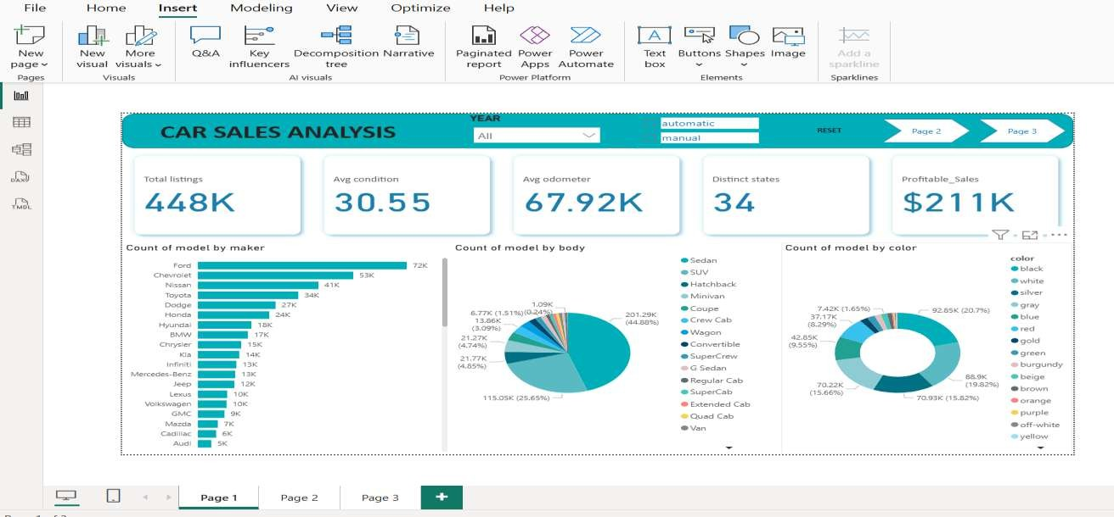Dashboard screenshots:

